**2.Give very short answer.**

1.What is a mixture? Write any two examples of mixture.

- The substance made by mixing two or more substances together is called mixture.

Two e.g:- salt and water , sugar and water etc.

2.What is a homogeneous mixture?

- The mixture in which particles cannot be seen clearly is called homogenous mixture.

3. What is a heterogeneous mixture?

- The mixture in which particles can be seen clearly is called heterogeneous mixture.

4.Write a difference between homogenous mixture and heterogeneous mixture.

-Particles cannot be seen clearly in Homogenous mixture and particles can be seen clearly heterogeneous mixture.

**3. Give an example of:**

a.Heterogenous mixture.

-salt and water

b.Mixture having liquid and liquid components.

-milk and water

c. Mixture having liquid and solid components.

- salt and sugar

d.Mixture having liquid and gas components.

-coca cola

e.Mixture having solid and solid components.

-salt and sugar

f. mixture having solid and gas components

-smoke

**4. Give reasons**.

a. Salt solution is a homogeneous mixture.

-Salt solution is a homogeneous mixture because salt dissolves evenly in water forming a uniform mixture.

b. Sedimentation process can be used to clean water at home.

-Sedimentation process can be used to clean water at home because heavy impurities settle down, leaving clean water on top.

c. Air is a mixture.

-Air is a mixture because air contains different gases.

**5. Draw a neat and labelled diagram of.**

a. Filtration process in a science laboratory.

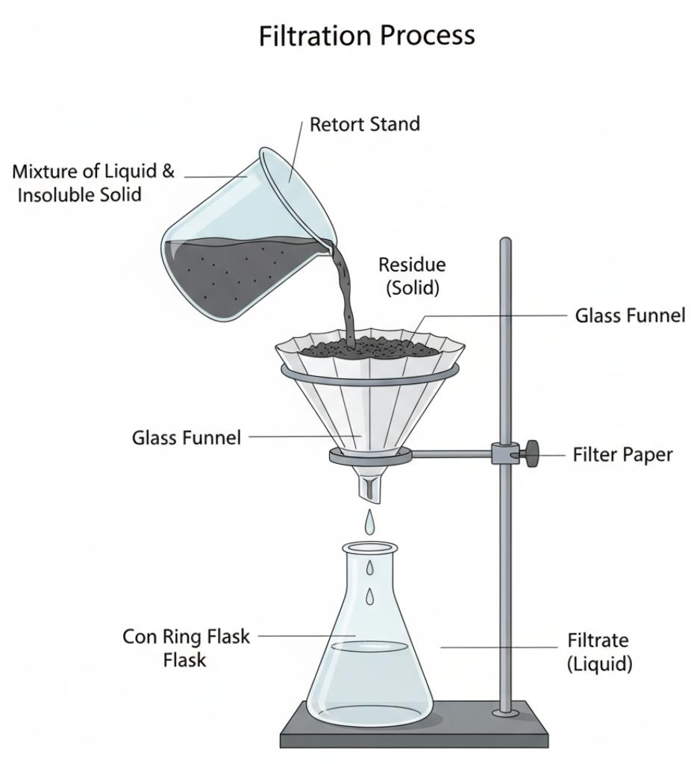-

b. Method used to separate solid components having different sizes.

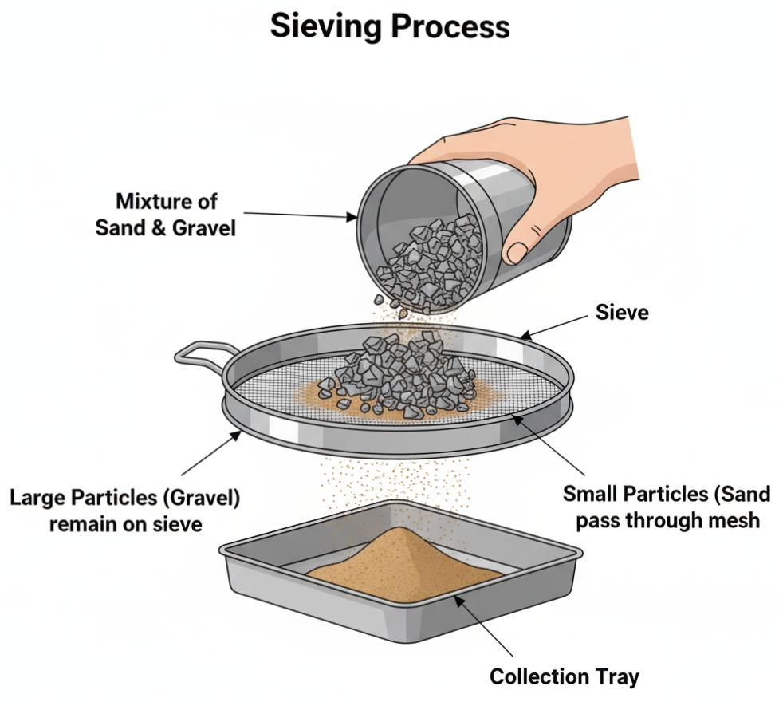

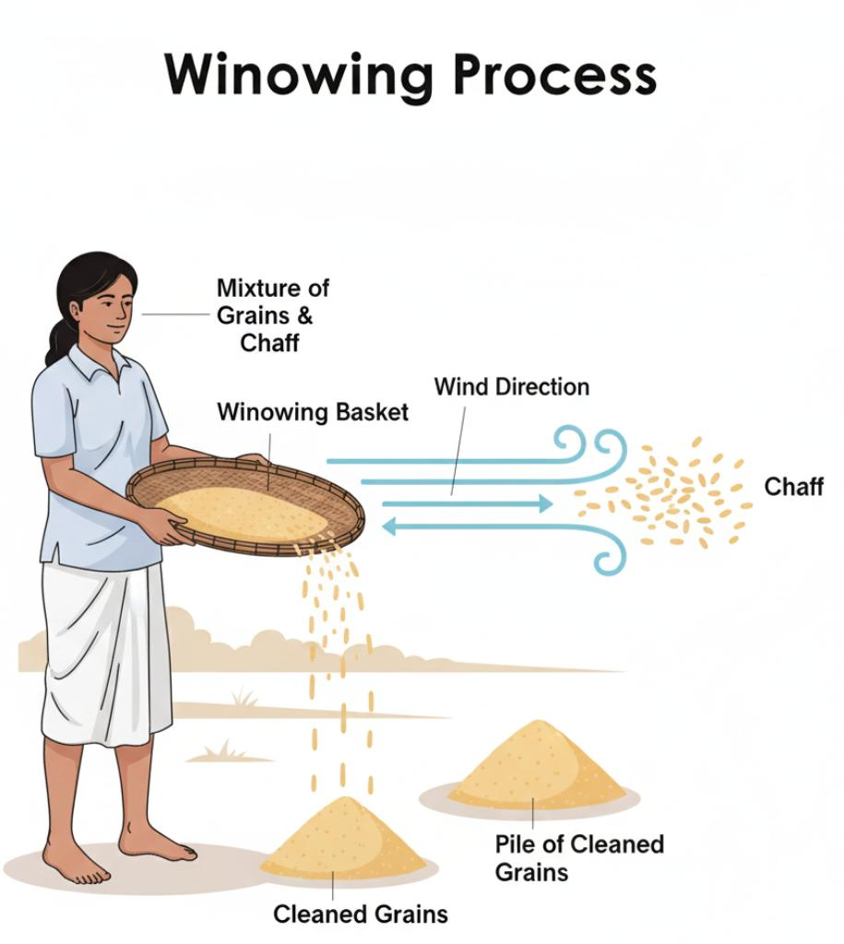c. Method used to separate solid components having different weights.