H. Long answer type questions.
1.What are the internal structures of the Earth? Compare the structure of the Earth with a boiled egg.
-The Earth has three main internal layers:
1,Crust
-The outermost layer of the Earth
2.Mantle
-The layer below the crus
3. Core
-The innermost part of the Earth.
•Comparison with a boiled egg:
Egg shell → Crust
Egg white → Mantle
Egg yolk → Core
So, the structure of the Earth is similar to a boiled egg.
2.The Earth has been tilted from its orbital plane during its revolution around the Sun. What are the effects of such revolution?
-The Earth Is tilted and revolves around the Sun. This causes the following effects:
- Change of seasons
Summer, winter, spring, and autumn occur because of Earth’s tilt.
- Unequal length of day and night
Days are longer in summer and nights are longer in winter.
- Different climate in different places
Some places are hot while others are cold.
Thus, Earth’s tilted revolution is very important for life.
3.Introduce the members of the solar system.
-The solar system consists of the Sun and all the objects that revolve around it.
The members of the solar system are:
- The Sun – The main source of heat and light
- Eight planets – Mercury, Venus, Earth, Mars, Jupiter, Saturn, Uranus, and Neptune
- Satellites – Like the Moon
- Asteroids – Small rocky bodies
- Comets – Bodies with a tail
- Meteoroids – Small pieces of rocks in space
4.What do axis and orbit of the Earth mean? Show them in a figure.
Axis:
The axis is an imaginary line passing through the center of the Earth from north to south.The Earth rotates on its axis.
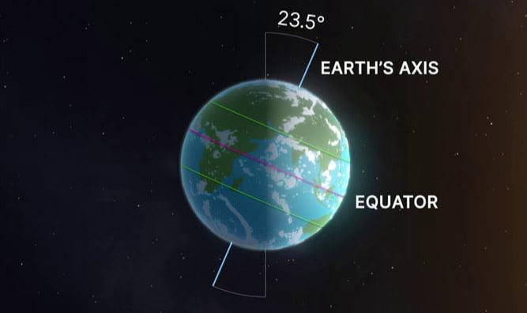
Orbit:
The orbit is the fixed path along which the Earth revolves around the Sun.
