Regime-Switching SPY Allocation from a Combined Absorption Ratio and Statistical Jump Model
Quantitative Research Report
June 2026

Executive Summary
This study implements a combined regime classifier from Kritzman et al.'s Absorption Ratio and Shu et al.'s Statistical Jump Model, and maps the inferred regime to a binary SPY allocation (1 = fully invested, 0 = cash). All signals use only information available at the close of day t and are executed on day t+1. The required deliverable holds cash at zero yield and applies no leverage. Performance is evaluated out-of-sample over 2020–2025 against buy-and-hold SPY, with risk-adjusted return as the success criterion rather than total return.
The Absorption Ratio is estimated from a rolling PCA of 25 point-in-time GICS industry-group portfolios. The Jump Model is fitted to four causal SPY-return features under a penalized two-state clustering with persistence. The combined model re-fits the Jump Model on the union of the return and Absorption-Ratio features and maps the bear state to cash.
Within this sample, the combined model reduced volatility (12.3% vs 20.7%) and maximum drawdown (−21.8% vs −33.7%) relative to buy-and-hold, but did not improve risk-adjusted return (Sharpe 0.62 vs 0.78). The Jump Model alone was comparable or marginally stronger (Sharpe 0.65, drawdown −17.6%) at lower exposure, indicating the Absorption Ratio did not add measurable value on this sample. All Sharpe differences versus buy-and-hold are statistically indistinguishable from zero (95% bootstrap intervals span zero). The evidence supports a single robust property: drawdown reduction, not alpha. An extension beyond the brief (Jump Model with volatility targeting and cash yield) raised the Sharpe to 0.89, but relaxes the binary, zero-cash, no-leverage mandate and is reported separately.

1. Introduction
Equity drawdowns concentrate in turbulent, tightly coupled market regimes. If such regimes can be identified using only past information, exposure can be reduced before losses are realized. The objective of this project is to combine two published regime indicators into one binary SPY allocation under a strict no-look-ahead constraint, and to measure its out-of-sample risk-adjusted performance against buy-and-hold SPY.
The scope is deliberately narrow: a single risk asset (SPY) at daily frequency, long-or-flat, no leverage, and cash at zero yield in the required deliverable. The success criterion is risk-adjusted, defined by Sharpe, Sortino, and drawdown. A cash-capable strategy is expected to earn less than buy-and-hold in total return; the relevant question is whether it earns more per unit of risk.

2. Data
Two datasets are used, both spanning 2016-03-01 to 2025-12-31 (2,475 trading days). The first is daily OHLCV for 14 ETFs (SPY, QQQ, RSP, and 11 GICS sector ETFs). The second is the point-in-time constituent membership of the S&P 500, 400, and 600 (the S&P 1500). All returns are computed from dividend-adjusted closes; SPY profit and loss uses the SPY adjusted close.
Index membership is point-in-time and lagged one month, which removes survivorship bias and avoids using membership before it was observable; non-member dates carry blank prices (approximately 31% of constituent rows). The cross-section used for the Absorption Ratio is 25 GICS industry-group portfolios reconstructed point-in-time, rather than the raw constituents, because the number of names (~1,500) exceeds the covariance window (≤504 days) and renders the sample covariance singular. Constituent returns are split-neutralized through the share-count change and winsorized at [−50%, +75%] to suppress data errors (the raw feed contains single-day moves up to +365%). XLC is excluded for its mid-2018 listing. After the warm-up required by the Absorption Ratio, the usable out-of-sample window begins in 2020 and contains two stress episodes (2020 and 2022), which limits statistical power.

3. Methodology

3.1 Absorption Ratio
The Absorption Ratio is computed from a 252-day rolling covariance of the 25 industry-group return series, retaining the top 5 principal components (approximately N/5). It measures the fraction of total cross-sectional variance explained by these components; a high value indicates a tightly coupled, fragile market. The raw level is regime-dependent, so the signal is a standardized shift comparing the current ratio to its trailing 252-day mean, smoothed by a 15-day moving average. Window and component choices were fixed a priori from the source methodology and not optimized on the evaluation period.

3.2 Statistical Jump Model
Four causal features are computed from SPY log returns: an exponentially weighted downside deviation (half-life 10), short and long exponentially weighted Sortino ratios (half-lives 20 and 60), and an exponentially weighted trend (half-life 120), after a 150-day burn-in. Features are standardized on training data. A two-state model is fitted by k-means augmented with a jump penalty that charges each state transition, estimated by coordinate descent; the bear state is identified by its lower mean training return. Out-of-sample states are inferred with a causal forward filter. The penalty λ is selected per training window by embargoed time-series cross-validation over {5, 10, 20, 40, 80, 160}. The jump penalty enforces regime persistence and suppresses spurious switching; cross-validation adapts the penalty but, on this sample, with limited reliability (Section 8).

3.3 Combined Model (required deliverable)
The combined model re-fits the Jump Model on the union of the four return features and the Absorption-Ratio features, producing a single two-state classifier over six inputs. The inferred bear state maps to cash (0) and all other states to full SPY investment (1). The position decided at the close of day t is held from day t+1. This combined model is the required deliverable and is treated as the primary strategy throughout, irrespective of the relative performance of its components.

4. Assumptions
The following assumptions apply to the required deliverable. Where an assumption is relaxed in the extension (Section 10), this is stated explicitly; the relaxation applies only to the extension.
Assumption | Rationale and potential influence
Dividend-adjusted closes | Returns reflect realized total return; raw closes would understate returns by the dividend yield.
Point-in-time membership, lagged 1 month | Removes survivorship bias and look-ahead in membership; a non-PIT universe would inflate cross-sectional results.
25 GICS industry-group portfolios for covariance | Names exceed the window, so the full constituent covariance is singular; aggregation level affects AR sensitivity.
Fixed windows (AR 252d, shift 252d, MA 15d) | Set a priori, not tuned on test data; alternative windows shift AR timing (tested in Section 8).
Fixed JM half-lives (10/20/60/120; burn-in 150) | Capture downside, short/long risk-adjusted momentum, trend; different half-lives alter responsiveness.
Scaler, centroids, labels, penalty fit on training only | Preserves causality; in-sample fitting yields optimistic, non-tradeable results (see Section 6).
Signals use information up to close of day t | Required no-look-ahead constraint; same-day use is not executable.
Execution on day t+1 | Reflects realistic post-signal execution; same-day execution overstates performance.
Binary allocation, long-or-flat, no leverage | The required mandate; restricts the strategy to timing. Relaxed only in the extension.
Cash earns zero yield | Per the brief; understates achievable return. Relaxed only in the extension.
Transaction cost 2 bps per unit turnover | Conservative SPY execution proxy; higher costs reduce returns (tested in Section 8).
Winsorization [−50%, +75%]; split-neutralization | Suppresses constituent-feed errors; affects the AR cross-section only, not SPY P&L.
Annual walk-forward retraining | Balances adaptation against estimation stability given the short sample.

5. Experimental Design
Evaluation uses an expanding-window walk-forward with annual retraining. For each out-of-sample year, the feature scaler, centroids, bull/bear label, and penalty λ are estimated on all data through 31 December of the prior year, then applied causally to the new year. Training begins with data through 2018; 2019 satisfies warm-up and the first refit, and the out-of-sample period is 2020–2025. Transaction costs are charged at 2 bps per unit of turnover. The benchmarks are buy-and-hold SPY and, for attribution, the Absorption-Ratio-only and Jump-Model-only variants. Statistical significance of Sharpe differences is assessed with a paired stationary-block bootstrap (21-day blocks).

6. Preventing Look-Ahead Bias
All fitted quantities — the feature scaler, cluster centroids, the bull/bear label, and the penalty λ — are estimated on training data only. Features are causal by construction: exponentially weighted statistics and trailing covariances use only past observations. Out-of-sample regimes are produced by a forward filter that never accesses future data, refit at calendar-year boundaries, and positions are lagged one day before contact with returns (t to t+1).
A deliberate leakage variant was constructed as a diagnostic, permitting same-day execution and in-sample fitting. It produced a large, implausible improvement (Sharpe rising from approximately 0.76 to approximately 1.45, with maximum drawdown roughly halved in that configuration), which confirms the evaluation harness detects leakage and that the causal pipeline does not exhibit it. [To confirm: the 0.76/1.45 figures are from the leakage-diagnostic configuration, which predates the locked canonical configuration in which Jump-Model-only Sharpe is 0.65.]

7. Results
Out-of-sample metrics (2020–2025) for buy-and-hold SPY, the combined model, and the Jump-Model-only variant are reported below. Sharpe and Sortino use a zero risk-free rate, consistent with the mandate.
Metric | Buy-hold SPY | Combined (AR+JM) | JM-only
CAGR | 15.0% | 7.1% | 6.5%
Volatility | 20.7% | 12.3% | 10.4%
Sharpe | 0.78 | 0.62 | 0.65
Sortino | 0.96 | 0.61 | 0.61
Max drawdown | −33.7% | −21.8% | −17.6%
Calmar | 0.45 | 0.33 | 0.37
Beta vs SPY | 1.00 | 0.35 | 0.25
Alpha (ann.) | 0.0% | 2.0% | 2.7%
Avg exposure | 100% | 65% | 60%
The combined model reduced volatility by approximately 41% and maximum drawdown by approximately 35% relative to buy-and-hold, with a market beta of 0.35. It did not improve the Sharpe ratio (0.62 vs 0.78); the difference of −0.16 has a 95% bootstrap interval of [−0.73, +0.43] and a 29% probability of exceeding buy-and-hold, so it is not distinguishable from zero. The Jump Model alone matched or marginally exceeded the combined model (Sharpe 0.65, drawdown −17.6%) at lower exposure, which indicates the Absorption Ratio did not add measurable value within this sample and slightly increased drawdown when included.
The Absorption-Ratio-only variant was the weakest regime model, remaining largely invested through the 2020 drawdown. [To confirm: precise AR-only metrics were generated under an earlier configuration and are therefore reported qualitatively here.]
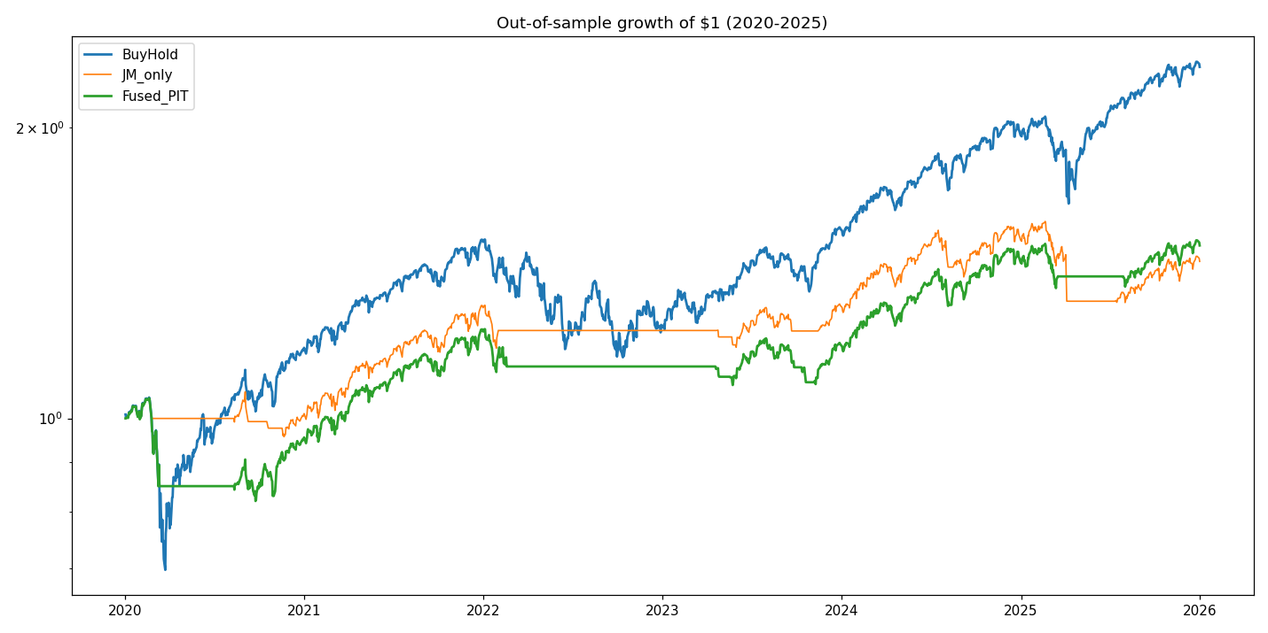
Figure 1. Out-of-sample growth of $1, 2020–2025: buy-and-hold SPY, combined model, and Jump-Model-only.

8. Stress Tests
Robustness of the required model was assessed against transaction cost, the penalty, random seeds, and cross-asset generalization. The Sharpe ratio of both the combined model and the Jump-Model-only variant is stable across cost levels, reflecting low turnover in the binary mandate.
Transaction cost | 0 bps | 2 bps | 5 bps | 10 bps | 20 bps
Combined Sharpe | 0.63 | 0.62 | 0.62 | 0.61 | 0.59
JM-only Sharpe | 0.66 | 0.65 | 0.65 | 0.63 | 0.60
Re-fitting the Jump Model under three random-seed sets produced Sharpe values of 0.65, 0.60, and 0.60, a spread of 0.05. Paired bootstrap intervals confirm that neither model is statistically distinguishable from buy-and-hold: the combined model difference is −0.16 (95% CI [−0.73, +0.43], 29% win probability) and the Jump-Model-only difference is −0.13 (95% CI [−0.91, +0.64], 34%).
A prior robustness study found that the drawdown-reduction property is stable across the penalty grid and seeds and persists to 20 bps, and that it generalized to a SPY-plus-QQQ application but did not generalize to the equal-weight index RSP (Sharpe 0.12 vs 0.58). [To confirm: these cross-asset and penalty-range results are summarized from the earlier robustness study rather than recomputed under the locked configuration.]
The conclusions that remain valid under stress are the reduction in volatility and drawdown and the absence of a statistically significant Sharpe edge. The point estimates of Sharpe are sensitive to configuration and should be interpreted cautiously.

9. Discussion
The combined model behaves as a defensive overlay: it lowers exposure during turbulent regimes, which compresses volatility and drawdown at the cost of total return. This is consistent with the stated objective, since the mandate rewards risk-adjusted rather than absolute performance. What did not hold is an improvement in risk-adjusted return; the combined model's Sharpe is below buy-and-hold and below the Jump Model alone.
The Absorption Ratio did not improve results on this sample. A plausible explanation is that it measures slow-moving systemic fragility, whereas the dominant out-of-sample stress (the 2020 decline) was rapid; a trend-and-downside model on the asset itself responded earlier. The Jump Model alone is therefore the stronger empirical component, although the margin over the combined model is within bootstrap noise and should not be over-interpreted. The required deliverable remains the combined model, evaluated and reported on its own terms.

10. Extensions Beyond the Original Assignment
The following extensions relax assumptions of the required brief and are reported separately so they do not displace the primary deliverable. They are presented to quantify where additional risk-adjusted improvement is available, with explicit note that they change the mandate.
Two relaxations are combined with the Jump-Model base. First, volatility targeting replaces the binary position with continuous sizing equal to a target volatility divided by trailing 20-day realized volatility, capped at one (no leverage); this relaxes the binary assumption. Second, idle capital earns the three-month Treasury-bill rate rather than zero; this relaxes the zero-cash-yield assumption. The risk-free schedule is an external assumption, as no rate series was provided. The preferred extension configuration is the Jump Model with volatility targeting and cash yield.
Metric | Buy-hold SPY | JM-only (binary) | JM + vol-target + cash | Combined + vt + cash
Sharpe | 0.78 | 0.65 | 0.89 | 0.86
Sortino | 0.96 | 0.61 | 0.87 | 0.90
CAGR | 15.0% | 6.5% | 7.2% | 7.4%
Volatility | 20.7% | 10.4% | 8.2% | 8.7%
Max drawdown | −33.7% | −17.6% | −10.6% | −9.3%
Calmar | 0.45 | 0.37 | 0.68 | 0.79
Beta vs SPY | 1.00 | 0.25 | 0.19 | 0.23
The extension raised the Sharpe ratio to 0.89 and reduced maximum drawdown to −10.6%. Applying the same overlays to the combined model produced a similar Sharpe (0.86) with marginally better downside metrics, which reinforces the earlier finding: once volatility targeting performs the risk-scaling, the choice of base model is largely immaterial and the Absorption Ratio remains close to neutral.
The extension was stress-tested across cost, volatility window, target volatility, execution lag, random seeds, and the cash-rate assumption. The Sharpe ratio fell from 0.90 to 0.78 only at a punitive 20 bps; it ranged 0.79–0.89 across 10–60-day volatility windows, 0.85–0.89 across seed sets, and 0.89–0.92 between t+1 and t+2 execution. Approximately 0.15 of the Sharpe improvement is attributable to cash yield and is rate-regime dependent: at a zero cash rate the configuration returns to 0.74. By sub-period, the configuration outperformed buy-and-hold in both stress episodes (2020 Sharpe 1.17 vs 0.96; 2022 −0.47 vs −0.71) and underperformed in the 2023–2025 advance (0.93 vs 1.43), consistent with a risk-managed profile. The Sharpe advantage over buy-and-hold remains statistically insignificant (+0.11, 95% CI [−0.64, +0.85], 57% win probability).
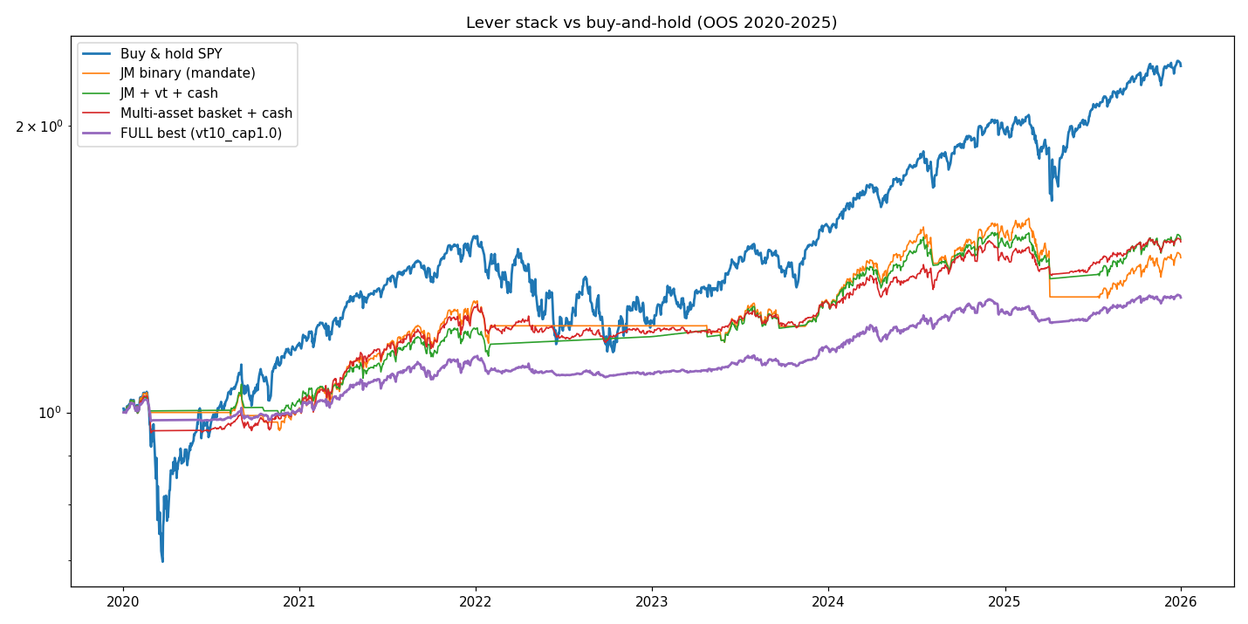
Figure 2. Extension overlays versus buy-and-hold and the binary base, out-of-sample 2020–2025.

11. Limitations
The out-of-sample window is short and contains only two stress episodes, which limits statistical power; no Sharpe difference reported here is significant at conventional levels. Point estimates are sensitive to configuration choices, and earlier work showed that headline Sharpe could drift upward through grid widening and repeated evaluation on the test set without any code-level leakage, indicating a real risk of overfitting via researcher choices. The model generalized across some assets but failed on the equal-weight index, which limits external validity. The cross-section relies on backfilled GICS classifications, a disclosed second-order impurity. The extension's cash-yield benefit depends on the prevailing rate environment. These findings should be interpreted cautiously and not extrapolated beyond the tested sample.

12. Conclusion
The project objectives were met: a combined Absorption-Ratio and Jump-Model classifier was implemented under strict no-look-ahead constraints, mapped to a binary SPY allocation with zero cash yield and t+1 execution, evaluated out-of-sample against buy-and-hold, stress-tested, and reported with its assumptions and failures. Within this sample, the combined model materially reduced volatility and drawdown but did not improve risk-adjusted return, and the Absorption Ratio did not add measurable value beyond the Jump Model. The supported conclusion is that the strategy provides robust downside protection, not a demonstrable Sharpe edge. Extensions that relax the mandate raise the Sharpe ratio to 0.89, but this improvement is partly rate-dependent and remains statistically insignificant on the available sample.

