Design of Django Framework
(Sahal Sajjad - 201301021)

THE MOTIVATION
There is a need for:
- Python based MVC pattern framework
- Rapid Prototyping for short deadlines
- Modularity for reusability
- Code readability at all layers of abstraction

THE DESIGN
An Abstract View

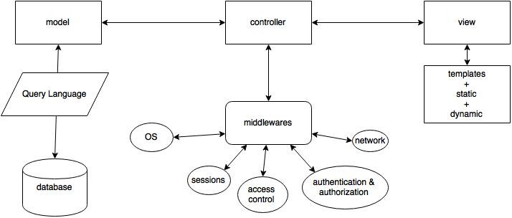

The Modular View
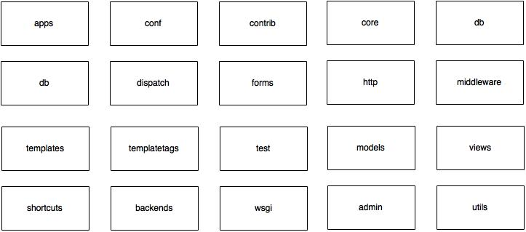

The Application Building Workflow in a glance

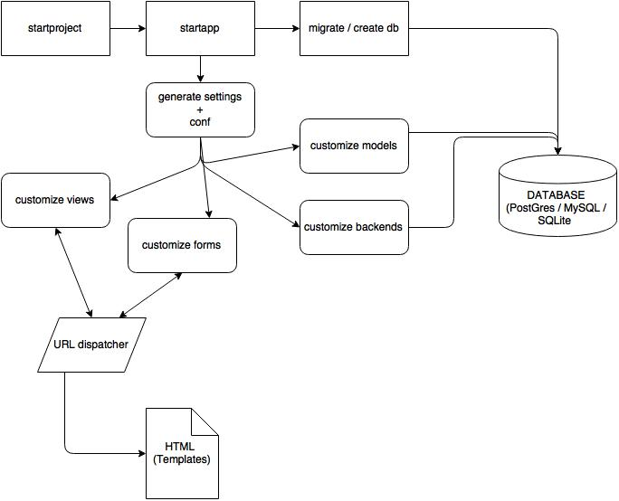
Layers of Abstraction
