Inde No: 19APSE4268  
Name: M.R.S.C. Abewardhana

**SE6103 - Parallel and Distributed Systems**

**Assignment 03**

**Question 02**

*# Create project directory*

mkdir hadoop-wordcount

cd hadoop-wordcount

Create docker compose file

Create Hadoop env file

Create WordCount.java file

Start the docker containers

Put the sample text into the container

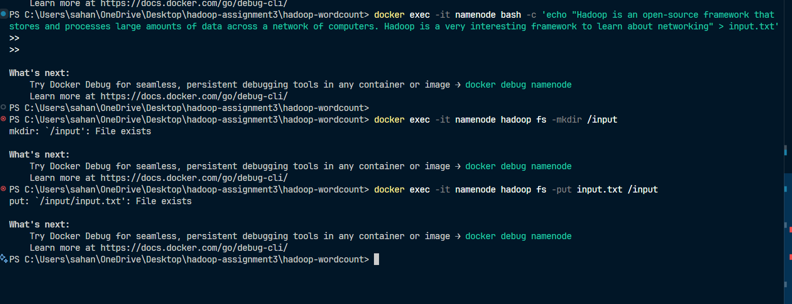

Check whether text is present

Copy compiled jar into the container



Run the jar file

View the word count result

