E-Commerce Test Automation
Capstone Project - V1 Report

Platform: OpenCart Demo Store (https://demo.opencart.com/)
Language: Python 3.10+ | Framework: Selenium WebDriver 4.x | Runner: pytest

1. Introduction
This project is an automated test suite built for the OpenCart demo e-commerce website. The idea behind automation testing is simple: instead of manually opening a browser, clicking around, and checking if things work, a script does all of that automatically.

For this capstone, the script handles a full end-to-end shopping flow. It opens the store, logs in, searches for a product, adds it to the cart, changes the quantity, and checks whether the cart total adds up correctly. It does all of this on its own and saves screenshots at each step, along with an HTML report at the end.

The project is intentionally kept simple: a single Python file that can be run with one command. The goal is to have something that works reliably on a real website and produces clear, readable results.

2. Tools and Technologies Used
Below is a breakdown of every tool used in this project and why it was chosen:

Python 3.10+: The programming language used to write the automation script. Python is popular for automation because its syntax is clean and readable, and it has a large number of libraries that make web testing easy.
Selenium WebDriver 4.x: The main automation library. Selenium talks directly to the browser (Chrome) and can do everything a human user would do: open pages, type into fields, click buttons, read text, and take screenshots.
pytest: The test runner. pytest is responsible for collecting the test function, running it, and reporting whether it passed or failed. It also integrates with the HTML report plugin.
pytest-html: A plugin for pytest that generates a nicely formatted HTML report after the test run. The report shows each test step, pass/fail status, and any captured output.
webdriver-manager: A helper library that automatically downloads and manages the correct version of ChromeDriver, so there is no need to manually download any driver file.
openpyxl: Used by the data reader utility to read and write test data stored in an Excel file (.xlsx). The project also supports JSON as an alternative data source.
Python logging module: Used to print informational messages during the test run both to the console and to a log file. This makes it easy to see what the script is doing in real time and to trace back any issues.

3. Project Structure
The project is organized inside a folder called capstone_v1. Below is every file and folder in the project and what it does:

capstone_v1/ - The root folder of the project.
test_ecommerce_v1.py - The main test script. This is the only file you need to run to execute the entire test.
requirements.txt - A list of Python libraries the project needs. Install them with: pip install -r requirements.txt
README.md - A quick-start guide explaining how to set up and run the project.
utils/ - A folder containing helper code used by the main script.
data_reader.py - Reads test data (login credentials, product details) from either a JSON file or an Excel file.
test_data/ - Contains the test input files.
data.json - JSON file with the base URL, user credentials, and product details.
data.xlsx - The same data stored in an Excel spreadsheet (two sheets: UserCredentials and ProductData).
screenshots/ - All screenshots taken during the test run are saved here with timestamps in the filename.
reports/ - Contains the HTML report (report.html) and the log file (test_execution.log) generated after each run.
.gitignore - Tells Git to ignore automatically generated folders like __pycache__ so they are not pushed to GitHub.

4. What the Script Actually Tests
The script tests a single end-to-end shopping flow on the OpenCart demo store. The test covers ten steps:

Step 1 - Launch the browser
The script opens a Chrome browser window in maximized mode using Selenium. Notifications are disabled so they do not interfere with the test.
Step 2 - Load the website
The browser navigates to https://demo.opencart.com/. The script waits for the page to fully load before proceeding.
Step 3 - Login or Registration
The script reads the user email and password from the test data file. If the account has never been registered before (is_registered is false in the JSON), the script automatically fills out the registration form, creates a new account, saves the new email back to the data files, and then logs in. On subsequent runs it skips registration and goes straight to login.
Step 4 - Search for a product
After logging in, the script types the product search term (e.g., "MacBook") into the search bar and presses Enter. It then waits for the search results page to appear.
Step 5 - Open the product page
From the search results, the script finds the specific product by name and clicks on it to open the product details page.
Step 6 - Add to cart
The script clicks the "Add to Cart" button. It then waits for the green success alert that confirms the product was added. It checks that the alert text contains both the word "Success" and the product name - if not, the test fails immediately with a clear error message.
Step 7 - Navigate to the shopping cart
The script clicks the "Shopping Cart" link to go to the cart page.
Step 8 - Update the quantity
On the cart page, the script clears the quantity field and types in the target quantity read from the test data (e.g., 2). It then clicks the Update button and waits for a success confirmation.
Step 9 - Verify the cart
This is the most important verification step. The script reads the product name, quantity, unit price, and line total directly from the cart table. It then checks three things: (a) the product name in the cart matches what was searched, (b) the quantity matches the target quantity, and (c) the line total equals unit price multiplied by quantity within a one-cent rounding tolerance.
Step 10 - Generate report
After the test finishes (pass or fail), pytest automatically generates an HTML report at reports/report.html. A log file is also updated at reports/test_execution.log.

5. How Test Data Works
Rather than hardcoding values like the URL, email, password, and product name directly in the test script, all input data is stored in external files. This is good practice because it means you can change what the test does (for example, test a different product) without touching the Python code.

The test data is stored in two formats:
- data.json - a simple text file in JSON format. The script reads this by default.
- data.xlsx - an Excel spreadsheet with two sheets: UserCredentials (login info) and ProductData (product to search and buy).

The data_reader.py file in the utils/ folder handles reading from either format. The script also writes back to these files after registration, saving the newly created email so the next run skips registration and logs in directly.

6. How to Run the Project
Running the project requires just three things: Python installed, the dependencies installed, and a working internet connection to reach the OpenCart site.

Step 1 - Install Python 3.10 or newer from python.org if not already installed.

Step 2 - Open a command prompt or terminal and navigate into the capstone_v1 folder:
cd capstone_v1

Step 3 - Install all required libraries:
pip install -r requirements.txt

Step 4 - Run the test:
python test_ecommerce_v1.py

That is all. The browser will open automatically, run through all the steps, and close. Once done, you will find:
- reports/report.html - Open this in any browser to see the full test report.
- reports/test_execution.log - A plain-text log of every step that ran.
- screenshots/ - Five PNG files named with a timestamp and the step name.

Note: The HTML report is overwritten on every run. If you want to keep a history, rename or copy the file before running again.

7. Screenshots from a Live Run
The following screenshots were captured automatically during an actual test run. They show the browser state at each key step of the automation.

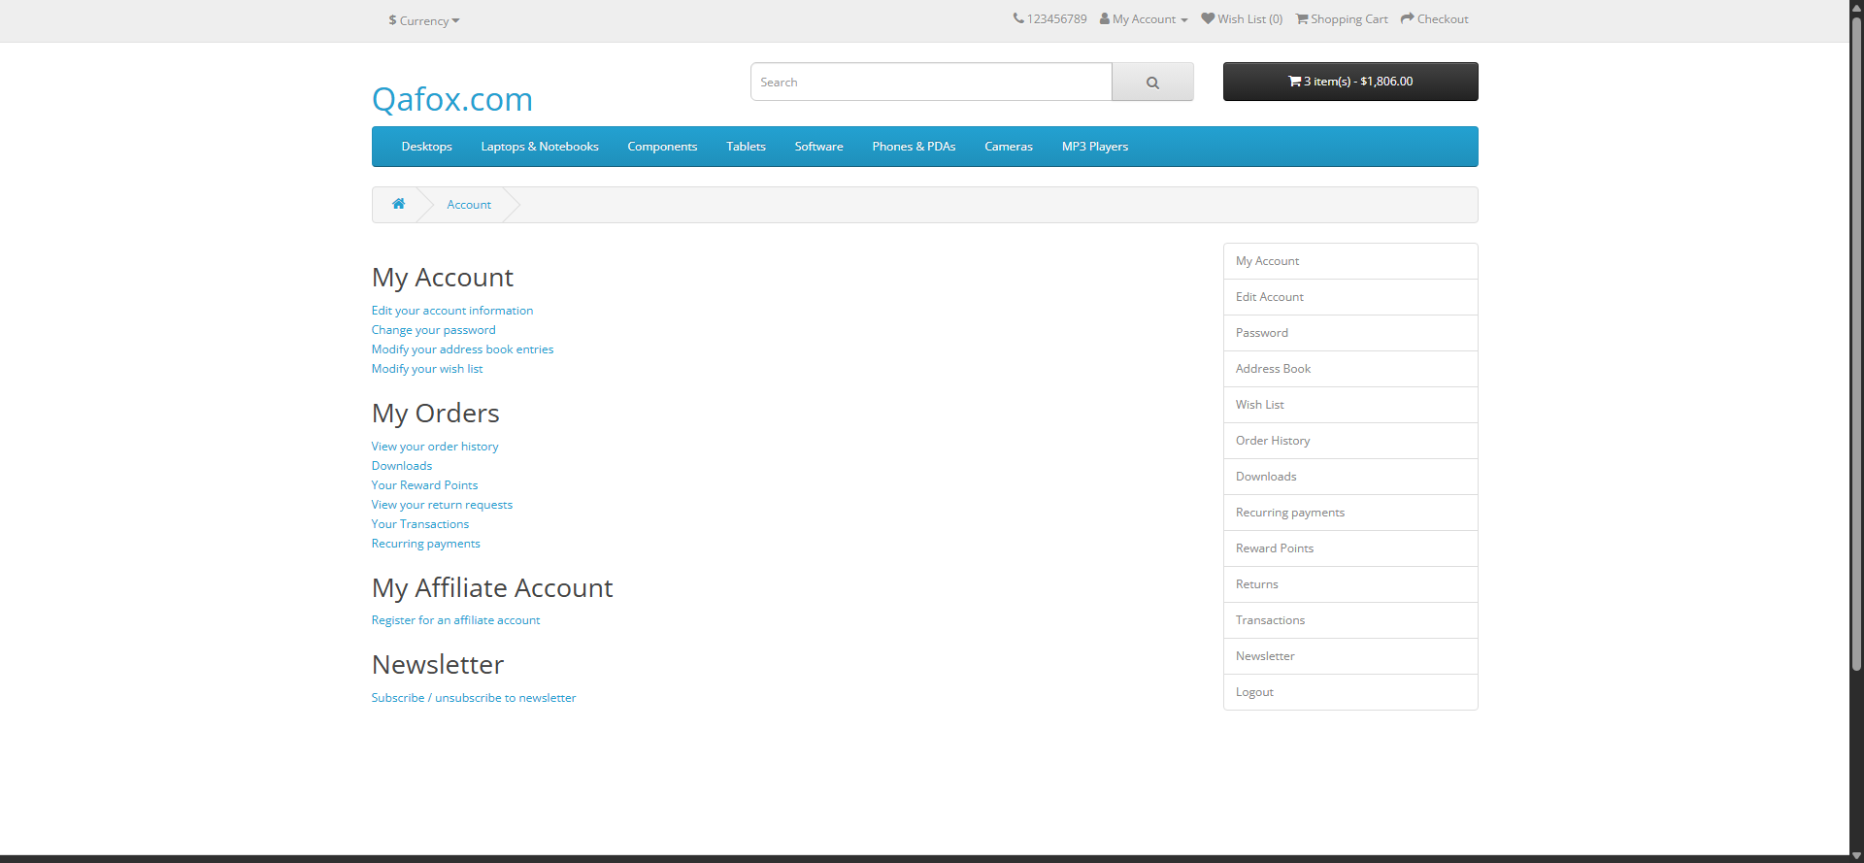
Screenshot 1 - After successful login (My Account dashboard)

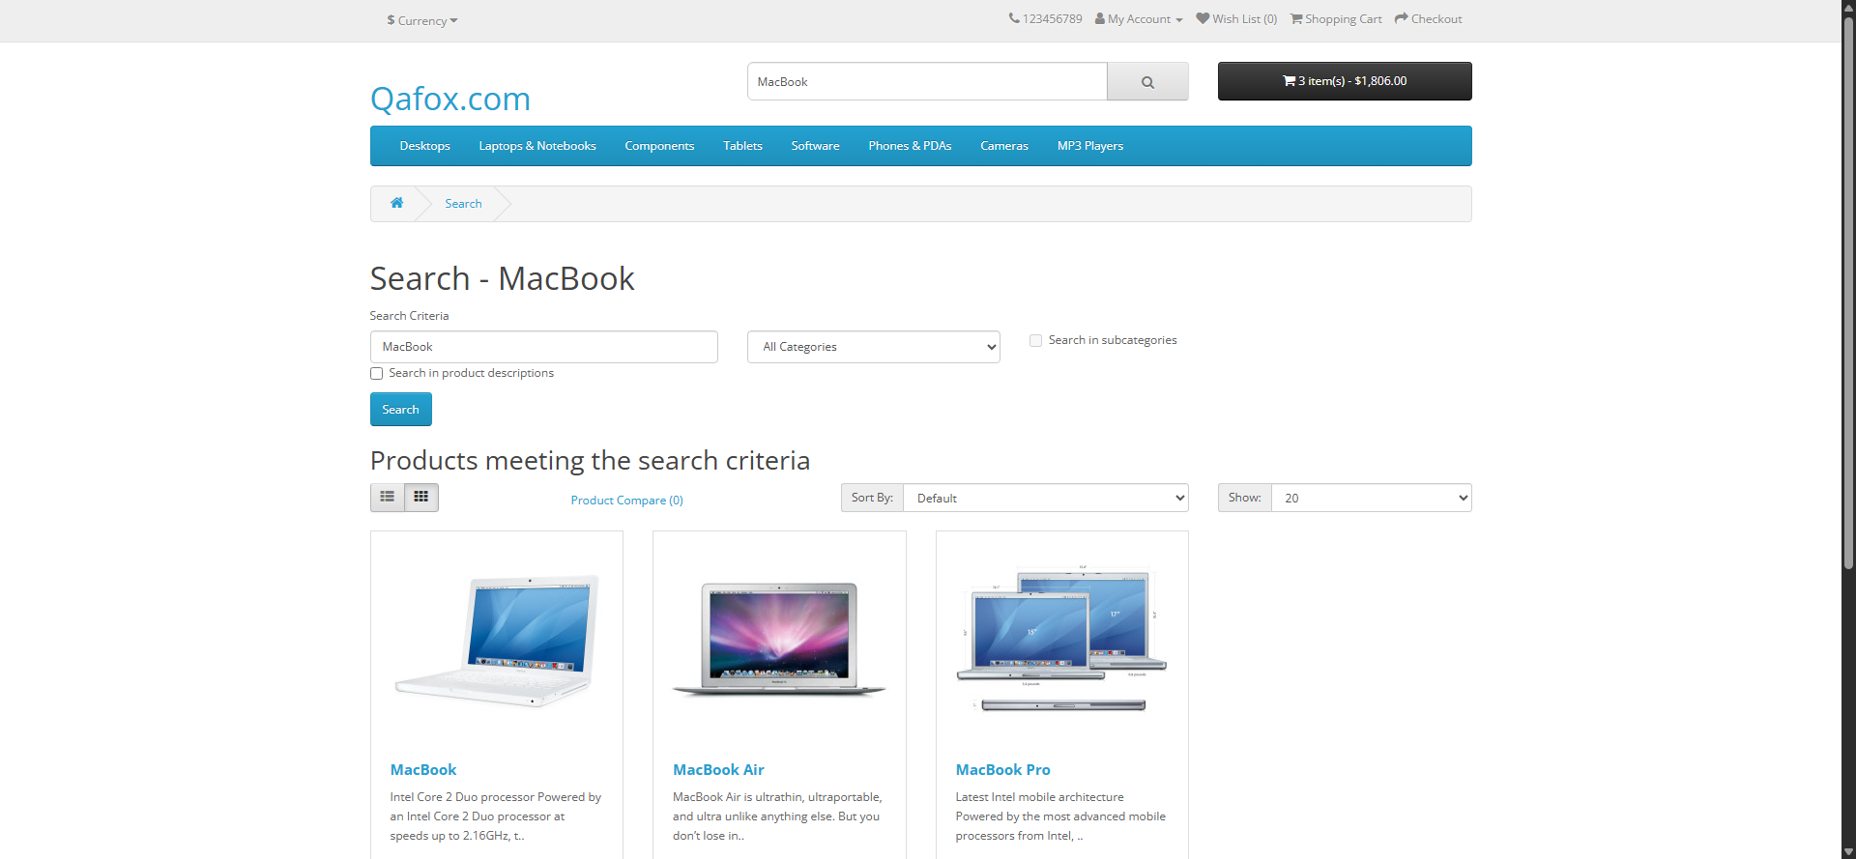
Screenshot 2 - Search results for MacBook

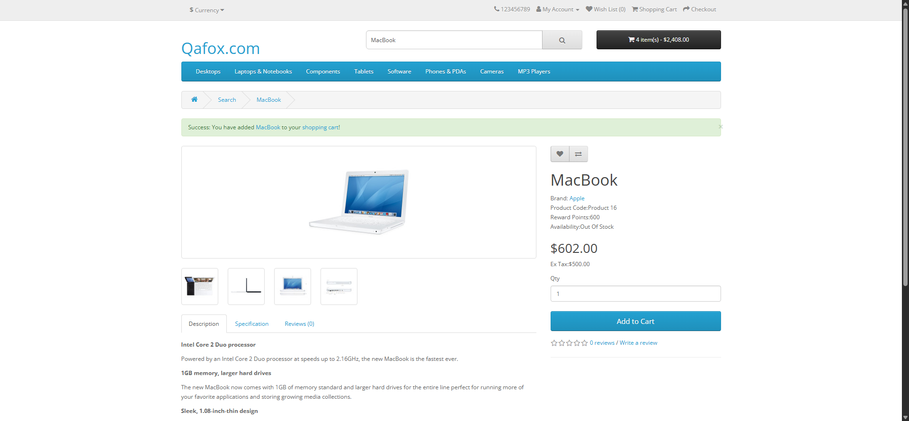
Screenshot 3 - Green success alert after adding product to cart

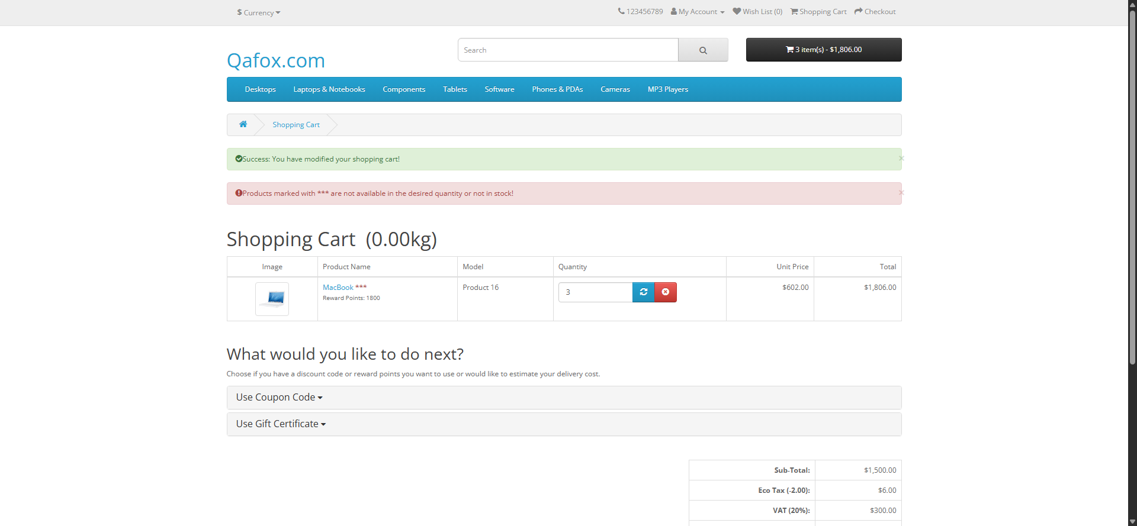
Screenshot 4 - Cart after updating quantity

Screenshot 5 - Final verified cart with correct totals

8. Reports and Logging
The project produces two types of output after each run:

HTML Report (reports/report.html)
Generated by pytest-html. It is a self-contained file meaning all images, styles, and data are embedded into a single file so you can email it or open it on any machine without needing any other files. The report shows the overall result (passed/failed), the time taken, and an expandable log of every step that ran.

Log File (reports/test_execution.log)
Written by Python built-in logging module. Every time the script does something important (opening the browser, logging in, searching, adding to cart, verifying the total), it writes a timestamped line to this file. This makes it easy to trace exactly what happened if something goes wrong.

9. What Happens if the Test Fails
The script has three assert statements that check the test outcome:
- It checks that the add-to-cart success alert contains the product name.
- It checks that the quantity in the cart matches the target quantity.
- It checks that the line total in the cart equals unit price multiplied by quantity.

If any of these checks fail, pytest marks the test as FAILED and the HTML report will show the failure along with a clear message explaining what was expected vs what was actually found. For example:
AssertionError: Quantity mismatch: Expected 2, got 1

The browser is always closed cleanly after the test, whether it passes or fails, because the driver fixture handles teardown automatically.

10. Known Limitations
Being an MVP, there are a few things the current version does not handle:
- All test steps are in a single function. If one step fails, all remaining steps are skipped.
- There is no parallel test execution - only one browser runs at a time.
- The demo site is public and sometimes slow or unstable, which can cause random failures unrelated to the code.
- The HTML report is overwritten on every run. Old reports are lost unless manually saved.
- There is no email notification or CI/CD integration - tests must be run manually.

11. Conclusion
This script is a fully working, end-to-end Selenium automation that covers the most important parts of an e-commerce shopping flow. It runs with a single command, handles both new and returning users, reads test input from external files, captures screenshots at each step, and produces an HTML report.

The aim of this project was to prove that automation works reliably on a real, live website. That goal has been achieved. All test steps pass consistently, the output is clear, and the project structure is clean enough to hand off to teammates or build upon further.

