

Tribhuvan University
Faculty of Humanities and Social Sciences

“Backend Intern at Mindrisers (Tukee Foundation)”
A INTERNSHIP REPORT ON
Submitted to Department of Computer Application
NIST College,Banepa

In partial fulfillment of the requirements for the Bachelors in Computer Application

Submitted by
Sahan Takhachhen(101402099)

Under the Supervision of
Samish Shrestha

March , 2026


Tribhuvan University
Faculty of Humanities and Social Sciences
NIST College, Banepa-09

MENTOR RECOMMENDATIONS
I hereby recommend this internship work prepared under my supervision by Sahan Takhachhen in partial fulfillment of the requirements for the degree of Bachelor of Computer Application for the final evaluation. I have thoroughly looked over the work she has done during her internship period.

……………….
SIGNATURE
Samish Shrestha
SUPERVISOR
Lecturer at NIST College
BCA Department
Banepa, Kavre, Nepal.

SUPERVISOR'S RECOMMENDATION

I hereby recommend that this intern project prepared under my supervision by MR. SAHAN TAKHACHHEN entitled “MINDRISERS TECH” in partial fulfillment of the requirements for the degree of Bachelors in Computer Applications is processed for the evaluation.

................................
Mr. Samish Shrestha
Supervisor
NIST College, Banepa

LETTER OF APPROVAL

This is to certify that this intern project prepared by MR. SAHAN TAKHACHHEN entitled “MINDRISERS TECH” in partial fulfillment of the requirements for the degree of Bachelors in Computer Applications has been well studied. In our opinion it is satisfactory in the scope and quality as a project for the required degree.

................................ ................................
Dr. Deepak Bhatta Mr. Samish Shrestha
Principal Coordinator
NIST College, Banepa Department of BCA

NIST College, Banepa
................................
External

ACKNOWLEDGEMENT
This intern report is prepared in partial fulfillment of the requirements for the degree of Bachelor of Computer Application (BCA). The satisfaction and success of completing this task would be incomplete without heartfelt thanks to the people whose constant guidance, support, and encouragement made this work successful.
Firstly, I would like to express my gratitude towards my mentor Ms. Diya Shrestha, a flutter developer at Mind Risers Tech for his unquestionable support. Without his support and encouragement, it would have been difficult to work on.
I would also like to thank my supervisor Mr. Samish Shrestha, lecturer of NIST College, Banepa for his invaluable encouragement, guidance, and ever willingness to spare time from his otherwise busy schedule.
I would like to dedicate our hearty gratitude to Mind Risers Tech, for providing us with an opportunity to do an internship at this reputed organization with full support and cooperation.
In the end, I would like to express my sincere thanks and appreciation to all my colleagues and seniors who have helped me directly or indirectly during this internship period. I would like to make them part of my success.

Sincerely,
Sahan Takhachhen
(TU Reg no.:6-2-1014-86-2021)

ABSTRACT
This internship report presents the development of the Tukee Foundation Backend System, carried out at MindRisers Tech as partial fulfillment of the requirements for the Bachelor of Computer Application (BCA) degree. The system is designed to support the digital operations of the Tukee Foundation by providing a secure and structured backend platform where administrators can manage and publish organizational content, while the general public can access information through read-only APIs. The development of the system followed the Incremental Software Development Life Cycle (SDLC) model to ensure systematic progress, testing, and refinement.
The tools and tech used during the project include Django and Django REST Framework for backend development, PostgreSQL for database management, Redis for caching, Swagger for API documentation, and Visual Studio Code for development. The frontend of the system was developed using React, while API testing was performed using Postman. During the internship, the author worked as a Backend Developer Intern, focusing on RESTful API development, authentication, database design, and system security. Under the supervision of the assigned mentor, practical experience was gained in real-world backend development, teamwork, and adherence to professional software development practices. This internship provided valuable exposure to industry standards, problem-solving skills, and professional growth in backend system development.
Keywords: Django, Django REST Framework, PostgreSQL, Redis, REST API, SDLC, Backend Development, IT

TABLE OF CONTENT
MENTOR RECOMMENDATIONS i
SUPERVISOR'S RECOMMENDATION ii
LETTER OF APPROVAL iii
ACKNOWLEDGEMENT iv
ABSTRACT v
LIST OF FIGURES ix
LIST OF TABLES x
LIST OF ABBREVIATIONS xi
CHAPTER 1: INTRODUCTION 1
1.1 Internship Introduction 1
1.2 Problem Statement 2
1.3 Objective 2
1.3.1 Internship Program Objective 2
1.3.2 Internship Project Objective 3
1.4 Scope and Limitations 3
1.4.1 Scope 3
1.4.2 Limitations 4
1.5 Report Organization 5
CHAPTER 2: INTRODUCTION TO ORGANIZATION 6
2.1 Introduction to Organization 6
2.2 Organization Hierarchy 7
2.3 Working Domains of Organization 7
2.4 Description of Intern Department 8
2.4.1 Introduction 8
2.4.2 Mentors 8
2.4.3 Team 9
CHAPTER 3: BACKGROUND STUDY AND LITERATURE REVIEW 10
3.1 Background Study 10
3.2 Literature Review 10
CHAPTER 4: INTERNSHIP ACTIVITIES 13
4.1 Roles and Responsibilities 13
4.2 Weekly log 14
4.3 Description of the Project 19
4.3.1 Development Methodology 20
4.3.2 System Design 21
4.3.3 Tools and Tech Used 23
4.4 Tasks/Activities Performed 24
CHAPTER 5: CONCLUSION AND LEARNING OUTCOME 25
5.1 Conclusion 25
5.2 Learning Outcome 25
REFERENCES 27
APPENDIX 28

LIST OF FIGURES

Figure 1: Logo of Organization 6
Figure 2: Organizational Hierarchy 7
Figure 3: Incremental Model 20

LIST OF TABLES

Table 1: Internship Period Details 9
Table 2: Weekly Log 14
Table 3: Supervisor's Visit Log Sheet 28

LIST OF ABBREVIATIONS

API | Application Programming Interface

BCA | Bachelor of Computer Application

BOD | Board of Directors

DB | Database

DRF | Django REST Framework

IDE | Integrated Development Environment

IT | Information Technology

JWT | JSON Web Token

NGO | Non-Governmental Organization

ORM | Object Relational Mapping

OTP | One-Time Password

REST | Representational State Transfer

SDLC | Software Development Life Cycle

SMTP | Simple Mail Transfer Protocol

SQL | Structured Query Language

UI | User Interface

UX | User Experience

CHAPTER 1: INTRODUCTION

Internship Introduction
The internship program is designed to provide students with the opportunity to gain real-world industry experience and to work toward achieving their professional goals and career aspirations. The primary objective of an internship is to enable students, referred to as interns, to apply theoretical knowledge gained during their academic studies to practical situations in a real-world working environment.
The Bachelor of Computer Application (BCA) program requires final-year students to complete a six-credit internship, with a minimum duration of eight weeks or 300 working hours, as a mandatory academic requirement. Students may complete this internship in either government or private sector organizations. In addition, feedback collected from host organizations plays a vital role in evaluating student performance and improving the overall quality and professionalism of BCA graduates.
During the internship period, the intern was assigned to the backend development of the organization under the supervision of the assigned supervisor. The primary project on which the intern contributed was a Tuki Foundation and Free Chocolate.
The Tukee Foundation backend system is designed to securely manage and deliver organizational data through a structured API architecture. Developed using Django Rest Framework, the system allows only administrators to create and manage content via the admin panel, while the public is provided with read-only access to retrieve information through GET APIs. The primary objective of this backend is to ensure reliable, scalable, and controlled data management that supports the foundation’s website and other client applications. PostgreSQL is used as the primary database to maintain data integrity, performance, and scalability. Through this project, practical experience was gained in backend API development, role-based access control, and database management in a professional environment.

Problem Statement
The theoretical knowledge gained through academic coursework helps establish a solid foundation; however, it alone is not enough to meet the expectations of real-world professional settings. In the highly competitive IT industry, individuals must be capable of applying their theoretical understanding to practical situations and real problems. Without hands-on exposure, graduates may find it difficult to adapt to industry practices, resulting in a gap between academic learning and professional demands.
In the modern job market, obtaining a graduate position no longer depends solely on achieving strong academic results. Employers increasingly value candidates who possess relevant practical experience, gained through internships, project work, or volunteer opportunities. Such experience has become equally important as formal education and examination performance. Consequently, internship programs play a vital role in bridging the gap between theory and practice while also offering valuable industry exposure, skill enhancement, and professional networking opportunities that contribute to long-term career development.

Objective
This internship program was conducted to fulfill the academic requirements of the BCA 7th Semester. The internship offers valuable opportunities for students to enhance their employability and initiate their professional careers. The primary objective of this internship project is to gain hands-on practical experience and develop technical skills in the field of mobile application development, while applying theoretical knowledge in a real-world working environment.

Internship Program Objective
The following is the list of objectives that the internship may fulfill:
      - To develop effective teamwork and collaboration skills in a professional environment.
      - To acquire hands-on practical experience in the field of backend development.
      - To improve professional competence and preparedness for working in the real-world IT industry.

Internship Project Objective
The broad objectives of this project are as follows:
- To develop a secure and scalable backend system using Django Rest Framework for managing organizational data.
- To allow authorized administrators to create, update, and manage content through a controlled admin interface while restricting public users to read-only access.
- To ensure reliable data storage, consistency, and performance by using PostgreSQL as the primary database system.
- To provide structured and efficient RESTful APIs for seamless data delivery to the public website and other client applications.

Scope and Limitations

Scope
An internship provides an opportunity to develop practical skills and gain real-world experience in a specific field, while also helping individuals explore different professional roles to identify long-term career interests. Internships strengthen resumes, offer exposure to professional working environments, and create valuable networking opportunities that support career growth. They also enable participants to develop a deeper understanding of their chosen career paths through hands-on learning and industry interaction.
During my internship, I had the opportunity to contribute to the development of the Tukee Foundation backend system, built using Django Rest Framework. The primary goal of this project was to develop a secure and efficient backend platform that enables administrators to manage organizational content, while providing the public with read-only access to information through RESTful APIs. This system supports seamless data delivery for the foundation’s website and other applications, ensuring reliable content management and accessibility. Through this real-world project, I gained valuable experience in backend development, database management using PostgreSQL, and role-based access control in a professional working environment.

Limitations
Some drawbacks the intern faced during the internship are:
      - It was challenging to balance internship work and college at the same time.
      - Certain financial and economic aspects of the project could not be included due to confidentiality constraints.
      - Complete details regarding the organization’s internal operations could not be disclosed because of privacy policies and organizational regulations.

Report Organization
This report has been organized into 5 chapters:
Chapter 1: Here, an Introduction about the internship and my project with the statement of the problem has been stated. The scope and limitations of the internship are listed along with the objectives of the internship and what it hopes to achieve.
Chapter 2: Here, I have introduced the company details including the organization’s structure, and its area of operation. Also, this chapter contains the descriptions of related works that I enrolled.
Chapter 3: Here, I have illustrated the previous work related to the project, and similar works were studied and different feasibility analyses are summarized in this section.
Chapter 4: Here, I have illustrated the roles and responsibilities I had at the organizations. Things such as the Weekly log, Description of the Project Involved during the Internship, Tasks/Activities, and requirements have been clarified.
Chapter 5: This section concludes the project that I have enrolled in. It gives a summary of what system was developed and the learning outcomes of the internship including references. The lesson learned is also included in this chapter.

CHAPTER 2: INTRODUCTION TO ORGANIZATION

Introduction to Organization
Mindrisers Tech is a well-established IT company based in Kathmandu, Nepal, with an employer size of approximately 51–200 employees. The organization provides professional software development services along with practical IT training programs. Its core services include web and mobile application development, custom software solutions, IT consulting, and skill-oriented training. Mindrisers focuses on delivering reliable digital solutions while preparing students and professionals with industry-relevant technical knowledge.
During the internship, Mindrisers Tech offered a supportive and professional environment to gain hands-on experience in backend development using Django and Django Rest Framework. The company emphasizes solving real-world problems by developing secure, scalable, and efficient backend systems. Interns are involved in tasks such as API development, database management, and backend logic implementation, which helps in applying theoretical knowledge to practical projects.
Mindrisers Tech is supported by a team of experienced developers and mentors who guide interns throughout the development process. With its collaborative work culture and project-based learning approach, the organization helps interns build technical skills, teamwork abilities, and professional confidence. This internship experience played an important role in understanding backend development practices and preparing for real-world challenges in the IT industry.

Figure 1: Logo of Organization

Organization Hierarchy
Mind Risers Tech comprises an administrative team along with interns, junior and senior programmers, and web designers.
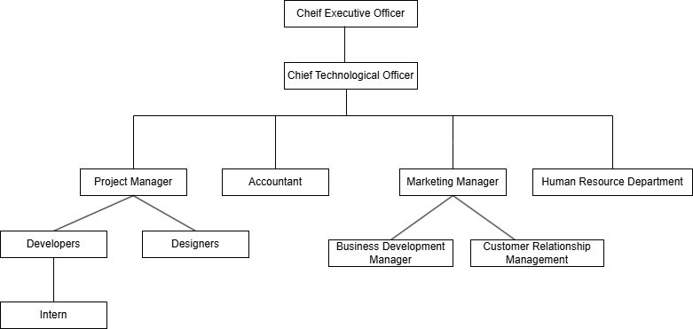

Figure 2: Organizational Hierarchy

Working Domains of Organization
Mindrisers Tech is a professional IT company delivering innovative solutions that align with modern software development practices. The organization is guided by an experienced management team and supported by skilled software developers, designers, and IT professionals with expertise across various technology domains. These include backend development, web and mobile application development, and digital solutions. Mindrisers emphasizes technical excellence, innovation, and client satisfaction while addressing real-world business and technological challenges through efficient and scalable software development practices.
In addition to software development services, Mindrisers Tech plays a significant role in skill development by offering industry-oriented training and internship programs. These programs are designed to provide students and fresh graduates with hands-on experience, real project exposure, and mentorship from experienced professionals, helping bridge the gap between academic learning and professional practice.
Major services and offerings provided by Mindrisers Tech include:
- Web Application Development
- Mobile Application Development
- Backend Development (Django / Django Rest Framework)
- Custom Software Development
- UI/UX Design
- Digital Marketing Solutions
- Learning Management Systems (LMS)
- E-commerce Solutions
- Business and Management Applications
- Professional IT Training Programs
- Internship Programs with Real-World Project Exposure
- Software Development as per Client Requirements

Description of Intern Department

Introduction
The intern was placed in the Development department. It deals with researching, ideating, and designing different mockups, layouts, and designs for various products and developing the system according to the client’s requirements and specifications. All in all, the department deals with all the research, designing & development-related works of the product in the organization.

Mentors
After joining the Developers Team at Mindrisers Tech, The intern got an opportunity to work and be supervised by a professional mentor, Ms. Diya Shrestha who has been working in this field for many years and helped the intern and guided them through their internship period.

Team
In Mindrisers Tech, the intern got an opportunity to work in a team for the first time in their professional career. The intern was guided by a very professional mentor and got the opportunity to work under the expertise of the mentor and a supportive team which helped them to develop and nourish their skills and experience new things.

Table 1: Internship Period Details

Start Date | 12th October,2025
End Date | 12th Janaury,2026
Position | Django Developer Intern
Working Hours | 5 hours a day
Office Days | Sunday- Friday

CHAPTER 3: BACKGROUND STUDY AND LITERATURE REVIEW

Background Study
The rapid advancement of information technology has significantly transformed the way organizations develop and manage software systems. In the modern digital era, backend systems play a crucial role in ensuring secure data handling, efficient performance, and reliable communication between applications and users. As a result, backend development has become an important area within the IT industry, requiring professionals to possess both strong theoretical knowledge and practical skills.
Although academic courses under Tribhuvan University (TU) provide a solid theoretical foundation in programming, database management, and software engineering, they offer limited exposure to real-world system development and professional working environments. This creates a gap between academic learning and industry requirements. To bridge this gap, the internship program is included in the curriculum. As part of this academic requirement, a three-month internship was completed at Mindrisers Tech from 12th October, 2025 to 12th January, 2026. During this period, practical experience was gained in backend development using Django and Django Rest Framework, along with database management using PostgreSQL, which helped apply theoretical concepts to real-world projects and enhanced professional readiness for the IT industry.

Literature Review
The effectiveness of modern web-based platforms largely depends on the reliability, scalability, and security of their backend systems. A well-designed backend architecture ensures efficient data management, seamless communication between system components, and consistent content delivery to end users. According to Fielding (2000), RESTful architectures improve system scalability and maintainability by promoting stateless communication and standardized API design. Therefore, using a robust backend framework is essential for organizations that aim to provide reliable and accessible digital services.

Backend frameworks such as Django and Django Rest Framework (DRF) are widely recognized for supporting rapid development, security, and clean architectural patterns. Studies highlight that Django’s built-in authentication, permission handling, and ORM capabilities significantly reduce development complexity while maintaining strong security standards (Holovaty & Kaplan-Moss, 2009). DRF further enhances backend systems by enabling structured API development, which is particularly useful for platforms where administrative users manage content while public users access information through read-only endpoints.

Data integrity and performance are critical factors for information-driven platforms, especially for non-profit and organizational websites that serve public audiences. PostgreSQL is considered one of the most reliable relational database management systems due to its support for data consistency, transactional reliability, and scalability (Stonebraker & Kemnitz, 1991). Research indicates that relational databases remain a preferred choice for backend systems requiring structured data storage and long-term reliability.

Security and access control are also key considerations in backend development. Role-based access control mechanisms help protect sensitive data by restricting write operations to authorized users only (Sandhu et al., 1996). For platforms like the Tukee Foundation, where administrators manage organizational content and the public consumes information, implementing admin-only data modification and public read-only access ensures data authenticity, prevents unauthorized changes, and builds user trust.

Overall, this project draws on established research and industry best practices to develop a secure, scalable, and maintainable backend system for the Tukee Foundation. By leveraging Django Rest Framework, PostgreSQL, and role-based access control, the system aims to provide efficient content management for administrators while ensuring reliable and transparent information access for the public.

Existing Systems in Non-Government Organization in Nepal
Several non-governmental organizations and foundations in Nepal currently use digital platforms to share information about their missions, programs, and social initiatives.

Maiti Nepal is one of the well-known non-profit organizations in Nepal and uses a digital platform to publish information related to women’s rights, rescue operations, and rehabilitation programs. The organization provides updates, reports, and awareness content to the public through its website (Maiti Nepal, 2023).
Teach For Nepal utilizes an online platform to communicate its educational programs, volunteer activities, and impact stories. The platform allows users to access information about ongoing initiatives and organizational goals, supporting transparency and public engagement (Teach For Nepal, 2023).
Room to Read Nepal operates a digital platform focused on literacy and gender equality initiatives. The organization shares program details, success stories, and reports to inform stakeholders and the public about its social impact (Room to Read Nepal, 2023).
Tukee Foundation, similar to other NGOs, uses an online platform to present information about its mission, programs, and activities. However, like many existing systems, content management and scalability depend on structured backend support to ensure efficient data handling and controlled administrative access.

CHAPTER 4: INTERNSHIP ACTIVITIES

Roles and Responsibilities
During my internship period, I was entrusted with a range of responsibilities by my mentor, Ms. Diya Shrestha. These responsibilities encompassed various tasks vital to the internship experience. Initially, my mentor assigned me the task of studying and conducting research on the forthcoming application that was to be developed. This phase allowed me to acquire a firm grasp of the foundational aspects of app development. Subsequently, I was responsible for implementing the core functionalities that needed to be integrated into the project.
As a Backend Developer (Intern) at Mindrisers Tech, the various tasks assigned during the internship are as follows:
- To understand the working environment, policies, and development practices of the organization.
- To complete the tasks and assignments provided by supervisors on a regular basis.
- To report progress and updates to the supervisor in a timely manner.
- To develop backend functionalities using Django and Django Rest Framework.
- To design and implement RESTful APIs for data handling and system communication.
- To integrate backend APIs with frontend applications.
- To manage and maintain databases using PostgreSQL.
- To identify, debug, and resolve errors occurring in the backend system.
- To test API endpoints and backend functionalities for reliability and performance.
- To follow proper coding standards, discipline, and professional conduct in the workplace.
- To collaborate with team members and build professional relationships.
- To participate in code reviews and optimize backend code for better performance and security.

Weekly log
During my internship period at Mindrisers Tech, I was actively involved in hands-on learning and practical work focused on backend development using Django and Django Rest Framework. Throughout the internship, I worked in a professional IT environment that emphasized real-world project development and continuous learning. My internship followed a six-day work schedule, from 11:00 AM to 4:00 PM, which provided sufficient time to gain practical exposure and understand industry-level development practices.
During this period, I worked on tasks related to backend logic implementation, API development, database management, and system testing. The internship allowed me to apply theoretical knowledge in real-world scenarios and improve my technical and professional skills. The following table presents the weekly log of activities performed during the internship period:

Table 2: Weekly Log
Week 1

Date | Activities
Oct 12 – Oct 18, 2025 | - Orientation and understanding organizational structure and workflow  - Internship briefing and clarification of objectives  - Task allocation and expectation setting  - Setup of development environment (Python, Django, Git)  - Introduction to company coding standards and tools  - Coordination with mentors and supervisors

Week 2:
Date | Activities
Oct 19 – Oct 25, 2025 | - Python programming fundamentals  - Object-Oriented Programming concepts (classes, objects, inheritance)  - Functions, modules, and exception handling  - Writing clean and reusable code  - Git and GitHub version control (commit, push, pull, branch)

Week 3:
Date | Activities
Oct 26 – Nov 1, 2025 | - Introduction to Django framework  - Django project and app structure  - Understanding MVT (Model–View–Template) architecture  - URL routing and views  - Basic request–response lifecycle

Week 4:
Date | Activities
Nov 2 – Nov 8, 2025 | - Django models and ORM concepts  - Database design using PostgreSQL  - Creating models and managing migrations  - Relationships between database tables  - Django Admin customization for data management

Week 5:
Date | Activities
Nov 9 – Nov 15, 2025 | - Introduction to Django Rest Framework (DRF)  - Creating Serializers and API views  - RESTful API principles and best practices  - API testing using Postman  - Handling JSON request and response formats

Week 6:
Date | Activities
Nov 16 – Nov 22, 2025 | - Authentication and authorization concepts  - User authentication using Djoser  - JWT-based authentication implementation  - Role-based access control  - Securing API endpoints

Week 7:
Date | Activities
Nov 23 – Nov 29, 2025 | - SMTP Email OTP implementation for user verification  - Password reset and email validation workflow  - Google reCAPTCHA integration for bot prevention  - Secure form validation techniques  - Introduction to Redis and its use cases

Week 8:
Date | Activities
Nov 30 – Dec 6, 2025 | - Redis caching for API performance improvement  - Rate limiting and OTP storage using Redis  - Performance optimization techniques  - Learning Microservices Architecture concepts  - Overview of clean and modular backend architecture

Week 9:
Date | Activities
Dec 7 – Dec 13, 2025 | - Start of backend project “Tukee Foundation System”  - Requirement analysis for NGO-based backend system  - Designing admin-only POST APIs for content management  - Designing public read-only GET APIs  - Planning database structure for posts and activities

Week 10:
Date | Activities
Dec 14 – Dec 20, 2025 | - Development of Tukee Foundation backend APIs  - Admin-managed content posting system  - Database modeling and relationship handling  - API response standardization  - API documentation using Swagger (OpenAPI)

Week 11:
Date | Activities
Dec 21 – Dec 27, 2025 | - Start of backend project “Free Chocolate”  - Requirement analysis and system workflow design  - Chocolate request and distribution API development  - Business logic implementation  - API security, permissions, and validation

Week 12:
Date | Activities
Dec 28, 2025 – Jan 12, 2026 | - Learning eSewa payment gateway workflow Requirement analysis and system design  - Backend payment request creation and verification logic  - Understanding success and failure callback handling  - Performance monitoring and minor optimization  - Final testing and debugging  - Documentation completion and internship report preparation

Supervisor’s
Signature
Supervisor
Ms. Diya Shrestha

Description of the Project
During my internship period, I had the opportunity to work on multiple backend development projects under the guidance of my mentor. Among them, the most significant projects were the Tukee Foundation Backend System and the Free Chocolate Distribution System. At the beginning of each project, I worked closely with my mentor to understand the system requirements, data flow, and overall architecture. Based on the requirements, I was involved in designing database models, developing RESTful APIs, and implementing backend logic using Django and Django REST Framework.
The Tukee Foundation Backend System was developed to manage organizational content and activities efficiently. In this system, the admin users were responsible for posting and managing data, while the public users could only access data through read-only APIs. The backend was designed with proper authentication, authorization, and security measures. Similarly, the Free Chocolate project focused on managing chocolate requests and distribution processes through a structured backend system, ensuring data validation, secure access, and smooth API communication.

Key Features of the Backend Systems:
- Admin-only content creation and management APIs
- Public read-only APIs for accessing information
- Secure authentication using JWT and Djoser
- PostgreSQL database integration
- Email OTP verification and notification system
- Redis-based caching and performance optimization
- API documentation using Swagger
- eSewa payment workflow learning and integration support
- Proper validation, error handling, and logging
These projects helped me gain real-world experience in backend development, understand scalable system design, and apply theoretical knowledge in practical scenarios.

Development Methodology

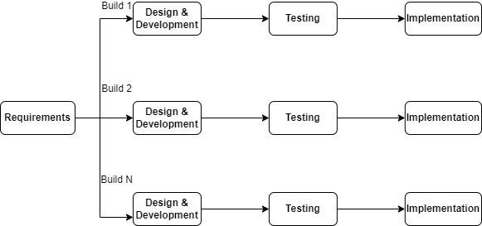

Figure 3: Incremental Model

The Incremental Model of the System Development Life Cycle (SDLC) was used for the development of this project. In this model, the system was developed in multiple increments, where each increment included requirement analysis, design, development, testing, and implementation. This approach allowed continuous improvement and easy incorporation of changes during development.

A) Requirement Analysis
In this phase, the existing systems related to the project domain were studied to understand their features and limitations. Requirements for the new system were identified based on the needs of users and administrators. Information was collected through journals, articles, online documentation, and research papers. All gathered requirements were analyzed and documented to define the scope of the system clearly.

B) Design and Development
Based on the requirements identified, the system architecture and database design were created. During this phase, the requirements were transformed into technical designs, including API structure, database models, and system workflows. The backend system was developed using Django and Django REST Framework, following modular and clean coding practices. Each increment added new functionalities to the system.

C) Testing
Testing was performed for each module before integrating it into the complete system. APIs were tested to ensure correct functionality, proper data validation, and secure access. Error handling, authentication, and authorization mechanisms were also tested. Integration testing was carried out to verify that the frontend and backend communicated correctly through APIs.

D) Implementation
After successful testing, the system was deployed for use by the intended users. The implemented system allowed users to interact with the application efficiently, while administrators could manage data securely. The incremental approach ensured that the system was stable, reliable, and met the defined requirements.

System Design
The backend system design plays a vital role in ensuring the reliability, security, and scalability of the application. It is responsible for handling business logic, data processing, authentication, and communication between the client application and external services. The backend was designed using a modular and service-oriented approach to support future enhancements and efficient maintenance.
The backend system consists of the following core components:

I. API Layer
The API Layer serves as the primary communication interface between the frontend and the backend. It is implemented using RESTful principles, allowing client applications to send and receive data through HTTP requests. This layer handles request validation, response formatting, and error handling. API documentation is provided using Swagger for better readability and testing.

II. Authentication and Authorization Service
This service manages secure user access to the system. It includes user registration, login, and logout functionalities using token-based authentication. Djoser and JWT authentication mechanisms are used to ensure secure access control, while role-based authorization restricts sensitive operations to authorized users only.

III. Business Logic Layer
The Business Logic Layer processes application-specific rules and workflows. It handles operations such as data validation, request processing, payment verification, and notification triggering. This layer ensures that all operations follow defined rules and maintain system consistency.

IV. Payment Integration Service
The Payment Integration Service is responsible for handling digital transactions. It manages payment requests, verification, and response handling using the eSewa payment gateway. Secure communication and validation mechanisms are implemented to ensure reliable and safe payment processing.

V. Caching and Performance Service
Redis is used as a caching mechanism to enhance system performance. It supports features such as rate limiting, session management, and caching frequently accessed data, thereby reducing database load and improving response time.

VI. Data Storage Service
The Data Storage Service manages persistent data storage using PostgreSQL. It stores user information, transaction records, and application data in a structured manner. Django ORM is used to manage database interactions efficiently while maintaining data integrity.

VII. Notification and Email Service
This service handles system notifications and email communication. SMTP is used for sending email-based OTPs and system alerts, while notification services ensure timely updates to users regarding system events.

Tools and Tech Used
The following software tools and programming languages were used in project development:

Figma:
Figma is a web-based UI/UX design and prototyping tool used to design application layouts and user flows. In the Tukee Foundation project, Figma designs helped the backend developer understand system requirements and API data structures needed to support the frontend.

Frontend:
React.js is a JavaScript library used for building dynamic and responsive user interfaces. In the Tukee Foundation system, React was used to develop the frontend web application. It consumes RESTful APIs provided by the Django backend to display data, manage user interactions, and handle form submissions efficiently.

Backend:
The backend of the Tukee Foundation system was developed using Python and Django along with Django REST Framework (DRF). Django was responsible for business logic, authentication, and authorization, while DRF was used to create secure and scalable REST APIs.
PostgreSQL was used as the relational database to store user data, content, and system records.

Software tools:
- Visual Studio Code: Used as the primary code editor for backend and frontend development.
- Git and GitHub/GitLab: Used for version control and team collaboration.
- Postman: Used for testing and validating backend APIs.
- Browser Developer Tools: Used for debugging frontend requests and API responses.

Documentations:
- MS Word is used for the documentation process.

Tasks/Activities Performed
At the beginning of the internship, the intern was introduced to the core concepts of backend development using Python and the Django framework. This phase focused on building a strong foundation in programming logic, including data structures, functions, object-oriented programming, and error handling. The intern also explored the structure of a Django project, learning how different components such as apps, settings, URLs, and configurations work together. A key part of this learning process was understanding the Model–View–Template (MVT) architecture, which defines how data is structured (Model), how requests are processed (View), and how results are presented (Template). In addition, the intern studied database management concepts, including relational databases, CRUD operations, and how Django’s ORM (Object Relational Mapping) simplifies database interactions. This phase also covered how backend systems handle user authentication, authorization, and business logic to ensure secure and efficient web applications.
During the internship, the intern applied this knowledge in a real-world project called “Tukee Foundation System”, which was designed as a backend solution for an NGO-based platform. The primary goal of the project was to create a scalable and maintainable system that could manage organizational data and user interactions. The intern was responsible for developing RESTful APIs using Django REST Framework, enabling smooth communication between the frontend and backend systems. This included designing and implementing database models to represent entities such as users, events, and content. The intern also developed APIs for administrative use, allowing authorized personnel to create, update, and manage platform data, as well as public APIs that provided read-only access for general users.
Additionally, the intern worked on implementing authentication and security mechanisms, such as user login systems, token-based authentication, and permission controls to protect sensitive data. Data validation techniques were applied to ensure the accuracy and consistency of information being processed by the system. The project also involved testing APIs, handling errors, and optimizing performance for better reliability. Through this hands-on experience, the intern gained practical skills in backend development, API design, system architecture, and real-world application deployment, significantly enhancing their understanding of how scalable web systems are built and maintained.

CHAPTER 5: CONCLUSION AND LEARNING OUTCOME

Conclusion
The Tukee Foundation System is designed to support the digital presence and operational efficiency of the Tukee Foundation by providing a reliable and structured backend platform. The system allows administrators to securely manage and publish organizational content such as programs, events, announcements, and other informational resources through an admin-controlled interface. At the same time, the public users can access this information through read-only APIs, ensuring transparency and easy access to organizational updates. The primary objective of this system is to digitalize content management, improve information dissemination, and ensure secure and efficient data handling through RESTful APIs.
This project was successfully completed with the guidance and support provided by MindRisers Tech during the internship period. The internship offered valuable practical exposure to real-world backend development using Django and Django REST Framework. Through active collaboration with mentors and team members, the intern gained hands-on experience in API development, database design, authentication, and system security. Overall, this internship played a significant role in enhancing professional skills, teamwork abilities, and technical confidence, which will be highly beneficial for future academic and career endeavors.

Learning Outcome
Learning outcomes include the knowledge, skills, attitudes, and professional habits gained through practical work experience. Working at MindRisers Tech provided valuable exposure to a real-world IT environment, helping me better understand industry expectations while identifying my own strengths and areas for improvement. The experience and skills acquired during this internship will be highly beneficial for my future academic and professional career in the field of software development.
Some of the key learning outcomes of the internship are as follows:
- Ability to work with multiple backend features under time constraints and project deadlines
- Familiarity with a professional software development environment
- Understanding of organizational culture and workplace ethics
- Experience in designing, testing, and consuming RESTful APIs using Postman
- Improved teamwork skills through collaboration with mentors and development teams
- Enhanced time management, problem-solving, and communication skills

REFERENCES
Django Software Foundation. (2024). Django documentation. Retrieved from https://docs.djangoproject.com
Django REST Framework. (2024). Django REST Framework documentation. Retrieved from https://www.django-rest-framework.org
PostgreSQL Global Development Group. (2024). PostgreSQL documentation. Retrieved from https://www.postgresql.org/docs/
Redis Ltd. (2024). Redis documentation. Retrieved from https://redis.io/documentation
Maiti Nepal. (2023). About Maiti Nepal. Retrieved from https://maitinepal.org
Teach For Nepal. (2023). About Teach For Nepal. Retrieved from https://teachfornepal.org
Room to Read Nepal. (2023). Room to Read Nepal programs. Retrieved from https://www.roomtoread.org
Tukee Foundation. (2024). Official website. Retrieved from https://tukee.org.np

APPENDIX
Table 3: Supervisor's Visit Log Sheet

S no. | Date | Task Done | Remarks
1. | 20/05/2082 | Intern proposal defense
2. | 14/07/2082 | Reviewed some internship tasks
4. | 4/09/2082 | First internal defense
5. | 6/11/2082 | Mid defense
6. | 1/12/2082 | Reviewed the overall documentation
7. | 3/12/2082 | Finalized the report

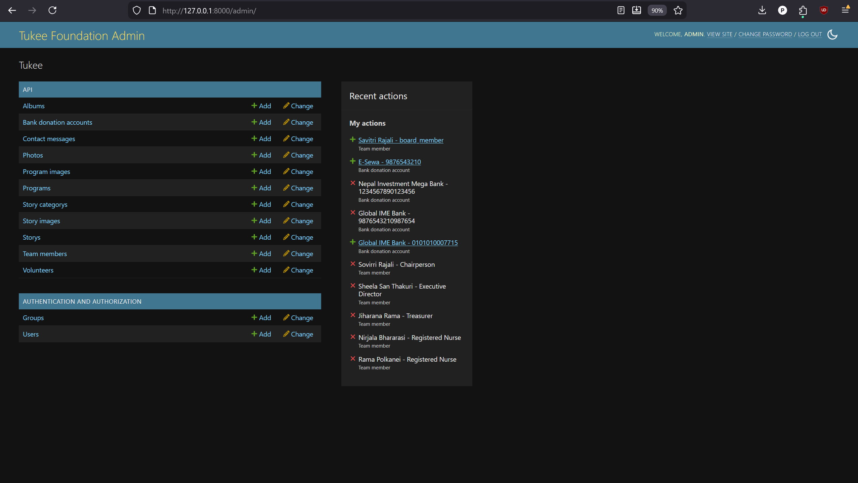

Appendix 1: admin

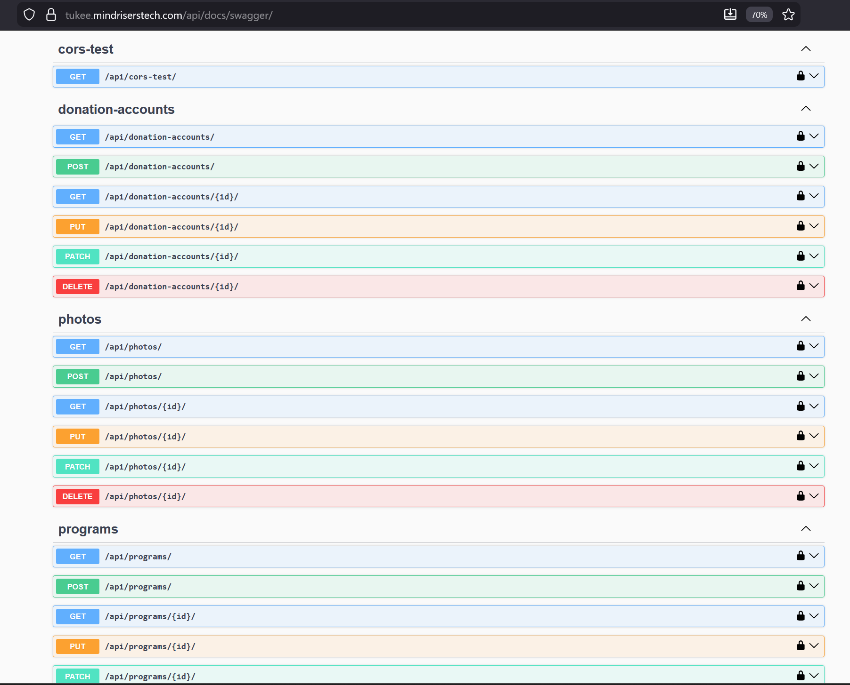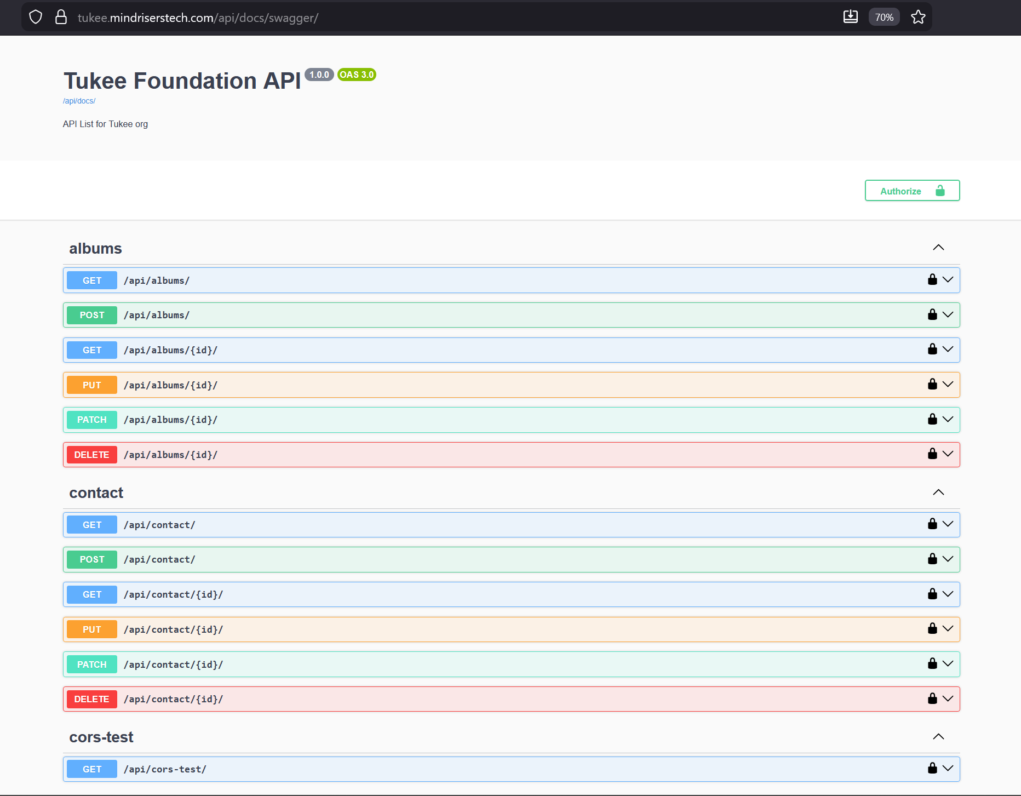

Appendix 2: Tuki Api Swagger view

