

Tribhuvan University
Humanities and Social Science
NIST College, Banepa

A Final Year Internship Report On
“Backend Developer Intern (Ruby on Rails)" At
Axios Softwork Pvt. Ltd.

In partial fulfillment of the requirement for the Bachelor Degree in Computer Application (BCA)

Under the Supervision of
Rupak Gyawali

Submitted By
Krishal Mahat(101402083)

Submitted To
Tribhuvan University Humanities and Social Science

Date of Submission
January, 2026
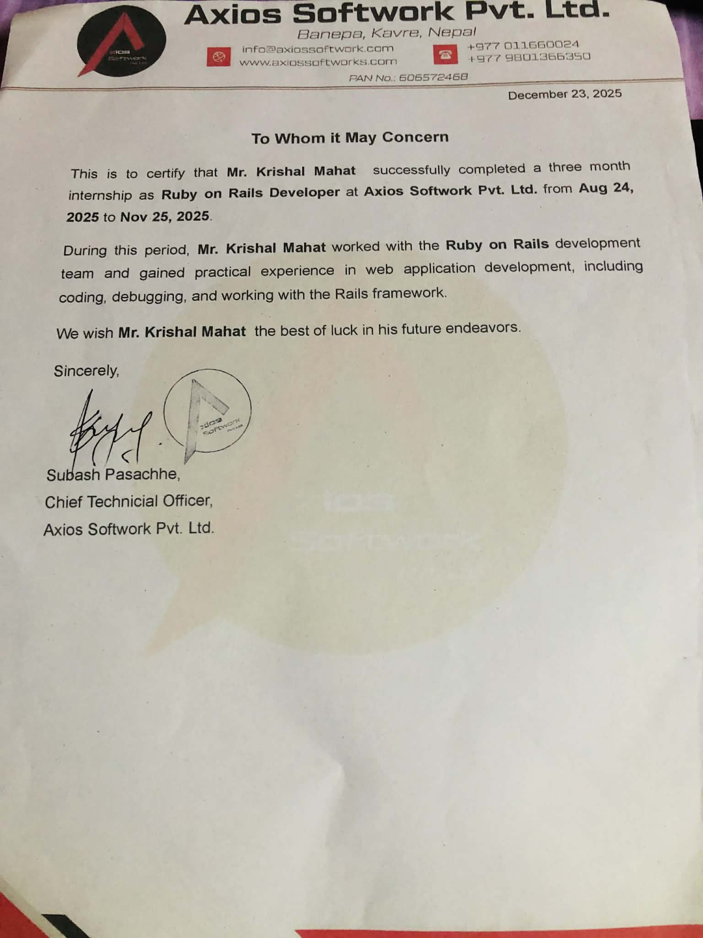

MENTOR’S RECOMMENDATION

I hereby recommend that the internship undertaken at Axios Softwork Pvt. Ltd. Under my supervision from August 24, 2025 to November 25, 2025 by Mr.Krishal Mahat in the field of Backend Development (Ruby on Rails), in partial fulfilment of the requirements for the degree of Bachelor in Computer Application, is recommended for final evaluation.

Sincerely,

Subash Pasachhe

Chief Technical Officer Axios Softwork Pvt. Ltd.


SUPERVISORS’ RECOMMENDATION

I hereby recommend that this Internship report entitled “Nivid School Management System" has been prepared by Krishal Mahat under my supervision be accepted as fulfillment of the requirements for the degree of Bachelor of Science in Computer Science and Information Technology is recommended for the final evaluation.

Mr. Rupak Gyawali

Supervisor

IT Department
NIST College, Banepa


LETTER OF APPROVAL

This is to certify that this project prepared by Krishal Mahat entitled “Nivid School Management System” in partial fulfillment of the requirements for the degree of Bachelor of Computer Application has been evaluated. In our opinion, it is satisfactory in the scope and quality as a project for the required degree.

Mr. Rupak Gyawali Mr. Samish Shrestha
Supervisor Co-ordinator
BCA Department NIST College, Banepa

Internal Examiner External Examiner

ACKNOWLEDGEMENT

I would like to express my sincere thanks to the Department of Computer Science and Information Technology, NIST College, Banepa for providing me with this opportunity to explore my thoughts, curiosity and interest in the field of Computer science through a Final Year Internship Project on "Nivid School Management System"
I am truly thankful to my Internship Supervisor, Mr. Rupak Gyawali, for his invaluable guidance, suggestions, encouragement, critical feedback and assistance in completing this work. His constant support and motivation have been a driving force for me, and I will always appreciate his contributions.
My deepest sense of gratitude is reserved for my highly respected and esteemed mentor, Subash Pasachhe Chief Technical Officer at Axios Softwork Pvt.Ltd. for his steady support, encouragement, and practical insights throughout the internship. His wise words and unwavering motivation enriched my learning and development remarkably. I would also like to thank Axios Softwork Pvt.Ltd for providing an opportunity to do an internship at this reputed organization with full support and cooperation. Their invaluable suggestions and cooperative behavior throughout this project are greatly appreciated
Furthermore, I would like to thank my friends and classmates for their encouragement, helpful criticism, and co-operation in hard times.
This internship was a learning experience, which increased my technical expertise, team working skills, and application development in the real-world scenario, getting me ready for my professional career in the future.

Sincerely,

Krishal Mahat (101402083) (6-2-1014-74-2021)

BCA NIST College, Banepa

ABSTRACT

This report outlines the work undertaken during 3 months internship at Axios Softwork Pvt. Ltd, focusing on the development and enhancement of the Nivid School Management System – a comprehensive education software platform aimed at digitizing academic management and education across Nepal.
Nivid is an all-in-one solution tailored for schools, offering a wide array of modules such as Biometric Attendance, Exam Management, Library Management, Time Table Management, Student/Teacher Profiles, CCTV Surveillance, Online Admission, Account Management, HR Management, Communication Hub, Inventory Management, Transport Management, and Bus Tracking. Each of these features is designed to streamline school operations and improve communication, security, and efficiency within the educational ecosystem.
The system is a comprehensive educational software platform designed to optimize school administrative processes through improved user experience, robust data security, modular customization, and increased operational efficiency. During the internship period at Axios Softwork Pvt.Ltd., the main tasks involved backend API development, resolution of database-related issues, and implementation of role-based data access controls. The internship provided practical exposure to backend development, including application of technical skills, deepening the understanding of backend development, data validation, and role-based permission. It also offered valuable insights knowledge on how large-scale educational software systems are built and maintained.
Keywords: Axios Softwork, Nivid, School Management System, Web and Mobile Platforms, Database, User Experience (UX), Internship Experience, Software Development, EduTech

TABLE OF CONTENTS

MENTOR’S RECOMMENDATION i
SUPERVISORS’ RECOMMENDATION ii
LETTER OF APPROVAL iii
ACKNOWLEDGEMENT iv
ABSTRACT v
LIST OF ABBREVIATIONS viii
LIST OF TABLES ix
LIST OF FIGURES x
CHAPTER 1 INTRODUCTION 1
  - Introduction 1
  - Problem Statement 1
  - Objectives 2
  - Scope and Limitations 2
    - Scope 2
    - Limitations: 2
  - Report Organization 3
CHAPTER 2: ORGANIZATIONAL DETAILS AND LITERATURE REVIEW 4
  - Introduction to Organization 4
  - Organizational Hierarchy 5
  - Working Domain of the Organization 5
  - Description of Internship Work/Project 6
    - Description of Intern Department: 6
2.5 Literature Review 7
CHAPTER 3: INTERNSHIP ACTIVITIES 8
  - Roles and Responsibilities 8
  - Weekly Log 9
  - Description of the Project(s) Involved During Internship 11
    - Requirement Analysis 12
Use Case Diagram 13
    - Tools Used: 14
  - Tasks / Activities Performed 16
    - System Setup and Environment Configuration 16
    - Multi-Tenant Architecture Setup 16
    - Remark Types and Teacher Remark System 16
    - Daily Logs and Report View for Teachers 18
    - Optional Filtering in Fee Scheme Settings 20
    - N+1 Query Optimization 20
    - Bug Fixing and Issue Tracking 21
    - API Testing 21
CHAPTER 4: CONCLUSION AND LEARNING OUTCOMES 23
  - Conclusion 23
  - Learning Outcome 23
    - Professional Level 23
    - Technical Level 24
    - Personal Level 24
REFERENCES 25
APPENDICES 26

LIST OF ABBREVIATIONS

API: Application Programming Interface

EdTech: Educational Technology

ERB: Embedded Ruby

Http: Hyper Text Transfer Protocol

IDE Integrated Development Environment
IT: Information Technology

JSON: JavaScript Object Notation

JSONB: JSON Binary (PostgreSQL data type)

MVC: Model View Controller

PSQL: Postgres SQL

RBAC: Role Based Access Control REST: Representational State Transfer ROR: Ruby on Rails
UAT: User Acceptance Testing
UI: User Interface
URL: Uniform Resource Locator
UX: User Experience

LIST OF TABLES
Table 2.1 Organization details 4
Table 2.2 Internship Details… 6
Table 3.1 Weekly Log 9
Table 3.2 Test Cases for Teacher Remark API 21
Table 3.3 Test Cases for Daily Logs API 22

LIST OF FIGURES

Figure 2.1 Organization logo 4

Figure 2.2 Organizational hierarchy 5

Figure 3.1 Use case of Nivid School Management System 13

Figure 3.2 Snapshot of Submit Teacher Remark Pseudo Code 17

Figure 3.3 Snapshot of Get t Teacher Remark Pseudo Code 18

Figure 3.4 Snapshot of Create daily_logs Pseudo Code 19

Figure 3.5 Snapshot of Fetch daily_logs Pseudo Code 20

CHAPTER 1 INTRODUCTION

Introduction
The Nivid School Management System is a comprehensive software solution designed to streamline the administrative and academic operations of educational institutions. It integrates key functions such as student record management, attendance tracking, assignment handling, and real-time communication into a single, user-friendly platform. This centralized approach enhances coordination and transparency among administrators, teachers, students, and parents.
The system promotes data-driven decision-making by offering insightful analytics that support better planning and resource allocation. These insights help track academic performance and evaluate institutional effectiveness, enabling school administrators to make informed decisions that positively impact overall operations.
By simplifying routine tasks and improving communication, the Nivid School Management System transforms how schools’ function in today’s fast-paced environment. It serves not only as a tool for operational efficiency but also as a catalyst for collaboration and continuous improvement within the educational ecosystem.

Problem Statement
Educational institutions often face challenges such as inefficient workflows, heavy reliance on paper-based systems, and poor communication. These traditional methods not only consume time and resources but also limit accessibility and coordination among staff, teachers, students, and parents. There is a growing need for a digital solution that reduces paper use, promotes sustainability, and enhances overall efficiency. Such a system should offer real-time access to academic and administrative information, improve communication across all stakeholders, and enable better tracking of daily activities and student performance. By centralizing operations, it can bring transparency, collaboration, and effectiveness to school management.

Objectives
The internship program aimed to bridge the gap between academic knowledge and practical experience in backend software development. It supported the development of key professional skills such as communication, teamwork, and responsibility. The experience also enhanced job readiness, including interview preparation and workplace behavior. The main objectives of the internship program were as follows:
    - To enhanced teacher-student communication by developing remark and follow-up APIs with role-based filtering and accurate token-based data access.
    - To improve data accessibility by adding filters in modules like fee and transport, enabling admins to retrieve relevant records efficiently.

Scope and Limitations
Below are the outline of the scope and limitations of the project:

Scope:

      - Develop an interactive and responsive interface tailored separately for administrators, teachers, and staff to ensure smooth and efficient user interactions.
      - Implement seamless integration between frontend and backend components to support all functionalities of the school management system.
      - Improve day-to-day school administrative operations through a unified platform.

Limitations:

There are certain limitations associated with this internship report, which are outlined as follows:
      - Not all technical and operational details of the Nivid have been disclosed due to organizational privacy policies and data protection regulations.
      - Specific designs and sensitive code details are omitted to maintain confidentiality
      - Financial and project cost information is not included for confidentiality reasons.

Report Organization
The report is organized into four chapters, each addressing key aspects of the internship project. Chapter 1 introduces the internship project, systematically divided into subchapters covering the problem statement, objectives, scope, and limitations. Chapter 2 provides an overview of the organization involved and presents a review of relevant literature related to the project’s domain. Chapter 3 details the internship activities, including roles, responsibilities, technical tasks undertaken, descriptions of the projects involved, and a comprehensive list of completed activities. Finally, Chapter 4 concludes the report by summarizing the project’s architectural design, data utilized, and overall execution process, as well as highlighting the learning outcomes gained during the internship.

CHAPTER 2: ORGANIZATIONAL DETAILS AND LITERATURE REVIEW

Introduction to Organization
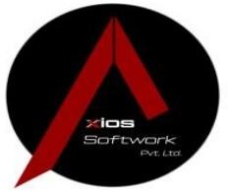

Figure 2. 1 Organization Logo

Axios Softwork Pvt. Ltd, a start-up business founded in 2018, is a leading, highly inventive software firm that was created to offer commercial organizations cutting-edge intelligent technical solutions and services. Team of professionals who uphold the highest standards of performance and ultimately help business flourish. Axios Softworks has earned a reputation as a well-established IT company, offering efficient and top-notch services. The company comprises engineers, developers, designers, quality assurance engineers, human resource managers, marketing executives, and other professionals who work to the highest industry standards. Axios Softworks specializes in robust web and mobile application solutions, utilizing the latest tools and incorporating up-to-date products into its web design programming.
Table 2. 1 Organization Details

Company Name | Axios Softwork Pvt.Ltd.
Organization Type | Private
Location | Banepa-1, Kavrepalanchok, Nepal
Established Date | 2018
Number of Employee | 25
Website | https://axiossoftworks.com/
Email | info@axiossoftwork.com

Organizational Hierarchy:
Axios Softwork Pvt. Ltd. has a team of a total of 25 people. Every member of the team is a professional offering a collaborative environment of continuous learning and growth. The hierarchy of the organization is displayed below in the figure below:
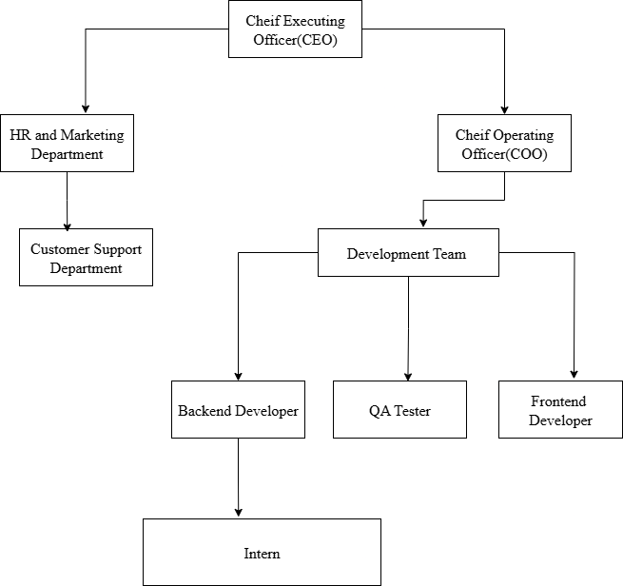

Figure 2. 2 Organizational Hierarchy

Working Domain of the Organization
Axios Sofwork Pvt. Ltd. provides multiple services in the area of web application design and development, Mobile App Development, Agile Development, Cloud Services, and Quality Assurance Service. The key working domains the following fields:

    - Software Development (React, Ruby on Rails, Python): Building web applications using React for dynamic user interfaces, Ruby on Rails for robust backend services, and Python for versatile programming and automation tasks.
    - Mobile App Development (Flutter): Creating cross-platform mobile apps with Flutter, enabling a single codebase to run smoothly on both iOS and Android devices.
    - Cloud Services (AWS) and API Development: Utilizing AWS cloud infrastructure to host and scale applications, and developing APIs to enable seamless communication between different software components.
    - UI and UX Designing: Designing intuitive user interfaces and engaging user experiences that enhance usability and satisfaction across digital products.

Description of Internship Work/Project

Description of Intern Department:

Every department at Axios Softwork offers internships to recent graduates and final-year bachelor's degree candidates. These internships are intended to be worthwhile educational opportunities that allow participants to advance their professional skills and obtain real- world, hands-on experience in the field of their choice. At Axios Softwork, interns work closely with seasoned professionals on practical projects and make direct contributions to the company's ongoing initiatives. The internship program, which usually lasts three months, gives interns plenty of time to get used to their new roles, learn new ideas, and put their theoretical knowledge to use in a fast-paced workplace.
The core goals of the internship program at Axios Softwork is to help participants build interpersonal and technical skills in line with their career goals. Regardless of their field software engineering, UI/UX design, customer support, or API development, interns are provided with training materials, development tools, and industry mentorship to strengthen their skills and set them up for future success in the workplace.
Table 2.2: Internship Details

Start Date | August 24, 2025
End data | November 25, 2025
Internship Duration | 3 Months
Position | Ruby on Rails Intern
Mentor | Subash Pasachhe
Working Days | Sunday - Friday
Working Hours | 10am - 6pm

2.5 Literature Review

In the context of school administration, an open-source school management system called Sikshya was developed to simplify and enhance day-to-day academic and administrative operations. Designed using PHP and MySQL, the platform supports essential functions such as student registration, attendance tracking, exam and grade management, fee collection, and timetable scheduling—all within a centralized, web-based environment. The system is particularly targeted toward educational institutions operating in resource- constrained settings, offering a user-friendly and cost-effective solution. The study emphasizes the value of digital recordkeeping and transparency, illustrating how open- source software can play a transformative role in modernizing school management and promoting digital infrastructure in education (Acharya, 2024).

A similar digital school management system was developed to improve the quality of education in Ugandan schools by addressing persistent administrative challenges. It includes features for managing student records, tracking attendance, publishing academic results, and monitoring teacher performance. Through pilot implementation, researchers identified significant issues such as poor record-keeping, communication delays, and lack of transparency in academic reporting. The system's deployment showed notable improvements in data accessibility, accuracy, and overall performance monitoring. The authors advocate for the adoption of affordable digital tools to enhance educational management in developing countries, underscoring the system’s potential to support sustainable and inclusive academic growth (Ujakpa et al., 2022).

CHAPTER 3: INTERNSHIP ACTIVITIES

Roles and Responsibilities
As a Backend Developer Intern at Axios Softwork, the primary responsibility was to support the development and maintenance of the backend functionalities of the Nivid School Management System. My role involved working closely with the development team to implement new features, resolve existing issues, and ensure the overall reliability and performance of the system.
The backend developer role has numerous tasks and responsibilities assigned as follows:

    - API Development and Integration: RESTful APIs were developed for modules such as the remark system, teacher remarks, and daily logs. Emphasis was placed on proper request validation, structured responses, and role-based access control.
    - Database Operations: SQL queries were written and optimized using ActiveRecord. The N+1 query issue was addressed, and data was efficiently managed across multiple relational tables and database views.
    - Bug Fixing and Debugging: Backend bugs related to data retrieval and access were analyzed and resolved, resulting in improved system performance and accuracy.
    - Code Collaboration: GitLab was used for version control. Feature branches were created, merge requests submitted, and code reviews actively participated in to ensure high-quality code integration.
    - API Testing and Documentation: APIs were tested using Postman to verify correct behavior across various user roles, including administrators, teachers, and students. Detailed documentation of API endpoints and workflows was maintained.
These activities contributed to hands-on experience in backend development and provided valuable insight into the structure and maintenance of large-scale SaaS applications within a collaborative team environment.

Weekly Log
The technical details described below are the work and tasks performed during the internship period. All the details are tabulated below:
Table 3. 1 Weekly Log

Weeks | Activity Log
Week 1 | - Learned basic concepts of Ruby programming.  - Studied data structures and object-oriented programming in Ruby.  - Set up a small Ruby project on the local machine.
Week 2 | - Learned the basics of the Ruby on Rails framework.  - Understood the MVC architecture, routing, models, and controllers.  - Set up a Rails API project.
Week 3 | - Deep dived into database systems, focusing on PostgreSQL and using DBeaver as the database management tool.
Week 4 | - Implemented a secure user authentication system in the Rails backend using Devise and JWT-based authentication with the Knock gem.  - Developed API endpoints for user registration and login.
Week 5 | - Integrated the Apartment gem in the Rails application to enable multi- tenancy support.  - Resolved issues related to tenant switching and tenant creation, including manually creating tenants to ensure functionality.
Week 6 | - Implemented image upload functionality in the Rails backend using ActiveStorage.
Week 7 | - Set up the Nivid School Management System (Rails project) in the local environment.  - Explored and understood the overall system architecture and backend workflows.

Week 8 | - Developed API for managing remarkTypes, enabling structured handling of remark categories.  - Worked on the teacher_api to fetch and display teacher remarks accurately.  - Finalized and completed the teacher_api with full functionality for handling teacher remarks.
Week 9 | - Created the daily_logs model and controller in the Rails backend.  - Designed and implemented the daily_report.html.erb view to display teacher activity logs based on selected dates.  - Used jQuery and AJAX to enable double-click editing of activities and remarks directly in the table.  - Wrote and tested raw SQL queries for retrieving logs by year, month, and teacher.
week 10 | - Implemented functionality to add remarks for teachers using token- based authentication.  - Implemented filtration on fee enhancing search and selection options to improve usability for administrative users.  - Added two new columns to the bus user list to provide additional student or transport-related data
Remaining Weeks | - Optimize database queries and refactoring code to resolve N+1 query issue, reducing redundant database hits and improving response time.  - Investigated and resolved a Sentry error related to undefined method error and nil class.  - Fixed a bug in the daily_logs module that affected correct data retrieval and display.

Description of the Project(s) Involved During Internship
During the internship period, active involvement was made in a live project titled "Nivid School Management System" (NIVID) — a web-based application built on the Ruby on Rails framework, designed to help schools manage daily operations efficiently. The system follows Rails' MVC architecture and supports multiple user roles — Administrators, Teachers, Students, and Parents — each with defined access levels enforced through role-based authorization.
Key contributions spanned both frontend and backend development. On the backend, RESTful API endpoints such as teacher_api#get_assigned_followup were created and optimized using ActiveRecord, with complex queries built against database views like calendar_meta and studentdetailmasternew. The N+1 query problem was identified and resolved through eager loading via includes and joins, and schema switching was implemented to support secure multi-tenant communication.
Features developed and enhanced included teacher and student remarks, follow-up tracking, daily activity logs, fee scheme filtering, and bus list management. A notable frontend contribution was the implementation of a popup image-based attendance sync feature, integrating a modal that displays real-time attendance synchronization status with visual indicators — built using Rails partial templates and JavaScript for a smooth, no-reload experience. Additional UI improvements and modal integrations were also delivered, with real-time issues tracked and resolved via ClickUp.
These contributions collectively improved the performance, usability, and functionality of NIVID, supporting more effective academic and administrative management for schools.

Requirement Analysis:

- Functional Requirement
The functional requirements for Nivid are as follows:

User Management
The system shall implement role-based access control to differentiate access levels for admins, teachers, and students. Admins and teachers shall have permissions to manage user accounts, view student remarks, and perform follow-up actions.

Student Information Management
The system shall store and manage comprehensive student records, including personal details, academic history, and guardian information. This data shall be accessible and utilized across related modules such as remarks, transport, and reporting.

Attendance Management
The system shall enable digital tracking and recording of daily attendance for students and staff. It shall support monitoring presence, generating attendance reports, and minimizing errors associated with manual attendance tracking.

Remarks System
The system shall enable teachers and administrators to record and manage qualitative feedback on students' behavior, academic performance, and social skills. This feedback can be entered on a daily or monthly basis. The system shall support multiple predefined remark types to ensure structured and consistent evaluations across different assessment periods.

Calendar Integration
The system shall use calendar_meta to link academic data with Nepali calendar dates through a unique dayToken. It shall ensure that logs and remarks are accurately associated with corresponding calendar entries, enabling precise date- based filtering and reporting.

Use Case Diagram

The use case diagram for the system is shown below:

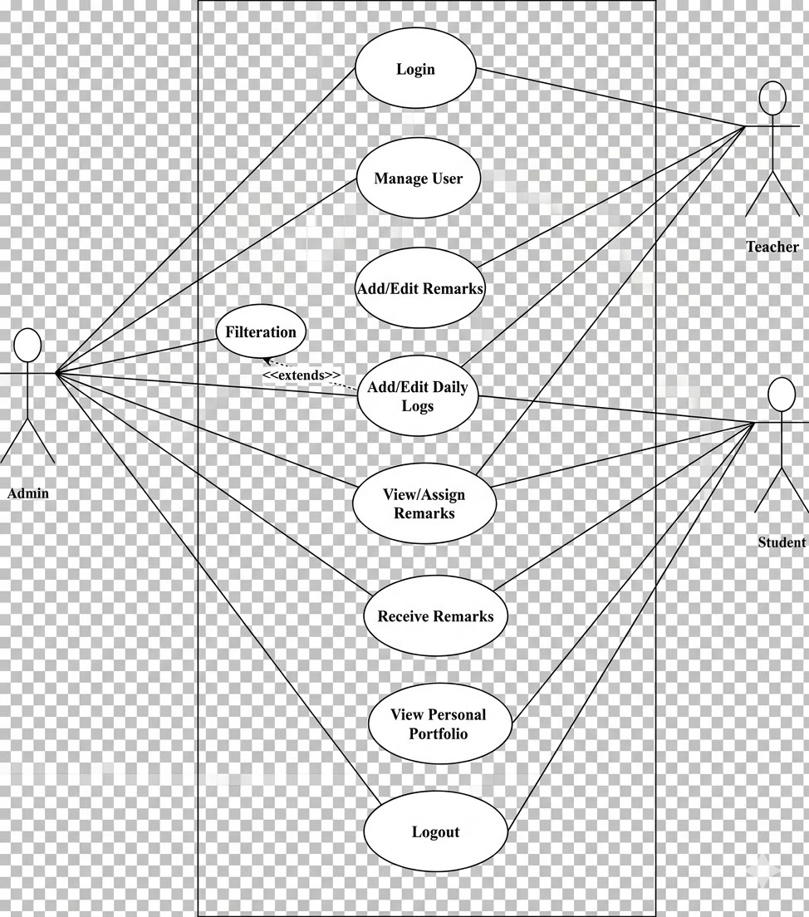

Figure 3. 1 Use Case of Nivid School Management System

This above use case diagram illustrates the interactions between three main actors—Admin, Teacher, and Student—within the system. The Admin can manage users, assign or filter remarks, and access all features including daily logs. Teachers can log in, add or edit remarks and daily logs, while students are limited to viewing their portfolio and receiving remarks. The system emphasizes role-based access and functionality sharing among user types.

Non-Functional Requirements:
The non-functional requirements of the project are as follows:
- The system should be able to handle multiple users at the same time with minimal delays.
- APIs are expected to respond quickly, ideally within 500 milliseconds for common queries.
- It must be scalable to support a growing number of schools, students, and staff members.
- All data should be stored in an encrypted format and API communications must be secure.
- The user interface should be easy to use for both technical and non-technical users.
- The system should maintain high availability, with at least 99.9% uptime during school hours.
- Code should be written in a clean and organized manner to allow easy maintenance and future updates.
- The platform should work smoothly on all major modern browsers like Chrome, Firefox, and Edge.
- Regular data backups must be scheduled, with recovery options available in case of data loss.
- The system should handle unexpected inputs properly, such as invalid login details or empty form submissions.
- Clear and helpful error messages and form validations should guide users to correct their mistakes effectively.

Tools Used:

The tools and technologies used while implementing the Nivid are:

Ruby on Rails (RoR)
Ruby on Rails was used to build the backend of the Nivid system. It handled the business logic, database operations, and API development. The framework followed the MVC architecture, used Devise for user authentication, ActiveStorage for managing image uploads, and PostgreSQL for data storage. ERB templates were used to render server-side views in the vendor panel.

GitLab
GitLab was used for version control and project collaboration. It helped manage the source code, track changes, and maintain multiple development branches. CI/CD pipelines were configured to automate testing and deployment processes, supporting efficient and organized code delivery.

Dbeaver
DBeaver was used for interacting with the PostgreSQL database. It provided a visual interface to browse schemas, execute queries, and inspect table structures. It was also helpful for verifying data integrity during backend development and testing.

Postman
Postman was used extensively to test the REST APIs built for the system. It helped validate endpoint responses, check authentication mechanisms, and simulate real- world API usage during both development and debugging phases.

ClickUp
ClickUp was used to manage tasks and track issues throughout the development cycle. Real-time bugs and feature requests were logged and assigned through the platform, helping the team stay organized and prioritize work effectively.

Visual Studio Code
Visual Studio Code was the primary code editor used during development. It supported writing and debugging both frontend and backend code efficiently, with features like integrated terminal, extensions, and IntelliSense to improve productivity.

Tasks / Activities Performed

System Setup and Environment Configuration

The internship began with setting up the backend environment needed to contribute to the Nivid School Management System. Initially, Ruby 3.4.2 and Rails 8 were installed, but these versions caused compatibility issues with token-based authentication libraries. As a result, the system was downgraded to Ruby 2.7.7 and Rails 5.1.6 to ensure compatibility with essential gems like Devise and Knock. After resolving these version mismatches, the system was successfully configured for development and testing.

Multi-Tenant Architecture Setup

To support school-specific data isolation, the Nivid system utilizes a schema-based multi- tenant architecture. The Apartment gem was integrated to manage separate schemas for each tenant (school). Initial errors in tenant schema creation were resolved by manually generating schemas. The system was extended to allow communication between tenants by enabling task assignment across schemas. This setup ensured secure and organized management of tenant-specific data within a shared platform.

Remark Types and Teacher Remark System

A significant portion of the internship focused on building and improving the remark system. This module allows teachers to submit evaluations for students and also receive feedback or assignments directed at them. Backend APIs were developed for both remark submission and retrieval. Logic was applied to distinguish between teacher and student remarks using the is_student_remark flag. Tasks also included handling various tokens such as dayToken, gradeToken, and teacherToken to accurately fetch and link related data. Issues related to missing or invalid tokens were identified and resolved, ensuring proper display and filtering of remarks.

Submit Teacher Remark
This logic allows only teachers or admins to submit a teacher-related remark. It validates the remark type and target teacher, creates a TeacherRemark record with relevant data, and returns a success or error message based on the outcome. Unauthorized users are blocked from submitting remarks.
IF current user is a teacher OR admin
Read submitted data from request params:
- teacher_id
- remark_type_id
- remark_text
- optional: subject, grade, etc. Validate:
- remark_type exists
- teacher_id is valid
- remark_type is not student-specific (i.e., meant for teacher remark) Create new TeacherRemark object (or appropriate model)
- Assign current user ID (as the submitter)
- Assign teacher_id as the target
- Assign remark_type_id
- Assign remark_text
- Set timestamp (created_at) Save the TeacherRemark record IF save is successful
Return success message or status ELSE
Return validation errors or failure message
ELSE
Return error: "Unauthorized to submit remark"

Figure 3.2 Snapshot of Submit Teacher Remark Pseudo Code
      - Get Teacher Remark
This funtion retrieves all remarks made about the currently logged-in teacher, optionally filtered by month and year. If no teacher record is found, it returns a message. Otherwise, it fetches relevant remarks sorted by newest first and returns them in the response.
Find the teacher record for the current user IF no teacher found
Return "No remark found" message and stop IF month and year are provided
Prepare filter to only get remarks for that month and year Get all remarks about this teacher where remark is for teachers,
optionally filtered by month and year, sorted from newest to oldest
Return the list of remarks as a successful response

Figure 3. 3 Snapshot of Get Teacher Remark Pseudo Code

Daily Logs and Report View for Teachers

Daily logs enable teachers to record classroom activities, which are then reviewed by school admins. The backend models and APIs were created to support this feature, storing information such as dayToken, slot ID, and teacher ID. A reporting interface was also developed using server-rendered views, which allowed logs to be filtered by date and teacher. Additionally, frontend modals were implemented to enable inline updates through double-click interactions, streamlining the editing experience for admins.

Create Daily Logs
This code allows a teacher to submit or update their daily activity log for a specific slot on the current day. It finds the teacher by user ID, checks if a log already exists, creates one if not, updates it with the provided activity, and returns a success or error response accordingly.
Find the teacher ID using the current user's ID IF teacher is found
Try to find a daily log using:
- today's day_token
- slot_id from params
- teacher ID
IF log does not exist
Initialize a new one with the same identifiers
Set the activities field in the daily log using the provided value Save the log
IF save is successful
Return success response with the saved log
ELSE
Return failure response: "No teacher record found"

Figure 3. 4 Snapshot of Create daily_logs Pseudo Code
      - Fetch Daily Logs
This function retrieves teacher daily logs, optionally filtered by year and month, by joining log data with calendar information. If date parameters are provided, only matching records are fetched; otherwise, all logs are returned in the response.
Get year and month from request parameters IF both year and month are provided
Add a filter to fetch only logs for that year and month
Run a SQL query to get daily logs joined with calendar data, filtered by year and month
ELSE
Run a SQL query to get all daily logs joined with calendar data (no filter) Return the fetched logs as a success response

Figure 3. 5 Snapshot of Fetch daily_logs Pseudo Code

Optional Filtering in Fee Scheme Settings

To improve efficiency in the fee management module, optional filters were added to the backend APIs. These included ledgerToken, yearToken, and class filters. Query parameters were implemented to allow users to retrieve only relevant records, and backend logic was optimized to ensure fast performance even when filters were applied. This made fee tracking and data access more precise and manageable for school administrators.

N+1 Query Optimization

Several APIs in the remark and daily logs modules were affected by N+1 query issues, which resulted in performance delays. These issues were identified by examining repeated database calls in loops. Using ActiveRecord’s includes and left_joins, the data loading strategy was optimized, reducing the number of database hits and improving response times for endpoints like teacher_api#remark and create_daily_logs.

Bug Fixing and Issue Tracking

Throughout the internship, various bugs were addressed across modules. Common issues included invalid tokens, missing relationships between tables, and inconsistencies in remark visibility. These bugs were tracked and managed using ClickUp, which allowed for proper documentation and assignment of tasks. GitLab was used for version control and collaboration, with changes submitted via merge requests after thorough testing.

API Testing

To ensure the reliability and correctness of the backend modules, API testing was conducted for the Teacher Remark and Daily Logs features. The tests focused on validating input parameters, error handling, role-based access, and expected data outputs. Both positive and negative scenarios were covered, including successful submissions, missing or invalid tokens, and filtered data retrieval. The results confirmed that the APIs functioned as intended, returning appropriate responses and error messages based on the request inputs.
Table 3. 2 Test Cases for Teacher Remark API

Test Cases | Expected Outcome | Actual Outcome
Submit a valid remark | Remark saved, response includes status 200 and message | Remark was saved with the status 200 and message
Submit without studentToken | The API should return an error with appropriate validation messages and 422 Unprocessable Entity status. | Pass
Submit with invalid remarkType | The API should return an error with appropriate validation messages and 422 Unprocessable Entity status. | Pass
token

Retrieve remark list by teacher | Only students from teacher's assigned grades are shown | Pass

Table 3. 3 Test Cases for Daily Logs API

Test Case | Expected Outcome | Actual Outcome
Teacher exists, daily log does not exist | Creates a new daily log and returns success | Daily log is created and success response is returned
Teacher exists, daily log already exists | Updates the existing log with new activities and returns success | Existing daily log is updated and success response is returned
Add new activity for a valid slot | Log saved successfully | Pass
No teacher record found | Returns failure response with message "No teacher record found" | Returns failure with proper message
View logs filtered by dayToken, year, month | Correct data displayed in table | Pass

CHAPTER 4: CONCLUSION AND LEARNING OUTCOMES

Conclusion
Throughout the course of my internship, I had the opportunity to deep into the IT industry and experience the dynamics of a real-world working environment. This hands-on experience allowed me to apply the knowledge and skills I had acquired during my four years of academic study, making it a highly fruitful period of my professional development. Working at Axios Softworks, a renowned company in the field, gave me a valuable chance to not only enhance my existing knowledge but also to work as an integral part of a collaborative team. Internships, like the one I undertook, are formal programs within organizations designed to provide practical work experience to individuals who are new to the field. The program offered me a unique window into the industry, enabling me to gain a deeper understanding of how things are truly done in practice. It was a golden opportunity that I am forever grateful for, as it allowed me to bridge the gap between theoretical knowledge and real-world application, equipping me with valuable insights and skills for my future career.

Learning Outcome
The internship at Axios Softwork provided hands-on experience in backend development through active involvement in the Nivid School Management System, a real-world EdTech application.

Professional Level

      - Strengthened collaboration and communication skills by regularly engaging with mentors, developers, and team leads throughout the backend development cycle.
      - Gained exposure to agile practices such as sprint planning, task allocation, daily standups, and progress tracking using ClickUp.
      - Practiced version control workflows using Git and GitLab, including branching, committing, and merge request handling to ensure code traceability and team coordination.

.

Technical Level

      - Designed and implemented RESTful APIs using Ruby on Rails following the MVC architectural pattern.
      - Developed key backend modules such as the teacher remark system, daily activity logging, and filtering mechanisms for fee and transport data.
      - Resolved N+1 query issue by applying efficient querying strategies using includes and left joins.
      - Integrated authentication with Devise and handled logic for role-based access (admin, teacher, student).
      - Performed API testing using tools like Postman and browser console to ensure expected data flows and error handling.

Personal Level

      - Improved time management by tracking daily progress and meeting expected task outcomes within weekly development sprints.
      - Gained confidence in working independently by resolving backend bugs, handling token- based data access issues, and debugging logic for various endpoints.
      - Enhanced problem-solving ability by navigating real-time challenges such as schema errors, token mismatches, and data visibility issues.
      - Strengthened technical writing and communication by documenting tasks, participating in code discussions, and proactively reporting issues to the team.
      - Built a solid foundation in backend development principles and gained clarity on how large-scale educational systems are structured and maintained.

REFERENCES

Acharya, K. (2024). Sikshya. https://dx.doi.org/10.2139/ssrn.4837837
Ujakpa, M. M., Mutalya, M. N., Osakwe, J., Iyawa, G., & Shililifa, E. N. (2022). School Management Information System (SMIS) for the Elite College. 2022 IST-Africa Conference (IST-Africa). https://doi.org/10.23919/ist-africa56635.2022.9845593

APPENDICES

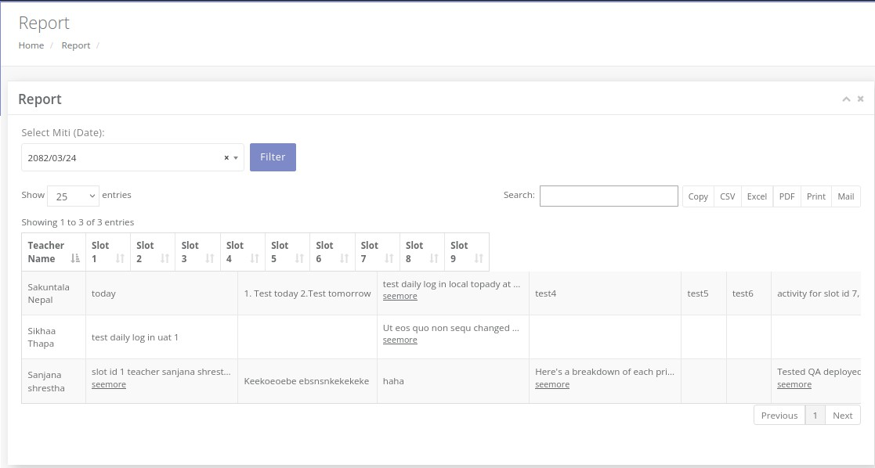
Figure 1 Daily Logs UI Page

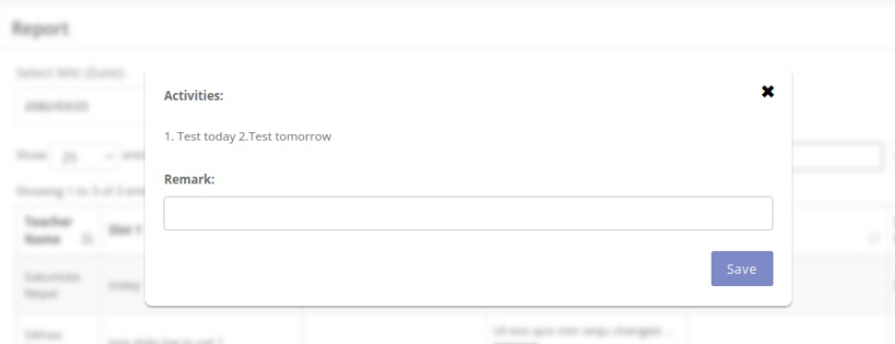
Figure 2 Activity Modal in Daily Log page
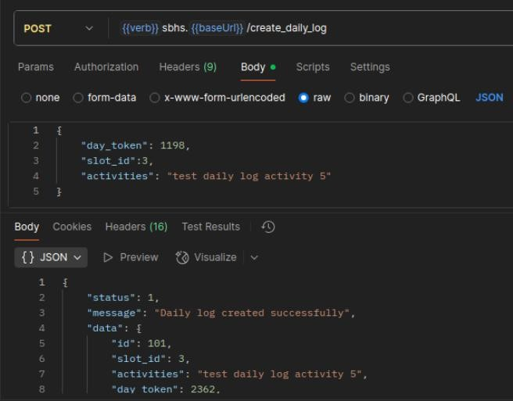
Figure 3 Create Daily Logs API Response

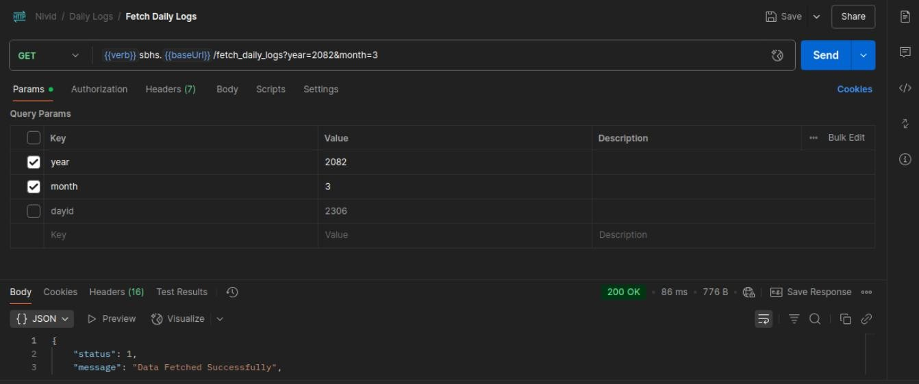

Figure 4 Dashboard PageFigure 5 Fetch Daily logs
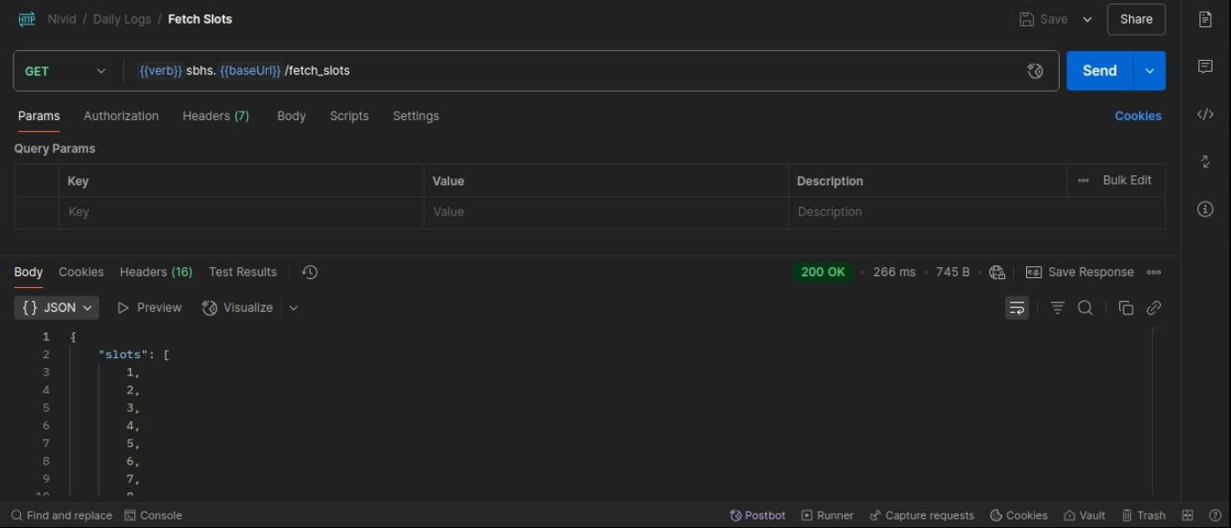
Figure 7 Fetch Slots

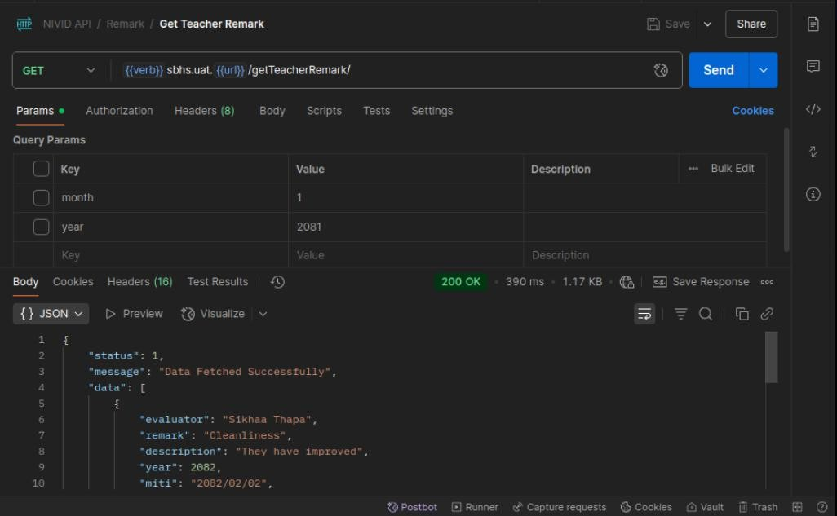

Figure 6 Successful API Response for "Get Teacher Remark" in Postman

Log of Supervisor Visits Internship

Krishal Mahat Under the supervision of
(101402083) Rupak Gyawali

S.N. | Date | Discussion
1. | 3rd september, 2025 | Internship criteria and types of projects discussion
2. | 13th sept,2025 | Internship report content discussion
3. | 22nd sept, 2025 | First draft of internship report submission
4. | 2nd oct, 2025 | Use case diagrams discussion
5. | 7th oct, 2025 | Report formats, Organizational Hierarchical diagram changes discussion
6. | 10th nov, 2025 | Work Log contents and its changes discussion
7. | 18th nov, 2025 | Project involved during internship module discussion for changes to add code.
8. | 29th nov, 2025 | Second draft of internship report submission
9. | 3rd jan, 2026 | Reference and activities format changes discussion
10. | 6th jan, 2025 | Final Report submission and demo with presentation

Rupak Gyawali
Intern Project Supervisor

