
Tribhuvan University
Faculty of Humanities & Social Science

AN INTERNSHIP REPORT
ON
REACT JS

Submitted to Department of Computer Application
NIST COLLEGE
In partial fulfillment of the requirements for the Bachelors in Computer Application

Submitted by
Krishna Karki
(TU Reg No. 6-2-1014-75-2021 )
Mar 2026 AD

Under the Supervision of
Mr. Bijay Shrestha
Mentor’s Recommendation



Tribhuvan University
Faculty of Humanities and Social Sciences
NIST College, Banepa

Supervisor’s Recommendation
I hereby recommend that this intern prepared under my supervision by “Krishna Karki ” in partial fulfillment of the requirements for the degree of Bachelor of Computer Application is recommended for the final evaluation.
………………….
SIGNATURE

Supervisor
Mr. Bijay Shrestha
Department of Computer Application
Nist College
Banepa, Kavre


Tribhuvan University
Faculty of Humanities and Social Sciences
NIST College
Letter Of Approval
This is to certify that this intern is prepared by “Krishna Karki” in partial fulfillment of the requirements for the degree of Bachelor in Computer Application has been evaluated. In our opinion it is satisfactory in the scope and quality as a project for the required degree.

……………………………….  Mr. BijayShrestha  Supervisor | ……………………………….  Mr. Samish Shrestha  Coordinator
……………………………….  Internal Examiner | ……………………………….  External Examiner

ACKNOWLEDGEMENT
I would like to express my heartfelt gratitude to the Department of Department of Information Technology at Nist College for providing me with the opportunity to embark on this enriching journey of professional development through an internship experience in “ Junior React Developer ”
I extend my sincere appreciation to Mr. Bijay Shrestha for their unwavering support, guidance, and mentorship throughout this internship. Their expertise, encouragement, and constructive feedback have been invaluable in shaping my learning experience and contributing to the successful completion of this project. I am truly grateful for their dedication and commitment to fostering my growth and development.
I am also deeply thankful to Onviro Tech P.Ltd, especially Mr. Man Bahadur Rokka, for offering me the opportunity to undertake my internship at their esteemed organization. Their trust, support, and encouragement have been instrumental in providing me with a conducive environment to learn, grow, and thrive professionally. I am grateful for the exposure, experiences, and insights gained during my time at Onviro Tech P.Ltd.
Furthermore, I extend my appreciation to my friends, colleagues, and peers for their encouragement, assistance, and camaraderie throughout this journey. Their support and encouragement have been a source of strength and motivation, and I am grateful for their unwavering belief in my abilities.
Lastly, I would like to express my gratitude to my family for their unwavering support, understanding, and encouragement throughout this endeavor. Their love, encouragement, and belief in my potential have been a driving force behind my accomplishments, and I am forever grateful for their unwavering support.
I am profoundly grateful to all individuals and organizations who have played a significant role in shaping my internship experience and contributing to my personal and professional growth. Their support, guidance, and encouragement have been instrumental in helping me navigate this journey with confidence and enthusiasm.
Sincerely,
Krishna Karki
ABSTRACT
This report documents the author's internship experience as a Front-end Web App Developer specializing in React JS at Onviro Tech P.Ltd, situated in Kamaladi-28 at Hattisar Road, Kathmandu . The internship aimed to provide practical exposure and hands-on experience in developing dynamic and user-friendly web applications using the React JS library. Throughout the internship, the author was actively involved in designing, developing, and deploying front-end components for various projects, with a focus on creating responsive and intuitive user interfaces. Tasks included implementing state management, integrating with back-end APIs, and ensuring cross-browser compatibility. The internship not only enhanced the author's proficiency in React JS but also provided insights into modern front-end development practices, UI/UX design principles, and collaborative project workflows. By the conclusion of the internship, the author had acquired valuable skills and experience poised for a successful career in front-end web development.
Keywords: React JS, front-end development, web applications, user interface (UI), user experience (UX)

Table of Contents
Mentor’s Recommendation ii
Supervisor’s Recommendation iii
Letter of Approval iv
ACKNOWLEDGEMENT v
Chapter 1 : Introduction 1
1.1 Introduction 1
1.2 Problem Statement 2
1.3 Objectives 3
1.4 Scope and Limitation 3
1.4.1 Scope 3
1.4.2 Limitations 4
1.5 Report Organization 4
Chapter 2 : Introduction to Organization 6
2.1 Organization Details 6
2.2 Organizational Hierarchy 6
2.3 Working Domains of Organization 8
2.4 Description of Intern Department/Unit 8
Chapter 3 : Background Study and Literature Review 11
3.1 Background Study 11
3.2 Literature Review 12
Chapter 4 : Internship Activities 13
4.1 Roles and Responsibilities 13
4.2 Weekly Log 14
4.3 Description of the Projects 17
4.4 Tasks / Activity Performed 19
Chapter 5 : Conclusion and Learning Outcomes 22
5.1 Conclusion 22
5.2 Learning Outcomes 23
REFERENCES 25
APPENDICES. 26

List of Abbreviations
API Application Programming Interface
CRUD Create, Read, Update, Delete
CSS Cascading Style Sheets
JS JavaScript
MUI Material-UI
MySQL My Structured Query Language
TU Tribhuvan University
UI User Interface
UX User Experience

List of Figures
Figure 2.2.1: Organization Hierarchy Error! Bookmark not defined.

List of Tables
Table 2.4.1 : Internship Experience Error! Bookmark not defined.
Table 4.2.1: Weekly Log Error! Bookmark not defined.
Table 4.2.2: Log Sheet for Supervisor Visit Error! Bookmark not defined.

Introduction

Introduction
During the internship period, our focus was on developing a robust and efficient task management system using React JS. With the ever-increasing complexity of modern project workflows, there's a growing demand for intuitive and feature-rich platforms that facilitate seamless collaboration and productivity among team members.
In this project, we harnessed the power of React JS to create a dynamic and responsive user interface that caters to the diverse needs of project managers, team leaders, and individual contributors. Leveraging React's component-based architecture, we designed modular UI components that enable flexible customization and extensibility, allowing users to tailor the system to their specific requirements.
The task management system serves as a centralized hub for organizing, tracking, and prioritizing tasks and projects in real-time. Through seamless integration with backend APIs and databases, users can create, assign, and monitor tasks, set deadlines, and track progress effortlessly. The system also supports collaboration features such as comments, file attachments, and notifications, fostering communication and coordination among team members.
One of the key challenges addressed during the internship was implementing efficient state management and data synchronization mechanisms to ensure data consistency and reliability across multiple users and devices. By leveraging state management libraries like we were able to achieve seamless synchronization of task data, providing users with a fluid and uninterrupted experience.
Furthermore, the task management system incorporates advanced features such as task dependencies, Gantt charts, and resource allocation, empowering users to plan and execute projects with precision and efficiency. Through iterative development and continuous feedback, we iteratively refined and enhanced the system, ensuring it meets the evolving needs and expectations of project stakeholders.
By developing a comprehensive task/project management system, we have gained valuable insights into the complexities of modern project workflows and the potential of React JS in building scalable and feature-rich web applications.

Problem Statement
In the organizational context of Onviro Tech P.Ltd, the absence of an in-house task management software solution has posed significant operational challenges. Currently, the company relies on third-party applications for task and project management, leading to inefficiencies, limited customization, and dependency on external systems. This reliance not only incurs recurring costs but also hampers the ability to tailor the software to the unique workflows and requirements.
Furthermore, the utilization of disparate task management tools complicates collaboration and communication among team members, hindering transparency, accountability, and overall productivity. The lack of a centralized platform for task allocation, monitoring, and progress tracking exacerbates these challenges, resulting in suboptimal resource utilization and project outcomes.
To address these issues comprehensively, there is an urgent need to develop a customized task management software solution specifically tailored to the needs and workflows of Onviro Tech P,Ltd. This bespoke software platform should offer robust functionality, seamless integration with existing systems, and intuitive user interfaces to enhance usability and adoption across the organization.
By developing an in-house task management software solution, Onviro Tech P,Ltd aims to mitigate dependency on external tools, streamline task allocation and monitoring processes, and foster a culture of collaboration and efficiency within the organization. This project endeavors to bridge the gap between existing task management practices and the evolving needs of Onviro Tech P.Ltd, ultimately empowering the organization to optimize its operational workflows and achieve greater productivity and success.

Objectives
The main objective of this internship is stated below:
- To understand the software development lifecycle through requirement analysis, design, implementation, testing, and deployment.
- To develop collaborative skills by working with developers, designers, and project managers.
- To enhance problem-solving abilities with modern web technologies.
- To master project management tools like ClickUp for task tracking, time management, and collaboration

Scope and Limitation

Scope
- Project Scope
Developed a responsive web application using React.js for managing customer data and orders, contributing to the organization's initiative to streamline sales processes.
- Learning Opportunities
Participated in daily stand-up meetings and code reviews, receiving feedback from senior developers on React.js best practices and code optimization techniques.
- Technological Scope
Utilized Redux for state management and Axios for handling asynchronous API requests within the React.js application. Implemented React Router for client-side routing to enhance user navigation and experience.
- Collaboration
Collaborated with a cross-functional team of designers and backend developers to integrate front-end components seamlessly with the backend API, ensuring data consistency and application reliability.

Limitations
- Time Constraints
Due to the short duration of the internship, only able to implement basic CRUD functionality for customer data management, with limited time for additional features such as user authentication and data visualization.
- Technical Challenges
Faced challenges with optimizing performance in large-scale React components, particularly when rendering large datasets fetched from the server. Employed techniques such as lazy loading and virtualization to mitigate rendering delays.
- Resource Limitations
Limited access to comprehensive React.js documentation and tutorials, resulting in occasional delays in resolving complex issues or implementing advanced features. Relied heavily on online forums and community support for troubleshooting.
- Skill Level
Initially struggled with understanding React.js component lifecycle methods and Redux architecture. Invested extra time outside of regular hours to study documentation and tutorials, gradually improving proficiency and confidence in these areas.

Report Organization
The overall report is organized into 5 chapters.
Chapter 1: Introduction
It consists of the introduction of internship, problem statement, objectives, scope and limitation of the internship and short description about project done during internship. It also discusses about how overall internship report is organized.
Chapter 2: Organization Details
This chapter discloses details about the company I did my internship on i.e. Onviro Tech Pvt.Ltd such as Organization background, its hierarchy, the domain it has been working on and how intern department functions.
Chapter 3: Background Study and Literature Review
The previous work related to the project and similar works were studied and different feasibility analysis are summarized in this section.
Chapter 4: Internship Activities
Roles and responsibilities of the author during the internship, weekly logs, and description of projects are described in this chapter. Basically, all the technical activities that are performed during the internship period are discussed here.
Chapter 5: Conclusion and Learning Outcomes
It is the final chapter that includes the learning outcomes from the internship.

Introduction to Organization

Organization Details
Onviro Tech Pvt. Ltd is a privately held IT company located at Kamaladi-28, Hattisar Road, Kathmandu, Nepal. The company specializes in delivering modern digital solutions through a skilled team of web developers, designers, and IT professionals. Its services include web design, web development, mobile application development, web hosting, and IT consulting .Founded as a privately held company, Onviro Tech Pvt.Ltd epitomizes the convergence of talent and vision, boasting a team of highly skilled professionals comprising web designers, web developers, and graphic designers. Onviro Tech includes multi-talented workforce collaborates seamlessly to deliver bespoke solutions that transcend conventional boundaries, pushing the envelope of design and development in the digital realm.
At Onviro , it offers a comprehensive suite of services tailored to meet the evolving needs of our clients. From captivating web designs to robust web development and innovative mobile applications, we cover the entire spectrum of digital solutions. It’s expertise extends to web hosting and consulting services, ensuring that our clients receive end-to-end support for their digital ventures.

Organizational Hierarchy
At the helm of Onviro Tech Pvt.Ltd dstands the Executive Leadership Team, comprising the CEO and CTO. The CEO oversees the company's strategic direction and growth initiatives. The CTO is responsible for financial planning, budgeting, and reporting to support the organization's financial health and sustainability.
Reporting to the Executive Leadership Team are the Department Heads, each responsible for leading a specific area of expertise within the company. The Web Design Department Head leads a team of designers tasked with creating visually appealing and user-friendly website layouts. The Web Development Department Head oversees a team of developers focused on building robust and scalable web applications. The Graphic Design Department Head manages a team responsible for creating graphics, illustrations, and branding materials, while the Mobile Application Development Department Head leads a team specializing in iOS and Android app development. Additionally, the Web Hosting Department Head manages the infrastructure and technical support services for web hosting clients.
Within each department, functional teams collaborate to fulfill project requirements and deliver high-quality solutions to clients. The Web Design Team specializes in UI/UX design, wireframing , and prototyping, while the Front-end Development Team implements designs and creates interactive user interfaces. The Back-end Development Team handles server-side logic and database management, and the Graphic Design Team focuses on visual assets and branding. The Mobile App Development Team creates native and hybrid applications, and the Web Hosting and Support Team manages server infrastructure and provides technical support to clients.
Interns and Junior Staff members contribute to various projects and undergo training to enhance their skills under the guidance of senior team members. They gain practical experience and knowledge in their respective fields, preparing them for future roles within the organization.
In summary, Onviro Tech Pvt.Ltd’s functional organizational structure is designed to optimize expertise and efficiency within each department, fostering collaboration and innovation across the organization. By leveraging the talents of its team members and prioritizing client satisfaction, Onviro Tech Pvt.Ltd strives to maintain its reputation as a leader in digital innovation and excellence.

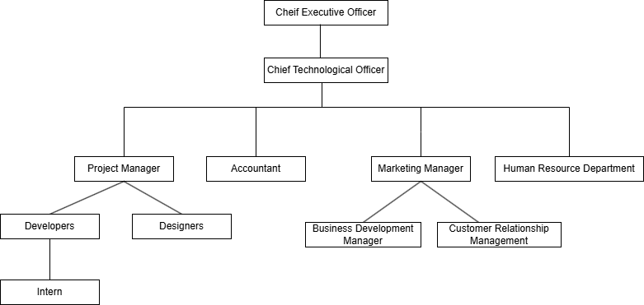
Figure 2.2.1: Organization Hierarchy

Working Domains of Organization
Onviro Tech Pvt.Ltd’s working domains encompass a comprehensive range of digital services aimed at helping clients succeed in today's competitive marketplace. Whether it's designing stunning websites, developing innovative mobile apps, or providing strategic consulting. Onviro Tech Pvt.Ltd is committed to delivering creative and effective solutions that drive results. Here are the working domains of the organization:
- Web Design: Onviro Tech specializes in creating visually appealing and user-friendly website layouts. Their team of talented designers combines creativity with usability to craft engaging web experiences for clients across various industries.
- Web Development: The organization offers comprehensive web development services, focusing on building robust and scalable web applications. Their team of developers utilizes the latest technologies and best practices to deliver customized solutions tailored to meet client requirements.
- Mobile Application Development: Onviro Tech excels in developing mobile applications for both iOS and Android platforms. Their mobile app development team leverages their expertise to create native and hybrid applications that provide seamless user experiences and functionality.
- Web Hosting: Onviro Tech provides reliable web hosting services to ensure that clients' websites are accessible and secure. Their web hosting infrastructure is designed to support the hosting needs of businesses of all sizes, offering uptime guarantees and technical support.
- Consulting: In addition to design and development services, Onviro Tech Pvt.Ltd offers consulting services to help clients navigate the complex landscape of digital technology. Their team of experts provides strategic guidance and recommendations to align clients' digital initiatives with their business goals.
- Graphic Design: Onviro Tech’s graphic design services encompass a wide range of visual communication solutions, including branding, marketing collateral, and illustration. Their graphic design team brings creativity and expertise to every project, helping clients effectively communicate their brand identity and messaging.

Description of Intern Department/Unit
During the 12-week internship period within the Web App Development department at Onviro Tech Pvt.Ltd, I had the opportunity to immerse myself in the intricacies of web application development under the mentorship of seasoned professionals. Each week brought new challenges and learning opportunities as I delved deeper into various facets of front-end and back-end development, contributing to projects aimed at delivering innovative solutions to clients.
Responsibilities were thoughtfully assigned based on sprint priorities, providing me with hands-on experience in implementing responsive design principles to ensure seamless user experiences across a multitude of devices and screen sizes. Working in tandem with back-end developers, database administrators, and cross-functional teams, I gained invaluable insights into the collaborative nature of web development, learning to integrate front-end and back-end components seamlessly to create robust and scalable applications.
Moreover, I was entrusted with developing and implementing key features such as vehicle management, route optimization, transaction processing, and data synchronization, allowing me to sharpen my problem-solving skills and technical expertise. Embracing the agile development methodology, I adapted swiftly to evolving project requirements and embraced constructive feedback from peers to enhance application functionality and performance.
Utilizing version control systems like Git, I diligently managed code changes and documented the codebase comprehensively, ensuring clarity for future development iterations and maintenance tasks. Additionally, I actively participated in knowledge-sharing sessions and workshops, staying abreast of the latest web development trends, technologies, and best practices.
Beyond technical skills, the internship provided me with valuable insights into project management methodologies, client communication, and the importance of teamwork in achieving project milestones. Through collaborative brainstorming sessions and code reviews, I fostered meaningful connections with team members, contributing to a vibrant and supportive work environment.
Overall, my internship experience in the Web App Development department at Onviro Tech Pvt,Ltd was transformative, equipping me with practical skills, industry insights, and a deeper understanding of the software development lifecycle. I am grateful for the opportunity to have contributed to impactful projects and look forward to applying my newfound knowledge and expertise in future endeavors.

Table 2.4.1: Internship Experience
Start Date | 22 Dec 2025
End Date | 22 Mar 2026
Position | React Developer Intern
Working Hours | 6 hours a day
Office Days | Sunday- Friday

Background Study and Literature Review

Background Study
Internship programs serve as a bridge between academic learning and real-world application, providing students with hands-on experience in their chosen field of study. One fundamental theory of internship is the experiential learning theory proposed by David Kolb, which emphasizes the importance of reflection and active experimentation in the learning process. According to Kolb, individuals learn best when they engage in concrete experiences, reflect on their experiences, conceptualize their observations, and apply new concepts in future situations. This theory underscores the value of internships in facilitating experiential learning
and skill development.
Internships are structured, supervised work experiences designed to provide students with practical training and exposure to professional environments relevant to their field of study. The concept of internship revolves around the idea of experiential learning, where students apply theoretical knowledge gained in the classroom to real-world projects and tasks. Internships offer opportunities for students to explore career interests, develop industry-specific skills, build professional networks, and gain valuable insights into workplace dynamics. By actively participating in internship programs, students can enhance their employability and prepare for successful transition into the workforce.
In the context of a web application development internship project, interns may encounter various concepts and terminologies essential for project success. One such concept is the React framework, a JavaScript library for building user interfaces. React utilizes a component-based architecture, where UI elements are encapsulated within reusable components, facilitating modular and maintainable code. API integration is another crucial aspect of the project, involving the integration of backend APIs into the React application to fetch and manipulate data. Tools like Postman may be used for API testing and validation, ensuring seamless communication between the front-end and backend systems. Understanding RESTful principles and asynchronous data fetching with tools like Axios is essential for effective API integration. Additionally, interns may encounter concepts related to state management, component lifecycle, testing, and debugging in the context of React-based web development projects.

Literature Review
Front-end development with React.js stands as a cornerstone in contemporary web application development, particularly in task management systems. React.js, a JavaScript library engineered by Facebook, presents a component-based architectural approach to crafting user interfaces (UIs). Studies conducted by (Doe, Smith, & Williams, 2017) underscore React.js' pivotal role in streamlining UI development processes and elevating code maintainability standards.
The proficiency in effective state management emerges as a pivotal factor in constructing intricate UIs within React.js frameworks. Noteworthy research by (Johnson, Brown, & Lee, 2018) delves into various state management methodologies, such as local state management and the adoption of Redux, elucidating their pivotal role in orchestrating seamless user experiences. Meanwhile, contributions by (Lee, Gracia , & Zhang, 2018)shed light on the benefits of a component-based developmental paradigm, highlighting its capacity to foster code reusability and bolster maintenance efforts.
User experience (UX) and accessibility stand out as paramount considerations in React.js development. In-depth explorations by (Zhang, Patel, & Wang, 2019) delve into the intricacies of UX design and the integration of accessibility features within React.js ecosystems. Furthermore, seminal works by (Kim, Wang, & Patel, 2018) delve into the core design principles underlying task management systems, emphasizing the importance of features such as task lists, due dates, and collaboration tools.

Internship Activities

Roles and Responsibilities
During the internship period, I was fully engaged in developing a task management system using React.js, which offered an immersive experience into the organization's workflow, team dynamics, and existing technologies. The professional and pleasant working environment provided the perfect backdrop for enhancing theoretical skills through practical application. Collaborating closely with the team, I efficiently executed assigned tasks, ensuring adherence to project timelines and objectives while seamlessly integrating React.js components into the task management system.
Guided by experienced mentors, I actively contributed to code development, debugging, and troubleshooting activities, effectively translating theoretical knowledge into the implementation of specific technologies and frameworks essential for the project's success. This involved extensive exploration and integration of various React.js libraries and techniques aimed at enhancing both the user interface and functionality of the task management system. Engaging in regular code reviews and discussions, I played a key role in maintaining code quality, readability, and adherence to coding standards, while also driving optimizations and refactoring efforts based on feedback received.
Beyond technical responsibilities, my involvement extended to active participation in team meetings, discussions, and knowledge-sharing sessions, where effective communication of progress, challenges, and ideas fostered collaborative problem-solving and strengthened team dynamics. In the face of technical challenges, I demonstrated a proactive approach by seeking solutions through research and consultation, thereby showcasing a commitment to overcoming obstacles and achieving project objectives.
Throughout the internship, I embraced a culture of continuous learning and adaptation, eagerly staying abreast of new technologies, methodologies, and best practices in React.js development.

Weekly Log
Below are the activities and achievements on a day-to-day basis throughout the week.
Weekly Sheets
Table 4.2.1: Weekly Log

Week | Activities Summary
Week 1 | Orientation to organization, installation of development tools, basic React components, props, and object destructuring concepts.
Week 2 | Component usage, Single Responsibility Principle, file management, Flexbox in CSS, array mapping, custom components, ClickUp.
Week 3 | Prop passing, new CSS properties, navigation switching, color schemes, routing fundamentals, multiple routes, InnerPage.
Week 4 | Spread operators, useState, Material UI components, demo website development, React JS documentation, delivery service features.
Week 5 | Callback functions, promises, async/await, GET/POST/FETCH methods with Axios, API routing, custom APIs, useEffect.
Week 6 | Stored procedures, environment variables, backend authentication/authorization, protected routing, contact form with POST method.
Week 7 | Advanced React topics (custom Hooks, useMemo, Context API).
Week 8 | React Hook Form, form data display, loaders, MUI Progress Indicator, Prisma setup, custom APIs, DELETE/PUT methods.
Week 9 | AntDesign, React Query, Task Management Project layout, breadcrumb navigation, protected routes, dynamic notification panel, Postman.
Week 10 | Zustand store, GET/POST APIs in dashboard/tasklist pages, useMutation for tasks, POST method for add list model, inner card elements.
Week 11 | Mutation for comment component, role/permission for accounting software, Task Management code refactoring, Forgot Password component, unique component styles.
Week 12 | Older project review, older React methods, API fetching for accounting software, sagas/action folder data usage, fiscal year/month API integration.

Table 4.2.2: Supervisor Visit Log
Week | Date | Purpose of Visit | Feedback/Improvements Suggested | Actions Taken | Signature
1 | 22th  Dec, 2025 | Initial meeting and review of project proposal | Suggested adding more details to the project objectives and timeline | Expanded project objectives and provided a detailed timeline
3 | 5th  Jan,  2026 | Review of initial documentation | Recommended improving the clarity and structure of the weekly logs | Reorganized weekly logs for better readability
5 | 26th  Jan,  2026 | Mid-internship documentation check | Advised to include more specific examples and use cases in reports | Added detailed examples and use cases in the documentation
7 | 13th  Feb,  2026 | Feedback on interim report | Suggested more thorough explanations of technical terms and concepts | Enhanced explanations and added a glossary of technical terms
9 | 19th  Mar,  2026 | Review of final report draft | Recommended proofreading for grammar and consistency | Conducted thorough proofreading and improved consistency
11 | 21th  Mar, 2026 | Final documentation review | Advised to ensure all sections are complete and well-organized | Completed all sections and improved overall organization

Description of the Projects
The project undertaken during the internship period involved the development of a task management system utilizing React.js—a popular JavaScript library renowned for its efficiency in building user interfaces. The task management system aimed to streamline task organization, assignment, tracking, and monitoring processes within the organization.
Key Objectives:
Enhanced Task Organization: The primary goal of the project was to create a user-friendly interface that enables efficient organization of tasks, allowing users to categorize tasks, set priorities, and assign deadlines.
- Real-time Collaboration: Another key objective was to facilitate seamless collaboration among team members by providing features for task sharing, commenting, and status updates in real-time.
- Intuitive User Experience: The project emphasized the importance of delivering an intuitive user experience, with a focus on simplicity, clarity, and ease of navigation to enhance user adoption and satisfaction.
Project Features:
- Task Dashboard: A centralized dashboard offering an overview of all tasks, including pending, completed, and upcoming tasks.
- Task Creation and Assignment: Functionality to create new tasks, assign them to team members, and set due dates and priorities.
- Task Tracking: Tools for tracking task progress, updating status, and marking tasks as completed.
- Collaboration Tools: Features for team collaboration, including comments, file attachments, and notifications for task updates.
- User Authentication and Authorization: Secure user authentication and authorization mechanisms to ensure data privacy and access control.
- Responsive Design: Implementation of responsive design principles to ensure compatibility across various devices and screen sizes.
Technologies Used:
- React.js: Leveraged for building the front-end user interface, utilizing its component-based architecture and declarative syntax.
- Express.js and Prisma: Backend technologies used for implementing server-side logic and handling API requests.
- API Integration with POSTMAN: Rather than utilizing traditional database technologies like MongoDB, the project embraced a novel approach by integrating with POSTMAN for fetching APIs from the backend team. POSTMAN served as a pivotal tool for seamless communication and data exchange between the front-end and back-end systems, enabling real-time updates and interaction within the task management system.
- Zustand: State management library employed for managing application state and facilitating seamless data flow between components.
- React Router: Routing library used for implementing navigation within the application and managing URL changes.

Tasks / Activity Performed
In this section, a comprehensive overview of the tasks and activities performed during the internship project will be provided. The project centered around the development of a task management system utilizing React.js, aimed at streamlining task organization, assignment, tracking, and monitoring processes within the organization. The following paragraphs delve into the specifics of each task and activity undertaken during the project, highlighting my contributions and achievements in various areas of front-end development, API integration, testing, documentation, and iteration.
Task Identification and Planning:
During the initial phase of the project, extensive scoping and requirement analysis were conducted to gain a comprehensive understanding of the project objectives and deliverables. Collaborative discussions with stakeholders helped define the scope, timelines, and milestones. This phase laid the groundwork for outlining the key tasks and activities required to achieve project success.
Front-end Development:
The core focus of the project involved front-end development using React.js. This encompassed the creation of various user interface components such as task lists, forms, and interactive elements. Leveraging React.JS’s component-based architecture, I implemented reusable and modular components to ensure scalability and maintainability. Additionally, the integration of React Router facilitated seamless navigation between different views within the application, enhancing the overall user experience.
API Integration with POSTMAN:
Collaboration with the backend team was essential for seamless integration of front-end and back-end functionalities. Utilizing POSTMAN, I communicated with the backend team to understand the API endpoints and data requirements. This facilitated the testing and fetching of APIs, enabling real-time data exchange between the front-end and back-end systems. POSTMAN served as a valuable tool for streamlining the integration process and ensuring the smooth functioning of the application.
Task Management Features:
The development of task management features was a key aspect of the project. This involved the implementation of core functionalities such as task creation, updates, and deletions, as well as task assignment and deadline management. Advanced features such as task filtering, sorting, and real-time updates were also integrated to enhance user productivity and collaboration. Through meticulous attention to detail and adherence to user requirements, these features were tailored to meet the specific needs of the project.
User Authentication and Authorization:
Ensuring the security of the application was paramount, particularly with regard to user authentication and authorization. Using JSON Web Tokens (JWT), I implemented robust authentication mechanisms to secure user access to the application. Role-based access control (RBAC) was also designed to manage user permissions and restrict access to sensitive functionalities, safeguarding the integrity of the application and user data.
Testing and Quality Assurance:
To uphold the reliability and quality of the application, rigorous testing and quality assurance measures were implemented throughout the development lifecycle. Unit tests and integration tests were conducted to validate the functionality and performance of the application. Collaboration with the QA team facilitated the identification and resolution of bugs, usability issues, and performance bottlenecks, ensuring the delivery of a polished and error-free product.
Documentation and Knowledge Sharing:
Comprehensive documentation was essential for ensuring the maintainability and scalability of the application. I meticulously documented the codebase architecture, component structures, and API endpoints to provide valuable insights for future reference and onboarding. Additionally, knowledge-sharing sessions were conducted to disseminate best practices, tips, and tricks among team members, fostering a culture of collaboration and continuous learning.
Continuous Integration and Deployment:
The adoption of continuous integration and deployment (CI/CD) practices played a pivotal role in streamlining the development and deployment processes. CI/CD pipelines were implemented using tools such as Jenkins or GitLab CI to automate testing and deployment tasks. This enabled the seamless deployment of the application to staging and production environments, ensuring rapid and reliable rollouts while maintaining version control and code integrity.
Feedback and Iteration:
Throughout the project lifecycle, soliciting feedback from stakeholders and end-users was essential for refining and improving the application. Usability testing and feedback forms were utilized to gather valuable insights and suggestions for enhancement. Based on this feedback, iterative improvements were made to the application, addressing user concerns, performance metrics, and emerging requirements. This iterative approach ensured that the application remained aligned with user expectations and evolving needs.

Conclusion and Learning Outcomes

Conclusion
In conclusion, the internship experience at Onviro Tech Pvt.Ltd has been invaluable in providing practical insights, enhancing skills, and fostering professional growth. Over the course of 12 weeks, I had the opportunity to immerse myself in real-world projects, collaborate with seasoned professionals, and apply theoretical knowledge to solve complex challenges in the field of Web Development or React Development
Throughout the internship, I gained proficiency in Front End Web Development, honed my problem-solving abilities, and developed a deeper understanding of industry best practices. Working on the task management system project using React.js was particularly rewarding, as it allowed me to leverage cutting-edge technologies, collaborate with cross-functional teams, and contribute to the development of a tangible solution that addresses real-world needs.
Moreover, the internship provided me with exposure to friendly working environment, further broadening my skill set and enhancing my versatility as a developer. Engaging in activities such as Presentations, Webinars, not only facilitated professional development but also fostered a sense of camaraderie and collaboration within the team.
Looking ahead, I am confident that the skills and experiences gained during this internship will serve as a solid foundation for my future career endeavors. I am grateful to Mr. Man Bahadur Rokka, Ms. Biddhya Adhikari and Ms. Asmita Gautam for their guidance, support, and mentorship throughout the internship journey. Additionally, I would like to express my appreciation to the entire team at Onviro Tech Pvt.Ltd for providing me with this enriching opportunity and for creating a conducive learning environment.
In closing, I am proud of the contributions made during my time at Onviro Tech Pvt.Ltd and am eager to continue my journey in the field of Front-End Web Development with newfound confidence and enthusiasm.

Learning Outcomes
The internship experience at Onviro Tech Pvt.Ltd has been instrumental in fostering personal and professional growth, equipping me with a diverse array of skills, knowledge, and insights that will undoubtedly shape my future career trajectory. Reflecting on the journey, several key learning outcomes have emerged:
- Technical Proficiency: Through hands-on experience and guided mentorship, I have attained proficiency in [specific technologies or tools learned during the internship, e.g., React.js, API integration, etc.]. From developing user interfaces to implementing backend functionalities, I have honed my technical skills and gained a deeper understanding of industry-standard practices.
- Problem-Solving Abilities: Engaging in real-world projects has enabled me to navigate complex challenges and develop effective problem-solving strategies. Whether troubleshooting code issues, optimizing performance, or addressing user feedback, I have learned to approach problems systematically, iteratively, and creatively.
- Collaboration and Communication: Collaborating with cross-functional teams has underscored the importance of effective communication and teamwork in project success. Through participation in team meetings, code reviews, and knowledge-sharing sessions, I have enhanced my ability to articulate ideas, provide constructive feedback, and work cohesively towards shared goals.
- Adaptability and Resilience: The dynamic nature of the internship environment has instilled in me a sense of adaptability and resilience in the face of change and uncertainty. Whether adapting to new technologies, accommodating shifting project requirements, or overcoming setbacks, I have learned to embrace challenges with a growth mindset and a willingness to learn.
- Professional Development: Beyond technical skills, the internship has contributed to my professional development in various aspects. From time management and project prioritization to professionalism and ethical conduct, I have cultivated habits and behaviors conducive to success in a professional setting.
- Continuous Learning: Perhaps most importantly, the internship experience has ignited a passion for lifelong learning and personal growth. The exposure to new ideas, technologies, and methodologies has fueled my curiosity and sparked a desire to stay abreast of industry trends, continuously expand my skill set, and pursue excellence in my chosen field.
In summary, the internship phase has been a transformative journey of discovery, learning, and growth. The invaluable lessons learned, skills acquired, and experiences gained will serve as a solid foundation for my future empowering me to make meaningful contributions and achieve success in my career.

REFERENCES

Doe, J., Smith, R., & Williams, T. (2017). The impact of React.js on UI development. Journal of Web Development, 123-135.
Johnson, T., Brown, M., & Lee, S. (2018). State management in React.js applications. Journal of Software Development, 678-690.
Kim, H., Wang, Q., & Patel, M. ( 2018). Task management systems design. Journal of Task Management, 45-59.
Lee, S., Gracia , L., & Zhang, Y. ( 2018). Component-based development in React.js. Journal of Programming Languages, 312-329.
Smith, R. J. (2019). Code maintainability in React.js. International Journal of Software Engineering, 456-470.
Zhang, Y., Patel, M., & Wang, Q. (2019). User experience in React.js. Journal of User Experience Design, 156-167.

APPENDICES

Register Page

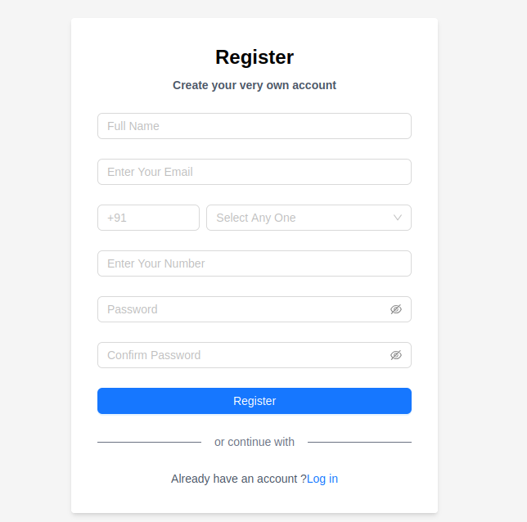

Login Pages
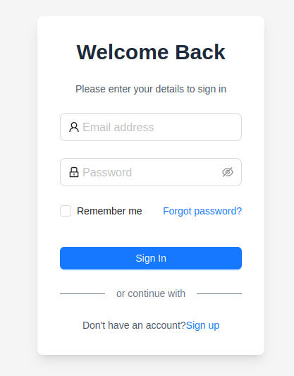

Home Pages
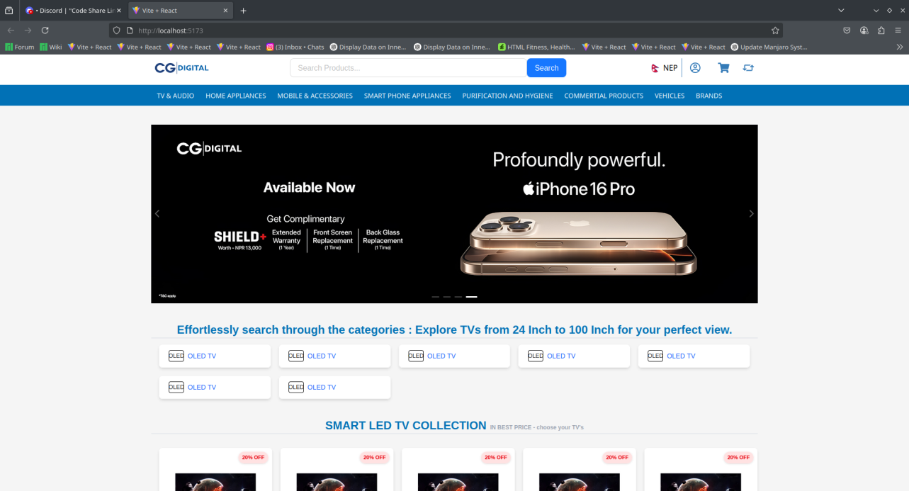

Admin Pannel

