

Tribhuvan University
Faculty of Humanities and Social Sciences

A PROJECT PROPOSAL ON
Online Plant Store
Submitted To:
Department of Computer Application
Nist College
In Partial Fulfilment of the Requirements for the degree of
Bachelor in Computer Application
Submitted By:
Pawan Kumar Banjara

ABSTRACT
In today’s fast changing business environment, it’s extremely important to able to respond to client needs in the most effective and timely manner. If your customers wish to see your business online and have instant access to your product or services. Online shopping is a lifestyle e-commerce web application, which retails various fashion and lifestyle products. This project allows viewing various products available enables registered user to purchase desired instantly using khalti and also can place order by using cash on delivery option. In order to develop an e-commerce website, a number of technologies must be studies and understood. These include multi-tiered architecture, server-side scripting and client techniques, implementation techniques such as HTML, CSS, Ajax, programming language such as PHP and relational database. This is a project with the objective to develop a basic website where a consumer is provided with a shopping cart application and also to know about the technologies used to develop such an application. This document will discuss each of the underlying technologies to create an e-commerce website.
Keywords:HTML,CSS,BOOTSTRAP,PHP,MYSQL
Table of Contents
ABSTRACT ii
1. Introduction 1
2. Problem Statement 1
3. Objectives 1
4. Methodology 2
a) Requirement Identification 2
i. Existing System Study 2
ii. Literature Review 3
iii. Requirement Analysis 4
b) Feasibility Analysis 6
i. Technical feasibility 6
ii. Operational feasibility 6
iii. Economic feasibility 6
c) High-Level Design of System 7
i. Working Mechanism of Proposed System 7
ii. Algorithms Description 7
Expected Outcome 12
REFERENCES 13

1. Introduction
Online plant store is the buying and selling of plants, or the transmitting of funds or data, over an electronic network, primarily the internet. These business transactions occur either as business-to-business, business-to-consumer, consumer-to-consumer or consumer-to business.
Online Shopping shops have become the part of our daily lives. Technological advancement has made it possible for people to sit in the convenience of their homes and still shop online without going to a physical shop. Nepal have also joined the trend of Online Shopping business, so this project is meant to design an e-commerce online shop so that the people in Nepal will be able to purchase their goods and services online. The customers can search for the products selection, update the card, remove products from the cart and out from the shop. The users are only able to browse the online shop and add a product to the cart. The user is limited to the use of the shop.
The project is mainly divided into two main categories. The administrators and the customers/users.
The store manager and the staff members operate as the administrators. They can add, edit, update products or delete products thus they able to change the name of products, change price and add or remove products.

2. Problem Statement
Customers and plant sellers face challenges in finding and offering the right plants efficiently. Current platforms are:
- Time-Consuming is use searching for plants or resources is slow.
- Not User-Friendly with Websites/apps lack intuitive design and features.
- Inefficient Resource Use in Poor inventory and decision-making tools.
- Poor Data Management is Limited personalization and care guidance.

3. Objectives
- To develop the online shopping platform for the plants which would be simple to use.
- To make buying and selling products which is make simpler.
- To develop the website so that users would not have to spend a lot time choosing what is right for them.

4. Methodology
I am going to use iterative methodology while building the website. It produces a working prototype early on in the project. As it is being reviewed and discussed, it's possible to isolate flaws in functions or design. Finding these issues at an early stage may help to address them quickly within a tight budget.
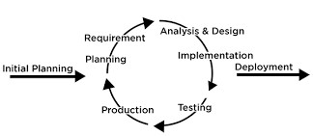
Figure : Iterative Model of Online Plant Store

a) Requirement Identification

i. Existing System Study
There are many more e-commerce websites that are available in the market such as daraz.com, allibaba.com, flipcart.com, etc. they are usually made up of HTML, CSS, JS, PHP and some other frameworks. They had the online payment systems as well as cash on delivery systems as per the wishes of the user. The graphics are much more attractive and customers enjoy being involved in their sites. Other websites are not functional in our country but “daraz.com” is functional and it is successful inn drawing customers attention but it has a lot of generalize content of almost everything from machinery items to goods items so customers find many items at a single place but the variety of the items that they search of clothing is not available there.
We researched on the applicability of e-commerce systems and found out that the system is highly successful in the most of the countries.

ii. Literature Review
The online consumer market is growing at an exponential rate. At the same time, technology has enhanced the capacity of online companies to collect, store, maintains, transfer and analyze vast amount of data from and about the consumer who visit their websites. This increase in the collection and use of data has raised public awareness and consumer concern about online privacy. Number of studies has been done in this field some of which are discussed below.
Subbu Rao, Truong, Seneca and Le, (2007) conducted the study on – How buyers expected benefits, perceived risks and e-business readiness moderated the relationship between expected benefits and usages of electronic market places. [1]
Prasad and Aryasri (2009) have explored the determinants of shopping behavior such as convenience, customers service, trust, web store environment and shopping enjoyment and examine the effect of these factors towards online buying behavior.
Dahiya Richa (2012) in the entitled – Impact of demographic factors on consumers on online shopping behavior. A study of consumers in India and the study found that online shopping is a recent phenomenon in the field of e-commerce and is definitely going to be the future if shopping in the world. Most of the companies are running their online portals to sell their products or service online.
Gupta (2014) in her paper “Ecommerce: Role of e-commerce in today’s business”, presents a comprehensive definition of e-commerce while isolating it from e-business. The paper enlists the different ecommerce models i.e. B2B, B2C, B2G and C2C, narrative analyzing the nit gritty of each. Rina(2016) also elaborates the different applications of e-commerce in “Challenges and Future Scope of Ecommerce in India”, at the same time, defining the degree to which they are operational in the country. Gunasekaran, Marri, Mc Gauchely, & Neshanic (2002) give a broad outlook of electronic commerce within organizational systems in “E-commerce and its impact on operations management”, defining it with reference to e-trading and elaborating- how it has permeated every field of business. The paper identifies the revolutionary role played by earlier internet applications like e-mail and electronic data interchange and details the revolutionary changes brought by the internet technologies in manufacturing, marketing, purchasing, design, production, selling and distribution, warehousing and human resource management. Internet based technologies have enabled business to shorten development, purchase and procurement cycles, maintain up to date product and market information, significantly increase the speed of communication and increase the quality of customer relationships by facilitating close contact and constant communication. The paper studies in depth, the significance of webbased technologies in different business operations, thus improving their efficiency through effective B2B e-commerce.
Mishra & Kotkar (2015) trace the timeline and development of B2C e-commerce in “A Study on Current Status of E-Commerce in India: A Comparative Analysis of Flipchart and
Amazon” with its inception in the mid-1990s through the advent of matrimonial and job portals. However, due to limited internet accessibility, weak online payment systems and lack of awareness, the progress was very slow. The Indian B2C e-commerce industry got a major boost in mid 2000s with the expansion of online services to travel and hotel booking which continue to be a major contribution even today.

iii. Requirement Analysis
1) Functional Requirements
Functional requirements are the what of your website. It is all about the functions and core operations of your e-store that enables a user to take action on the website. They can be implemented as a single website feature and form the basis of the whole software development process. Some of the functional requirements of the system are listed below.
i. Third party integration
Indicate which third-party software you want to add to your new website. Or maybe you’re replant forming and wish to preserve the systems you’re using now. These requirements concern both systems streamlining business operations and flexible payment gateways for your customers.
ii. Products attributes
Indicates various product characteristics, and the development agency should know about them to implement the corresponding features.
iii. Order and checkout flow
Your functional requirements for an online shopping system should specify how the orders are processed in your store and whether this functionality should be optimized.
- User will be able to register, login and order the items
- Administrator will be able to update, edit,delete the products.
2) Non-functional Requirements
Non-functional requirements articulate the quality attributes of the websites that build positive user experience ad optimal website performance. The non-functional requirements of the purposed system are listed below:
i. Usability
No matter the size of your business, you want your website to be intuitive and easy to use.
It takes about 0.05 seconds for figure out if your website is worth their time and attention. Website usability is also defined by
- How easily a user can achieve their goal in a single page visit
- How quickly they perform the task in the store
- How memorable and intuitive the design is
- Number and time of errors users make
ii. Security
Security is paramount while dealing with monetary transactions and sensitive data. A simple SSL certification and data privacy policy will instill trust into your website and convert the customers into your brand advocates.
iii. Performance
If your goal is increasing your website traffic, performance should be the priority NFR in your specification document. This NFR is often found I briefs from large enterprises or websites with legacy architecture.
iv. Maintainability
It’s widely known that the tricky part of planning a business budget is accounting for the operational costs of business maintenance. Striving to make the website maintainable from the initial development phase means cutting the time and cost to identify and resolve the system faults in the future.
v. Scalability
If you are looking into a future-proof solution, scalability should be your take. This requirement defines how the website can grow and expand its functionality without affecting its performance.

b) Feasibility Analysis
A feasibility study is an evaluation and analysis of a project or system that somebody has proposed.
Following feasibilities were studies before building the system to see if the system could be built with exact requirements in the required time.

i. Technical feasibility
In order to design this system, it uses off-self and existing technologies, software and hardware so there is no technological hurdle to build this system. During technical analysis, the technical merits of the system are studied and at the same time collecting additional information about performance, reliability, maintainability and predictability.
As the software is very much economically feasible, then it really important for it to be technically sound the software will be built among SQL Server as backend.

ii. Operational feasibility
This system uses simple technologies to design. So, it user friendly. This project is being made for the convenience of the users who are very busy and unable to visit near shops to buy things.

iii. Economic feasibility
Among the most important information contained in a feasibility study is cost benefit analysis and assessment of the economic justification for a computer-based system project. Cost benefit analysis delineates cost for the project development and weighs them against tangible and intangible benefits of a system. Cost benefits analysis is complicated by the criteria that vary with the characteristics of the system to be developed, the relative size of the project and the expected return o investment desired as the part of company’s strategic plan. I addition, many benefits derived from a computer-based system are intangible (e.g. better design quality through iterative optimization, increased customer satisfaction through programmable control etc.)

c) High-Level Design of System

i. Working Mechanism of Proposed System

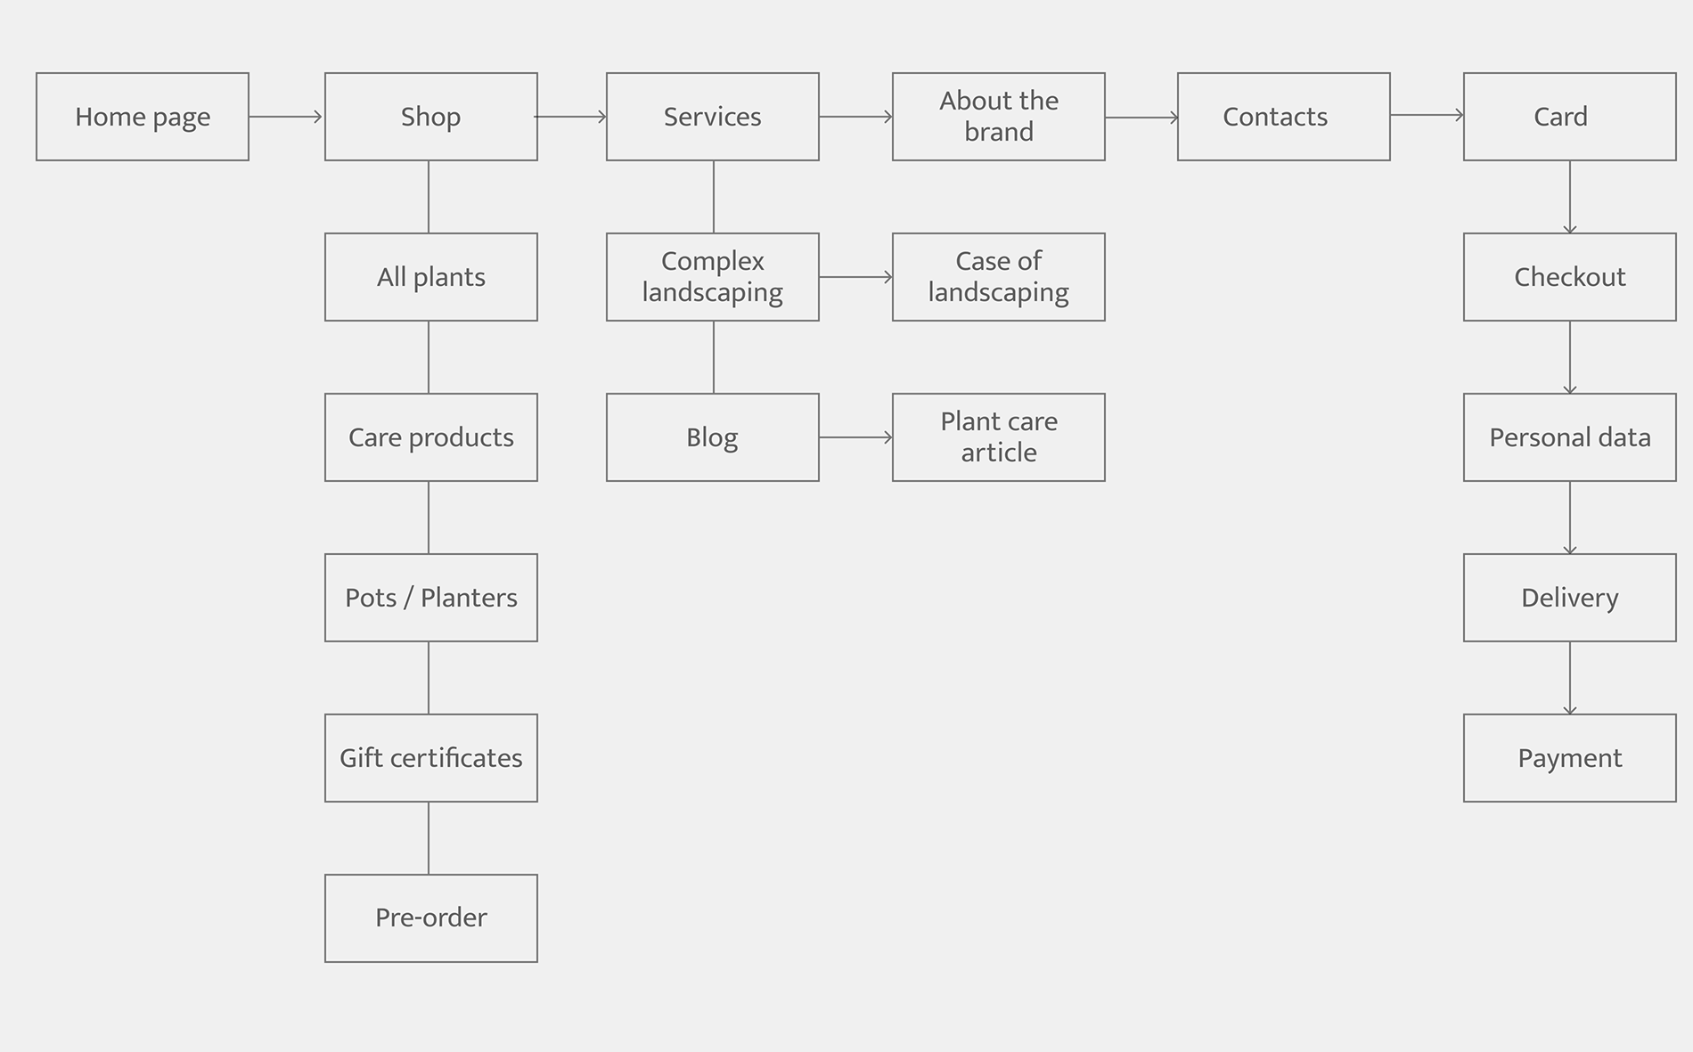
figure: flow chart of online plant store

ii. Algorithms Description

Popularity-Based Recommendations Algorithm Introduction
A popularity-based recommendation algorithm is one of the simplest and most straightforward methods for making recommendations. It doesn't personalize recommendations based on a user's specific preferences but instead recommends items based on their overall popularity or general appeal. This can be useful in cases where you have limited user data or when you want to highlight popular items.
- Recommendation System
  - Collaborative Filtering: Suggest plants or products based on user behavior and preferences of similar users.
  - Content-Based Filtering: Recommend plants by matching user preferences (e.g., plant type, size, light requirements) with product attributes.
  - Hybrid Recommendation System: Combine collaborative and content-based methods for better accuracy.
- Search and Ranking
  - TF-IDF (Term Frequency-Inverse Document Frequency): Rank plants or accessories in search results based on relevance to user queries.
  - Elasticsearch: Enable fast and efficient search with autocomplete and typo tolerance.
- Classification and Categorization
  - Decision Trees or Random Forests: Categorize plants based on attributes like indoor/outdoor, care level, or climate suitability.
  - Naïve Bayes: Classify user queries for accurate search results.
- Inventory Management
  - Dynamic Programming: Optimize inventory by predicting demand and managing stock efficiently.
  - ARIMA (Auto-Regressive Integrated Moving Average): Forecast sales trends to ensure adequate supply.
- Personalization
  - K-Means Clustering: Group users based on preferences and buying patterns for targeted recommendations.
  - Neural Networks: Provide personalized plant care tips and product suggestions.
- Image Recognition (Optional)
  - Convolutional Neural Networks (CNNs): Identify plants from uploaded images to provide care guides or find similar products.
3..The recommended algorithms with corresponding mathematical formulations:

Collaborative Filtering
Collaborative filtering predicts a user's interest in an item based on the preferences of similar users.
Equation:
r^ui=μ+bu+bi+∑f=1Fqfpf\hat{r}_{ui} = \mu + b_u + b_i + \sum_{f=1}^F q_f p_fr^ui​=μ+bu​+bi​+f=1∑F​qf​pf​
Where:
- r^ui\hat{r}_{ui}r^ui​: Predicted rating of user uuu for item iii.
- μ\muμ: Overall average rating.
- bub_ubu​: User bias.
- bib_ibi​: Item bias.
- qfq_fqf​: Latent features of the item.
- pfp_fpf​: Latent features of the user.

TF-IDF for Search and Ranking
TF-IDF evaluates how important a term is to a document in a collection.
Equation:
TF-IDF(t,d)=TF(t,d)×IDF(t)\text{TF-IDF}(t, d) = \text{TF}(t, d) \times \text{IDF}(t)TF-IDF(t,d)=TF(t,d)×IDF(t)
Where:
- TF(t,d)=Frequency of term t in document dTotal terms in d\text{TF}(t, d) = \frac{\text{Frequency of term } t \text{ in document } d}{\text{Total terms in } d}TF(t,d)=Total terms in dFrequency of term t in document d​.
- IDF(t)=log⁡(N1+nt)\text{IDF}(t) = \log\left(\frac{N}{1 + n_t}\right)IDF(t)=log(1+nt​N​):
NNN: Total number of documents.
ntn_tnt​: Number of documents containing term ttt.

K-Means Clustering
Groups users or items into kkk clusters based on feature similarity.
Equation:
J=∑i=1k∑x∈Ci∥x−μi∥2J = \sum_{i=1}^k \sum_{x \in C_i} \| x - \mu_i \|^2J=i=1∑k​x∈Ci​∑​∥x−μi​∥2
Where:
- JJJ: Sum of squared distances within clusters.
- CiC_iCi​: Cluster iii.
- μi\mu_iμi​: Centroid of cluster iii.
- xxx: Data point.

ARIMA for Sales Forecasting
ARIMA predicts future values in a time series using past data.
Equation:
+ \dots + \phi_p y_{t-p} + \theta_1 \epsilon_{t-1} + \dots + \theta_q \epsilon_{t-q} + \epsilon_tyt​=c+ϕ1​yt−1​+ϕ2​yt−2​+⋯+ϕp​yt−p​+θ1​ϵt−1​+⋯+θq​ϵt−q​+ϵt​
Where:
- yty_tyt​: Predicted value at time ttt.
- ϕp\phi_pϕp​: Autoregressive coefficients.
- θq\theta_qθq​: Moving average coefficients.
- ϵt\epsilon_tϵt​: Error term.
- p,qp, qp,q: AR and MA orders.

Convolutional Neural Networks (CNNs) for Image Recognition
Detect plant species or health status from an image.
Equation (Convolution Operation):
S(i,j)=∑m∑nI(i+m,j+n)⋅K(m,n)S(i, j) = \sum_m \sum_n I(i+m, j+n) \cdot K(m, n)S(i,j)=m∑​n∑​I(i+m,j+n)⋅K(m,n)
Where:
- S(i,j)S(i, j)S(i,j): Output feature map.
- I(i,j)I(i, j)I(i,j): Input image pixel.
- K(m,n)K(m, n)K(m,n): Convolution kernel (filter).
- m,nm, nm,n: Kernel dimensions.
How It Works
- Data Collection: Gather data on user interactions with items. This data can include views, clicks, purchases, ratings, or any other form of user engagement with items.
- Item Popularity: Calculate a popularity score for each item in your dataset. Common metrics include the number of views, clicks, or purchases, the average rating, or any other engagement metric. You can also consider time-based popularity, where you give more weight to recent interactions.
- Recommendation Generation: When a user requests recommendations, the system will recommend items with the highest popularity scores. This can be done by recommending the top N most popular items overall or within a specific category or time frame.
- Filtering: You can apply additional filtering based on user demographics, such as age, location, or other relevant attributes, to provide more relevant recommendations for a specific group of users.

Advantages
- Simplicity: Popularity-based recommendations are easy to implement and require minimal computational resources.
- No Cold Start Problem: Since recommendations are not based on individual user profiles, these systems don't face the "cold start" problem, where new users with no historical data can still receive recommendations.
- Helpful for New Items: Popularity-based algorithms are useful for promoting new items that may not have gathered enough data to generate personalized recommendations.

Limitations
- Lack of Personalization: They do not consider individual user preferences, so recommendations may not be tailored to the specific interests of users.
- Limited Diversity: They tend to recommend the most popular items, which can lead to a lack of diversity in recommendations.
- Not Suitable for Niche Markets: In niche markets or for users with unique tastes, popularity-based recommendations may not be very effective.
- Trends Change: Popularity can change rapidly, so recommendations may not reflect longterm user preferences.

Conclusion
Incorporating the Collaborative Filtering Recommendations Algorithm into our job recruiter app enhances the user experience by providing tailored job recommendations. By analyzing user interactions and identifying patterns, the algorithm contributes to connecting job seekers with relevant and engaging employment opportunities.

Expected Outcome
While doing the overall project I have learnt so many useful things such as basic PHP, Bootstrap, CSS etc. When the project is completed the user will able to add the items in cart and able to pay payment through khalti.

REFERENCES
- K.S. Talwar, A. Oraganti and et, “Recommendation System using Apriori Algorithm,” IJSRD – International Journal for Scientific Research & Development, pp. Vol. 3, Issue 01, 2015.
- Broekhuizen, “Online Shopping,” no. Time Saving, 2009.
- “What is feasibility study?” https://www.investopedia.com/terms/f/feasibilityhttps://www.investopedia.com/terms/f/feasibility-study.aspstudy.asp
- “National Population and Housing Census 2011 (National report)”¹³ (PDF). Central
Bureau of Statistics (Nepal). Archived from the original (PDF) on 18 April 2013. Retrieved
- https://www.thesill.com/
- https://www.youtube.com/watch?v=1SnPKhCdlsU
- https://www.tutorialspoint.com/php/index.htm

