

Tribhuvan University
Faculty of Humanities and Social Sciences

CLEANING SERVICE BOOKING SYSTEM

A PROJECT REPORT
Submitted to
Department of Computer Application
Nepal Mega College

In partial fulfillment of the requirements for the bachelor’s in computer application
Submitted by
Isan Adhikari (26602020)
November 2024
Under the Supervision of
Niraj Pokharel

Tribhuvan University
Faculty of Humanities and Social Science
Nepal Mega College
Department of Bachelor’s in Computer Application
Babar mahal, Kathmandu, Nepal

SUPERVISOR’S RECOMMEDATION

I hereby recommend that this project prepared under my supervision by Isan Adhikari entitled “Cleaning Service Booking System” in partial fulfillment of the requirements for the degree of Bachelor of Computer Application is recommended for the final evaluation.

…………………………
SIGNATURE
Niraj Pokharel
SUPERVISOR
Senior Lecturer of BCA
Nepal Mega College
Babar mahal, Kathmandu, Nepal



Tribhuvan University
Faculty of Humanities and Social Science
Nepal Mega College

LETTER OF APPROVAL

This is to certify that this project prepared by ISAN ADHIKARI entitled “CLEANING SERVICE BOOKING SYSTEM” in partial fulfillment of the requirements for the degree of Bachelor’s in Computer Application has been evaluated. In our opinion it is satisfactory in scope and quality as a project for the required degree.
……………………  Niraj Pokharel  Senior Lecturer of BCA  Nepal Mega College, Kathmandu | ……………………..  Dharma Raj Poudel  Program Coordinator of BCA  Nepal Mega College, Kathmandu
……………………..  Internal Examiner | ……………………..  External Examiner

TABLE OF CONTENTS
SUPERVISOR’S RECOMMEDATION i
LETTER OF APPROVAL ii
TABLE OF CONTENTS iii
ABSTRACT v
ACKNOWLEDGEMENT vi
LIST OF ABBREVIATIONS vii
LIST OF FIGURES viii
CHAPTER 1: INTRODUCTION 1
1.1. Introduction 1
1.2. Problem Statement 1
1.3. Objectives 1
1.4. Scope and Limitation 1
1.5. Deployment Methodology 2
1.6. Report Organization ………………………………………………3
CHAPTER 2: BACKGROUND STUDY AND LITERATURE REVIEW 5
2.1 Background Study 5
2.2 Literature Review 6
CHAPTER 3: SYSTEM ANALYSIS AND DESIGN 8
3.1 System Analysis 8
3.1.1 Requirement Analysis 9
3.1.2 Feasibility Analysis 10
3.1.3 Data Modeling (ER Diagram) 14
3.1.4 Process Modeling (DFD): 15
3.2 System Design 17
3.2.1 Architectural Design 17
3.2.2 Database Schema Design 19
3.2.3 Interface Design (UI Interface) 20
3.2.4 Algorithm 22
CHAPTER 4: IMPLEMENTATION AND TESTING 24
4.1 Implementation 24
4.1.1 Tools Used 24
4.1.2 Implementation of Modules 25
4.2 Testing 26
4.2.1 Test Cases for Unit Testing 26
4.2.2 Test Case for System Testing 28
CHAPTER 5: 30
CONCLUSION AND FUTURE RECOMMENDATIONS 30
5.1 Lesson Learnt/Outcome 30
5.2 Conclusion 30
5.3 Future Recommendations 30
REFERENCES 31
APPENDICES

ABSTRACT
The Cleaning Service Booking System is a web-based platform designed to streamline the process of booking cleaning services by incorporating an intelligent recommendation feature powered by the K-Nearest Neighbors (KNN) algorithm. This system addresses the challenge of matching users with suitable cleaning solutions by analyzing inputs such as property size and cleaning frequency. Using the KNN algorithm, the system calculates the similarity between user preferences and available services based on the Euclidean distance metric, providing personalized recommendations ranked by relevance. Users can select a recommended service, ensuring a tailored and efficient booking experience. The platform also includes robust validation mechanisms to ensure data accuracy, such as verifying contact formats and input constraints. By integrating machine learning with a user-friendly interface, this system improves decision-making, enhances user satisfaction, and demonstrates the potential of intelligent algorithms in service-based applications.
Keywords: cleaning services, recommendations system, K-Nearest Neighbors (KNN), personalization, digital platform.

ACKNOWLEDGEMENT
Apart from the efforts of ourselves, we would like to show my greatest appreciation to our project supervisor, “Niraj Pokharel” for guiding us through all the project and providing valuable insights leading to the successful completion of this project. I feel motivated and encouraged every time we attend a meeting with him for the evaluation of the project work. Without his encouragement and guidance this project would not have materialized. I would like to express my sincere thanks to our program coordinator, “Dharma Raj Poudel” for daily feedback and regular guidance for every unit of this project. I would also like to express our sincere thanks to all my friends who have directly or indirectly helped me in this project. I am grateful for all your constant support and help.

Isan Adhikari (26602020)

LIST OF ABBREVIATIONS
CSBS: Cleaning Service Booking System
CSS: Cascading Style Sheet
DB: Database
DFD: Data Flow Diagram
ER: Entity Relationship
HTML: Hypertext Markup Language
PHP: Hypertext Preprocessor
ROI: Return on Investment
SQL: Structured Query Language
TC: Test Case
UC: Use Case
UI: User Interface

LIST OF FIGURES
Figure 1.1 Waterfall Model 3
Figure 3.1 Use Case Diagram of Cleaning Service Booking System 9
Figure 3.2 Gantt chart of Cleaning Service Booking System 13
Figure 3.3 ER Diagram of Cleaning Service Booking System 14
Figure 3.4 Context Diagram of Cleaning Service Booking System 15
Figure 3.5 Level 1 DFD of Cleaning Service Booking System 16
Figure 3.6 Three tier architecture of Cleaning Service Booking System 17
Figure 3.7 Relational Table of Cleaning Service Booking System 19
Figure 3.8 UI Design of Home Page 20
Figure 3.9 UI Design of Create Account 21
Figure 3.10 UI Design of Login Page 21
Figure 3.11 UI Design of Profile Page 22

LIST OF TABLES
Table 4.1 Test Cases for Login 26
Table 4.2 Test Cases for Sign Up. 27
Table 4.3 Test Case for Admin 27
Table 4.4 Testing entire system. 28

CHAPTER 1: INTRODUCTION

Introduction
The Cleaning Service Booking System is a web-based platform developed by me to efficiently connect customers with our cleaning professionals. With the increasing demand for cleaning services and the growing trend of online service bookings, we recognized the need for a streamlined and user-friendly system to manage cleaning services and allocate resources effectively.

Problem Statement
The traditional process of finding and hiring a cleaning service is often time-consuming, unreliable, and lacks transparency. Customers often must rely on word-of-mouth recommendations or search through classified ads to find cleaning service, which can be a daunting task. On the other hand, cleaning services struggle to find new customers and expand their business due to limited visibility and reach. To address these challenges, we embarked on developing the Cleaning Service Booking System.

Objectives
The primary objectives of the Cleaning Service Booking System are:
- To streamline booking and managing cleaning services
- To provide cleaning service recommendations using K-Nearest Neighbors (KNN)

Scope and Limitation
1.4.1. Scope
The scope of the Cleaning Service Booking System project includes the development of a web-based platform accessible to both customers and our company administrators. The system will allow customers to create accounts, browse available cleaning services, and place order. Additionally, administrators will have access to a centralized dashboard for managing bookings and services.

1.4.2. Limitations
- The system will not support on-demand or instant booking services, as it focuses on first come first serve method.
- The system will not provide a platform for service providers or cleaning professionals.
- Payment integration will be limited to payment on delivery options, online payment on system will not be available.

Development Methodology
The deployment of the Cleaning Service Booking System follows the Waterfall methodology, ensuring a structured and sequential approach. The process begins with the Requirement Analysis phase, where user needs and system specifications are thoroughly documented, including features like booking forms, validation mechanisms, and the recommendation algorithm. In the Design Phase, system architecture is defined, covering the integration of user interface components and backend services with the KNN-based recommendation engine. During the Implementation Phase, coding and module development are completed, incorporating key functionalities such as user input handling, service recommendations, and database integration. This is followed by Testing, where unit tests, system tests, and validation checks ensure the system is functional, accurate, and user-friendly. Once validated, the Deployment Phase involves hosting the system on a suitable web server and configuring it for public access. Finally, in the Maintenance Phase, regular updates, bug fixes, and feature enhancements are implemented to address user feedback and ensure long-term performance.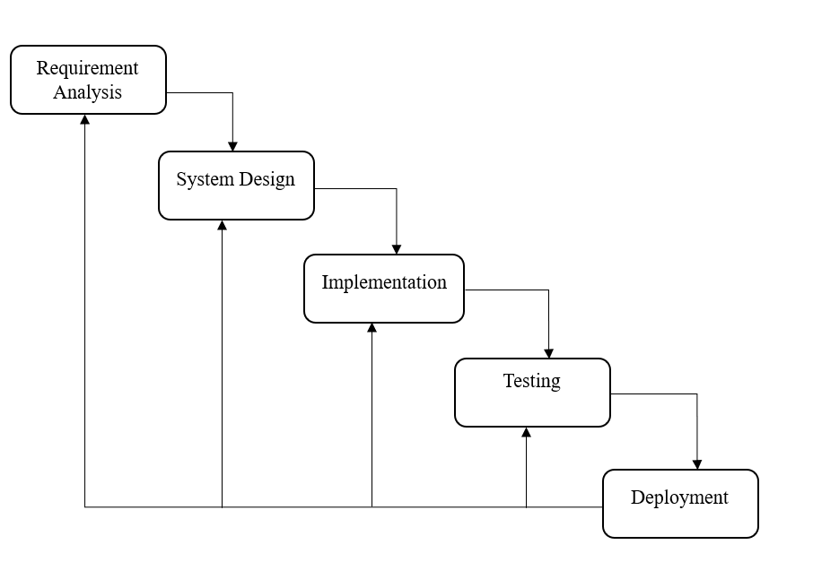 Figure 1.1: Waterfall Model
  - Report Organization
This is the report organization for the Cleaning Service Booking System which also includes charts/diagrams to illustrate the system architecture and design. Furthermore, it contains information regarding the tools and technologies used to build the system. Generally, it consists of five chapter’s altogether. The report has been organized in the order given as below:
First Chapter is about Introduction of Cleaning Service Booking System. It describes the project in detail with its scope, limitations, objectives, and problem statement.
Second Chapter is about Literature Review and Background Study of Cleaning Service Booking System.
Third Chapter includes the methodology which consists of Requirement Analysis, Feasibility Analysis and System Design of the system.
Fourth Chapter of the report includes the implementation and testing of the Cleaning Service Booking System
Fifth Chapter of the report organization includes deployment and methodology of Cleaning Service Booking System
Final Chapter of the report is Conclusion and Learning Outcomes, and it talks about the things that is learnt in the process of developing the project.

CHAPTER 2: BACKGROUND STUDY AND LITERATURE REVIEW

Background Study
The project on the cleaning service booking system aims to address the increasing demand for streamlined and convenient access to professional cleaning services. In today's fast-paced world, urbanization and busy lifestyles have led individuals and businesses to seek efficient and reliable cleaning solutions. However, the lack of an organized and user-friendly booking system poses significant challenges for both customers and service providers. Manual booking methods, such as phone calls or in-person inquiries, result in time-consuming processes and potential miscommunication, leading to frustration at both ends. Additionally, the absence of transparent information about service offerings, pricing, and the qualifications of cleaning professionals further complicates the decision-making process for customers, making it challenging to find reputable and trustworthy cleaning service providers.
To overcome these challenges, the platform aims to develop a comprehensive online platform that revolutionizes the cleaning service industry. By creating an easy-to-navigate booking system, customers will be able to browse through a range of services, view transparent pricing, and book appointments at their preferred times, providing a hassle-free experience. The platform will also incorporate a review and rating system, empowering customers to make informed decisions and promoting service providers to maintain high-quality standards. Moreover, the automated scheduling feature will minimize conflicts and delays, optimizing the overall service experience for both customers and service providers. By addressing the existing inefficiencies and lack of transparency in the traditional cleaning service booking process, this project aspires to transform the industry and meet the needs of modern consumers seeking reliable and convenient cleaning solutions.

Literature Review
For this project, we researched and reviewed some of the related websites and applications. Throughout the research, we find out that there are very few websites or applications related to Cleaning Service Booking System. The review highlights strengths, weaknesses, and innovations found in existing systems.
The focus lies on the development and deployment of an online booking system tailored specifically for cleaning services. The study delves into the design aspects of the system, including user interface and functionality, to ensure seamless customer interaction and booking processes. By incorporating modern web technologies, the online booking platform aims to enhance the overall customer experience, convenience, and accessibility. The research highlights the significance of such systems in streamlining service delivery, minimizing manual interventions, and optimizing resource allocation. Furthermore, the article discusses the challenges encountered during the implementation phase and the strategies employed to address them. The findings underscore the potential benefits of adopting online booking systems in the cleaning service industry, improving operational efficiency and customer satisfaction [1].
The comprehensive analysis of the Cleaning Services Market highlights key strengths, weaknesses, and innovations within the industry. The research identifies a substantial growth in the market size during the study period, driven by increasing awareness of cleanliness and the rise of dual-income households. The sector offers a diverse array of services, catering to both commercial and residential clients, ranging from regular cleaning to specialized and eco-friendly options, allowing companies to cater to varied customer demands. However, a notable weakness is the heavy reliance on manual labor, which can lead to inefficiencies and inconsistent service quality across providers. To address these challenges, the report indicates promising innovations, including the integration of technology like IoT and machine learning. These advancements empower companies to optimize cleaning schedules, monitor supplies, and predict cleaning demands in real-time. Additionally, a noteworthy innovation in the industry is the adoption of green cleaning initiatives, where eco-friendly products and practices are utilized to meet the growing demand for sustainable and healthier cleaning solutions. By capitalizing on strengths and embracing innovations, cleaning service providers can better position themselves in the competitive market and deliver enhanced services that align with evolving customer preferences.[2]
The writer’s focus centers on the development and implementation of a Cleaning Service Management System. The study presents a comprehensive system that integrates various functionalities to optimize the management of cleaning services. The system incorporates features such as customer registration, service scheduling, staff management, and real-time tracking of cleaning activities. By leveraging advanced computer science techniques, the platform aims to enhance service efficiency, resource allocation, and customer satisfaction. The research highlights the importance of adopting such management systems in the cleaning service industry to automate processes, reduce manual errors, and improve overall service quality. Furthermore, the study discusses the outcomes of system implementation and the benefits it brings to both service providers and customers. The findings emphasize the potential of this Cleaning Service Management System to revolutionize the industry, offering an innovative and streamlined approach to managing cleaning operations.[3]

CHAPTER 3: SYSTEM ANALYSIS AND DESIGN

System Analysis
The Cleaning Service Booking System is a comprehensive platform designed to simplify the process of booking cleaning services while enhancing user experience through intelligent recommendations. This system leverages modern web technologies and machine learning to provide personalized service suggestions based on user inputs such as property size and cleaning frequency. By integrating structured processes or object-oriented principles, the system ensures modularity, scalability, and efficient data management. This document outlines the analysis and design of the system, focusing on breaking down its functionalities and interactions, ensuring that every component aligns with user needs and project objectives. The following sections detail the requirements, architecture, and logical flow of the system.

Requirement Analysis
This system fulfills both the functional and non-functional requirements.
- Functional Requirements (Illustrated using use case diagram)
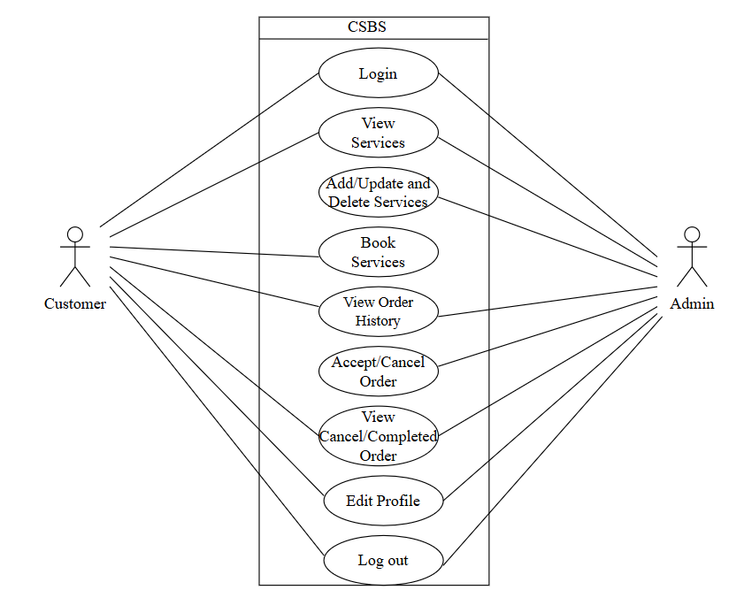
Figure 3.1 Use Case Diagram of Cleaning Service Booking System
This Use Case Diagram is a graphic depiction of the interactions among the elements of the Cleaning Service Booking System. The main actors of the Cleaning Service Booking System in this Use Case Diagram are Customer and Admin, who perform different type of use cases. Customers perform Management of account (such as Create Account, Login/Signup, and Edit Profile), Service Booking, View Schedule, and View History whereas Admin perform Management of Customer Account, Management of Booking and Scheduling, Management of History, Adding or Removing service option.
- Non-Functional Requirements
The non-functional requirements of Cleaning Service Booking System are as follows:
Availability
The system is available 100% for the user and is used 24hrs a day and 365 days a Year. The system shall be operational 24hrs a day and 7 days a week.
Security
This system is secure, and the user password shall be in encrypted format in the database. Every user shall have a unique Session while logging into the system.
Performance
This system is able to load pages faster and smoother. It shall have good optimization and good response. The customer will not have any issue with being able to book services.
Reliability
This system shall be dependable for customers to use.
Usability
The customer shall be able to use the system in an easy manner.
Compatibility
The system shall be compatible across all platforms under the required environment.

Feasibility Analysis
A feasibility study is an evaluation and analysis of a project that somebody has proposed. The following feasibility were studied before building the system to see if the system could be built with exact requirements in the required time.
- Technical
- The system have database dictionary, storage devices and network infrastructure as per the requirement.
- The software part of the proposed system will be developed by using programming languages (such as PHP, JavaScript, MySQL, HTML and CSS etc.) databases and web development frameworks as per the requirement.
- Operational
- The system’s user interface is easy to use and understand for customers with simple navigation, clear instructions, and minimal training required.
- The system can provide a clear value proposition to both groups, such as easy access to reliable cleaning services and the ability to expand the business.
- The system can handle or manage a large number of users and transactions as the user base grows.
- The system can provide adequate support and maintenance, with a resolute support team to address any user issues.
- Economic
- The cost of developing and operating the system has been evaluated against the expected benefits. The benefits will include revenue, reduced costs, improved customer satisfaction and increased market share.
- The availability of financial, human, and other resources required for developing and operating the system has also been evaluated.
- Following are the cost estimation on different fields:
- Documentation Costs- Rs.2000
- Development and Testing- Rs.25,000
- Collection of Requirement and Analysis Costs- Rs.15,000
- Extra Expenditure- Rs.5000

- Schedule
Here is the Gantt Chart showing the scheduled time limits from Requirement Identification to Documentation phases, by a planned due date.
- Requirement Identification: 7 days
- Feasibility Study: 21 days
- High-Level Design of System: 35 days
- Development and Testing: 63 days
- Deployment and User Testing: 28 days
- Documentation: 154 days

Figure 3.2 Gantt chart of Cleaning Service Booking System

Data Modeling (ER Diagram)
For data modeling, the ER diagram of Cleaning Service Booking System is shown below as:

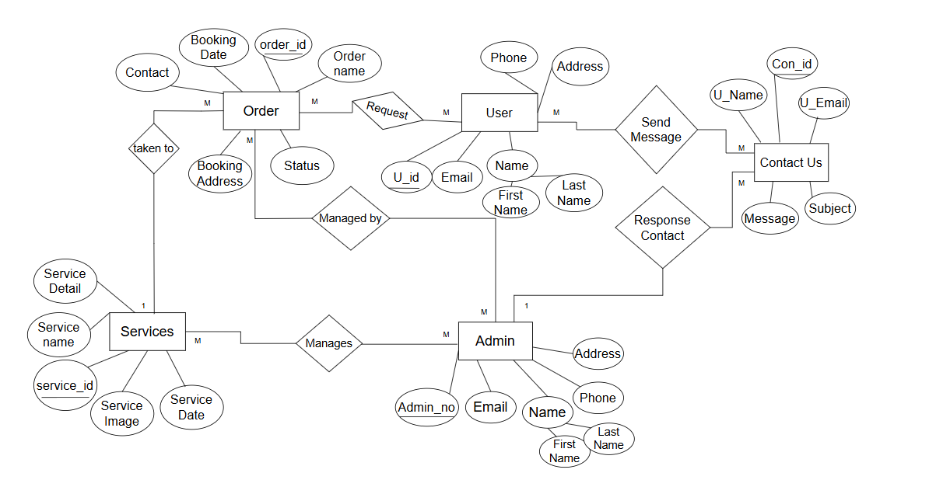
Fig: 3.3 ER Diagram of Cleaning Service Booking System
This ER Diagram represents the model of Cleaning Service Booking System Entity. The entity relationship diagram of Cleaning Service Booking System shows all the visual instruments of database table and the relations between Admin, Customer, Services, and Orders. It used structure data to define the relationship between structured data groups of Cleaning Service Booking System functionalities.

Process Modeling (DFD):
For process modeling of Cleaning Service Booking System, context diagram and level 1 DFD are as follows:
- Context Diagram
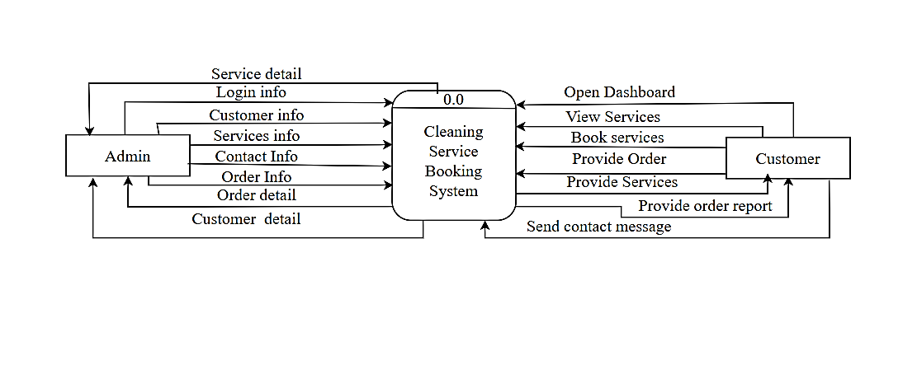
Figure 3.4 Context Diagram of Cleaning Service Booking System

This is the context diagram of Cleaning Service Booking System, where we have elaborated the high-level process of Cleaning Service Booking System or process being analyzed or modeled. It is designed to glance at the view of Admin and Customer showing the system as a single high process. Wide audience can easily understand it.

- Level 1 DFD:
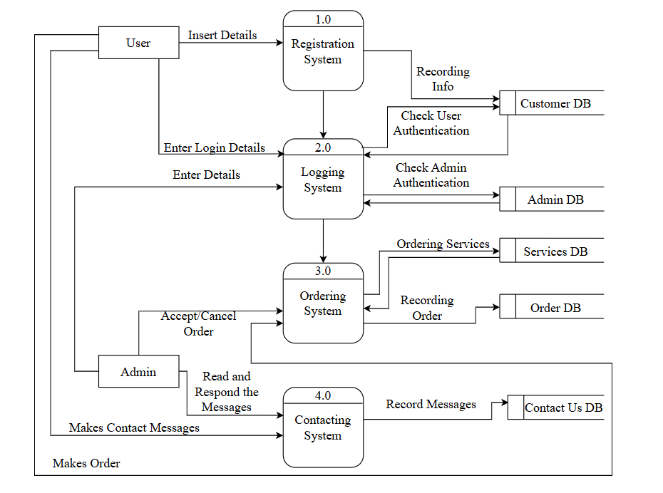
Figure 3.5 Level 1 DFD of Cleaning Service Booking System
First Level DFD (1st Level) of Cleaning Service Booking System show how the system is divided into sub-systems(processes), each of which deals with one or more of the data flows to or from an external agent, and which together provide all of the functionality of the Cleaning Service Booking System as a whole. It also identifies internal data stores of Customer and Admin must be presented for the Cleaning Service Booking System to do its job and show the flow of data between the various parts of the Cleaning Service Booking System.

System Design
The system design of Cleaning Service Booking System consists of architectural design, database schema design, user interface design and physical DFD are shown as follows:

Architectural Design
There are several types of architecture i.e., one tier architecture, two tier architecture and three tier architecture. The architectural design of the Cleaning Service Booking System is based on three tier architecture. There are three component which are as follows:
- Presentation Layer
- Logical Layer
- Database Layer
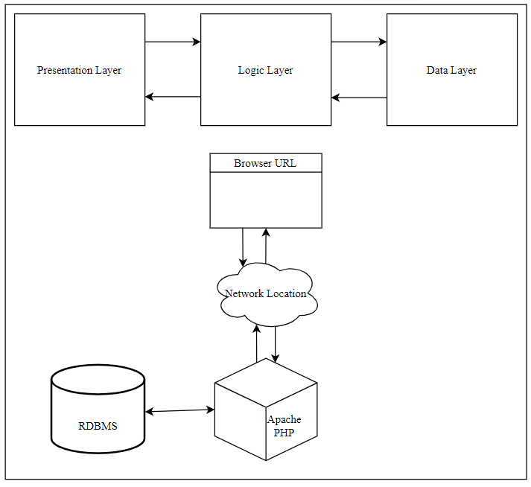
Figure 3.6 Three tier architecture of Cleaning Service Booking System
Client server is server to run our website on the webpage. A web server is the part where all coding practices occur like PHP. And as a database we have used MySQL to store all the information on the website. The Cleaning Service Booking System has three components, the client, server, and the network connection in between. Server-Client architecture defines a system network in which a centralized server is used to provide resources and services to many clients using remote devices. In this architecture the server is responsible for data storage, data access logic and application logic. The client computer also shares responsibility with the server for the application logic.

Database Schema Design
The database schema design for Cleaning Service Booking System showing all the relations along with their respective attributes and inter-relationship between the relations is shown below:
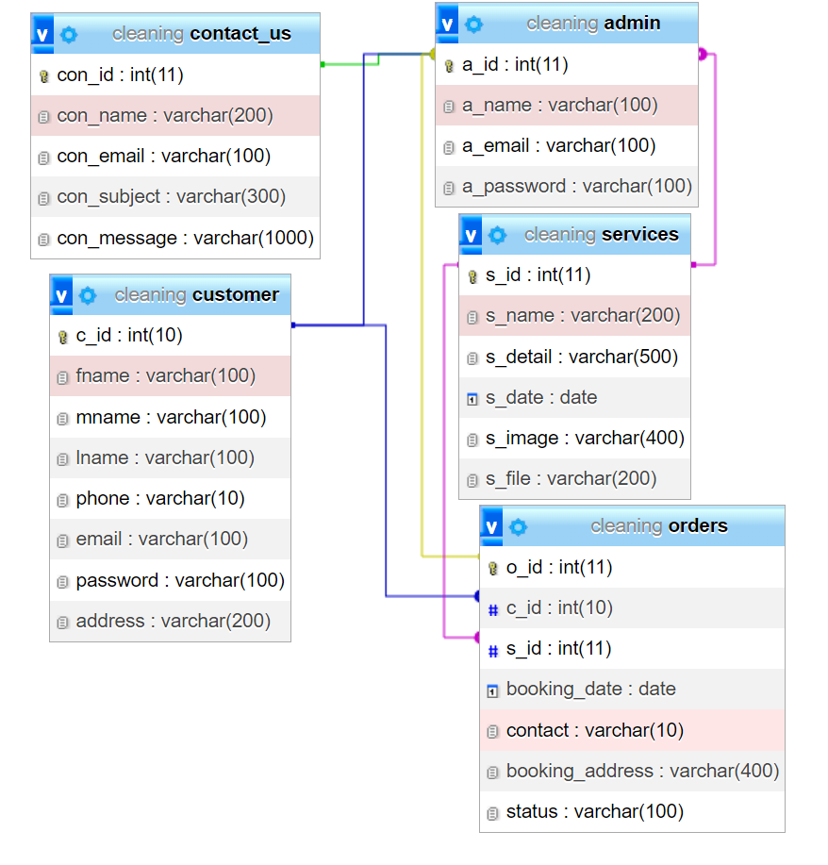
Figure 3.7 Relational Table of Cleaning Service Booking System

Interface Design (UI Interface)
The interface design for all major pages of Cleaning Service Booking System are shown as follows:
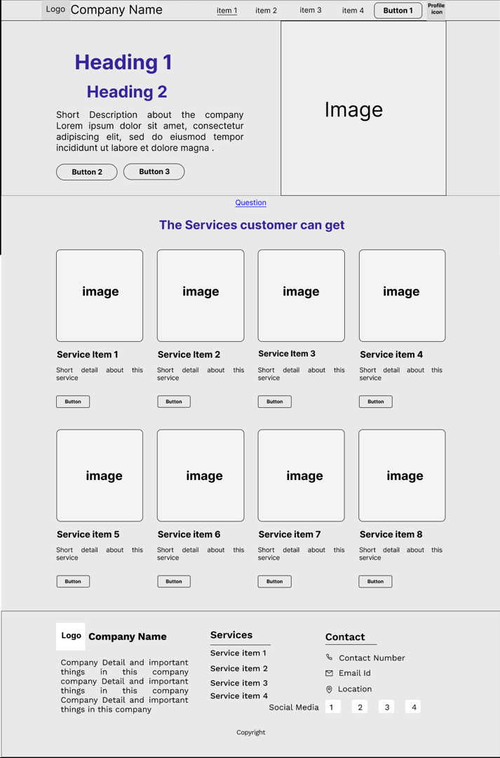
Figure 3.8 UI Design of Home Page
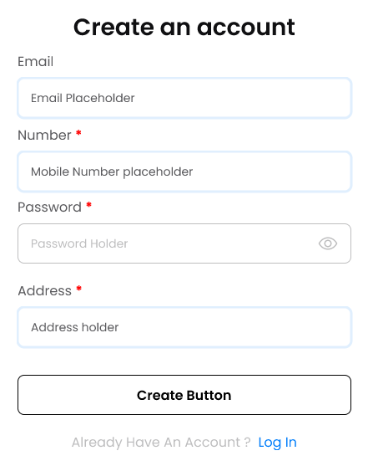
Figure 3.9 UI Design of Create Account
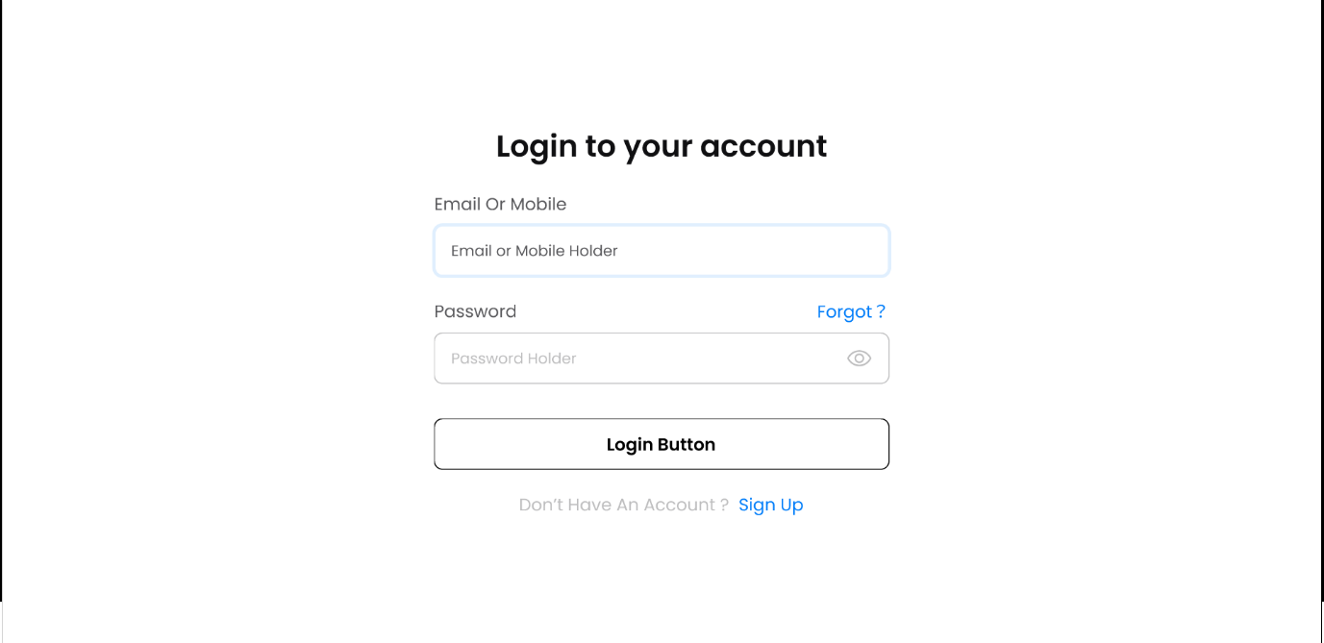
Figure 3.10 UI Design of Login Page
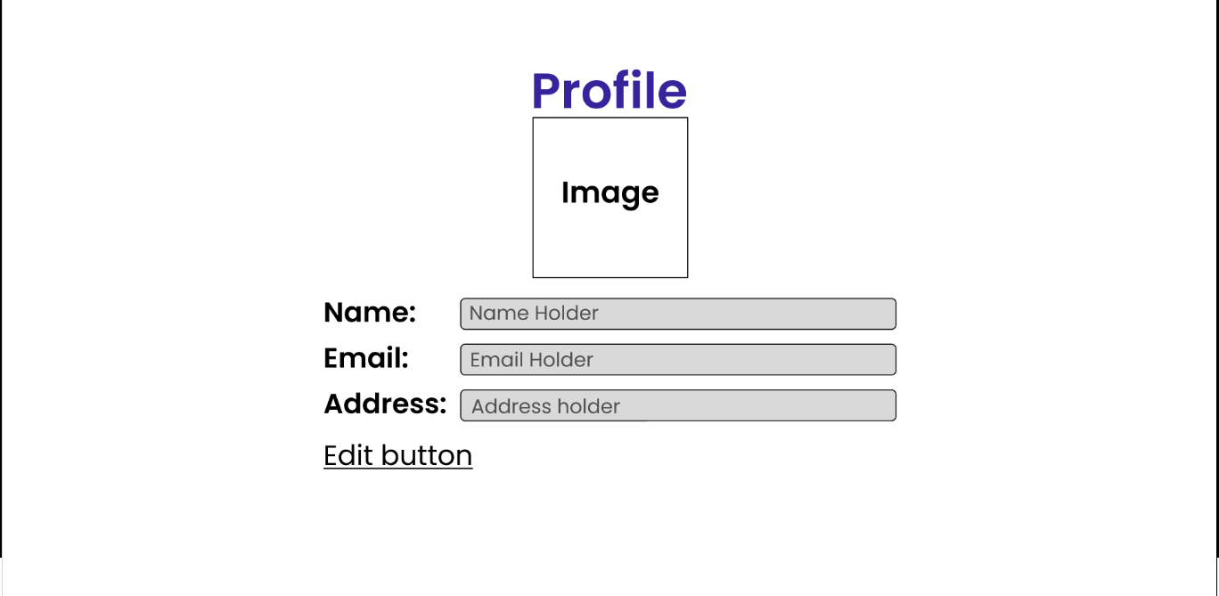
Figure 3.11 UI Design of Profile Page

Algorithm
- Overview
The K-Nearest Neighbors (KNN) algorithm is a simple and effective supervised learning technique used for classification and regression. In the cleaning service booking system, the KNN algorithm is used to recommend suitable cleaning services based on user input, such as property size and cleaning frequency. The value 𝑘 represents the number of closest neighbors to consider for generating the recommendation.
- Integration
In the cleaning service booking system, the KNN algorithm is used within the recommendation.js file and is integrated into the booking page (bookingpage.php) to suggest cleaning services to users. The following steps describe how and where the algorithm operates in the project
- Mathematical Representation
Input Variables
(𝑥1): Property size (in square feet)
(𝑥2): Cleaning frequency (1 = weekly, 2 = bi-weekly, 3 = monthly)
(𝑥3): User satisfaction score (default is 4)
Distance Formula
To calculate the similarity between the user's query and a service:
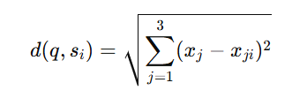
Where:
𝑞=[ 𝑥1,𝑥2, 𝑥3]: Query vector
𝑠𝑖 =[ 𝑥1i,𝑥2i, 𝑥3i]: Service feature vector
d(𝑞, 𝑠𝑖): Distance between query 𝑞 and service 𝑠𝑖

- Algorithm Step in Project
Step 1: User Input Collection
Inputs are collected via the "Service Recommendation" section in bookingpage.php:
Property size (𝑥1)
Cleaning frequency (𝑥2)

Step 2: KNN Implementation (recommendation.js)
Feature Extraction: The algorithm takes the user inputs 𝑞=[𝑥1,𝑥2] and compares them with the dataset of services.
Distance Calculation: Euclidean distance is calculated between the user query and each service in the dataset.
Service Ranking: Services are sorted based on their distance from the query vector.
Recommendation Selection: The top 𝑘-nearest services are displayed to the user.
Step 3: User Action
The user selects one of the recommended services from the dropdown menu added dynamically after recommendations are displayed.

CHAPTER 4: Implementation and Testing

Implementation
The tools and techniques used to the system and the implementation details of various modules of Cleaning Service Booking System are as follows:

Tools Used
The tools used for the implementation of Cleaning Service Booking System are listed below:
Draw.io
It is used for designing system designs such as flowchart, ER diagram, relational model, architectural design, Use case diagram etc.
HTML CSS JavaScript
HTML, CSS, and JavaScript are used for the front-end development. HTML is used for webpage elements. CSS is used for providing own styling to the components. JavaScript is used for client-side validations and adding dynamic components to the website.
BOOTSTRAP
Bootstrap is used for adding responsive components in our system as well as other bootstrap components are used such as buttons, cards, navbar etc.
PHP
PHP is used as the back-end programming language. The project is completely based on PHP.
MySQL
MySQL is used for the implementation of the database of system. We have used it for creating databases and tables, performing updates on the data, and deleting the data from the database.
XAMPP
As mentioned above HTML CSS and PHP are the languages used in this project. As PHP is server-side language it requires a server to be interpreted. Therefore, we have used XAMPP server. This software was used to connect to Apache and MySQL.
VS Code
The code of the system is written using Visual Studio Code.

Implementation of Modules
This system is divided into three modules i.e., Register/Login Module, Customer Module and Admin Module.
- Register/Login Module: This module serves as the entry point of the system, featuring a login portal for both customers and admins. It ensures secure authentication, allowing users to access the respective customer or admin sections. Once logged in, users can navigate to their designated pages, either for booking services (customers) or managing the system (admins).
- Customer Module: After logging in, customers can view a list of available cleaning services, order their desired services, and manage their bookings. This module allows customers to schedule appointments, track their orders, and make necessary changes to their service requests, providing a user-friendly interface for seamless interaction with the system.
- Admin Module: Admins have full control over the system, including creating, managing, and updating services. They can view and modify customer orders, assign schedules, and monitor order details. The admin also has the ability to generate reports on various aspects of the system, ensuring smooth operations and efficient management. Admins can also update their own information and delete accounts when needed.
- Services Module: This module is responsible for adding, updating, or deleting available cleaning services in the system. Admins can modify service offerings, ensuring the system reflects the most up-to-date options for customers to choose from. It enables flexible management of service categories such as basic clean, deep clean, etc.
- Order Module: The order module manages customer orders, allowing both customers and admins to add or update the order details. It tracks the status of each order, ensures accurate service details, and provides essential information regarding service scheduling. This module is critical for organizing and fulfilling customer requests effectively.
- Contact Module: This module enables customers to report problems or send messages directly to the admin. It facilitates communication between the customer and the admin, allowing for issue resolution and customer support. Whether it's reporting a problem or seeking assistance, this module ensures smooth communication within the system.

Testing
Unit testing is a software development process in which the smallest testable parts of an application, called units, are individually and independently scrutinized for proper operation. This testing methodology is done during the development process by the software developers and sometimes QA staff.

Test Cases for Unit Testing
Unit testing refers to the testing of every small modular component of the system, keeping them isolated from other modules. In this test phase, the errors were corrected, and modifications made as and where required.
Table 4.1 Test Cases for Login
Precondition: User is already registered in system
Step | Test Steps | Expected Results | Actual Results | Remarks
1 | Navigate to Login Page | Login Page should open | User was able to navigate to login page | User was able to access login page of Cleaning Service Booking System
2 | Correct email(isan.adh123@gmail.com) and password(123456) | User must login successfully | As expected, | User was able to access services.
3 | Valid password(123456) but invalid email(isan.adh123gmail.com) | The user cannot login | As expected, | User was not able to access services
4 | Valid username(Esan) but invalid password(654864) | The user cannot login | As expected, | User was not able to access services

Table 4.2: Test Cases for Sign Up.
  - Precondition: User is not registered in the system
Step | Test Steps | Expected Results | Actual Results | Remarks
1 | Navigate to Sign up Page | Sign Up Page should open | User was able to navigate to sign up page | User was able to access sign up page of Cleaning Service Booking System
2 | Correct email(isan.adh123@gmail.com) and password(123456) | User must sign up successfully | As expected, | User was able to access services.
3 | Invalid email(123gmail.com) | The user cannot sign up | As expected, | User was able to access services.
4 | All field not empty | The user cannot sign up | As expected, | User was able to access services.

Table 4.3: Test Case for Admin
S. N | Test Case | Input Data | Expected Outcomes | Result
1 | Admin login | Enter email(cleaning@gmail.com) password(123456) | login successful | Pass
2 | Admin  Dashboard | Admin Dashboard should be visible. | Admin dashboard should be viewed | Pass
3 | View  registered  user | Click on view user  from admin  dashboard | Registered user must be  shown | Pass
4 | Update user | Select a user from  list and enter  updated information | User data should be updated  successfully | Pass
5 | Delete user | Select a user and  click on delete  button | User should be successfully  deleted | Pass
6 | View Services | Click on services from admin dashboard | Service must be shown | Pass
7 | Update Services | Select service  and enter  updated information | Service data must be updated successfully | Pass
8 | Delete Services | Select a service and click on delete button | Service data must be deleted successfully | Pass
9 | Add services | Input service information | Service should be successfully added | Pass
10 | View order | Click on order from admin dashboard | Order must be shown | Pass
11 | Accept order | Click on the accept order | Order should be accepted | Pass
12 | Cancel order | Click on the cancel order | Order should be cancelled | Pass
13 | View cancelled order | Click on view cancelled order | Cancelled order must be shown | Pass
14 | View completed order | Click on view completed order | Completed order must be shown | Pass
15 | Admin Logout | Click on logout button | Admin should be successfully logged out | Pass

Test Case for System Testing
System Testing is a type of software testing that is performed on a completely integrated system to evaluate the compliance of the system with the corresponding requirements. System testing is conducted on the entire system in the context of either system requirement specifications or functional requirement specifications or both.
Table 4.4: Testing entire system.
SN | Test Case Name | Test Case Descript ion | Step | Expected Result | Actual Result | Test Case status Pass/  Fail
1 | Security Testing | Checking Security to access system | Login with your registered username(Esan) and  Password(123456) | Successfuly Login Directed to User dashboard. | Successful Login Directed to User dashboard. | Pass
2 | Security Testing | Checking Security to access system | Try Login with unauthorized email(hello@hotmail.com) and password(852468) | An error message “Invalid credentials” must be displayed. | An error message “Invalid credentials” displayed. | Pass
3 | Usability Testing | Eliminate Duplicate email data on registration | User Registration with already available email(isan.adh123@gmail.com) | Message displayed “Email already exists.” | Message displayed “Email already exists.” | Pass
4 | Usability Testing | User booking services | User booking services | Ordered successfully | Ordered  Successfully. | Pass
5 | Load Testing | Testing Load of system | For demo test five users(Isan, Tara,Yujan, Rahul, Shiva)  were added | System performs well | System performs well | Pass
6 | Regression Testing | Testing new bugs during the development and changes | Development and changes on code. | Bugs found and solved | Bugs found and solved | Pass
7 | Migration testing | Migrating System to another PC | Migrating System to another PC | System works successfully | System works successfully | Pass

CHAPTER 5:

CONCLUSION AND FUTURE RECOMMENDATIONS

Lesson Learnt/Outcome
This project has helped to learn how to develop web-based Cleaning Service Booking System works and implement it across various platforms. It helped to get familiar with both client-applications locally on host computer. It helped us to get familiar with Bootstrap and its components, it helped to learn how to do pair programming and finish the project within the schedule. It helped to know how to implement theoretical knowledge gained from different subjects in practical life. This project has helped us to gain skills for project management and software development.

Conclusion
The Cleaning Service Booking System is finally developed which is an online website and can be used at any place, any time and by any person. This application will avoid the service provider module for cleaning professionals and simplify the process by providing well experienced cleaning professional.

Future Recommendations
In near future, the system interface will be improved with more attractive, interactive features such as adding service providers portal and customer directly connect with cleaning professionals through application and the system may have payment method also which make the application more user-friendly.

REFERENCES
[1] Grand View Research. (2020). Cleaning Services Market Size, Share & Trends Analysis Report by Service Type (Commercial & Residential), By Region (North America, Europe, APAC, LATAM, MEA), And Segment Forecasts, 2015 - 2022.

[2]. F. Abukhader, "Designing and Implementing Online Booking System for Cleaning Service," International Journal of Advanced Computer Science and Application., vol. 11, no. 1, 2020.

[3] S. N. A. M. F. e. al, "Cleaning Service Management System," International Journal of Advanced Reasearch in Computer Science., vol. 9, 2018.

APPENDICES
