Resources:

[Facebook graph api : Graph api to extract data from facebook - YouTube](https://www.youtube.com/watch?v=qdy_2GS4Yrs)

[Graph API Explorer - Facebook for Developers](https://developers.facebook.com/tools/explorer/)

[Overview - Graph API (facebook.com)](https://developers.facebook.com/docs/graph-api/overview)

[Facebook Graph API Get and Display Users Info - Bing video](https://www.bing.com/videos/search?q=access+facebook+data+graph+api+github&docid=608032464350312552&mid=220C83B28D5C725B1B4A220C83B28D5C725B1B4A&view=detail&FORM=VIRE)

Project-Unveil:

Instructions on website: [How To Access your Facebook Files (unveil-data.com)](https://unveil-data.com/Facebook-File-Instructions/)

[Link](https://www.facebook.com/dyi/?referrer=yfi_settings) a user can get this data from.

Requirements:

1. change the format setting from html to json (mandatory)..
2. need three boxes need to be checked: Ads and business, profile information, apps and websites (mandatory)
3. default date range

Other inputs:



* Every profile is associated with a unique id: eg, mine is sahana.srinivas.121 (above)
* We need the user to log in to facebook (we can add a login widget for that)
* If the user has logged in to facebook, we can have an access token for that user (we need to get this first)
* Facebook now [caps](https://madmaxlax.medium.com/using-the-facebook-graph-api-to-get-public-posts-and-events-from-your-fb-page-17f912a0883) long access tokens at 90 days expiration. We need to get a “[page access token](https://developers.facebook.com/docs/pages/access-tokens/)”. This has no expiry.
* [Web - Facebook Login](https://developers.facebook.com/docs/facebook-login/web) This needs to be integrated to their website
* The app can ask for people's name and photo (the [default profile fields](https://developers.facebook.com/docs/facebook-login/permissions/#reference-default)) and for [email](https://developers.facebook.com/docs/facebook-login/permissions/#reference-email) without going through [app review](https://developers.facebook.com/docs/facebook-login/auth-vs-data), but all other permissions require review.

Steps::

Need to undergo app review: [App Review (facebook.com)](https://developers.facebook.com/docs/app-review)

For this project, we did not need an access token that lived forever. So we can proceed with the one capped at 2 months

1. **create a** [**Facebook app**](https://developers.facebook.com/docs/development/create-an-app)

-Have selected the “None” type of the app for now.

1. **Generate the access token after selecting the app**

Link: [Graph API Explorer - Facebook for Developers](https://developers.facebook.com/tools/explorer/)

Select the permissions as necessary and generate the user access token

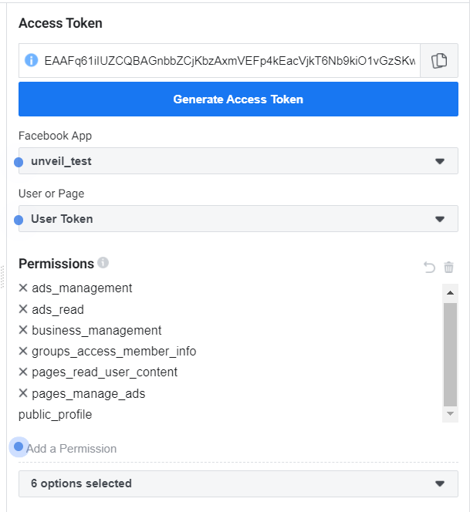

App ID and secret code need to be handy

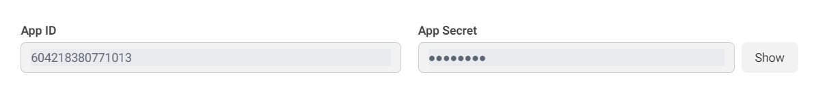

1. **Now we need to connect to facebook and try to access the data:**

Write python code to connect to facebook, parse the received data.

[Access Token Tool - Facebook for Developers](https://developers.facebook.com/tools/accesstoken/) - Here we can get consolidated information about the access tokens and the apps.

**Attempt #2**

**Selenium**

Using Selenium might be the way to go given that fb is pretty restrictive with apis

* Login to a website is given [here.](https://www.educba.com/how-to-use-selenium/)
* Using selenium IDE is something we can try [What is a Selenium Script? Programming Performance Testing | ThousandEyes](https://www.thousandeyes.com/learning/techtorials/selenium-scripts#:~:text=In%20essence%2C%20Selenium-enabled%20scripts%20simulate%20a%20user%20interaction,wait%20times%20at%20various%20checkpoints%20in%20the%20interaction.)

<https://www.facebook.com/robots.txt>

Automating the login: [Login automation using Selenium Webdriver: Tutorial | BrowserStack](https://www.browserstack.com/guide/login-automation-using-selenium-webdriver)

Edge Webdriver: [Microsoft Edge Driver - Microsoft Edge Developer](https://developer.microsoft.com/en-us/microsoft-edge/tools/webdriver/)

Chrome webdriver: [ChromeDriver - WebDriver for Chrome - Downloads (chromium.org)](https://chromedriver.chromium.org/downloads)

Helpful screenshots:

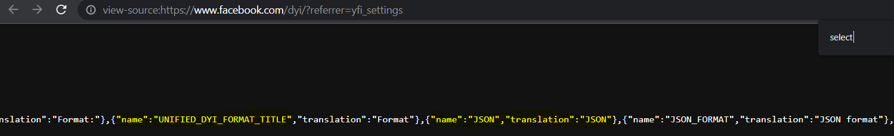

Concerns:

1. There is no official 64 bit chrome driver. The browser should be 32 bit. Not sure if it will work.
2. What if the user is using an edge browser? The user should have the web drivers installed as well. So I doubt this can be incorporated in the website as a script.
3. Bot detection might not allow access to any data (it’s illegal as well!)
4. The data is generated on the fly, so how can the data be accessed?