# 

# **NeuroLearn - AI-Powered Adaptive Smart Classroom**

**Team members:**

Sahana .M.D

Shreya .G.Mantha

Sumangala

**College name**: Sharnbasva University, Kalaburagi

Academic year:2024-2025

**Guide/ Mentor:**

## Dr.Basanti.Ghanti

**Submitted Under:**

Intel Unnati AI Lab

## **1. Executive Summary**

NeuroLearn stands at the forefront of educational innovation, presenting an advanced adaptive learning platform meticulously engineered to revolutionize personalized education through the strategic application of artificial intelligence. This platform is designed to transcend the inherent limitations of conventional, uniform educational models by offering highly individualized learning experiences that cater to the diverse needs and capabilities of students across all backgrounds. By leveraging Intel's OpenVINO toolkit, NeuroLearn achieves unparalleled efficiency in AI inference, facilitating real-time analysis of intricate student learning patterns, precise performance prediction, and dynamic optimization of educational content. This comprehensive document delves into the core functionalities, architectural design, technological underpinnings, and future potential of NeuroLearn, illustrating its transformative impact on the future of learning.

## **2. Overview: Redefining Education with AI**

The vision behind NeuroLearn is to cultivate a truly personalized educational ecosystem where every student's unique learning journey is recognized, supported, and optimized. Traditional educational paradigms, often characterized by a "one-size-fits-all" approach, frequently overlook the vast spectrum of individual learning paces, cognitive styles, and socio-economic disparities. NeuroLearn directly addresses this critical gap by employing cutting-edge artificial intelligence to dynamically tailor content, pedagogical strategies, and assessment methods.

Our platform is built upon the principle of continuous adaptation. As students interact with the system, NeuroLearn's AI engine gathers and processes a rich tapestry of data points – from response times and accuracy to engagement levels and navigation patterns. This data is then fed into sophisticated machine learning models, accelerated by OpenVINO, to construct a comprehensive profile of each learner. This profile informs intelligent decisions, such as adjusting the difficulty of questions, recommending supplementary materials, or even suggesting alternative learning modalities (e.g., visual aids for a visual learner, interactive simulations for a kinesthetic learner).

The ultimate goal of NeuroLearn is to foster an inclusive and effective learning environment where every student can achieve their full potential, regardless of their starting point or specific challenges. By providing educators with deep, actionable insights and empowering students with truly personalized pathways, NeuroLearn aims to bridge achievement gaps and cultivate a lifelong love for learning.

## **3. Problem Statement: The Imperative for Personalized Learning**

The contemporary educational landscape is fraught with challenges that traditional teaching methodologies struggle to overcome. These challenges manifest in various forms, leading to suboptimal learning outcomes and widening educational disparities:

* **Diverse Learning Paces:** Students absorb information at different speeds. In a conventional classroom, faster learners may become disengaged, while slower learners may fall behind, leading to frustration and a sense of inadequacy.
* **Varied Learning Styles:** Individuals process information differently. Some are visual learners, others auditory, and many are kinesthetic. A uniform teaching approach often caters to only one or two styles, leaving others underserved.
* **Learning Disabilities and Special Needs:** Students with dyslexia, ADHD, autism spectrum disorders, or other learning challenges require specialized support and adapted materials that are rarely available in a generalized classroom setting.
* **Socio-Economic Barriers:** Access to resources, stable home environments, and supplementary educational support varies significantly. Students from underserved regions or disadvantaged backgrounds often lack the personalized attention that could mitigate these external factors.
* **Lack of Real-Time Feedback and Adaptation:** Educators in large classrooms find it challenging to monitor every student's progress in real-time and adapt their teaching strategies on the fly. This often results in a reactive rather than proactive approach to student difficulties.
* **Engagement and Motivation:** Monotonous or overly challenging/easy content can lead to decreased student engagement and motivation, impacting retention and overall learning effectiveness.

NeuroLearn directly confronts these systemic issues by leveraging the power of AI to create a dynamic, responsive, and equitable learning environment. By providing a highly personalized learning path, the platform ensures that each student receives the precise support and challenge they need, when they need it, thereby maximizing their potential and fostering a more inclusive educational experience.

## **4. Key Features: Pillars of Personalized Education**

NeuroLearn's robust feature set is designed to deliver a truly adaptive and insightful learning experience. Each feature is meticulously crafted to address specific aspects of personalized education, powered by advanced AI and optimized for performance.

### **4.1. AI-Powered Learning Analysis**

This core component distinguishes NeuroLearn from conventional e-learning platforms. It's where raw student interaction data is transformed into actionable intelligence.

* **OpenVINO Integration**: At the heart of our AI inference engine lies Intel's OpenVINO toolkit. This integration is crucial for achieving high-performance, hardware-accelerated AI inference, allowing NeuroLearn to process complex machine learning models with minimal latency. This means real-time analysis and adaptation, even on edge devices, ensuring a seamless learning experience. OpenVINO optimizes pre-trained deep learning models for various Intel hardware, including CPUs, GPUs, FPGAs, and VPUs (e.g., Intel Neural Compute Stick), maximizing throughput and minimizing power consumption.
* **Learning Style Detection**: NeuroLearn employs sophisticated neural network models to identify dominant learning preferences. By analyzing a rich dataset of student interactions – including their preferred content formats (e.g., video vs. text), navigation patterns (e.g., re-watching specific sections), performance on different question types (e.g., multiple-choice vs. drag-and-drop), and even response times – the system can infer whether a student is primarily a visual, auditory, or kinesthetic learner. For example, a student who consistently performs better after watching video explanations and prefers diagrams might be classified as a visual learner.
* **Pattern Recognition**: Beyond simple metrics, NeuroLearn's AI analyzes deeper engagement, accuracy, and behavioral trends. This involves identifying recurring patterns such as:
  + **Struggling Points**: Consistently incorrect answers on specific topics or question formats.
  + **Engagement Peaks/Troughs**: Times when a student is most or least engaged, potentially indicating optimal learning windows or signs of fatigue.
  + **Growth Trajectories**: Identifying areas where a student is showing rapid improvement versus areas of stagnation.
  + **Distraction Indicators**: Patterns that might suggest a student is disengaged or distracted (e.g., rapid clicking without reading, long periods of inactivity). This granular pattern recognition informs highly nuanced adaptive strategies.
* **Real-Time Adaptation**: The insights generated by the AI are immediately fed back into the content delivery system. This enables dynamic adjustments to content difficulty, presentation format, and instructional approach on-the-fly. For instance, if a student is struggling with a concept, the system might immediately present a simpler explanation, an interactive simulation, or a different example. Conversely, if a student masters a topic quickly, the system can introduce more challenging material or advanced concepts to maintain engagement.

### **4.2. Adaptive Content Delivery**

This feature ensures that the learning experience is always tailored to the individual, promoting deeper understanding and retention.

* **Personalized Difficulty**: The system dynamically modifies the complexity of questions and learning materials. This is not just about making questions easier or harder; it involves adjusting the cognitive load, the number of steps required to solve a problem, or the level of abstraction in explanations. For example, a student excelling in algebra might be presented with multi-step word problems, while a struggling student might receive simpler equation-solving tasks with step-by-step hints.
* **Multi-Modal Learning**: NeuroLearn supports a diverse range of content types to cater to identified learning styles. This includes:
  + **Visual**: Infographics, diagrams, video tutorials, interactive simulations.
  + **Auditory**: Audio explanations, podcasts, narrated presentations.
  + **Kinesthetic**: Drag-and-drop exercises, interactive quizzes, virtual labs, problem-solving scenarios requiring active input. The system intelligently selects and presents content in the most effective modality for each student.
* **Progress Tracking**: Continuous monitoring of student engagement and performance provides a granular view of their learning journey. This includes tracking time spent on tasks, completion rates, accuracy scores, number of attempts, and specific areas of mastery or difficulty. This real-time data forms the basis for all AI analysis and adaptation.
* **Smart Recommendations**: NeuroLearn provides actionable suggestions for both students and educators.
  + **For Students**: Recommendations for supplementary resources, practice exercises, alternative explanations, or even suggestions to take a break if signs of fatigue are detected.
  + **For Educators**: Insights into individual student struggles, common misconceptions across a group, areas where the curriculum might need adjustment, or suggestions for one-on-one intervention. These recommendations empower educators to provide targeted support efficiently.

### **4.3. Comprehensive Analytics**

Data visualization and predictive insights are crucial for understanding and improving the learning process.

* **Progress Visualization**: Interactive dashboards and charts provide a clear, intuitive display of individual and group learning trajectories. Educators can quickly identify trends, pinpoint struggling students, and assess the overall effectiveness of teaching strategies. Visualizations might include mastery grids, progress timelines, and performance heatmaps.
* **Performance Metrics**: Detailed analysis of accuracy, improvement rates, and engagement levels offers a quantitative understanding of student performance. Metrics include average scores, time-to-completion, number of attempts per question, and growth over time in specific knowledge domains.
* **Predictive Insights**: Leveraging AI, NeuroLearn can forecast future performance and identify potential learning needs or risks. For example, the system might predict that a student is likely to struggle with an upcoming topic based on their performance in prerequisite areas, allowing for proactive intervention. This predictive capability transforms educators from reactive problem-solvers to proactive facilitators of learning.

## **5. Technology Stack: The Engine Behind NeuroLearn**

NeuroLearn is built upon a robust and scalable technology stack, carefully selected to ensure high performance, flexibility, and maintainability.

* **Backend**: **Python Flask** serves as the lightweight and flexible web framework for the backend. Flask's simplicity allows for rapid development of the API endpoints and business logic, while its extensibility enables integration with various libraries and services.
* **AI/ML**:
  + **OpenVINO**: The cornerstone for high-performance AI inference. It optimizes deep learning models for Intel hardware, providing significant speedups for real-time analysis.
  + **scikit-learn**: Used for traditional machine learning algorithms, particularly for the fallback system and potentially for initial model prototyping or simpler analytical tasks.
  + **NumPy**: Essential for numerical operations and efficient array manipulation, critical for data processing in machine learning workflows.
  + **Pandas**: Provides powerful data structures (DataFrames) and data analysis tools, used for data cleaning, transformation, and preparation before feeding into AI models.
* **Frontend**:
  + **HTML5, CSS3, JavaScript (ES6+)**: Standard web technologies form the foundation of the user interface, ensuring broad compatibility and a rich interactive experience.
  + **Bootstrap 5**: A popular CSS framework that provides responsive, mobile-first design components, accelerating UI development and ensuring a consistent look and feel across devices.
* **Visualization**:
  + **Matplotlib**: A comprehensive library for creating static, animated, and interactive visualizations in Python, used for generating detailed charts and graphs for analytics dashboards.
  + **Seaborn**: Built on Matplotlib, Seaborn provides a high-level interface for drawing attractive and informative statistical graphics, enhancing the visual appeal and interpretability of data.
* **Database**: **SQLite** is employed for demonstration purposes due to its simplicity and file-based nature, making setup straightforward. For production environments, it can be seamlessly replaced with more robust relational databases like PostgreSQL or MySQL, or NoSQL databases depending on scalability and data structure requirements.

## **6. OpenVINO Integration: The Core of Intelligent Adaptation**

OpenVINO (Open Visual Inference and Neural Network Optimization) is central to NeuroLearn's ability to deliver real-time, adaptive learning experiences. It acts as the high-performance inference engine for all deep learning models within the platform, ensuring that AI insights are generated with minimal latency and maximum efficiency.

### **6.1. How OpenVINO Powers NeuroLearn's AI**

* **Learning Pattern Analysis**: Neural network models, trained on diverse student interaction data (e.g., clickstreams, response times, content consumption patterns), are optimized with OpenVINO. These models infer dominant learning styles (visual, auditory, kinesthetic) by identifying correlations between student behavior and their performance on content presented in different modalities. For instance, a model might detect that a student frequently pauses video lessons and revisits specific visual diagrams, indicating a visual learning preference. OpenVINO accelerates the inference of these complex models, allowing for near-instantaneous style detection.
* **Performance Prediction**: Time series models, potentially recurrent neural networks (RNNs) or simpler regression models, are used to forecast student progress and identify potential challenges. These models analyze historical performance data, engagement metrics, and time spent on topics to predict future scores or areas of difficulty. OpenVINO enables these predictions to be made rapidly, allowing the system to proactively suggest interventions or content adjustments before a student falls significantly behind.
* **Content Optimization**: AI-driven recommendation systems, often based on collaborative filtering or content-based filtering techniques, suggest optimal content types and difficulty adjustments. These models, once optimized by OpenVINO, can quickly evaluate a student's current state and recommend the next best learning resource or question difficulty level. For example, if a student has mastered a concept, the model might recommend an advanced problem set; if they are struggling, it might suggest a more fundamental explanation or a different teaching approach.
* **Device Detection**: OpenVINO's API allows NeuroLearn to automatically detect and intelligently utilize available hardware resources. This includes:
  + **CPU**: General-purpose processing.
  + **GPU**: For parallel processing, especially beneficial for larger models.
  + **Intel Neural Compute Stick (NCS)**: A dedicated VPU (Vision Processing Unit) for highly efficient deep learning inference at the edge.
  + **FPGA**: Field-Programmable Gate Arrays for custom hardware acceleration. This dynamic device detection ensures that NeuroLearn always runs its AI models on the most optimal hardware available, maximizing performance and efficiency.
* **Performance Benchmarking**: OpenVINO provides built-in tools and APIs to measure inference speed (latency) and throughput (inferences per second) for deployed models. NeuroLearn leverages this to continuously monitor the performance of its AI engine, ensuring real-time analytics are consistently delivered. This data is critical for system administrators to identify bottlenecks and optimize resource allocation.
* **Model Status Monitoring**: The platform provides live status updates for all OpenVINO-deployed models and the devices they are running on. This includes information on model loading status, device utilization, and any potential errors, ensuring high availability and reliability of the AI services.

### **6.2. API Endpoints for OpenVINO Interaction**

The backend exposes specific API endpoints to interact with the OpenVINO-powered AI services. These endpoints facilitate modularity and allow for easy integration with other systems or future frontend enhancements.

* GET /api/openvino/status
  + **Description**: Returns the current status of the OpenVINO system, including available devices, loaded models, and their operational state.

**Example Response**:  
{

"status": "success",

"openvino_version": "2023.2.0",

"available_devices": ["CPU", "GPU", "MYRIAD"],

"loaded_models": {

"learning_style_detector": {"status": "loaded", "device": "CPU"},

"performance_predictor": {"status": "loaded", "device": "GPU"},

"content_optimizer": {"status": "loaded", "device": "CPU"}

}

}

* GET /api/openvino/benchmark
  + **Description**: Triggers a performance benchmark for the currently loaded OpenVINO models and returns metrics like inference speed (latency) and throughput.

**Example Response**:  
{

"status": "success",

"benchmark_results": {

"learning_style_detector": {"latency_ms": 15.2, "throughput_fps": 65.8},

"performance_predictor": {"latency_ms": 22.1, "throughput_fps": 45.2},

"content_optimizer": {"latency_ms": 10.5, "throughput_fps": 95.2}

}

}

* POST /api/openvino/analyze_learning_style
  + **Description**: Accepts student interaction data and analyzes their learning style using the OpenVINO-optimized model.

**Request Body**:  
{

"student_id": "S001",

"interaction_data": {

"video_watch_time": 300,

"text_read_time": 120,

"quiz_attempts": 5,

"quiz_accuracy": 0.85,

"preferred_content_type": ["video", "diagrams"]

}

}

**Example Response**:  
{

"status": "success",

"student_id": "S001",

"learning_style": "visual",

"confidence": 0.92,

"recommendations": ["Suggest more visual aids", "Provide interactive diagrams"]

}

* POST /api/openvino/predict_performance
  + **Description**: Predicts future student performance based on historical data using the OpenVINO-optimized model.

**Request Body**:  
{

"student_id": "S002",

"historical_data": {

"past_scores": [75, 80, 88],

"engagement_score": 0.7,

"time_on_platform_hours": 50,

"current_topic_mastery": 0.65

}

}

**Example Response**:  
{

"status": "success",

"student_id": "S002",

"predicted_score_next_quiz": 92,

"risk_areas": ["Advanced Calculus"],

"intervention_needed": false

}

* POST /api/openvino/optimize_content
  + **Description**: Recommends optimal content delivery strategies and difficulty adjustments based on real-time student state.

**Request Body**:  
{

"student_id": "S003",

"current_context": {

"topic": "Newtonian Physics",

"current_difficulty": "medium",

"last_question_correct": true,

"time_on_current_page_seconds": 60

}

}

**Example Response**:  
{

"status": "success",

"student_id": "S003",

"recommended_action": "increase_difficulty",

"new_content_type": "interactive_simulation",

"suggested_next_resource_id": "PHY101_Sim005"

}

* GET /api/openvino/demo
  + **Description**: Runs a comprehensive demonstration of OpenVINO's capabilities, simulating data flow through the various AI models and showcasing their outputs. This is useful for verification and testing.

### **6.3. Fallback System: Ensuring Uninterrupted Functionality**

While OpenVINO is the preferred and primary inference engine, NeuroLearn incorporates a robust fallback mechanism to ensure continuous operation even if OpenVINO is unavailable or encounters issues (e.g., missing drivers, incompatible hardware, or specific model loading failures).

In such scenarios, the system automatically reverts to simulated analysis using traditional machine learning algorithms from **scikit-learn** and **rule-based algorithms**.

* **Learning Style Detection (Fallback)**: Instead of neural networks, the system might use simpler classification algorithms like Decision Trees or K-Nearest Neighbors on pre-processed interaction data, or even a set of predefined rules (e.g., "If student watches more than 70% of videos, classify as visual preference").
* **Performance Prediction (Fallback)**: Linear regression models or simpler statistical methods (e.g., moving averages of past scores) would be employed instead of time series neural networks.
* **Content Optimization (Fallback)**: Rule-based systems would dictate content adjustments (e.g., "If 3 consecutive answers are incorrect, decrease difficulty by one level and provide a hint").

This fallback system is crucial for maintaining system stability and providing a consistent, albeit less nuanced, adaptive experience under adverse conditions. The transition to the fallback system is designed to be seamless from the user's perspective, with internal logging to alert administrators about the change in operational mode.

## **7. Application Architecture: A Modular Design**

NeuroLearn's architecture is designed for clarity, scalability, and maintainability, separating concerns into logical components.

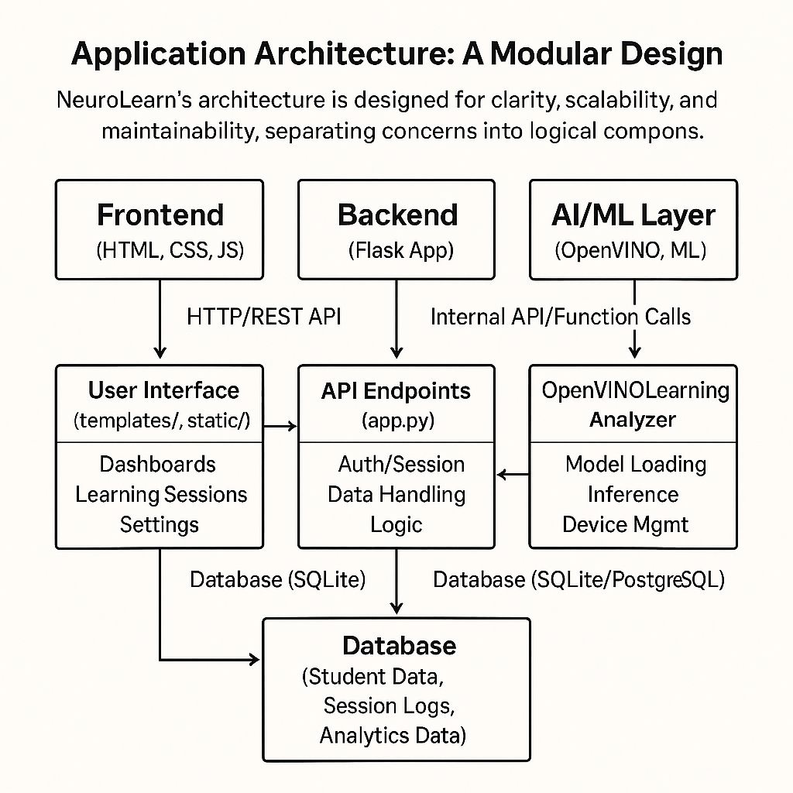

* **openvino_utils.py**: This module encapsulates the core AI logic. It contains the OpenVINOLearningAnalyzer class, which is responsible for:
  + **Model Initialization**: Loading pre-trained deep learning models (e.g., for learning style detection, performance prediction) into OpenVINO's Inference Engine.
  + **Inference Management**: Handling input data preprocessing, executing inference requests on the loaded models, and post-processing the raw model outputs into meaningful insights.
  + **Device Detection and Selection**: Automatically identifying available Intel hardware (CPU, GPU, VPU) and intelligently selecting the optimal device for each model or inference task.
  + **Performance Benchmarking**: Measuring the latency and throughput of inference operations to monitor and report on the AI engine's efficiency.
  + **Fallback Logic**: Managing the transition to scikit-learn/rule-based analysis if OpenVINO is unavailable.
* **app.py**: This is the main Flask application file, serving as the central hub of the NeuroLearn platform. Its responsibilities include:
  + **API Endpoint Exposure**: Defining and managing all RESTful API endpoints (e.g., /api/openvino/status, /api/learning_session/start, /analytics).
  + **Request Handling**: Receiving HTTP requests from the frontend, validating input, and orchestrating the flow of data and logic.
  + **Integration with OpenVINOLearningAnalyzer**: Calling methods from openvino_utils.py to perform AI-driven analysis and receive insights.
  + **Database Interaction**: Managing data persistence by interacting with the chosen database (e.g., SQLite for demo, PostgreSQL for production) to store student profiles, learning session data, and analytics.
  + **Adaptive Learning Engine Logic**: Implementing the core logic for adapting content based on AI insights, fetching appropriate learning materials, and managing the state of a learning session.
  + **Rendering Frontend Templates**: Serving HTML pages and static assets to the user's browser.
* **templates/**: This directory contains all the HTML templates rendered by Flask. These templates define the structure and layout of the user interface, including:
  + dashboard.html: For visualizing student progress and overall analytics.
  + learning_session.html: The interactive interface where students engage with content.
  + settings.html: For configuring OpenVINO options and running demos.
  + Other partials and layouts for consistent UI elements.
* **static/**: This directory holds static assets such as:
  + **JavaScript (JS)** files: For client-side interactivity, API calls to the backend, and dynamic UI updates.
  + **CSS** files: For styling the web interface, ensuring a modern and responsive design (leveraging Bootstrap).
  + **Uploads**: Potentially for storing static learning content (e.g., images, pre-recorded audio/video) if not served from a separate CDN.
* **requirements.txt**: This file lists all Python dependencies required for the project, ensuring a consistent development and deployment environment. It includes flask, openvino, scikit-learn, numpy, pandas, matplotlib, seaborn, and bootstrap-flask (if used for Bootstrap integration).

This modular architecture promotes clear separation of concerns, making the system easier to develop, debug, scale, and extend in the future.

## **8. Setup and Installation: Getting Started with NeuroLearn**

Setting up NeuroLearn is a straightforward process, designed to get you up and running quickly.

### **8.1. Prerequisites**

Before you begin, ensure your system meets the following requirements:

* **Python 3.8 or higher**: NeuroLearn is developed and tested with modern Python versions. You can download Python from [python.org](https://www.python.org/).
* **pip package manager**: This usually comes bundled with Python installations. It's used to install Python libraries.
* **Intel OpenVINO toolkit**: This is the most crucial prerequisite for optimal performance. You can install OpenVINO in several ways:

**Recommended (pip installation)**: For most users, installing OpenVINO via pip is the simplest method. This will install the core components necessary for inference.  
pip install openvino openvino-dev

* + **From Intel's Website**: For more advanced users or specific hardware configurations, you might prefer to download the full OpenVINO distribution from the official Intel website. This provides additional tools, samples, and documentation. Follow the installation instructions provided by Intel for your specific operating system and hardware.

### **8.2. Installation Steps**

Follow these steps to get NeuroLearn running on your local machine:

**Clone the repository**: First, you need to obtain the NeuroLearn source code. Open your terminal or command prompt and execute the following command:  
git clone <repository-url>

1. (Replace <repository-url> with the actual URL of the NeuroLearn GitHub repository.)

**Navigate into the project directory**:  
cd AI\ intel

1. (Ensure you are in the directory containing app.py, requirements.txt, etc.)

**Create a Python Virtual Environment (Recommended)**: It's best practice to create a virtual environment to manage project dependencies. This prevents conflicts with other Python projects on your system.  
python -m venv venv

1. **Activate the virtual environment**:

**On Windows**:  
.\venv\Scripts\activate

**On macOS/Linux**:  
source venv/bin/activate

1. You should see (venv) or a similar indicator in your terminal prompt, signifying that the virtual environment is active.

**Install dependencies**: With your virtual environment activated, install all the required Python libraries listed in requirements.txt:  
pip install -r requirements.txt

1. This command will download and install Flask, OpenVINO, scikit-learn, NumPy, Pandas, Matplotlib, Seaborn, and any other specified dependencies.

**Run the application**: Once all dependencies are installed, you can start the Flask development server:  
python app.py

1. You should see output indicating that the Flask server is running, typically on http://127.0.0.1:5000 or http://localhost:5000.
2. **Access the application in your browser**: Open your preferred web browser and navigate to the address provided in the terminal output (e.g., http://localhost:5000). You should now see the NeuroLearn web interface.

### **8.3. Troubleshooting Common Issues**

* **ModuleNotFoundError**: If you encounter this error, ensure you have activated your virtual environment and run pip install -r requirements.txt successfully.
* **OpenVINO Errors**: If OpenVINO fails to load models or detect devices, check the official OpenVINO documentation for specific installation and configuration steps for your hardware. Ensure necessary drivers are installed. The fallback system should still allow the application to run, albeit with simulated AI.
* **Port in Use**: If http://localhost:5000 is already in use, Flask will usually suggest an alternative port. You can also manually specify a port when running app.py (e.g., python app.py --port 8000).

## **9. Usage: Interacting with NeuroLearn**

NeuroLearn is designed for intuitive interaction, providing distinct interfaces for students and educators, and a powerful API for developers.

### **9.1. For Students: Engaging with Personalized Learning**

1. **Start a Learning Session**:
   * From the main dashboard, navigate to the "Start Session" or "Learning Path" section.
   * You will be prompted to enter a **Student ID** (or select from a list if pre-registered).
   * Choose a **Subject** (e.g., Mathematics, Science, History) and a desired **Difficulty Level** (e.g., Beginner, Intermediate, Advanced).
   * Click "Begin Session".
   * The system will then present you with learning content and questions. As you interact, NeuroLearn's AI will continuously analyze your responses, engagement, and learning patterns.
   * **Dynamic Adaptation**: Observe how the content changes. If you answer several questions correctly, the difficulty might subtly increase. If you struggle, the system might offer a simpler explanation, a different type of example, or a hint. The presentation format might also change based on your detected learning style (e.g., more videos if you're a visual learner).
   * **Interactive Elements**: Engage with quizzes, drag-and-drop exercises, simulations, and other interactive elements designed to reinforce learning.
2. **View Your Progress**:
   * Access the "My Progress" or "Analytics" dashboard.
   * Here, you can see visualizations of your learning journey:
     + **Mastery Score**: A score indicating your proficiency in different topics.
     + **Time Spent**: How much time you've dedicated to various subjects.
     + **Performance Trends**: Graphs showing your accuracy and improvement over time.
     + **Recommended Resources**: Personalized suggestions for further study, practice, or alternative learning materials based on AI insights.
   * This dashboard empowers you to take ownership of your learning and understand your strengths and areas for improvement.

### **9.2. For Educators: Gaining Actionable Insights**

1. **Access the Educator Dashboard**:
   * Log in to the platform with educator credentials.
   * The main dashboard provides an aggregated view of your class or group's performance.
   * **Group Progress Visualization**: See overall class mastery, common areas of difficulty, and engagement trends.
   * **Individual Student Drill-Down**: Click on any student's profile to view their detailed analytics, identical to what a student would see, but with additional educator-specific insights.
   * **AI-Driven Recommendations for Teaching**:
     + **Intervention Alerts**: Identify students who are consistently struggling or at risk of falling behind.
     + **Curriculum Optimization**: Discover which topics are consistently challenging for the majority of students, potentially indicating a need for revised teaching strategies or supplementary lessons.
     + **Personalized Assignments**: Use the AI's insights to assign targeted practice or remedial work to individual students.
2. **OpenVINO Settings and Benchmarking**:
   * Navigate to the "Settings" or "Admin" page.
   * Here, you can:
     + **Test OpenVINO Integration**: Verify that the AI inference engine is running correctly and detecting available hardware.
     + **Run Demos**: Execute a comprehensive OpenVINO demo to see the AI models in action with simulated data, providing a deeper understanding of their capabilities.
     + **Benchmark Performance**: Measure the inference speed and throughput of the AI models on your system, ensuring optimal performance for real-time adaptation.

### **9.3. For Developers: Leveraging the API**

NeuroLearn provides a comprehensive set of API endpoints, allowing for seamless integration with external systems, custom dashboards, or automated analysis workflows.

* **API Documentation**: Refer to the API Endpoints section (Section 6.2) for detailed information on available endpoints, request formats, and response structures.
* **Integration Examples**:
  + **LMS Integration**: Connect NeuroLearn to an existing Learning Management System (LMS) to sync student data, import/export grades, and embed NeuroLearn content.
  + **Custom Reporting**: Build custom analytics dashboards or reports by fetching raw performance data and AI insights via the API.
  + **Automated Content Generation**: Potentially integrate with external content generation tools, feeding them AI insights to create new adaptive materials.

By providing these diverse usage pathways, NeuroLearn aims to be a versatile and powerful tool for transforming education for all stakeholders.

## **10. Extensibility: Future-Proofing NeuroLearn**

NeuroLearn's architecture is designed with extensibility in mind, allowing for future growth, integration with new technologies, and adaptation to evolving educational needs.

* **Database Scalability**: The current demo utilizes SQLite for simplicity. For production deployments requiring high availability, concurrent access, and large datasets, transitioning to a robust relational database is straightforward.
  + **Recommendation**: **PostgreSQL** or **MySQL** are excellent choices for their maturity, performance, and extensive tooling. For highly unstructured data or massive scale, NoSQL databases like **MongoDB** or **Cassandra** could be considered, though they would require significant changes to the data access layer.
  + **Implementation**: This would involve updating the database connection string in app.py and potentially refactoring database interaction logic to use an ORM (Object-Relational Mapper) like SQLAlchemy, which provides an abstraction layer over different database backends.
* **Custom AI Models and Workflows**: The openvino_utils.py module is designed to be modular, making it easy to replace or extend the existing OpenVINO models.
  + **New Learning Styles**: Train and integrate models to detect more nuanced learning styles (e.g., logical-mathematical, interpersonal, intrapersonal).
  + **Affective Computing**: Integrate models that analyze student emotions (e.g., frustration, engagement) from webcam data (with appropriate privacy considerations) to further personalize interventions.
  + **Adaptive Assessment**: Develop models for dynamic assessment generation, where questions are generated on the fly based on a student's current knowledge state.
  + **Implementation**: This involves training new deep learning models (e.g., using TensorFlow, PyTorch), converting them to OpenVINO's Intermediate Representation (IR) format using the Model Optimizer, and then loading and inferring with these new models within the OpenVINOLearningAnalyzer class.
* **Frontend Framework Integration**: While the current UI uses Bootstrap and vanilla JavaScript, it can be easily customized or integrated with modern JavaScript frameworks for enhanced interactivity and developer experience.
  + **Recommendation**: **React**, **Vue.js**, or **Angular** are popular choices that offer component-based architectures, state management, and efficient UI rendering.
  + **Implementation**: This would involve building the frontend as a separate single-page application (SPA) that communicates with the Flask backend via its REST API. The Flask app would then primarily serve the static SPA files.
* **Deployment Strategies**: For production environments, the Flask development server is not suitable.
  + **WSGI Server**: Use a production-ready WSGI (Web Server Gateway Interface) server like **Gunicorn** or **uWSGI** to serve the Flask application.
  + **Web Server**: Place a robust web server like **Nginx** or **Apache** in front of the WSGI server to handle static files, load balancing, and SSL termination.
  + **Containerization**: Containerize the application using **Docker** for consistent environments across development, testing, and production. This also facilitates deployment on container orchestration platforms like **Kubernetes**.
  + **Cloud Deployment**: Deploy on cloud platforms like **Google Cloud Platform (GCP)**, **Amazon Web Services (AWS)**, or **Microsoft Azure**, leveraging their managed services for databases, compute, and scaling.
  + **Environment Variables**: Configure sensitive information (e.g., database credentials, API keys) using environment variables rather than hardcoding them, enhancing security and flexibility.
* **Content Management System (CMS) Integration**: For large-scale content management, integrate with a dedicated CMS.
  + **Benefits**: Streamline content creation, versioning, and delivery, allowing educators to easily add and update learning materials without developer intervention.
* **Real-time Communication**: For features like live tutoring or collaborative learning, integrate real-time communication protocols.
  + **Recommendation**: **WebSockets** could be used for bidirectional communication between the client and server, enabling features like live chat, collaborative whiteboards, or immediate feedback loops.

By embracing these extensibility pathways, NeuroLearn can evolve into an even more powerful, scalable, and versatile platform, capable of meeting the dynamic demands of future education.

## **11. Replacing Demo Data: Transitioning to Real-World Application**

The demo version of NeuroLearn uses placeholder data and simplified endpoints for ease of setup and testing. To transition to a full-fledged, production-ready system, several key areas require replacement and integration with real-world data sources.

* **Student Data Management**:
  + **Demo**: Simple student IDs and basic profiles stored in SQLite.
  + **Production**: Replace demo data with actual student records from your existing **Learning Management System (LMS)**, **Student Information System (SIS)**, or a dedicated user management database.
  + **Implementation**: Implement robust user authentication and authorization. Integrate with an external API or set up data synchronization processes (e.g., ETL jobs) to populate NeuroLearn's database with real student demographics, enrollment information, and historical academic records.
* **Learning Sessions and Content**:
  + **Demo**: Simulated questions and basic content adaptation.
  + **Production**: Integrate real educational exercises, questions, and learning materials.
  + **Implementation**:
    - **Content Repository**: Connect to a comprehensive content repository or a **Content Management System (CMS)** that houses your curriculum, lessons, quizzes, videos, and interactive simulations.
    - **User Input Handling**: Develop sophisticated handling for diverse user input, including free-text answers, complex problem-solving steps, and interactive simulation results. This might involve natural language processing (NLP) for grading open-ended responses or advanced parsing for code submissions.
    - **Adaptive Content Logic**: Refine the adaptive content delivery logic to pull relevant materials from the content repository based on AI recommendations (e.g., fetch "Algebra Chapter 3, Advanced Exercises" if the AI suggests increasing difficulty).
* **Analytics Pipeline**:
  + **Demo**: Basic performance metrics stored locally.
  + **Production**: Connect to your existing analytics pipeline or a dedicated data warehouse/lake for real-time data ingestion and deeper insights.
  + **Implementation**:
    - **Data Ingestion**: Implement robust data ingestion mechanisms to capture every student interaction (clicks, views, answers, time spent, errors) and stream it to a centralized analytics system (e.g., Kafka, Google Cloud Pub/Sub, AWS Kinesis).
    - **Data Warehousing**: Store this granular data in a scalable data warehouse (e.g., Google BigQuery, Snowflake, Amazon Redshift) for complex queries and long-term trend analysis.
    - **Business Intelligence (BI) Tools**: Integrate with BI tools (e.g., Tableau, Power BI, Looker Studio) for advanced reporting and custom dashboard creation beyond NeuroLearn's built-in visualizations.
* **OpenVINO Models**:
  + **Demo**: Pre-trained, generic models for basic analysis.
  + **Production**: Train and export your own specialized models tailored to your specific educational context, curriculum, and student population.
  + **Implementation**:
    - **Data Collection**: Systematically collect large volumes of real student interaction data from your platform.
    - **Data Annotation**: Annotate this data for learning styles, performance levels, and content effectiveness.
    - **Model Training**: Use frameworks like TensorFlow or PyTorch to train custom deep learning models for:
      * Highly accurate learning style detection specific to your content.
      * Precise performance prediction for your unique curriculum.
      * Personalized content recommendation engines that understand your content taxonomy.
    - **Model Optimization**: Utilize OpenVINO's Model Optimizer to convert these trained models into the Intermediate Representation (IR) format, ensuring they are optimized for inference on Intel hardware.
    - **Deployment**: Deploy these custom, optimized models within the openvino_utils.py module, replacing the demo models.

By systematically addressing these areas, NeuroLearn can evolve from a powerful demonstration into a robust, data-driven, and highly effective adaptive learning solution for any educational institution or content provider.

## **12. Future Enhancements and Roadmap**

NeuroLearn's current capabilities lay a strong foundation for personalized education. However, the potential for further innovation is vast. Here are some key areas for future development and a potential roadmap:

### **12.1. Advanced AI and Pedagogical Features**

* **Affective Computing Integration**:
  + **Goal**: Detect student emotional states (frustration, confusion, engagement, boredom) through webcam analysis (with explicit consent and privacy safeguards).
  + **Impact**: Enable real-time emotional support, adaptive pacing to prevent burnout, and content adjustments based on emotional responses, leading to a more empathetic learning experience.
* **Natural Language Processing (NLP) for Open-Ended Responses**:
  + **Goal**: Automatically grade and provide feedback on essays, short answers, and coding exercises.
  + **Impact**: Scale personalized feedback, reduce educator workload, and provide immediate, constructive criticism for complex tasks.
* **Generative AI for Content Creation**:
  + **Goal**: Utilize large language models (LLMs) to dynamically generate new practice questions, explanations, examples, or even entire lesson modules tailored to a student's specific needs and learning style.
  + **Impact**: Create an infinitely adaptable content pool, ensuring students always have fresh and relevant material.
* **Collaborative Learning Features**:
  + **Goal**: Facilitate intelligent group work by pairing students based on complementary strengths or weaknesses, or by suggesting collaborative projects.
  + **Impact**: Foster peer learning, develop teamwork skills, and provide diverse perspectives.
* **Gamification and Incentive Systems**:
  + **Goal**: Integrate game-like elements (points, badges, leaderboards, challenges) to increase student motivation and engagement.
  + **Impact**: Make learning more enjoyable and provide tangible rewards for progress.

### **12.2. Platform and Infrastructure Enhancements**

* **Multi-Tenancy Support**:
  + **Goal**: Enable multiple educational institutions or teachers to use the platform independently with their own data and configurations.
  + **Impact**: Expand the platform's reach and marketability as a SaaS solution.
* **Offline Learning Capabilities**:
  + **Goal**: Allow students to download content and continue learning without an internet connection, syncing data when online.
  + **Impact**: Improve accessibility for students in areas with limited or unreliable internet access.
* **Enhanced Security and Privacy**:
  + **Goal**: Implement advanced encryption, data anonymization, and compliance with educational data privacy regulations (e.g., FERPA, GDPR).
  + **Impact**: Build trust with users and institutions, ensuring data integrity and student privacy.
* **Scalable Cloud Deployment**:
  + **Goal**: Transition from a single-server deployment to a fully scalable cloud-native architecture.
  + **Impact**: Handle millions of concurrent users, ensure high availability, and dynamically scale resources based on demand. This would involve leveraging services like Kubernetes, managed databases, and serverless functions.

### **12.3. Integration and Ecosystem Expansion**

* **LMS/SIS Deep Integration**:
  + **Goal**: Develop robust, two-way integrations with popular Learning Management Systems (e.g., Canvas, Moodle, Blackboard) and Student Information Systems.
  + **Impact**: Streamline administrative tasks, provide seamless data flow, and embed NeuroLearn directly into existing educational workflows.
* **Open Educational Resources (OER) Integration**:
  + **Goal**: Connect with and leverage vast repositories of Open Educational Resources to expand the content library.
  + **Impact**: Provide a richer, more diverse set of learning materials and reduce content development costs.
* **API for Third-Party Developers**:
  + **Goal**: Publish a comprehensive, well-documented API for third-party developers to build extensions, custom analytics tools, or integrate NeuroLearn's AI capabilities into their own applications.
  + **Impact**: Foster an ecosystem of innovation around NeuroLearn.

### **12.4. Research and Development**

* **Longitudinal Studies**: Conduct long-term research to measure the impact of personalized learning on student outcomes, retention, and academic achievement.
* **Explainable AI (XAI)**: Develop methods to make the AI's decision-making process more transparent to educators and students, fostering trust and understanding.
* **Adaptive Curriculum Design**: Research how AI can not only adapt content delivery but also dynamically restructure entire curricula based on student performance and learning trends.

This roadmap represents a vision for NeuroLearn's evolution, aiming to continually push the boundaries of AI-powered adaptive education and create truly transformative learning experiences.

**13. Website Flow**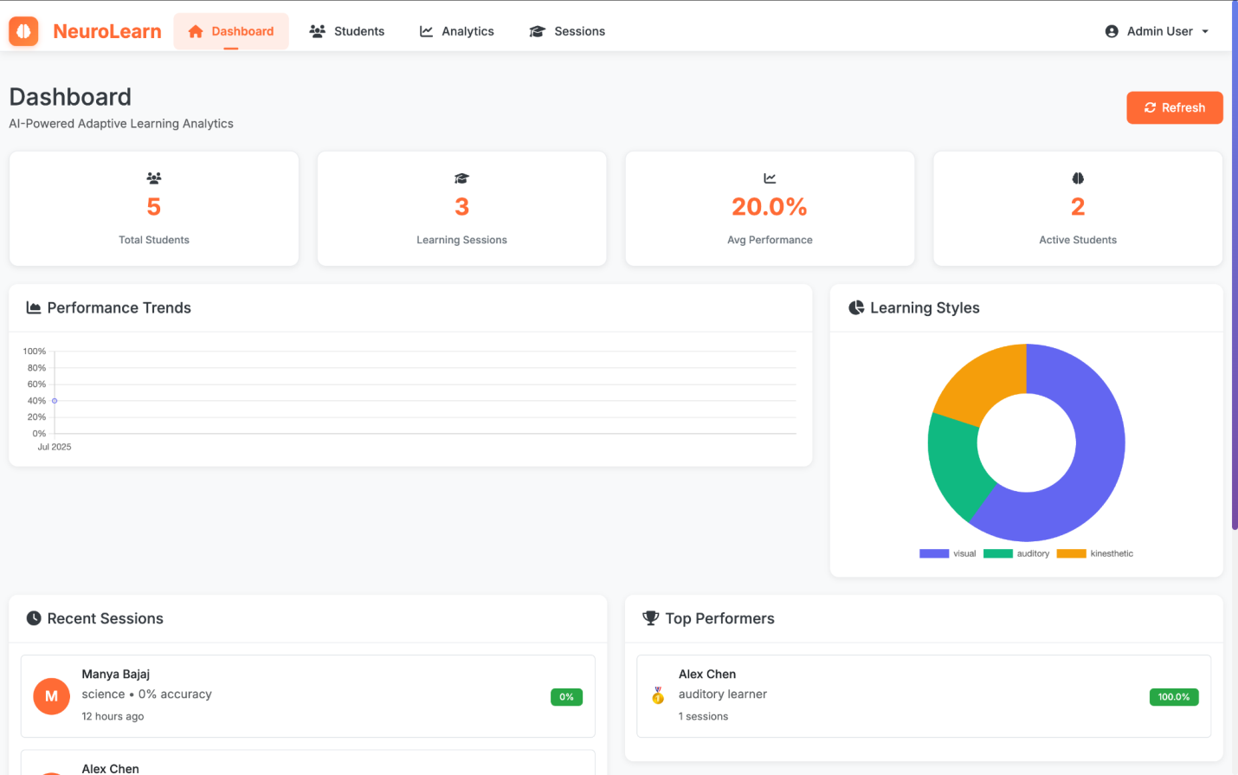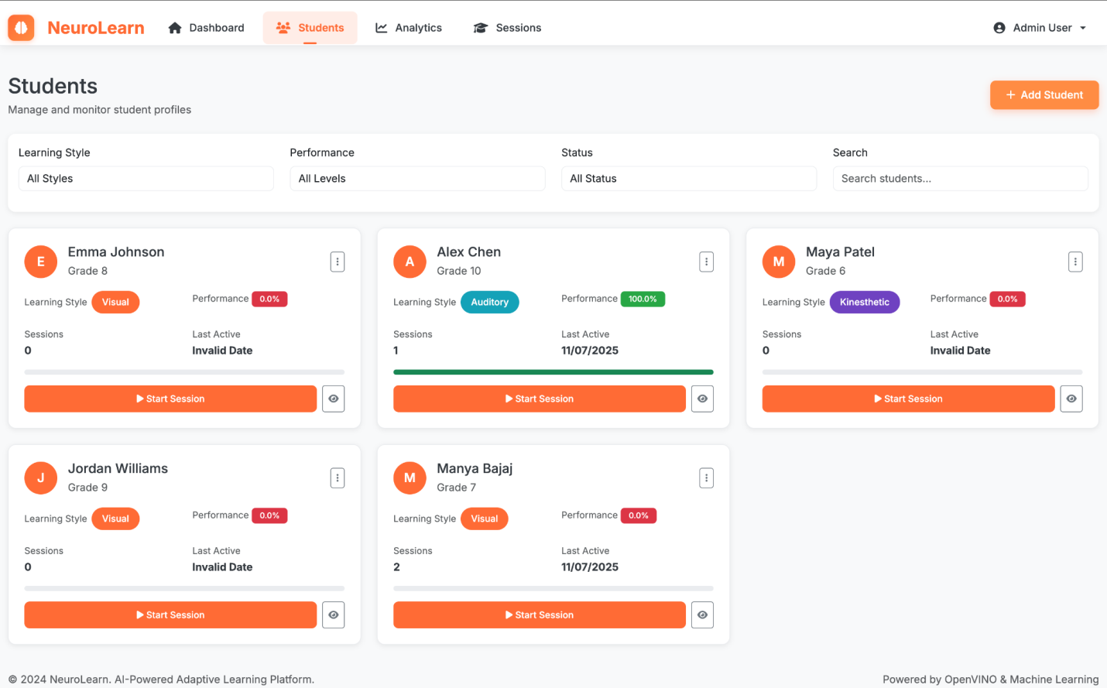

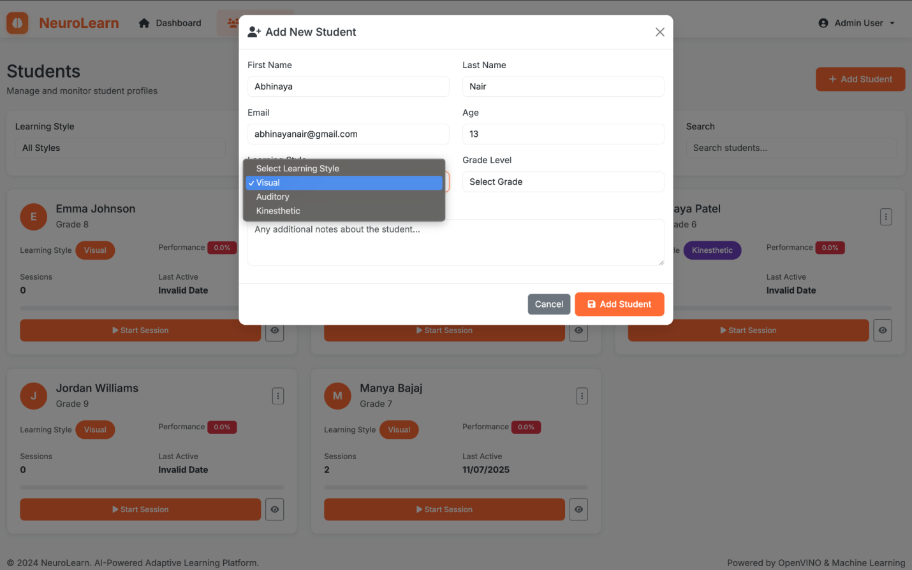

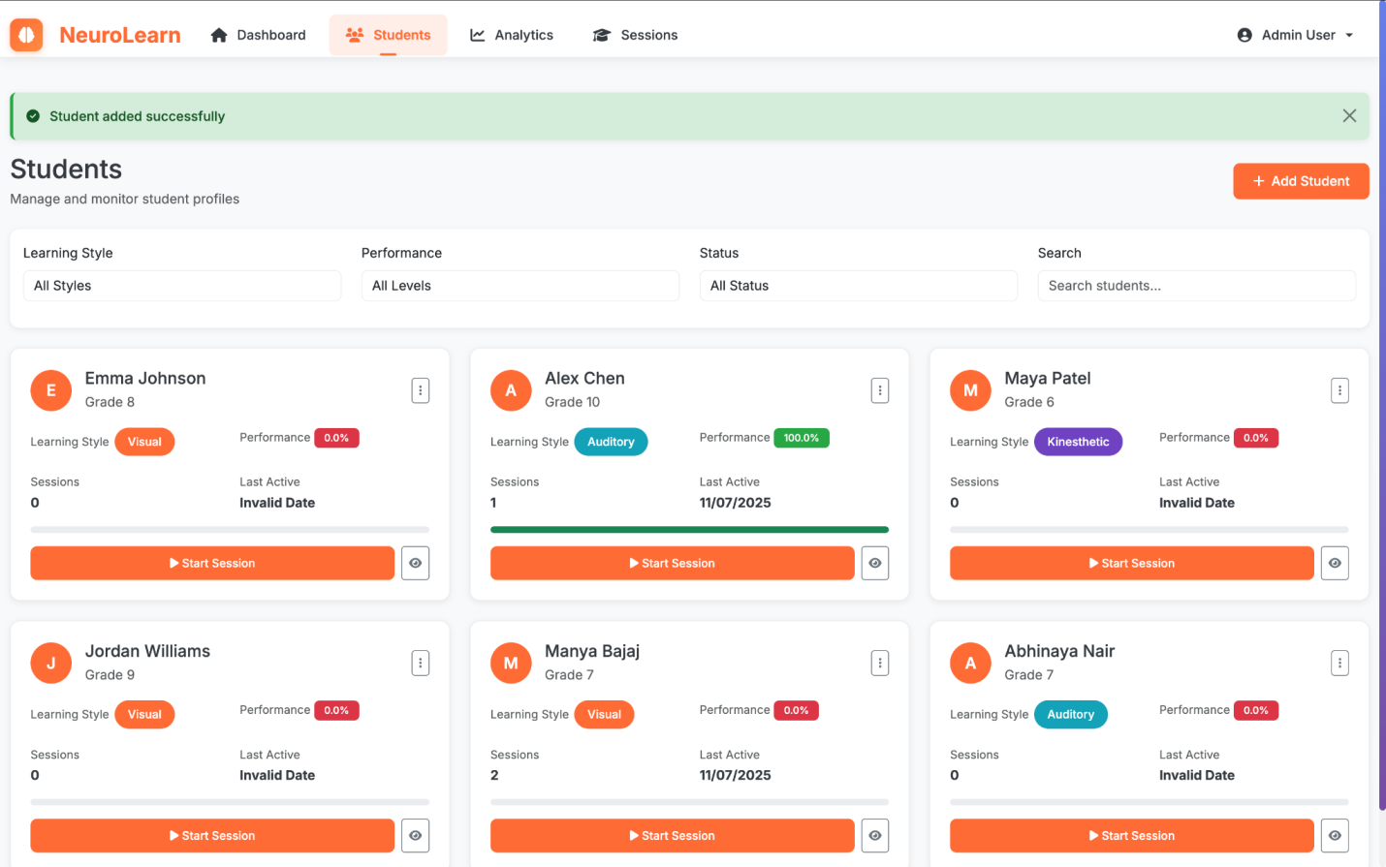

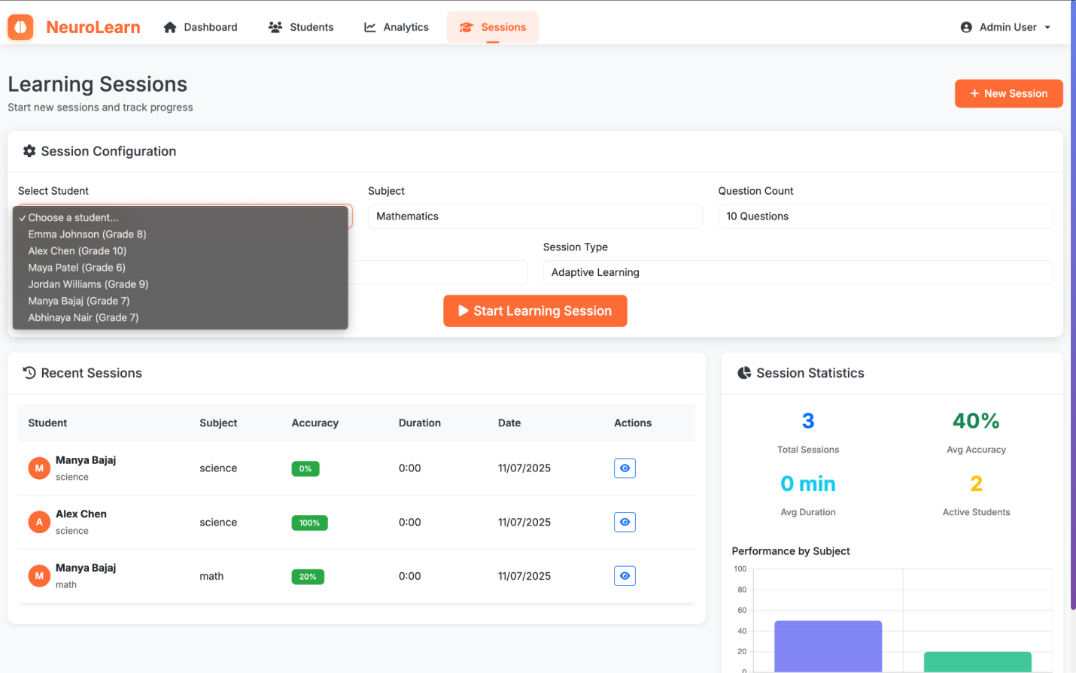

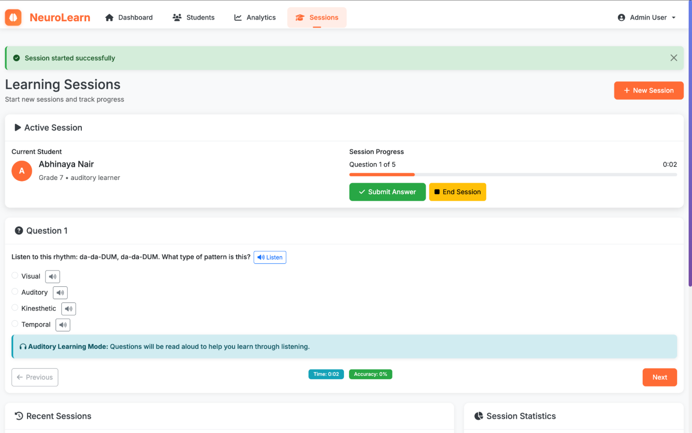

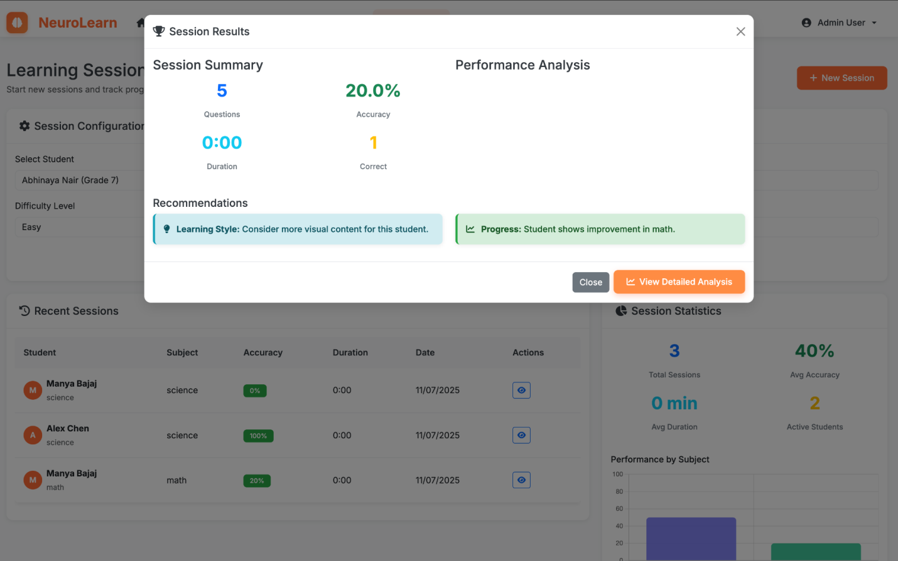

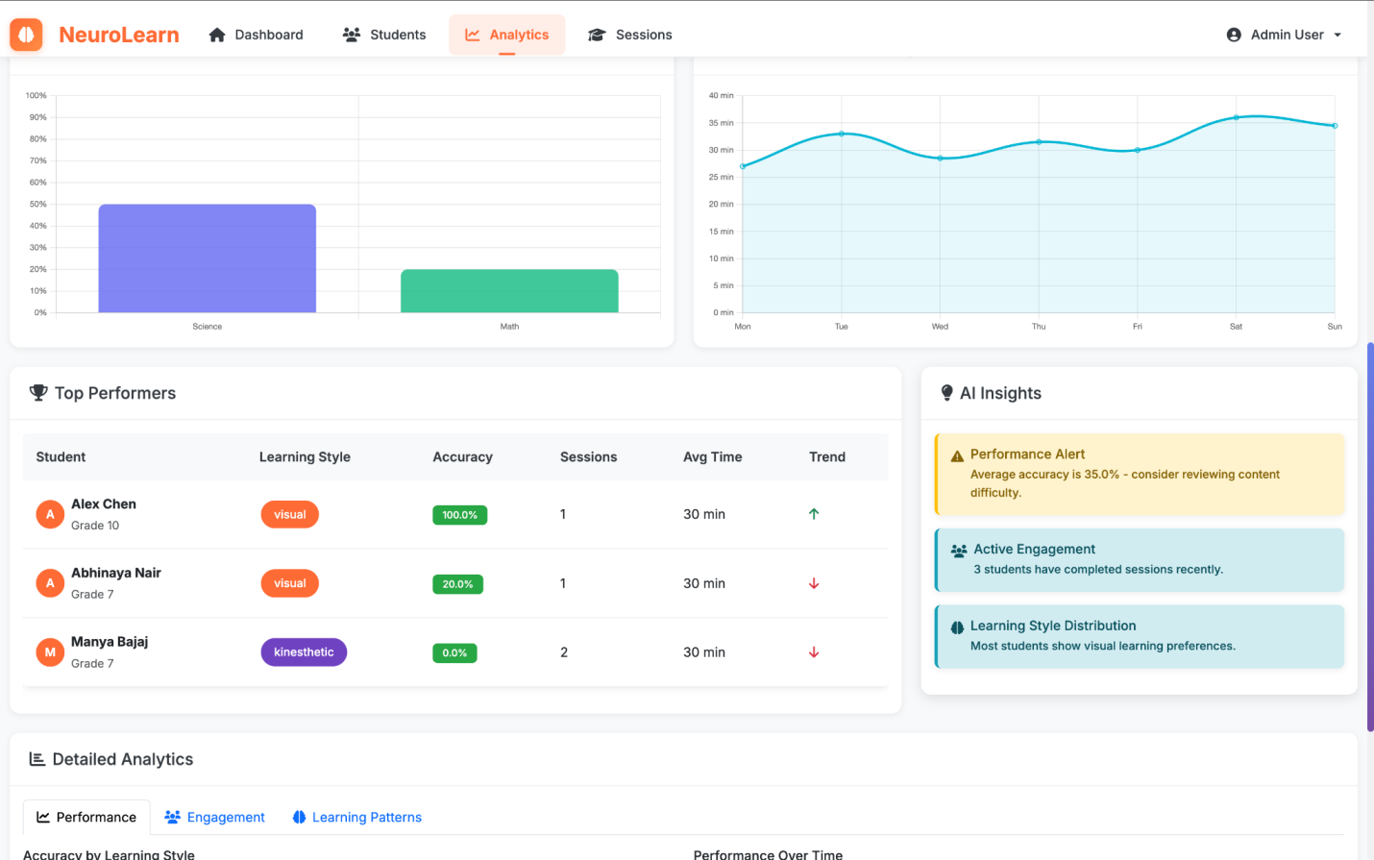

**14. Conclusion**

NeuroLearn represents a significant leap forward in the realm of educational technology. By meticulously integrating cutting-edge artificial intelligence, particularly through the efficient inference capabilities of Intel's OpenVINO toolkit, the platform addresses the long-standing challenge of providing truly personalized education.

From its sophisticated AI-powered learning analysis that discerns individual learning styles and patterns, to its dynamic content delivery mechanisms that adapt in real-time, and its comprehensive analytics that empower both students and educators with actionable insights, NeuroLearn is engineered to foster an environment where every learner can thrive. The robust technology stack, modular architecture, and clear extensibility pathways ensure that NeuroLearn is not just a solution for today's educational challenges but also a future-proof platform ready to evolve with the demands of tomorrow.

NeuroLearn is more than just a piece of software; it is a commitment to a more equitable, engaging, and effective educational future. By harnessing the power of AI, we aim to unlock the full potential of every student, transforming the traditional classroom into a smart, adaptive, and truly personalized learning space.

## **15. License**

This project is licensed under the MIT License.

The MIT License is a permissive free software license originating at the Massachusetts Institute of Technology (MIT). It allows reuse within proprietary software provided that all copies of the licensed software include a copy of the MIT License terms and the copyright notice.

See the LICENSE file in the project repository for full details.

## **16. Acknowledgments**

We extend our sincere gratitude to the following entities and communities for their invaluable contributions and support in the development of NeuroLearn:

* **Intel OpenVINO**: For providing the powerful and efficient AI inference capabilities that are central to NeuroLearn's adaptive engine. Their commitment to optimizing deep learning models for diverse hardware has been instrumental in achieving real-time performance.
* **Bootstrap**: For the robust and responsive UI framework that enabled rapid development of an intuitive and aesthetically pleasing user interface, ensuring accessibility across various devices.
* **Flask**: For the lightweight and flexible web application framework that provided the backbone for NeuroLearn's backend services and API endpoints.
* **scikit-learn, NumPy, Pandas, Matplotlib, Seaborn**: For the foundational Python libraries that underpin our data analysis, machine learning, and visualization components.
* **The Open Source Community**: To all developers, researchers, and contributors who continuously advance the fields of artificial intelligence, web development, and education technology, making projects like NeuroLearn possible.
* **All Contributors and Supporters of Adaptive Learning Technology**: Your dedication to transforming education inspires our work and drives us to innovate further.