**Testing –**

Test Case 1:

Invalid Case -> When admin enters wrong username and password, an error message is displayed.

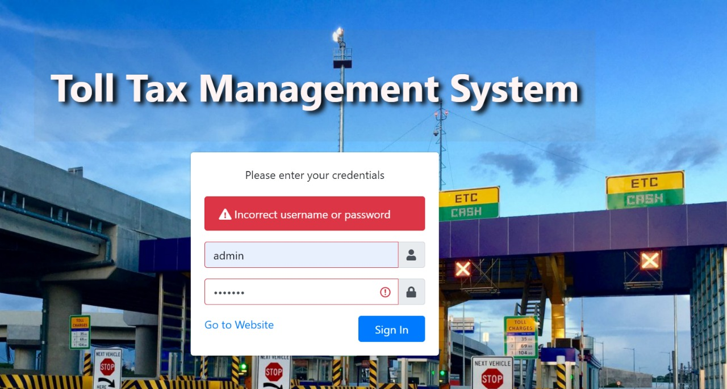

Valid Case -> When admin credentials are correct, it lets the admin into the main page.

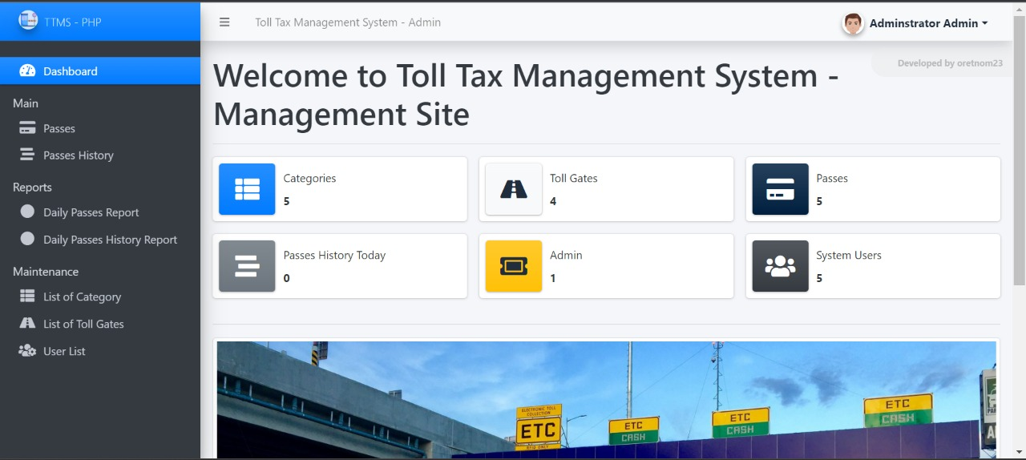

Test Case 2:

Invalid Case -> Toll Gate block is a mandatory field and hence it won’t take blank values.

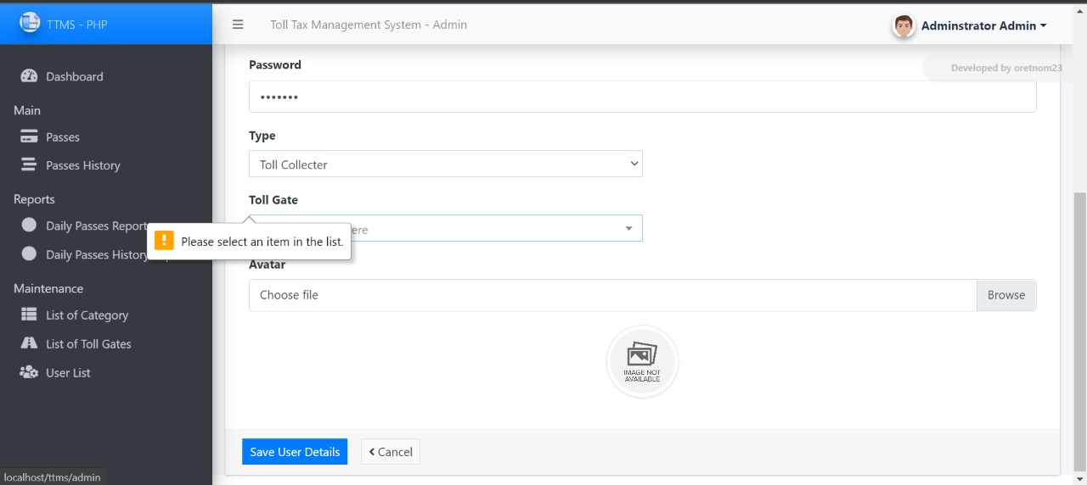

Valid Case -> Toll Gate block is filled with a value.

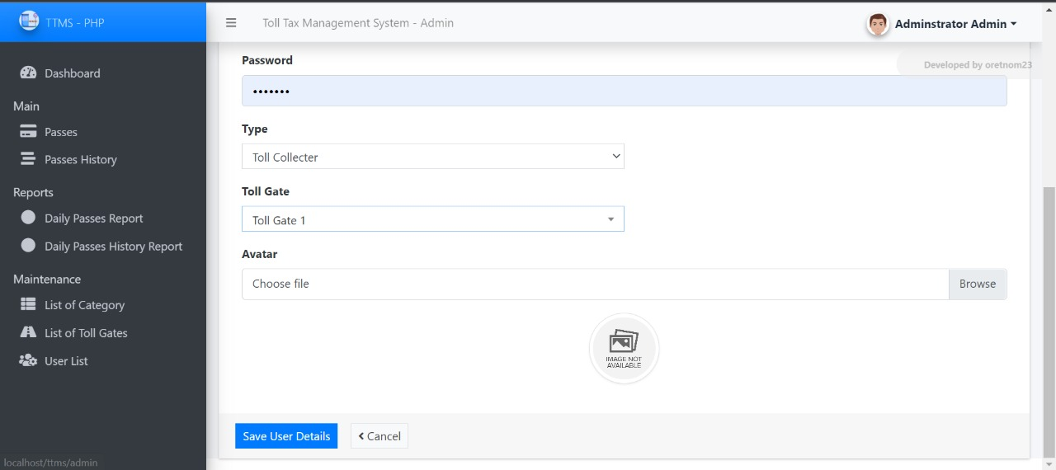

Test Case 3:

Invalid Case -> If a username is present in the user list, then it indicates that the username already exists.

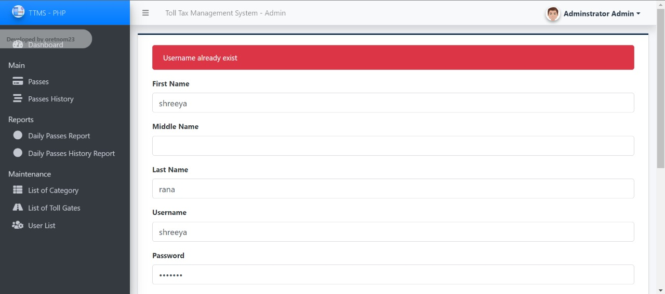

Valid Case -> Else a new user is created in the user list.

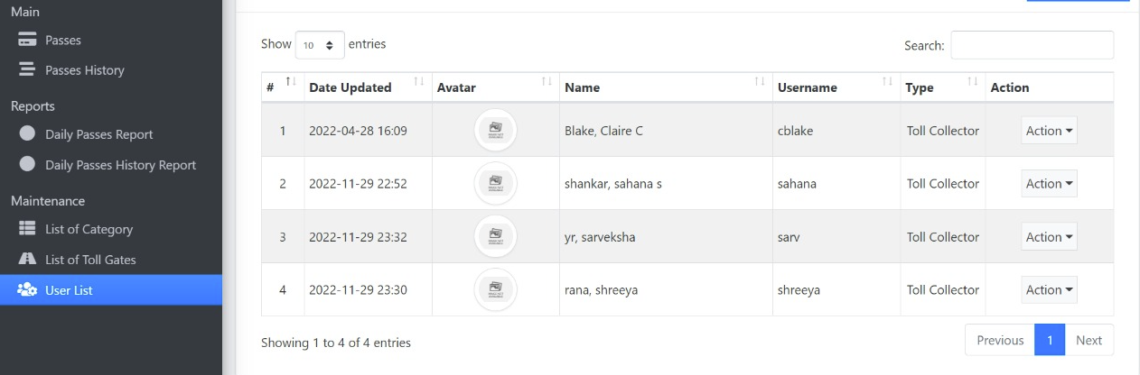

Test Case 4:

Invalid Case -> If @ is not present in the Email ID.

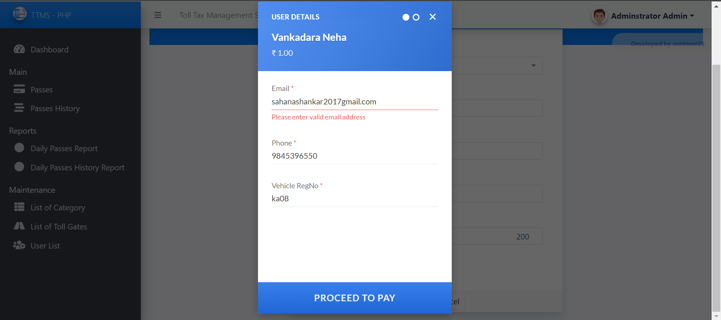

Invalid Case -> If 10 digits are not present in the phone number.

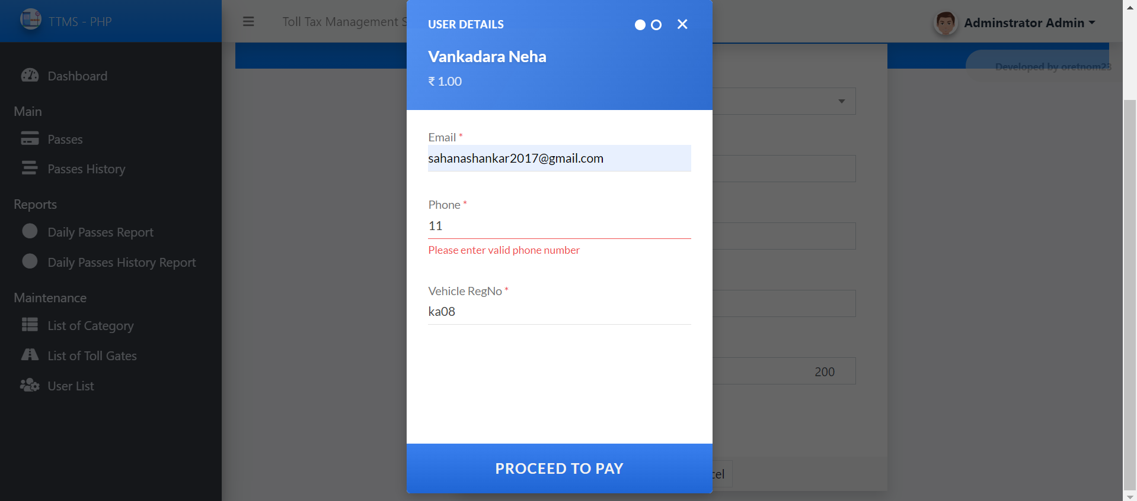

Valid Case -> Payment options displayed.

