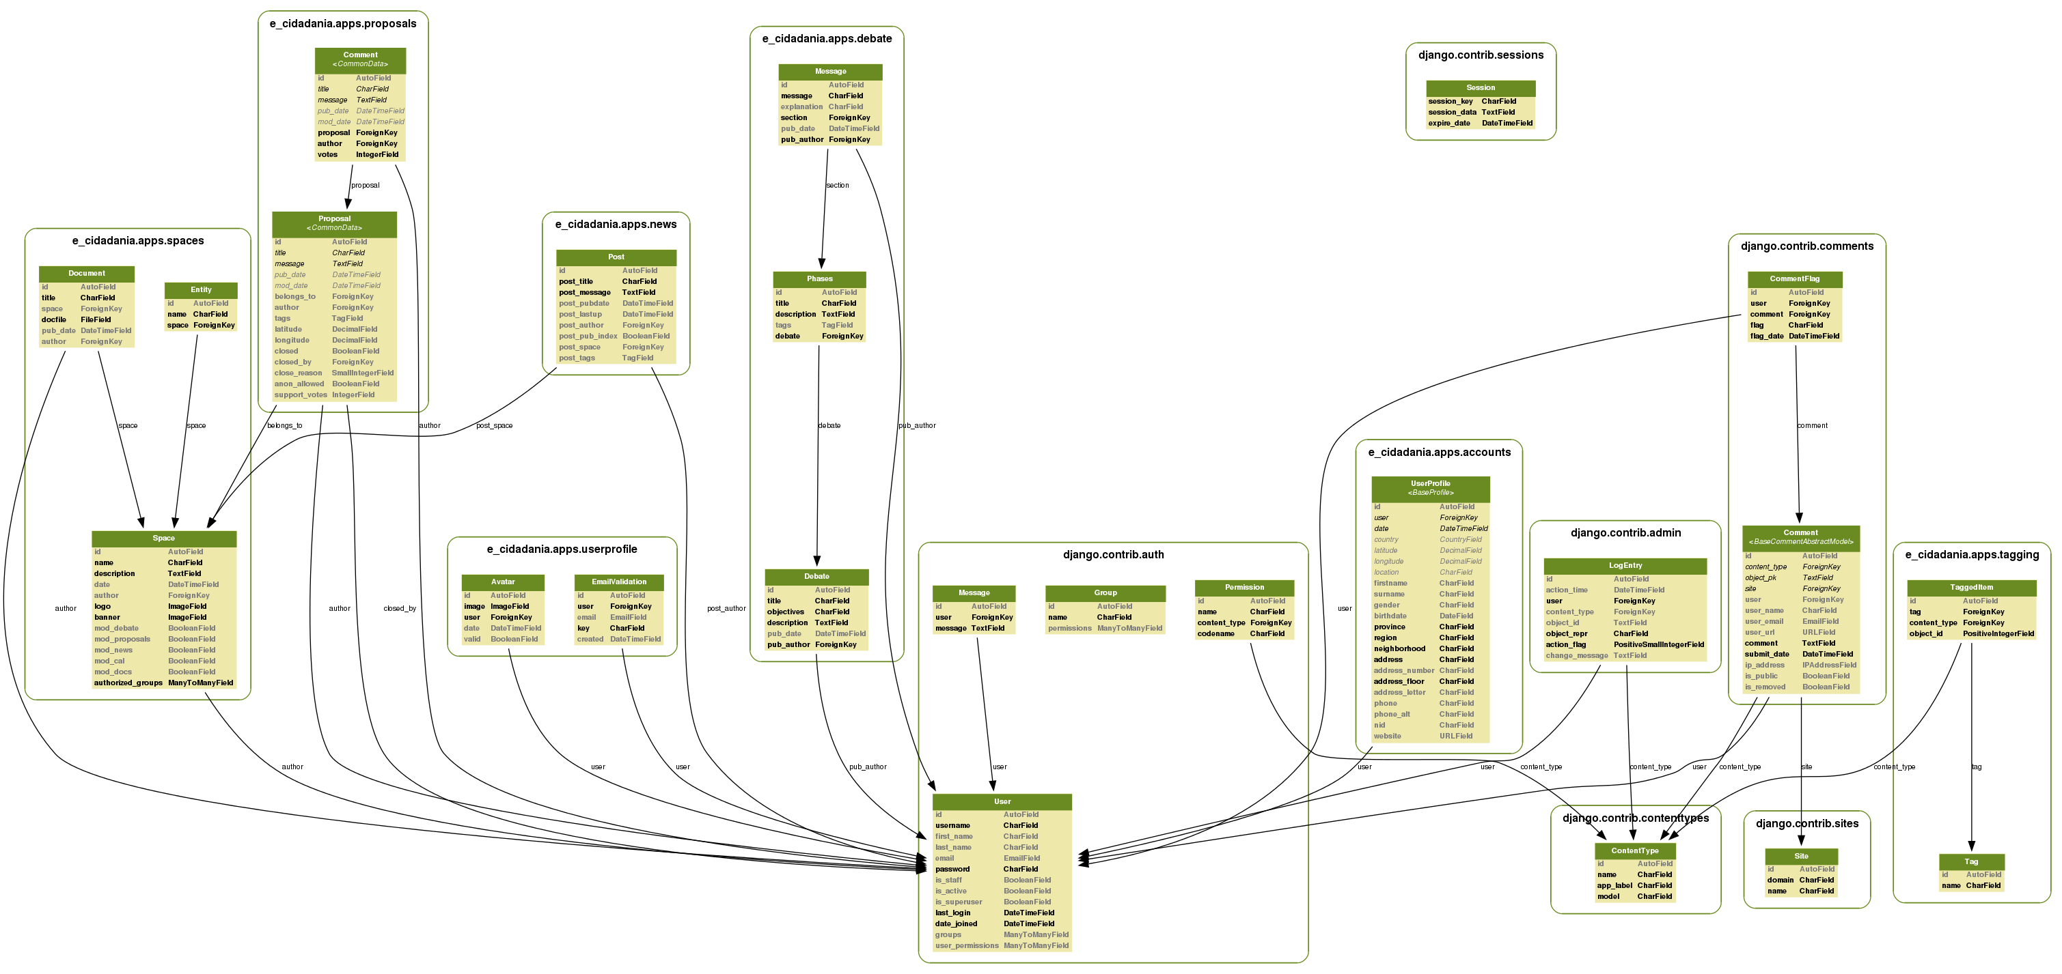
e-cidadania 0.1 ALPHA (March 18, 2011)

Active modules:  - Proposals  - News  - Documents  - Spaces  - User profiles (from django-userprofile)  - Comments (from django.contrib) | Inactive modules:  - Debates | Not implemented:  - SMS  - E-Mail  - Web notifications (via django.messages)  - Initial data (via fixtures)  - Cache  - URL naming

