

Xerauditron Implementation & Reporting SOP Document
Xerago – Digital Analytics


Table of Contents

- What is xeraudition.
- Objectives of Xeraudition
- Key features
- Xerauditron Website Structure & Functions
  - Analyze website
  - Quick links
  - Analyze all the links
  - Form validation
- Tech stack
  - Frontend
  - Backend
  - Database
  - Hosting and Deployment
  - Other tools and Files
- Architecture overview
  - System architecture design
  - Folder structure format
- API Documantation
  - Base URL’s and EndPoints
  - Summary of endpoints
- Setup and Installation Prerequisites
  - Prerequisites
  - Installation Steps
- Usage Guide
  - Step-by-Step Usage Flow
  - Use Cases
  - Best Practices
  - Privacy Note
- Security and Validation
  - Form Validation Security
  - Input Sanitization
  - Authentication & Authorization
- Deployment
  - Deployment Guide
- Limitations and Challenges
  - Crawling Issues
  - QC Limitations
  - Integration & Backend Process Challenges
- Future Enhancement

What is Xerauditron
Xerauditron is a comprehensive web auditing and automation platform designed to analyze, simulate, and validate digital user interactions across websites. While it includes intelligent form extraction and validation capabilities, its core purpose extends beyond form handling to full-spectrum analytics tracking, tag auditing, and automation-based quality assurance.

Objective of Xerauditron
The primary objective of Xerauditron is to automate the auditing of web forms, links, and analytics integrations through intelligent simulation of user interactions. It aims to extract and validate forms, track analytics tag behavior, detect CMS platforms, and log all events in real-time. By emulating real users, Xerauditron helps developers and QA teams ensure accurate form functionality, tag firing, and compliance across digital assets—streamlining validation, reporting, and overall tracking reliability.
Key Features of Xerauditron
🔗 Total Link Collection
Scans and logs all hyperlinks on a given URL, categorizing them for structural or navigational analysis.
⚙️ CMS Tool Detection
Identifies common content management systems (e.g., WordPress, Drupal) and embedded third-party tools to assist in audit reporting and compatibility checks.
🧠 Analytics Tracking Audit: Detects and logs triggers from analytics platforms like Google Analytics, Adobe Analytics, and Matomo.
🛠 Bot-based Automation: Simulates user actions to test form behavior, submission logic, and event tracking.
📈 Real-time Event Logging: Captures timestamped events such as autofill actions, tag fires, and script detections.
📊 Reporting Integration: Exports tracking results and tag behavior data for use in analytics dashboards and QA documentation.
🔍 Form Extraction & Autofill: Automatically identifies and populates web forms for testing input validation and user flow accuracy.

Xerauditron Website Structure & Functions
The Xerauditron interface provides a user-friendly and intuitive platform for performing comprehensive website audits. It enables users to analyze websites for structural links, detect CMS platforms, and validate forms using bot-driven automation — all in one unified dashboard.
Features Highlighted in the UI:
URL input field
Users can paste any website URL to initiate the audit process. The platform includes URL format validation to ensure only valid domains are processed.
Audit Mode Buttons
Analyze Website: Performs a full website audit including CMS detection, analytics tracking, and element inspection.
Quick Links: Extracts all hyperlinks quickly without deeper analysis.
deep analysis: Crawls and audits all linked pages from the root URL.
Form Validation : An feature to enable bot-powered form validation during the audit. When checked, the system automatically identifies and simulates filling in web forms — capturing analytics and validation behaviors.
“Quick Links: Fast link extraction only | Full Analysis: Complete audit with CMS detection, analytics, and element analysis”



A live preview of Xerauditron’s input and control panel.
Enables users to control:
What website to analyze
How deeply to audit it
Whether or not to include intelligent form validation
Combines aesthetics with functional clarity — key for UX success in automation tools.

analyze website:

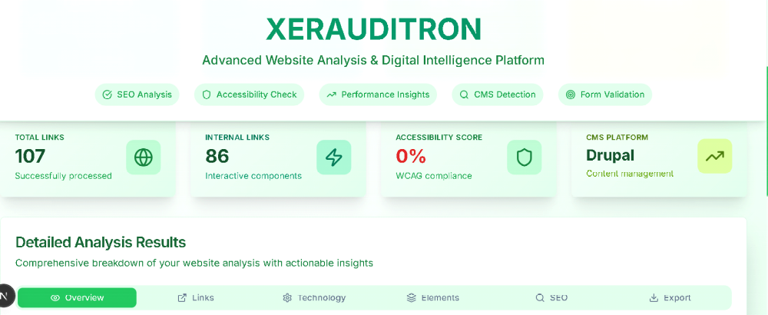

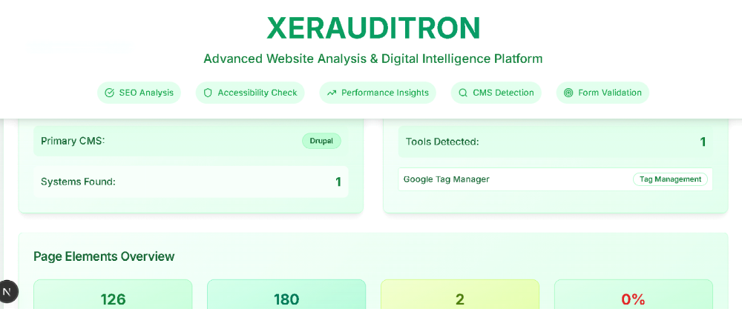

overview of the result
CMS Detected: drupal,Total Links: 107 links found on the page,internal Links:87,External Links:24,Sitemap URLs: 1,Analytics & Tools:2 tools detected (e.g., Google Analytics, Adobe Analytics),2 categories of tools found,Page Elements:Headings: 12 total (including one H1 tag).Forms: 2 (detected on the page).Interactive Elements: 15 (e.g., buttons, inputs).SEO & Accessibility:Accessibility Score: 81%meta Description: PresentAlt Text Coverage: 75% (3 out of 4 images have alt attributes)H1 Tag Usage: Single H1 tag used correctlylet me know if you want this as a downloadable .docx, .pdf, or .pptx format.
internal links:
- internal links of the pasted url should be listed in the website audit webpage with the title of the domain has been in the website.
all the internal links of the pasted URL website page is crawled and listed in the webpage of the xerauditron.
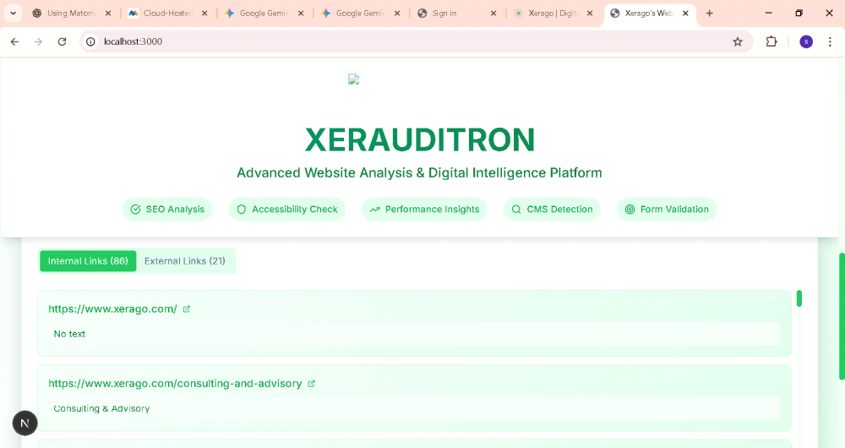

external links:
external links of the pated URL is also listed below in the website of the xerauditron.

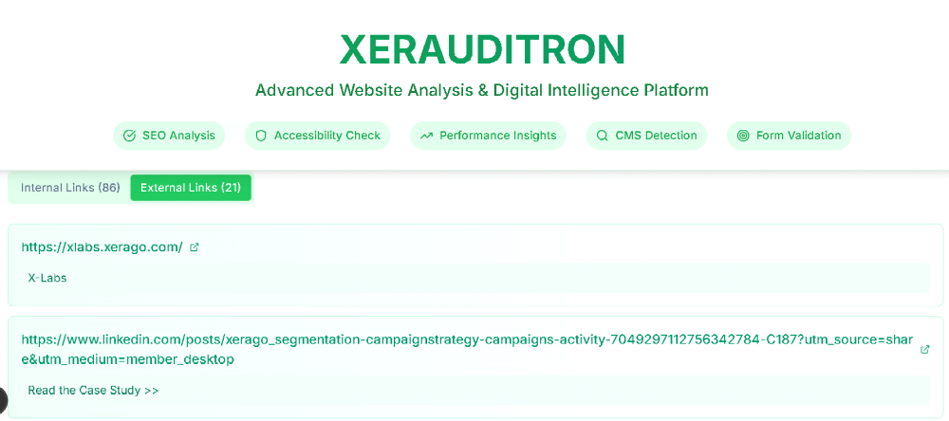

sitemap URLS :
if any sitemap URLs present in the website of the pasted Url is also listed in the header under under the sitemap URLs.
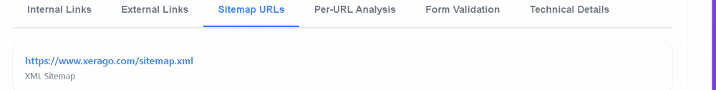

per-URL analysis:
it analyse the every URL and the efficiency of the URL and result in the basics .
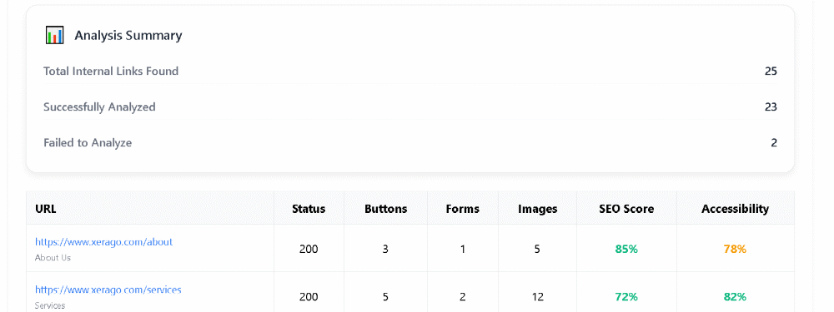

form validation:
from validation result in analysing all the forms of the pasted URL were the URLs which are have forms have been extracted by the website and the URL links are available under form validation.
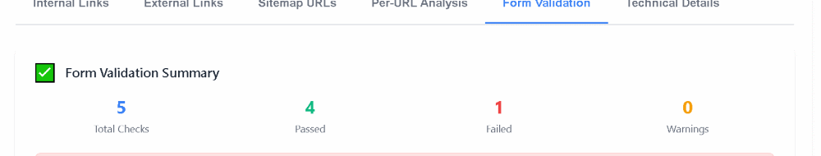
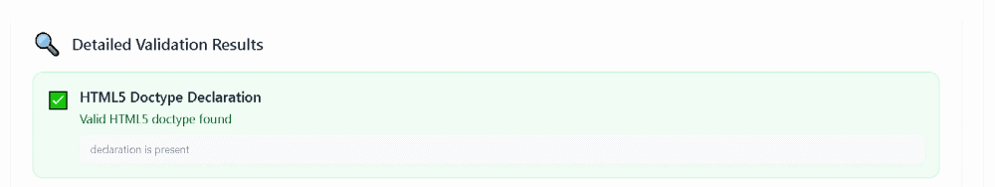

technical details:
technical detail result in the detection of cms detection result, analytics and marketing tools,detail elements analysis which include head structure elements detection , image analysis and accessibility analysis.

Quick links
the "Links Overview" section provides a summary of the website's linking structure . These quick links help enhance user navigation and contribute to search engine optimization by organizing the website’s core content. However, the relatively low number of internal links compared to the total indicates an opportunity to improve internal linking strategies, which can boost both user engagement and crawlability for search engines.

Analyse all links:
all the links of the pasted website has been analysed in the analyse all links session were the analysis of total links, both internal and external links ,sitemap urls are listed with the summary of the link analysis
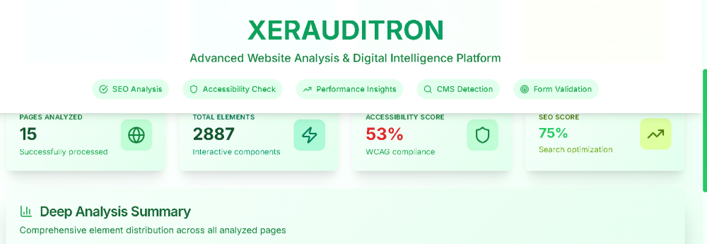
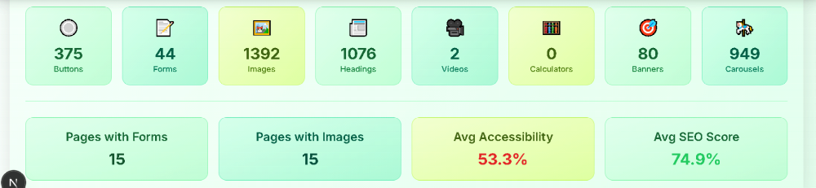

form validation:
>The form validation module in Xerauditron enables automatic detection, analysis, and auditing of forms across a given website.
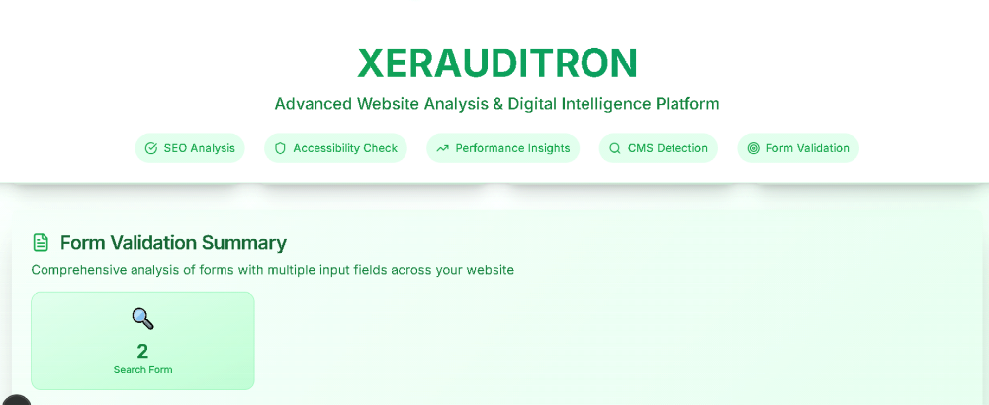
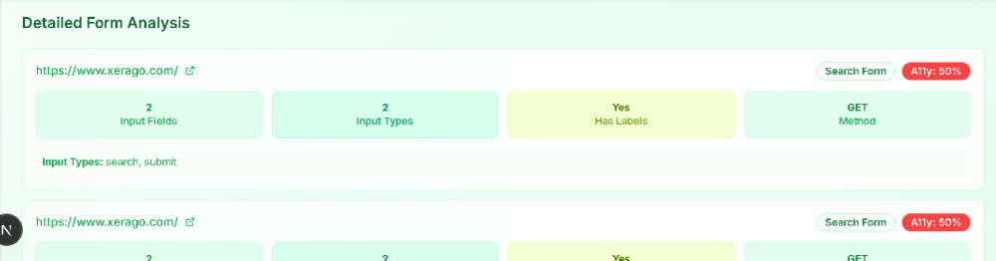
🧾 Form Validation Summary
Clearly displays the total number of detected forms on the audited webpage (e.g., 2 Search Forms found on https://www.xerago.com/).
Provides a comprehensive summary of forms containing multiple input fields.
Uses intuitive icons and large cards to enhance data visibility and user interaction.
result format:
where the analysis results and all the validation result of the auditing information can be downloaded as json format, csv and report as notes for the future use of the documentation

Tech stack:
frontend :
Frontend (User Interface Layer)
Component Description
Framework Next.js – React-based framework for building fast, server-rendered UIs.
Language TypeScript – Offers type safety and better developer tooling.
Styling Tailwind CSS – Utility-first CSS framework for responsive and modern UI styling.
UI Components ShadCN/UI – For consistent, accessible component structures.
Icons Lucide-react – Icon set used across buttons and inputs.
Charting (Optional) Recharts – For future analytics visualization
The frontend handles:
URL input
Form validation toggle
Action buttons (Analyze Website, Quick Links)
Form preview
- Activity logs
Backend:(Server & Automation Logic)
Component Description
Language Python 3.x
Framework Flask-style API (can also be ported to FastAPI)
Automation Engine Playwright (or optionally Selenium) – Automates form extraction and autofill.
HTML Parsing BeautifulSoup (bs4) – Used for parsing the HTML and extracting form elements.
HTTP Requests Requests – Fetches website content for scanning.
Form Analysis Custom Python scripts detect form fields, methods, input types, and labels.
Analytics Detection Regex and JS parsing used to detect Google Analytics, Matomo, and Adobe Analytics scripts.

The backend:
Receives URL input from frontend.
Extracts all forms and input fields.
Validates fields using a bot.
Sends analytics event logs back to the frontend.

database:
Component: Description
Type: None (currently stateless)
Note: In the current version, no database is used. All data is processed in-memory and returned via API.
Future Scope: Can integrate SQLite, MongoDB, or PostgreSQL for storing form data, logs, or reports.
hosting and deployement:
Component Description:
Frontend Hosting: Vercel – Ideal for deploying Next.js frontend.
Backend Hosting: Localhost (for now), but can be deployed using.
other tools and file:
Tool / File Purpose
setup.py, install_minimal.py-Python setup scripts for dependency installation.
requirements.txt-Lists backend dependencies (bs4, playwright, requests, etc.)
run.bat, run.sh-Quick launcher scripts for Windows/Linux environments.
.env (optional)-Used for storing backend configs, API tokens, etc.
Architecture overview :
system architecture diagram:
👤 User (Browser)
|
| [Enters URL, clicks Analyze]
↓
🖥️ Frontend (Next.js + Tailwind)
- URL Input Field
- Buttons:
• Full Analysis
• Deep Analysis
• Form Validation
• Quick Links
- Displays:
> cms tool
> analytics tool
> Extracted Forms
> elements
>buttons,images
>Quick/Internal/External Links
|
| [API calls: /api/form-validation, /api/analyze, /api/quick-links, /api/analyze-all-links]
↓
🌐 Backend (Python Flask/FastAPI style)
|
├── 🔍 Form Extractor (BeautifulSoup4)
├── 🤖 Autofill Bot (Playwright/Selenium)
| └── 📈 Analytics Detector (GA, Adobe, GTM, Matomo)
|
|
├── 🔗 Quick Links Extractor
| └── Finds all internal links on the homepage
|
├── 🔬 Deep Analysis Module
| └── Recursively audits internal links for forms + analytics
|
├── 📊 Full Analysis Module
├── Internal Link Auditor
└── External Link Auditor
|
↓
[Response → Frontend → Renders Forms + Activity Logs + Link Lists]
Folder Structure Format:
xerauditron/
│
├── 📁 frontend/ # Next.js frontend app
│ ├── 📁 components/ # Reusable React components (FormCard, ActivityLog, etc.)
│ ├── 📁 pages/ # Next.js pages (index.tsx, api routes)
│ │ ├── index.tsx/ # Main landing UI
│ │ └── api/
│ │ └── form-validation.ts /# API route to send URL to backend
│ ├── 📁 styles/ # Tailwind or global CSS
│ ├── 📁 public/ # Static assets (icons, images)
│ └── tailwind.config.js # Tailwind CSS configuration
│
├── 📁 backend/ # Python-based backend logic
│ ├── form_extractor.py / # Extracts forms from given webpage
│ ├── autofill_bot.py / # Launches Playwright bot to autofill forms
│ ├── analytics_detector.py/ # Detects GA, Adobe, or Matomo scripts
│ ├── log_generator.py / # Generates activity log messages
│ ├── main.py / # Flask app or FastAPI main entry
│ └── requirements.txt / # Python dependencies
│
├── 📁 scripts/ # Dev and run scripts
│ ├── install_minimal.py # Script to install only needed packages
│ ├── run.sh # Bash script to launch backend
│ └── run.bat # Windows batch script to launch backend
│
├── 📁 test_data/ # Sample HTML files or dummy URLs (optional)
│
├── .env/ # Environment variables for backend
├── README.md / # Project overview and usage guide
└── LICENSE /# (If applicable)
Api documentation of base URL and endpoints :
base URLs:
Base URL:
backend running locally on :
http://localhost: HYPERLINK "http://localhost:5000/"5000 HYPERLINK "http://localhost:5000/"/
If deployed (e.g., on Render, Railway):
https:// HYPERLINK "https://%3cyour-backend-domain%3e/"< HYPERLINK "https://%3cyour-backend-domain%3e/"your-backend-domain HYPERLINK "https://%3cyour-backend-domain%3e/"> HYPERLINK "https://%3cyour-backend-domain%3e/"/
frontend running on:
https://localhost: HYPERLINK "https://localhost:3000/"3000 HYPERLINK "https://localhost:3000/"/
if deployed(dev, vercel v0)
Endpoint Api:
1. POST /api/form-validation
Purpose:
Extracts all forms from the given URL, runs bot-based autofill, detects analytics scripts (GA, Adobe, Matomo), and returns form info + event logs.
Request Example:
POST /api/form-validation
Content-Type: application/json
{
"url": "https://www.example.com/"
}
Response Example:
{
"forms": [
{
"form_type": "Search Form",
"method": "GET",
"input_fields": ["search", "submit"],
"has_labels": true,
"a11y_score": "50%",
"source_url": "https://www.example.com/"
}
],
"logs": [
"✔ Google Analytics detected"
"✔ Adobe Analytics script detected"
],
"cms_detected": "WordPress"
}
2. POST /api/quick-links
Purpose:
Extracts only the list of all hyperlinks from the given URL (used in "Quick Links" button).
response Example:
POST /api/quick-links
{
"url": "https://www.example.com/"
}
Response Example:
{
"links": [
"https://www.example.com/about",
"https://www.example.com/contact",
"https://www.example.com/blog"
]
}
3. POST /api/analyze-all-links
Purpose:
Performs a deep crawl on all internal links from the base URL and performs full audits (form + CMS + analytics detection) on each.
Request:
{
"url": "https://www.example.com/"
}
Response:
{
"total_links": 25,
"forms_detected": 10,
"pages_with_ga": 15,
"cms": "WordPress",
"logs": [...]
}
4. GET /api/health
Purpose:
A basic health check endpoint to verify the backend is live.
Response:
{
"status": "Xerauditron backend is running"
}.

📎 Summary of Endpoints
Method Endpoint Purpose
POST /api/form-validation Extract & autofill forms + log events
POST /api/quick-links Get all links on a webpage
POST /api/analyze-all-links Crawl and audit every internal page
GET /api/health Ping backend to check if it's running
Setup and installation prerequisities:
Xerauditron is a full-stack auditing and form validation tool combining Python automation with a modern Next.js frontend. Below are the steps and requirements to get it up and running on your local machine or server.
Prerequisities:
💻 System Requirements:
OS: Windows / Linux / macOS
RAM: Minimum 4 GB (8 GB recommended)
Python 3.9
Node.js 16+
npm or pnpm (recommended)
📦 Required Software
Tool Purpose
Python 3.9+ Backend server
pip Python package manager
Playwright Automation bot for autofilling
Node.js For building Next.js frontend
Vercel (optional) Hosting frontend (cloud)
Browser (Chrome, Edge) For bot operation (Playwright uses Chromium)
installation steps:
Backend setup:
step1: to run locally :
open cmd: cd xerauditron
Step 2: Set Up the Backend (Python)
python -m venv venv
source venv/bin/activate # On Windows: venv\Scripts\activate
pip install -r requirements.txt
step3:Run the Playwright setup:
playwright install
Step 4: Launch the Backend Server
python main.py
It will start the API at:
http://localhost: HYPERLINK "http://localhost:5000/"5000 HYPERLINK "http://localhost:5000/"/
frontend setup:
step1: Set Up the Frontend (Next.js)
bash: cd xerauditron
step2: pnpm install # or use: npm install
pnpm dev # or: npm run dev
It will start the UI at:
http://localhost: HYPERLINK "http://localhost:3000/"3000 HYPERLINK "http://localhost:3000/"/
step3 : Access the Tool
Visit:
http://localhost: HYPERLINK "http://localhost:3000/"3000
Enter a website URL
Click on “Form Validation” or “Analyze Website”
View extracted forms and activity logs
🧪 Optional (Test the Installation)
Run a sample audit:
POST http://localhost: HYPERLINK "http://localhost:5000/api/form-validation"5000 HYPERLINK "http://localhost:5000/api/form-validation"/api/form-validation
{
"url": "https://www.example.com"
}
You should receive:
Extracted form structure
Analytics tracking detection
with time stamp
optional:
Frontend:
Deploy to Vercel (Next.js-native)
Backend:
Use Render, Replit, or Railway
Run using uvicorn or Flask

Usage Guide:
step by step usage flow:
Step 1: Open the Xerauditron Website
Launch the frontend:
Locally: http://localhost: HYPERLINK "http://localhost:3000/"3000
Deployed (e.g., Vercel): https://xerauditron.vercel.app (if hosted)
Step 2: Enter the Website URL
Paste the full URL of the website you want to audit (e.g., https://www.xerago.com).
Ensure the website is live and publicly accessible.
Step 3: Use Available Functionalities
You’ll see the following main options/buttons:
Button Name Function
Analyze Website - Extracts basic metadata, CMS, and visible forms
Form Validation - Triggers full audit: extract all forms, autofill them, track analytics
Quick Links -Lists all internal page links from the homepage
Analyze All Links -Crawls every internal link and performs batch audits (if implemented)

Step 4: analyze website
The system will render a preview of each page exactly as seen on the live website.
you’ll see:
Form method (GET/POST)
elements button ,forms , links external,internal links
Step 5: View the Activity Log
Each logs detailed steps in real-time.
Example log entries:
Google Analytics detected
cms tool detected
external and internal links
button founds
Adobe Analytics script detected
This helps verify that analytics tracking tools respond properly to user interactions.
Step 6: Analyze CMS and Analytics Tools
Xerauditron also detects:
CMS: WordPress, Joomla, Shopify, etc.
Analytics: Google Analytics (UA/GA4), Adobe Analytics, Matomo
This is shown in summary or metadata results for each site.
Step 7: Advanced Features (Optional)
Track A11y Scores: Accessibility score per form
Detect Missing Labels: For screen-reader compatibility
Download Logs or Reports: (Optional with future DB support)
Use Cases:
Validate your company or client’s web forms
Ensure analytics tools are firing correctly
Perform competitive audits
Prepare for WCAG or GDPR compliance checks
Automate website QA and debugging
Best Practices
Use real domains (not localhost or behind login).
Ensure no CAPTCHA blocks are present.
Allow 10–20 seconds for full analysis (some sites load scripts late).
Use headless mode for faster results (configured in .env).

Privacy Note
Xerauditron does not store any data unless explicitly configured with a database. All form extractions and logs are processed in-memory.
Example Scenario
You want to test whether a contact form on https://example.com/contact is working correctly and if it’s tracked via Google Analytics.
paste the URL in Xerauditron
Click “Form Validation”
Review the form preview
total form links in the url
form links to load to the exact form page
Security and Validation:
Xerauditron has been built with core security principles to ensure that any form extraction, autofill testing, or analytics detection is performed safely, without exposing vulnerabilities. Below is a breakdown of the current and scalable future-ready security mechanisms integrated into the platform.
Form Validation Security:
1. Form Validation (Frontend + Backend)
Frontend (Next.js)
Validates that the user has entered a properly formatted URL (must include http:// or https)
Prevents actions like form submission unless the input passes validation.
Ensures the form controls (like buttons) remain disabled for empty or malformed fields.
security code at frontend:
if (!url.startsWith("http://") && !url.startsWith("https://")) {
alert("Enter a valid URL including https://");
return;
}
Backend (Python)
Checks JSON structure before processing any audit logic.
Verifies the presence and validity of "url" key in all POST requests.
Rejects any malformed or missing payload with 400 Bad Request.
Input Sanitization:
2. Input Sanitization
All URL inputs are stripped of unsafe characters before they’re processed.
Prevents:
XSS (Cross-Site Scripting)
Code injection
Broken automation due to malformed domains
input sanitization:
from urllib.parse import urlparse
parsed = urlparse(user_input_url)
if not parsed.scheme or not parsed.netloc:
raise ValueError("Invalid URL")
Authentication & Authorization:
3. Authentication & Authorization (Scalable Design)
While the current version is public for demonstration/testing, the architecture supports easy integration of auth logic:
to implement in future:
Type Description
Token-Based Auth - Protect backend endpoints with API keys or JWT token headers
Role-Based Access - Admins can see advanced logs, others only limited data
Session Control - Add login/logout functionality using NextAuth or Flask-Login
Deployment :
Deployment Guide:
The Xerauditron platform has a Next.js frontend and a Python backend (Flask or FastAPI). It can be deployed in a distributed or unified fashion using cloud platforms, container services, or CI/CD pipelines.

1. Project Structure :
xerauditron/
├── frontend/ # Next.js + Tailwind UI
├── backend/ # Python + Playwright automation API
├── scripts/ # Launcher scripts
└── .env # Environment variables (per app)
2. Deployment Options:
Component Recommended Host
Frontend - Vercel / Netlify
Backend - Render, Railway, or Replit
Full Stack - Docker (optional) for bundled deployment
3. Environment Setup
other way of deploying insist of local hosting :
Frontend (frontend/.env.local)
env:
NEXT_PUBLIC_BACKEND_URL=https://your-backend-service.com
Backend (backend/.env)
env
PLAYWRIGHT_HEADLESS=true
TIMEOUT_SECONDS=20
ALLOWED_ORIGINS=http://localhost:3000,https://xerauditron.vercel.app
Make sure both frontend and backend have appropriate .env files before deployment.
4. Frontend Deployment (Vercel)
Vercel is ideal for Next.js projects. Automatic build and deploy with GitHub integration.
Steps:
Push frontend/ to GitHub
Go to Vercel.com → Import Project
Choose the frontend repo/folder
Set environment variable:
NEXT_PUBLIC_BACKEND_URL=https://your-backend-service.com
Click Deploy
5. Backend Deployment (Render / Railway)
Render provides fast Flask/FastAPI deployment with background worker support for Playwright.
Steps (Render.com):
Push backend/ folder to GitHub
Go to Render → New Web Service
Link your GitHub repo
Fill deploy settings:
Build Command: pip install -r requirements.txt && playwright install
Start Command: python main.py or uvicorn main:app --host 0.0.0.0 --port 10000
Set environment variables:
From your .env file
Click Deploy
Enable Background Workers if Playwright needs long-running operations.
Limitation and challenges:
Limitation:
Crawling Issue in Xerauditron:
While Xerauditron is equipped with a basic crawling mechanism for analyzing websites, it currently faces several limitations that affect its ability to fully audit and extract data from multi-page websites.
Problem Overview
Xerauditron performs crawling to discover links and analyze deeper pages, but the following issues restrict its effectiveness:
1. Limited Crawl Depth
Description: The crawler does not recursively follow links beyond 1–2 levels from the homepage.
Impact: Many subpages (like nested blog posts, service pages, or product listings) are missed during the analysis.
Example: A form on https://site.com/products/item/details might never be discovered if it’s not directly linked on the homepage.
2. No Dynamic Link Discovery
Description: Xerauditron’s crawler currently relies on static HTML parsing using BeautifulSoup.
Impact: Links that are generated or rendered dynamically via JavaScript (e.g., in single-page apps like React, Angular) will not be seen.
Example: A navigation menu that loads on hover or a “Load More” button will be invisible to the bot.
QC Limitation in Xerauditron:
Despite its strong automation and analytics capabilities, Xerauditron currently lacks dedicated QC mechanisms, which leads to certain functional risks:
1. No Output Verification or Data Accuracy Scoring
Issue: After extracting forms, scripts, or links, there's no automated check to validate the correctness of the extracted results.
Impact: Xerauditron may report false detections or miss subtle issues, especially in complex or script-heavy web environments.
Example: A form partially rendered via JavaScript may be marked as complete or missed entirely.
Challenges:
Challenges in Xerauditron: Integration & Backend Processes
While Xerauditron provides a powerful framework for automated web form validation and analytics tracking, several integration and backend-related challenges can affect its scalability, maintainability, and usability.
1.Frontend-Backend API Communication:
Issue: Requires consistent CORS handling, API versioning, and error management.
Impact: Without proper headers and endpoint stability, frontend components can fail silently or receive unstructured responses.
Analytics Tool Integration:
Issue: Detecting tools like Google Analytics, Adobe Analytics, GTM, or Matomo depends on how the scripts are loaded (inline vs. async).
Impact: Variations in script names or obfuscation can lead to false negatives.
2. Backend Process Challenges
Playwright or Selenium Overhead:
Issue: Browser automation tools are heavy and resource-intensive.
Impact: Slows down performance when multiple users trigger audits simultaneously.
Lack of Asynchronous Processing:
Issue: Most backend tasks are synchronous (blocking).
Impact: Slows down overall execution, especially for Deep Analysis or Full Site Scans.
Future Enhancement:
As Xerauditron continues to evolve, several future-focused improvements can significantly enhance its scalability, accuracy, usability, and overall impact. potential upgrades aligned with analytics, and automation practices.
1. Complete Form Autofill and Submission Workflow
Enhancement: Implement full form interaction — from autofill to actual (test-safe) submission.
Goal: Validate whether the form is not only filled correctly but also accepted and submitted successfully.
Benefit: Ensures complete testing coverage from input to backend connection.
2. Crawl the Entire Website (Multi-Level Deep Crawling)
Enhancement: Introduce a full recursive crawler that explores all internal pages, following multiple levels of internal links.
Goal: Capture hidden or nested forms and embedded analytics tags.
Benefit: Broadens analysis beyond just homepage or shallow pages.
3. Real-Time Activity Log with Analytics Tool Detection
Enhancement: Enhance the logging interface to show:
Time-based events (e.g., GA/Adobe detection)
Script execution
DOM injections
Goal: Visually represent what happens during an audit, step-by-step.
Benefit: Improves user understanding and debugging capability.
4. Form Status Indicators
Enhancement: Add form states such as:
Form Start
Form In Progress
Validation Failed / Validation Passed
Form Submitted
Goal: Help QA teams track form behavior like a real user journey.
Benefit: Simulates UX flow for testers and developers to observe form integrity.

