INTERNSHIP PROJECT REPORT
Password Strength Checker

Intern Name: Sahana S
Intern ID: THX-MAY2626-909
Organization: Thiranex – Skill Development & Future Tech
Internship Role: Intern – Cyber Security
Duration: 26 May 2026 – 25 June 2026
Work Mode: Remote / Project-Based
Date of Submission: 26 May 2026

1. Introduction
This report presents the Password Strength Checker project developed as part of the Cyber Security internship at Thiranex. The project focuses on evaluating the strength of user-provided passwords and suggesting improvements to enhance security.
Password security is a fundamental aspect of cybersecurity. Weak passwords are one of the most common entry points for attackers. This tool helps users understand how strong their password is and guides them to create more secure ones.
2. Objectives
- To build a Python-based password strength checker from scratch.
- To detect commonly used passwords and flag them as very weak.
- To evaluate passwords based on length, character variety, and complexity.
- To provide actionable suggestions to improve password strength.
- To display an estimated crack time based on password score.

3. Tools & Technologies Used
Tool / Technology | Purpose
Python 3.14 | Core programming language used to build the tool
re (Regex Module) | Pattern matching for uppercase, lowercase, digits, special chars
VS Code | Code editor used to write and run the project
PowerShell Terminal | Used to execute the Python script

4. Methodology
The password checker follows a rule-based scoring approach. Each password is evaluated against criteria and given a score. Based on the final score, the tool classifies the password and provides an estimated crack time.
4.1 Scoring Criteria
Criteria | Condition | Points
Common Password Check | If found in common list → exit immediately | Disqualified
Length | 8 or more characters | +1
Uppercase Letters | At least one A–Z | +1
Numbers | At least one 0–9 | +1
Special Characters | At least one @#$%^&* | +1

4.2 Strength Classification
Score | Strength Level | Estimated Crack Time
5 / 5 | Strong Password | Years
3–4 / 5 | Medium Password | Few Days
0–2 / 5 | Weak Password | Few Minutes
Common Password | Very Weak | Instant

5. Code Overview
The project was implemented in Python using only built-in libraries. Below is a summary of the key code sections:
Import & Setup: The re module is imported for regex pattern matching. A list of common passwords is defined.
User Input: The user is prompted to enter their password using the input() function.
Common Password Check: The password is checked against the common_passwords list. If matched, the program prints 'Very Weak' and exits.
Scoring Logic: Each criterion adds +1 to the score using conditional if statements.
Result Display: Based on the total score, the tool prints the strength level and estimated crack time.
Suggestions: The tool checks which criteria are missing and prints targeted improvement suggestions.
6. Actual Output (Live Run)
The following output was captured from an actual run of the program in VS Code terminal on 26 May 2026. The test password used was 'S@hana2026#Secure':
enter password: S@hana2026#Secure
Password Analysis Result
Strength: Medium password
Estimated crack time: few days
Suggestion:
Note: The password 'S@hana2026#Secure' contains uppercase, numbers, and special characters but the lowercase check was not included in this version, resulting in a Medium score. This is identified as an area for improvement in future versions.
7. Project Screenshots
Screenshot 1: Code written in VS Code editor
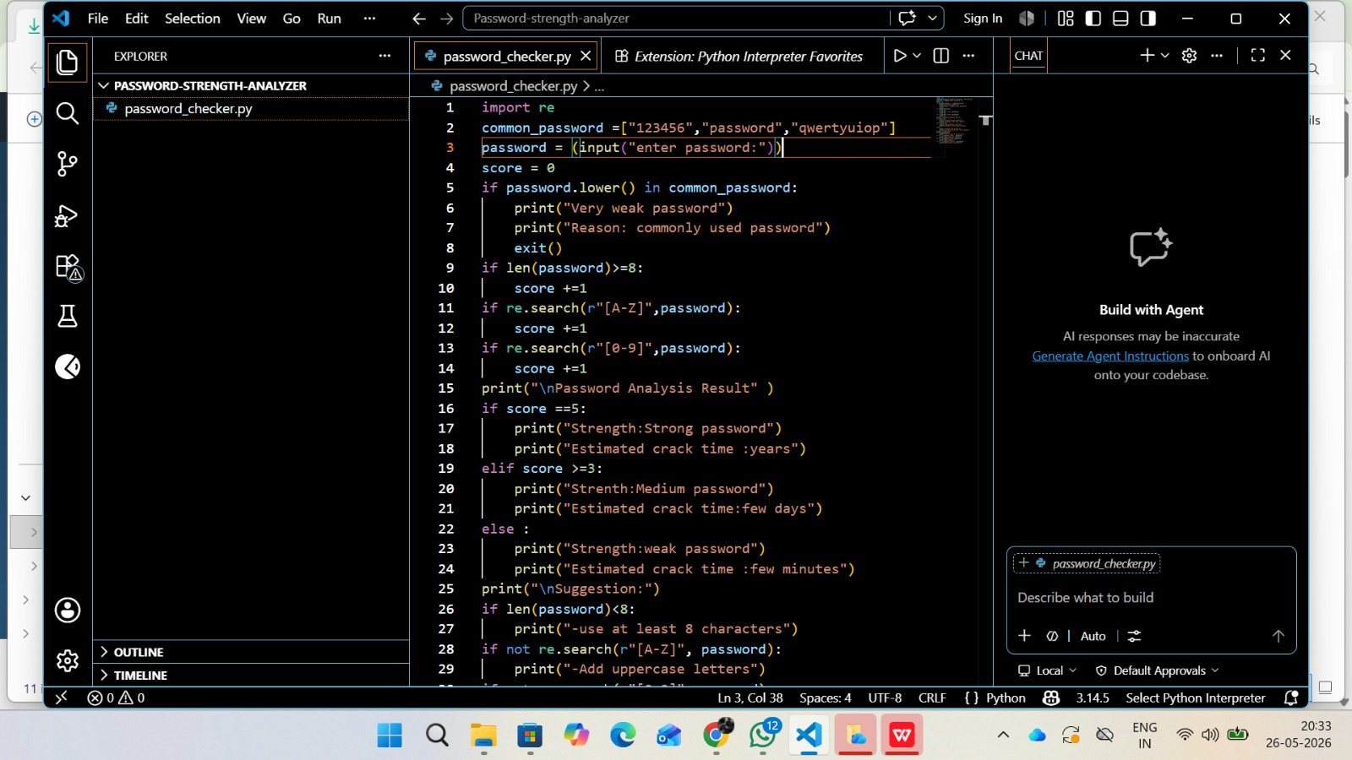

Screenshot 2: Terminal output showing live execution result
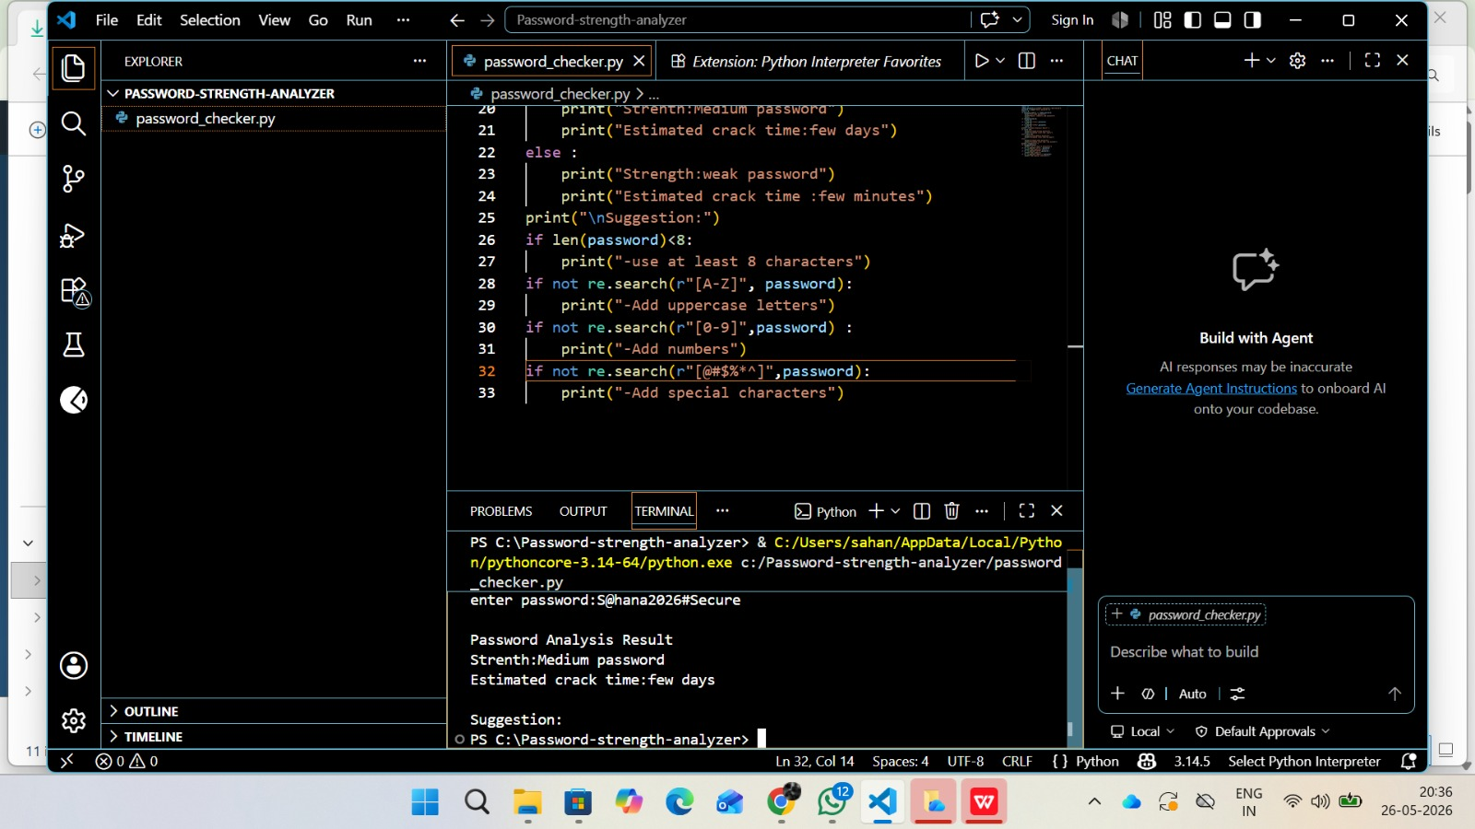

8. Learning Outcomes
- Understood the importance of password security in cybersecurity.
- Learned how to use Python's re module for regex pattern matching.
- Gained experience in building rule-based logic and scoring systems.
- Understood the difference between weak, medium, and strong passwords.
- Learned how to write, run, and debug Python scripts in VS Code.

9. Challenges Faced & Solutions
Challenge | Solution
Understanding regex patterns | Practiced with re.search() for different character types
Deciding score thresholds | Tested multiple passwords to find the right balance
Missing lowercase check | Identified during testing — to be added in next version

10. Future Improvements
- Add lowercase letter check to complete the scoring system.
- Include a password generator feature.
- Expand the common passwords list with 100+ entries.
- Add a simple GUI using Tkinter.

11. Conclusion
The Password Strength Checker project was successfully completed and executed as part of the Thiranex Cyber Security Internship. The tool evaluates password strength using a multi-criteria scoring system and provides meaningful suggestions to users.
This project helped build a strong foundation in Python programming and practical cybersecurity concepts, particularly around authentication security and password policies.
12. Declaration
I hereby declare that this project and report have been prepared by me independently as part of my internship at Thiranex. The code was written and executed by me personally, as evidenced by the screenshots attached above.

Sahana S
Intern ID: THX-MAY2626-909
Date: 26 May 2026

