**Assignment 2**

**package** com.bank;

**import** java.util.Scanner;

//Superclass Animal

**class** Animal {

//Method to print a generic sound made by an animal

**public** **void** makeSound() {

System.***out***.println("The animal makes a sound.");

}

}

//Subclass Dog inherits from Animal

**class** Dog **extends** Animal {

// Override the makeSound() method to provide specific behavior

@Override

**public** **void** makeSound() {

System.***out***.println("The dog barks.");

}

}

//Subclass Cat inherits from Animal

**class** Cat **extends** Animal {

// Override the makeSound() method to provide specific behavior for Cat

@Override

**public** **void** makeSound() {

System.***out***.println("The cat meows.");

}

}

//Main class to run the program

**public** **class** AnimalSoundDemo {

**public** **static** **void** main(String[] args) {

// Create Scanner object to read user input from console

Scanner scanner = **new** Scanner(System.***in***);

**int** choice;

// Loop to repeatedly show the menu until the user chooses to exit

**do** {

//Display menu options

System.***out***.println("\n=== Animal Sound Menu ===");

System.***out***.println("1. Create Animal");

System.***out***.println("2. Create Dog");

System.***out***.println("3. Create Cat");

System.***out***.println("4. Exit");

System.***out***.print("Enter your choice: ");

//read user choice

choice = scanner.nextInt();

// Animal reference for demonstrating polymorphism

Animal animal;

**switch** (choice) {

**case** 1:

// Create a generic Animal object

animal = **new** Animal();

System.***out***.println("\nAnimal created:");

// Call the makeSound() method of Animal class

animal.makeSound();

**break**;

**case** 2:

// Create a Dog object

animal = **new** Dog();

System.***out***.println("\nDog created:");

// Call the overridden makeSound() method of Dog class

animal.makeSound();

**break**;

**case** 3:

// Create a Cat object

animal = **new** Cat();

System.***out***.println("\nCat created:");

// Call the overridden makeSound() method of Cat class

animal.makeSound();

**break**;

**case** 4:

// Exit the program

System.***out***.println("Exiting program...");

**break**;

**default**:

// Handle invalid input

System.***out***.println("Invalid choice. Please try again.");

}

} **while** (choice != 4);// Continue until user selects option 4

// Close the Scanner object to prevent resource leak

scanner.close();

}

}

**Output**

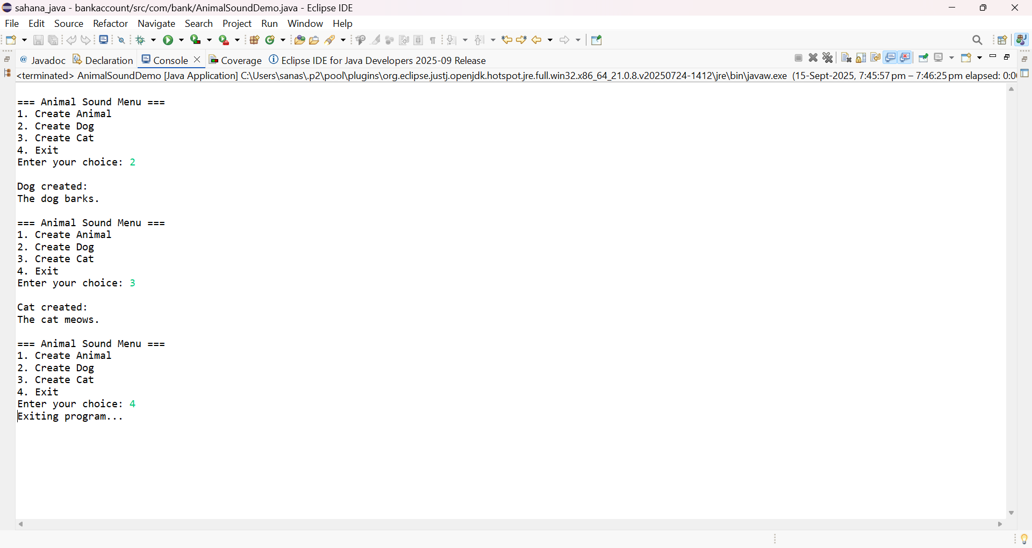

**Assignment 3**

**public** **enum** BankName {

***ICICI***(6.3),

***HDFC***(5.8),

***SBI***(6.0);

**double** interestRate;

/**

* **@param** interestRate

*/

**private** BankName(**double** interestRate) {

**this**.interestRate = interestRate;

}

**public** **double** getInterestRate() {

**return** interestRate;

}

}

**BankAccount Class implementation**

public class BankAccount {

private double accountBalance;

private String accountHolderName;

private BankName bankName;

/**

* @param accountBalance

* @param accountHolderName

* @param bankName

*/

public BankAccount(double accountBalance, String accountHolderName, BankName bankName) {

super();

this.accountBalance = accountBalance;

this.accountHolderName = accountHolderName;

this.bankName = bankName;

}

public double getAccountBalance() {

return accountBalance;

}

public void deposit(double amount) {

if (amount > 0) {

accountBalance += amount;

System.*out*.println(amount + " deposited into " + bankName + " account of " + accountHolderName);

} else {

System.*out*.println("Invalid deposit amount.");

}

}

// Method to withdraw money

public void withdraw(double amount) {

if (amount > 0 && amount <= accountBalance) {

accountBalance -= amount;

System.*out*.println(amount + " withdrawn from " + bankName + " account of " + accountHolderName);

} else {

System.*out*.println("Invalid withdrawal amount or insufficient balance.");

}

}

// Display account details

public void displayAccountInfo() {

System.*out*.println("Account Holder: " + accountHolderName);

System.*out*.println("Bank Name : " + bankName);

System.*out*.println("Balance : " + accountBalance);

System.*out*.println("-------------------------------------------");

}

public class BankAccountDemo {

public static void main(String[] args) {

// TODO Auto-generated method stub

// Create three bank accounts

BankAccount account1 = new BankAccount("Alice", "ICICI", 1000);

BankAccount account2 = new BankAccount("Bob", "HDFC", 2000);

BankAccount account3 = new BankAccount("Charlie", "SBI", 3000);

// Perform transactions on account1

account1.deposit(500); // Deposit money

account1.withdraw(200); // Withdraw money

account1.displayAccountInfo();

// Perform transactions on account2

account2.deposit(1000);

account2.withdraw(500);

account2.displayAccountInfo();

// Perform transactions on account3

account3.deposit(1500);

account3.withdraw(1000);

account3.displayAccountInfo();

}

}

}

**Main Class:**

**public** **class** Main {

**public** **static** **void** main(String[] args) {

// Creating three BankAccount objects with initial balance, account holder name, and associated bank enum

BankAccount account1 = **new** BankAccount(12000, "Sahana", BankName.***SBI***);

BankAccount account2 = **new** BankAccount(15000, "Preetu", BankName.***ICICI***);

BankAccount account3 = **new** BankAccount(10000, "Shwetha", BankName.***HDFC***);

// Display account info and calculate interest for 3 years

account1.displayAccountInfo();

account1.calculateInterest(5);

// Print a separator for clarity in output

System.***out***.println("---------------------------");

// Display account information for account2 and calculate interest for 5 years

account2.displayAccountInfo();

account2.calculateInterest(9);

// Print a separator for clarity in output

System.***out***.println("---------------------------");

// Display account information for account3 and calculate interest for 2 years

account3.displayAccountInfo();

account3.calculateInterest(4);

}

}

**Output:**

