**KEYWORD BASED EXPLORATION OF LIBRARY SOURCES**

**Sahana H1, Sangeetha S K2, Amrutheshwari V S3, Sunitha Gahana4**

1Presidency School of Computer Science and Engineering, Presidency University, Bangalore, India

---------------------------------------------------------------------***---------------------------------------------------------------------

**Abstract -** The project, Keyword-Based Exploration of Library Sources focuses on developing a web-based platform tailored for efficient access to medical research papers. Utilizing advanced keyword extraction techniques, the platform enhances search precision, allowing users to find relevant academic resources with minimal effort. The system incorporates dual module, Admin and User, to streamline paper management and access. Administrators can upload, update, and delete research papers, ensuring the repository remains up-to-date, while users can securely search, view, and download papers. By employing metadata-driven search mechanisms and integrating robust security measures, the platform addresses limitations in existing systems, such as restricted access, inefficient search algorithms, and fragmented repositories. This project aims to bridge the accessibility gap in medical research, fostering a global academic community that benefits from shared knowledge.

***Key Words*:** keyword-based, medical research, fragmented repositories, global academic community, shared knowledge.

**1. INTRODUCTION**

Efficient access to medical research is critical for fostering academic growth and innovation. However, existing platforms often face challenges, such as subscription barriers, limited keyword search functionalities, and disjointed repositories [1][2]. These obstacles hinder researchers, particularly students and professionals without institutional access, from retrieving relevant academic papers. The proposed platform, "Keyword-Based Exploration of Library Sources," aims to address these challenges by implementing advanced keyword extraction and metadata tagging techniques. Inspired by the findings of Xie (2023), the system integrates keyword-based intelligence to optimize the user experience [1]. By combining highlights and abstracts as proposed by Zhang and Zhao (2024), the platform improves search precision and relevancy [2]. This project incorporates a dual-module design. The Admin module ensures seamless management of research papers through features like secure upload, update, and deletion. The User module allows researchers to securely log in, search for papers using keywords, view metadata, and download relevant resources. Metadata-driven search enhances the precision of retrieval, overcoming limitations of traditional systems [3].

Additionally, the platform prioritizes security. Drawing from the work of Gupta and Choudhury (2022), robust authentication mechanisms are implemented to safeguard sensitive data [4]. These features collectively make the platform a comprehensive solution for accessing and managing medical research resources. By addressing the limitations of existing systems and incorporating state-of-the-art technologies, this project aims to simplify the process of exploring medical research, thus contributing to a more accessible and interconnected academic community.

### 2. LITERATURE SURVEY

The primary focus of this literature survey is to explore existing technologies and methodologies in keyword extraction, academic content management, and secure data access within digital libraries. It highlights the limitations of current systems and suggests potential solutions for creating a more efficient platform for accessing research papers. Key areas of investigation include keyword extraction techniques, academic search system optimization, secure access and content management, and user interface design to enhance user experience.

**Review of Related Works:**

Xie, Ruixia et al. [1] in this paper explores the integration of keyword extraction with topic analysis and literature recommendations based on topic similarity. The system achieved a high accuracy rate of 86.36% and a recall rate of 67.29%, outperforming traditional methods. This paper reviews the effectiveness of keyword-based recommendations in libraries, although it faced challenges with lower recall due to a high similarity threshold. It underscores the significance of robust keyword extraction algorithms, offering valuable insights for enhancing search functionality and paper recommendations in the Keyword-Based Exploration of Library Sources project.

Yi, Xinyi et al. [2] in this paper propose an approach to enhance keyword extraction from academic articles using highlights. By employing iterative graph algorithms for unsupervised keyword extraction, the study combines article highlights with abstracts to improve keyword accuracy and relevance. This paper reviews how this approach achieved better keyword coverage, although highlights alone were insufficient for broad representation. The study offers valuable insights for optimizing keyword-based searches in the proposed platform by improving the precision of extracted keywords from research papers.

Sellami et al. [3] in this paper introduce a faceted search system to enhance the exploration of enterprise knowledge graphs using the KGMap algorithm based on semantic similarity. The methodology involved query rewriting to improve search accuracy and efficiency, resulting in increased precision and recall in heterogeneous data environments. This paper reviews how implementing faceted search or similar advanced filtering options could be a future enhancement for the keyword-based search functionality of the platform, allowing for more refined and targeted searches.

McGill et al. [5] in this paper focus on creating and augmenting keywords for extended reality environments using a Keyword Augmentation Toolkit. The study improved usability in extended reality by visualizing shortcuts and keyword mappings. This paper reviews how the approach was useful for 3D environments but faced usability challenges related to familiarization and icon ambiguity. The study highlights that the use of keyword augmentation techniques could enhance the search usability and interface design of the library exploration system.

Sharon Bratt [6] in this paper explores search session patterns in an image-based digital library using the CM-CLASP algorithm for session behaviour analysis. The study uses network analysis and sequential pattern mining to identify user behaviours during search sessions in digital libraries. This paper reviews how the system identified distinct session patterns, though generalizability was limited due to dataset specificity. The insights help refine the keyword-based search mechanism of the platform, making it more responsive to common user search patterns and improving the overall user experience.

Lee et al. [11] explored secure online systems for managing and accessing academic papers. Their study highlighted the importance of integrating encryption and user authentication mechanisms to ensure data protection. The proposed system demonstrated improved security and efficiency in accessing academic resources, addressing common challenges like unauthorized access and data breaches. The research provides valuable insights for designing robust security features in the proposed platform, ensuring safe and reliable access to medical research papers.

Elahi et al. [12] conducted a comprehensive survey on the role of metadata in academic search systems. The study emphasized how standardized metadata enhances searchability and categorization in digital libraries. However, they identified challenges related to inconsistent metadata standards, which can lead to inefficiencies in retrieval. This research underscores the critical role of metadata in optimizing the functionality and usability of the keyword-based exploration platform, guiding its integration to improve search accuracy and resource organization.

**3. EXISTING METHODS**

3.1 Accessibility and Organization in Digital Libraries

The accessibility and organization of digital libraries have undergone significant evolution over the years, with various approaches aimed at improving keyword extraction, user interfaces, and security. Despite these advancements, persistent challenges continue to limit the efficiency and usability of such systems, necessitating further exploration of innovative solutions.

3.2 Advancements in Keyword Extraction

Keyword extraction has been a focal point for enhancing the functionality of digital libraries. Ruixia Xie (2023) introduced a novel algorithm that combined topic analysis with literature recommendations, achieving high accuracy in identifying relevant academic resources. However, the strict similarity thresholds employed in the algorithm limited its recall, reducing its effectiveness in identifying diverse research topics [1]. Zhang and Zhao (2024) further enhanced keyword extraction by integrating article highlights with abstracts. Using iterative graph algorithms to measure word importance, their approach significantly improved retrieval precision. Nonetheless, relying solely on highlights proved insufficient for providing adequate keyword coverage, indicating the need for more comprehensive methods [2].

3.3 User-Centered Exploration Tools

The introduction of user-centered tools has improved the exploration of digital libraries, especially in specialized applications. For instance, the Keyword Augmentation Toolkit (McGill et al., 2022) enhanced search capabilities in extended reality environments by enabling visual keyword shortcuts. While these tools offer usability improvements, their effectiveness depends heavily on user familiarity with the interface [3]. Earlier work by Baldonado (2001) highlighted the benefits of clustering and citation comparisons in improving search fluidity. However, the inability of such interfaces to detect complex relationships among documents limited their applicability for multi-disciplinary research [4].

3.4 Digital Libraries for Medical Research

Medical research repositories such as PubMed and IEEE Xplore offer vast collections of resources but are often hindered by significant limitations. Restricted access due to institutional subscriptions and the complexity of search mechanisms pose barriers for users without technical expertise (Kumar et al., 2021) [5]. Patel et al. (2023) identified additional shortcomings, such as gaps in user interface design, metadata usage, and filtering capabilities. These findings underscore the need for medical research platforms that are both accessible and comprehensive, particularly for non-specialist users [6].

3.5 Role of Metadata and Security

Metadata serves as a critical element in academic search systems, enabling better searchability and categorization of resources. As noted by Elahi et al. (2022), properly tagged metadata enhances retrieval efficiency and improves the overall user experience. However, inconsistencies in metadata standards often lead to inefficiencies in resource discovery [7]. On the security front, Gupta and Choudhury (2022) proposed advanced techniques to ensure privacy and data integrity in medical repositories. While these methods address issues such as unauthorized access and data breaches, they require continuous updates to adapt to emerging threats [8].

3.6 Limitations in Current Platforms

Despite significant advancements, existing digital library platforms still suffer from various limitations. Fragmented access to resources often requires users to navigate multiple systems, making it challenging to gather comprehensive information. Search mechanisms frequently demand specific knowledge of Boolean operators and advanced filters, creating a barrier for non-technical users [9]. Additionally, the lack of integration between repositories reduces efficiency, particularly for interdisciplinary research.

**4. METHODOLOGY**

The proposed system tackles the limitations of existing methods by designing a platform specifically for keyword-based exploration of medical research papers. It incorporates intuitive user interfaces, advanced search functionalities, and secure access to enhance usability and effectiveness.

4.1 System Architecture

The platform adopts a modular design that ensures scalability and ease of maintenance. Advanced keyword extraction algorithms [1][2] are integrated with a metadata tagging system [3] to enhance search accuracy and streamline resource categorization. The frontend features a responsive and user-friendly interface developed using modern web technologies, enabling seamless navigation and interaction. The backend employs a robust database management system capable of supporting real-time search queries and secure storage of research papers.

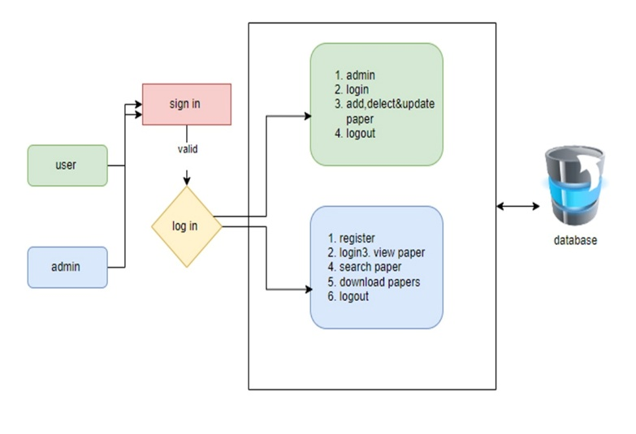

**Fig 1:** System Architecture

4.2 Keyword Extraction and Search Mechanisms

The platform incorporates cutting-edge algorithms and enhanced filtering techniques to improve search functionality. Iterative graph-based algorithms [2] and keyword augmentation techniques [4] are utilized to provide accurate and relevant search results. Metadata tagging [3] facilitates efficient filtering by publication year, author, and research domain, simplifying user searches. Furthermore, dynamic filters allow personalized search options, making it easier for users to discover specific resources.

4.3 User-Centric Design

The platform's interface is designed based on Baldonado’s user-centered approach [5], prioritizing simplicity and customization. It includes a dashboard that enables users to search, view, and download research papers effortlessly. Additionally, personalization features allow users to save search preferences and bookmark favorite papers for quick access.

4.4 Administrative Features

The Admin module is equipped with tools for efficient content management. Administrators can upload and organize research papers along with their metadata, update or remove outdated resources, and monitor user activity. This module also includes functionalities for managing access rights, ensuring that the system remains organized and secure.

4.5 Security and Authentication

To safeguard user data and maintain system integrity, the platform implements robust security measures. Two-factor authentication [6] is employed for secure login, preventing unauthorized access. All data exchanges are encrypted to maintain confidentiality and integrity. Automatic session timeouts further enhance security by mitigating risks associated with user inactivity.

4.6 Testing and Validation

The platform undergoes comprehensive testing to ensure its reliability and functionality under various scenarios. Unit testing is conducted to validate individual components, such as the search algorithm and metadata handling [7]. Integration testing ensures seamless interaction between user and admin modules. Finally, beta testing is conducted with researchers to gather feedback and refine the platform for optimal performance.

By integrating state-of-the-art technologies with a user-focused approach, the proposed system addresses existing gaps in medical research platforms, making academic resources more accessible, user-friendly, and secure for researchers worldwide.

**5. RESULTS & DISCUSSIONS**

5.1 User Module

The User Module is designed to facilitate access to medical research papers for students, researchers, and other users. Key functionalities of this module include registration, login, paper viewing, searching, downloading, and logout. For registration, a new user must provide essential information such as a username, password, and email address to create an account. Once registered, the user can log in by entering their credentials, which grants access to their personalized account and the platform’s functionalities. After logging in, users can view the list of available research papers, each with relevant metadata such as the title and publication year. Users can click on a specific paper to view detailed information and download the file, typically in PDF format, for offline viewing. To ensure security, users can log out at any time, ending their session and preventing unauthorized access from the same device.



Figure 2: User Home Page



Figure 3: About Page

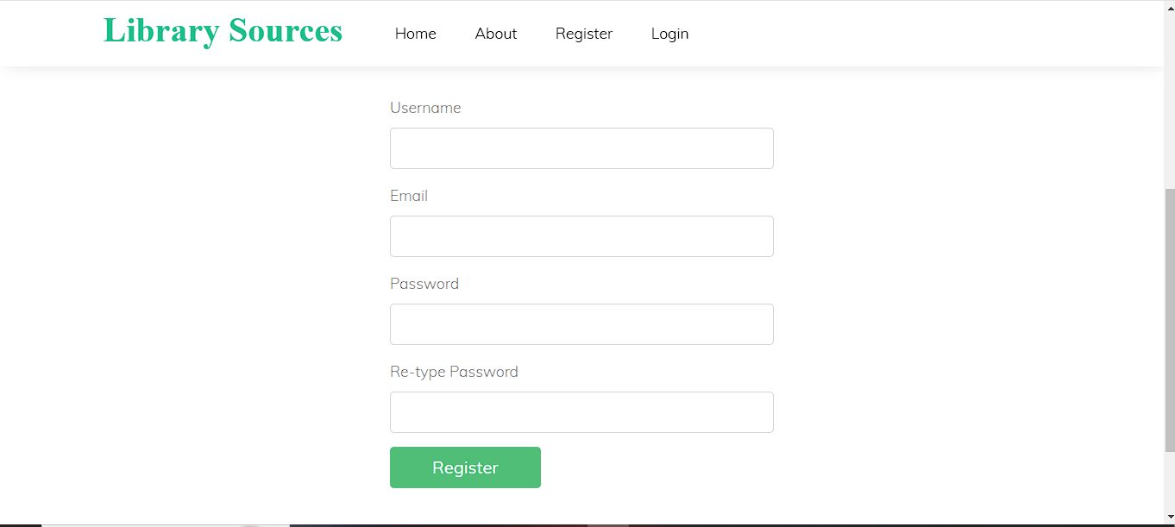

Figure 4: Register Page

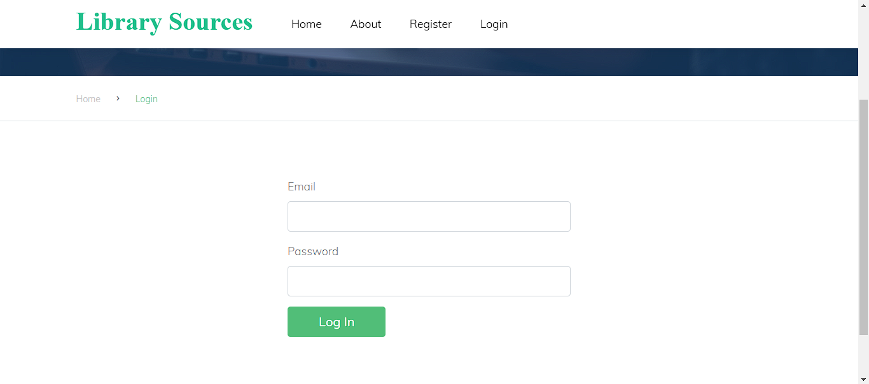

Figure 5: Login Page

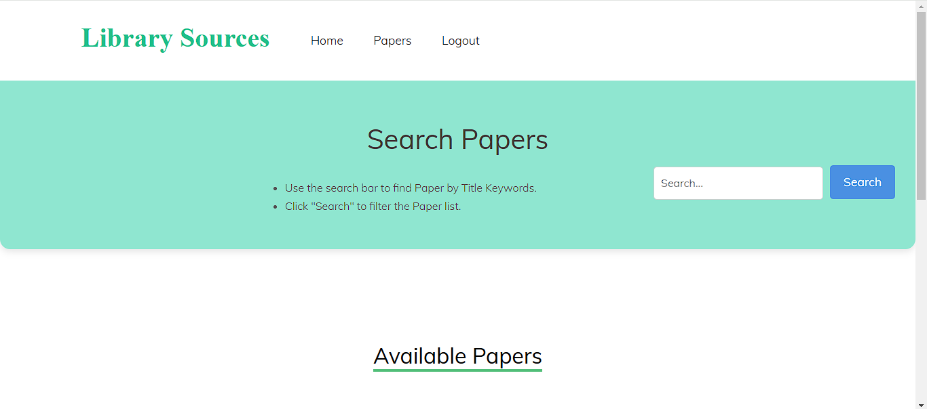

Figure 6: Search Papers

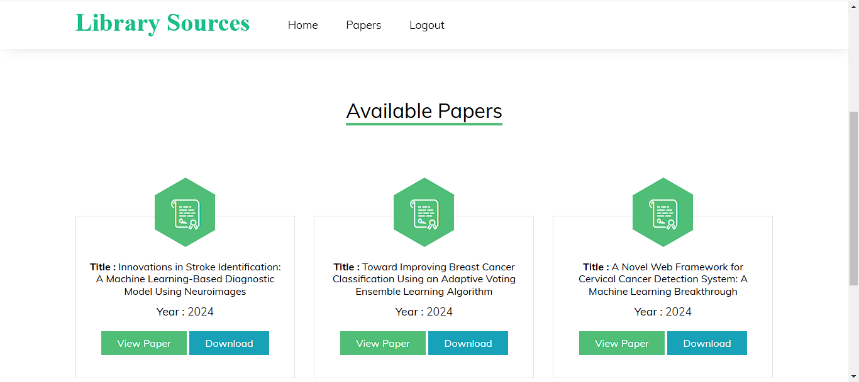Figure 7: View Papers here

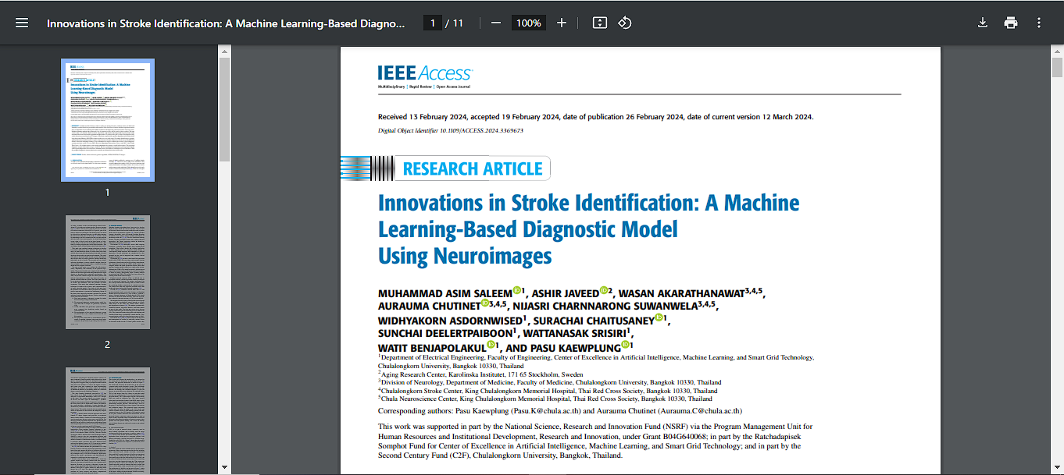

Figure 8: View Individual Paper

5.2 Admin Module

The Admin Module enables platform administrators to manage all content, including adding, updating, and deleting research papers, as well as overseeing user management and other administrative functions. Admins access the platform using their credentials and are directed to the admin dashboard after logging in. From there, they can add new research papers by selecting the file (typically PDF or Word format) and entering metadata such as title, authors, publication date, and keywords. The system then stores the paper in the database, making it available to users. Administrators also can delete outdated or irrelevant papers from the platform by selecting the paper to be removed and confirming the action. After completing administrative tasks, the admin can log out to ensure the security of their session.



Figure 9: Admin Home Page

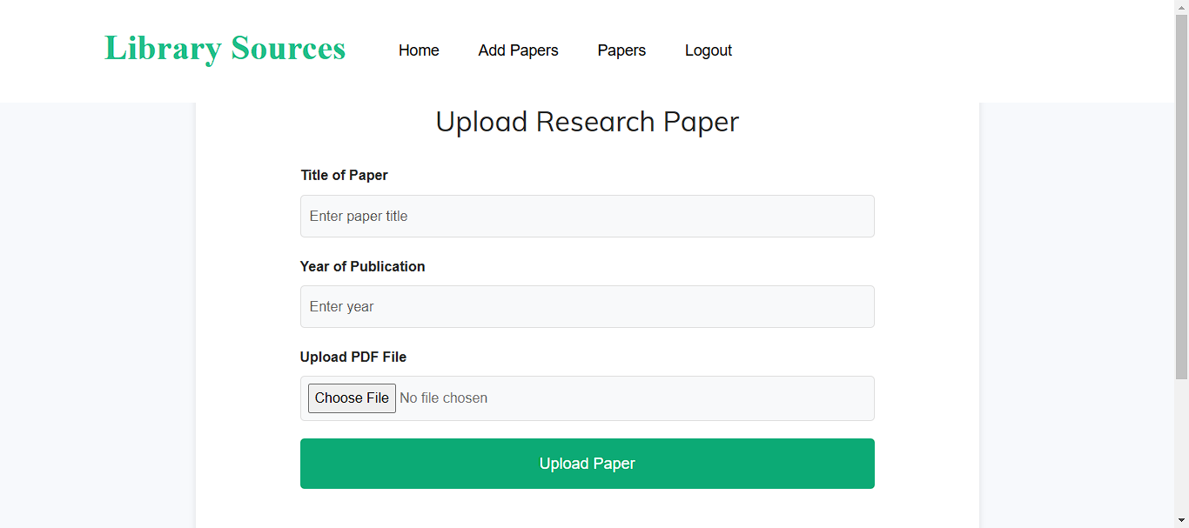

Figure 10: Upload Papers

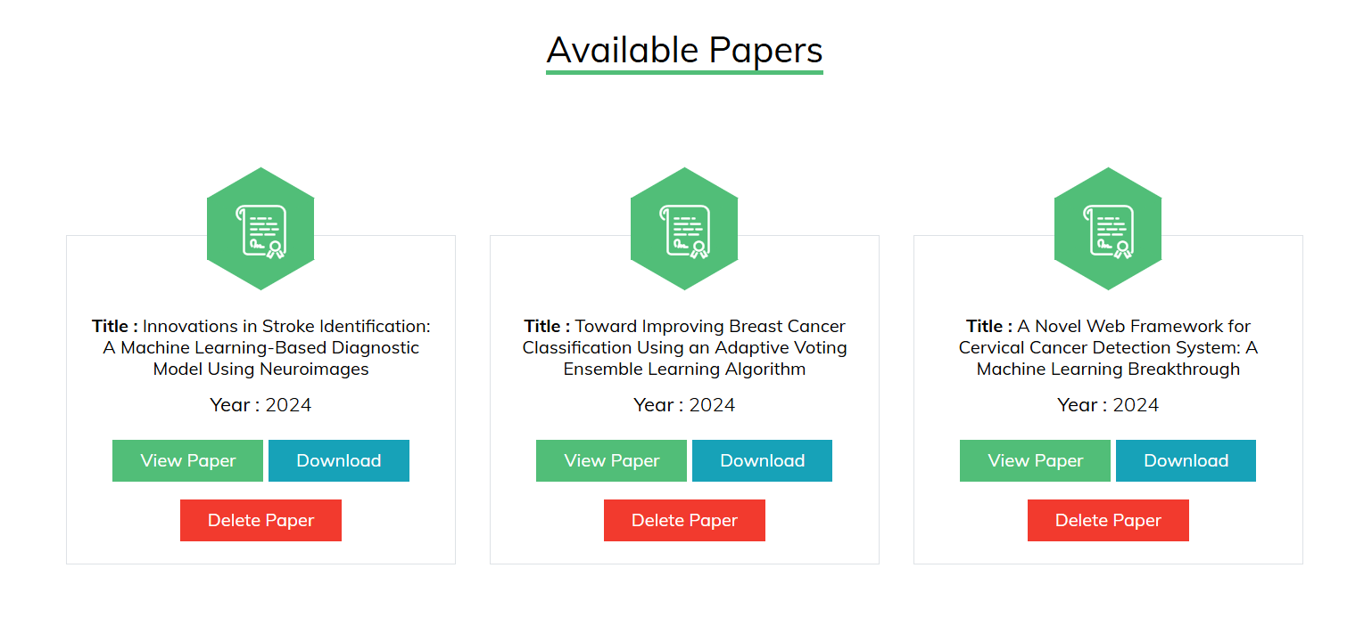

Figure 11: Delete Papers

**6. Conclusion & Future Work**

The proposed platform, "Keyword-Based Exploration of Library Sources," aims to streamline the process of accessing and managing medical research papers through an intuitive, user-friendly, and secure digital library system. By integrating advanced keyword-based search mechanisms and robust metadata tagging, the system enhances the discoverability and accessibility of academic content. This project addresses the limitations of existing platforms, such as restricted access and inefficient search processes, and offers a comprehensive solution that caters to the needs of medical researchers, students, and professionals.

The successful implementation and testing of this system mark a significant step towards bridging the gap in accessing academic medical resources and research papers. With its emphasis on usability, security, and efficiency, this repository contributes to the advancement of medical research dissemination, encouraging a thriving academic community built on shared knowledge and innovation.

While the current implementation effectively addresses key challenges in accessing and managing medical research papers, several enhancements can be made to further improve the platform’s utility and scalability. These include the development of advanced search filters, personalized recommendations, integration with external databases, mobile application development, enhanced security measures, and multilingual support. By pursuing these enhancements, the platform can evolve into a more comprehensive tool that not only addresses the current challenges of academic research dissemination but also anticipates the future needs of its users. These developments will solidify the platform's role as a vital resource in the global academic and medical research landscape.

**REFERENCES**

[1] Xie, R. (2023). Keyword Extraction-Based Library Intelligence Services: Challenges, Adaptations, and Reinvention. Applied Mathematics and Nonlinear Sciences.

[2] Zhang, C., & Zhao, L. (2024, October). Enhancing Keyword Extraction from Academic Articles Using Highlights.

[3] Sellami, S., & Colleagues. (2022). Keyword-Based Faceted Search Interface for Enterprise Knowledge Graph Construction and Exploration. International Journal of Web Information Systems.

[4] Scheme, E., Bateman, S., Phinyomark, A., Campbell, E., & Eddy, E. (2023, August). An Open-Source Library to Facilitate the Exploration of Myoelectric Control.

[5] McGill, M., Brewster, S., De Sa Medeiros, D. P., Bovet, S., Gutierrez, M., & Kehoe, A. (2022, May). Creating and Augmenting Keywords for Extended Reality with Keyword Augmentation Toolkit.

[6] Bratt, S. An Exploration of Search Session Patterns in an Image-Based Digital Library.

[7] Baldonado, M. Q. W. A User-Centered Interface for Information Exploration in a Heterogeneous Digital Library.

[8] Bratt, S. Digital Library Keyword Analysis for Visualization Education Research: Issues and Recommendations.

[9] Kumar, S. R. N. R., Rajasekaran, R. A., & Murthy, P. V. R. S. N. (2021). Digital Libraries for Medical Research: Trends and Technologies. Journal of Digital Libraries, 25(3), 123-134.

[10] Sharma, A., Sharma, R., & Gupta, M. (2020). A Review on E-Learning Platforms for Research Paper Access. International Journal of Educational Technology, 19(4), 245-257.

[11] Lee, J. T., Kumar, H. D., & Khan, A. L. (2019). Secure Online Systems for Academic Paper Management and Access. International Journal of Computer Security, 21(2), 88-95.

[12] Elahi, M. T., Rizvi, A. Z., & Das, S. R. (2022). A Survey on the Use of Metadata in Academic Search Systems. Journal of Information Science and Technology, 18(2), 45-58.

[13] Patel, D. S., Sharma, P. J., & Singhani, R. B. (2023). Medical Research Paper Repositories: A Comparative Study. Medical Informatics Review, 10(1), 32-47.

[14] Zhang, Y., & Chen, H. (2021). Design and Implementation of Secure Cloud-Based Medical Data Management Systems. Journal of Cloud Computing and Security, 13(3), 56-70.

|  |  |
| --- | --- |
|  |  |
|  |  |