TN SKILLS PROJECT



DEPARTMENT OF COMPUTER APPLICATIONS

ALPHA ARTS AND SCIENCE COLLEGE PORUR, CHENNAI
(Reaccredited by NAAC and Affiliated to University of Madras)
COLLEGE NM ID: UNM1429

OCTOBER 2026

PROJECT TITTLE:

AI-Augmented Backend Development

AI STUDYBUDDY API

TEAM DETAILS:

TEAM ID:6ab4ca906f290be8a6b4514e

Team lead:INIYA S
NM ID:F1F18457E437B1793564E6F4A8AFAE44

Team member: Sahana C
NM Id: E53C8078F8F033FB01C44F01B3FD86A5

Team member: Keerthana P
NM Id: EC0717DE86B9C9B998A4346ACD299AA2

Team member: Menaka S
NM Id: 458CCFA8563100C829D4F36217B2977A

IMPLEMENTATION / PROCESS:
1. Project Setup – Create the project in VS Code and install required Node.js packages.
2. Backend Development – Use Node.js and Express.js to develop the server and REST APIs.
3. Database – MongoDB stores user and FAQ data, while Mongoose manages database operations.
4. Authentication – JWT provides authentication and bcrypt secures passwords.
5. FAQ Management – Users can create, view, update, delete, search, and categorize FAQs.
6. AI Integration – Google Gemini AI generates FAQ questions, answers, and topic suggestions.
7. Testing – Postman or ThunderClient is used to test the APIs.
8. Execution – The backend server is started using the npm development command.

PROJECT ARCHITECTURE
The system uses a layered backend architecture for better organization and security.
1. API Layer – Handles REST API requests.
2. Express Server – Manages routing and HTTP requests.
3. Authentication Layer – Uses JWT and bcrypt for security.
4. Business Logic – Handles users, FAQs, categories, and AI operations.
5. Database Layer – Mongoose connects the application with MongoDB.
6. AI Layer – Google Gemini AI provides FAQ generation and AI-assisted answers.
Flow:
Client → Express.js → JWT → Controllers/Services → Mongoose → MongoD
AI Flow:
Client → API → Controller → Gemini AI → FAQ Response
TECHNICAL ARCHITECTURE
- Runtime: Node.js
- Framework: Express.js
- Database: MongoDB
- ODM: Mongoose
- Authentication: JWT
- Security: bcrypt
- AI: Google Gemini AI
- Pattern: MVC
FEATURES
- User Registration and Login
- FAQ Create, View, Update and Delete
- FAQ Search and Categories
- AI FAQ Generation
- AI-assisted Answers
- Protected Routes
- Role-based Access
- Validation and Error Handling
ROLES
Admin:
Manages users, FAQs, categories, and AI content.
Content Creator:
Creates, edits, deletes, and generates FAQs using AI.
Authenticated User:
Views, searches, and gets AI-assisted answers.
Public User:
Views and searches published FAQs.
USER FLOW
Public User → View/Search FAQs → Register → Login → JWT Authentication → FAQ Search / AI Answers → Content Creator → FAQ Management → Admin Management
OUTPUT
- Registration: User registers with name, email, and password.
- Login: Registered user logs in securely.
- FAQ Retrieval: FAQ details are retrieved using the FAQ ID.
- FAQ Deletion: Selected FAQ is deleted using its ID.

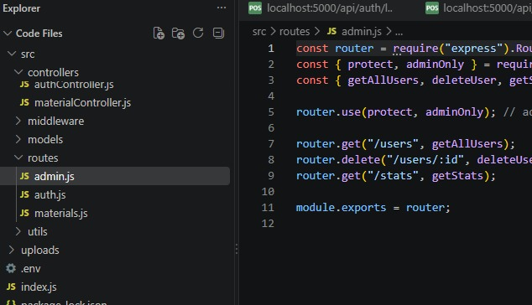
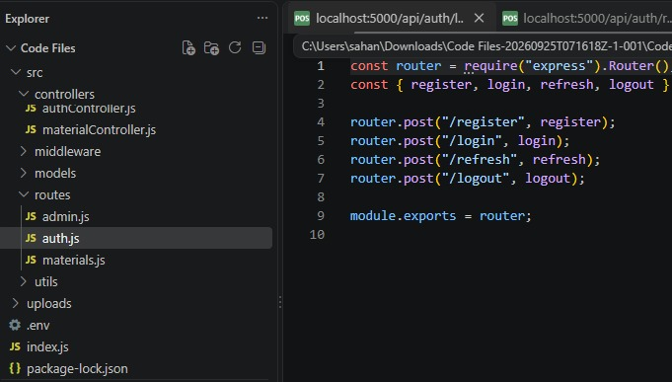

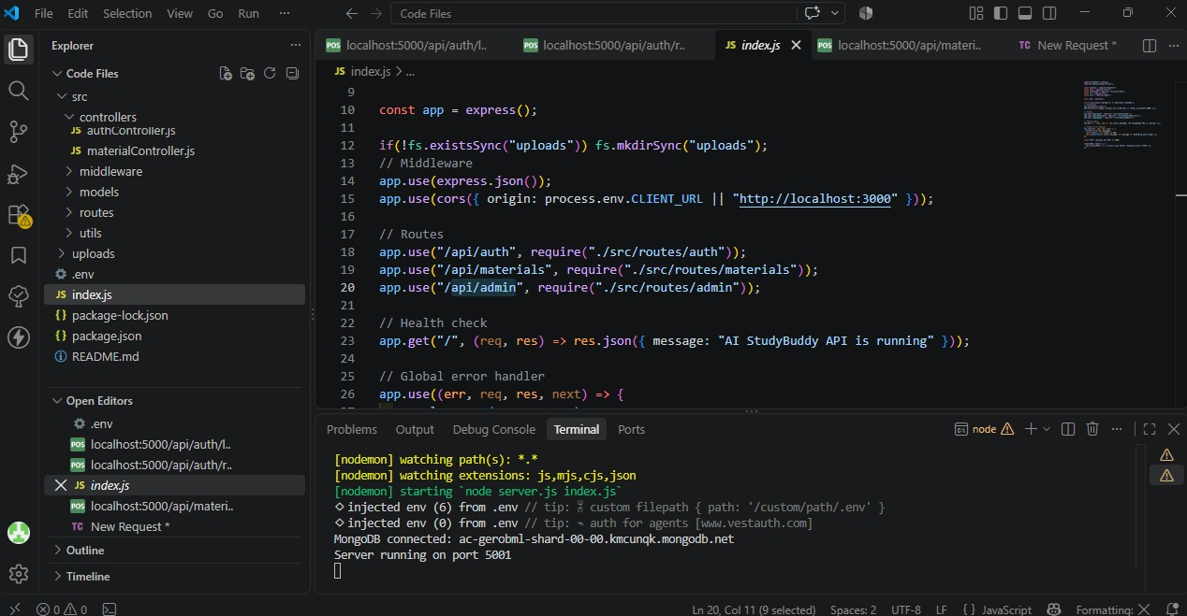

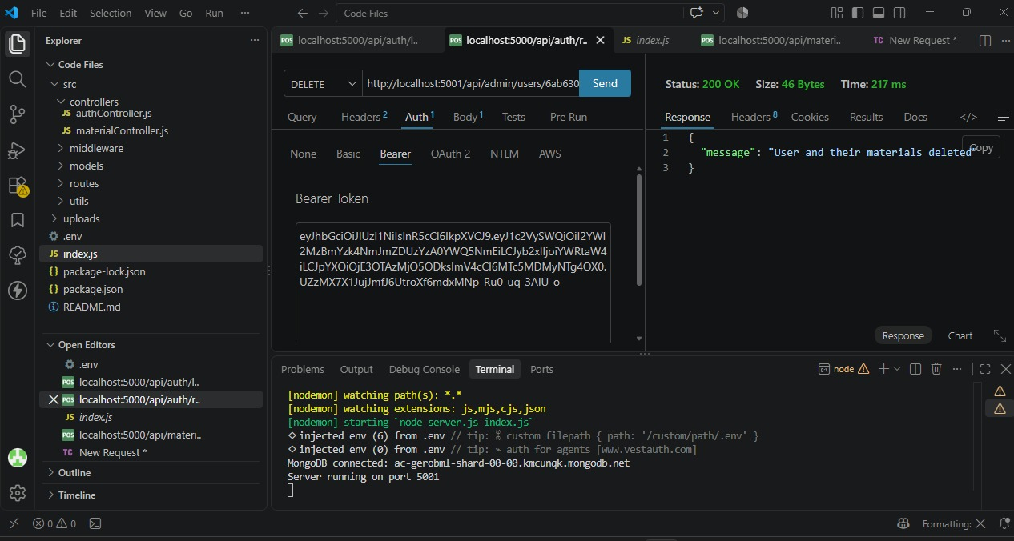

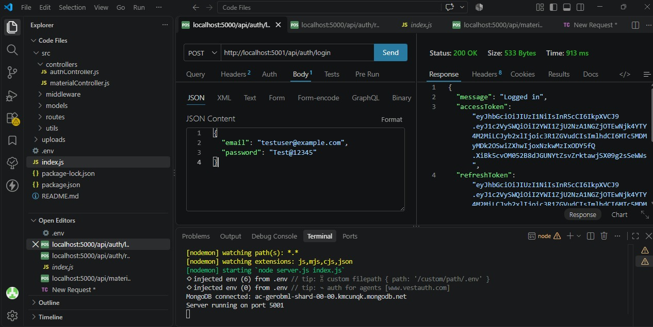

GitHub link:
https://github.com/sahanabca2024/AI_Studybuddy_API.git

Demo video link:
https://drive.google.com/file/d/1Yf8rZicnUY-nfWV0yUNOjnRoeo59qkvA/view?usp=drive_link

