ResearchPilot
An Autonomous Multi-Agent AI System for Research Discovery, Analysis, and Report Generation
Project workflow and implementation guide
This document explains the project in simple terms, from the problem statement to deployment. The proposed system helps users discover research papers, understand them, compare evidence, identify possible research gaps, and prepare a structured report. It supports researchers; it does not replace expert review or guarantee that every generated statement is correct.

1. Problem Statement and Use Case
Finding and understanding research papers takes time. A student may need to search many websites, read long papers, compare methods and results, check citations, and then write a report. Doing these tasks manually can be slow, and important details may be missed.

Proposed solution
ResearchPilot is a multi-agent AI application. Each agent has one clear responsibility and uses tools to complete part of the research workflow. The agents share results, check evidence, and work together to create a draft report with references.

Example use case
A user enters: “Recent applications of machine learning in weather forecasting.” ResearchPilot finds relevant papers, summarizes each paper, compares datasets and evaluation metrics, proposes candidate research gaps based on the collected evidence, checks citations, and exports a report.

Main users
- College students preparing literature reviews or project proposals.
- Researchers exploring a new topic.
- Project teams comparing methods and datasets.
- Mentors who want a starting-point summary before reviewing original papers.

2. System Design and Analysis
The system follows a controlled workflow. The Planner Agent creates tasks, specialist agents perform those tasks, and an Evaluator checks the draft before it is delivered. The system should save source metadata and evidence snippets so that important claims can be traced back to their sources.

Main agents and responsibilities
Agent | Responsibility | Output
1. Planner Agent | Breaks the topic into research questions and creates a task plan. | Search plan and task list
2. Research Agent | Searches approved academic sources and collects relevant papers. | Paper list and metadata
3. Paper Analysis Agent | Extracts problem, method, dataset, results, and limitations from each paper. | Structured paper summaries
4. Research Gap Agent | Compares papers and identifies patterns or possible gaps. | Evidence-based candidate gaps
5. Evidence Verification Agent | Checks claims against source text, metadata, and citation records. | Supported, uncertain, or unsupported claim flags
6. Report Writer Agent | Combines verified information into report sections. | Report draft
7. Evaluator Agent | Checks completeness, clarity, citations, and required sections. | Pass/fail checklist and revision notes

End-to-end workflow diagram
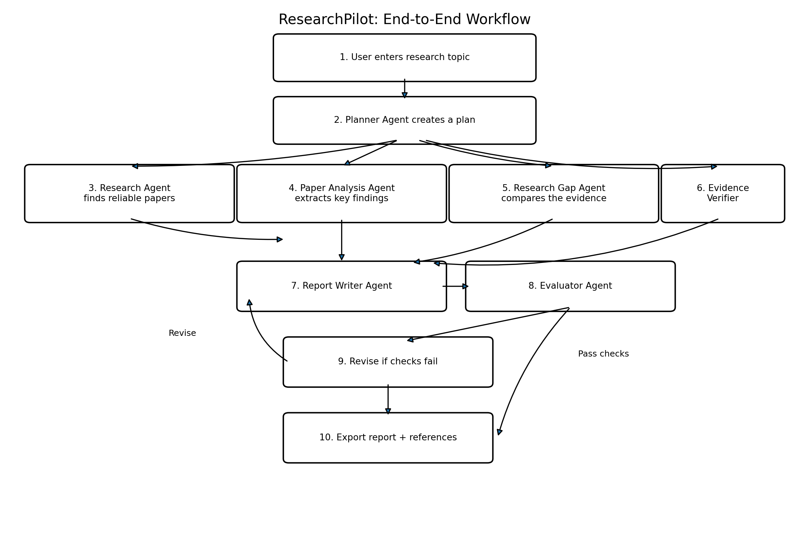
Figure 1. Proposed ResearchPilot workflow. If evaluation fails, the draft returns for revision.

Step-by-step workflow
Step 1 — Topic input: The user enters a topic, optional keywords, date range, preferred sources, and desired report length.
Step 2 — Planning: The Planner Agent creates sub-questions, such as methods used, datasets, evaluation metrics, limitations, and future directions.
Step 3 — Paper discovery: The Research Agent searches academic APIs or approved repositories. It removes duplicates and stores title, authors, year, DOI or URL, abstract, and source.
Step 4 — Paper analysis: The Analysis Agent reads accessible abstracts or full texts and extracts the research problem, approach, dataset, reported results, and limitations. It must mark missing information as “not reported.”
Step 5 — Cross-paper comparison: The Research Gap Agent compares papers in a table and looks for recurring limitations, under-studied settings, or conflicting results.
Step 6 — Evidence verification: The Verification Agent checks whether each important statement is supported by the cited paper and whether numerical results match the source.
Step 7 — Report drafting: The Writer Agent prepares the introduction, literature review, comparison, candidate gaps, conclusion, and references.
Step 8 — Quality evaluation: The Evaluator checks required sections, citation coverage, repeated content, unsupported claims, and readability. Failed checks create revision tasks.
Step 9 — Human review: The user reviews the report, opens original papers, corrects issues, and approves the final version.
Step 10 — Export: The system exports the final report to DOCX or PDF and provides the paper comparison table and reference list.

3. LLM Choice
An LLM (Large Language Model) is the language engine used to understand instructions, extract information, compare evidence, and write report sections. Choose the model based on quality, cost, privacy, context length, and availability. The project should not depend on one provider if possible.
Option | Advantages | When to use
Hosted LLM API | Easy to integrate; often strong at reasoning and writing; no local GPU required. | Best for a first prototype when API access and budget are available.
Open-weight model locally or on a hosted GPU | More control over data and deployment; may reduce per-request API cost. | Use when privacy or self-hosting matters and compute is available.
Hybrid approach | Use a smaller/cheaper model for extraction and a stronger model for difficult synthesis. | Useful for controlling cost while keeping quality acceptable.

Recommended starting choice
Start with one reliable hosted LLM API, then keep the model name and settings in environment variables so it can be changed later. Use a model with a sufficiently large context window for paper excerpts. Do not send entire copyrighted papers to a service unless its terms and the user's access rights permit it.

Use the LLM for
- Turning a broad topic into focused research questions.
- Extracting structured information from papers.
- Comparing methods and reported results.
- Drafting readable report sections from verified notes.
- Explaining limitations and uncertainty in plain language.

Do not rely on the LLM alone for
- Inventing references or DOIs.
- Claiming that a research gap is definitely new without a broad literature search.
- Guessing missing metrics or results.
- Making final decisions about scientific correctness without source review.

4. Tools and Technology Stack
Tool / technology | Purpose | Suggested use
Python | Main programming language | Agent logic, data processing, API calls
LangGraph | Controls multi-step agent workflows and state | Planner, agent routing, retry loops, checkpoints
Academic search APIs (e.g., OpenAlex or Semantic Scholar) | Discover research papers and metadata | Search by topic, date, author, DOI
PyMuPDF | Read text from accessible PDF files | Extract text and page numbers
ChromaDB (optional) | Stores embeddings for semantic search | Find relevant passages in collected documents
Embedding model | Converts text into vectors for retrieval | Retrieve passages related to a question
Gradio | Web user interface | Topic input, progress, tables, downloads
python-docx / ReportLab | Create output documents | DOCX and PDF export
SQLite or MongoDB | Store jobs and research metadata | Save runs, paper records, and report status
Git and GitHub | Version control | Track code and share the project
Environment variables / secrets manager | Protect API keys | Keep keys out of source code

5. Data Flow and Storage
Store information in separate, clearly named records:
- Research job: topic, search filters, date created, status, and selected settings.
- Paper record: title, authors, year, DOI/URL, abstract, source, and access status.
- Evidence record: claim, supporting quotation or short excerpt, paper ID, page/section, and verification status.
- Analysis record: method, dataset, metrics, limitations, and fields that were not reported.
- Report record: generated sections, citation map, evaluation results, and file paths.
For reliable traceability, every key factual claim in the report should point to one or more evidence records. Store only the text and metadata needed for the workflow, and respect copyright, API terms, and access restrictions.

6. Train and Tune the System
A first version usually does not need to train a new LLM. Build the workflow using an existing model, then improve it through prompt design, structured outputs, retrieval, evaluation, and optional fine-tuning.

Phase A — Build a baseline
- Choose a small set of research topics and manually collect a few papers for testing.
- Create fixed prompts for planning, paper extraction, comparison, verification, and writing.
- Ask agents to return structured JSON or clearly defined fields instead of free-form text wherever possible.
- Save the model name, prompt version, temperature, source IDs, and outputs for each test run.

Phase B — Improve retrieval and extraction
- Split long documents into sections or chunks while preserving page numbers and headings.
- Retrieve only passages relevant to the current research question.
- Require each extracted result to include its source and location.
- Use “not found in source” when information is absent instead of guessing.
- Deduplicate papers using DOI, normalized title, and author/year.

Phase C — Evaluate quality
Metric | What it measures | How to test
Search relevance | Whether retrieved papers fit the topic | Manually label a sample as relevant/not relevant
Extraction accuracy | Whether extracted facts match the paper | Compare fields with human-reviewed reference answers
Citation support rate | Whether claims are supported by cited sources | Review a sample of claims against the original papers
Reference correctness | Whether titles, authors, years, and links are correct | Check metadata against the academic source
Report completeness | Whether required sections are present | Run a checklist
Latency and cost | Time and cost per report | Record per-stage duration and token/API usage

Phase D — Tune
- Improve prompts for stages with the weakest evaluation scores.
- Adjust chunk size and retrieval count based on test results.
- Use a stronger model only for tasks that need more reasoning.
- Add retries for temporary API failures and strict validation for structured outputs.
- Consider fine-tuning only if a representative, permission-cleared dataset exists and simpler improvements are insufficient.
Important: the goal is not to train the model to memorize papers. The goal is to retrieve the right evidence, extract it correctly, and generate claims that remain traceable to the sources.

7. Guardrails and Responsible Use
Guardrails are rules and checks that keep the system safe, honest, and reliable. They should operate before, during, and after generation.
Guardrail | Implementation
Source-grounded answers | Require claims about a paper to use retrieved source text or metadata. Flag unsupported claims.
Citation validation | Check that every reference exists and that its metadata matches the source. Do not invent citations.
Prompt-injection protection | Treat text inside papers and web pages as untrusted data, not as instructions to the agents.
Tool permissions | Allow only approved search, document-read, and export tools. Do not allow arbitrary shell commands.
Privacy | Do not request unnecessary personal data. Avoid sending confidential drafts to external services without permission.
Copyright and access | Respect paper licences, publisher terms, API rules, and access controls. Do not bypass paywalls.
Human review | Show the sources and ask the user to review the report before academic submission or publication.
Uncertainty labels | Mark incomplete evidence, conflicting results, and candidate research gaps clearly.
Cost and abuse limits | Limit paper count, file size, run time, and API usage; authenticate users if deployed publicly.
Logging and error handling | Log stage status and safe error details, but never log API secrets.

8. User Interface (UI)
Use Gradio for a beginner-friendly web interface. Suggested screens and controls:
- Research topic: a text box for the topic and optional research questions.
- Filters: year range, maximum number of papers, preferred academic sources, and report length.
- Start Research button: begins the workflow and displays stage-by-stage progress.
- Agent status panel: shows Planning, Searching, Analyzing, Verifying, Writing, or Completed.
- Paper table: title, year, authors, source link, relevance, and access status.
- Comparison table: methods, datasets, metrics, limitations, and key findings.
- Research gap panel: candidate gaps with supporting papers and confidence/uncertainty notes.
- Evidence review: key claims with citations and verification status.
- Report preview: view generated sections before export.
- Download buttons: export DOCX/PDF and the paper comparison table.

Simple UI layout
ResearchPilot — Research Discovery Workspace
Topic: [________________________________________]
Years: [From ____] [To ____] Max papers: [20]
[ Start Research ] [ Cancel Run ]
Progress: Planning → Searching → Analysis → Verification → Report
Papers found | Paper comparison | Candidate research gaps
Evidence and citation checks
Report preview
[ Download DOCX ] [ Download PDF ]

9. Deployment
Deploy the app only after the local version works and the main quality checks pass. A simple student-project deployment can use a hosted Python app platform or a virtual machine. Check the current platform limits before choosing.

Deployment steps
- Organize the project into modules: ui.py, workflow.py, agents/, tools/, storage.py, prompts/, evaluation/, and requirements.txt.
- Move API keys into environment secrets. Never commit keys to GitHub.
- Create requirements.txt with pinned or tested dependency versions.
- Test locally with a few known topics and compare results with manually reviewed sources.
- Add timeouts, retries, request limits, and clear error messages for API failures.
- Deploy the Gradio interface to a supported hosting service or a secured server.
- Configure persistent storage only if needed; temporary hosting disks may be cleared after restarts.
- Test the public URL from another device and verify that downloads work.
- Monitor failures, cost, response time, and citation-check results.
- Keep a human approval step before the user treats the report as submission-ready.

Suggested project folder structure
ResearchPilot/
├── app.py # Gradio interface
├── workflow.py # Agent workflow and routing
├── agents/
│ ├── planner.py
│ ├── researcher.py
│ ├── paper_analyzer.py
│ ├── gap_analyzer.py
│ ├── verifier.py
│ ├── report_writer.py
│ └── evaluator.py
├── tools/
│ ├── academic_search.py
│ ├── pdf_reader.py
│ └── citation_checker.py
├── prompts/ # Versioned agent prompts
├── evaluation/ # Test topics and quality checks
├── outputs/ # Generated reports (if persistent storage is used)
├── requirements.txt
├── .env.example # Names of required environment variables only
└── README.md

10. Development Plan
Phase | Tasks | Deliverable
1. Minimum viable product | Topic input, academic search, paper list, one-paper summary | Basic research assistant
2. Multi-agent workflow | Planner, analysis, writer, and shared workflow state | Coordinated agent pipeline
3. Evidence and citations | Source tracking, citation checks, unsupported-claim flags | More trustworthy report
4. Gap analysis and evaluation | Cross-paper comparison, candidate gaps, evaluator loop | Full report workflow
5. UI and export | Gradio progress, tables, DOCX/PDF downloads | Usable web application
6. Deployment and testing | Secrets, limits, error handling, user testing | Deployed project

11. Expected Output and Success Criteria
For a selected topic, the system should produce:
- A deduplicated list of relevant research papers with working source links where available.
- Structured summaries that separate reported facts from the model's interpretation.
- A comparison table of methods, datasets, metrics, and limitations.
- Candidate research gaps linked to evidence from multiple papers.
- A report draft with traceable citations and an exportable DOCX/PDF.
- An evaluation summary that identifies uncertain or unsupported claims.
A successful project is not defined only by how long the report is or how fluent it sounds. Measure source relevance, extraction accuracy, citation support, completeness, time, and cost. Review a sample of outputs manually.

12. Final Summary
ResearchPilot is best built in stages. First create a working research search and summarization tool. Then add specialist agents, source-grounded evidence checks, a revision loop, a Gradio UI, and deployment. Use an existing LLM instead of training one from scratch. Keep every important claim connected to its source and require human review before academic use.

