1. #include <iostream>
using namespace std;

int main() {
int n;
cout << "Enter a number: ";
cin >> n;

try {
if (n % 2 != 0)
throw "Number is not even";

cout << "Number is EVEN";
}
catch (const char* msg) {
cout << "Exception: " << msg;
}

return 0;
}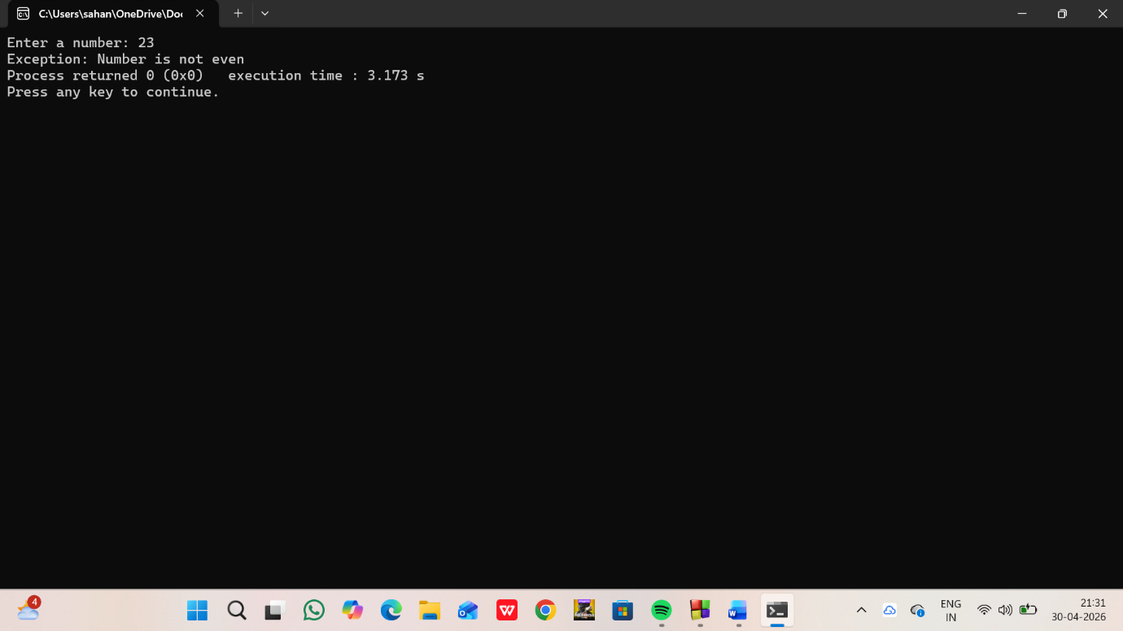
2.
#include <iostream>
using namespace std;

int main() {
int age;
cout << "Enter your age: ";
cin >> age;

try {
if (age < 18)
throw "Not eligible (below 18)";

cout << "Eligible (18 or above)";
}
catch (const char* msg) {
cout << "Exception: " << msg;
}

return 0;
}

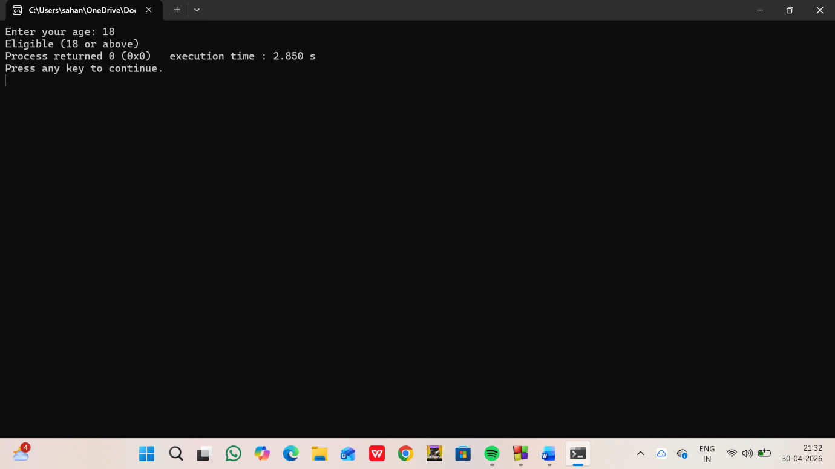

3.
#include <iostream>
using namespace std;

int main() {
int n;
cin >> n;

try {
if (n < 0)
throw "Negative number";

if (n % 2 != 0)
throw "Odd number";

cout << "Even number";
}
catch (const char* msg) {
cout << msg;
}

return 0;
}

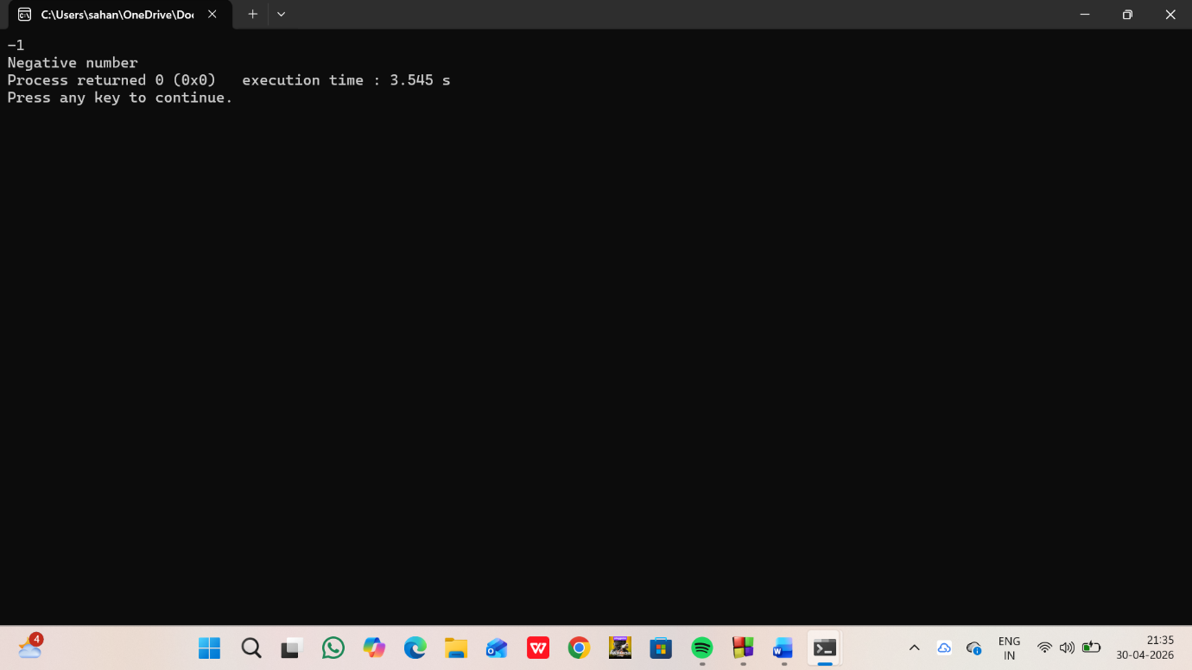
4.
<iostream>
using namespace std;
class ParkingFullException {
public:
void message() {
cout << "Exception: Parking is FULL!" << endl;
}
};

class ParkingEmptyException {
public:
void message() {
cout << "Exception: Parking is EMPTY!" << endl;
}
};

class ParkingLot {
int capacity;
int vehicles;

public:
ParkingLot(int cap) {
capacity = cap;
vehicles = 0;
}

void parkVehicle() {
if (vehicles == capacity)
throw ParkingFullException();

vehicles++;
cout << "Vehicle Parked. Total vehicles: " << vehicles << endl;
}

void removeVehicle() {
if (vehicles == 0)
throw ParkingEmptyException();

vehicles--;
cout << "Vehicle Removed. Total vehicles: " << vehicles << endl;
}

void display() {
cout << "Available slots: " << (capacity - vehicles) << endl;
}
};

int main() {
ParkingLot p(5);
int choice;

while (true) {
cout << "\n1. Park Vehicle\n2. Remove Vehicle\n3. Display\n4. Exit\n";
cout << "Enter choice: ";
cin >> choice;

try {
switch (choice) {
case 1:
p.parkVehicle();
break;

case 2:
p.removeVehicle();
break;

case 3:
p.display();
break;

case 4:
return 0;

default:
cout << "Invalid choice!" << endl;
}
}
catch (ParkingFullException e) {
e.message();
}
catch (ParkingEmptyException e) {
e.message();
}
}
}

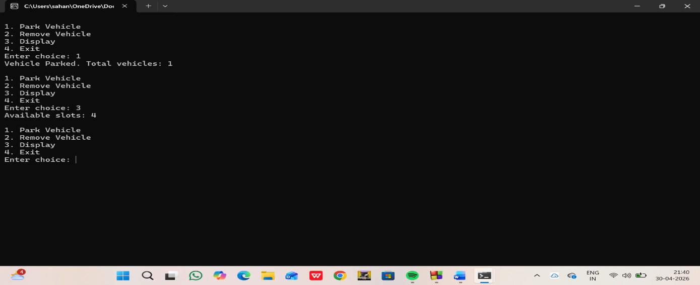5.
include <iostream>
using namespace std;

class ShowFullException {
public:
void message() {
cout << "Exception: Show is FULL!" << endl;
}
};

class NoBookingException {
public:
void message() {
cout << "Exception: No tickets booked!" << endl;
}
};

class MovieTicket {
int capacity;
int booked;

public:
MovieTicket(int cap) {
capacity = cap;
booked = 0;
}

void bookTicket() {
if (booked == capacity)
throw ShowFullException();

booked++;
cout << "Ticket Booked. Total booked: " << booked << endl;
}

void cancelTicket() {
if (booked == 0)
throw NoBookingException();

booked--;
cout << "Ticket Cancelled. Total booked: " << booked << endl;
}

void display() {
cout << "Available seats: " << (capacity - booked) << endl;
}
};

int main() {
MovieTicket m(5);
int choice;

while (true) {
cout << "\n1. Book Ticket\n2. Cancel Ticket\n3. Display\n4. Exit\n";
cout << "Enter choice: ";
cin >> choice;

try {
switch (choice) {
case 1:
m.bookTicket();
break;

case 2:
m.cancelTicket();
break;

case 3:
m.display();
break;

case 4:
return 0;

default:
cout << "Invalid choice!" << endl;
}
}
catch (ShowFullException e) {
e.message();
}
catch (NoBookingException e) {
e.message();
}
}
}
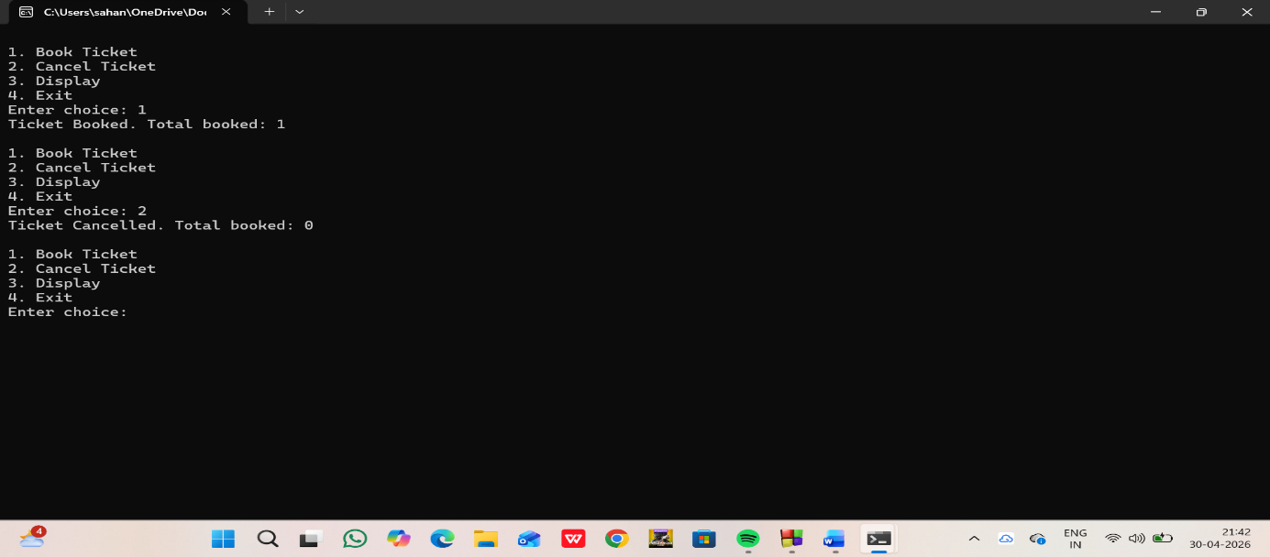
6.
#include <iostream>
using namespace std;

class OutOfStockException {
public:
void display() {
cout << "Error: Requested quantity exceeds available stock!" << endl;
}
};

// Product Class
class Product {
private:
int stock;

public:

Product(int s) {
stock = s;
}

void purchase(int quantity) {
if (quantity > stock) {
throw OutOfStockException();
} else {
stock -= quantity;
cout << "Successfully purchased!" << endl;
cout << "Stock left: " << stock << endl;
}
}
};

int main() {
int availableStock, requestedQty;

cout << "Enter available stock: ";
cin >> availableStock;

cout << "Enter requested quantity: ";
cin >> requestedQty;

Product p(availableStock);

try {
p.purchase(requestedQty);
}
catch (OutOfStockException e) {
e.display();
}

return 0;
}
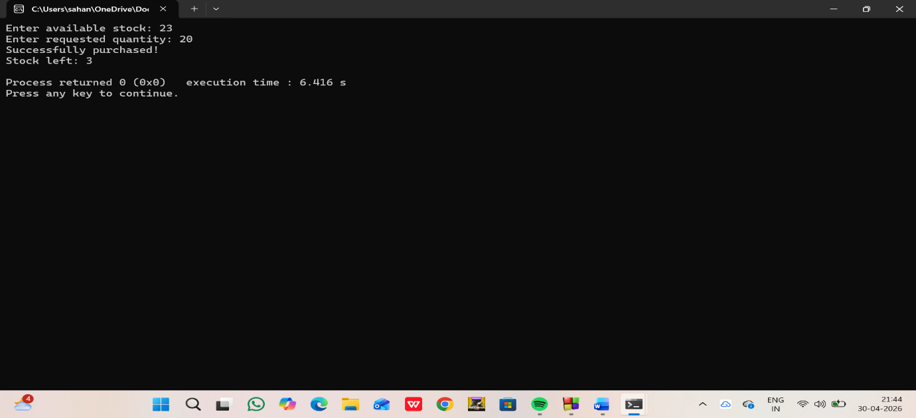
7.
#include <iostream>
using namespace std;

class IndexException {
public:
const char* message() {
return "Error: Array index out of bounds!";
}
};

int main() {
int arr[5] = {10, 20, 30, 40, 50};
int index;

cout << "Enter index (0-4): ";
cin >> index;

try {
if (index < 0 || index >= 5) {
throw IndexException();
}

cout << "Element: " << arr[index] << endl;
}
catch (IndexException e) {
cout << e.message() << endl;
}

return 0;
}
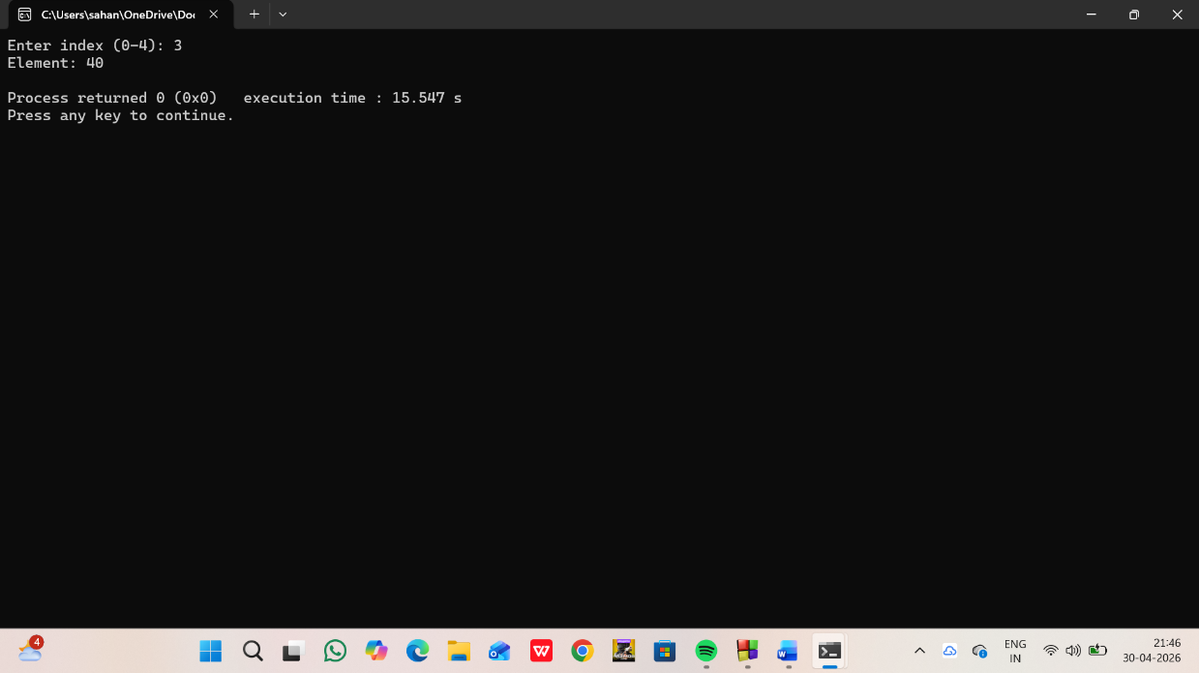
8.
#include <iostream>
using namespace std;

template <class T>
T findSum(T arr[], int size) {
T sum = 0;
for (int i = 0; i < size; i++) {
sum += arr[i];
}
return sum;
}

int main() {
int intArr[] = {1, 2, 3, 4, 5};
double doubleArr[] = {1.5, 2.5, 3.5};

cout << "Sum of integer array: "
<< findSum(intArr, 5) << endl;

cout << "Sum of double array: "
<< findSum(doubleArr, 3) << endl;

return 0;
}
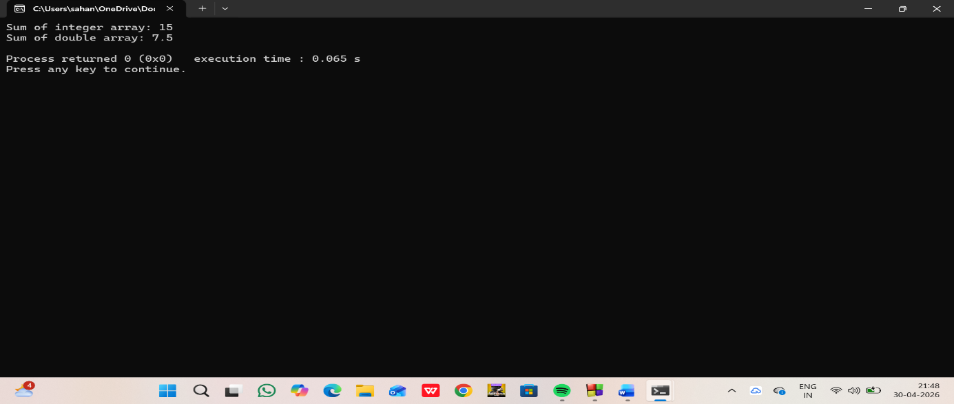
9.
#include <iostream>
using namespace std;

template <class T>
T findMin(T arr[], int size) {
T min = arr[0];

for (int i = 1; i < size; i++) {
if (arr[i] < min) {
min = arr[i];
}
}
return min;
}

int main() {
int intArr[] = {5, 2, 9, 1, 7};
double doubleArr[] = {2.5, 1.1, 3.8, 0.9};

cout << "Minimum (int array): "
<< findMin(intArr, 5) << endl;

cout << "Minimum (double array): "
<< findMin(doubleArr, 4) << endl;

return 0;
}

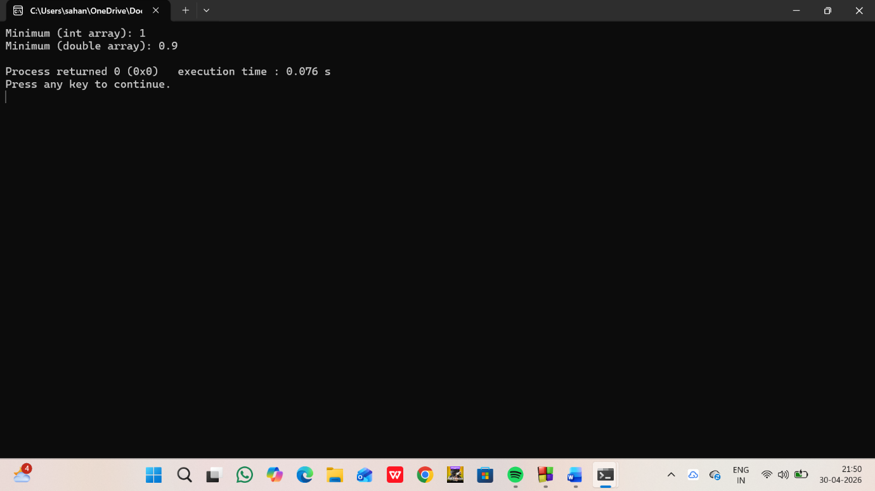
10.
#include <iostream>
using namespace std;

template <class T>
T findMax(T arr[], int size) {
T max = arr[0];

for (int i = 1; i < size; i++) {
if (arr[i] > max) {
max = arr[i];
}
}
return max;
}

int main() {
int intArr[] = {5, 2, 9, 1, 7};
double doubleArr[] = {2.5, 1.1, 3.8, 0.9};

cout << "Maximum (int array): "
<< findMax(intArr, 5) << endl;

cout << "Maximum (double array): "
<< findMax(doubleArr, 4) << endl;

return 0;
}
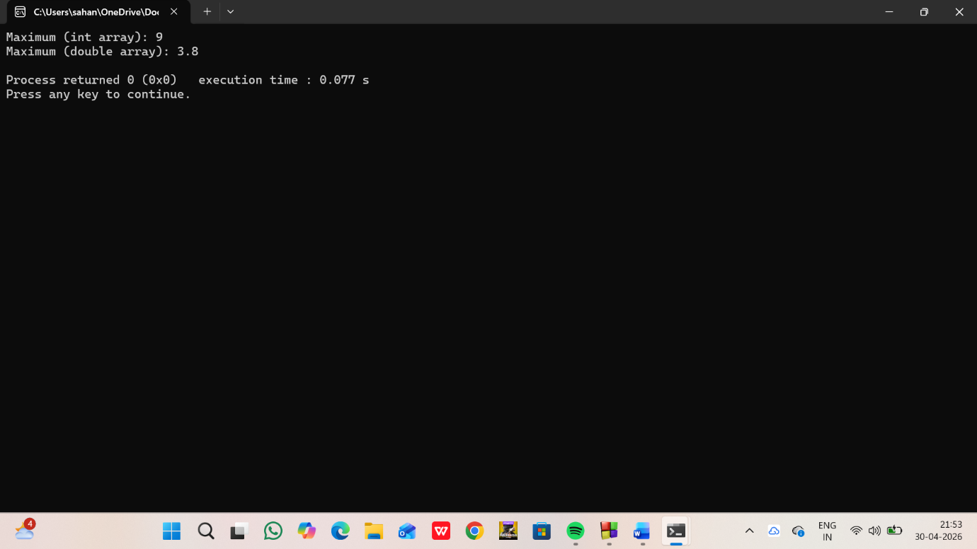
11.
#include <iostream>
using namespace std;

template <class T>
class Calculator {
T a, b;

public:
Calculator(T x, T y) {
a = x;
b = y;
}

void add() {
cout << "Addition: " << a + b << endl;
}

void subtract() {
cout << "Subtraction: " << a - b << endl;
}

void multiply() {
cout << "Multiplication: " << a * b << endl;
}

void divide() {
if (b != 0)
cout << "Division: " << a / b << endl;
else
cout << "Division by zero error!" << endl;
}
};

int main() {
Calculator<int> c1(10, 5);
cout << "Integer operations:\n";
c1.add();
c1.subtract();
c1.multiply();
c1.divide();

Calculator<double> c2(10.5, 2.5);
cout << "\nDouble operations:\n";
c2.add();
c2.subtract();
c2.multiply();
c2.divide();

return 0;
}
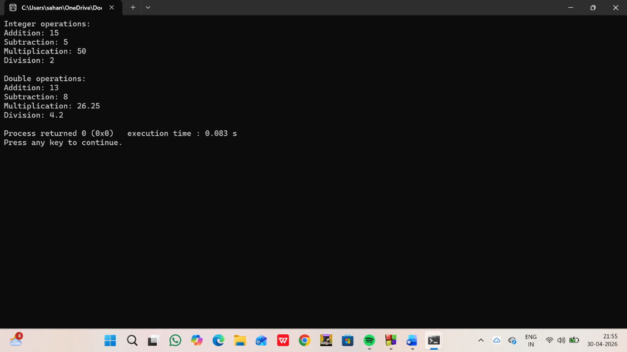
12.
include <iostream>
using namespace std;

template <class T>
void swapVal(T &a, T &b) {
T temp = a;
a = b;
b = temp;
}

int main() {
int x = 10, y = 20;
cout << "Before swap: x = " << x << ", y = " << y << endl;

swapVal(x, y);

cout << "After swap: x = " << x << ", y = " << y << endl;

double a = 1.5, b = 2.5;
cout << "\nBefore swap: a = " << a << ", b = " << b << endl;

swapVal(a, b);

cout << "After swap: a = " << a << ", b = " << b << endl;

return 0;
}
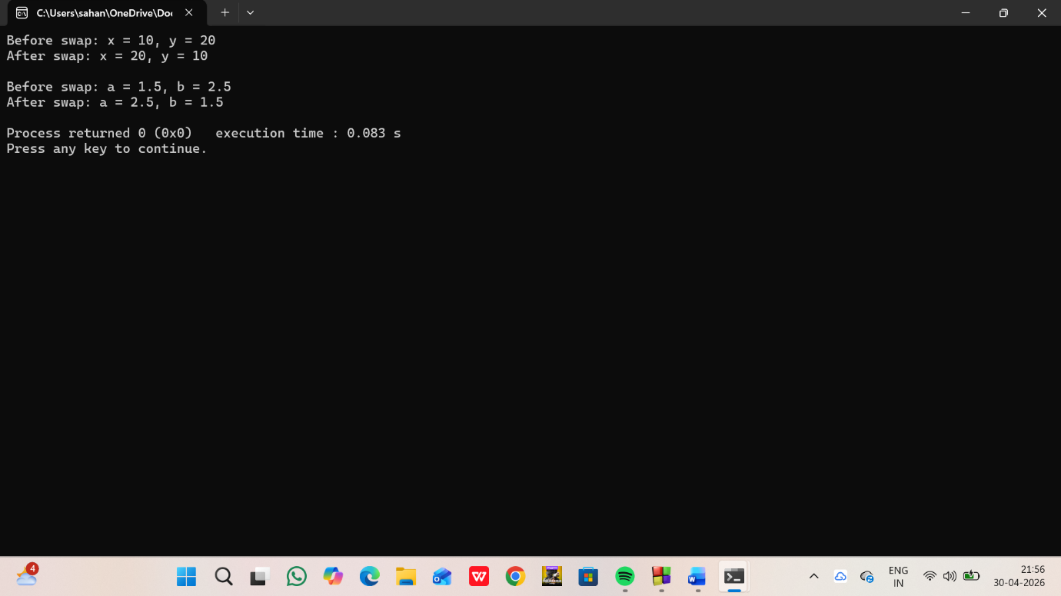
13.
include <iostream>
using namespace std;

template <class T>
class Test {
T data;
public:
Test(T x) {
data = x;
}
void display() {
cout << "Value: " << data << endl;
}
};

int main() {
Test<int> t1(10);
Test<double> t2(5.5);

t1.display();
t2.display();

return 0;
}
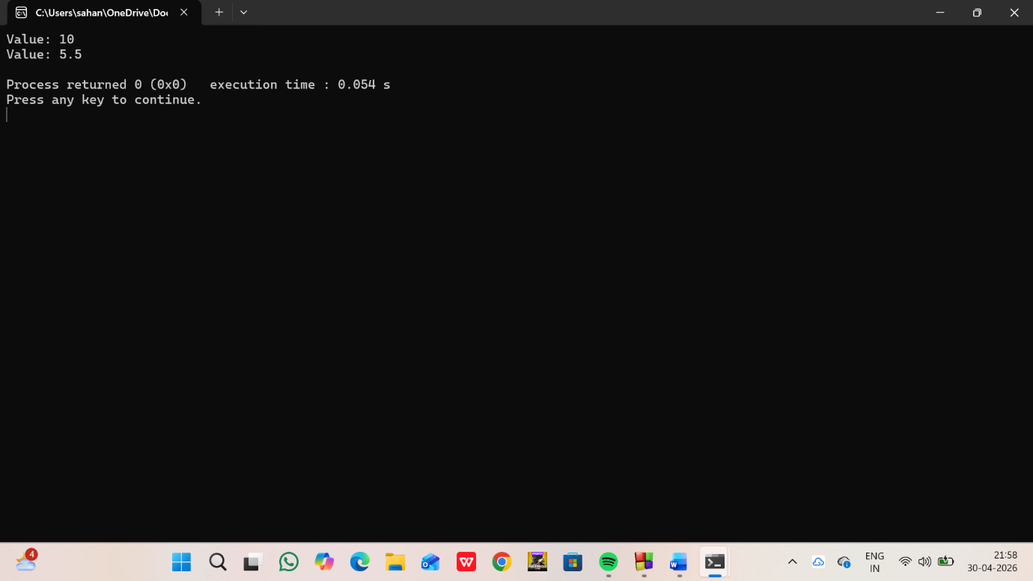
14.
#include <iostream>
using namespace std;

template <class T1, class T2>
class Pair {
T1 a;
T2 b;

public:
Pair(T1 x, T2 y) {
a = x;
b = y;
}

void display() {
cout << "A: " << a << " B: " << b << endl;
}
};

int main() {
Pair<int, float> p1(10, 2.5);
p1.display();

Pair<char, string> p2('A', "Hello");
p2.display();

return 0;
}

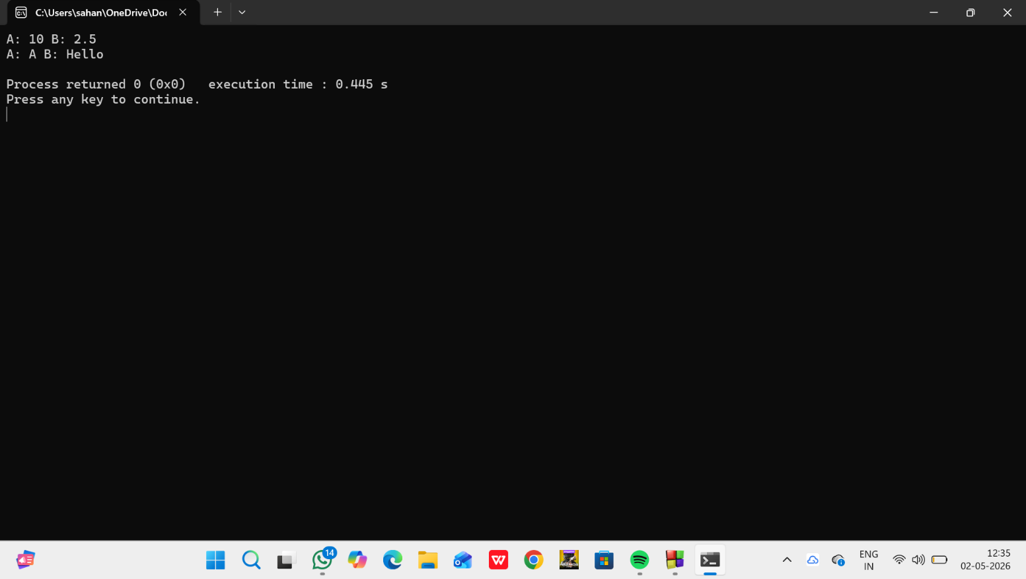
`15. #include <iostream>
#include <stack>
using namespace std;

int main() {
stack<int> s;

s.push(10);
s.push(20);
s.push(30);

cout << "Top: " << s.top() << endl;

s.pop();

cout << "Top after pop: " << s.top() << endl;
}
Output: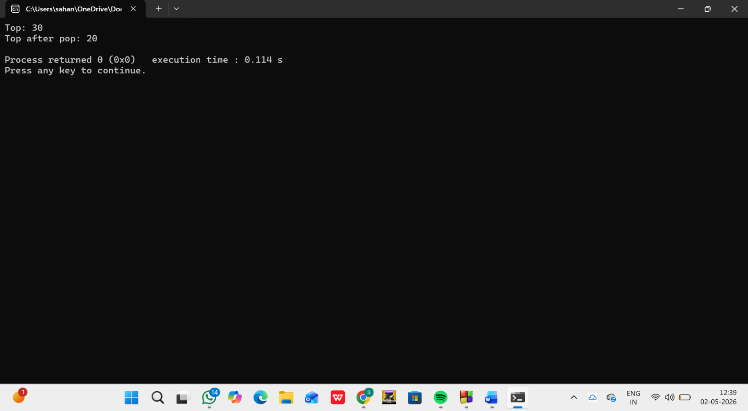
16.
#include <iostream>
#include <fstream>
using namespace std;

int main() {
ifstream file("data.txt");
string word;
int count = 0;

while (file >> word) {
count++;
}

cout << "Word count: " << count;
file.close();
}
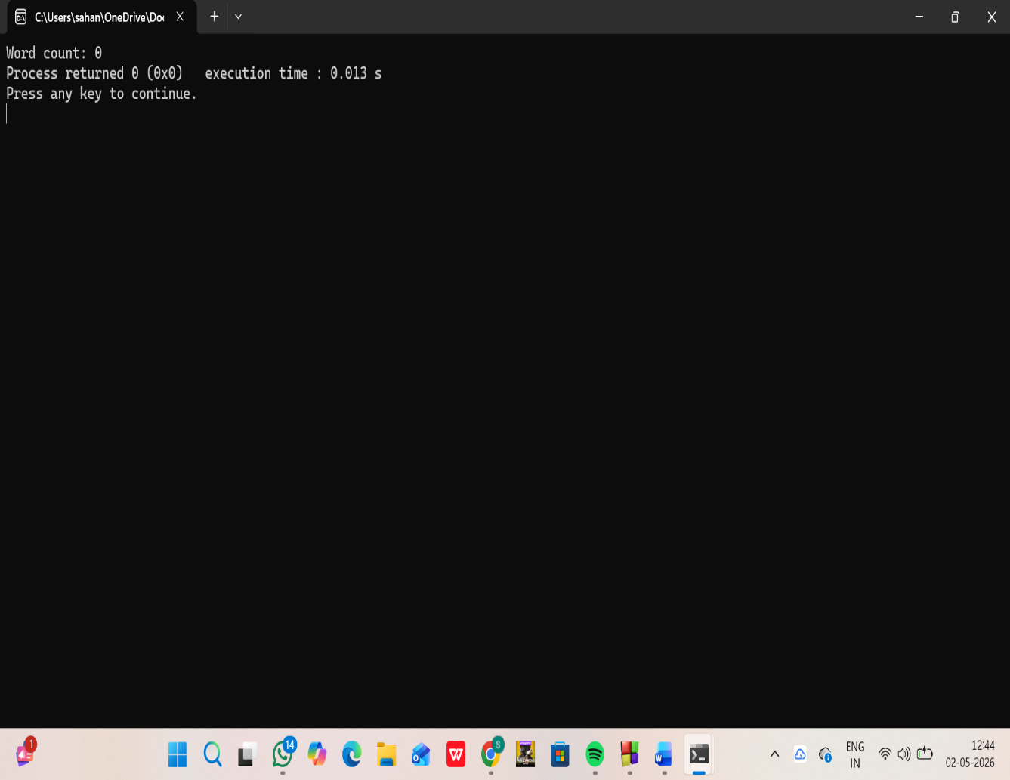

17. #include <iostream>
#include <vector>
using namespace std;

int main() {
vector<int> v = {1, 2, 3, 4};

v.push_back(5);
v.pop_back();

cout << "Size: " << v.size() << endl;
cout << "First: " << v.front() << endl;
cout << "Last: " << v.back() << endl;
}
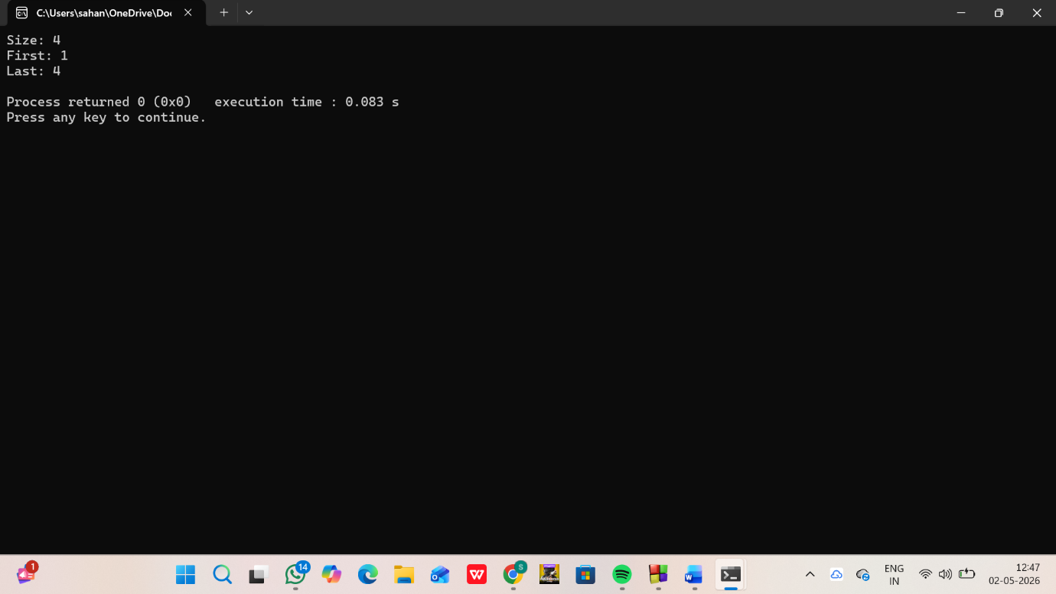
18.
include <iostream>
#include <fstream>
using namespace std;

int main() {
ofstream file("data.txt");

file << "Hello World";
file.close();

cout << "Data written to file";
return 0;
}
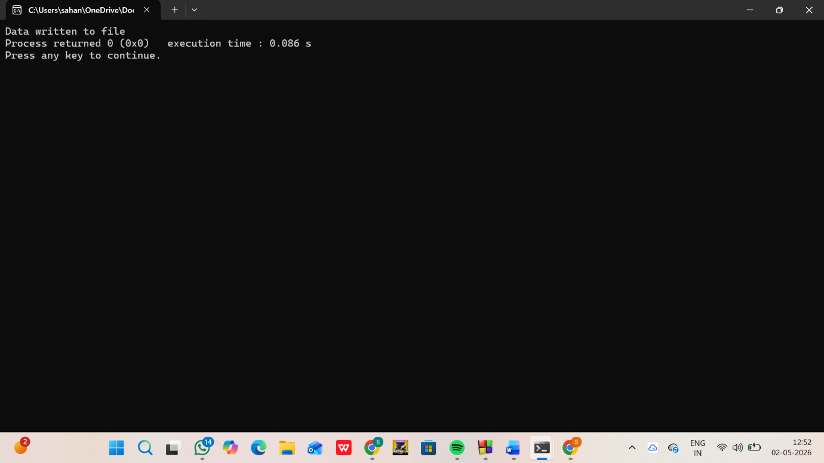
19.
#include <iostream>
#include <fstream>
using namespace std;

class Student {
public:
int id;
char name[20];
};

int main() {
Student s = {1, "San"};

ofstream file("student.dat", ios::binary);
file.write((char*)&s, sizeof(s));
file.close();

ifstream in("student.dat", ios::binary);
Student s1;
in.read((char*)&s1, sizeof(s1));

cout << s1.id << " " << s1.name;

in.close();
return 0;
}
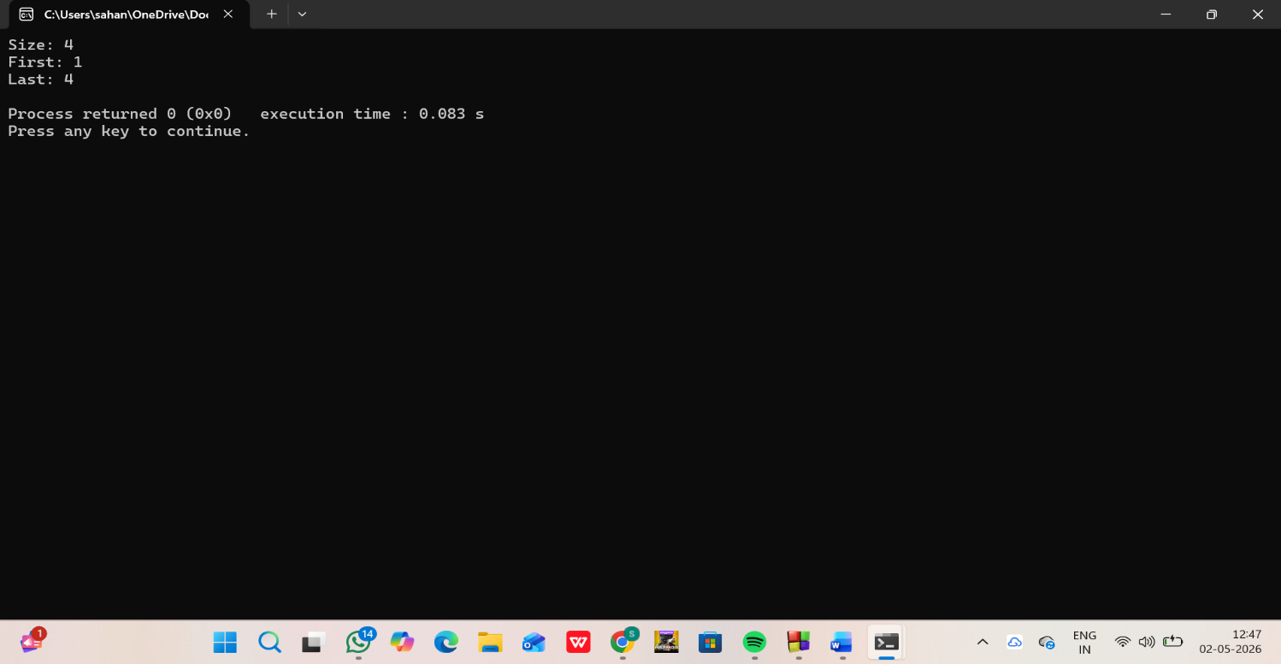
20.
#include <iostream>
#include <fstream>
using namespace std;

int main() {
ifstream file("data.txt");
string line;

while (getline(file, line)) {
cout << line << endl;
}

file.close();
return 0;
}
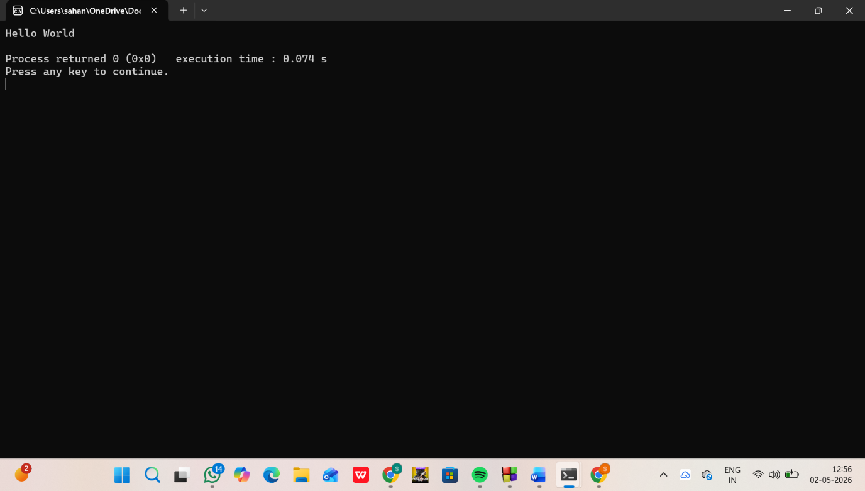
21.
#include <iostream>
#include <fstream>
using namespace std;

int main() {
string name;
int age;
cout << "Enter your name: ";
cin >> name;
cout << "Enter your age: ";
cin >> age;

ofstream outFile("data.txt");
outFile << "Name: " << name << endl;
outFile << "Age: " << age << endl;
outFile.close();

ifstream inFile("data.txt");
string line;

cout << "\nReading from file:\n";
while (getline(inFile, line)) {
cout << line << endl;
}
inFile.close();

return 0;
}

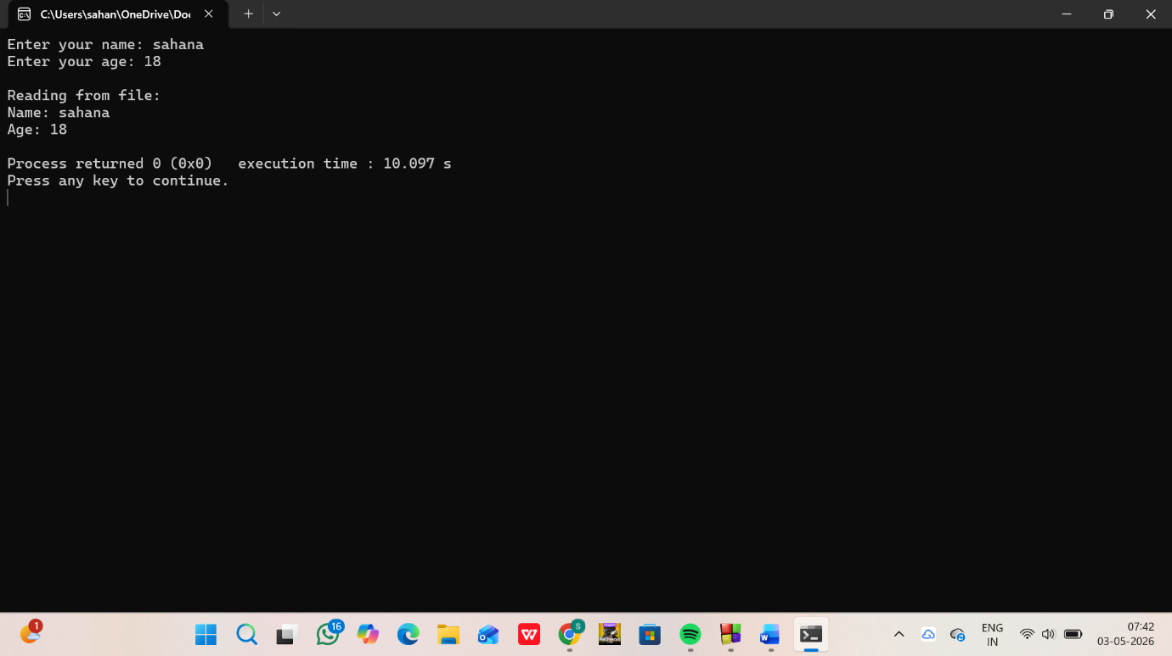
22.
#include <iostream>
#include <fstream>
using namespace std;

int main() {
int roll, marks, n;
string name;

cout << "Enter number of students: ";
cin >> n;

ofstream outFile("students.txt");

for (int i = 0; i < n; i++) {
cout << "\nEnter Roll No: ";
cin >> roll;
cout << "Enter Name: ";
cin >> name;
cout << "Enter Marks: ";
cin >> marks;

outFile << roll << " " << name << " " << marks << endl;
}

outFile.close();

ifstream inFile("students.txt");

cout << "\nStudent Records:\n";
while (inFile >> roll >> name >> marks) {
cout << "Roll No: " << roll << endl;
cout << "Name: " << name << endl;
cout << "Marks: " << marks << endl;
cout << "-------------------\n";
}

inFile.close();

return 0;
}

