**Coursera Capstone – The Battle of Neighbourhoods**

**Introduction**

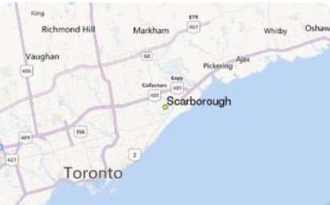

**Background:**

Toronto is the capital city of Canada with a huge population. Currently, the world is facing a pandemic caused by the novel [Corona Virus](https://www.who.int/health-topics/coronavirus#tab=tab_1). The citizens are requested to stay indoors and the majorly busy venues like Restaurants, Cinema, Malls, etc. are to remain closed. Despite the restrictions from the Toronto Police Department, there have been breaches of rules in some areas where people are still walking on the streets without a necessary reason and are not practicing social distancing. This will lead to the massive spread of virus in the community.

**Problem Statement:**

The Toronto Police Department has to manage the forces they have wisely in order to avoid the people from breaking the rules in the high alert zones. A clear analysis on the high alert zones will help the Department to assess how much Force has to be assigned in the area depending on how vast the area population is and how busy the area is.

**Target Audience:**

The target audience here is the Toronto Police Department which is seeking for information on the areas in Toronto. This will help them distribute their resources effectively.

**Success Criteria:**

The aim of this project is to give a clear picture to the Toronto Police Department on the zones that are highly prone to a huge spread of the virus based on 2 factors: Population in the Neighbourhood and the measure of how busy the area is.