Image Gallery

# Following was asked to accomplish:

Create an SPA using Angular 9 and primeNG that will:

* Allow user to upload an image ( you can mock this)
* Show a list of uploaded images.
* Select / View an uploaded image.
* Click a button to add a red circle (filled) on top of an selected image and show the X/Y for the circle outside of the picture in a div. Circle is a draggable element, so it can be moved with the mouse or with the touch.
* add a onClick event to the circle that will open a pop-up with two input fields. Store the input fields in the same object with the X/Y for the circle. Store all the circles in the same object (per image). More circles can be added in the same time over the same picture.

# Following was accomplished:

This project is made responsive for laptops and desktops. Not much time was spent on the design since more focus was on getting the logic right. Simple and user -friendly design is implemented

* Allow user to upload an image
* Show a list of uploaded images.
* Select / View an uploaded image.
* Click a button to add a red circle (filled) on top of an selected image and show the X/Y for the circle outside of the picture in a div. Circle is a draggable element, so it can be moved with the mouse or with the touch.
* Add a onClick event to the circle that will open a pop-up with two input fields. Store the input fields in the same object with the X/Y for the circle. Store all the circles in the same object (per image). More circles can be added in the same time over the same picture.

*\*I was not succeeded in making the circle draggable. I tried all the different ways possible, but I believe I was missing out something by overseeing. I spent most time in working on this single feature and did not want to take more time to submit. I apologize for not accomplishing one of the above features. I will continue working on that even after submission.*

# Design Model

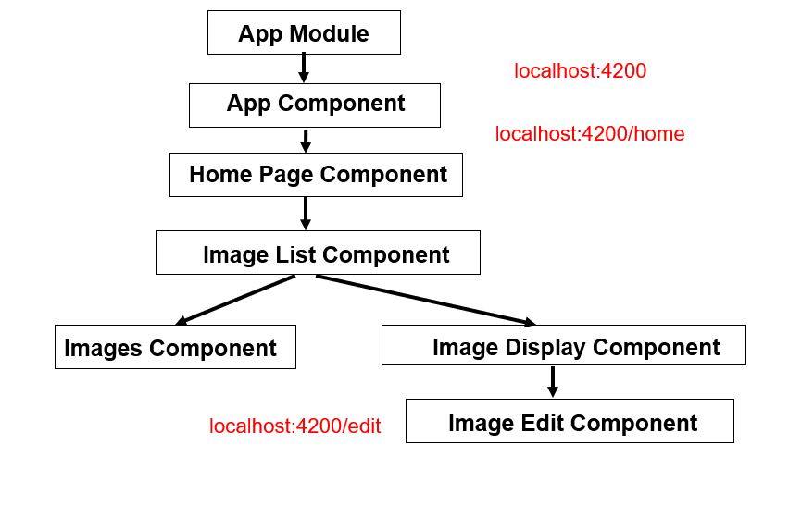

Image Gallery is designed as the above shown model. **Firebase Real Time Database** is used as a mock server to enable uploading of images. HTML5 Canvas is used to edit the image. CSS is used for styling and the global style sheet style.css is used. Images used for icons are placed in **“src/assets/images folder”.**

# Following features consumed more time than planned:

**Use of HTML5 Canvas –** This is something I have not used much during my work experience. It took a while to figure out how to draw image and shapes inside a canvas. Also found it challenging to make canvas responsive. Hence its width and height is fixed to fit all screens.

**Dragging circle on canvas –** This feature took more time than expected and delayed the submission.

Final thoughts

I enjoyed working on this project and loved the way questions covered various aspects of angular. I have completed this project as per my understanding of the questions. If there is something not done as expected please let me know I will be happy to work on it.