**Business Process, Quality Attributes, User Experience and User Interface (UX/UI) and Data Architecture**

**for**

***Learning Assistance System***

***Code Warriors***

Table of Contents

1 Introduction 3

2 Detailed Business Processes and Sub Processes 3

2.1 Detail business processes 3

2.2 Map the sub processes to User Stories 4

3 Identify Quality Attributes 5

3.1 Map user stories to quality attributes 5

3.2 Group User Stories based on Quality Attributes 7

4 UI / UX 9

5 Data Architecture 13

5.1 Identify Data Entities for each User Story 13

5.2 Build data architecture 15

6 System level Architectural choices 15

7 Applicable Standards 15

# Introduction

Developing a flexible learning portal where a registered user can customize and track their learning depending on their areas of interest. It is a platform of all the courses and resources where the users can interact with their co-learners and get rewards to recognize their achievements. Admin can add, delete or make any modifications to the learning portal.

# Detailed Business Processes and Sub Processes

## Detail business processes

|  |  |
| --- | --- |
| Key Business processes | Sub Processes |
| BP1 - Register/ Login | BP1.1 - Validate the role (admin/ registered user/ un-registered user) |
| BP2 - Authorization | BP2.1 – Determine and give access to their corresponding roles |
| BP3 – Privacy/Security | BP3.1 – Encrypt the user’s data to ensure privacy  Example: Triple DES, AES |
| BP4 – Manage Online Resources (e-books, articles, documentaries, google links, blogs, Netflix, Coursera etc.), live streaming, pre-recorded courses | BP4.1 - Verify eligibility of the member to use the resources.  BP4.2 – Create, Read, Update and Delete the list of resources available in the system |
| BP5 - Manage storage | BP5.1 - Validate the resources and store all those necessary and required resources in the cloud  BP5.2 - Parallelly update those resources based on users  interest |
| BP6 – Communication Platform | BP6.1- Provide the communication platform to the users to share, discuss with other users |
| BP7 – Manage and allocating Rewards | BP7.1 - Validate the registered users' accomplishments  BP7.2 - Allocate awards, in-app currency, points to the accomplished registered Users |
| BP8 – Email Notification | BP8.1 - Notify the users through emails about the new courses added, time pending to finish courses, etc. |
| BP9 – Manage Home Page and Dashboard | BP9.1 - Manage home page and dashboard contents  BP9.2 - Create, Read, Update and Delete the home page and dashboard contents |

## Map the sub processes to User Stories

|  |  |
| --- | --- |
| User Stories | Sub Processes |
| Creation of a user-friendly home page for learners | BP9.1  BP9.2 |
| Creation of an account with a username/ mobile number/Facebook/Gmail account and password for user | BP1.1  BP2.1 |
| Creation of an admin account and gaining admin access to do CRUD operation on the system contents. | BP1.1  BP2.1 |
| Creation of a user account to get user access and to do CRUD operations on learning | BP1.1  BP2.1 |
| Ability to perform CRUD operations on the system. So that admin can provide all the facilities to the users after a successful login to the system. | BP4.1  BP4.2 |
| Ability of the user to login successfully after entering valid login credentials and use the learning assistance system of his interest to set and track learning | BP2.1 |
| Granting of resources (by admin) for the users | BP4.1  BP4.2 |
| Ability to use my rewards, as a registered user to open other courses for my learning and share my accomplishments with other users. | BP7.1  BP7.2 |
| Ability of the admin to provide a platform to the users which ensures privacy of users' data. | BP3.1 |
| Registered users should be able to communicate with other users through a chat box or email. | BP3.1 |

# Identify Quality Attributes

## Map user stories to quality attributes

|  |  |  |
| --- | --- | --- |
| User Stories | Quality attributes mapping | Justification for the mapping |
| Creation of a user-friendly home page for learners | Usability, Supportability,  Flexibility, Portability | Usability- It should be possible to search al the home page contents  Supportability- The system maintains persistent logs of every functional operation in the home page for a registered user  Flexibility - The ability for the solution to adapt to possible or future changes in its requirements  Portability - The system works for all popular browsers (Google Chrome, Internet Explorer, Safari) and mobile operating systems (Android, iOS)  Portability - Users should be able to access the system through a mobile device or desktop |
| Creation of an account with a username/ mobile number/Facebook/Gmail account and password for user | Security, Usability, Portability | Security – The system must be able to validate the user’s role and identity.  Security - All the personal data of the registered user must be encrypted.  Usability – User login has maximum of 3 attempts  Portability - The system works for all popular browsers (Google Chrome, Internet Explorer, Safari) and mobile operating systems (Android, iOS)  Portability - Users should be able to access the system through a mobile device or desktop |
| Creation of an admin account and gaining admin access to do CRUD operation on the system contents. | Modifiability,  Security | Modifiability – The admin has access to add/delete/modify/vary functionality  Security- The admin must have access related to all the users |
| Ability of the user to login successfully after entering valid login credentials and use the learning assistance system of his interest to set and track learning | Security | Security- The user must have access to all the contents |
| Granting of resources (by admin) for the users | Usability, Performance,  Scalability | Usability – The admin makes the system efficient and minimize impact of errors  Performance - The system should be able to support a maximum of 2000 users in its first year  Scalability – The system should grow by 50% per year. |
| Ability to use my rewards, as a registered user to open other courses for my learning and share my accomplishments with other users. | Supportability,  Portability | Supportability - The system should have a built-in mechanism to send emails  Supportability - The system maintains persistent logs of every functional operation in the home page for a registered user  Portability - The system works for all popular browsers (Google Chrome, Internet Explorer, Safari) and mobile operating systems (Android, iOS)  Portability - Users should be able to access the system through a mobile device or desktop |
| Ability of the admin to provide a platform to the users which ensures privacy of users' data. | Security | Security - All the personal data of the registered user must be encrypted |
| Registered users should be able to communicate with other users through a chat box or email. | Supportability | Supportability - The system should have a built-in mechanism to communicate with others through chat box |

## Group User Stories based on Quality Attributes

|  |  |  |
| --- | --- | --- |
| Quality attribute | User stories | Explanation of the attributes |
| Availability |  | Availability is defined as the probability that the system is operating properly when it is requested for use. |
| Security | Ability of the admin to provide a platform to the users which ensures privacy of users' data,  Ability of the user to login successfully after entering valid login credentials and use the learning assistance system of his interest to set and track learning  Creation of an account with a username/ mobile number/Facebook/Gmail account and password for user  Creation of an admin account and gaining admin access to do CRUD operation on the system contents. | 1. Security is responsible for the ability of the system to reduce the likelihood of malicious or accidental actions as well as the possibility of theft or loss of information. |
| Portability | Creation of a user-friendly home page for learners  Creation of an account with a username/ mobile number/Facebook/Gmail account and password for user  Ability to use my rewards, as a registered user to open other courses for my learning and share my accomplishments with other users. | Portability is defined as in how many other platforms a system is expected to run on and in what browsers and devices is the system compatible with |
| Performance | Granting of resources (by admin) for the users | **Performance** shows the response of the system to performing certain actions for a certain period of time. |
| Usability | Creation of a user-friendly home page for learners  Creation of an account with a username/ mobile number/Facebook/Gmail account and password for user  Granting of resources (by admin) for the users | **Usability** is one of the most important attributes, because, unlike in cases with other attributes, users can see directly how well this attribute of the system is worked out. |
| Testability |  | **Testability** shows how well the system allows performing tests, according to predefined criteria. |
| Scalability | Granting of resources (by admin) for the users | **Scalability** is the ability of the system to handle load increases without decreasing performance, or the possibility to rapidly increase the load. |
| Agility |  | Agility is the flexibility in supporting new business models, enables service discovery and provides visibility into business process health. |
| Supportability | Creation of a user-friendly home page for learners  Ability to use my rewards, as a registered user to open other courses for my learning and share my accomplishments with other users.  Registered users should be able to communicate with other users through a chat box or email. | **Supportability** is the ability of the system to provide useful information for identifying and solving problems. |
| Flexibility | Creation of a user-friendly home page for learners | Flexibility is the ability for the solution to adapt to possible or future changes in its requirements |

# UI / UX

1. Login Page

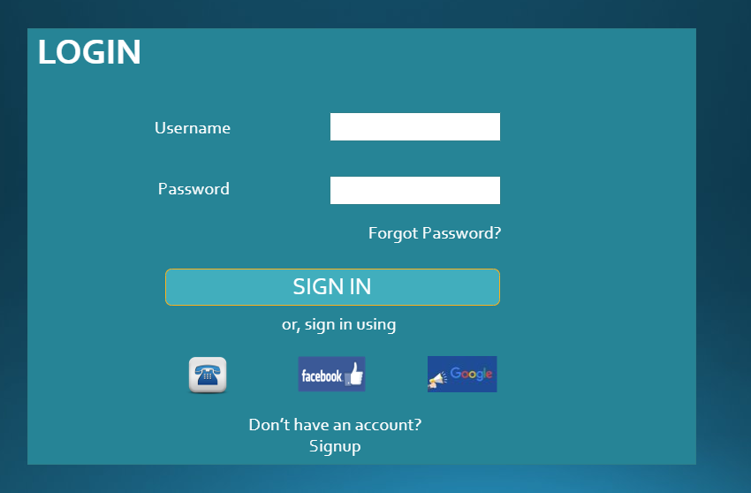

1. Sign Up page

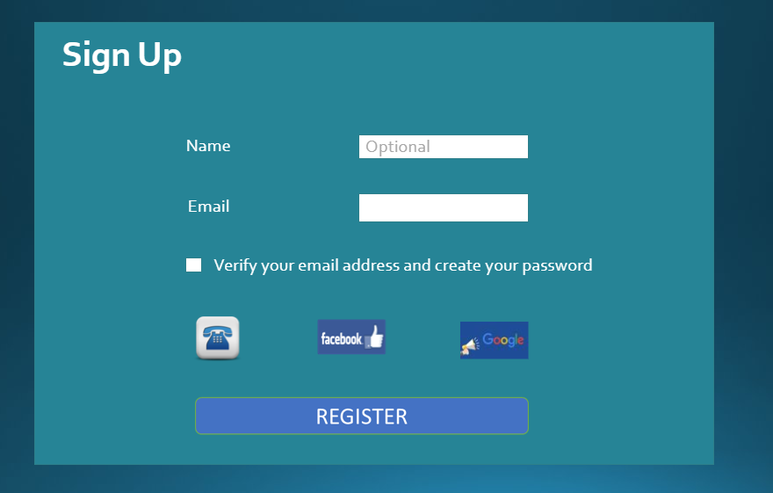

1. Account Verification Page

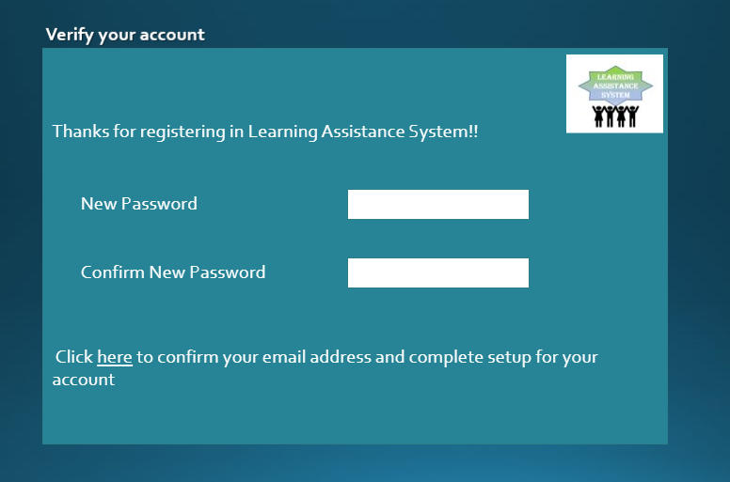

1. Forgot Password page

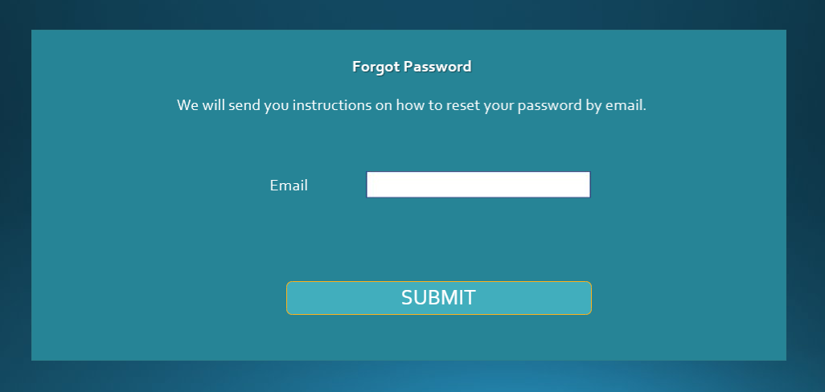

1. Phone Number Verification Page

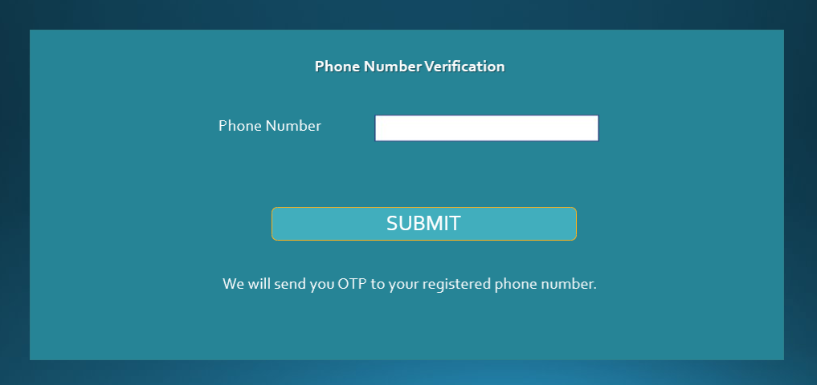

1. OTP page

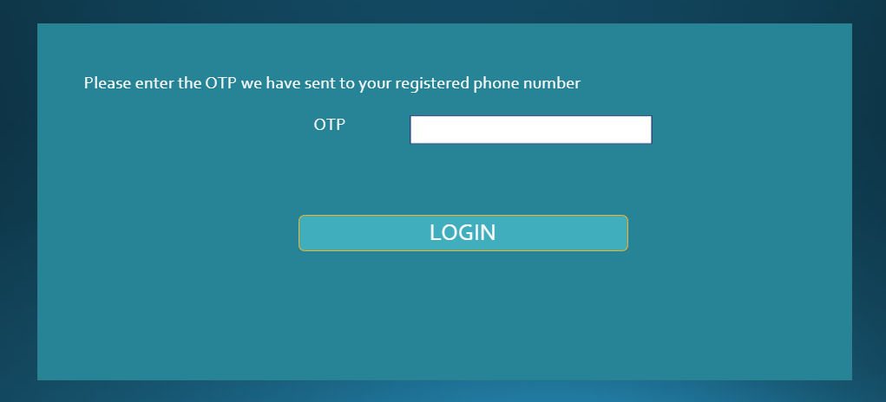

1. Home Page

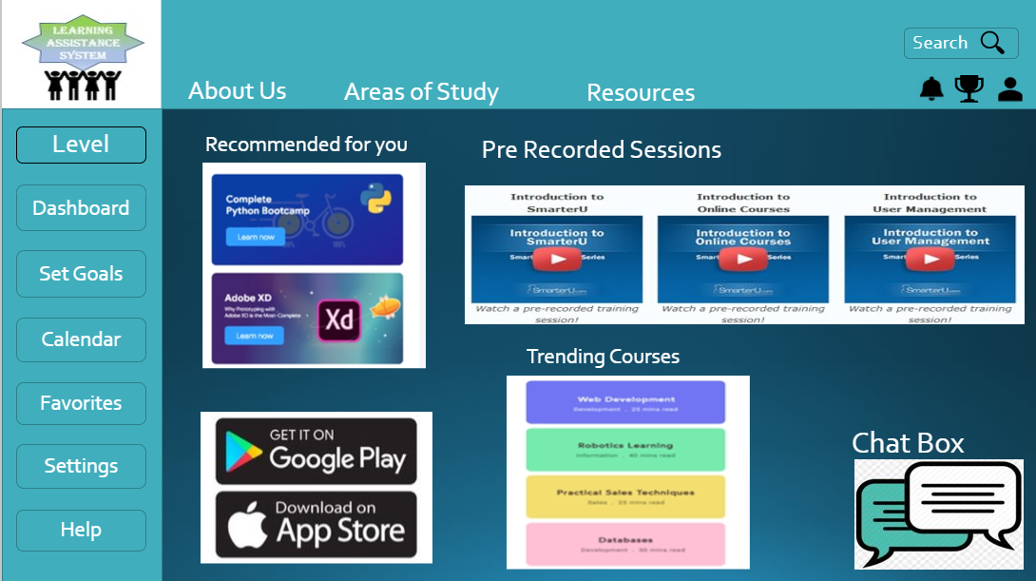

1. Dashboard

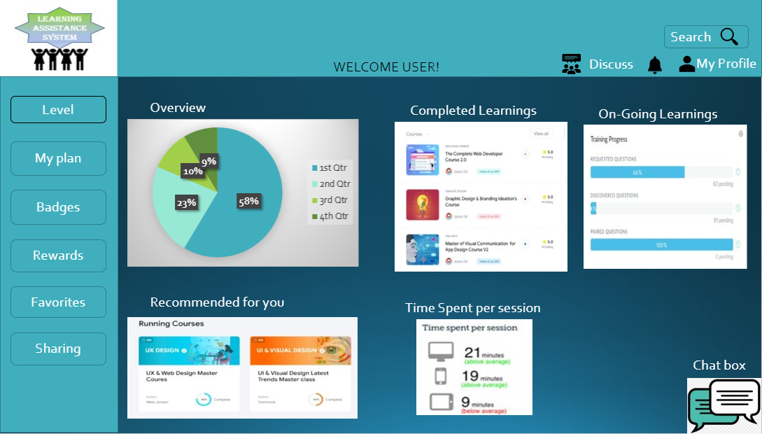

# Data Architecture

## Identify Data Entities for each User Story

|  |  |  |
| --- | --- | --- |
| User Stories | Entities | Description |
| Creation of a user-friendly home page for learners | Goals,  Online Resources,  Users, Communication Platform and  Rewards | System provides user-friendly Home page where the users can set and track their goals by using the online resources and also communicate with other users and get rewards for their accomplishments. |
| Creation of an account with a username/ mobile number/Facebook/Gmail account and password for user | Users | User can create an account giving username, or mobile number, or by sign in through Facebook or through Gmail. |
| Creation of an admin account and gaining admin access to do CRUD operation on the system contents. | Dashboard, Goals,  Online Resources,  Communication Platform and  Rewards | System has an admin who can do CRUD operations on system contents and has the right to give access to the users depending upon the users who are registered or not |
| Ability of the user to login successfully after entering valid login credentials and use the learning assistance system of his interest to set and track learning | Dashboard,  Goals,  Online Resources,  Users, Communication Platform and  Rewards | After the user login successfully, the user should be able to use all system benefits |
| Granting of resources (by admin) for the users | Dashboard, Goals,  Online Resources,  Users, Communication Platform and  Rewards | Admin is the one who give access to the users to use the resources. |
| Ability to use my rewards, as a registered user to open other courses for my learning and share my accomplishments with other users. | Dashboard, Goals,  Online Resources,  Users, Communication Platform and  Rewards | After completing a learning, registered user will get rewards. User can then use these rewards to open other courses and also the user can share their accomplishments with other registered users |
| Ability of the admin to provide a platform to the users which ensures privacy of users' data. | Dashboard, Goals,  Online Resources,  Users, Communication Platform and  Rewards | Admin should take care of protecting users data to ensure privacy |
| Registered users should be able to communicate with other users through a chat box or email. | Users, Communication Platform | Users can use communication platform to communicate with other registered users. |

## Build data architecture

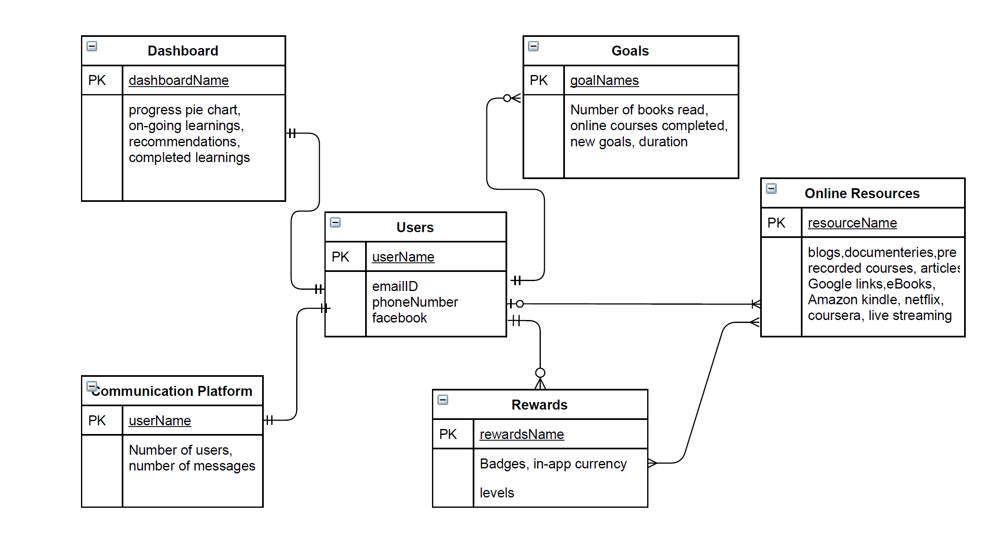

# System level Architectural choices

This section is used to document the system level decisions.

⦁ we are using homepage and dashboard UI architectural styles in our system

⦁ we are using cloud technology

⦁ Security, Usability, flexibility, high performance, scalability, portability, Modifiability and other qualities for which we make architectural, system wide choices

# Applicable Standards

Data Privacy Act - System uses Data Privacy Act to ensure users privacy

User data storage and handling should comply with General Data Protection Regulation(GDPR) standards