CIA-1 PROJECT

TESTING

PROBLEM STATEMENT:

QUESTION NO:1

CODING:

package com.Test.Testing;

import org.openqa.selenium.By;

import org.openqa.selenium.WebDriver;

import org.openqa.selenium.WebElement;

import org.openqa.selenium.chrome.ChromeDriver;

import org.openqa.selenium.chrome.ChromeOptions;

import io.github.bonigarcia.wdm.WebDriverManager;

public class Card {

public static void main(String[] args) {

// **TODO** Auto-generated method stub

ChromeOptions co=new ChromeOptions();

co.addArguments ("--remote-allow-origins=*");

WebDriverManager.*chromedriver*().setup ();

WebDriver driver=new ChromeDriver(co);

driver.get ("https://www.amazon.in/Spigen-Urban-Fabric-Compatible-MacBook/dp/B09R2KCXD2/?_encoding=UTF8&pd_rd_w=hN3t9&content-id=amzn1.sym.e0e8ce89-ede3-4c51-b6ad-44989efc8536&pf_rd_p=e0e8ce89-ede3-4c51-b6ad-44989efc8536&pf_rd_r=10MH3SN3ES208H0RRNSQ&pd_rd_wg=wPWJi&pd_rd_r=13f23fa2-e355-40ad-a989-abace7275caf&ref_=pd_gw_ci_mcx_mr_hp_d");

driver.manage().window().maximize() ;

String currentTitle=driver.getTitle();

System.***out***.println(currentTitle);

String expectedTitle="Spigen Urban Fit Fabric Case Cover Compatible with MacBook Pro 14 inch (2021) - Black - Buy Spigen Urban Fit Fabric Case Cover Compatible with MacBook Pro 14 inch (2021) - Black Online at Low Price in India - Amazon.in";

if(currentTitle.equals(expectedTitle)) {

System.***out***.println("Title Matched");

}

else {

System.***out***.println("Title not Matched");

}

driver.findElement(By.*xpath*("//*[@id=\"add-to-cart-button\"]")).click();

driver.findElement(By.*xpath*("//*[@id=\"nav-cart\"]")).click();

driver.findElement(By.*xpath*("//*[@id=\"a-autoid-0-announce\"]")).click();

driver.findElement(By.*xpath*("//*[@id=\"quantity_4\"]")).click();

driver.findElement(By.*xpath*("//*[@id=\"sc-buy-box-ptc-button\"]/span/input")).click();

WebElement txtBoxl=driver.findElement(By.*xpath*("//*[@id=\"ap_email\"]"));

txtBoxl.sendKeys("9600768691");

driver.findElement(By.*xpath*("//*[@id=\"continue\"]")).click();

WebElement txtBox2=driver.findElement(By.*xpath*("//*[@id=\"ap_password\"]"));

txtBox2.sendKeys("Sahana@2119");

driver.findElement(By.*xpath*("//*[@id=\"signInSubmit\"]")).click();

}

}

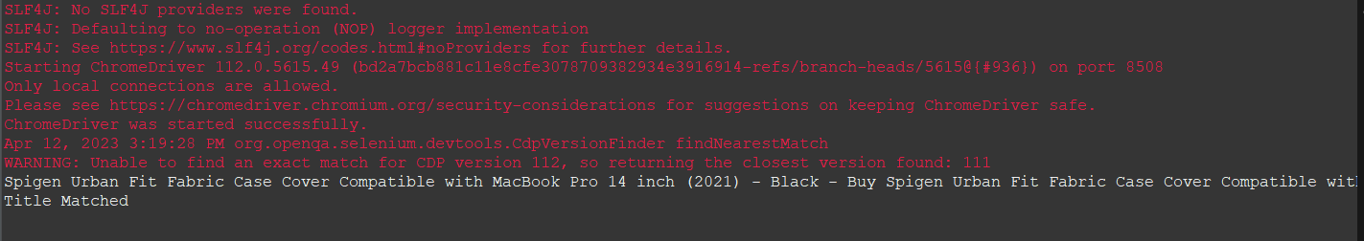

OUTPUT:

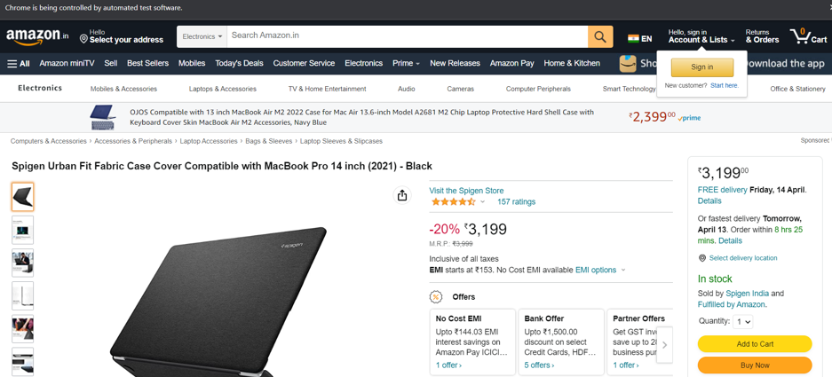

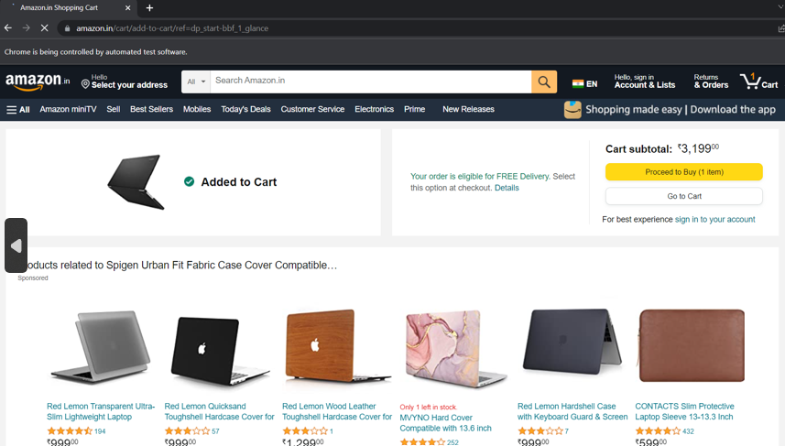

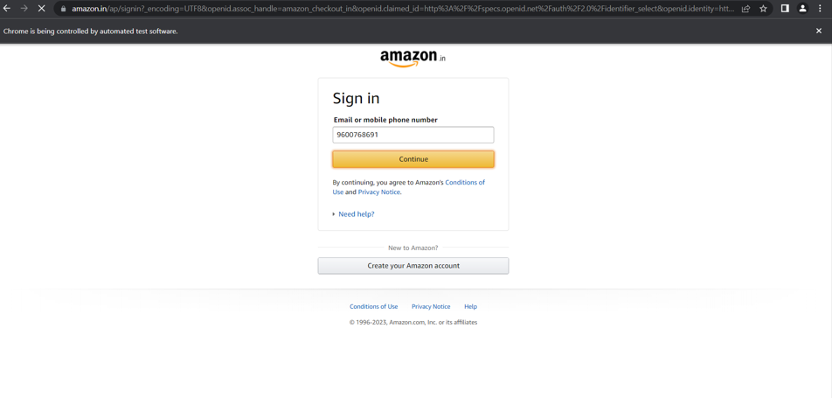

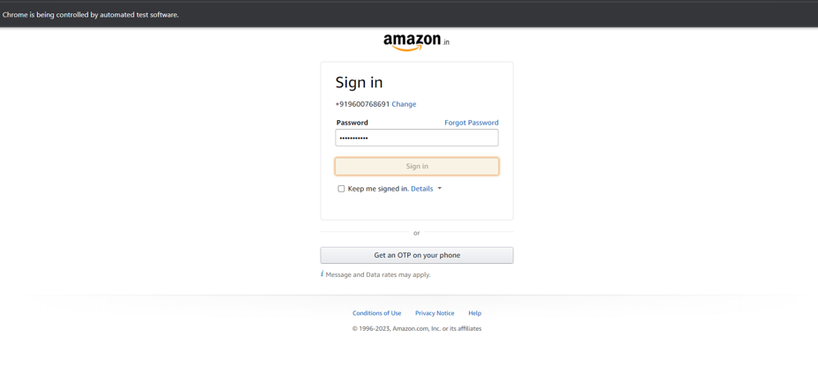

QUESTION NO:2

CODING:

package com.Test.Testing;

import java.util.List;

import org.openqa.selenium.By;

import org.openqa.selenium.WebDriver;

import org.openqa.selenium.WebElement;

import org.openqa.selenium.chrome.ChromeDriver;

import org.openqa.selenium.chrome.ChromeOptions;

import io.github.bonigarcia.wdm.WebDriverManager;

public class Name {

public static void main(String[] args) throws InterruptedException {

ChromeOptions co=new ChromeOptions();

co.addArguments ("--remote-allow-origins=*");

WebDriverManager.*chromedriver*().setup ();

WebDriver driver=new ChromeDriver(co);

driver.get("https://www.amazon.in/");

driver.manage().window().maximize();

String CurrentTitle=driver.getTitle();

System.***out***.println(CurrentTitle);

String ExpectedTitle="Online Shopping site in India: Shop Online for Mobiles, Books, Watches, Shoes and More - Amazon.in";

if(CurrentTitle.equals(ExpectedTitle))

{

System.***out***.println("Title Matched.");

}

else

{

System.***out***.println("Title not Matched");

}

Thread.*sleep*(3000);

driver.findElement(By.*xpath*("//*[@id=\"twotabsearchtextbox\"]")).sendKeys("Bangles");

driver.findElement(By.*xpath*("/html/body/div[1]/header/div/div[1]/div[2]/div/form/div[3]/div/span/input")).click();

List<WebElement> li=driver.findElements(By.*className*("s-line-clamp-1"));

for(WebElement link:li) {

System.***out***.println(link.getText());

}

driver.findElement(By.*xpath*("//*[@id=\"p_89/Skybags\"]/span/a/div/label/i")).click();

driver.findElement(By.*xpath*("//*[@id=\"p_89/Safari\"]/span/a/div/label/i")).click();

}

}

OUTPUT:

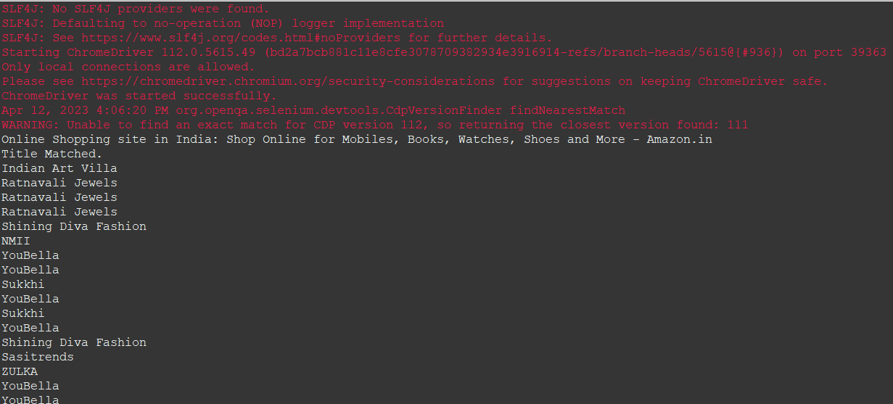

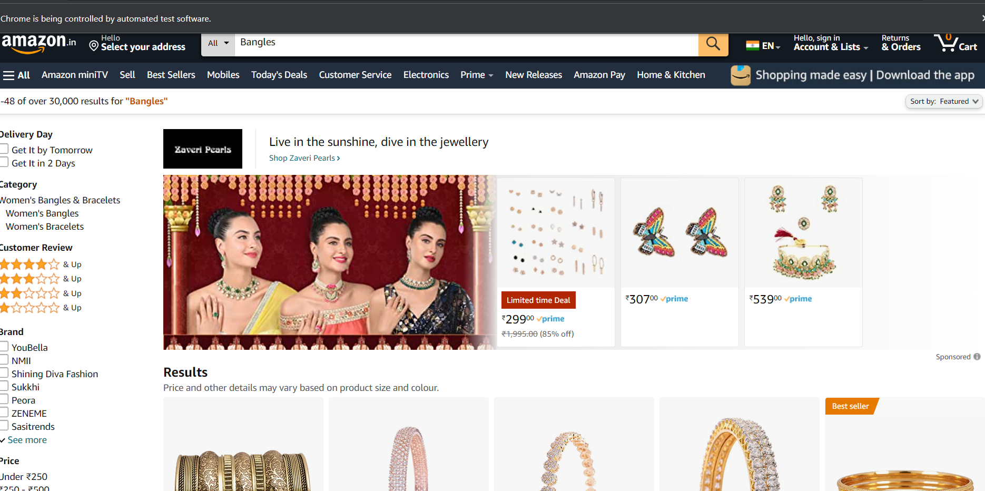

QUESTION NO:3

CODING:

package com.Test.Testing;

import org.openqa.selenium.By;

import org.openqa.selenium.WebDriver;

import org.openqa.selenium.WebElement;

import org.openqa.selenium.chrome.ChromeDriver;

import org.openqa.selenium.chrome.ChromeOptions;

import io.github.bonigarcia.wdm.WebDriverManager;

public class Account {

public static void main(String[] args) throws InterruptedException {

ChromeOptions co=new ChromeOptions();

co.addArguments ("--remote-allow-origins=*");

WebDriverManager.*chromedriver*().setup ();

WebDriver driver=new ChromeDriver(co);

driver.get ("https://www.amazon.in/");

driver.manage().window().maximize();

String currentTitle=driver.getTitle();

System.***out***.println(currentTitle);

String expectedTitle="Online Shopping site in India: Shop Online for Mobiles, Books, Watches, Shoes and More - Amazon.in";

if(currentTitle.equals(expectedTitle)) {

System.***out***.println("Title Matched");

}

else {

System.***out***.println("Title not Matched");

}

driver.findElement(By.*xpath*("//*[@id=\"nav-link-accountList\"]")).click();

driver.findElement(By.*xpath*("//*[@id=\"ap_email\"]")).sendKeys("9600768691");

driver.findElement(By.*xpath*("//*[@id=\"continue\"]")).click();

driver.findElement(By.*xpath*("//*[@id=\"ap_password\"]")).sendKeys("sahana@2119");

driver.findElement(By.*xpath*("//*[@id=\"signInSubmit\"]")).click();

Thread.*sleep*(1000);

driver.findElement(By.*xpath*("//*[@id=\"nav-orders\"]")).click();

String order = driver.findElement(By.*xpath*("//*[@id=\"a-page\"]/section/div[1]/div[4]/form/label")).getText();

System.***out***.println("Your last Order:"+order);

}

}

OUTPUT:

