Functional Requirements Document
AttendX — Photo-Verified, Geofenced Attendance Tracking System
Version 1.0
September 9, 2026

1. Purpose & Scope
This document defines the functional and non-functional requirements for AttendX, translating the PRD into implementable, testable requirements for engineering.

2. System Actors
Actor | Description
Employee | Registered staff member who performs checkpoint actions during a shift.
Section Admin | Manages and reviews attendance for employees within one section.
Super Admin | Manages all sections, employees, shifts, and system configuration.
System (background jobs) | Runs late-detection checks, geofence validation, lockout timers, and notification dispatch.

3. Functional Requirements

FR-1: Authentication & Session Security
ID | Requirement
FR-1.1 | System shall authenticate users via Employee ID/Admin ID + password.
FR-1.2 | System shall lock the account after 3 consecutive failed password attempts; unlock requires Super Admin/Section Admin action.
FR-1.3 | System shall intercept the browser Back button; on trigger, the session is re-locked and requires password/ID re-entry to resume, for all roles.
FR-1.4 | System shall auto-expire idle sessions after a configurable timeout (default 15 minutes).

FR-2: Employee Management
ID | Requirement
FR-2.1 | Admin shall be able to add a new employee via an 'Add New Detail' form capturing: name, photo, employee ID, section, assigned shift, login credentials.
FR-2.2 | Admin shall be able to edit, deactivate, or reassign an employee's section/shift.
FR-2.3 | System shall prevent duplicate employee IDs.
FR-2.4 | Section Admin may add/manage employees only within their own section; Super Admin may manage all sections.

FR-3: Shift & Checkpoint Configuration
ID | Requirement
FR-3.1 | System shall support 6 configurable shifts per day, each with a start time, end time, and late grace period.
FR-3.2 | System shall support a default checkpoint sequence per shift: Sign In, Lunch Out, Lunch In, Tea Out, Tea In, Sign Out.
FR-3.3 | Admin shall be able to add additional custom checkpoints (7th, 8th, and beyond) per shift.
FR-3.4 | Each checkpoint shall be configurable with a name, expected time window, and whether it triggers late detection.

FR-4: Attendance Capture Flow
ID | Requirement
FR-4.1 | At each checkpoint, the system shall capture a photo/short clip (1–2 minutes) of the employee performing the action.
FR-4.2 | Each capture shall be tagged with: employee ID, section, shift, checkpoint name, GPS coordinates, and timestamp.
FR-4.3 | System shall reject a checkpoint submission if photo capture fails, and shall prompt the employee to retry.
FR-4.4 | Checkpoints must be completed in sequence per shift (cannot log 'Lunch In' before 'Lunch Out').

FR-5: Late Detection
ID | Requirement
FR-5.1 | System shall compare the Sign In checkpoint timestamp against the assigned shift start time plus grace period.
FR-5.2 | If the Sign In timestamp exceeds the shift start time + grace period (e.g., start 10:30 AM, grace 10 min, actual 10:45 AM), the record shall be flagged 'LATE'.
FR-5.3 | Late-flagged records shall surface the checkpoint photo prominently on the Section Admin and Super Admin dashboards.
FR-5.4 | System shall support configurable grace periods per shift.

FR-6: GPS Geofencing
ID | Requirement
FR-6.1 | Each office location shall be registered with a center coordinate and a configurable radius (default 20–50m; the 1m target requested is below consumer GPS accuracy and is not achievable in practice).
FR-6.2 | System shall validate the device's GPS position against the geofence before permitting any checkpoint action.
FR-6.3 | If the device is outside the geofence, the system shall block the action and display a popup: 'You are outside the office location.'
FR-6.4 | If the device re-enters the geofence, the system shall re-enable checkpoint actions automatically.
FR-6.5 | System shall log all geofence rejection events for audit purposes.

FR-7: Admin Dashboard & Folder-Wise Display
ID | Requirement
FR-7.1 | Section Admin dashboard shall present records in a folder hierarchy: Section → Employee → Date → Checkpoint.
FR-7.2 | Section Admin shall see only employees within their assigned section(s).
FR-7.3 | Super Admin dashboard shall present all sections with the same folder-wise structure.
FR-7.4 | Dashboard shall visually flag LATE records and provide one-click access to the associated photo.

FR-8: Reporting & Export
ID | Requirement
FR-8.1 | Admins shall be able to filter attendance records by date range, section, employee, shift, and checkpoint.
FR-8.2 | Admins shall be able to export filtered results (CSV/Excel) — Phase 2.

FR-9: Notifications
ID | Requirement
FR-9.1 | System shall notify Section Admins when an employee in their section is flagged LATE — Phase 2.
FR-9.2 | System shall notify an employee when a geofence rejection occurs during their shift window.

FR-10: Installable Web App (PWA)
ID | Requirement
FR-10.1 | Application shall be installable to a device home screen via standard PWA manifest + service worker.
FR-10.2 | Application shall function within a mobile browser without installation as a fallback.

4. Non-Functional Requirements
Category | Requirement
Performance | Checkpoint submission (photo + GPS + record save) shall complete in under 5 seconds on a standard 4G connection.
Security | All photo and location data shall be encrypted in transit (TLS) and at rest.
Privacy/Compliance | Employees shall provide consent for photo and location capture at onboarding; data retention policy shall be configurable (default 180 days).
Availability | System shall target 99.5% uptime during business hours.
Scalability | System shall support organizations from 50 to 10,000+ employees without architecture change.
Usability | Checkpoint action shall be completable in 3 taps or fewer from app open.
Auditability | Every geofence rejection, lockout event, and late flag shall be permanently logged and immutable.

5. Data Model (Summary)
Entity | Key Fields
Employee | employee_id, name, photo_url, section_id, shift_id, credentials_hash, status
Section | section_id, name, admin_ids[]
Shift | shift_id, name, start_time, end_time, grace_period_minutes
Checkpoint | checkpoint_id, shift_id, name, sequence_order, is_late_check
AttendanceRecord | record_id, employee_id, checkpoint_id, timestamp, photo_url, gps_lat, gps_lng, status(ON_TIME/LATE/REJECTED)
GeofenceZone | zone_id, section_id/org_id, center_lat, center_lng, radius_meters
LoginAttempt | attempt_id, user_id, timestamp, success(bool)
AdminUser | admin_id, name, role(section/super), section_ids[]

6. System Flow Diagram
The diagram below illustrates the end-to-end flow from app open through geofence validation, checkpoint capture, late detection, and role-based dashboard delivery.
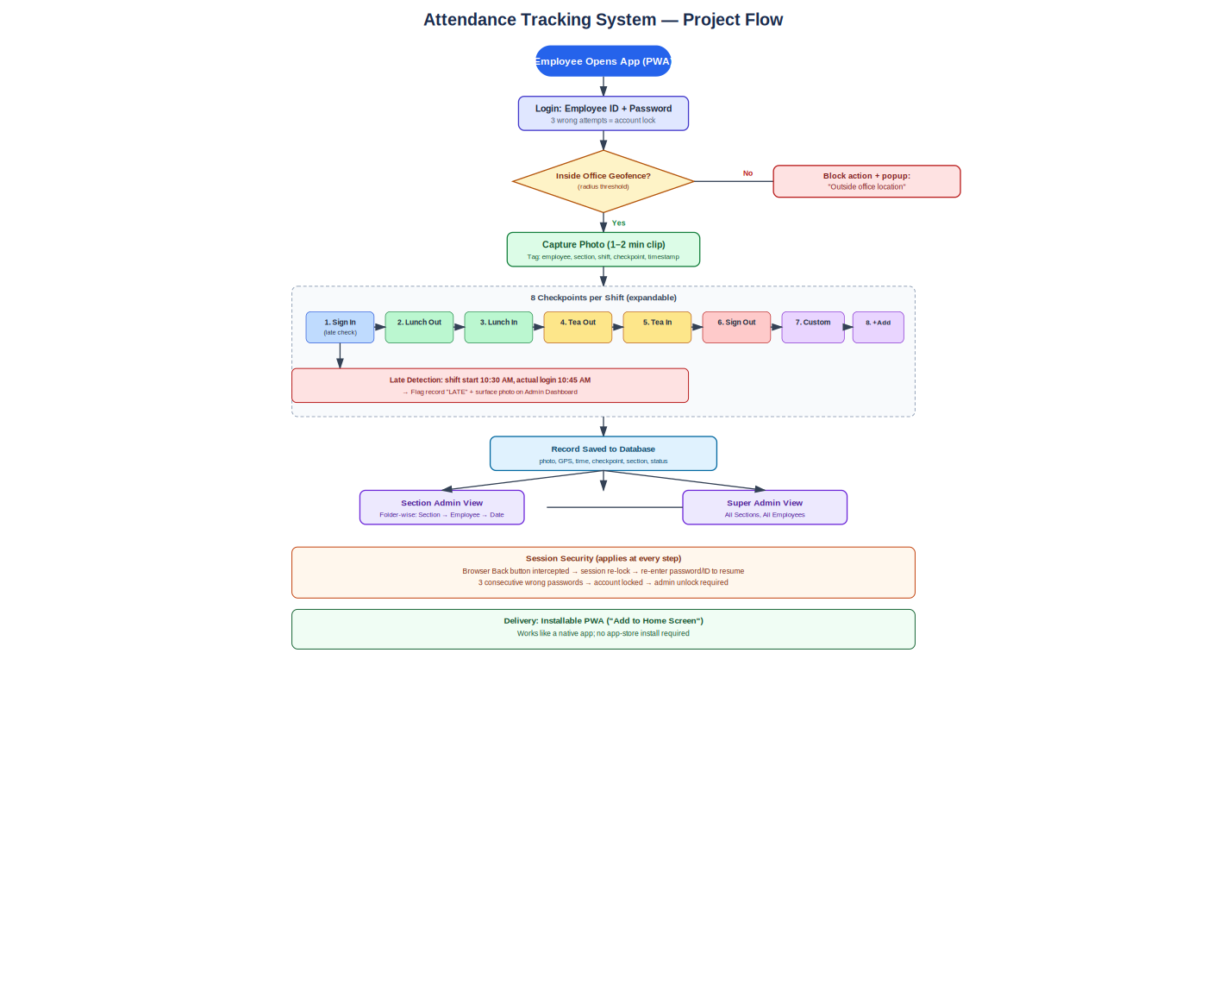

7. Acceptance Criteria (Samples)
Requirement | Acceptance Criteria
FR-5.2 Late Detection | Given shift start = 10:30 AM and grace = 10 min, when Sign In is logged at 10:45 AM, then record.status = LATE and photo is visible on admin dashboard within 5 seconds.
FR-6.3 Geofence Block | Given device GPS is outside the configured radius, when employee taps any checkpoint, then action is blocked and popup 'You are outside the office location' is shown.
FR-1.2 Lockout | Given 3 consecutive failed password attempts, when the 3rd fails, then account status = LOCKED and further login attempts are rejected until admin unlock.
FR-1.3 Back Button | Given an active session, when the user presses browser Back, then the app intercepts navigation and requires password/ID re-entry before resuming.

