**SAHANA L**

**1BM18CS089**

**STUDENT DATABASE**

**QUERIES**

CREATE TABLE STUDENTS(

REGNO VARCHAR2(20),NAME1 VARCHAR2(30),MAJOR VARCHAR2(10),BDATE DATE,

PRIMARY KEY(REGNO));

CREATE TABLE COURSE(

COURSEID NUMBER(10),CNAME VARCHAR2(10),DEPT VARCHAR2(10),

PRIMARY KEY(COURSEID));

CREATE TABLE TEXT(

ISBN NUMBER(10),BOOK_TITLE VARCHAR2(30),PUBLISHER VARCHAR2(30),AUTHOR VARCHAR2(10),

PRIMARY KEY(ISBN));

CREATE TABLE BOOK_ADOPTION(COURSEID NUMBER(9),SEM NUMBER(10),ISBN NUMBER(10),

PRIMARY KEY(COURSEID,ISBN),

FOREIGN KEY(COURSEID) REFERENCES COURSE(COURSEID) ON DELETE CASCADE,

FOREIGN KEY (ISBN) REFERENCES TEXT(ISBN) ON DELETE CASCADE);

CREATE TABLE ENROLL(REGNO VARCHAR2(10), COURSEID NUMBER(10), SEM NUMBER(10), MARKS NUMBER(10),

PRIMARY KEY(REGNO,COURSEID),

FOREIGN KEY(REGNO) REFERENCES STUDENTS(REGNO) ON DELETE CASCADE,

FOREIGN KEY(COURSEID) REFERENCES COURSE(COURSEID) ON DELETE CASCADE);

INSERT INTO STUDENTS VALUES('&REGNO','&NAME','&MAJOR','&DATE');

SELECT * FROM STUDENTS;

INSERT INTO COURSE VALUES(&COURSEID,'&CNAME','&DEPT');

SELECT * FROM COURSE;

INSERT INTO TEXT VALUES(&ISBN,'&BOOK_TITLE','&PUBLISHER','&AUTHOR');

SELECT * FROM TEXT;

INSERT INTO BOOK_ADOPTION VALUES(&COURSEID,&SEM,&ISBN);

SELECT * FROM BOOK_ADOPTION;

INSERT INTO ENROLL VALUES('&REGNO',&COURSEID,&SEM,&MARKS);

SELECT * FROM ENROLL;

1. **STUDENT**

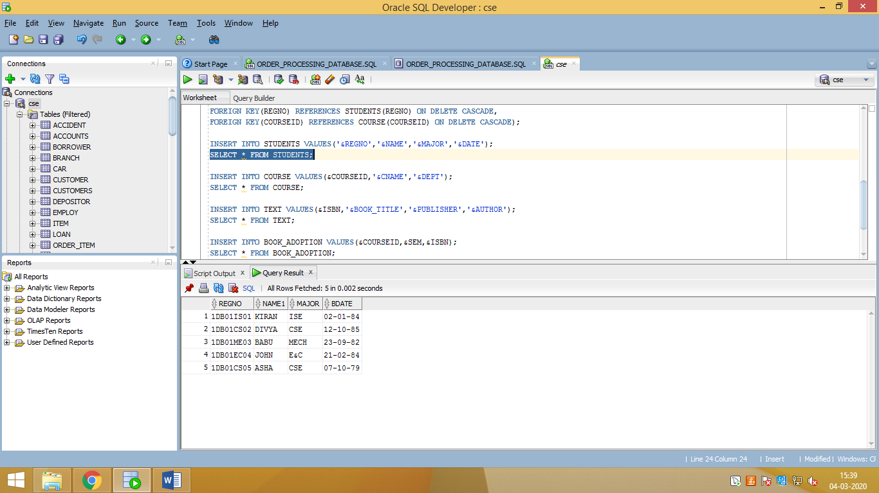

1. **COURSE**

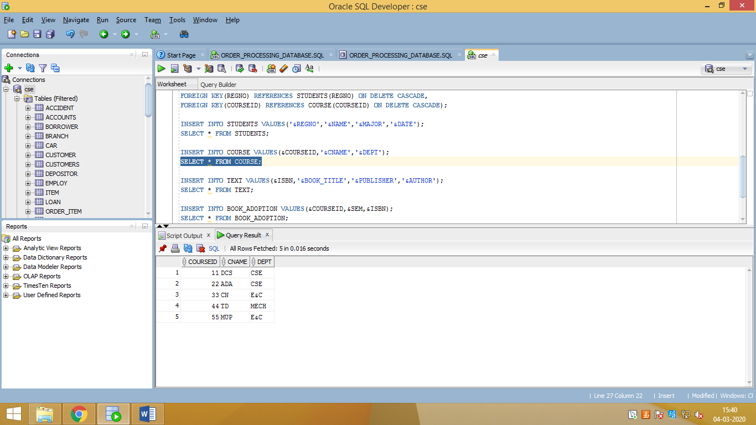

1. **TEXT**

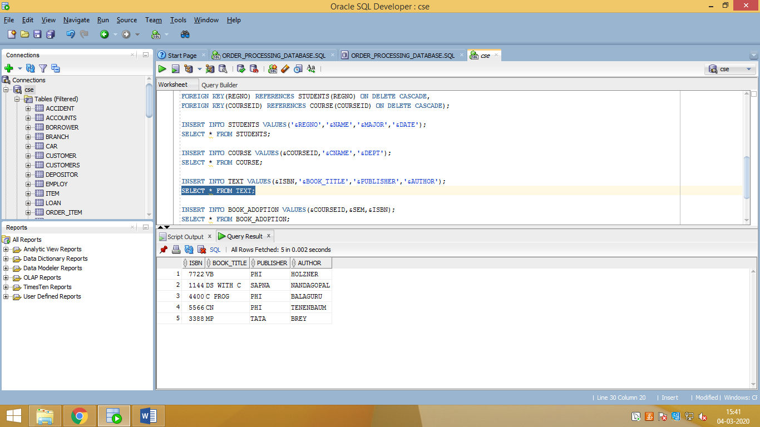

1. **BOOK ADOPTION**

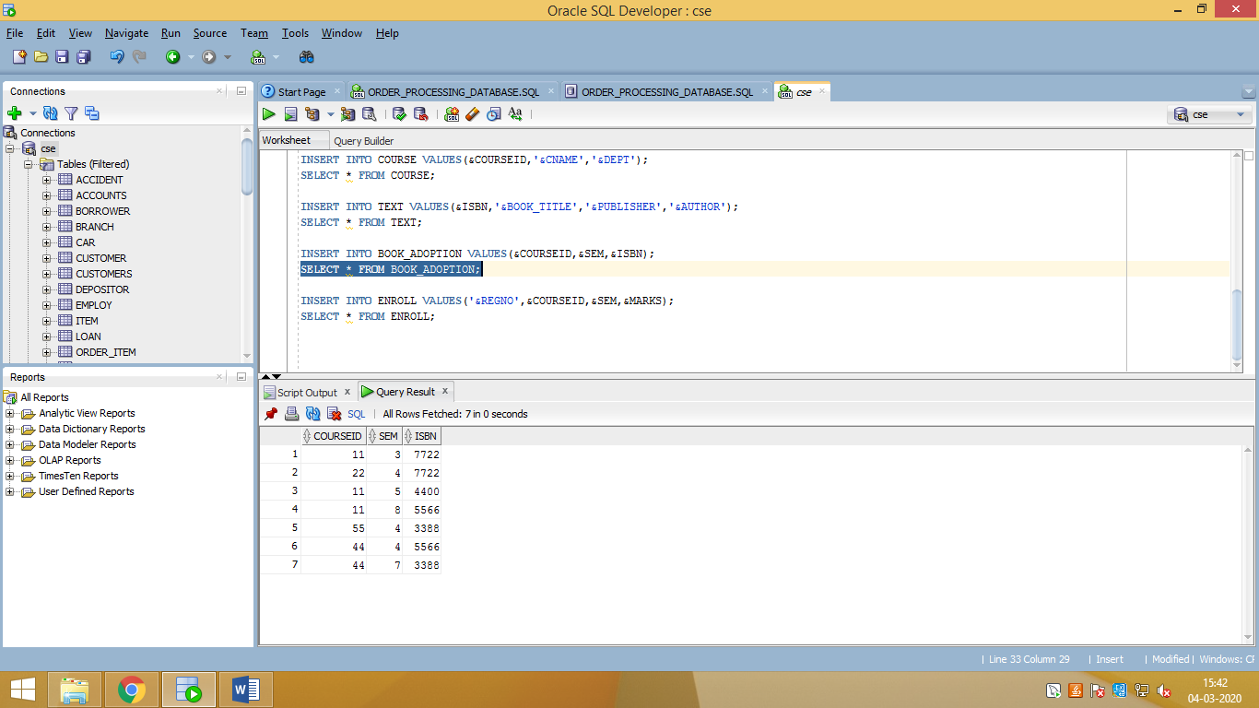

1. **ENROLL**

