**VISVESVARAYA TECHNOLOGICAL UNIVERSITY**

**“Jnana Sangama”, Belgaum -590014, Karnataka.**



**PROJECT WORK-1 REPORT**

**on**

**BMS CAR N AUTO POOL**

***Submitted by***

**SAAKSHI NAVALE (1BM18CS088)**

**SAHANA L(1BM18CS089)**

**RASHMI DHADUTI (1BM18CS080)**

**P SAI DEEKSHITH (1BM18CS148)**

***Under the Guidance of***

|  |  |
| --- | --- |
| **Mr. Selva Kumar S**  **Assistant Professor, BMSCE** |  |

***in partial fulfillment for the award of the degree of***

**BACHELOR OF ENGINEERING**

***in***

**COMPUTER SCIENCE AND ENGINEERING**



**B.M.S. COLLEGE OF ENGINEERING**

**(Autonomous Institution under VTU)**

**BENGALURU-560019**

**DEC 2019**

**B. M. S. College of Engineering,**

**Bull Temple Road, Bangalore 560019**

(Affiliated To Visvesvaraya Technological University, Belgaum)

**Department of Computer Science and Engineering**



**CERTIFICATE**

This is to certify that the project work entitled “**BMS CAR N AUTO POOL**” carried out by **SAAKSHI NAVALE(1BM18CS088), SAHANA L(1BM18CS089), RASHMI DHADUTI(1BM18CS080) AND P SAI DEEKSHITH(1BM18CS148)** who are bonafide students of **B. M. S. College of Engineering.** It is in partial fulfillment for the award of **Bachelor of Engineering in Computer Science and Engineering** of the Visveswaraiah Technological University, Belgaum during the year 2019. The project report has been approved as it satisfies the academic requirements in respect of **Project Work-1 (19CS3PWPW1)**work prescribed for the said degree.

Signature of the Guide                 Signature of the HOD

Mr. Selva Kumar S Dr. V. Umadevi

Assistant Professor Prof & Head of Dept of CSE

BMSCE, Bengaluru BMSCE, Bengaluru

External Viva

Name of the Examiner                                                                                       Signature with date

1._____________________________ ________________________

2. _____________________________ _________________________

**B.M.S. College of EngineerinG**

**DEPARTMENT OF COMPUTER SCIENCE AND ENGINEERING**



***DECALARATION***

We, SAAKSHI NAVALE (1BM18CS088), SAHANA L(1BM18CS089),RASHMI DHADUTI (1BM18CS080), P SAI DEEKSHITH(1BM18CS148), students of 3rd Semester, B.E, Department of Computer Science and Engineering, BMS College of Engineering, Bangalore, hereby declare that, this Project Work-1 entitled "BMS CAR N AUTO POOL" has been carried out by us under the guidance of Prof. Selva kumar S, Assistant Professor, Department of CSE, BMS College of Engineering, Bangalore during the academic semester Aug-Dec 2019.

We also declare that to the best of our knowledge and belief, the development reported here is not from part of any other report by any other students.

Signature

SAAKSHI NAVALE (1BM18CS088)

SAHANA L (1BM18CS089)

RASHMI DHADUTI (1BM18CS080)

P SAI DEEKSHITH (1BM18CS148)

**TABLE OF CONTENTS**

|  |  |  |
| --- | --- | --- |
| **CHAPTER NO.** | **TITLE** | **PAGE NO.** |
| 1 | **Introduction** | 1 |
| 1.1 | Overview | 1 |
| 1.2 | Motivation | 1 |
| 2 | **Software Requirement Specification** | 2 |
| 2.1 | Hardware Requirements | 2 |
| 2.2 | Software Requirements | 2 |
| 3 | **User Interface Design** | 3 |
| 3.1 | Home Screen | 3 |
| 3.2 | Login Screen | 4 |
| 3.3 | Sign-up Screen | 5 |
| 3.4 | Booking Screen | 6 |
| 3.5 | Selection Screen | 7 |
| 3.6 | Chat Box Screen | 8 |

**Chapter 1**

**INTRODUCTION**

**1.1 Overview**

BMS car n auto pool is an eco-smart option for handling all your travels to college by connecting u with your fellow students. As our cities are growing, increasing traffic adds to the chaos and pollution.

**1.2 Motivation**

Our major advantages can be summarized as follows:

(1) Verified users: We wish you a safe trip every time and that’s why when you ride on BMS car n auto pool, we ensure all user’s are verified ,that is all users are students of BMS and verified on our platform.

(2) Privacy Protected: Your details are kept with us. When u chat with fellow travelers, the chats are kept safe with us and are secured with end-to-end encryption, means BMS car n auto pool or other third parties cannot read them.

(3) Networking on the go: Create new friendship with your fellow auto poolers or car poolers , connect with various students and enjoy networking while on your rides.

(4) No Transaction charges: We believe in making every ride even more pleasant .Therefore , enjoy your pool without any transaction charges.

(5) Share-ride-save money: Since you are sharing your ride with two other users, your trip fare will almost be reduced to one third. Thus, you are saving money on every ride.

SOFTWARE REQUIREMENTS

**2.1 Hardware Requirements:**

* A PC with the following or greater specifications:
  + Intel Core i3 (6th gen or higher)
  + 8 GB RAM
  + 500 GB Hard Drive
* A stable internet connection (2Mbps or higher).

**2.2 Software Requirements:**

* Operating system : Windows 10
* Technologies : HTML, CSS, Javascript

USER INTERFACE DESIGN

**1. Home Screen**

This page redirects you to login or sign up page depending on whether you have an account or not.

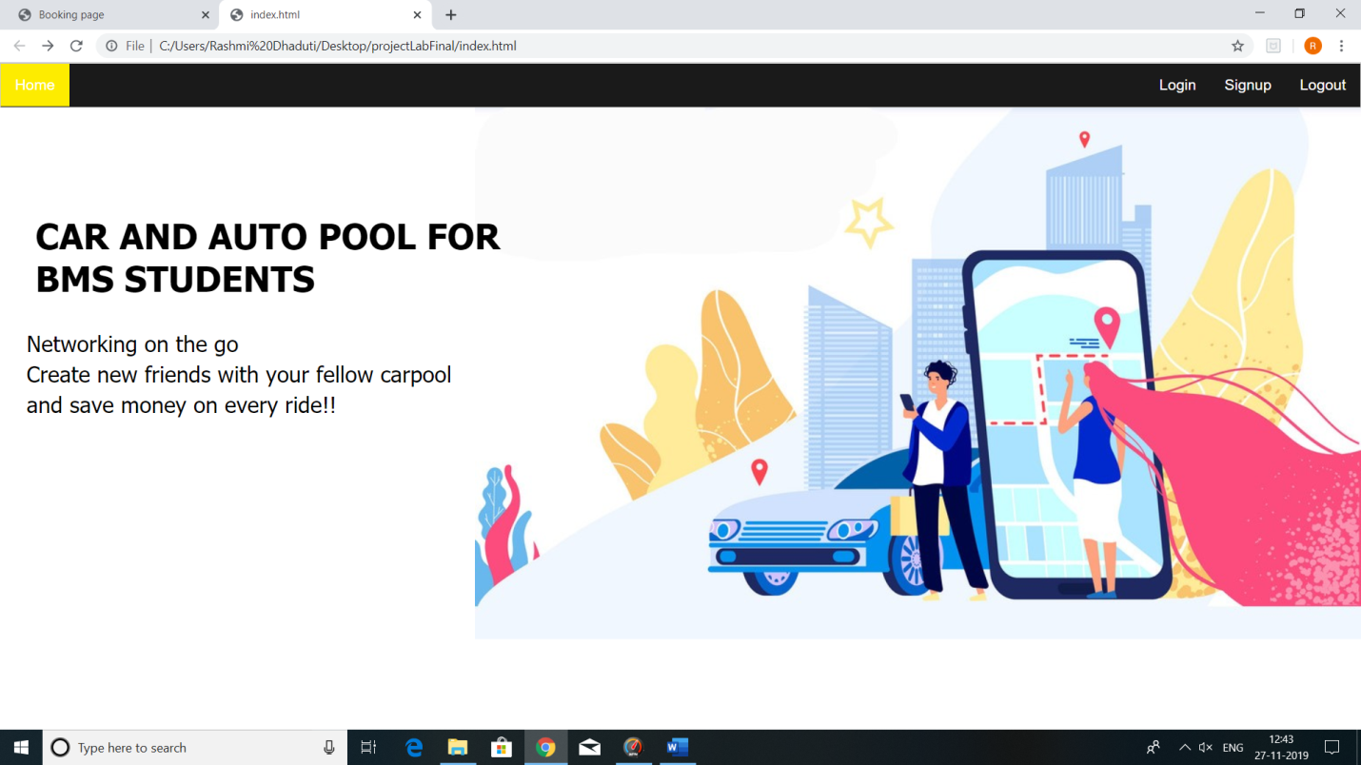

**Fig.1 Home Screen**

**2. Login Screen**

i. This page asks for Username and password, and directs you to the Booking page.

ii. you can reset your password if you have forgotten it.

iii. You can also jump in to sign up page if you don’t have an account.

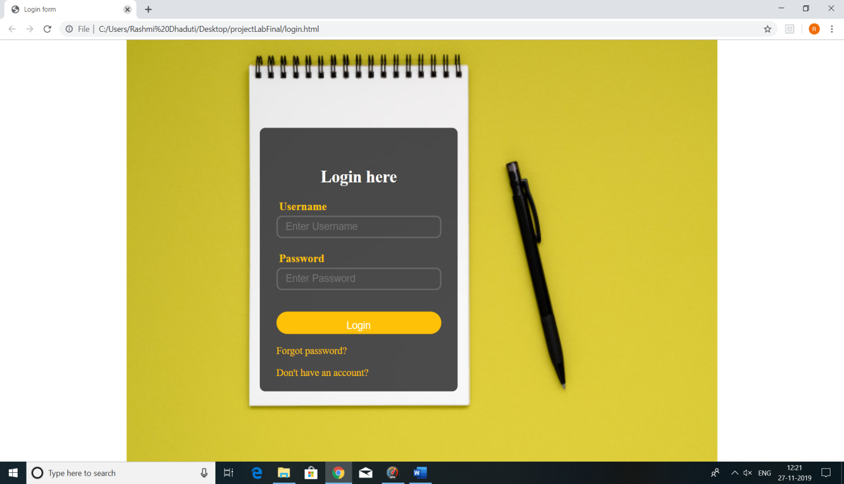

**Fig.2 Login Screen**

**3. Sign-up Screen**

i. This page takes user details – Email id, user name, phone number, password to create a new account.

ii. You can also sign up with your google account.

iii. If you already have an account, it directs you to login page.

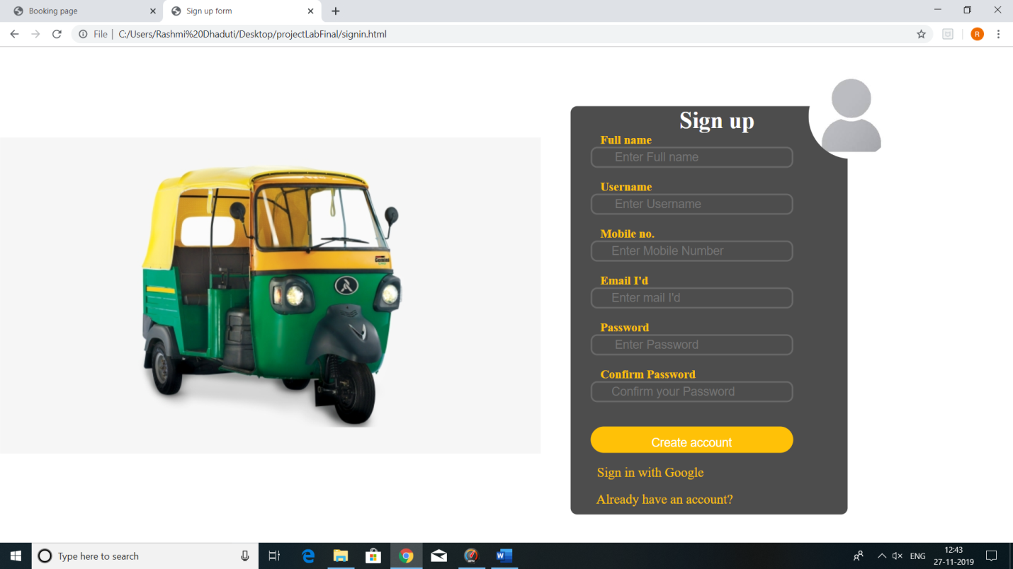

**Fig.3 Sign-up Screen**

**4. Booking page**

This page takes pick up and drop location and directs you to Selection screen when you make yourself available.

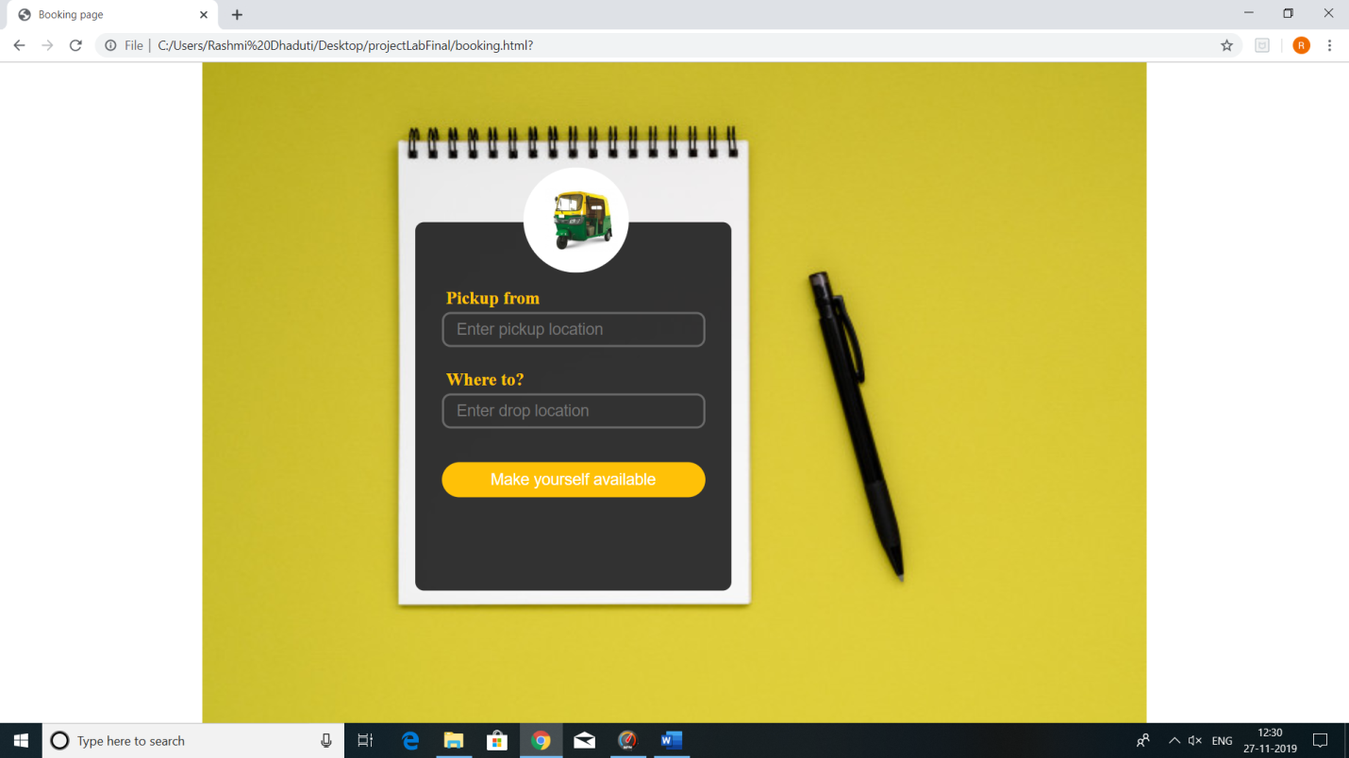

**Fig.4 Booking Screen**

**5. Selection Screen**

i. This page displays the users who have selected the same pick up and drop location as yours and have made themselves available.

ii. This page lets you select two other users with whom you would wish to share the ride.

iii. After you select 2 users ,it directs you to the chat box screen.

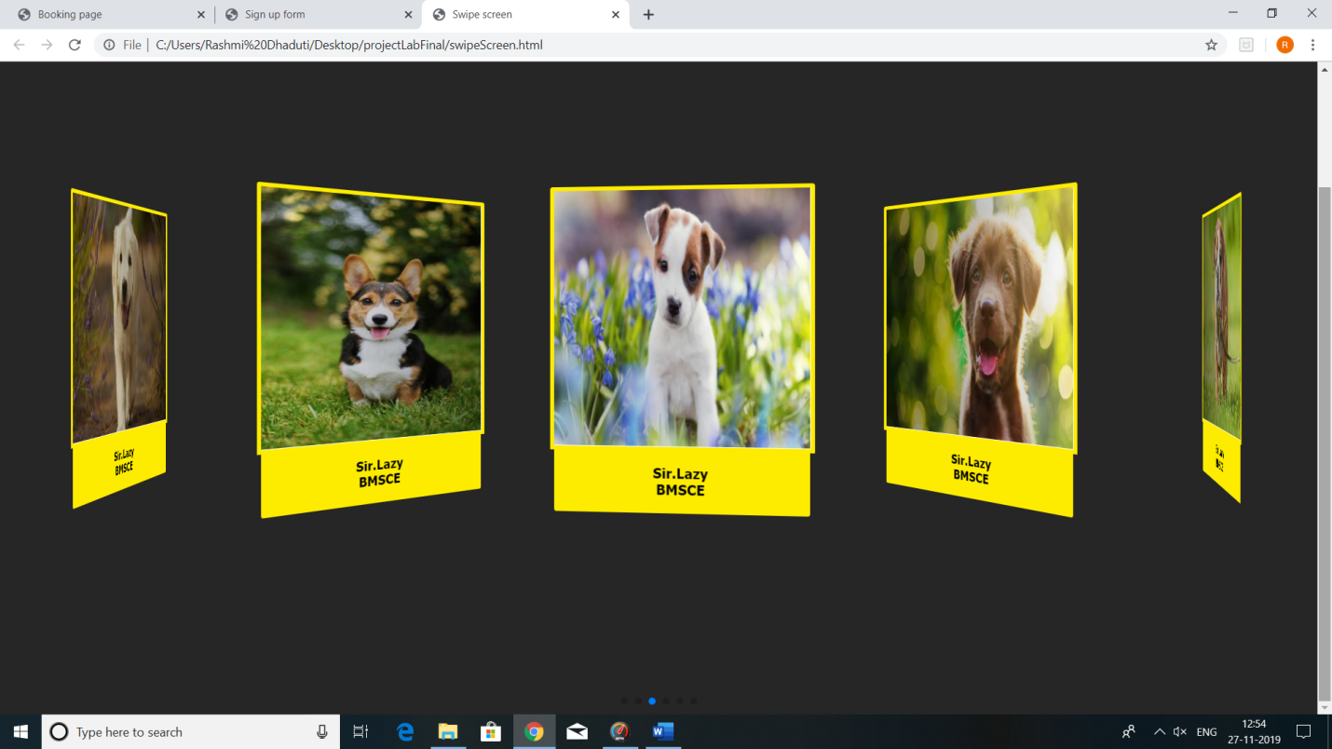

**Fig.5 Selection Screen**

**6. Chat-Box Screen**

1. This page allows user to chat with the other two users whom he would have selected.

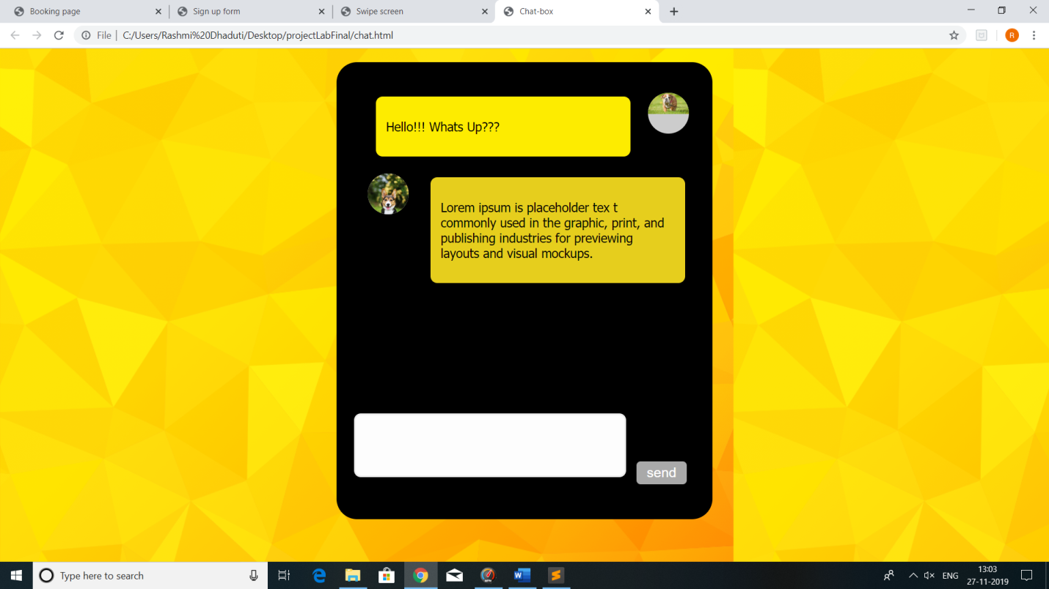

**Fig.6 Chat-Box Screen**