** **

**Social Innovation Program**

**PROJECT REPORT**

**2023-24**

**VISION ASSIST**

**Section G**

**CONTENTS**

**Project Overview** **1**

**1. Introduction** **3**

1.1 Introduction 3

**2. Field Visit** **4**

**3. Problem statement** **5**

3.1 Problem statement: 5

3.1 a) What is the problem? 5

3.1 b) Why is it a problem? 5

3.1 c) Who is facing the problem? 5

3.1 d) When and where does the problem occur? 5

3.1 e) What are the existing solutions? 5

3.1 f) What are users/ stakeholders complaining about the existing solutions? 5

**4. Solution** **6**

4.1 Ideation 6

4.2 Prototype 6

4.3 Business Model Canvas 6

**5. Conclusion** **7**

**6. Reference** **7**

|  |  |  |
| --- | --- | --- |
| ProjectTitle | **VISION ASSIST** | |
| Class/section | SECTION G | |
| Team Name | TEAM – SIX MIX | |
| Team Members | Name | USN |
| Sahana | 4SF23CS181 |
| Prewal | 4SF23CS114 |
| Mandara | 4SF23CS098 |
| Rashmith Shetty | 4SF23CI119 |
| Nidarsh Shetty | 4SF23CI098 |
| Sanjith Anchan | 4SF23CI134 |
| Problem identified | Vision Assist | |
| Solution proposed | VR set for Blind people | |
| Link to the idea pitch  presentation | https://d.docs.live.net/1020bd30ca0200cb/Documents/SIX%20MIX%5b1%5d.pptx | |
| Link to photos drive | https://drive.google.com/drive/folders/1thxImyqYX3e2Rn7GHKzmJzLEbcraybSq | |

## Project Overview

## 

## 1. Introduction

### 1.1 Introduction

Vision assist technology refers to a diverse range of innovative tools and systems designed to support individuals with visual impairments in navigating and interacting with their surroundings. These technologies harness the power of artificial intelligence, computer vision, and wearable devices to provide real-time assistance with various tasks, such as object recognition, text-to-speech conversion, and navigation aids. By leveraging cutting-edge advancements, vision assist solutions aim to enhance the independence and quality of life for visually impaired individuals, empowering them to navigate the world with greater confidence and autonomy.

## 2. Field Visit

### 

### Visual impared school.

## 

## 3. Problem statement

### 3.1 Problem statement:

The Problem statement is Vision Assist, a vision assist is a VR set (a prototype) made for blind people to sense or detect anything.

**3.1 a) What is the problem?** Vision assist" can refer to various technologies or devices aimed at assisting people with visual impairments. The problems associated with these solutions can vary depending on the specific technology or device. Common issues include limited effectiveness in certain environments, high costs, usability challenges, and the need for continuous improvements to meet users' needs effectively.

**3.1 b) Why is it a problem?** Vision assist" can refer to various technologies designed to aid drivers with impaired vision. The challenge lies in ensuring these technologies are reliable and safe, as they need to accurately interpret the surrounding environment to provide helpful assistance. Issues such as false alerts, misinterpretation of objects, and technical malfunctions can pose significant risks on the road. Additionally, there are ethical considerations regarding the responsibility of the driver versus the technology in making critical driving decisions.

**3.1 c) Who is facing the problem?** People facing vision impairment or blindness might require vision assistive technologies or devices to help them navigate the world more independently. These technologies can include screen readers, magnifiers, braille displays, and various assistive apps designed to enhance accessibility.

**3.1 d) When and where does the problem occur?** People facing vision impairment or blindness might require vision assistive technologies or devices to help them navigate the world more independently. These technologies can include screen readers, magnifiers, braille displays, and various assistive apps designed to enhance accessibility.

### 3.1 e) What are the existing solutions?

### People facing vision impairment or blindness might require vision assistive technologies or devices to help them navigate the world more independently. These technologies can include screen readers, magnifiers, braille displays, and various assistive apps designed to enhance accessibility.

### 3.1 f) What are users/ stakeholders complaining about the existing solutions?

### People facing vision impairment or blindness might require vision assistive technologies or devices to help them navigate the world more independently. These technologies can include screen readers, magnifiers, braille displays, and various assistive apps designed to enhance accessibility.

## 4. Solution

### 4.1 Ideation

Creating a vision assist tool for blind students is a fantastic idea, aiming to empower them in their educational journey. Here are some ideation points to consider:

1. **Auditory Feedback System**: Develop a device that uses audio cues to provide real-time feedback about the surroundings. It could identify objects, obstacles, or even text, converting visual information into spoken words or sounds. This can help blind students navigate their environment more effectively.
2. **Text Recognition and Reading**: Implement a feature that can recognize text from books, whiteboards, or presentations using OCR (Optical Character Recognition) technology. The device would then convert the text into speech or Braille, allowing blind students to access written material independently.
3. **Interactive Maps and Navigation**: Design a system that utilizes GPS and indoor positioning technology to create detailed maps of school campuses. Blind students could use this tool to navigate from one classroom to another, locate amenities like restrooms or cafeterias, and receive turn-by-turn directions through audio instructions.
4. **Object Recognition and Description**: Develop a database of common classroom objects, such as desks, chairs, or laboratory equipment, and enable the device to identify and describe these items when pointed at them. This would help blind students understand their surroundings and interact with classroom materials more effectively.
5. **Remote Assistance and Tutoring**: Integrate a feature that allows blind students to connect with remote assistants or tutors who can provide real-time guidance and support. This could be particularly useful for complex tasks or subjects where additional assistance is needed beyond what the device can offer independently.
6. **Customizable Interfaces**: Provide options for personalization and customization based on individual preferences and needs. This might include adjustable speech settings, Braille output preferences, or the ability to prioritize certain types of information based on the user's specific requirements.
7. **Integration with Learning Management Systems**: Ensure compatibility with existing educational platforms and tools used by schools and universities. This could involve integrating with learning management systems (LMS) to access course materials, submit assignments, and participate in online discussions seamlessly.
8. **Collaborative Tools for Group Work**: Create features that facilitate collaboration and communication among blind students and their sighted peers. This could include shared virtual whiteboards, audio conferencing capabilities, or tools for exchanging digital notes and documents.
9. **Feedback Mechanism for Continuous Improvement**: Implement a system for collecting feedback from blind students, teachers, and other stakeholders to identify areas for improvement and iterate on the design of the vision assist tool. Regular updates and enhancements based on user input will ensure that the device remains relevant and effective over time.
10. **Affordability and Accessibility**: Consider the cost and accessibility of the vision assist tool to ensure that it is affordable for students and schools with limited resources. Explore options for funding, subsidies, or partnerships to make the device more widely available.

## 

* **High Impact, Low Effort**: Features like "Object Recognition" and "Auditory Feedback System" have the potential for significant impact on improving the user experience while requiring relatively low effort to implement.
* **High Impact, High Effort**: Integration with Learning Management Systems and Remote Assistance could have a high impact but might require more effort due to technical complexities and integration challenges.
* **Low Impact, Low Effort**: These are features that may not significantly enhance the tool's effectiveness but are relatively easy to implement. It might include minor enhancements or optimizations.
* **Low Impact, High Effort**: Features falling into this quadrant may require substantial effort to implement but offer relatively low impact on the overall effectiveness of the tool. These should be carefully evaluated to determine if they're worth pursuing.

### 4.2 Prototype

1. **Sensors and Perception**:
   * Use various sensors such as ultrasonic sensors, infrared sensors, or LiDAR to detect obstacles and objects in the environment.
   * Integrate a camera or depth-sensing technology for capturing visual data, which can be processed to provide additional information about the surroundings.
2. **Data Processing and Interpretation**:
   * Develop algorithms to process sensor data and extract meaningful information about the environment, such as the distance and direction of obstacles.
   * Use machine learning and computer vision techniques to analyze visual data and identify objects, landmarks, or navigation cues.
3. **Navigation and Guidance**:
   * Implement algorithms for path planning and navigation, considering factors like obstacle avoidance, shortest routes, and accessibility.
   * Provide auditory feedback or haptic feedback through vibration motors to guide the user along the planned route and alert them to obstacles or changes in direction.
4. **User Interface and Interaction**:
   * Design a user-friendly interface that allows blind users to interact with the device easily.
   * Provide options for input methods such as voice commands, tactile buttons, or gestures, depending on the user's preferences and abilities.
5. **Integration with Assistive Technologies**:
   * Ensure compatibility with existing assistive technologies such as screen readers, Braille displays, or mobility aids.
   * Enable seamless integration with smartphones or other devices commonly used by blind individuals, allowing for enhanced functionality and connectivity.
6. **Testing and Feedback**:
   * Conduct thorough testing of the blind guide system in real-world environments to evaluate its performance, accuracy, and usability.
   * Gather feedback from blind users and incorporate their input to improve the design and functionality of the system iteratively.
7. **Accessibility and Inclusivity**:
   * Consider accessibility guidelines and standards to ensure that the blind guide system is usable by individuals with varying levels of vision impairment.
   * Provide customization options and settings to accommodate different user preferences and needs.

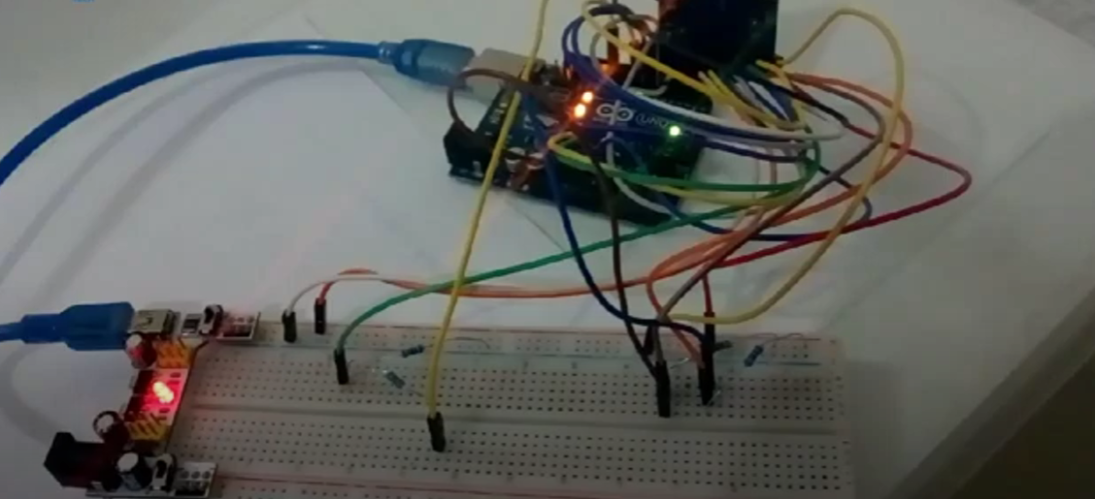

### 4.3 Business Model Canvas

1. **Key Partnerships**:
   * Collaborate with technology providers for sensors, cameras, and other hardware components.
   * Partner with organizations serving the visually impaired community for user testing, feedback, and outreach.
2. **Key Activities**:
   * Research and development to continuously improve the vision assist guide's functionality and usability.
   * Testing and validation of the technology in real-world environments.
   * Marketing and outreach to raise awareness and reach potential users.
3. **Key Resources**:
   * Technology infrastructure for data processing, machine learning, and navigation algorithms.
   * Skilled personnel including engineers, designers, and accessibility experts.
   * Access to funding or investment to support research, development, and marketing efforts.
4. **Value Proposition**:
   * Empower blind individuals to navigate their surroundings safely and independently.
   * Enhance accessibility and inclusivity by providing a reliable and intuitive vision assist guide.
   * Improve quality of life and confidence for blind users through enhanced mobility and freedom.
5. **Customer Segments**:
   * Blind and visually impaired individuals of all ages who require assistance with navigation and mobility.
   * Caregivers, family members, and organizations supporting blind individuals who may be involved in the decision-making process.
6. **Channels**:
   * Direct sales through online platforms, specialized assistive technology stores, or partnerships with healthcare providers.
   * Marketing and outreach through social media, disability advocacy organizations, and relevant events and conferences.
7. **Customer Relationships**:
   * Provide personalized support and assistance to users during onboarding and setup.
   * Establish channels for feedback and communication to address user needs and concerns.
   * Foster a community of blind users to share experiences, tips, and best practices.
8. **Revenue Streams**:
   * Direct sales of the vision assist guide hardware and software.
   * Subscription-based models for ongoing updates, support, and premium features.
   * Potential partnerships or licensing agreements with organizations or governments for widespread adoption and distribution.
9. **Cost Structure**:
   * Research and development costs for technology development and improvement.
   * Manufacturing and production costs for hardware components.
   * Marketing and sales expenses for promoting the vision assist guide and reaching target customers.
   * Operational costs including personnel, infrastructure, and ongoing support services.
10. **Key Metrics**:
    * Number of active users and adoption rate among the blind and visually impaired community.
    * Customer satisfaction and feedback ratings.
    * Revenue growth and profitability.
    * Impact metrics such as improved mobility, independence, and quality of life for users.

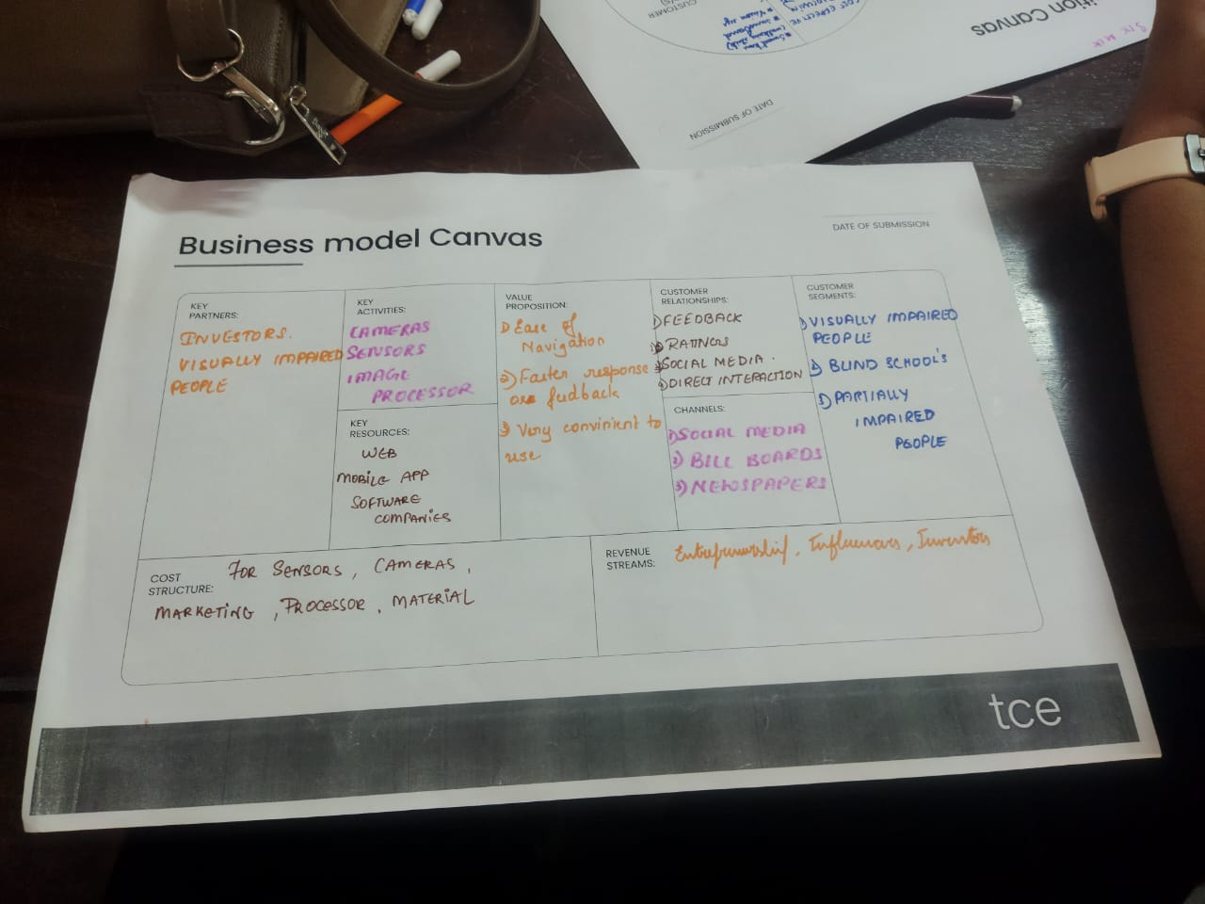

## 

## 5. Conclusion

## Vision assist technology for visually impaired individuals has made significant strides in recent years, offering innovative solutions to enhance independence and quality of life. Through advancements in AI, computer vision, and wearable devices, these technologies provide real-time assistance with tasks such as navigation, object recognition, and text-to-speech conversion. While there's still room for improvement and broader accessibility, the progress signifies a promising future where visually impaired individuals can navigate the world with greater confidence and autonomy.

## 6. Reference <https://www.bing.com/ck/a?!&&p=6e1c65c1f30bff7cJmltdHM9MTcxNjc2ODAwMCZpZ3VpZD0zYzcwMzFhZS1kM2Q1LTY1ODItMjNhYS0yMjMwZDIyMjY0M2YmaW5zaWQ9NTI5Mg&ptn=3&ver=2&hsh=3&fclid=3c7031ae-d3d5-6582-23aa-2230d222643f&psq=refernces+for+vission+assist+for+visually+impaired&u=a1aHR0cHM6Ly92aXNpb25haWQub3JnL2VtcG93ZXIvc21hcnQtdmlzaW9uLWdsYXNzZXMtcGx1cy8&ntb=1>

## 7. Image Gallery

## 

## 