INTERNSHIP REPORT SUBMITTED FOR THE DEGREE OF
MASTER OF ARTS IN BUSINESS ECONOMICS
By MAHAVIDHYA S 2513312016009
( Duration :20-04-26 to 17-05-26 )



POST – GRADUATE AND RESEARCH DEPARTMENT OF ECONOMICS

ETHIRAJ COLLEGE FOR WOMEN (AIDED) (AUTONOMOUS)
CHENNAI – 600 008

INTERNSHIP REPORT SUBMITTED FOR THE DEGREE OF
MASTER OF ARTS IN BUSINESS ECONOMICS
By MAHAVIDHYA S 2513312016009
( Duration :20-04-26 to 17-05-26 )



POST – GRADUATE AND RESEARCH DEPARTMENT OF ECONOMICS

ETHIRAJ COLLEGE FOR WOMEN (AIDED) (AUTONOMOUS)
CHENNAI-600 008

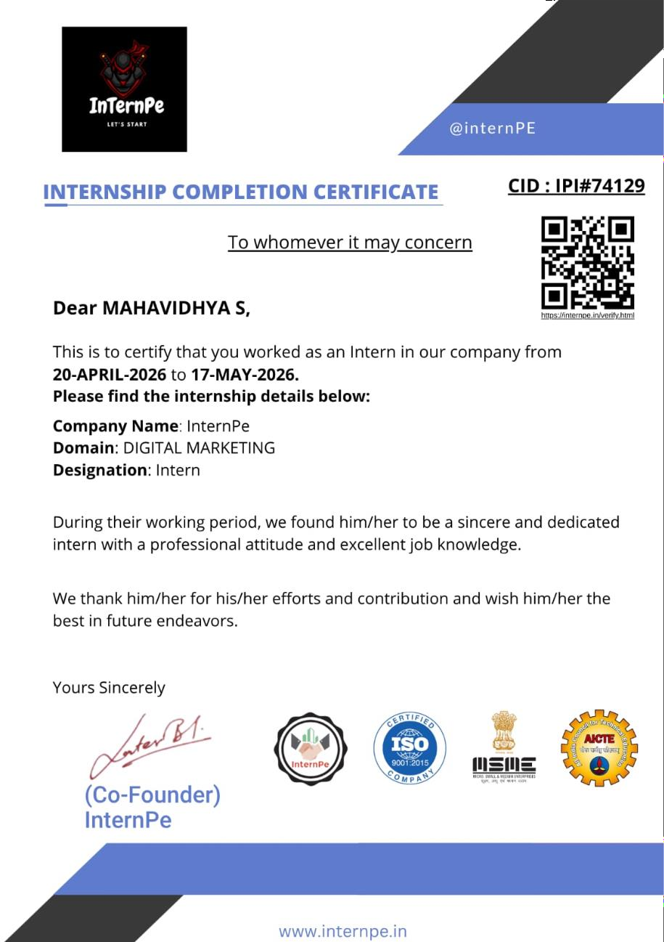

REPORT ON THE INTERNSHIP PROGRAMME

Name Mahavidhya S

Register number 2513312016009

Course M A Business Economics

Batch 2025 – 2027

College Ethiraj College For Women

Name of the Company Internpe

Duration of the internship 20-04-2026 to 17-05-2026

Portfolio Handled Content Creation and Content Marketing

ACKNOWLEDGEMENT

I would like to express my gratitude to the Management, for extending the opportunity to undergo an internship programme as part of my curriculum.

I express my sincere and deepest gratitude to Dr. D. B. Usha Rani, MA., M.Phil., Ph.D., Associate professor ana Head, Department of economics who has been a constant source of support and motivation in all endeavours.

I extend my heartiest thanks to Dr G. Neelavathy M.A., M.Phil., Associate professor and all my other faculty members for their valuable guidance and suggestions in the successful completion of this internship.

I would like to thank Mr Latesh Bansal, Manager, Internpe, Jaipur for giving me the opportunity to work under his guidance . I also express my sincere gratitude to the Internpe for allowing me to work under the esteemed company.

DECLARATION

I hereby declare that the internship report prepared by me after the completion internship at the InternPe
I also declare that this report is prepared and organised by me and prepared for academic requirements, not for any other purpose.

DATE: 17-05-2026
PLACE: CHENNAI MAHAVIDHYA S

DESCRIPTION OF THE COMPANY

InternPe is an internship and training platform established on 2nd October 2022 with the objective of bridging the gap between academic learning and industry requirements. The organization provides students and fresh graduates with practical exposure through internships, training programs, and project-based learning opportunities. InternPe is registered under MSME and operates as an IT Services and Training Company headquartered in Jaipur, Rajasthan. The company focuses on empowering students by providing real-world industry experience and career-oriented skill development programs.

InternPe offers internship opportunities across various domains including:

- Digital Marketing
- Web Development
- Artificial Intelligence and Machine Learning
- Human Resource Management
- Finance
- Cybersecurity
- Data Science and Analytics
- UI/UX Design

The organization aims to create industry-ready professionals through structured internship programs, mentorship, practical assignments, and real-time projects. Its mission is to help students learn, grow, and achieve their career goals through meaningful learning experiences.

FUNCTIONS

InternPe operates as an internship and skill development platform with the primary objective of providing students and fresh graduates with practical industry exposure. The organization performs the following key functions:

Internship Program Management
InternPe offers structured virtual internship programs in various domains such as Digital Marketing, Web Development, Data Science, Artificial Intelligence, Human Resources, Finance, Cybersecurity, and Business Development. These internships provide students with practical industry experience through real-world assignments and projects.

Skill Development and Training
The company conducts training sessions designed to improve students' technical and professional competencies. The training focuses on current industry practices, digital tools, communication skills, and problem-solving techniques, helping students become industry-ready professionals.

Project-Based Learning
InternPe follows a project-based learning approach where interns work on practical assignments, case studies, and live projects. This enables students to apply theoretical concepts to real business situations and gain hands-on experience.

Digital Marketing Services
Under the Digital Marketing domain, InternPe provides exposure to content creation, social media marketing, branding, online promotions, digital campaign planning, audience engagement, and basic Search Engine Optimization (SEO). These activities help interns understand modern digital marketing strategies.

MANAGEMENT AND LEADERSHIP

InternPe is managed by a team of professionals responsible for overseeing the company's operations, training programs, internship management, and business development. The leadership team focuses on providing quality internship opportunities, industry-oriented training, and career guidance to students across India.

Founder & Leadership
Mr. Latesh Bansal – Founder and Director of InternPe. He established the company with the vision of bridging the gap between academic education and industry requirements by providing practical internships and skill development opportunities.

Key Departments
- Training and Development Department
- Digital Marketing Department
- Human Resources Department
- Business Development Department
- Student Support and Operations Department

These departments work together to ensure that interns receive quality training, project-based learning, mentorship, and professional guidance throughout their internship.

LEARNING OUTCOMES OF THE INTERNSHIP

During my internship at InternPe in the Digital Marketing Department, I gained valuable practical knowledge about the fundamentals of digital marketing and its role in promoting businesses through online platforms. The internship provided me with hands-on experience in various digital marketing activities, enabling me to understand how organizations create and implement effective marketing strategies to reach their target audience.
One of the key learning outcomes was developing an understanding of digital marketing concepts, including the importance of social media marketing, content creation, and online brand promotion. I learned how engaging and creative content plays a significant role in attracting consumers and increasing customer engagement. Through various assignments, I enhanced my ability to create informative and visually appealing social media posts that effectively communicate marketing messages.
The internship also improved my communication, creativity, and analytical skills. While completing different marketing tasks, I learned how to identify target audiences, prepare relevant content, and apply suitable marketing techniques to increase brand visibility. Additionally, I gained knowledge about the importance of consistency, planning, and audience interaction in successful digital marketing campaigns.
Working in a professional environment helped me develop essential employability skills such as time management, teamwork, responsibility, adaptability, and problem-solving. I learned to complete assigned tasks within deadlines while maintaining quality and professionalism.
Overall, this internship provided me with valuable industry exposure and strengthened both my technical and professional skills. It successfully bridged the gap between theoretical knowledge and practical application, enhancing my confidence and preparing me for future career opportunities in the field of digital marketing.

OVERVIEW OF THE INTERNSHIP PROGRAMME

As part of my internship with InternPe under the Digital Marketing Department, I gained practical exposure to various aspects of digital marketing and online brand promotion. The internship was designed to provide hands-on learning through assignments, projects, and digital marketing activities.
During the internship, I worked on understanding social media marketing strategies, content creation, audience engagement, campaign planning, and digital communication techniques. The internship provided valuable exposure to industry practices and helped me understand how businesses use digital platforms to connect with customers and improve their online presence.
The primary objective of this internship was to develop practical digital marketing skills, gain industry exposure, and understand the role of digital technologies in modern marketing practices.

REVIEW OF THE INTERNSHIP PROGRAMME

I hereby declare that this internship report has been sincerely prepared by me as part of my academic internship with InternPe under the Digital Marketing Department.

During the internship, I gained valuable practical knowledge and experience in digital marketing. Through various assignments and activities, I developed an understanding of social media marketing, content strategy, digital branding, customer engagement, and online communication.

The internship enhanced my knowledge of digital marketing concepts and improved my skills in communication, creativity, teamwork, time management, and analytical thinking. I also learned how digital platforms can be effectively utilized to achieve marketing objectives and build customer relationships.

This internship experience has contributed significantly to my academic learning and professional development by providing practical exposure to the corporate environment and digital marketing industry.

DATE: 30-06-2026
PLACE:CHENNAI MAHAVIDHYA S

