Integrating a Zoho Creator Application with Another Zoho Service Using Connections and APIs
Gym Membership Enrollment Form – Bigin by Zoho CRM Integration Use Case
SAHANA R
241401086
Aim
To integrate the Gym Membership Enrollment & Front Desk Management application in Zoho Creator with Bigin by Zoho CRM using a microservice connection, form workflow, and Deluge scripting, so that member details submitted through the Membership Enrollment Form are automatically created as records in Zoho CRM.
Procedure
Phase A: Creating the Bigin by Zoho CRM Connection
- Log in to Zoho Creator and open the Gym Membership Enrollment & Front Desk Management application.
- Under the Develop section, open Microservices.
- Select the Connections tab and click Add Connection.
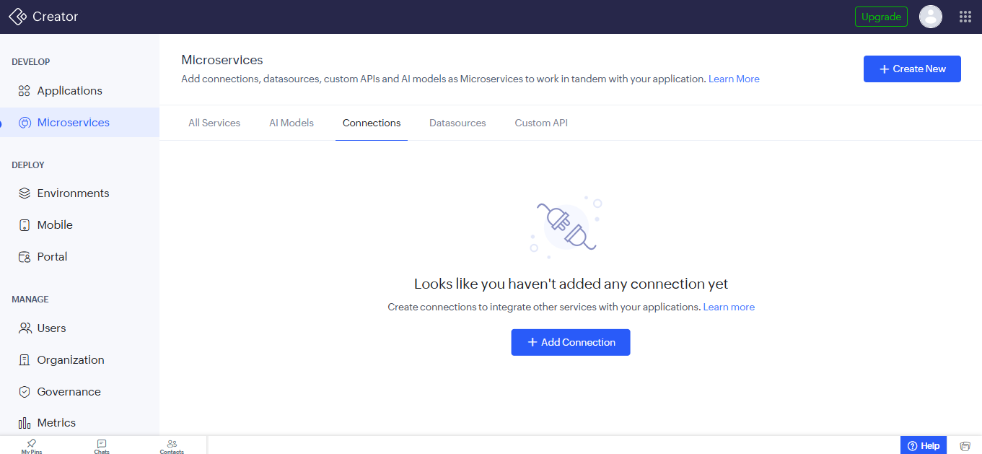

- The Create New Microservice window lists the available microservice types (AI Models, AR Library, Connections, Data sources and Custom API). For Connections, click Pick & Create to open the list of built-in connectors.
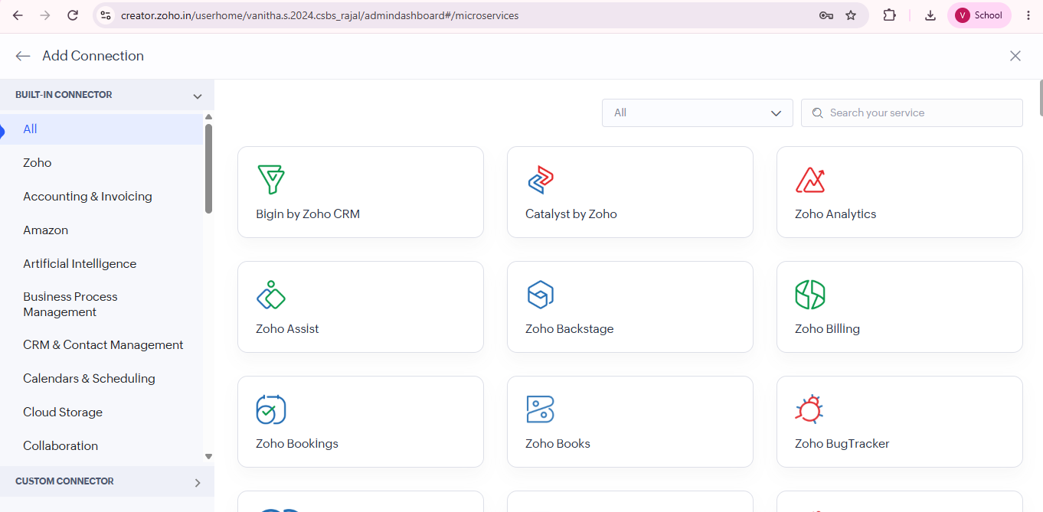
- From the built-in connectors, select Bigin by Zoho CRM.
- Enter the connection details:
  - Connection Name: Bigin by Zoho CRM Connection
  - Authorization Access: Administrators only
  - Connection Mode: Quick connect (Zoho credential)
  - Access: All Actions
- Click Create And Authorize.
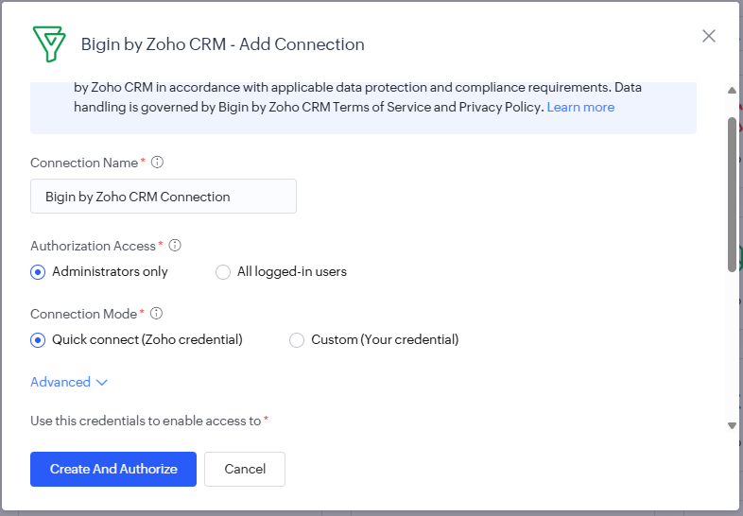
Phase B: Verifying the Connection
- Go to Microservices → Connections and check that the Bigin by Zoho CRM Connection displays a green Connected status.
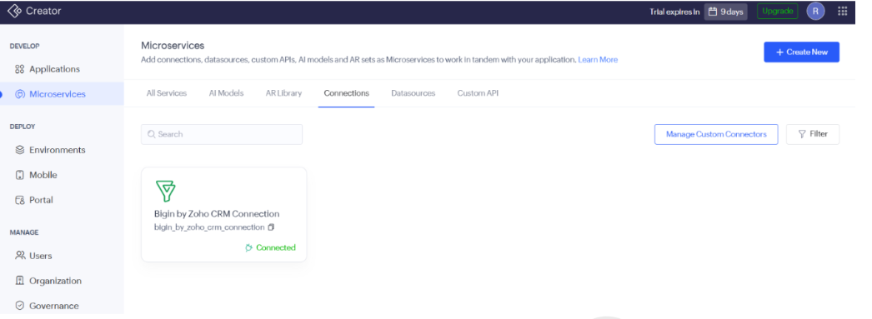
- Open the connection and note its Link Name. This link name will be used in the Deluge script.
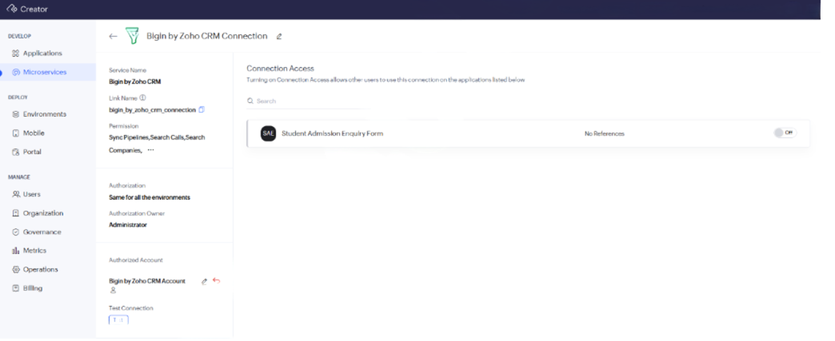
Phase C: Setting Up the Form Workflow
- Return to the application and select:
Membership_Enrollment_Form
- Open Workflow and create a new Form Workflow.
- Configure it to run on:
Created → Successful form submission
- Set Run this action → Always.
- Choose Deluge Script as the action type.
- Phase D: Writing the Deluge Script
- Create a map containing your gym member information.
Member_Name → Last_Name
Email_Address → Email
Contact_Number → Phone
Membership_Plan → Description
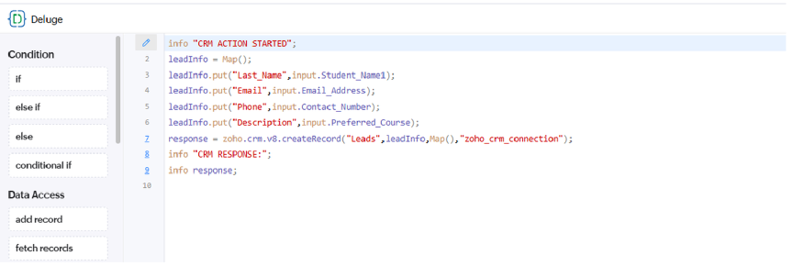
Output & System Verification
The Gym Membership Enrollment Form is connected to Bigin by Zoho CRM through a microservice connection and form workflow.
After submitting a new gym membership record:
- The workflow runs automatically.
- Member details such as name, email, contact number, and membership plan are transferred.
- The connection status can be verified as Connected.
- The created record can be checked in the configured CRM/Bigin module.
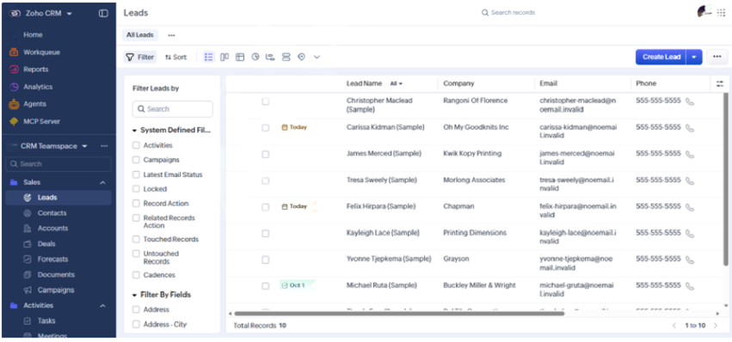
Conclusion
Thus, the Gym Membership Enrollment & Front Desk Management application was successfully integrated with Bigin by Zoho CRM using Connections, Form Workflow, and Deluge scripting. The integration automatically transfers submitted gym membership details from Zoho Creator to the connected CRM service, reducing manual data entry and improving member management.

