Exploring AI-Assisted Features and Built-in Analytics (Zia) in Zoho Creator
Gym Membership Enrollment & Front Desk Management
Vanitha S
241401122
AIM
To explore the built-in analytics, dashboard components, interactive charts, and report display options of the Gym Membership Enrollment & Front Desk Management application in Zoho Creator and to check the availability of Zia / AI-assisted features.
2. OBJECTIVE
- To observe the summary panels, charts, and reports on the Gym Membership dashboard.
- To study the interactive behaviour of the column chart.
- To identify the different report display formats available in Zoho Creator.
- To check the Design and Workflow sections for Zia / AI-assisted features.
These activities follow the same analytics exploration performed in the reference experiment.
3. SOFTWARE / TOOLS REQUIRED
- Zoho Creator
- Gym Membership Enrollment & Front Desk Management application
- Web browser with internet connection
- Zoho account with access to the application
. PROCEDURE
- Open Zoho Creator and sign in.
- Open the Gym Membership Enrollment & Front Desk Management application and click Access this application.
- Open the Dashboard and observe the three summary panels:
  - Total Gym Members
  - New Members
  - Upcoming Memberships
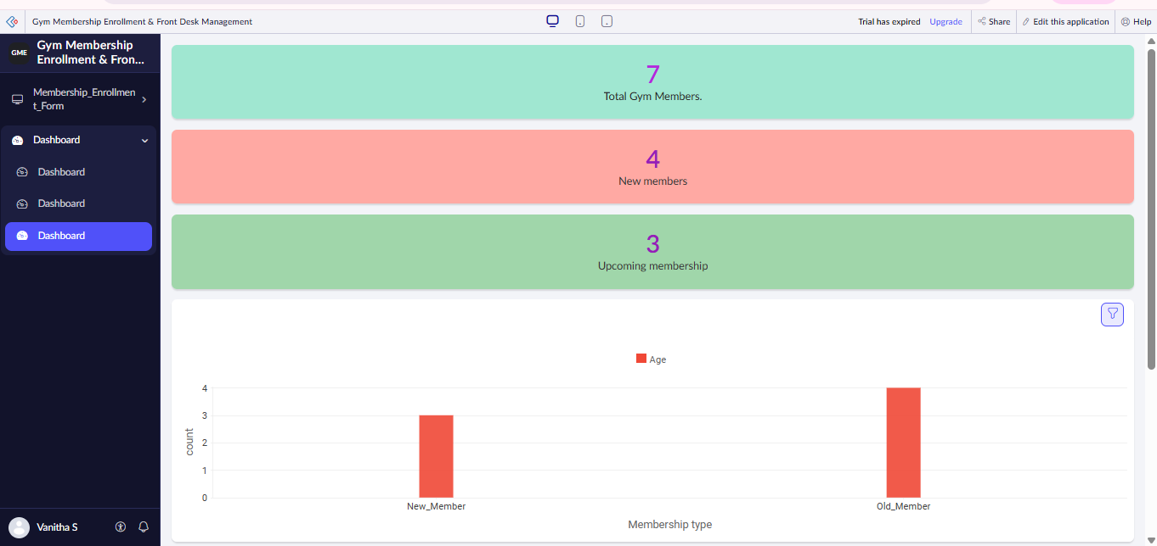
- Examine the Membership Type / Membership Plan column chart and observe the number of members in each category.
- Place the mouse pointer over each column. Verify that the chart displays the corresponding category and count.
- Open the Membership Enrollment Report and examine the member details such as Member Name, Membership Type, Membership Plan, Preferred Activities, and Preferred Start Date.
- Open the report options and select Show As to observe the available report display formats such as List, Calendar, Timeline, Spreadsheet, and Kanban. The reference experiment explores these different report views in the same way.
- Click Edit this application and check the Design section for Zia, Analytics, or AI-assisted options.
- Check the Workflow section for any available Zia/AI analytics features.
- If the account shows “Trial has expired” or an Upgrade option and Zia is unavailable, record that Zia could not be tested with the current account. The uploaded experiment records the same limitation.
5. DASHBOARD ANALYTICS
The Gym Membership dashboard displays important information using summary panels and charts.
Component | Purpose
Total Gym Members | Shows total membership records
New Members | Shows newly registered members
Upcoming Memberships | Shows upcoming memberships
Column Chart | Compares members based on membership category
Membership Report | Displays complete member information
6. INTERACTIVE CHART ANALYSIS
The column chart displays the number of members belonging to different membership categories. When the pointer is placed over a column, the exact category and member count are displayed.
This makes it easier to understand and compare membership data without manually counting records.
S. No. | Activity | Observation
1 | Open the Gym Membership Dashboard. | The dashboard displays membership summary panels and a column chart.
2 | Observe the column chart. | The chart displays member counts for different membership categories.
3 | Move the mouse pointer over a column. | The chart displays the corresponding category and member count.
4 | Compare the columns. | The number of members in each membership category can be compared easily.
5 | Analyze the chart results. | The chart helps gym staff understand membership distribution.
7. BUILT-IN REPORT VIEWS
The membership report can be explored using the Show As options:
List, Calendar, Timeline, Spreadsheet, Kanban, and Import.
These options allow the same membership records to be viewed in different formats.

S. No. | Report View | Purpose
1 | List View | Displays membership records in a list format.
2 | Calendar View | Displays membership records based on dates.
3 | Timeline View | Shows membership-related activities or records over time.
4 | Spreadsheet View | Displays membership data in rows and columns.
5 | Kanban View | Organizes membership records into cards and categories.
6 | Import Option | Allows membership data to be imported from supported files or sources.

8. ZIA / AI-ASSISTED FEATURE EXPLORATION
The Design and Workflow sections of the Gym Membership application are checked for Zia/AI-assisted functionality.
If the account displays “Trial has expired” and no Zia option is available, Zia is not configured or demonstrated. Only the built-in dashboard, charts, and report analytics are explored. This matches the limitation described in the reference experiment.
9. CONCLUSION
The experiment demonstrated how Zoho Creator's built-in dashboard and analytics features can be used to monitor gym membership information. Summary panels provide important counts, charts help compare membership categories, and reports provide different ways to view member records. Zia/AI functionality was not demonstrated because it was unavailable in the current account/interface.

RESULT
The built-in analytics features of the Gym Membership Enrollment & Front Desk Management application were successfully explored. The dashboard summary panels, interactive column chart, and different report display options were examined. The Zia / AI-assisted feature could not be explored because it was not available in the current account/interface.

