Role-Based Access Control (RBAC) in a Zoho Creator Application
Gym Membership Enrollment & Front Desk Management
SAHANA R
241401086
AIM
To configure user management and Role-Based Access Control (RBAC) for the Gym Membership Enrollment & Front Desk Management application in Zoho Creator, so that different users such as Gym Manager, Front Desk Staff, Trainers, and gym members are provided with appropriate roles and permissions without giving unnecessary access.
PROCEDURE
2.1 Defining Roles and Role Hierarchy
- Open the Gym Membership Enrollment & Front Desk Management application in Zoho Creator.
- Go to Settings → Permissions → User Permissions → Roles.
- Create a role named Gym Manager and add the description:
“Manages gym membership enrollments and member records.”
- Enable Share Data with Peers if users under the same role need access to each other's membership records.
The role hierarchy controls which users can access and manage membership information.
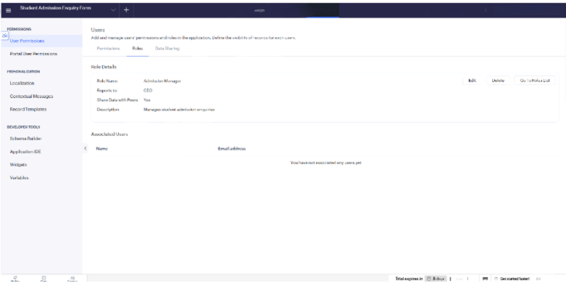
2.2 Creating Permission Profiles
- Go to Settings → Permissions → User Permissions → Permissions.
- Click Add Permission and create permission profiles for different users.
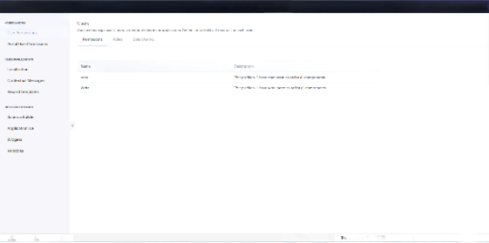
2.3 Setting Portal User Permissions
- Open Portal User Permissions.
- Create or use a Member/Customer permission profile.
- Give portal users only the required permissions, such as:
Add → Yes
View → Yes
Edit/Delete → Restricted
This allows gym members to submit membership details without accessing internal management information.
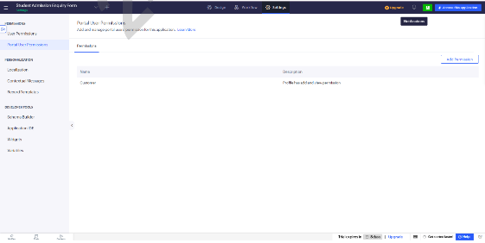
2.4 Configuring Application Localization
- Go to Settings → Personalization → Localization.
- Select User's browser language.
- Keep English as the default language.
This allows the application interface to display according to the user's browser language.
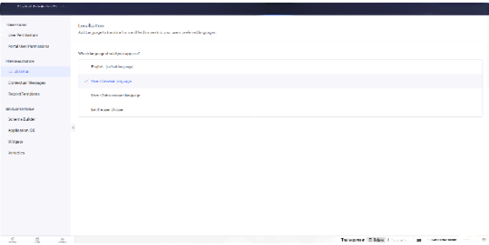
2.5 Verifying Workflow Automation
- Go to Workflow → Form Workflows.
- Check that the workflow created for Membership_Enrollment_Form is Enabled.
- Verify that the membership notification/approval workflow continues to work correctly.
When a membership record is submitted, the configured workflow should continue to execute even after roles and permissions are applied.

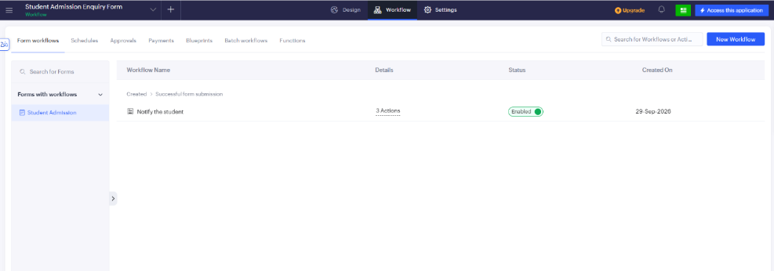
2.6 Adding a User and Assigning Role & Permission
- Open Zoho Creator → Users → Add User.
- Enter the user's Name and Email Address.
- Keep Send Notification Mail enabled.
- Under Add to Application, select:
Application: Gym Membership Enrollment & Front Desk Management
Role: Front Desk Staff
Permission: Your created permission profile
- Click Add User.
The new user will receive an invitation and can access only the features allowed by the assigned role and permission.
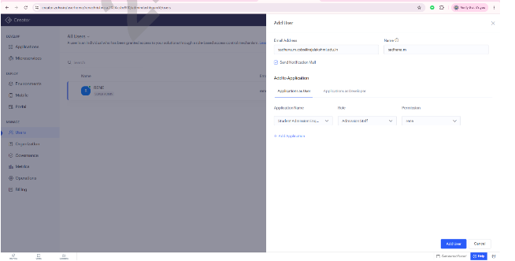
OUTPUT
After configuring the roles, permission profiles, portal permissions, and localization settings, the added users are displayed on the All Users page. Each user can access the Gym Membership application according to their assigned role and permissions.
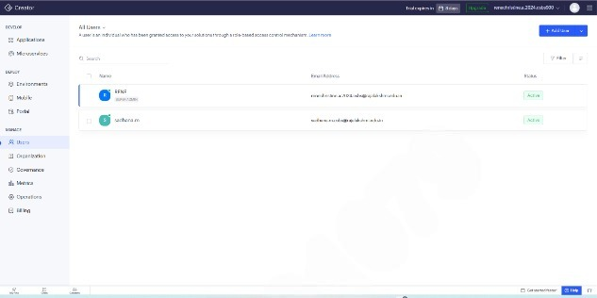

RESULT
Thus, Role-Based Access Control (RBAC) was successfully configured for the Gym Membership Enrollment & Front Desk Management application in Zoho Creator. Different access permissions were assigned to the Gym Manager, Front Desk Staff, Trainers, and gym members, ensuring that each user can access only the required data and features while the existing workflow automation continues to function correctly.

