**Hello World RESTful Web Service**   
  
Write a REST service in the spring learn application created earlier, that returns the text "Hello World!!" using Spring Web Framework. Refer details below:  
  
**Method:** GET  
**URL:** /hello  
**Controller:** com.cognizant.spring-learn.controller.HelloController  
**Method Signature:** public String sayHello()  
**Method Implementation:** return hard coded string "Hello World!!"  
**Sample Request**: http://localhost:8083/hello  
**Sample Response:** Hello World!!   
  
**IMPORTANT NOTE**: Don't forget to include start and end log in the sayHello() method.  
  
Try the URL http://localhost:8083/hello in both chrome browser and postman.  
  
SME to explain the following aspects:

* In network tab of developer tools show the HTTP header details received
* In postman click on "Headers" tab to view the HTTP header details received

**pom.xml**

<project xmlns="http://maven.apache.org/POM/4.0.0"

xmlns:xsi="http://www.w3.org/2001/XMLSchema-instance"

xsi:schemaLocation="http://maven.apache.org/POM/4.0.0

http://maven.apache.org/xsd/maven-4.0.0.xsd">

<modelVersion>4.0.0</modelVersion>

<groupId>com.cognizant</groupId>

<artifactId>spring-learn</artifactId>

<version>0.0.1-SNAPSHOT</version>

<packaging>jar</packaging>

<name>spring-learn</name>

<description>Hello World Spring Boot Application</description>

<parent>

<groupId>org.springframework.boot</groupId>

<artifactId>spring-boot-starter-parent</artifactId>

<version>3.2.4</version>

<relativePath/> <!-- lookup parent from repository -->

</parent>

<properties>

<java.version>17</java.version>

</properties>

<dependencies>

<!-- Spring Boot Starter Web -->

<dependency>

<groupId>org.springframework.boot</groupId>

<artifactId>spring-boot-starter-web</artifactId>

</dependency>

<!-- Logging -->

<dependency>

<groupId>org.springframework.boot</groupId>

<artifactId>spring-boot-starter-logging</artifactId>

</dependency>

<!-- Test -->

<dependency>

<groupId>org.springframework.boot</groupId>

<artifactId>spring-boot-starter-test</artifactId>

<scope>test</scope>

</dependency>

</dependencies>

<build>

<plugins>

<!-- Spring Boot Plugin -->

<plugin>

<groupId>org.springframework.boot</groupId>

<artifactId>spring-boot-maven-plugin</artifactId>

<version>3.2.4</version>

</plugin>

</plugins>

</build>

</project>

**SpringLearnApplication.java**

package com.cognizant.springlearn;

import org.springframework.boot.SpringApplication;

import org.springframework.boot.autoconfigure.SpringBootApplication;

@SpringBootApplication

public class SpringLearnApplication {

public static void main(String[] args) {

SpringApplication.run(SpringLearnApplication.class, args);

}

}

**HelloController.java**

package com.cognizant.springlearn.controller;

import org.slf4j.Logger;

import org.slf4j.LoggerFactory;

import org.springframework.web.bind.annotation.*;

@RestController

public class HelloController {

private static final Logger LOGGER = LoggerFactory.getLogger(HelloController.class);

@GetMapping("/hello")

public String sayHello() {

LOGGER.info("START - sayHello()");

String response = "Hello World!!";

LOGGER.info("END - sayHello()");

return response;

}

}

**application.properties**

server.port=8083

**OUTPUT**

**REST - Country Web Service**   
  
Write a REST service that returns India country details in the earlier created spring learn application.  
  
**URL**: /country  
**Controller**: com.cognizant.spring-learn.controller.CountryController  
**Method Annotation**: @RequestMapping  
**Method Name**: getCountryIndia()  
**Method Implementation**: Load India bean from spring xml configuration and return  
**Sample Request**: http://localhost:8083/country  
**Sample Response**:

{

"code": "IN",

"name": "India"

}

SME to explain the following aspects:

* What happens in the controller method?
* How the bean is converted into JSON reponse?
* In network tab of developer tools show the HTTP header details received
* In postman click on "Headers" tab to view the HTTP header details received

**Country.java**

package com.cognizant.springlearn.model;

public class Country {

private String code;

private String name;

public Country() {}

public Country(String code, String name) {

this.code = code;

this.name = name;

}

public String getCode() {

return code;

}

public void setCode(String code) {

this.code = code;

}

public String getName() {

return name;

}

public void setName(String name) {

this.name = name;

}

}

**CountryController.java**

package com.cognizant.springlearn.controller;

import org.springframework.web.bind.annotation.RequestMapping;

import org.springframework.web.bind.annotation.RestController;

import org.springframework.context.ApplicationContext;

import org.springframework.context.support.ClassPathXmlApplicationContext;

import com.cognizant.springlearn.model.Country;

@RestController

public class CountryController {

@RequestMapping("/country")

public Country getCountryIndia() {

ApplicationContext context = new ClassPathXmlApplicationContext("country.xml");

Country country = (Country) context.getBean("in");

return country;

}

}

**SpringLearnApplication.java**

package com.cognizant.springlearn;

import org.springframework.boot.SpringApplication;

import org.springframework.boot.autoconfigure.SpringBootApplication;

@SpringBootApplication

public class SpringLearnApplication {

public static void main(String[] args) {

SpringApplication.run(SpringLearnApplication.class, args);

}

}

**Scountry.xml**

<?xml version="1.0" encoding="UTF-8"?>

<beans xmlns="http://www.springframework.org/schema/beans"

xmlns:xsi="http://www.w3.org/2001/XMLSchema-instance"

xsi:schemaLocation="http://www.springframework.org/schema/beans

http://www.springframework.org/schema/beans/spring-beans.xsd">

<bean id="in" class="com.cognizant.springlearn.model.Country">

<property name="code" value="IN"/>

<property name="name" value="India"/>

</bean>

</beans>

**pom.xml**

<project xmlns="http://maven.apache.org/POM/4.0.0"

xmlns:xsi="http://www.w3.org/2001/XMLSchema-instance"

xsi:schemaLocation="http://maven.apache.org/POM/4.0.0

http://maven.apache.org/xsd/maven-4.0.0.xsd">

<modelVersion>4.0.0</modelVersion>

<groupId>com.cognizant</groupId>

<artifactId>spring-learn</artifactId>

<version>1.0</version>

<parent>

<groupId>org.springframework.boot</groupId>

<artifactId>spring-boot-starter-parent</artifactId>

<version>2.7.18</version>

</parent>

<dependencies>

<dependency>

<groupId>org.springframework.boot</groupId>

<artifactId>spring-boot-starter-web</artifactId>

</dependency>

<dependency>

<groupId>org.springframework</groupId>

<artifactId>spring-context</artifactId>

</dependency>

</dependencies>

<build>

<plugins>

<plugin>

<groupId>org.springframework.boot</groupId>

<artifactId>spring-boot-maven-plugin</artifactId>

</plugin>

</plugins>

</build>

</project>

**application.properties**

# Optional: To run server on port 8083 instead of 8080

server.port=8083

**OUTPUT:**

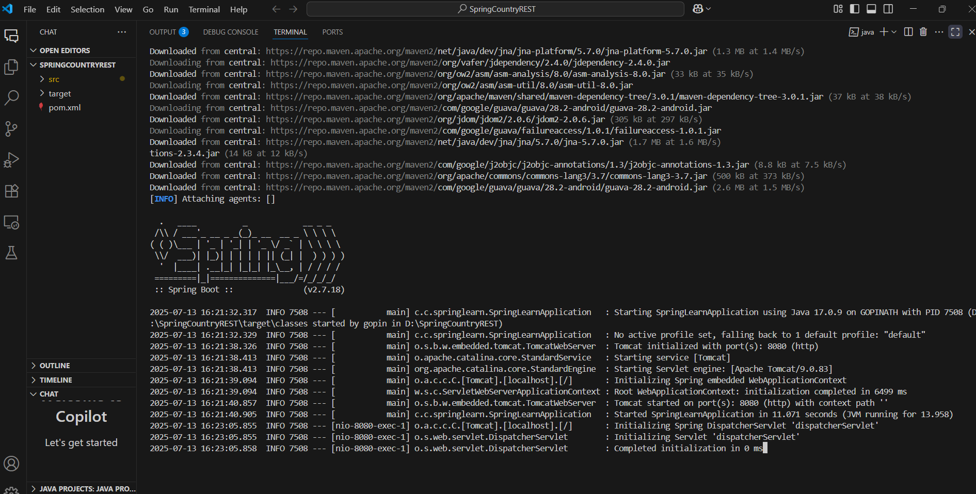

**REST - Get country based on country code**   
  
Write a REST service that returns a specific country based on country code. The country code should be case insensitive.  
  
**Controller**: com.cognizant.spring-learn.controller.CountryController  
**Method Annotation:** @GetMapping("/countries/{code}")  
**Method Name**: getCountry(String code)  
**Method Implemetation**: Invoke countryService.getCountry(code)   
**Service Method:** com.cognizant.spring-learn.service.CountryService.getCountry(String code)  
  
**Service Method Implementation**:

* Get the country code using @PathVariable
* Get country list from country.xml
* Iterate through the country list
* Make a case insensitive matching of country code and return the country.
* Lambda expression can also be used instead of iterating the country list

**Sample Request**: http://localhost:8083/country/in  
  
**Sample Response**:

{

"code": "IN",

"name": "India"

}

**pom.xml**

<project xmlns="http://maven.apache.org/POM/4.0.0"

xmlns:xsi="http://www.w3.org/2001/XMLSchema-instance"

xsi:schemaLocation="http://maven.apache.org/POM/4.0.0 http://maven.apache.org/xsd/maven-4.0.0.xsd">

<modelVersion>4.0.0</modelVersion>

<groupId>com.cognizant</groupId>

<artifactId>SpringCountryCodeApp</artifactId>

<version>1.0</version>

<packaging>jar</packaging>

<name>SpringCountryCodeApp</name>

<description>Spring Boot REST Country Code App</description>

<parent>

<groupId>org.springframework.boot</groupId>

<artifactId>spring-boot-starter-parent</artifactId>

<version>2.7.5</version>

</parent>

<dependencies>

<dependency>

<groupId>org.springframework.boot</groupId>

<artifactId>spring-boot-starter-web</artifactId>

</dependency>

<dependency>

<groupId>com.fasterxml.jackson.dataformat</groupId>

<artifactId>jackson-dataformat-xml</artifactId>

</dependency>

</dependencies>

<build>

<plugins>

<plugin>

<groupId>org.springframework.boot</groupId>

<artifactId>spring-boot-maven-plugin</artifactId>

</plugin>

</plugins>

</build>

</project>

**SpringCountryCodeApp.java**

package com.cognizant.spring_learn;

import org.springframework.boot.SpringApplication;

import org.springframework.boot.autoconfigure.SpringBootApplication;

@SpringBootApplication

public class SpringCountryCodeApp {

public static void main(String[] args) {

SpringApplication.run(SpringCountryCodeApp.class, args);

}

}

**CountryController.java**

package com.cognizant.spring_learn.controller;

import com.cognizant.spring_learn.model.Country;

import com.cognizant.spring_learn.service.CountryService;

import org.springframework.beans.factory.annotation.Autowired;

import org.springframework.web.bind.annotation.*;

@RestController

public class CountryController {

@Autowired

private CountryService countryService;

@GetMapping("/countries/{code}")

public Country getCountry(@PathVariable String code) {

return countryService.getCountry(code);

}

}

**CountryService.java**

package com.cognizant.spring_learn.service;

import com.cognizant.spring_learn.model.Country;

import org.springframework.stereotype.Service;

import javax.annotation.PostConstruct;

import javax.xml.parsers.DocumentBuilderFactory;

import org.w3c.dom.*;

import java.io.InputStream;

import java.util.ArrayList;

import java.util.List;

@Service

public class CountryService {

private List<Country> countries = new ArrayList<>();

@PostConstruct

public void init() {

try {

InputStream is = getClass().getClassLoader().getResourceAsStream("country.xml");

Document doc = DocumentBuilderFactory.newInstance().newDocumentBuilder().parse(is);

NodeList nodeList = doc.getElementsByTagName("country");

for (int i = 0; i < nodeList.getLength(); i++) {

Element element = (Element) nodeList.item(i);

Country country = new Country();

country.setCode(element.getElementsByTagName("code").item(0).getTextContent());

country.setName(element.getElementsByTagName("name").item(0).getTextContent());

countries.add(country);

}

} catch (Exception e) {

e.printStackTrace();

}

}

public Country getCountry(String code) {

return countries.stream()

.filter(c -> c.getCode().equalsIgnoreCase(code))

.findFirst()

.orElse(null);

}

}

**Country.java**

package com.cognizant.spring_learn.model;

public class Country {

private String code;

private String name;

public String getCode() {

return code;

}

public void setCode(String code) {

this.code = code;

}

public String getName() {

return name;

}

public void setName(String name) {

this.name = name;

}

}

**application.properties**

<countries>

<country>

<code>IN</code>

<name>India</name>

</country>

<country>

<code>US</code>

<name>United States</name>

</country>

</countries>

**OUTPUT:**

