THE E-COMMERCE PRODUCT CATALOG

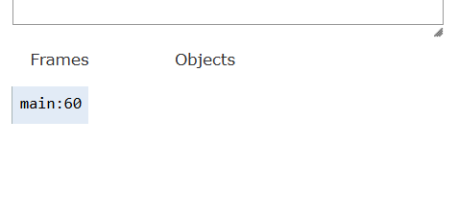
- The program started running the main method and about to create the first electronics object. No object has been created yet.

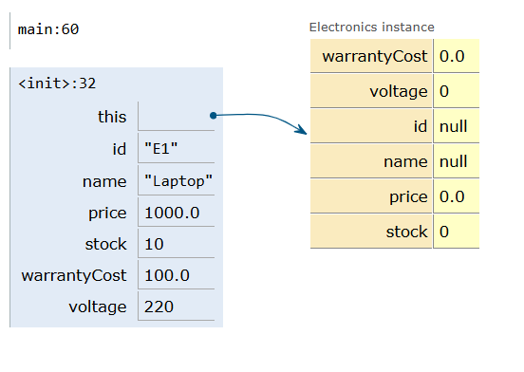
- Calling the electronics constructor and by using the keyword “super” we are passing values for the laptop to the parent class “Product”.

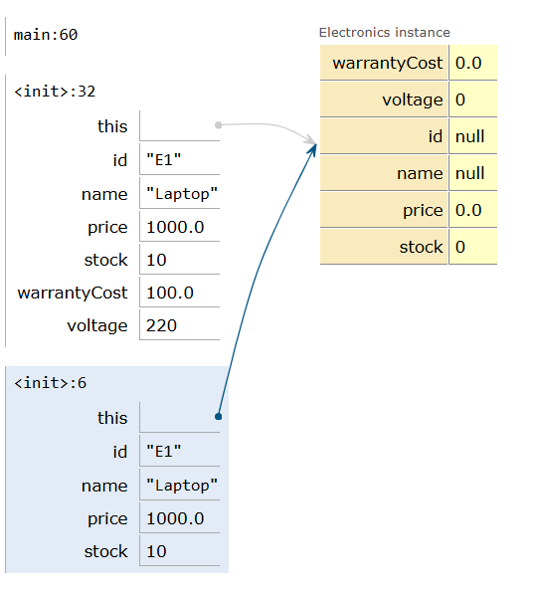
- Program enters the Product constructor. And here the common details like id, name, price and stock are assigned to the object.
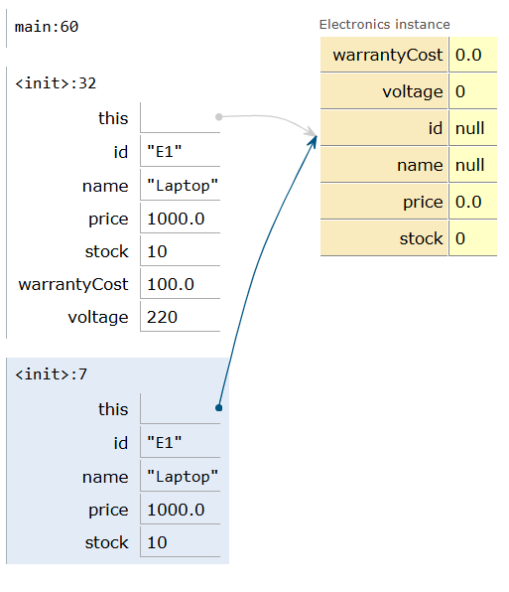
- Product constructor is assigning the values like id, name, price, and stock to the laptop object. This shows that the basic project info is set up before moving back to electronics constructor.
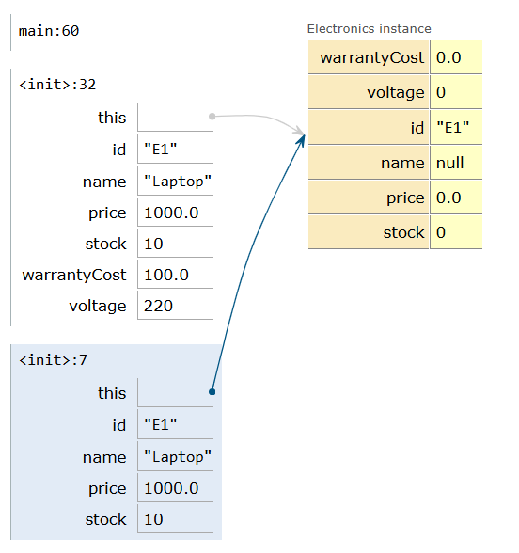
- Id has been assigned.
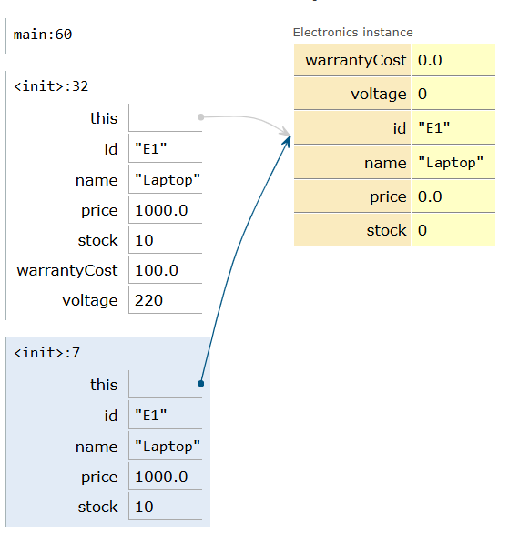
- Name has been assigned.

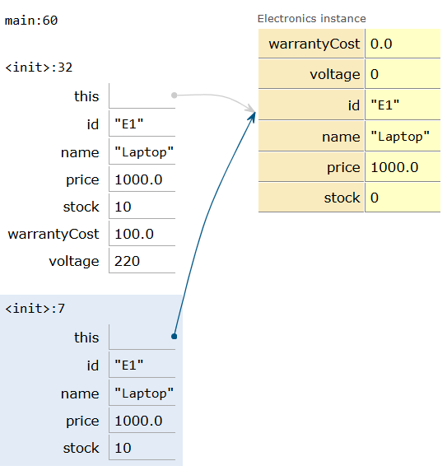
- Price has been assigned.
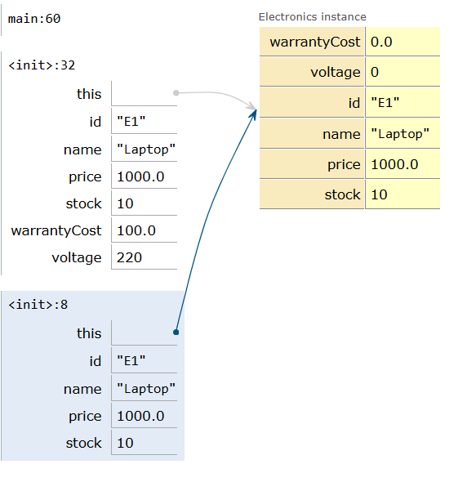
- Stock has been assigned. This ends the assignment of the common product details.
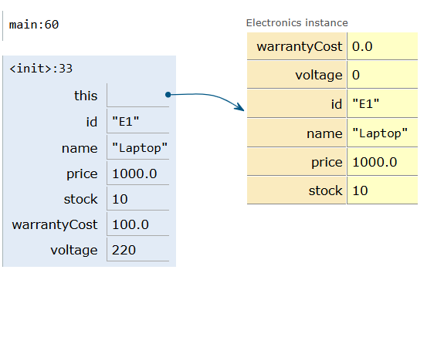
- Returning back to the electronics constructor. To initialize extra attributes like cost and warranty.

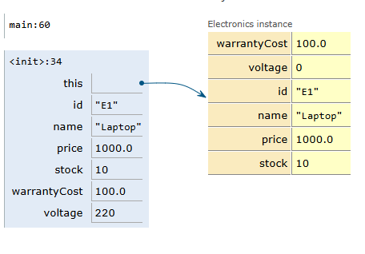
- Initialization of warranty cost.
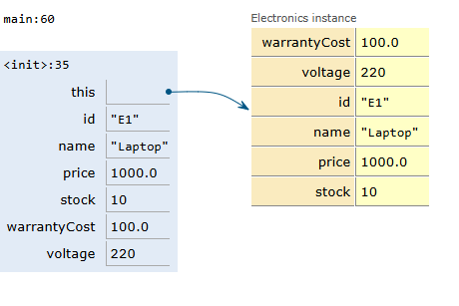
- Initialization of voltage.
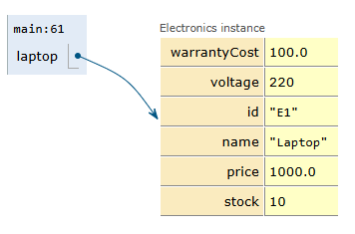
- Variable laptop in the electronics object has been created completely. And now moving on to create the next object which shows that multiple objects can be created independently from different class.

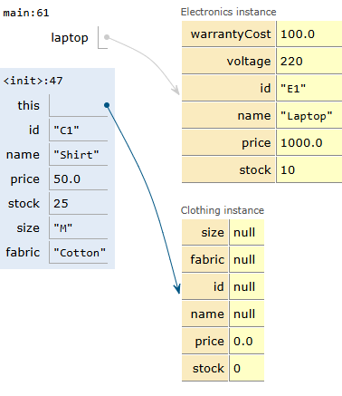
- Clothing constructor started and basic details are being passed to parent product class using keyword super. Here the common attributes are initialized.
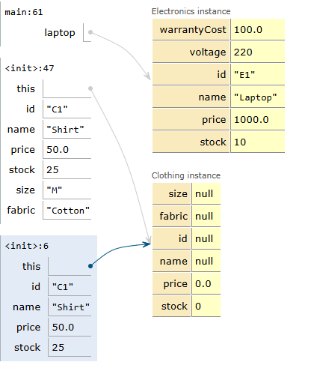
- Product constructor is assigning the values like id, name, price, and stock to the shirt object. This shows that the basic project info is set up before moving back to clothing constructor.
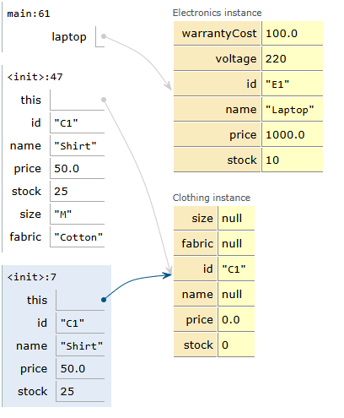
- Initialized the id.

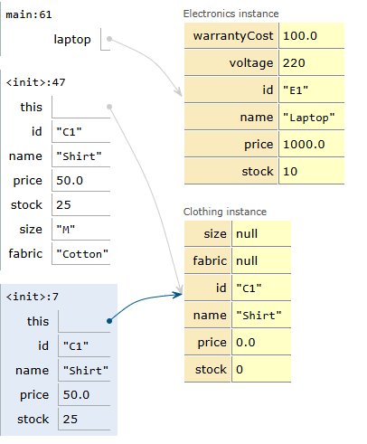
- Initialized the name.
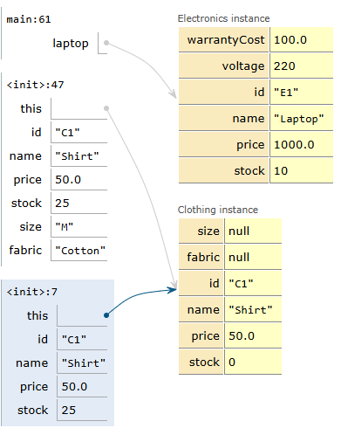
- Initialized the price
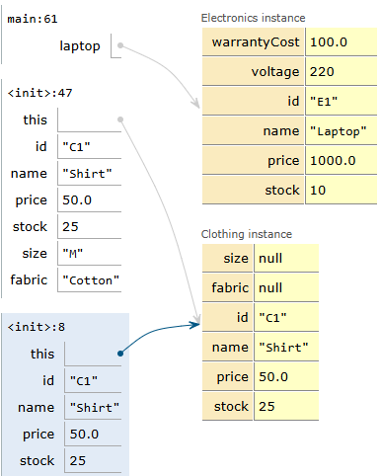
- Initialized the stock. This ends the initialization of the common product details.
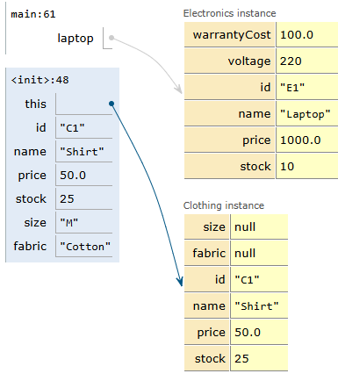
- The shirt object’s basic details have been initialized. Now the clothing specific attributes like size and fabric are assigning.
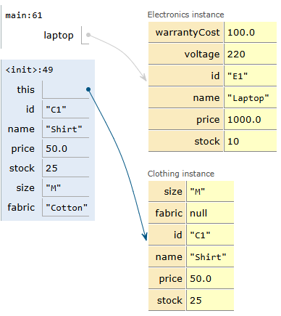
- The size value has been assigned. Now the constructor is setting the fabric type.
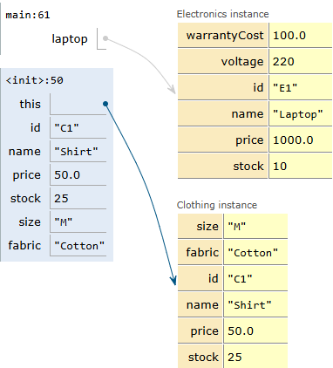
- Initializing the fabric type. Shirt object is fully initialized with ball its details.
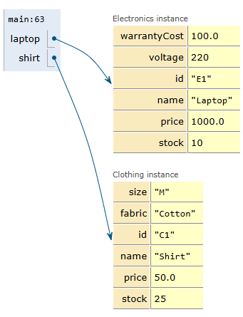
- Both the objects are created successfully. The program is now calling the printDetails for the laptop to display its info.

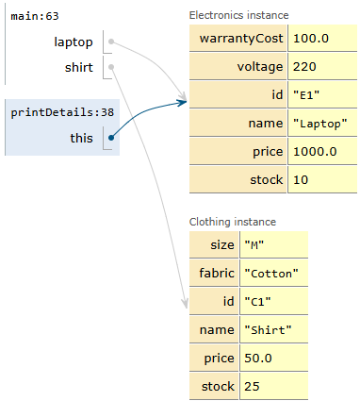
- Program has entered print details method for the object. Where it is displaying both the inherited product info and electronics specific details like warranty cost and voltage.

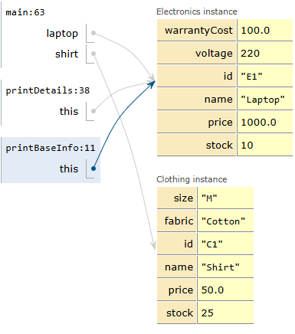
- The printDetails() method is calling the parent class method printBaseInfo().

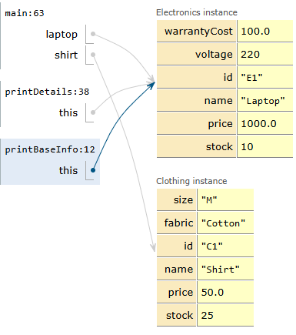
- The base product info has been printed successfully. Now program returns to the printDetails method to display laptop’s additional details.
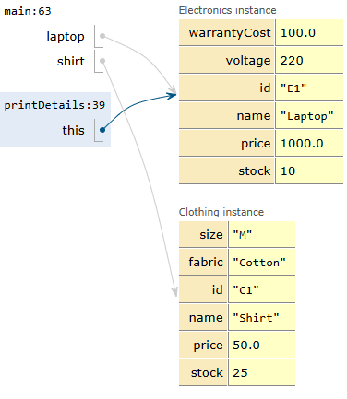
- Now it displays laptop’s details like warranty cost and voltage after printing basic product info.
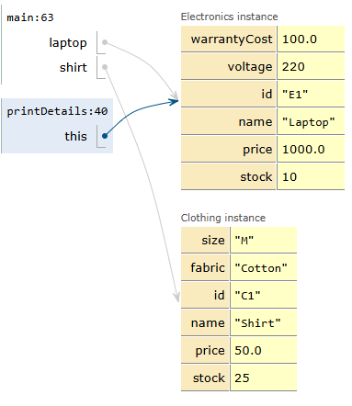
- Laptop details has been printed successfully.

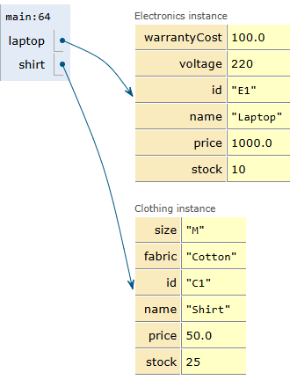
- Now program is moving to shirt.printDetails after displaying laptop details.
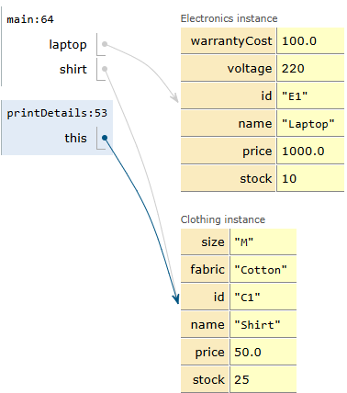
- The program entered print details method for shirt object.
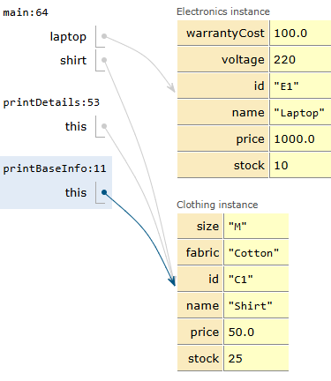
- The shirt’s basic info is printed through parent class method printBaseInfo.
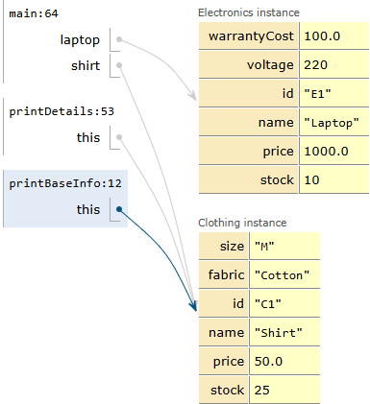
- The shirt’s basic details are displayed successfully. Program is now returning to printDetails to print the clothing specific info.

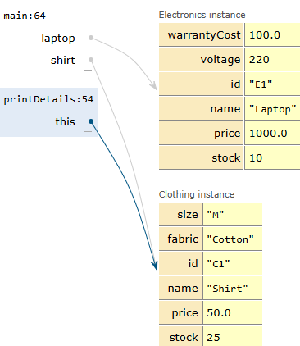
- Printing the shirt’s specific details.

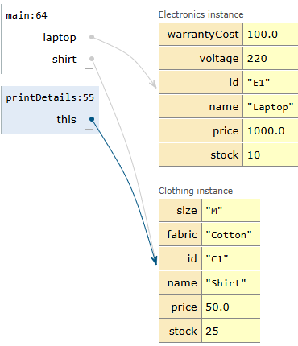
- The shirt’s details printed successfully. The control is now returning to main() method to continue with discount operation.
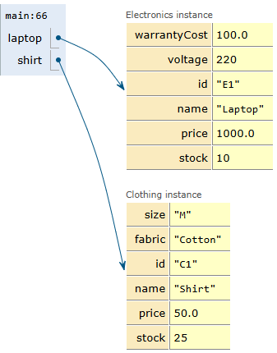
- The program has finished displaying all product details. And it is moving to the discount section where a 10% will be applied to the laptop’s price.
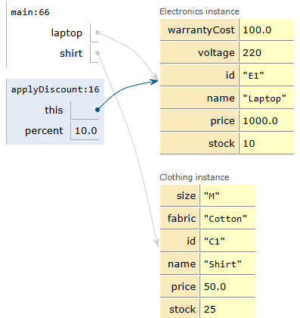
- The program has entered applyDiscount method for the laptop. The discount value of 10% is passed as an argument and the method id now calculating the new price after applying the discount.
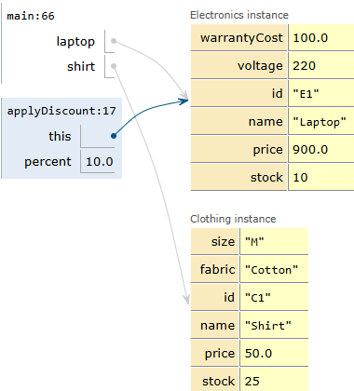
- The discount applied successfully. Now the price changed from 1000 to 900.
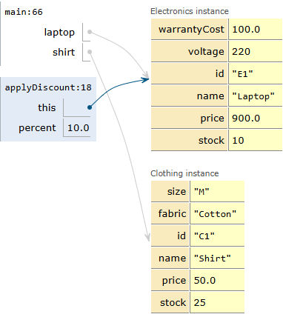
- The updated laptop price has been displayed to the user.
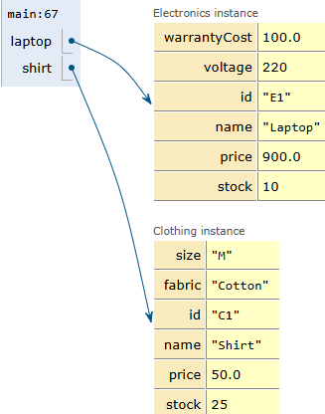
- The laptop discount process us complete and the updated price is stored in the object.
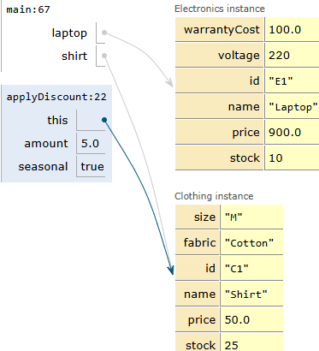
- The program entered applyDiscount method for the shirt were a flat discount of 5.0 is being applied and seasonal value is true.
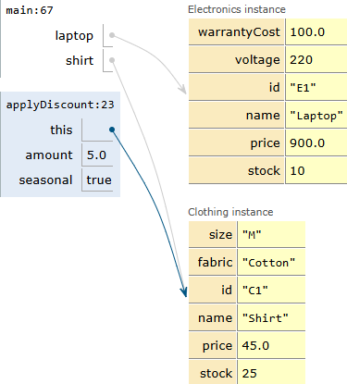
- The flat discount applied successfully to shirt and its price decreased from 50 to 45.
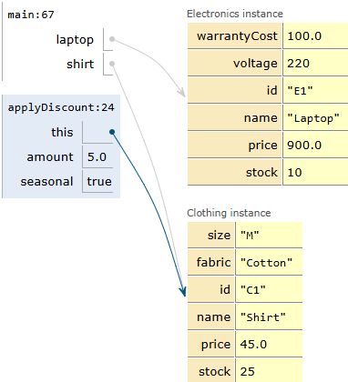
- The seasonal discount has been applied successfully. Now the final shirt price is 45.

CODE :
class Product {
private String id, name;
private double price;
private int stock;

public Product(String id, String name, double price, int stock) {
this.id = id; this.name = name; this.price = price; this.stock = stock;
}

public void printBaseInfo() {
System.out.println("ID: " + id + ", Name: " + name + ", Price: $" + price + ", Stock: " + stock);
}

// Overload 1: Percentage discount
public void applyDiscount(double percent) {
price -= price * (percent / 100.0);
System.out.println(name + " price after " + percent + "% off: $" + price);
}

// Overload 2: Flat amount discount with seasonal flag
public void applyDiscount(double amount, boolean seasonal) {
price -= amount;
System.out.println((seasonal ? "[Seasonal] " : "") + name + " price after $" + amount + " off: $" + price);
}
}

class Electronics extends Product {
private double warrantyCost;
private int voltage;

public Electronics(String id, String name, double price, int stock, double warrantyCost, int voltage) {
super(id, name, price, stock); // Constructor chaining
this.warrantyCost = warrantyCost;
this.voltage = voltage;
}

public void printDetails() {
super.printBaseInfo(); // Parent method invocation using super
System.out.println("Warranty: $" + warrantyCost + ", Voltage: " + voltage + "V\n");
}
}

class Clothing extends Product {
private String size, fabric;

public Clothing(String id, String name, double price, int stock, String size, String fabric) {
super(id, name, price, stock); // Constructor chaining
this.size = size;
this.fabric = fabric;
}

public void printDetails() {
super.printBaseInfo(); // Parent method invocation using super
System.out.println("Size: " + size + ", Fabric: " + fabric + "\n");
}
}

public class Main {
public static void main(String[] args) {
Electronics laptop = new Electronics("E1", "Laptop", 1000.0, 10, 100.0, 220);
Clothing shirt = new Clothing("C1", "Shirt", 50.0, 25, "M", "Cotton");

laptop.printDetails();
shirt.printDetails();

laptop.applyDiscount(10.0);
shirt.applyDiscount(5.0, true);
}
}
SAHANA H T (1BY25AI206)
KRUTHIKA K (1BY25AI118)

