**DAILY ONLINE ACTIVITIES SUMMARY**

|  |  |  |  |  |  |  |  |
| --- | --- | --- | --- | --- | --- | --- | --- |
| **Date:** | **01-06-20** | | | | **Name:** | **SAHANA C** | |
| **Sem & Sec** | **VI B** | | | | **USN:** | **4AL17CS116** | |
| **Online Test Summary** | | | | | | | |
| **Subject** | | **CNSC 2 IA Test** | | | | | |
| **Max. Marks** | | **60** | | **Score** | | **52** | |
| **Certification Course Summary** | | | | | | | |
| **Course** | **FRONT END DEVELOPMENT-HTML** | | | | | | |
| **Coding Challenges**   1. Python Program to remove duplicate elements from a list 2. Java Program to left rotate the elements of an array 3. C Program to find the leaders in the array   P11 | | | | | | | |
| **Certificate Provider** | | | **Great learning** | **Duration** | | | **6days** |
| **Status:Completed** | | | | | | | |
| **Uploaded the report in Github** | | | | **Yes** | | | |
| **If yes Repository name** | | | | **https://github.com/sahanasanu/Daliy-status** | | | |
| **Uploaded the report in slack** | | | | **Yes** | | | |

**IA MARKS DETAILS:**

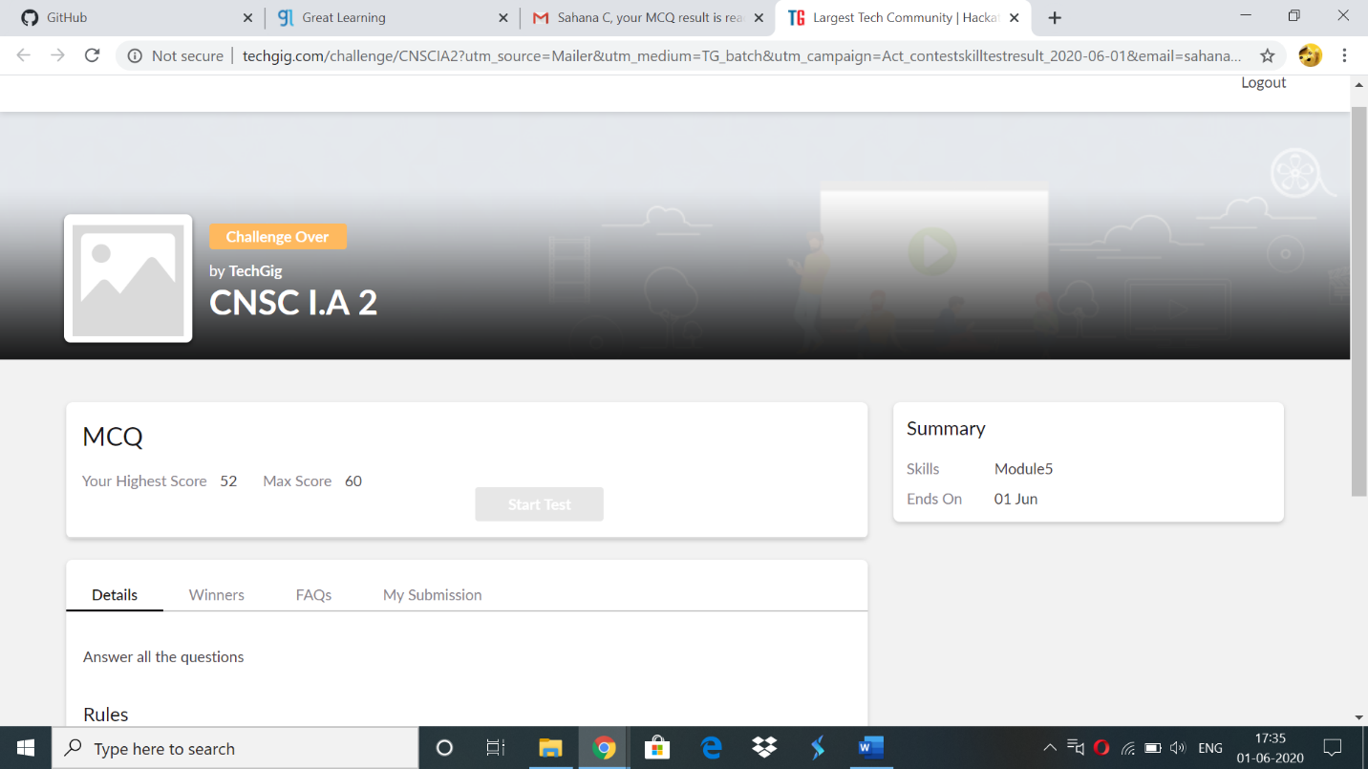

**Online Certification Details:**

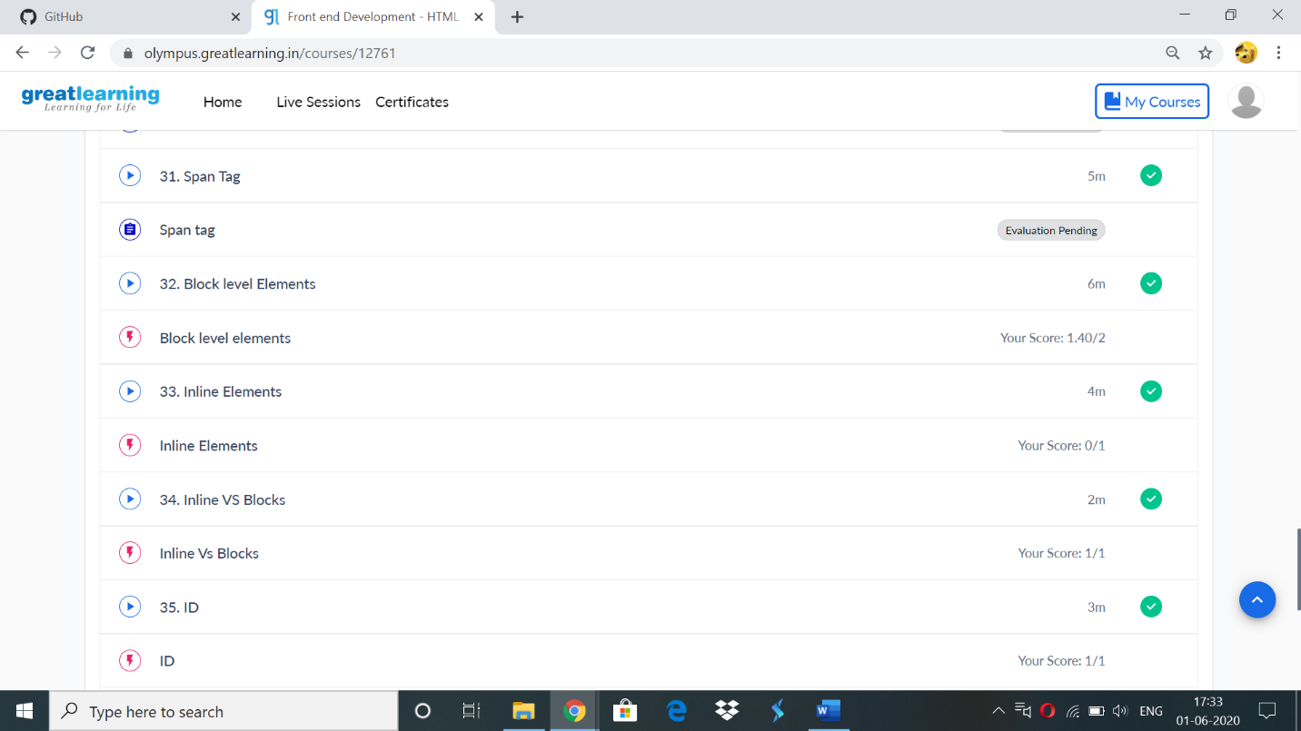

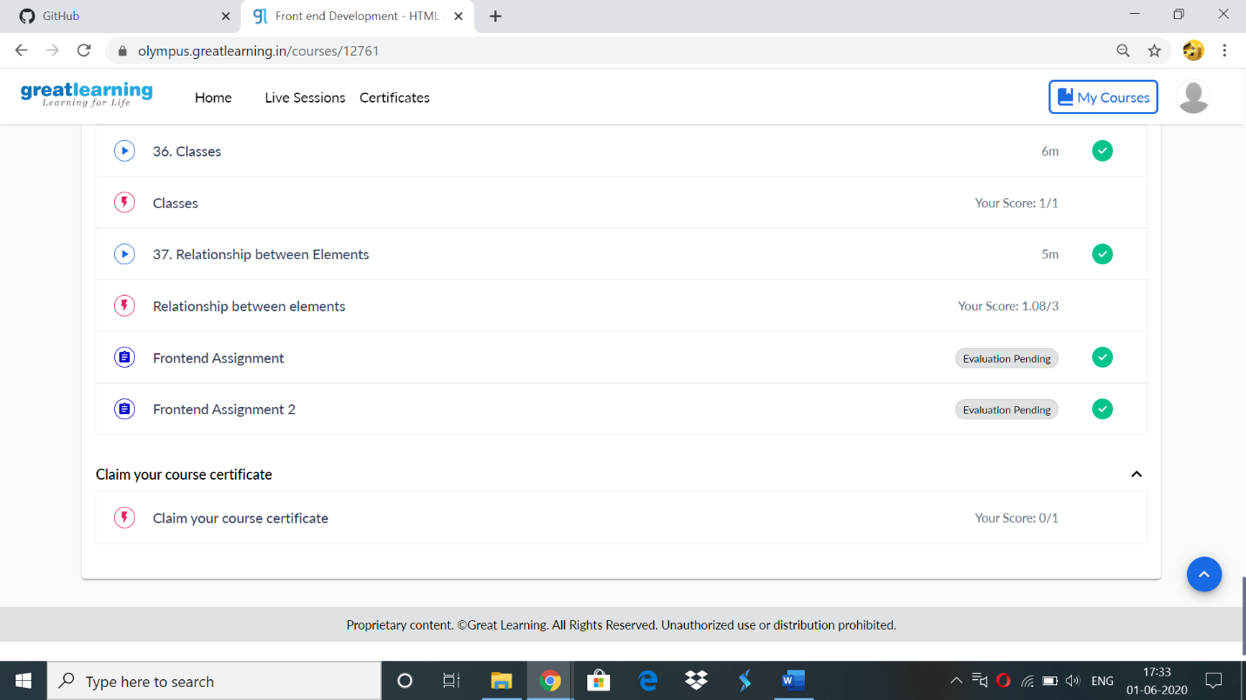

**Assignment:**

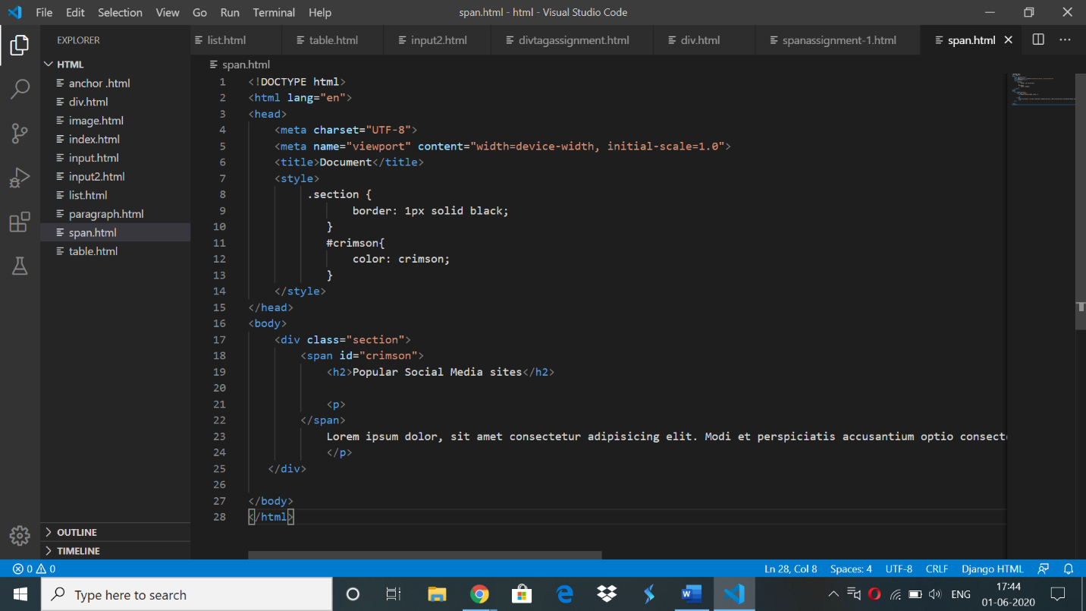

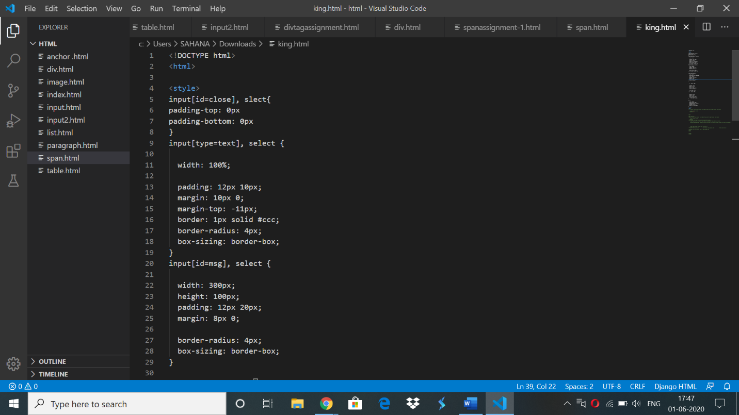

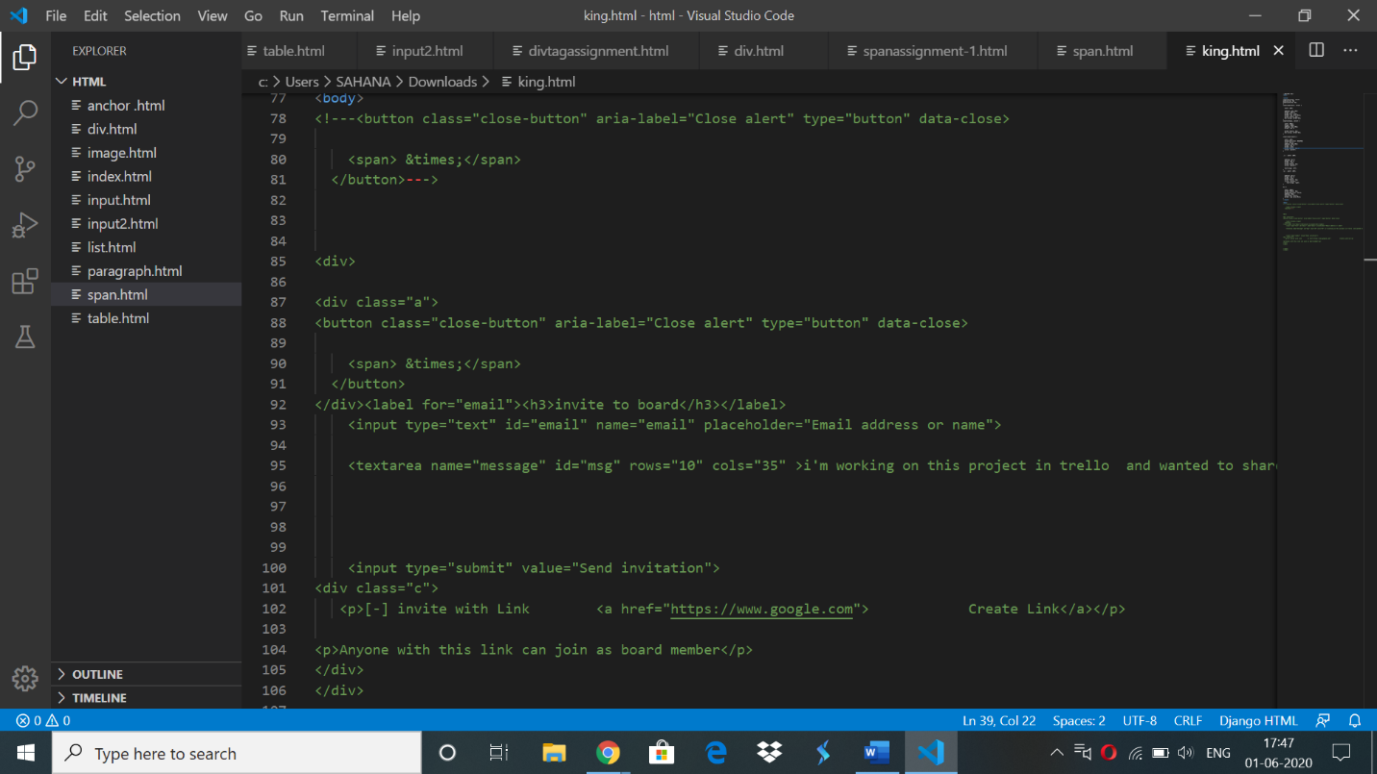

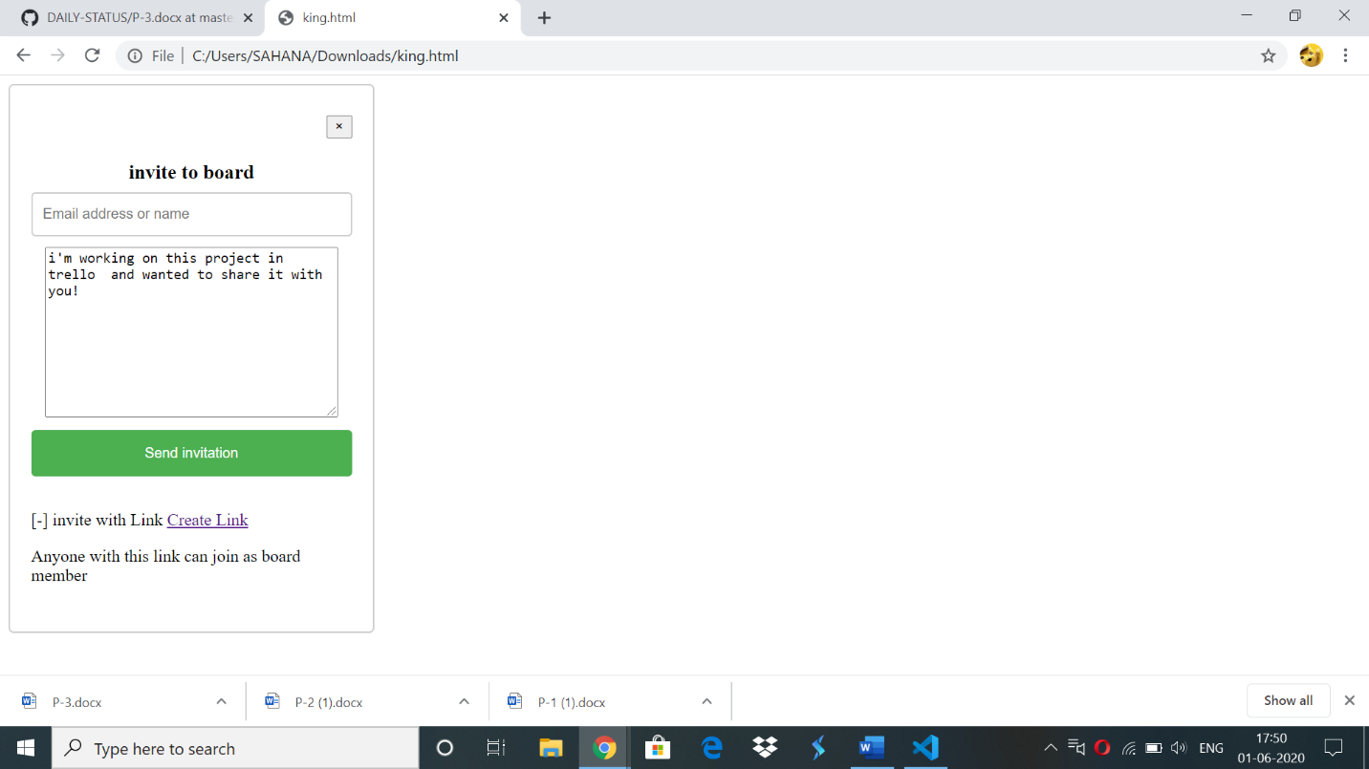

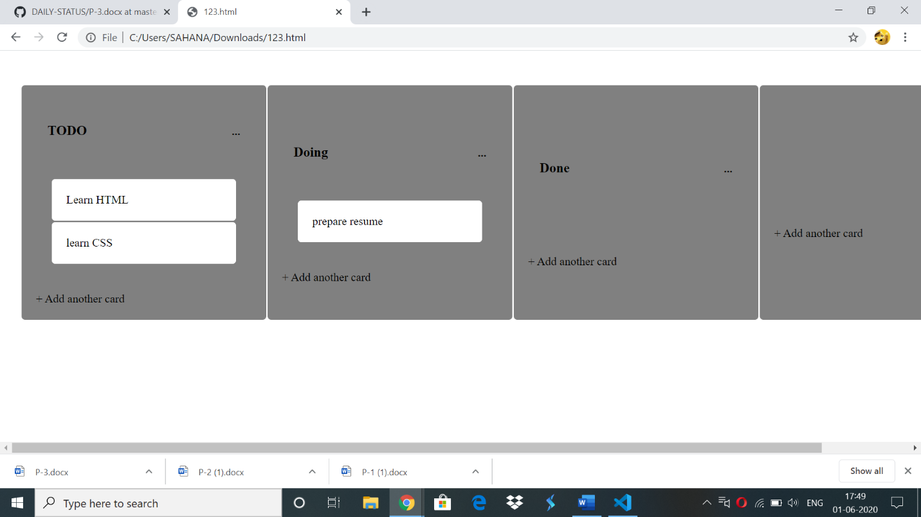

**Certificate:**



**Online coding:**

**1)**

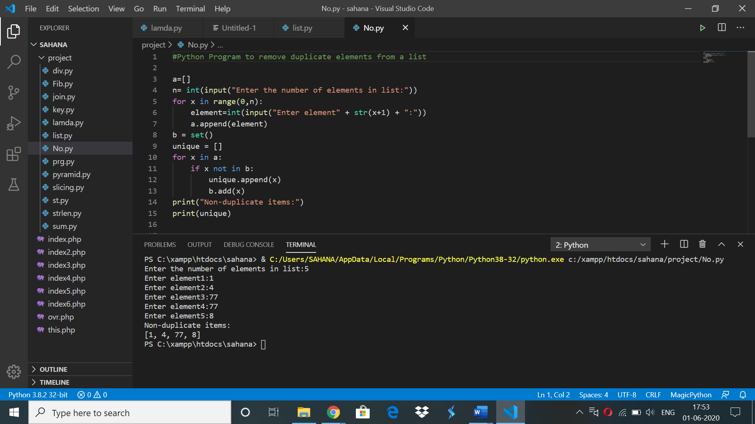

**2)**

**package** monday;

**import** java.util.Scanner;

**public** **class** RotateLeft {

**public** **static** **void** main(String[] args) {

//Initialize array

**int** p;

Scanner s = **new** Scanner(System.***in***);

System.***out***.print("Enter no. of elements you want in array:");

p = s.nextInt();

**int** arr[] = **new** **int**[p];

System.***out***.println("Enter all the elements:");

**for**(**int** i = 0; i < p; i++)

{

arr[i] = s.nextInt();

}

//Displays original array

System.***out***.println("Original array: ");

**for** (**int** i = 0; i < arr.length; i++) {

System.***out***.print(arr[i] + " ");

}

System.***out***.println("\nenter the number to rotate number of times left");

**int** n=s.nextInt();

//Rotate the given array by n times toward left

**for**(**int** i = 0; i < n; i++){

**int** j, first;

//Stores the first element of the array

first = arr[0];

**for**(j = 0; j < arr.length-1; j++){

//Shift element of array by one

arr[j] = arr[j+1];

}

//First element of array will be added to the end

arr[j] = first;

}

System.***out***.println();

//Displays resulting array after rotation

System.***out***.println("Array after left rotation: ");

**for**(**int** j = 0; j< arr.length; j++){

System.***out***.print(arr[j] + " ");

}

}

}

**OUTPUT:**

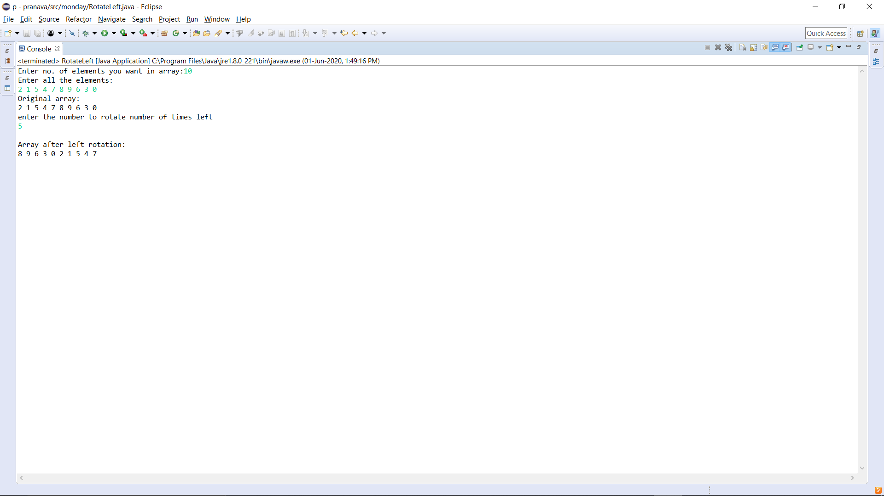

3)

#include<stdio.h>

void printLeaders(int arr[], int size)

{

for (int i = 0; i < size; i++)

{

int j;

for (j = i+1; j < size; j++)

{

if (arr[i] <= arr[j])

break;

}

if (j == size)

printf("%d\n",arr[i]);

}

}

int main()

{

int arr[100];

int n,t;

printf("enter num of test cases\n");

scanf("%d",&t);

while(t--)

{

printf("\nN=");

scanf("%d",&n);

printf("enter array elements\n");

for(int i=0;i<n;i++)

scanf("%d",&arr[i]);

printf("leadersin array\n");

printLeaders(arr, n);

}

return 0;

}

OUTPUT

