**DAILY ONLINE ACTIVITIES SUMMARY**

|  |  |  |  |  |  |  |  |
| --- | --- | --- | --- | --- | --- | --- | --- |
| **Date:** | **03-06-20** | | | | **Name:** | **SAHANA C** | |
| **Sem & Sec** | **VI B** | | | | **USN:** | **4AL17CS116** | |
| **Online Test Summary** | | | | | | | |
| **Subject** | | **PAP ASSIGNMENT TEST** | | | | | |
| **Max. Marks** | | **20** | | **Score** | | **16** | |
| **Certification Course Summary** | | | | | | | |
| **Course** | **FRONT END DEVELOPMENT-CSS** | | | | | | |
| **Coding Challenges**  **1)Take a list of length 3 containing integers, find out which is larger, first or last one and set all the elements in the list to be that value. Print the updated list**  **2) Python Program to Find the Largest Number in a List without using sorting algorithm**  **3)Python Program to find different digits r from number n using combination.** | | | | | | | |
| **Certificate Provider** | | | **Great learning** | **Duration** | | | **3 days** |
| **Status:Completed** | | | | | | | |
| **Uploaded the report in Github** | | | | **Yes** | | | |
| **If yes Repository name** | | | | **https://github.com/sahanasanu/Daliy-status** | | | |
| **Uploaded the report in slack** | | | | **Yes** | | | |

**ASSIGNMENT MARKS DETAILS:**

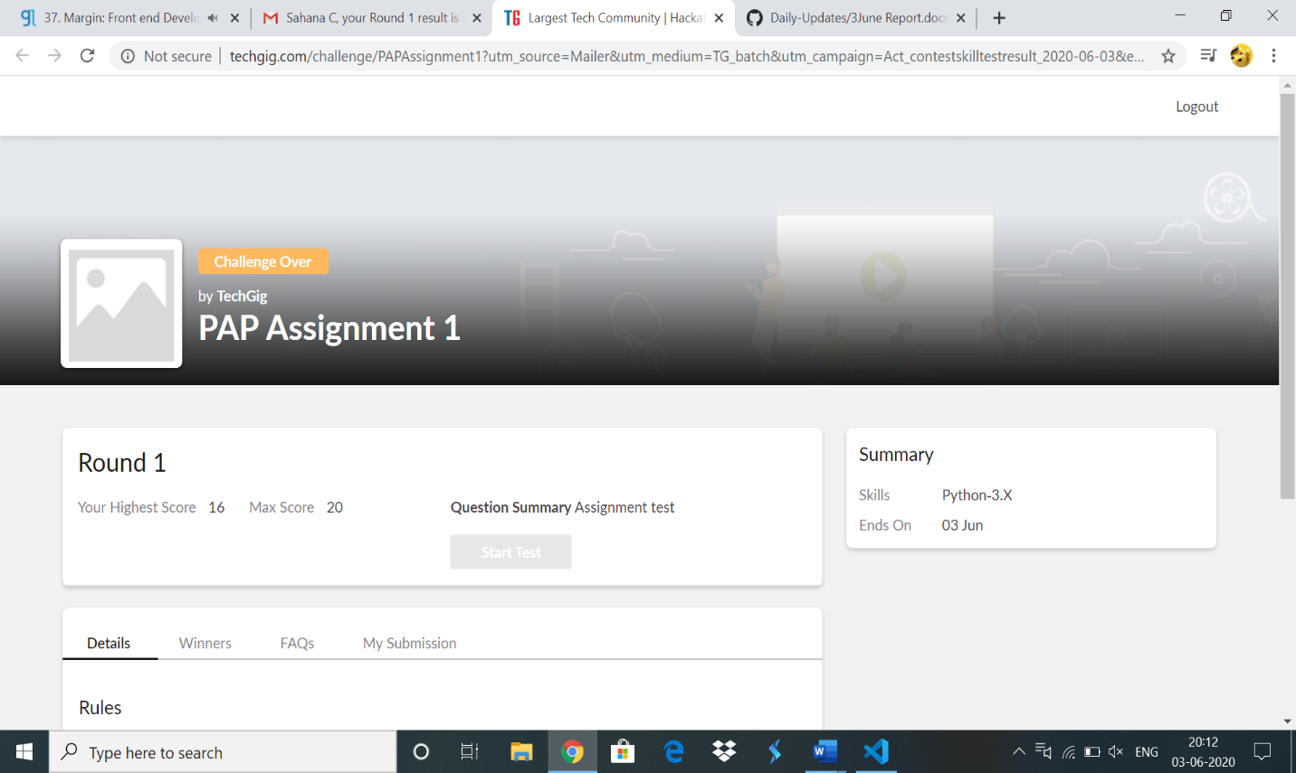

**Online Certification Details:**

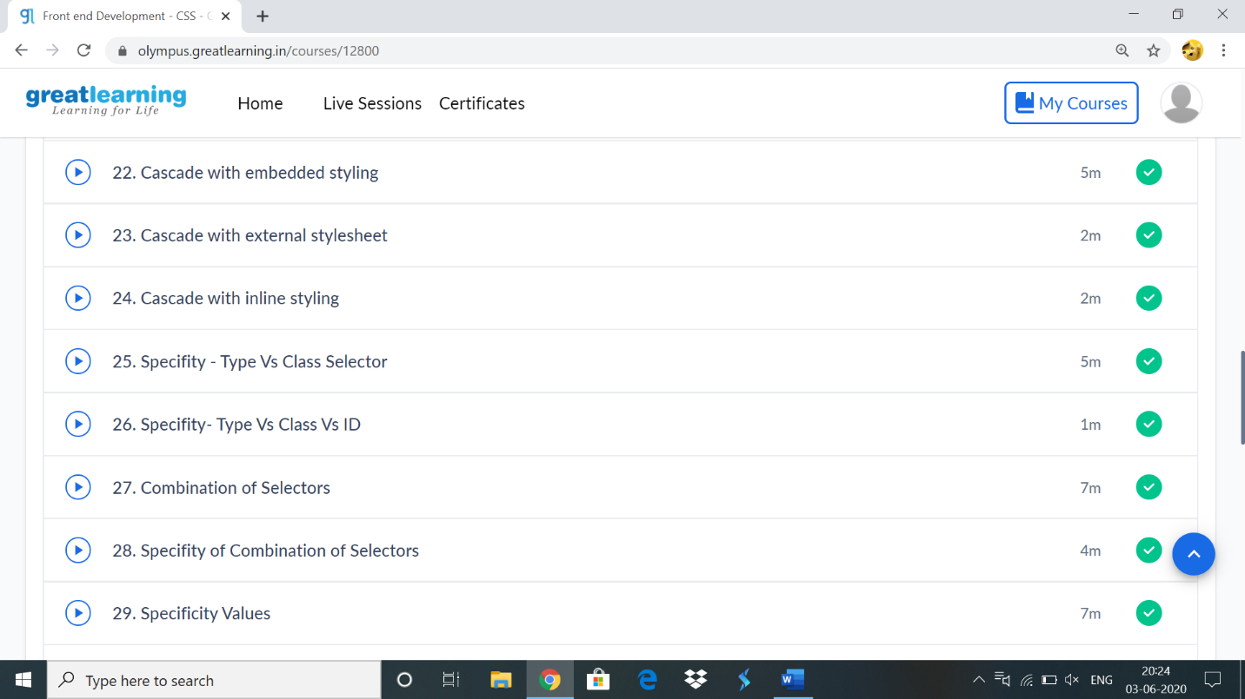

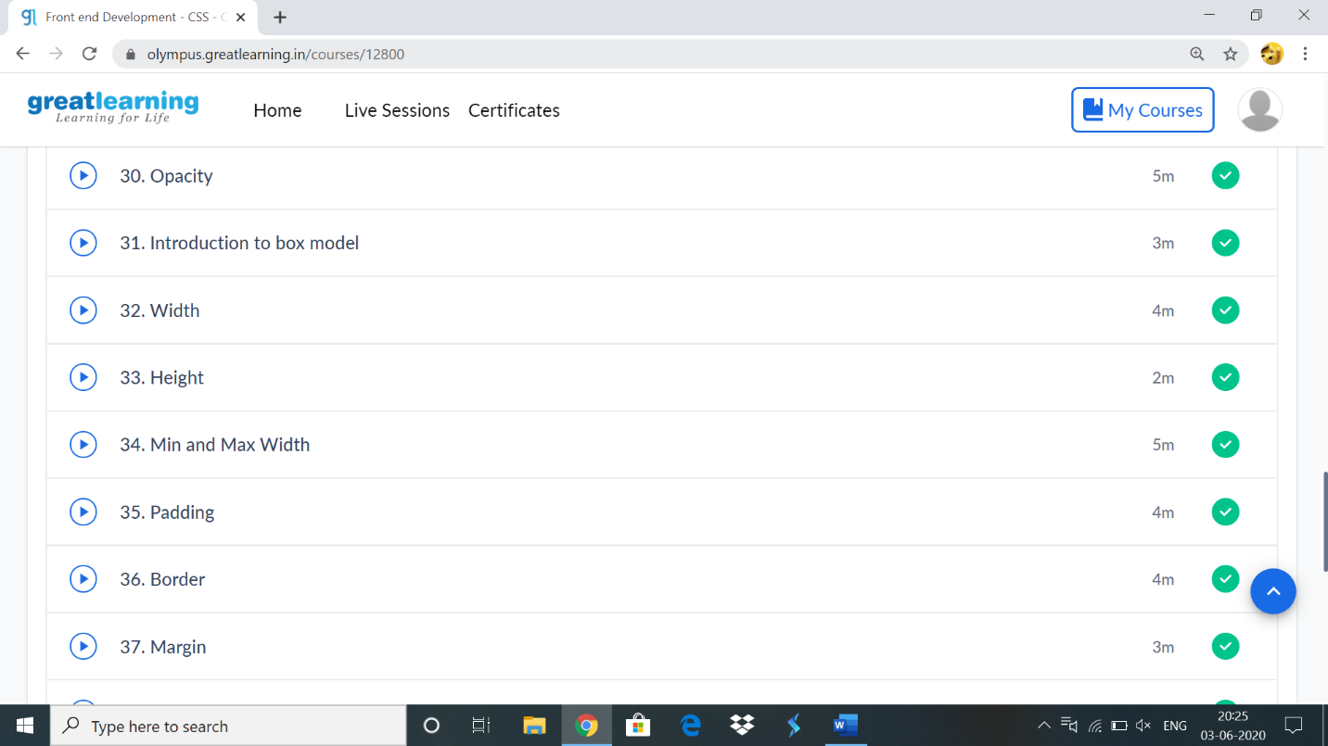

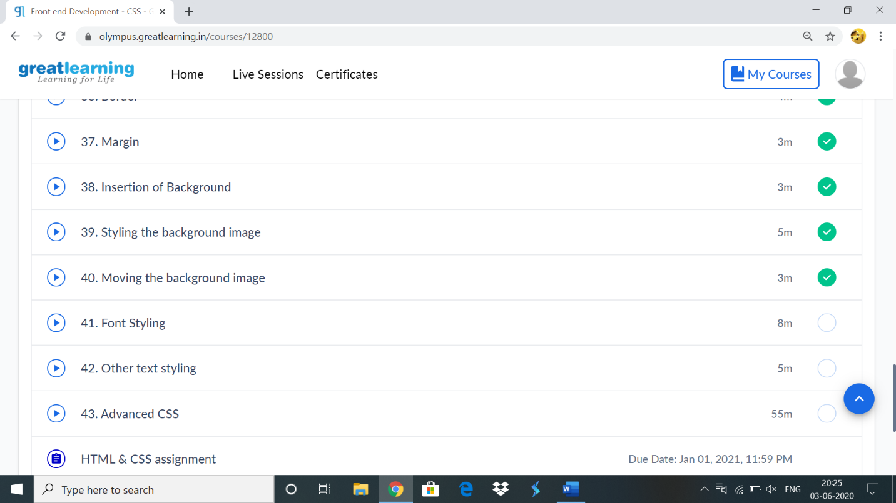

**Online coding:**

**1)**

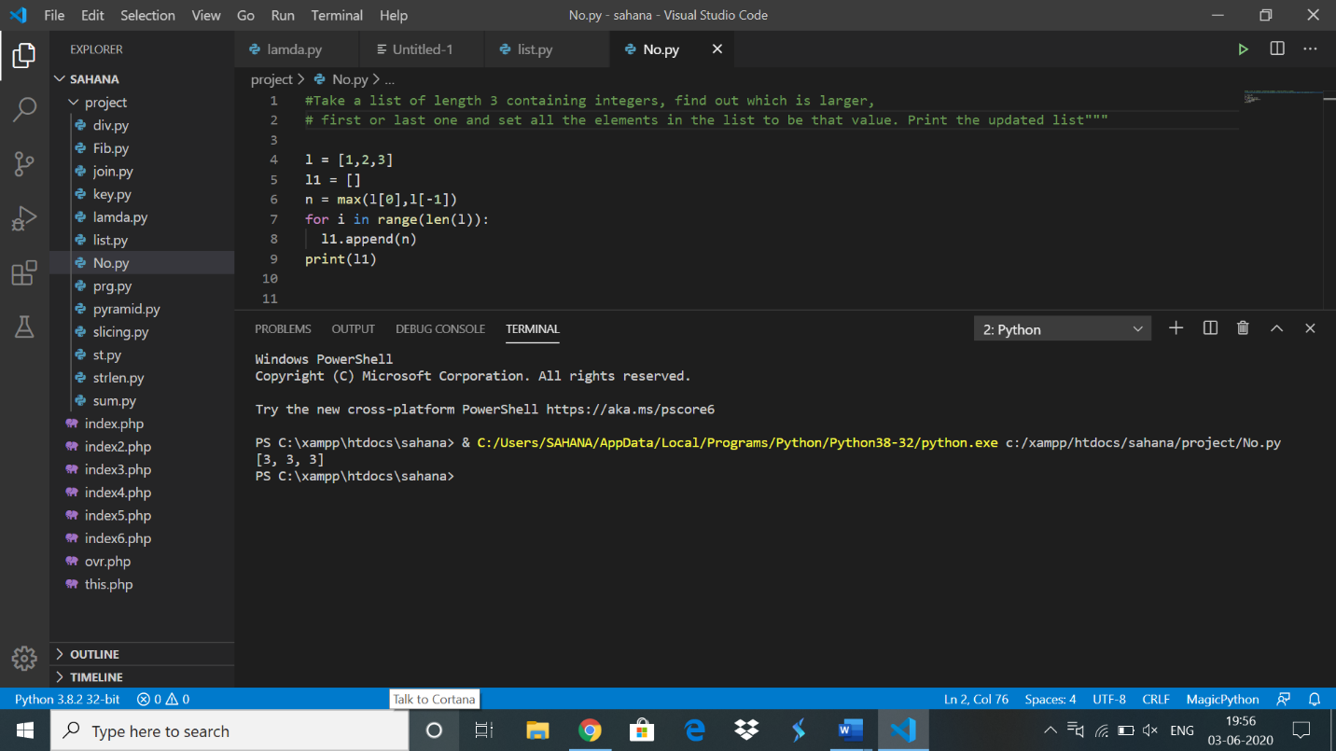

2)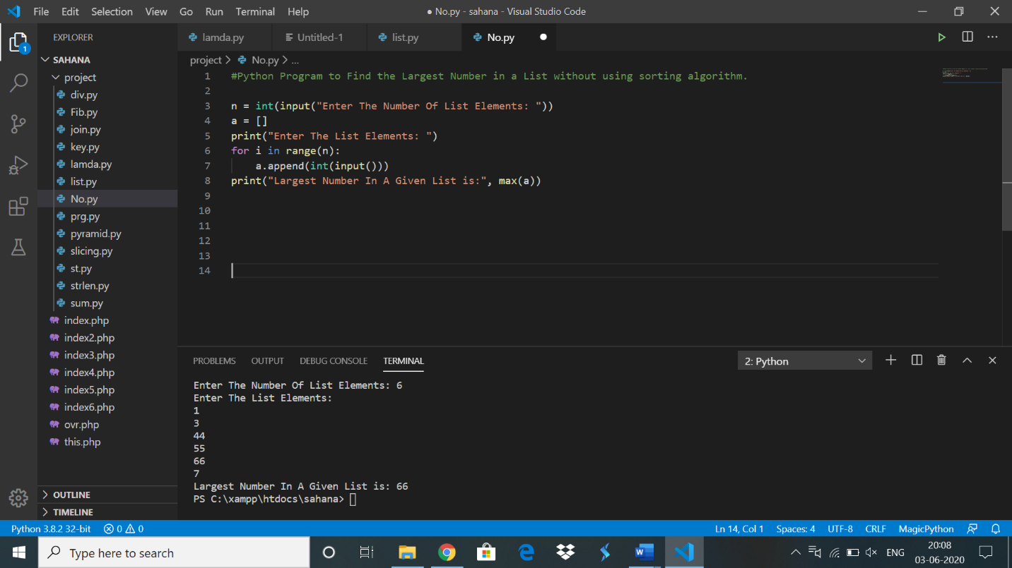

3)

