**DAILY ONLINE ACTIVITIES SUMMARY**

|  |  |  |  |  |  |  |  |
| --- | --- | --- | --- | --- | --- | --- | --- |
| **Date:** | **06-06-20** | | | | **Name:** | **Sahana c** | |
| **Sem & Sec** | **VI B** | | | | **USN:** | **4AL17CS116** | |
| **Online Test Summary** | | | | | | | |
| **Subject** | | **PAP IA** | | | | | |
| **Max. Marks** | | **30** | | **Score** | | **23** | |
| **Certification Course Summary** | | | | | | | |
| **Course** | Programming Essentials in Python | | | | | | |
| **Coding Challenges** 1)Write a program in C to rotate an array by N positions 2)Python programs to take marks of 5 students and and display the grades  3)python program to map two lists into dictionary  . | | | | | | | |
| **Certificate Provider** | | | **Cisco -python institution** | **Duration** | | | **No limit** |
| **Status:on going** | | | | | | | |
| **Uploaded the report in Github** | | | | **Yes** | | | |
| **If yes Repository name** | | | | **https://github.com/sahanasanu/Daliy-status** | | | |
| **Uploaded the report in slack** | | | | **Yes** | | | |

**IA MARKS DETAILS:**

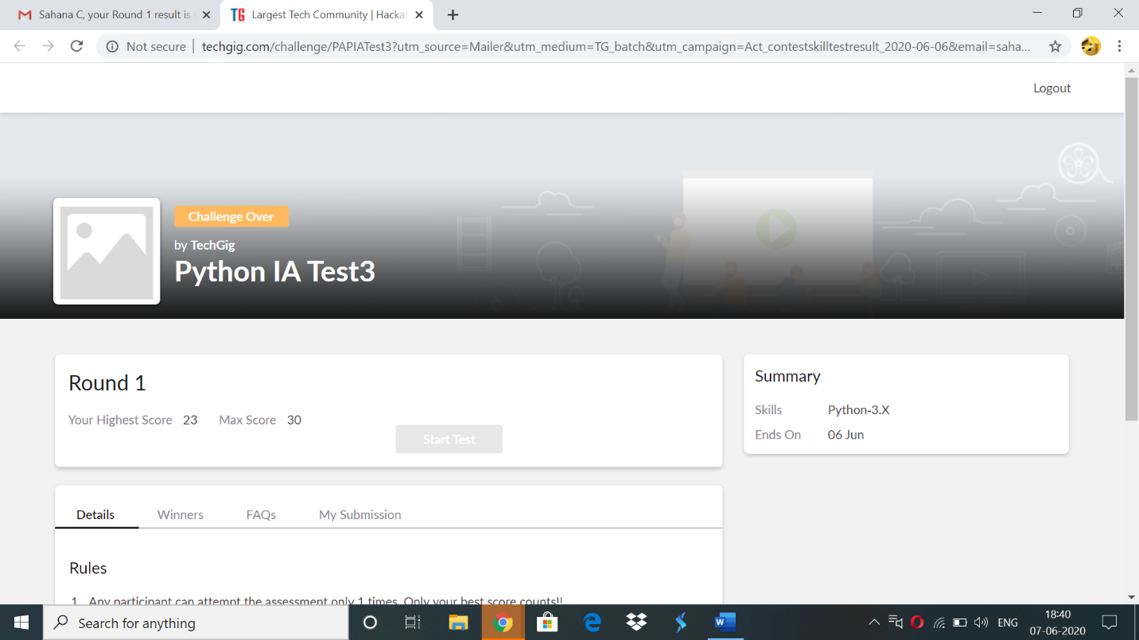

**Online Certification Details:**

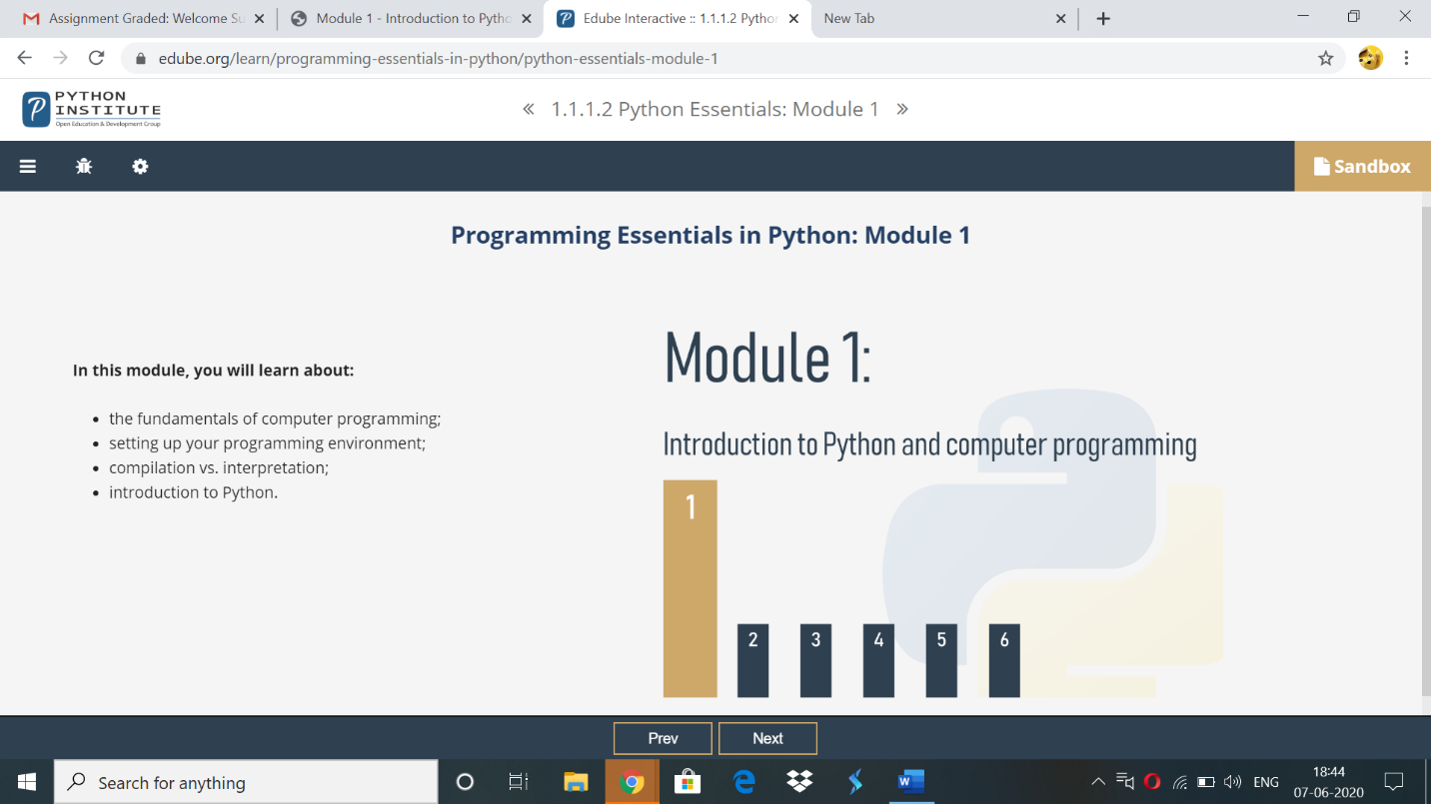

Topics covered:

1)How does computer program work?

2)Natural languages vs programming lanuages

3)what makes a languages?

4)compilation vs.interpretation

5)what does the interpreter acutally do?

6)compilation vs interpretation advantages and disadvantages

**Online coding:**

**1)** Write a program in C to rotate an array by N positions

#include <stdio.h>

void shiftArrayOnePosition(int *array, int size) {

int i, temp;

/*Save first element in a temporary variable and

shift remaining elements by one index left */

temp = array[0];

for(i = 0; i < size-1; i++) {

array[i] = array[i+1];

}

/* Now put the firt element of

original array to last index */

array[i] = temp;

}

/*

This function shifts array by N positions

*/

void rotateArray(int *array, int size, int N){

int i;

for(i = 0; i < N; i++){

shiftArrayOnePosition(array, size);

}

return;

}

int main(){

int i,n,N;

printf("enter the size of the array: ");

scanf("%d",&n);

int array[n];

printf("enter the array elements: ");

for(i=0;i<n;i++)

scanf("%d",&array[i]);

printf("Enter the Position N from where you want to rotate:");

scanf("%d",&N);

printf("Original Array\n");

for(i = 0; i<n; i++){

printf("%d ", array[i]);

}

rotateArray(array, n,N);

printf("\nRotated Array\n");

for(i = 0; i<n; i++){

printf("%d ", array[i]);

}

return 0;

}

OUTPUT

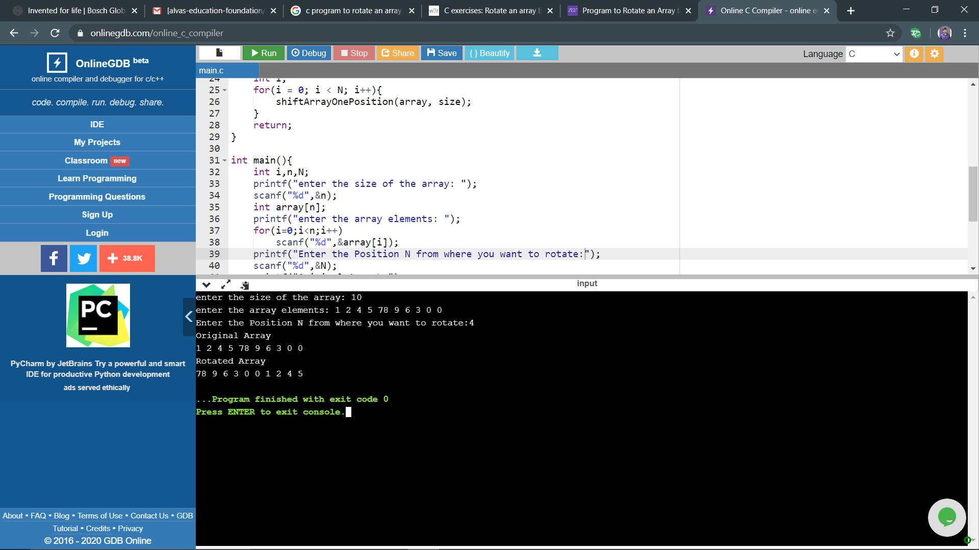

2)

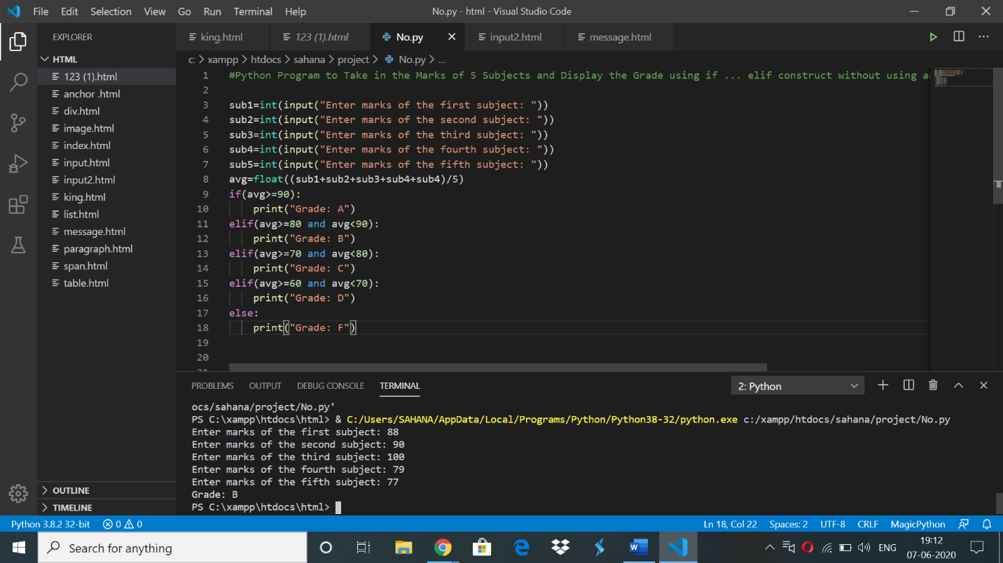

3)

