**DAILY ONLINE ACTIVITIES SUMMARY**

|  |  |  |  |  |  |  |  |  |
| --- | --- | --- | --- | --- | --- | --- | --- | --- |
| **Date:** | | **06-07-2020** | | | | **Name:** | **SAHANA C** | |
| **Sem & Sec** | | **6th & B** | | | | **USN:** | **4al17cs116** | |
| **Online Test Summary** | | | | | | | | |
| **Subject** | | | **IA MODULE1 CNSC** | | | | | |
| **Max. Marks** | | | **30** | **Score** | | | **-** | |
| **Certification Course Details** | | | | | | | | |
| **Topic** | **Webinar on Salesforce - Job ready program** | | | | | | | |
| **Faculty** | [**https://www.salesforce.com/in/**](https://www.salesforce.com/in/) | | | | **Duration** | | | **2 hours** |
| **Coding Challenges** | | | | | | | | |
| **Problem Statement**: 1 programs | | | | | | | | |
| **Status: Solved** | | | | | | | | |
| **Uploaded the report in Github** | | | | | **yes** | | | |
| **If yes Repository name** | | | | | [**https://github.com/sahanasanu/Daliy-status/tree/master/report**](https://github.com/sahanasanu/Daliy-status/tree/master/report) | | | |
| **Uploaded the report in slack** | | | | | **yes** | | | |

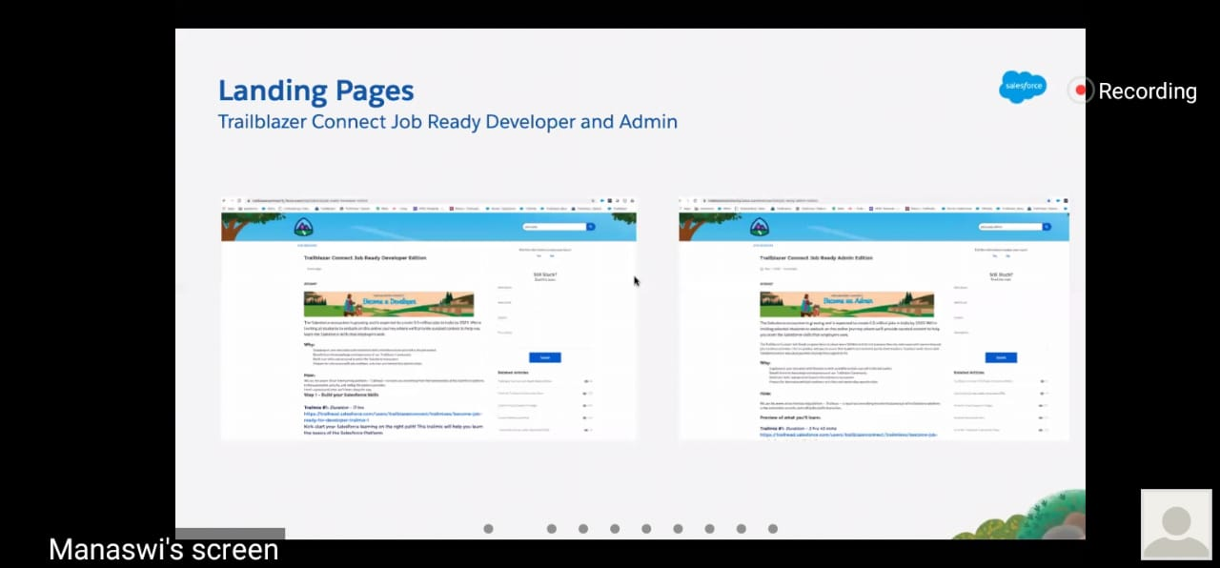

**Snapshot of the test result**

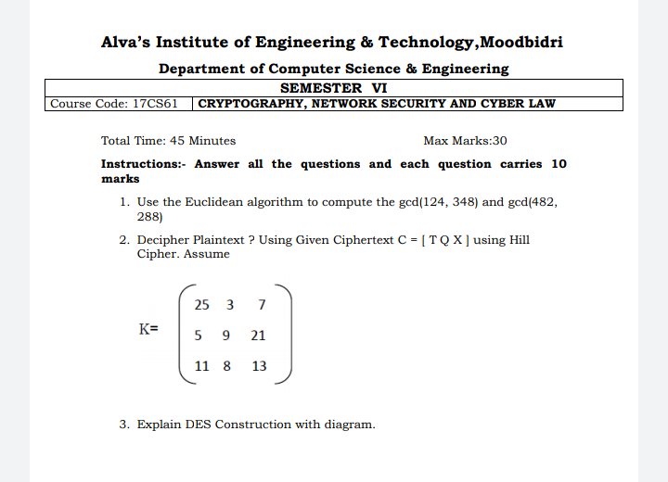

**ONLINE CODING**

**Python Program to Append, Delete and Display Elements of a List Using Classes**

class ele():

def __init__(self):

self.n=[]

def add(self,a):

return self.n.append(a)

def remove(self,b):

self.n.remove(b)

def dis(self):

return (self.n)

obj=ele()

choice=1

while choice!=0:

print("0. Exit")

print("1. Add")

print("2. Delete")

print("3. Display")

choice=int(input("Enter choice: "))

if choice==1:

n=int(input("Enter number to append: "))

obj.add(n)

print("List: ",obj.dis())

elif choice==2:

n=int(input("Enter number to remove: "))

obj.remove(n)

print("List: ",obj.dis())

elif choice==3:

print("List: ",obj.dis())

elif choice==0:

print("Exiting!")

else:

print("Invalid choice!!")

print()

