**DAILY ONLINE ACTIVITIES SUMMARY**

|  |  |  |  |  |  |  |  |
| --- | --- | --- | --- | --- | --- | --- | --- |
| **Date:** | **07-06-20** | | | | **Name:** | **SAHANA C** | |
| **Sem & Sec** | **VI B** | | | | **USN:** | **4AL17CS116** | |
| **Online Test Summary** | | | | | | | |
| **Subject** | | **SSCD IA** | | | | | |
| **Max. Marks** | | **30** | | **Score** | | **23** | |
| **Certification Course Summary** | | | | | | | |
| **Course** | Programming Essentials in Python | | | | | | |
| **Coding Challenges**   1. write a java Program to print smallest and biggest possible palindrome word in a given string 2. Print a list of first and last 5 elements where the values are square of numbers between 1 and 30 (both included) | | | | | | | |
| **Certificate Provider** | | | **Cisco -python institution** | **Duration** | | | **No limit** |
| **Status:on going** | | | | | | | |
| **Uploaded the report in Github** | | | | **Yes** | | | |
| **If yes Repository name** | | | | **https://github.com/sahanasanu/Daliy-status** | | | |
| **Uploaded the report in slack** | | | | **Yes** | | | |

**IA MARKS DETAILS:**

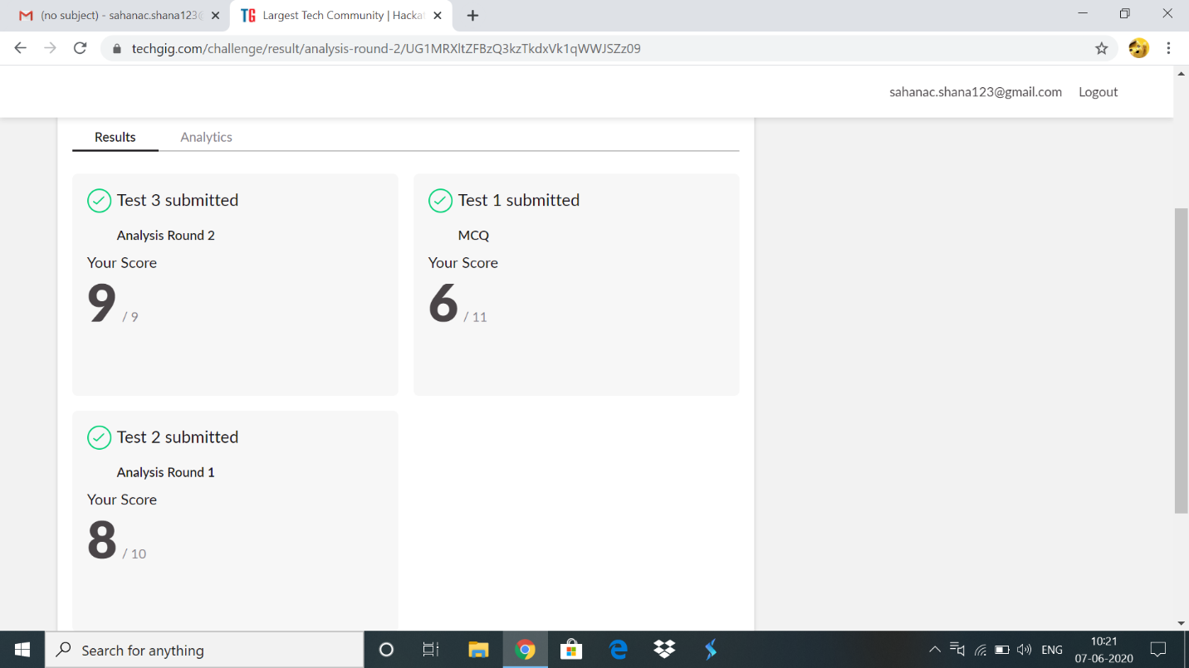

**Online Certification Details:**

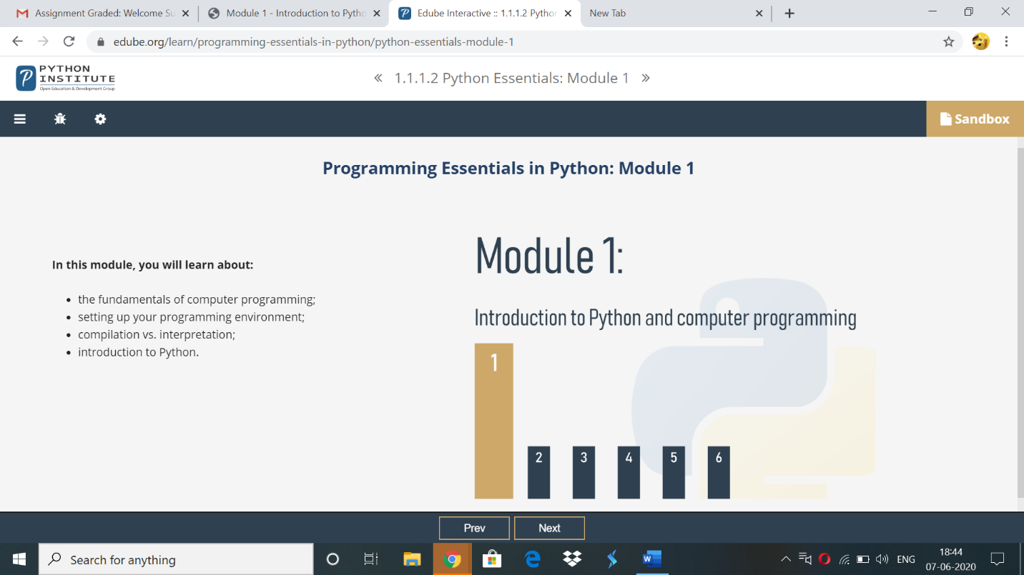

Topics covered:

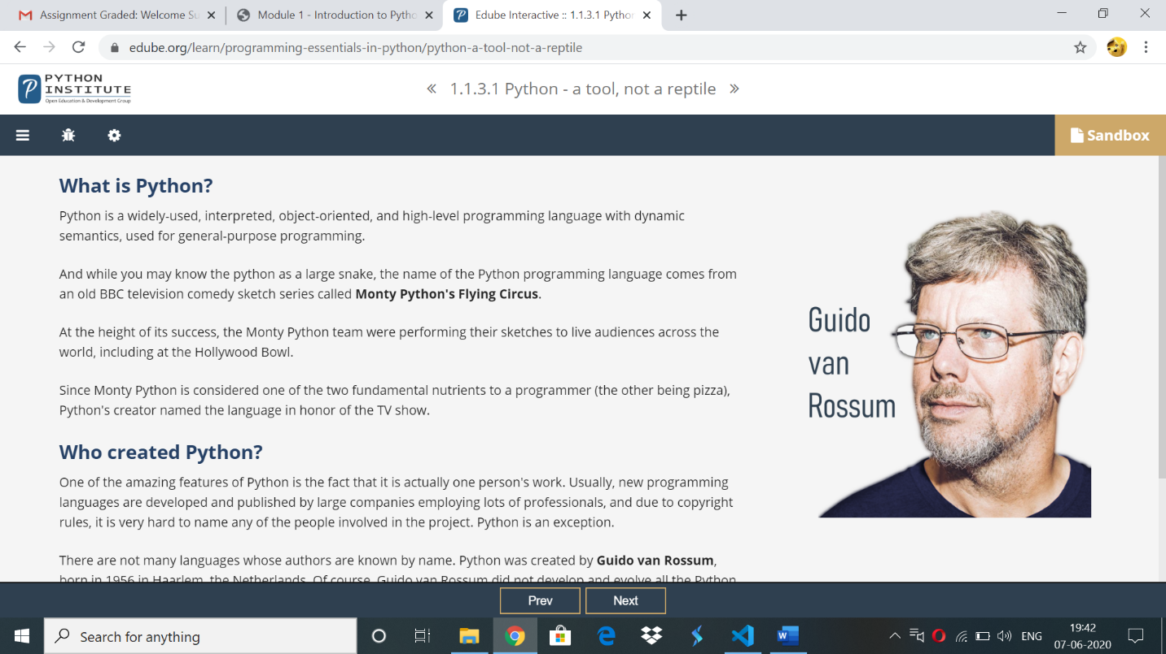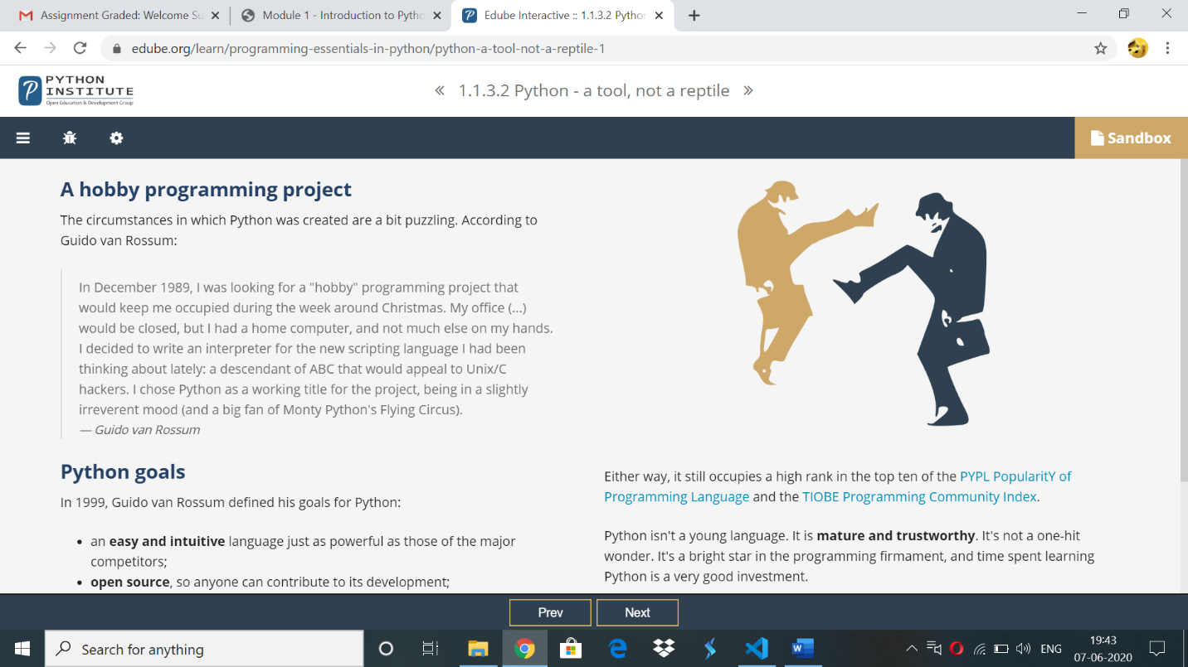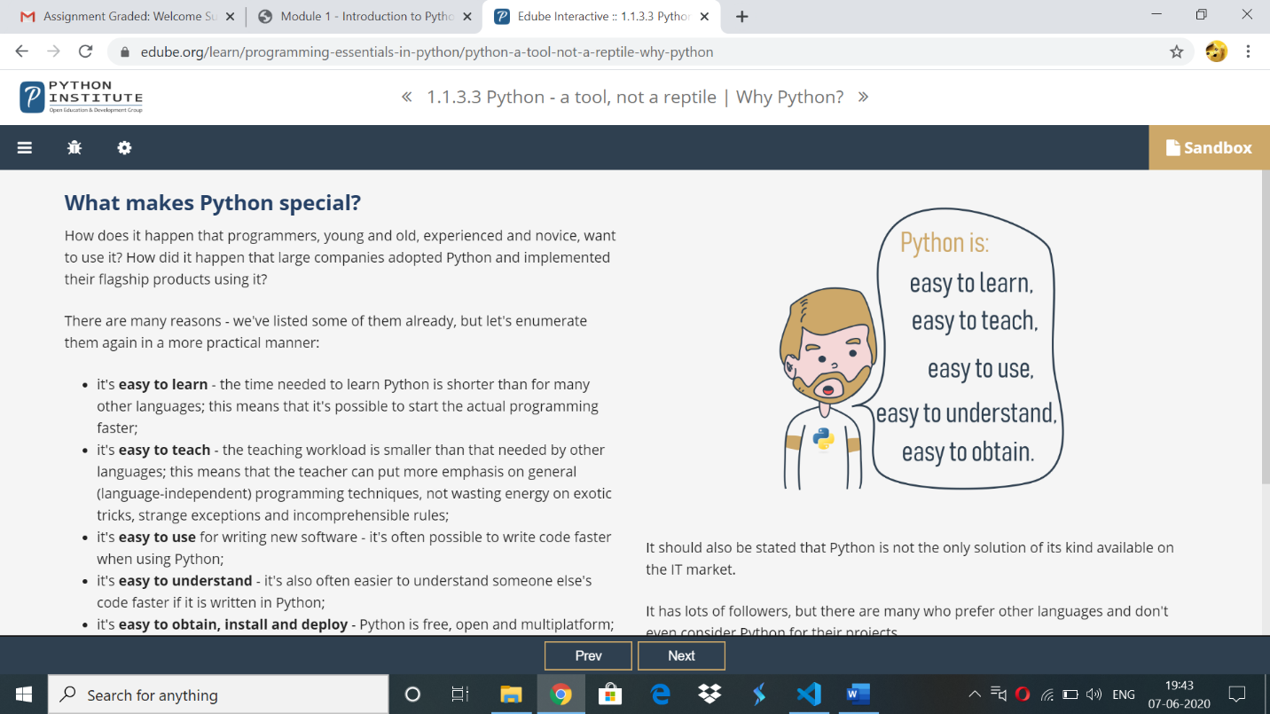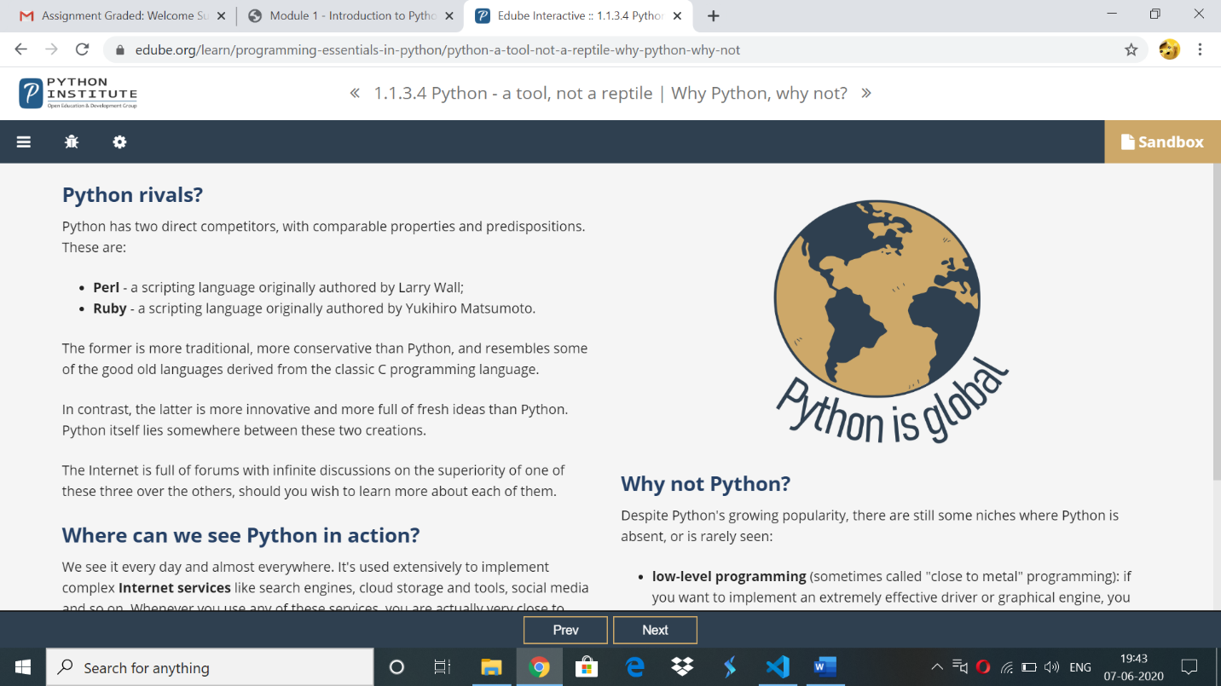

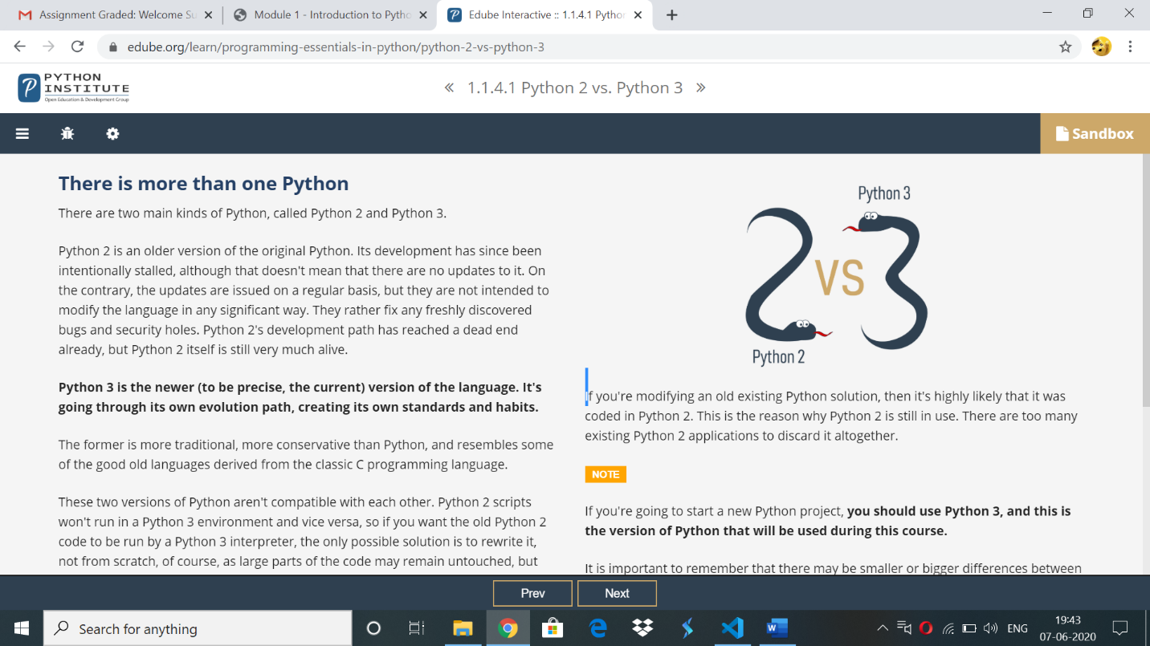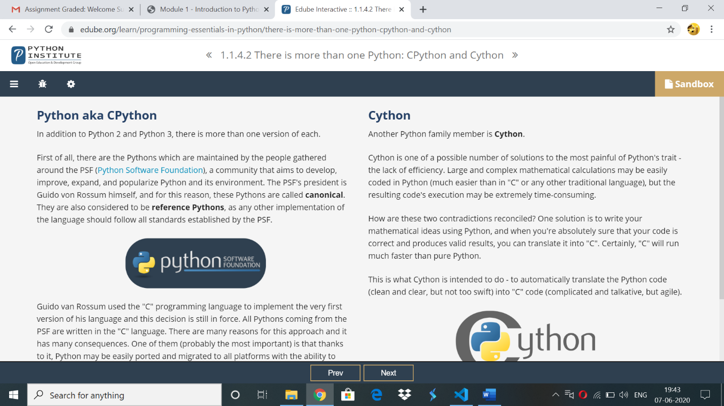

**Online coding:**

**1)** write a java Program to print smallest and biggest possible palindrome word in a given string

import java.util.*;

public class SmallestBiggestPalindrome

{

//isPalindrome() checks whether a string is palindrome or not

public static boolean isPalindrome(String a){

boolean flag = true;

//Iterate the string forward and backward and compare one character at a time

//till middle of the string is reached

for(int i = 0; i < a.length()/2; i++){

if(a.charAt(i) != a.charAt(a.length()-i-1)){

flag = false;

break;

}

}

return flag;

}

public static void main(String[] args){

Scanner sc=new Scanner(System.in);

String string = sc.nextLine();

String word = "", smallPalin = "", bigPalin="";

String[] words = new String[100];

int temp = 0, count = 0;

//Converts the given string into lowercase

string = string.toLowerCase();

//Add extra space after string to get the last word in the given string

string = string + " ";

for(int i = 0; i < string.length(); i++){

//Split the string into words

if(string.charAt(i) != ' '){

word = word + string.charAt(i);

}

else{

//Add word to array words

words[temp] = word;

//Increment temp

temp++;

//Make word an empty string

word = "";

}

}

//Determine the smallest and biggest palindromes in a given string

for(int i = 0; i< temp; i++){

if(isPalindrome(words[i])){

count++;

//When first palindromic word is found

if(count == 1)

//Initialize smallPalin and bigPalin with first palindromic word

smallPalin = bigPalin = words[i];

//Compare smallPalin and bigPalin with each palindromic words

else{

//If length of smallPalin is greater than next palindromic word

//Store that word in smallPalin

if(smallPalin.length() > words[i].length())

smallPalin = words[i];

//If length of bigPalin is less than next palindromic word

//Store that word in bigPalin

if(bigPalin.length() < words[i].length())

bigPalin = words[i];

}

}

}

if(count == 0)

System.out.println("No palindrome is present in the given string");

else{

System.out.println("Smallest palindromic word: " + smallPalin);

System.out.println("Biggest palindromic word: " + bigPalin);

}

}

}

**OUTPUT:**

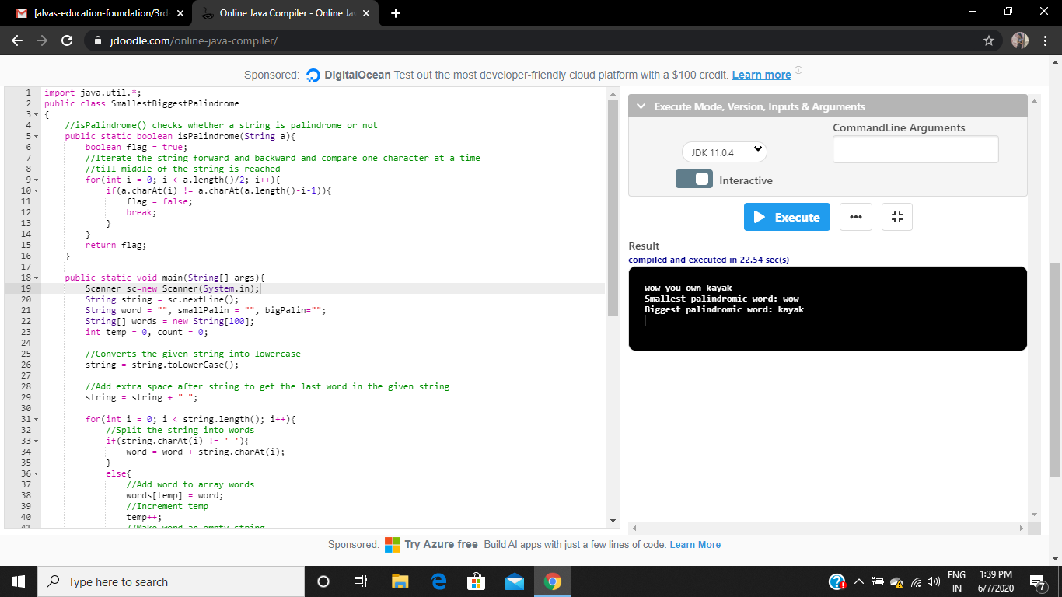

**2)**