**DAILY ONLINE ACTIVITIES SUMMARY**

|  |  |  |  |  |  |  |  |
| --- | --- | --- | --- | --- | --- | --- | --- |
| **Date:** | **09-06-20** | | | | **Name:** | **SAHANA C** | |
| **Sem & Sec** | **VI B** | | | | **USN:** | **4AL17CS116** | |
| **Online Test Summary** | | | | | | | |
| **Subject** | | **CGV IA** | | | | | |
| **Max. Marks** | | **30** | | **Score** | | **26** | |
| **Certification Course Summary** | | | | | | | |
| **Course** | Programming Essentials in Python | | | | | | |
| **Coding Challenges**  1)C Program to rotate the matrix by K times.  2)Python to implement Perfect Sum Problem.  3)java Program to print smallest and biggest possible palindrome word in a given string  4)Python Program to count even and odd numbers  5)Java Program to remove all white spaces from a string without using replace() | | | | | | | |
| **Certificate Provider** | | | **Cisco -python institution** | **Duration** | | | **No limit** |
| **Status:on going** | | | | | | | |
| **Uploaded the report in Github** | | | | **Yes** | | | |
| **If yes Repository name** | | | | **https://github.com/sahanasanu/Daliy-status** | | | |
| **Uploaded the report in slack** | | | | **Yes** | | | |

**IA MARKS DETAILS:**

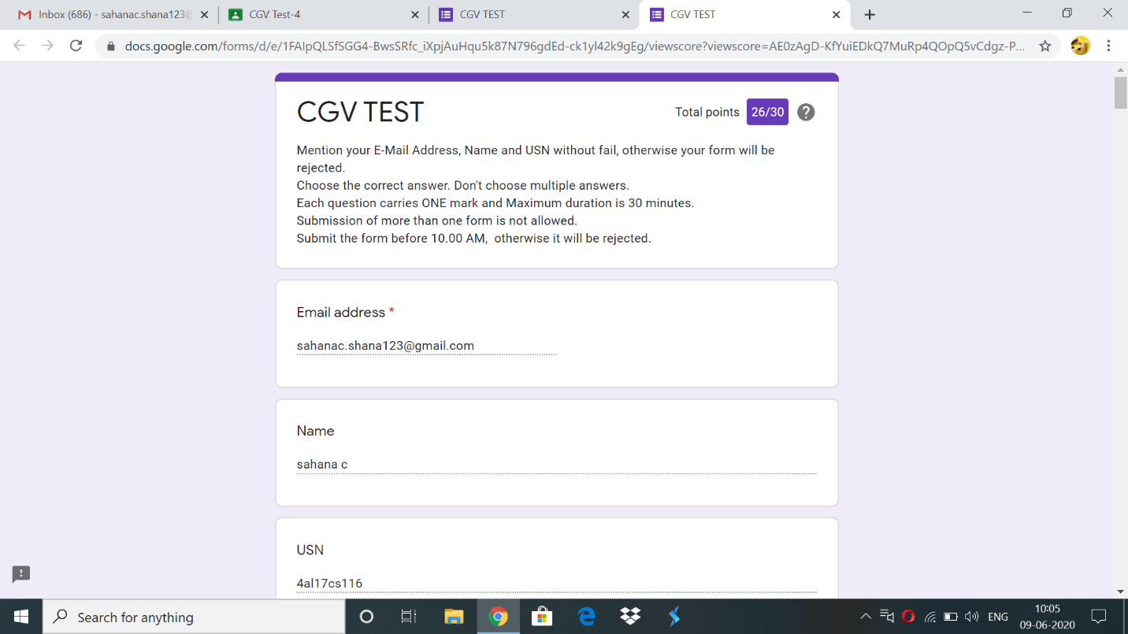

**Online Certification Details:**

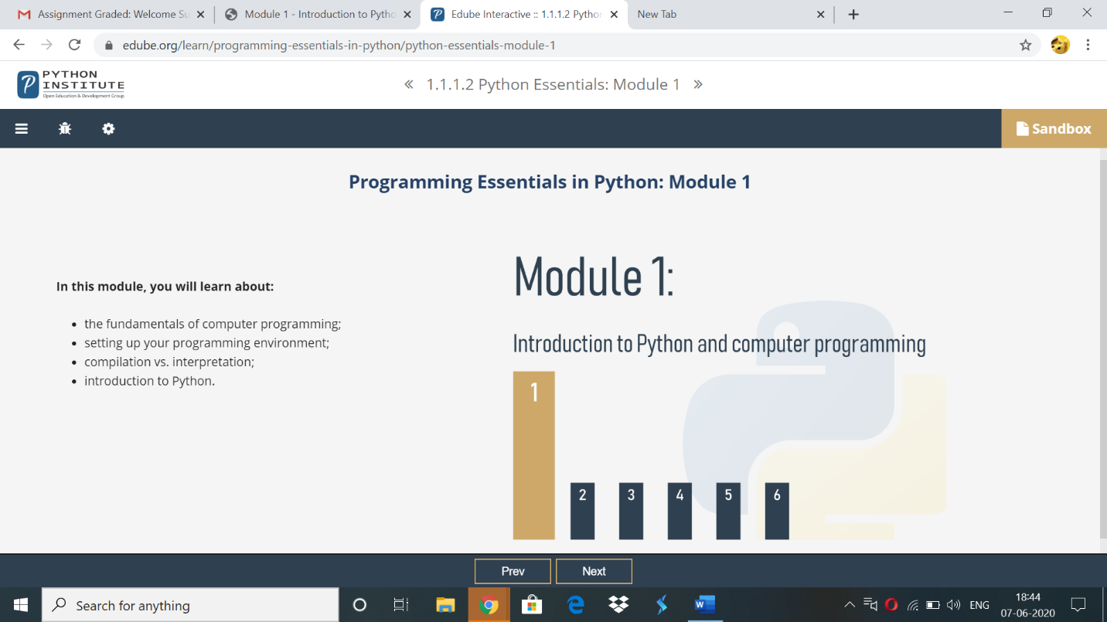

Topics covered:

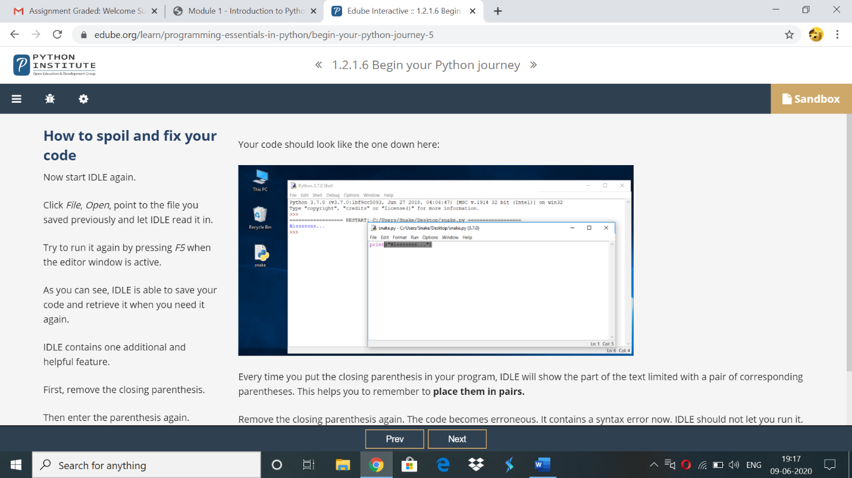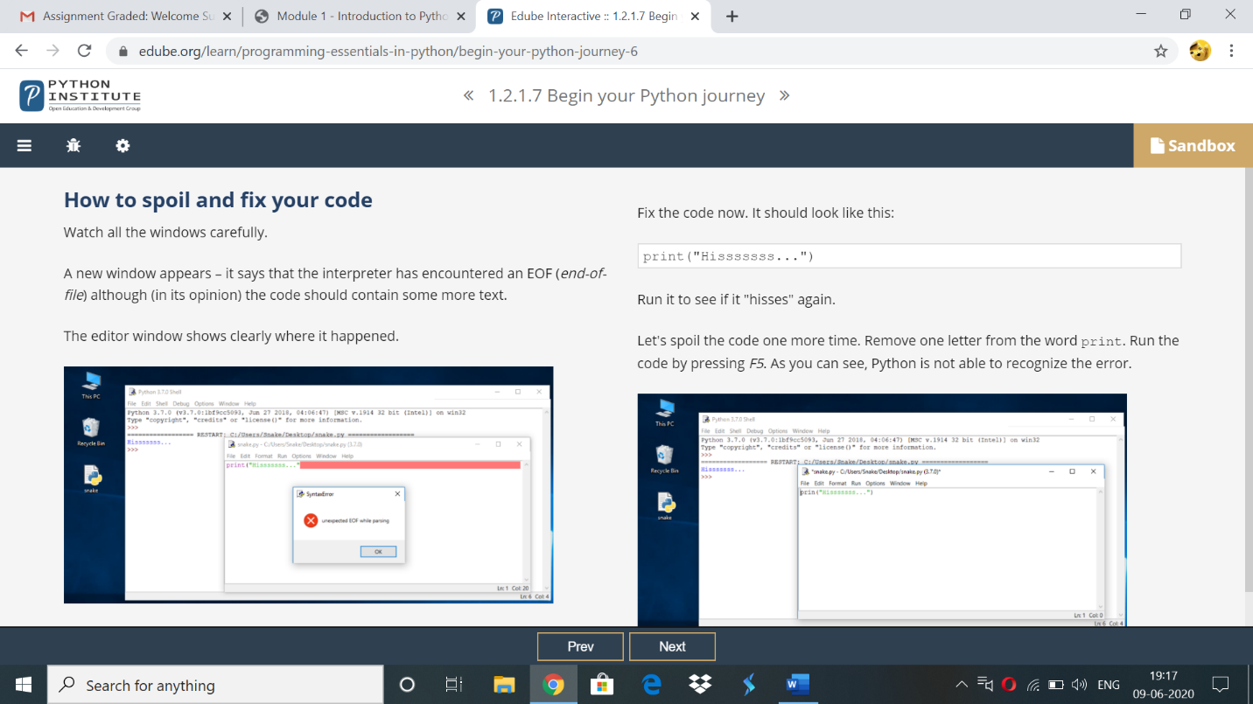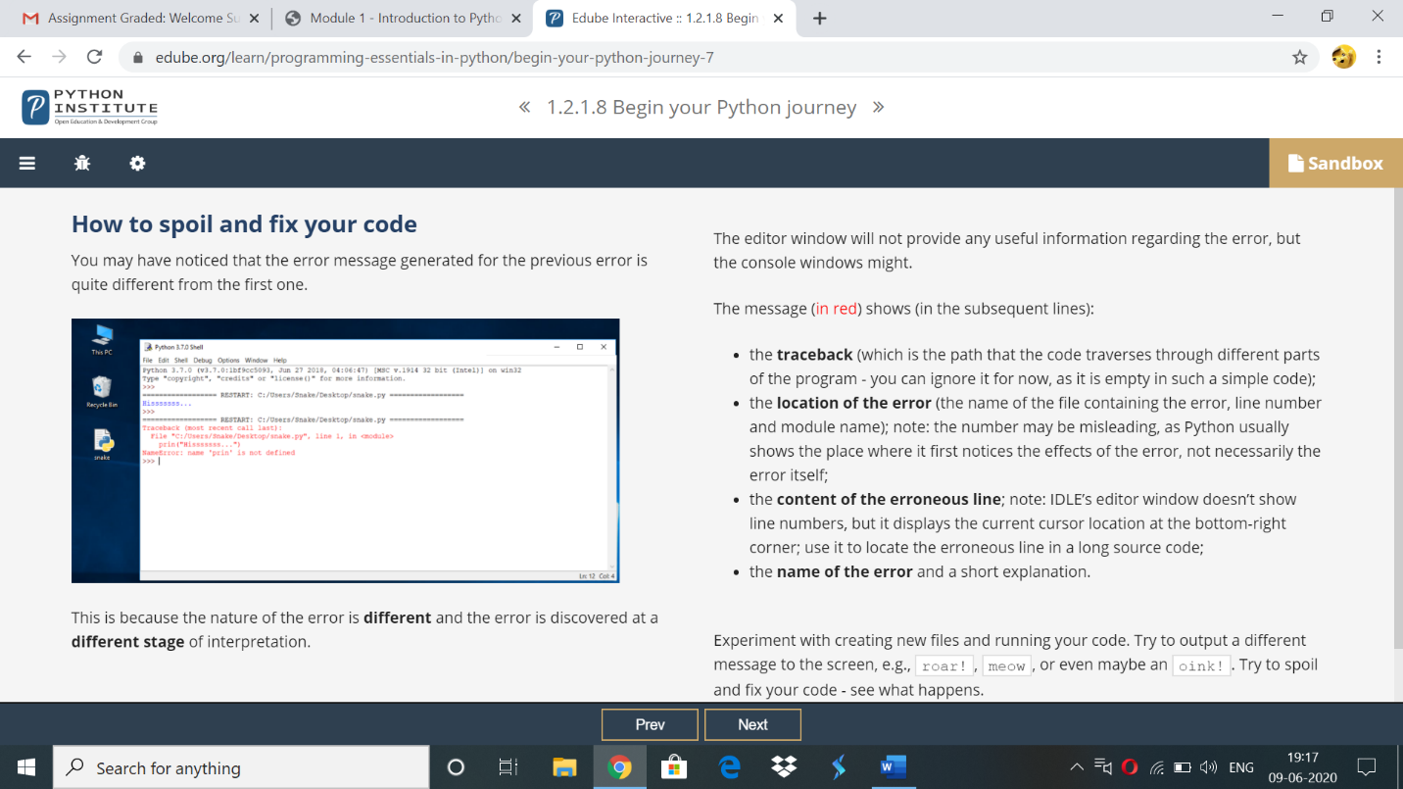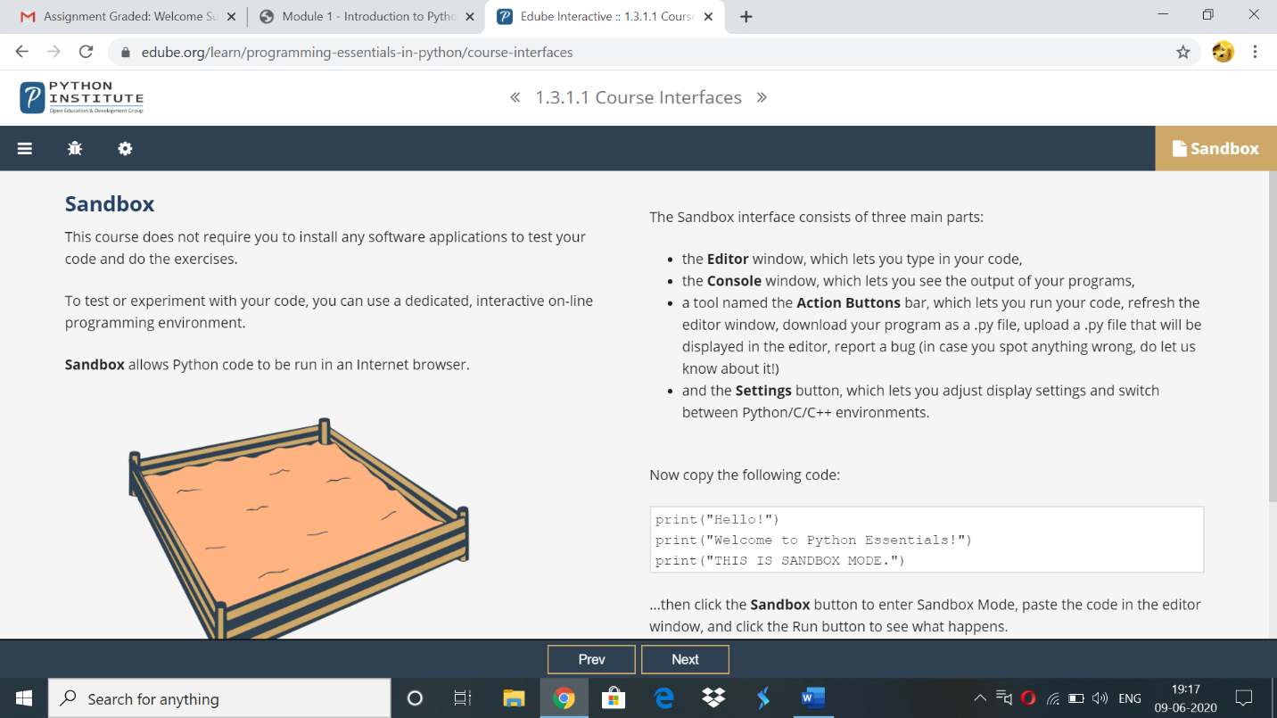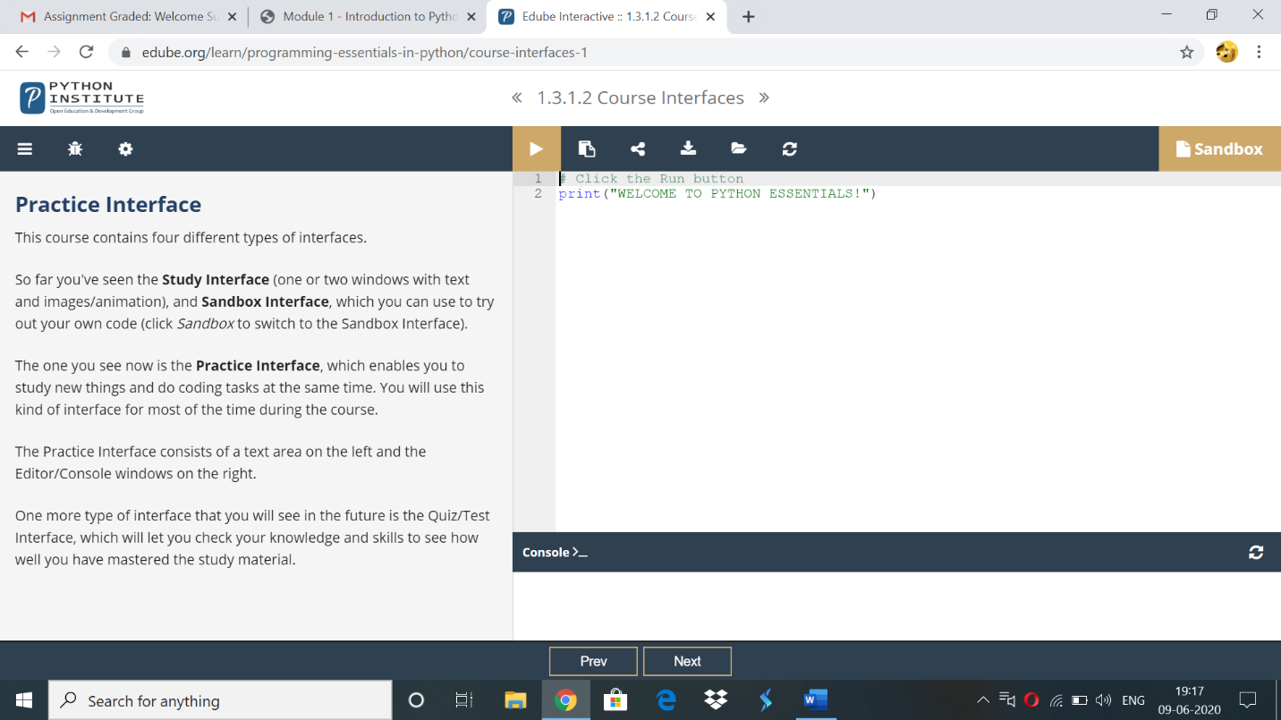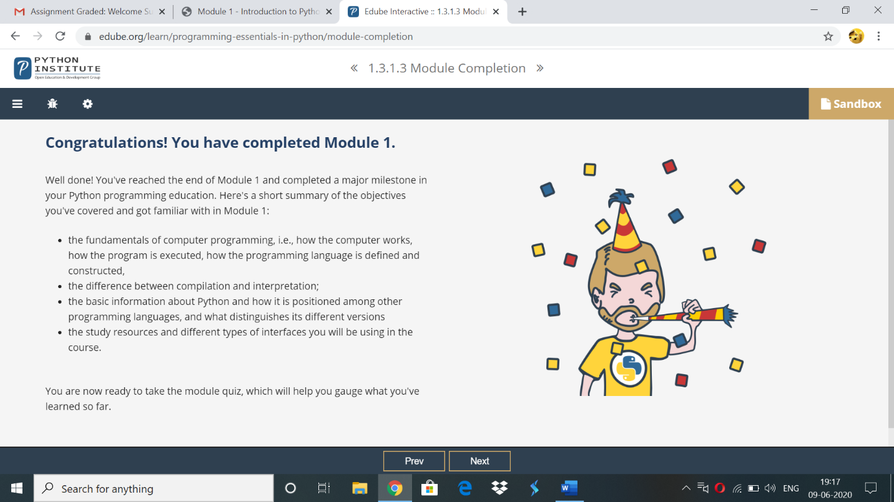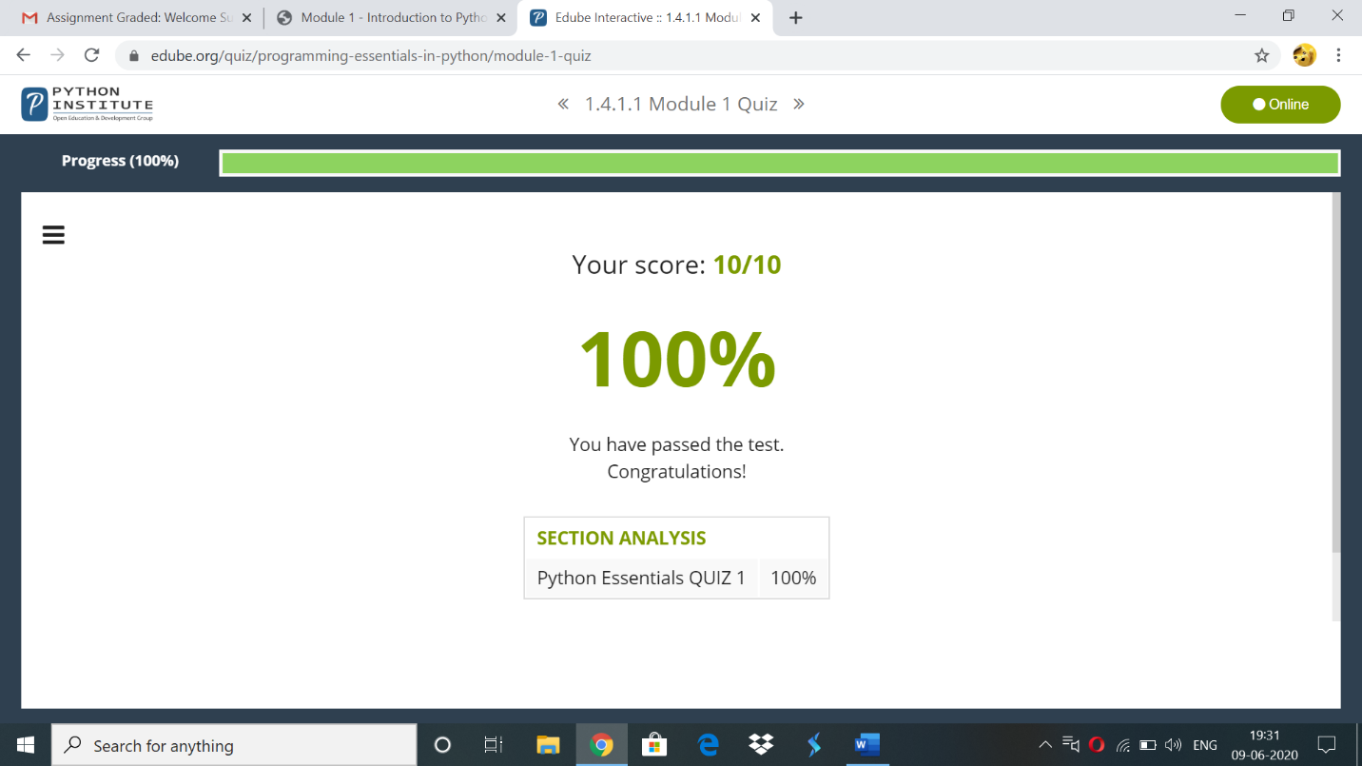

**Online coding:**

**1)** C Program to rotate the matrix by K times.

#include<stdio.h>

int main() {

int matrix[100][100],M,N,k;

printf("Enter size of matrix\n");

scanf("%d%d",&M,&N);

printf("Enter the matrix elements\n");

for( int i = 0 ; i < M ; i++)

{

for(int j = 0 ; j < N ; j++)

{

scanf("%d",&matrix[i][j]); // Input the matrix elements

}

}

printf("Enter k value\n");

scanf("%d",&k);

int temp[M];

k = k % M;

for (int i = 0; i < N; i++) {

for (int t = 0; t < M - k; t++)

temp[t] = matrix[i][t];

for (int j = M - k; j < M; j++)

matrix[i][j - M + k] = matrix[i][j];

for (int j = k; j < M; j++)

matrix[i][j] = temp[j - k];

printf("The rotated matrix is\n");

for (int i=0; i < N; i++)

{

for (int j = 0; j < M; j++)

{

printf("%d ",matrix[i][j]);

}

printf("\n");

}

}

return 0;

}

**OUTPUT:-**

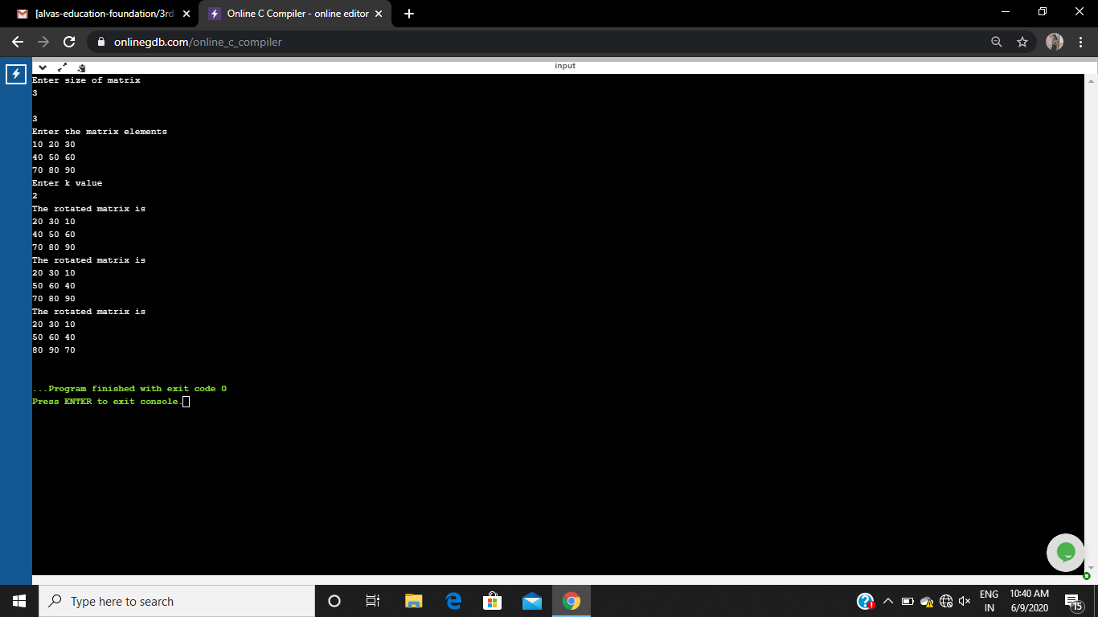

2) **Write a Python to implement Perfect Sum Problem.**

def printAllSubsetsRec(arr, n, v, sum):

if (sum == 0):

for value in v:

print(value, end=" ")

print()

return

if (n == 0):

return

printAllSubsetsRec(arr, n - 1, v, sum)

v1 = [] + v

v1.append(arr[n - 1])

printAllSubsetsRec(arr, n - 1, v1, sum - arr[n - 1])

def printAllSubsets(arr, n, sum):

v = []

printAllSubsetsRec(arr, n, v, sum)

n = int(input("Enter Number Of Elements: "))

a = []

print("Enter The Elements Into List:")

for i in range(n):

a.append(int(input()))

sum = int(input("Enter The K value: "))

print("Subsets with sum", sum, "are:")

print(printAllSubsets(a, n, sum))

**Output:**

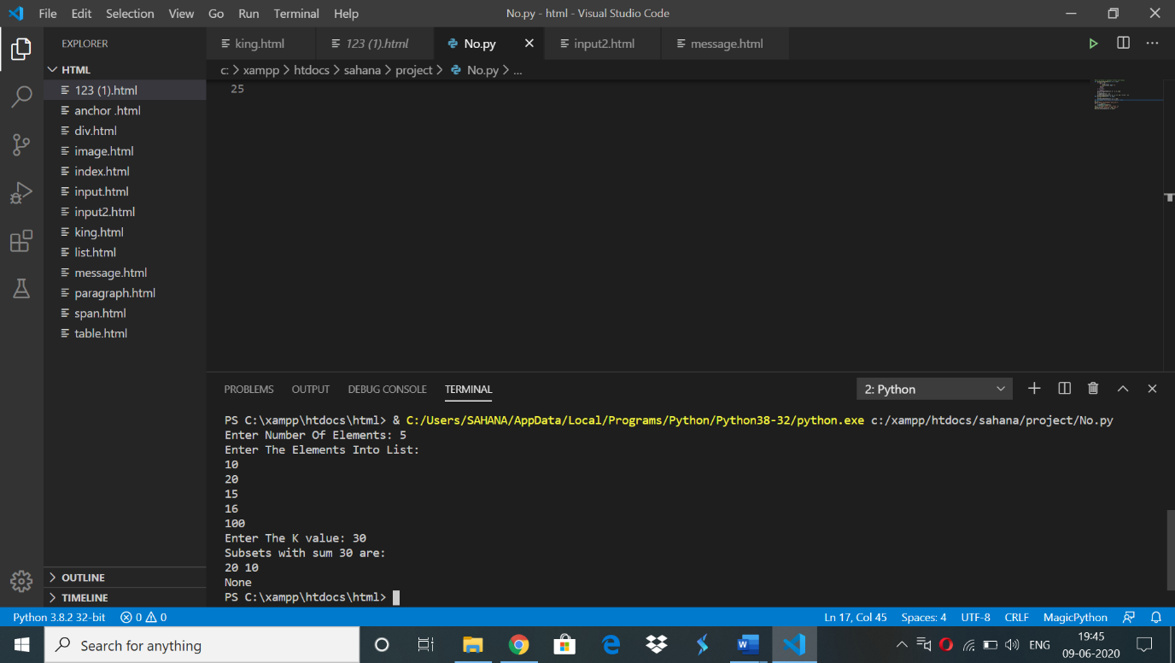

3) write a java Program to print smallest and biggest possible palindrome word in a given string

import java.util.*;

public class SmallestBiggestPalindrome

{

//isPalindrome() checks whether a string is palindrome or not

public static boolean isPalindrome(String a){

boolean flag = true;

//Iterate the string forward and backward and compare one character at a time

//till middle of the string is reached

for(int i = 0; i < a.length()/2; i++){

if(a.charAt(i) != a.charAt(a.length()-i-1)){

flag = false;

break;

}

}

return flag;

}

public static void main(String[] args){

Scanner sc=new Scanner(System.in);

String string = sc.nextLine();

String word = "", smallPalin = "", bigPalin="";

String[] words = new String[100];

int temp = 0, count = 0;

//Converts the given string into lowercase

string = string.toLowerCase();

//Add extra space after string to get the last word in the given string

string = string + " ";

for(int i = 0; i < string.length(); i++){

//Split the string into words

if(string.charAt(i) != ' '){

word = word + string.charAt(i);

}

else{

//Add word to array words

words[temp] = word;

//Increment temp

temp++;

//Make word an empty string

word = "";

}

}

//Determine the smallest and biggest palindromes in a given string

for(int i = 0; i< temp; i++){

if(isPalindrome(words[i])){

count++;

//When first palindromic word is found

if(count == 1)

//Initialize smallPalin and bigPalin with first palindromic word

smallPalin = bigPalin = words[i];

//Compare smallPalin and bigPalin with each palindromic words

else{

//If length of smallPalin is greater than next palindromic word

//Store that word in smallPalin

if(smallPalin.length() > words[i].length())

smallPalin = words[i];

//If length of bigPalin is less than next palindromic word

//Store that word in bigPalin

if(bigPalin.length() < words[i].length())

bigPalin = words[i];

}

}

}

if(count == 0)

System.out.println("No palindrome is present in the given string");

else{

System.out.println("Smallest palindromic word: " + smallPalin);

System.out.println("Biggest palindromic word: " + bigPalin);

}

}

}

**OUTPUT:**

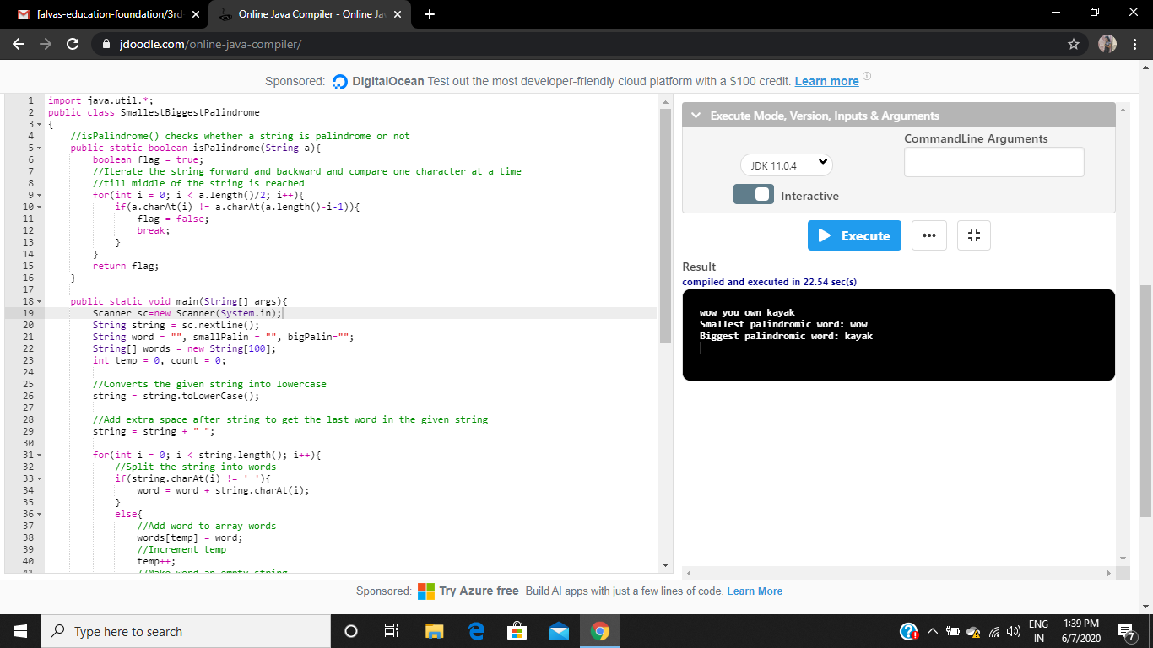

4) **Python Program to count even and odd numbers.**

n = int(input("Enter The Number Of Elements: "))

c = 0

print("Enter The Elements: ")

for i in range(n):

if int(input()) % 2 == 0:

c += 1

print("Number Of Even Numbers:", c, "\nNumber Of Odd Numbers:", n-c)

**Output:**

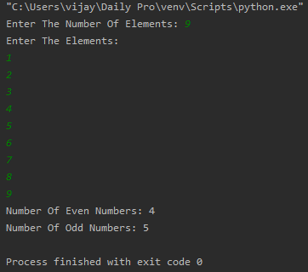

**5) Write a Java Program to remove all white spaces from a string without using replace().**

**package** pblm;

**import** java.util.*;

**public** **class** pro2{

**public** **static** **void** main(String[] args) {

Scanner s = **new** Scanner(System.***in***);

System.***out***.println("Enter The String:");

String str = s.nextLine();

**char**[] a = str.toCharArray();

String str1=" ";

**for**(**int** i=0;i<a.length;i++)

{

**if**(a[i]!=' ')

str1=str1+a[i];

}

System.***out***.println("Input String Without Spaces : "+str1);

}

}

**Output:**

