**DAILY ONLINE ACTIVITIES SUMMARY**

|  |  |  |  |  |  |  |  |  |
| --- | --- | --- | --- | --- | --- | --- | --- | --- |
| **Date:** | **09-07-2020** | | | | | **Name:** | **SAHANA C** | |
| **Sem & Sec** | **6th & B** | | | | | **USN:** | **4al17cs116** | |
| **Online COUSESummary** | | | | | | | | |
| **Subject** | | **System Software and Compiler Design** | | | | | | |
| **BY** | | **Mrs.Merlyn melita** | | **Duration** | | | **-2hr** | |
| **ONLINE CERTIFICATION Summary** | | | | | | | | |
| **Course** | **PROGRAMMING FOR EVERYBODY (PYTHON)** | | | | | | | |
| **Certificate Provider** | | | **COURSERA** | | **Duration** | | | **19 hours** |
| **Coding Challenges** | | | | | | | | |
| **Problem Statement:**  **Python Program for Efficient program to print all prime factors of a given number** | | | | | | | | |
| **Status: Solved** | | | | | | | | |
| **Uploaded the report in Github** | | | | | **yes** | | | |
| **If yes Repository name** | | | | | [**https://github.com/sahanasanu/Daliy-status/tree/master/report**](https://github.com/sahanasanu/Daliy-status/tree/master/report) | | | |
| **Uploaded the report in slack** | | | | | **yes** | | | |

**CERTIFICATION COURSE:**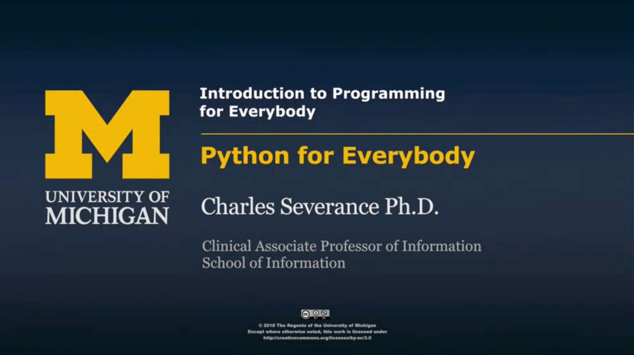

**ONLINE CODING**

**Python Program for Efficient program to print all prime factors of a given number**

**import math**

**def primeFactors(n):**

**while n % 2 == 0:**

**print(2),**

**n = n / 2**

**for i in range(3,int(math.sqrt(n))+1,2):**

**while n % i== 0:**

**print(i),**

**n = n / i**

**if n > 2:**

**print(n)**

**n = 412**

**primeFactors(n)**

