**DAILY ONLINE ACTIVITIES SUMMARY**

|  |  |  |  |  |  |  |  |
| --- | --- | --- | --- | --- | --- | --- | --- |
| **Date:** | **14-06-20** | | | | **Name:** | **SAHANA C** | |
| **Sem & Sec** | **VI B** | | | | **USN:** | **4AL17CS116** | |
| **Online Test Summary** | | | | | | | |
| **Subject** | | **No test** | | | | | |
| **Max. Marks** | |  | | **Score** | |  | |
| **Certification Course Summary** | | | | | | | |
| **Course** | Programming Essentials in Python | | | | | | |
| **Coding Challenges**  1) Write a C Program to implement the Binary Reversal.  2) write a java program to remove specific characters in the String  2) | | | | | | | |
| **Certificate Provider** | | | **Cisco -python institution** | **Duration** | | | **No limit** |
| **Status:on going** | | | | | | | |
| **Uploaded the report in Github** | | | | **Yes** | | | |
| **If yes Repository name** | | | | **https://github.com/sahanasanu/Daliy-status** | | | |
| **Uploaded the report in slack** | | | | **Yes** | | | |

**Online Certification Details:**

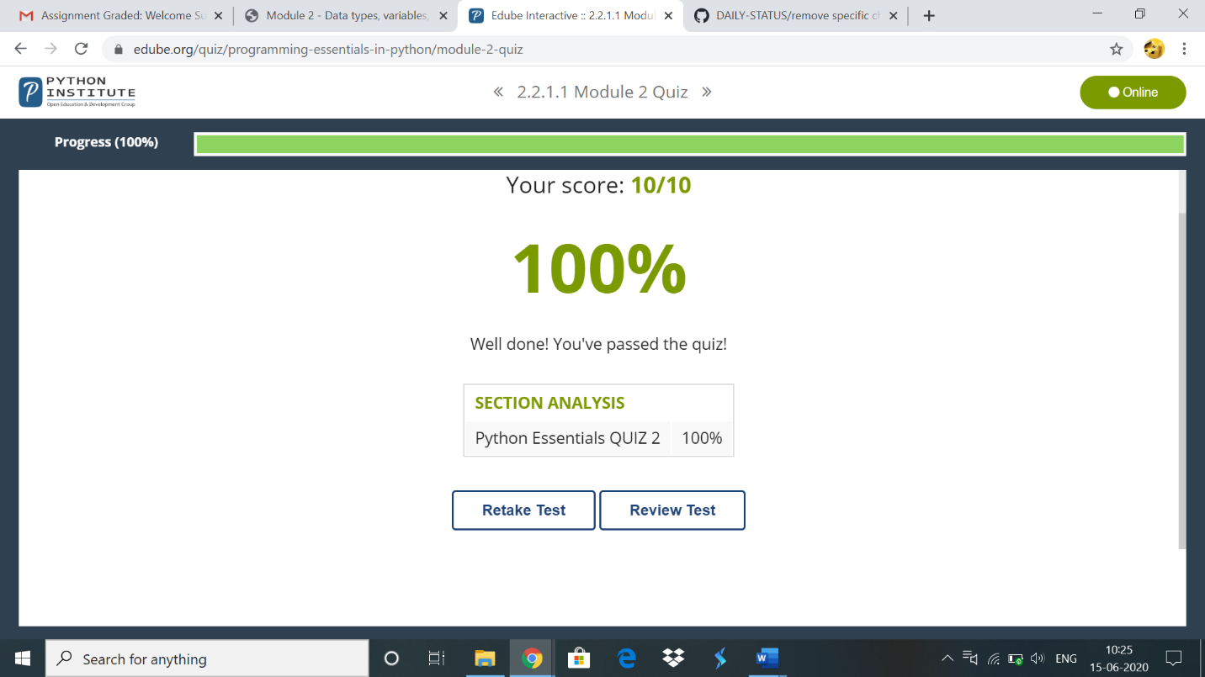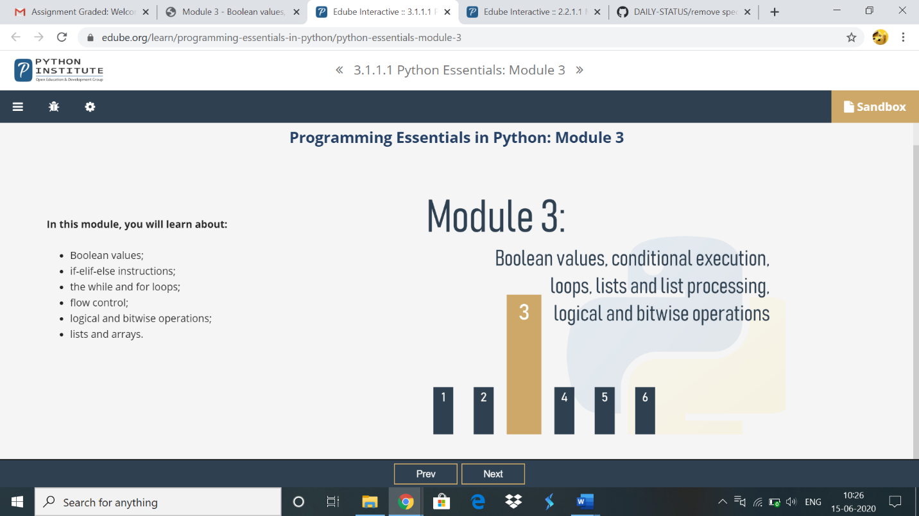

**Online coding:**

**1)**  Write a C Program to implement the Binary Reversal.

#include<stdio.h>

unsigned int reverseBits(unsigned int n)

{

unsigned int rev = 0;

while (n > 0)

{

rev <<= 1;

if (n & 1 == 1)

rev ^= 1;

n >>= 1;

}

return rev;

}

int main()

{

unsigned int n;

printf("input: ");

scanf("%d",&n);

printf("output: %d\n", reverseBits(n));

return 0;

}

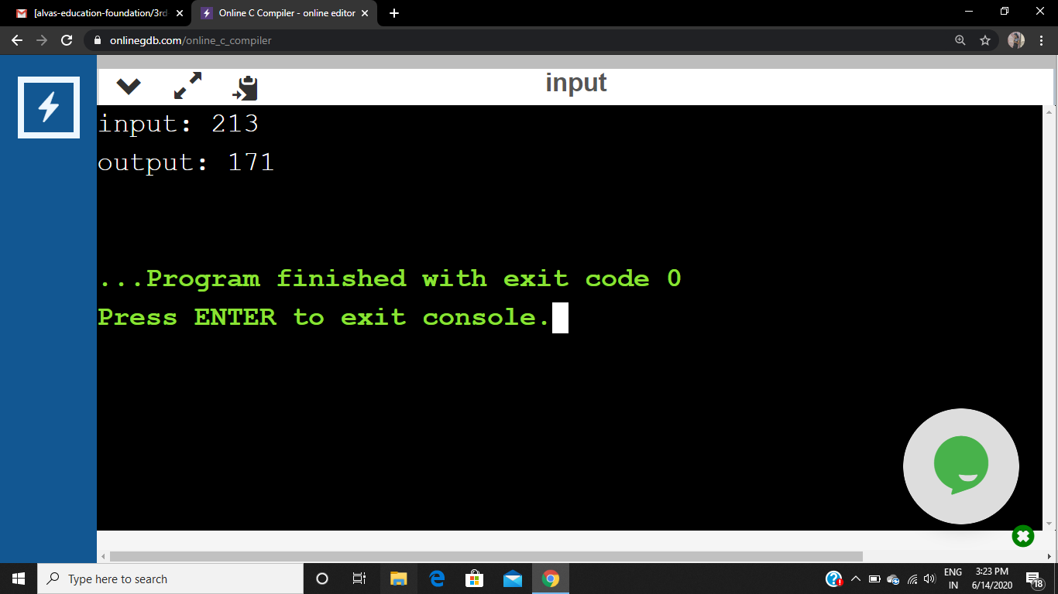

write a java program to remove specific characters in the String

import java.util.Scanner;

public class RemoveSpecificCharacter {

public static void main(String[] args)

{

Scanner sc=new Scanner(System.in);

System.out.println("enter string");

String originalstring=sc.nextLine();

System.out.println("Original string is >> "+ originalstring);

System.out.println("");

System.out.println("Please enter unwanted characters as String");

System.out.println("");

System.out.println("");

Scanner in =new Scanner(System.in);

String removecharacterstring=in.nextLine();

String output=removeSpecificChars(originalstring, removecharacterstring);

System.out.println("");

System.out.println("");

System.out.print("Output is >> " );

System.out.println(output);

}

public static String removeSpecificChars(String originalstring ,String removecharacterstring)

{

char[] orgchararray=originalstring.toCharArray();

char[] removechararray=removecharacterstring.toCharArray();

int start,end=0;

//tempBoolean automatically initialized to false ,size 128 assumes ASCII

boolean[] tempBoolean = new boolean[128];

//Set flags for the character to be removed

for(start=0;start < removechararray.length;++start)

{

tempBoolean[removechararray[start]]=true;

}

//loop through all characters ,copying only if they are flagged to false

for(start=0;start < orgchararray.length;++start)

{

if(!tempBoolean[orgchararray[start]])

{

orgchararray[end++]=orgchararray[start];

}

}

return new String(orgchararray,0,end);

}

}

