**“DAILY ONLINE ACTIVITIES SUMMARY”**

|  |  |  |  |  |  |
| --- | --- | --- | --- | --- | --- |
| **Date:** | **20-06-2020** | | | **Name:** | **SAHANA C** |
| **Sem & Sec** | **6th - B** | | | **USN:** | **4AL17CS116** |
| **PRE-PLACEMENT TRAINING** | | | | | |
| **Subject** | **Basics of C++** | | | | |
| **Max. Marks** | **--** | **Score** | | | **--** |
| **C-Programing**  **Python workshop** | 9:15 to 11:00 Ms. Ankitha Shetty  11:00 to 1:40 Mr. Pradeep Nayak | | | | |
| **Coding Challenges** | | | | | |
| **Problem Statemen:**  **1.Write a Java Program to find area of Square, Rectangle and Circle using Method Overloading**  **2.Write a C Program to rotate an array by K positions.** | | | | | |
| **Status: executed** | | | | | |
| **Uploaded the report in Github** | | | **yes** | | |
| **If yes Repository name** | | | [**https://github.com/sahanasanu/Daliy-status**](https://github.com/sahanasanu/Daliy-status) | | |
| **Uploaded the report in slack** | | | **Yes** | | |

ONLINE PROGRAMS:

Write a C Program to rotate an array by K positions.

#include <stdio.h>

int main() {

int arr[100];

int i, N, len, j;

printf("enter n value\n");

scanf("%d",&len);

printf("enter array elements\n");

for(i=0;i<len;i++)

scanf("%d",&arr[i]);

printf("enter num rotation \n");

scanf("%d",&N);

int temp=0;

for (i = 0; i < N; i++) {

int x = arr[0];

for (j = 0; j < len; j++) {

temp=arr[j];

arr[j] = arr[j + 1];

arr[j+1]=temp;

}

arr[len - 1] = x;

}

for (i = 0; i < len; i++) {

printf("element at %d index : %d\n",i,arr[i]);

}

}

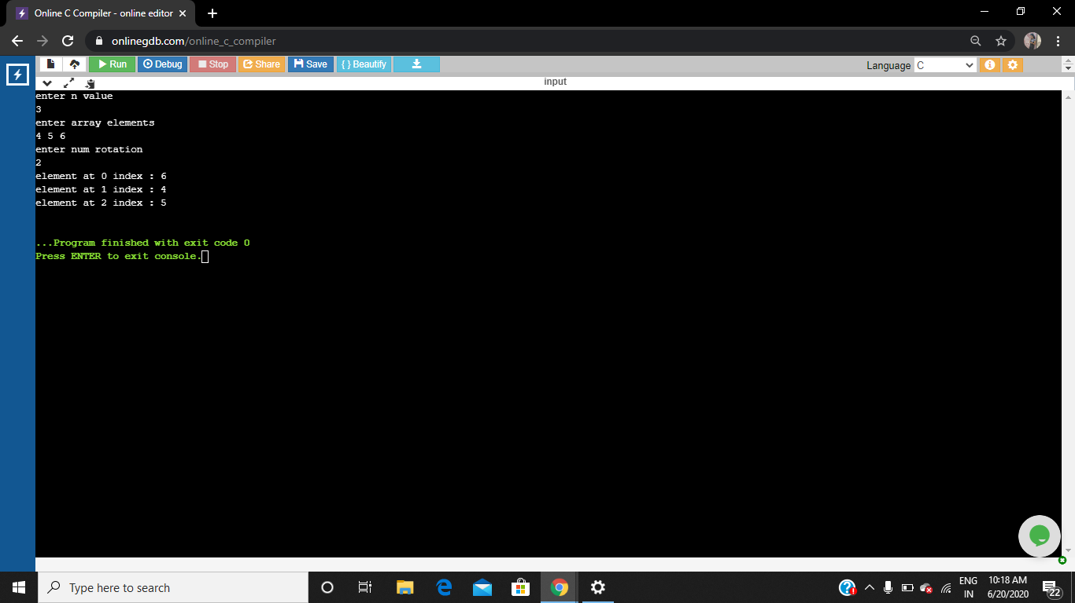

**Write a Java Program to find area of Square, Rectangle and Circle using Method Overloading**

class OverloadDemo

{

void area(float x)

{

System.out.println("the area of the square is "+Math.pow(x, 2)+" sq units");

}

void area(float x, float y)

{

System.out.println("the area of the rectangle is "+x*y+" sq units");

}

void area(double x)

{

double z = 3.14 * x * x;

System.out.println("the area of the circle is "+z+" sq units");

}

}

public class Overload

{

public static void main(String args[])

{

OverloadDemo ob = new OverloadDemo();

ob.area(5);

ob.area(11,12);

ob.area(2.5);

}

}

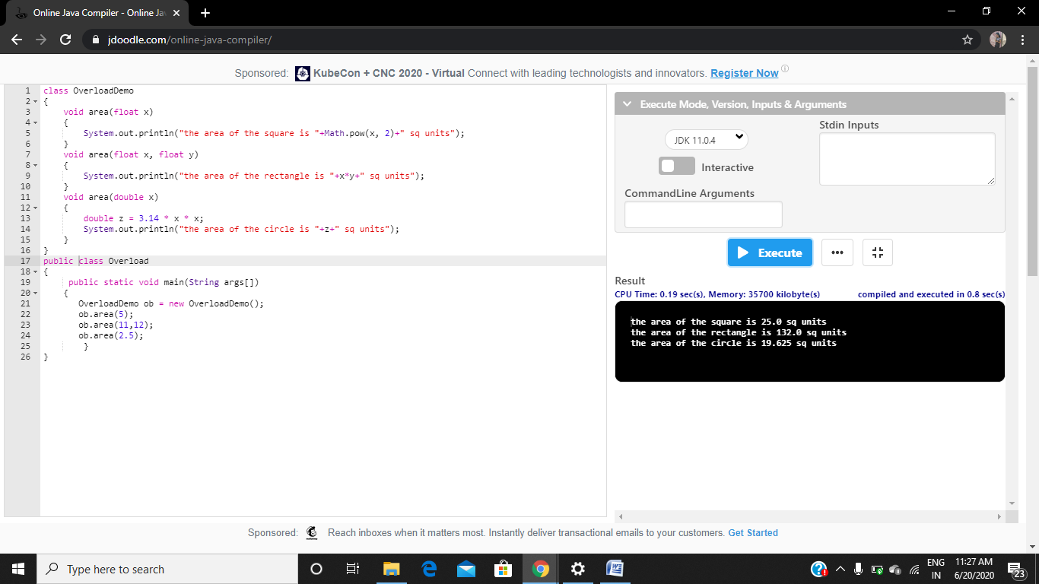

Training:

