**DAILY ONLINE ACTIVITIES SUMMARY**

|  |  |  |  |  |  |  |  |
| --- | --- | --- | --- | --- | --- | --- | --- |
| **Date:** | **28-05-20** | | | | **Name:** | **Sahana c** | |
| **Sem & Sec** | **VI B** | | | | **USN:** | **4AL17CS116** | |
| **Online Test Summary** | | | | | | | |
| **Subject** | | **OS 2 IA Test** | | | | | |
| **Max. Marks** | | **30** | | **Score** | | **24** | |
| **Certification Course Summary** | | | | | | | |
| **Course** | **Front end development in html** | | | | | | |
| **Coding Challenges**   1. **Python program to find digital root of a number** 2. **Python program to print largest no in a list** | | | | | | | |
| **Certificate Provider** | | | **Great learning** | **Duration** | | | **6 days** |
| **Status:Completed** | | | | | | | |
| **Uploaded the report in Github** | | | | **Yes** | | | |
| **If yes Repository name** | | | | **https://github.com/sahanasanu/Daliy-status** | | | |
| **Uploaded the report in slack** | | | | **Yes** | | | |

**IA marks details:**

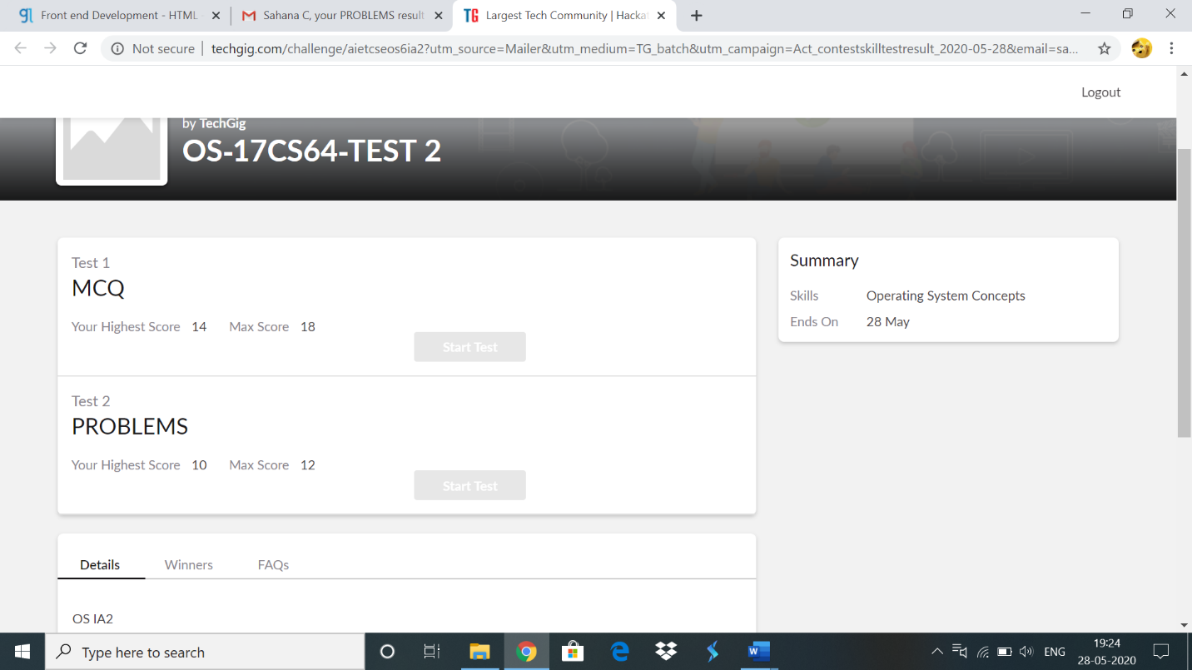

**Online Certification Details**

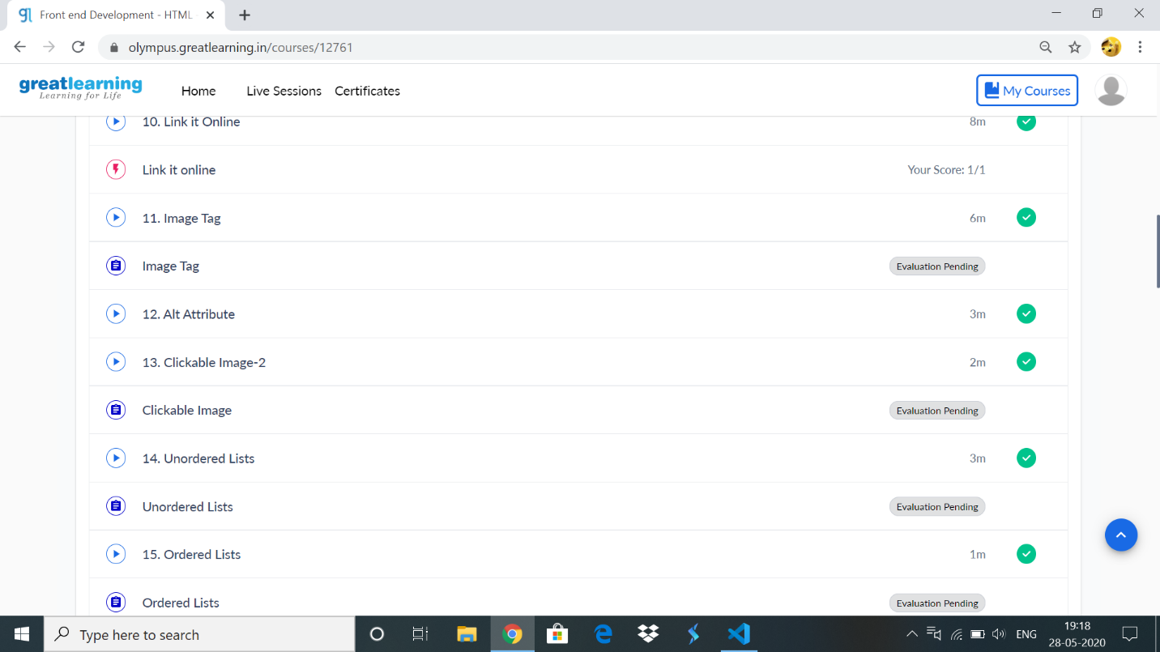

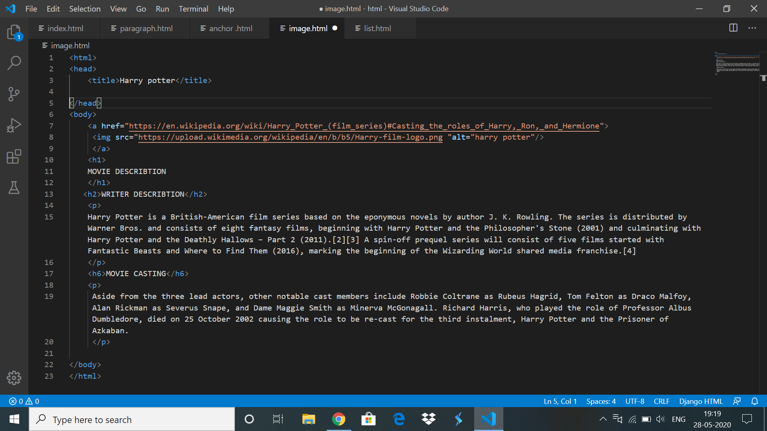

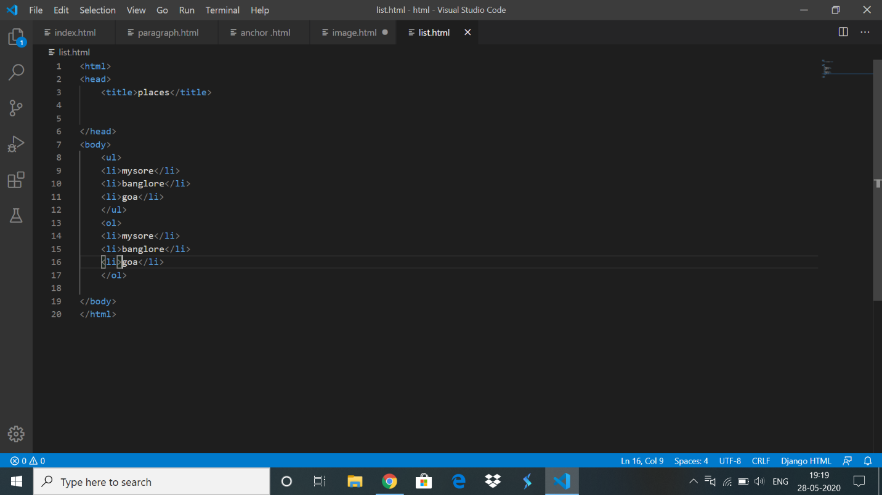

**Coding Challenge Details**

1)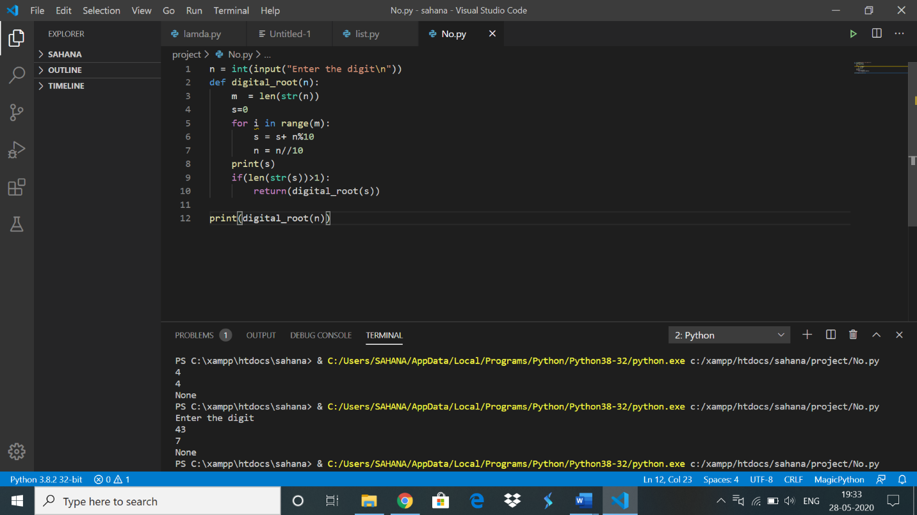

2)