jameel@ieltsacademy.org

Speaking:
1)Comprehension and coherence
2)comprehension

Simple sentences and basic convention of grammar
Essential parameters / Benchmarks : Speaking module
--------------------------------------------------------------------------

1)Accuracy— relevant to question
2)Comprehending and Coherence
3)Fluency- continuity
4)Pronunciation
5)Basic conventions of grammar -- adverbs and adjectives
6)Lexical resource – replace words with diff word eg: fast food-processed food

Structure/pattern-Speaking module :

1)Task 1: (Introduction/Personal interview)

a)You will encounter 6-7 questions
b)You will have to share (speaking) you views for 60 secs for each question
c)Duration = 4-5 mins

2)Task 2: (Cue card section)

a)You will get a group of 3-5 questions together on one topic.
b)You will have to share(speak) your views for 120 secs for all questions put together
c)Duration = 3-5mins

3)Task 3: Two way discussions/interactions

a)You will get 2-3 questions.
b)You will have to share/speak your views for 60 secs for each question.
C)Duration=3-5 mins

Lexical words :
Perhaps-maybe : Perhaps she will come
Eventually

Personal Interview and Introduction
Recognize crucs of the question
1)Hobbies –
stressbuster,happiness, helps to connect with different people

2)Foreign visitor--------where and why, what --- food street
3)How long-- is imp (comprehend)
4)Special Times-vacations, celebrations,festivals,anniversary
5)32—benefit-skills, to comprehend and improve coherence. To speak more confidentally, I feel more comfortable speaking with strangers,Native language is not English
6)39-feeling..I am going to get excited, eagerly looking for food to taste, nervous,
7)44-usage
8)18—Out of 24 hrs,most of the time I spend in work – difference is 12 hrs but I work for 9 hrs

Day 2: Speaking Module
Steps/Approaches/Methods for Speaking module—Task 1 Task 3
Step 1: To recognize the crucs of the questions.(what is topic)
Step 2 : (What to talk about topic.)Identify what ielts wants me to share/speak on the crucs of the subject.
Step 3: You must generate atleast 4 points and above to complete 60 sec.
Step 4: Do not speak abruptly/bluntly instead open up each and every point.
My hobbies are painting and exercising regularly or hitting the gym. Since I am passionate about painting it makes me very happy and it’s a great stressbuster. My lifestyle has become more disciplined after going to gym. Both these hobbies not only relaxes my mind, but also keeps my body active and energetic whole day. It also brings positive mindset and healthy body, hence I feel hobbies play vital role in our lives.
Day 3 : Speaking module – Aug 10
- Photograph – nature, ancient painting photograph, family, village, pets – talk about something that is close to my heart
What-shows
Where-saw
Why-like
Do you like – pht/painting/drawing
Do you prefer-pht/pnt
- Character – player, queen, tutor, princess, teenager
Cue card section – Speaking module:
Step 1: Recognize crucs of question and make right choice.
Step 2 : You must transfer data from cue card to the paper within 30 secs.
Step 2 : H+4W –-- HOW WHAT WHERE WHY WHEN
Step 3: Firmly decide which question has huge scope for me to bring out my accuracy comprehency and coherence.
Step 4: You must generate atleast 6 points and above.
Step 5: Do not speak bluntly/abruptly instead open up each and every point.

11. Influential person – mother
13. something you own which is very important – spectacles, piano, car, phone
19. recent success – national medal in 400m 800m running which is close to my heart, brought jewelry/house
6. describe teacher – influenced
12.special place – crucs ? grandparents village, indoor games,
14. equipment- ipad, smart watch, cell phone
17.picnic trip – Munnar
20. School – diff blocks/buildings
21. Building --- health of building meaning is it old or new--- doctors colony, army buildings ,
Mall, Office building -- It is located at heart of city hence it has to be preserved. Which is useful for disabled and many people.
22.Fashion
Fashionable – By looks, dress code – we can judge a person based on way of dressing
Dark colours – bold attitude..light colours – soft nature/personality
Day 4 Speaking module : 11th Aug
4.Recent news story—crucs
How-heard
What-places/event/people
How-felt-----to speak more abt it
Why-interesting------ to speak more abt it
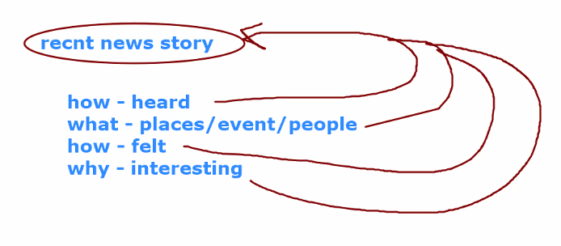
- Ideal home
Where – it be
How – big
What – contain
Do you think – live
Is this very diff – home today

- Wedding celebration
When-took place
Whose-was this
What happened
Why-enjoyed
Is this popular-country

10. Famous person
Who- is this
What-is like
Length of time-admired
For what-well known
why-special to you

character

why-chose
when-read/saw
how-influence
would-be like this
do you kno-anyone

film/tv prog-impression
what-was it
when-saw
what-was abt
why-impression on you

21. Building
What- features
What-criteria u look for
Is it-heritage , should we-preserve
Describe-health impact

22.Fashion /modern technology

Do you-appreciate-why/why not
How do u make out-is fashionable/not
can you make out-fashionable by dress
what-relationship bet dress/personality

25.child
Who-is this–where-you saw
How-it look
Do you-like – why/why not -- can speak more
What-learn - can speak more

Influential person

Who-person is mother
What-is like looks strict but friendly
Why-influential in ur view --
What- have in ur life

The person who has influenced the most in my life is my mother.
My mother is friendly, supportive and understanding person. She has always been there for me in all my highs and lows. She guides and motivates me to be an independent and role model to others.
There are various reasons why she is so inspiring in my life is the hardships she faced in raising 3 kids in Bangalore which isn’t easy at all, providing the best education and supporting all of us equally. At present, she feels very proud to see us work and earn independently. Even I feel happy to see her eyes shine and lips smile. She becomes very powerful person in my life because of her never give up attitude and keep moving in every situation. She has also taught me to stay calm and behave well even after achieving something unbelievable in life, her simplicity admires me the most in my life.

8,9,10,11,12,72

Day 5 : Practices for Listening Module:

- Six minutes BBC English. – listen and write words you heard
- Hollywood animation movies with subtitles. – Repeat each and every word you listen.
- ABC news channel(Australian broadcasting corperation).—focus on pronunciation
- Speed, Accent, Pronunciation

https://www.bbc.co.uk/learningenglish/english/features/6-minute-english

Different task(question)- Listening module:

- Mcq – to comprehend mother and child questions
- Summary completion. – to comprehend blanks/dash
- Note completion. – to comprehend blanks/dash
- Table completion. – heading, rows, columns
- Form completion. – either it is alpha or numeric
- Labelling a diagram. --- map(directions/commentary—stand at entrance of map)/static images (ending of arrow marks, headings ,sample answers)
- Answering short questions.
Mcq,summary completion,note completion ,labelling a diagram – appears for sure.
Raw score Band
16 (18) 5
23 (25) 6
30 (32) 7
35 (37) 8
40+ 9

Structure/Pattern – Listening module:
1.You will encounter 6-7 tapes.
2.Each tape is attached to 3/5/7/10 questions.
3.Duration of each tape is 2-3 minutes approximately.
4.There are 4 parts(sections)
5.Each part carries 1/2/3 tapes.
6.Each part has 10 questions.
7.In total there are 40+ questions.
8.At the end of each part, you will be given 30 secs for checking your answer.
9.At the end of the module, you will be given 10 mins, for transferring the answers from question booklet to the answer sheet.
10.Remember, ielts will not allow you to listen to any tape without comprehending the questions attached to it.

Select verb – looks..
Shows-distinguish deature
Have-briefcase
Standing
Quarter to 4-3:45
Quarter past 5-5.15
Half to- for 30mins
Half past
Comprehend the options

3. Note completion
A table must have comparison
Do not ignore headings or sub headings

Methods of comprehending a diagram
1.Sample answers
2.Ending of the arrow mark
3.Headings/Sub headings
Three important C’s in your answers
1.Clarity
2.Comprehending and Coherence
3.Conventions of grammar.
American, British, Scott, Australian
Listening Module : Day 7 --- 16 Aug
63.

Section 1 – Question 1-10
1. A 2. C 3.D 4.D 5.C
6. Prescott 7. 41 8.Fountain road 9.752239 10. 65
Section 2:
11.E 12.F 13.H
14 . 250 million 15.road system 16.too late 17.school children 18.3mins 19.boats and pleasure crafts 20.pilot 21.musical instruments
Section 3:
22.A 23.B 24.C 25.A
26. talk 27. write up/work 28. you can choose 29. open book 30. closed reserve 31. Occasional/occasional subjects/work/employment
Section 4: 32-41
32. B 33.C 34.history and economics 35. deadline for essay/meeting deadline 36.Attendance
37. B 38.C 39.B 40.D 41. A

Practice Test 4 Section 1: Pg 21
1.C 2.A 3.B 4 D 5.D
6.Julia Perkins 7.Waratah road(She pronounces as I for a) 8.Brisbane 9.to be advised/not connected/no phone/none 10.first year law
11. C 12.D
Section 2: 13-21 : pg 23
13. Hope street 14.evidence 15.passport 16. student/current 17.cheque book
18.withdraw 19.right out of 20.permission from bank 21. 4.30pm or 5pm

Swot – strength, weakness, opportunities, threat
Test 1:Section1 q1-10
1.city center/the city center 2.250 to 500 3.garden 4.325 5.water bill/water bill/bills/the water bills 6.telephone /phone
7.Wednesday /wed afternoon 8.employer 9. two weeks /forthnight 10.one month’s rent
Section 2
11.daughter Anna 12. practices –not practioner
13.6 14.4 15.faster/efficient/better 16.old/elderly 17.back trouble/back problems/bad backs
18.9 19.B E 20.5
Section3:
21.Politics 22.African country 25.rural coorperative 23.1990-1992 26.gEography 24.Teach south 27.form 5
28.homesick /missed my family/missed his family 29.favourite subject 30.useful applications
Section 4 :
31.A 32.B 33.B 34.C 35.A 36.B
37.B 38.A 39.B 40.C

Test 2 Section 1
1.main hall 2.Director 3.Student advisor 4 .11.0 5.placement
6. L 7.MH 8.CL
9.SR 10.SCR
Section2
11.queries regarding fees/student’s fees 12.Domestic area 13. Essay deadlines/deadlines 14.Social /social life 15.outings/trips
16.Kouachi 17.3269940 18.10am-4 pm 19.appointments 20.waiting list
Section 3:
21.B 22.C 23.A 24.C
25.selection procedure 26.ancient Chinese/Chinese 27.military/army 28. Two-thirds /almost two-thirds 29.experts 30.A

31.Secondary school 32.14years 33.over lapping/overlap 34. the underside/underneath
35.on paper 36.3 dimensional 37.white,grey,brown
38.C 39.D 40.A

TEST 3:Section 1:
1.Indian Restaurant Rajdoot 2. Park View hotel 3. London Arms 4. 208657 5.non smoking section
6.Lentil curry 7.50 pound 8. choose menu 9.4 November 10.newsletter
Section 2
11. 9 2.year/annum 13.reception
14.union card 15.book
16.weekdays 17.Reception 18.Dance studio 19.Squash court 20.Fitness Room

Section 3
21.Anne Rea 22.16 23.Blink puzzle 24.20 50 2.5
25.safe for children 26.educational 27.cheap price
28.electronics 29.plastic pieces 30.1st July
Section 4
31.rabbit 32. tough 33. beef 34.ladies fans 35. leather
36.meat 37.A 38.C 39.C 40.B
(36/40)
Test 4 : Section 1
1.4.25 2.46 3.A 4. D 5.C
6. chocolates 7.soft toy/teddy bear 8.MARKET 9.market 10. 35$
11.glass 12. 18hrs 13. strange taste 15.metal 14. small size 16.A
17.outside activities 18.underwater 19.weak light 20. flashing light
Section 3
21.B 2.C 23.C 24.C 25.B 26.C
27.Sight and sound 28.support tutor 29.proof reading 30.10th July
Section 4
31. 7.30pm-5.30am 32. housewives 33. Sunday 34. 25000 dollars 35.C
36.C 37.W 38.C
39.D 40.C
35/40

READING section -- Aug 21
RAW SCOPE BAND
16(18) 5
23(25) 6
30(32) 7
35(37) 8
40+ 9
Different task(questions)—Reading module
1.Matching features --- will be given
2.Short answers
3.Mcq --- will be given
4.T/F/NG or Y/N/NG --- will be given
5.Summary completion --- will be given
6.Flowchart completion
7.Table completion
8.Sentence completion ---will be given
9.Labelling a diagram
10.Paragraph/Passage-Heading
11.Identifying a paragraph
2 different kinds of text-Short and Running passages
Structure/Pattern-Reading module
1.Running passages(General/Academic)
2.Short texts(For general only)
3.There will be 3 2 4 sections
4.Each section carries 8/10/12/13/14 questions each
5.In total there will be 40+ questions
6.Duration=60 mins
7.Ielts General get only 1 running passage and remaining as short texts
8.Ielts Academic will get only running passages and no short texts
Mcq----crucs of question—

Page 7 1.MCQ 23- objectives
To provide. To list . to
24. verb-refer
Read as to support,to criticize ---options will have synonymous word
Illustrate-describe,define
2.T/F/NG – pg 7 : 16-22
First check if its G/NG then check if T/F by checking the data
Find action word,check if its given or not given. Then, if data is present or not write T/F.
16.find action word-dishonest
17.action word-made
18.action word-not known
What is not known? WZCS doc where?Eastern Europe
20.action word- knew
Who knew?no one
21.action word-dissatisfied
Who-Colin Tudge what-with treatment of animals
22.action word-unsatisfactory
3.Summary completion : page 3 q-1-6
Read as dash…and find out a word to fill the blannk
synonymous words
4.Flow chart completion pg 18 : Q 13-19
Comprehend and fill blanks
DO NOT IGNORE HEADINGS/SUB HEADINGS
5.Table completion page 10 : q-29-35
1.Do not ignore heading/sub heading—Period / style of period
2.
6.Sentence completion pg 22 q38-41
Simple sentence is divided into 2 sentences
38.action word—arises
What?our concept of tourism
7.Labelling the diagram
Methods for comprehending a diagram(Reading and Listening module)
1.Sample answers
2.Ending of the arrow mark
3.Headings and Sub headings
8.Paragraph/Passage heading pg 25 q1-6
6.action word – methods
10.action word-counts
What counts here? Accurate word frequency
3.learns 5.study -spoken(adjective) 7.tells 8.enter who?new phrases
11.provided
9.Identifying paragraph -- pg 41 q 14-19
14.action word-drawbacks restructuring – is adjective
Drawback of what? Current company restructuring patterns
18.mother action word-reasons employed
15.action word-provide
16.action word-success rate
17.action word-approaches who?male and female
19.action word-improvement

Understand/Comprehend sentences and later paragraph
Action words(verb)—is/was/are/were
Reading passage 1 :
Action word-control what? Fire
Was – the first,greatest,humanity steps
Life-enhancing -- technology
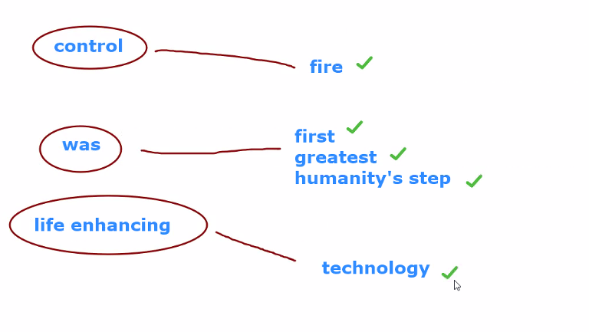
Action word-circle messages-underline
Every sentence has action word and action word carries messages
Was---who?early man, what?fire
Delivered—what?divine gift,how?randomly,in what form?lightining,forest fire,burning lava

Reading passage 2 page 16
Commercial beekeepers, Migrate, pollinate, haul the hives
Migratory beekeeping, clay hives, Moving bees, railroad and horse drawn wagons,beekeeping begin to catch on
Californinan beekeeper,pollination season, beehives in demand,32$,almond honey
Complete in 1.5 min
Early March, pack the 4000,but at night,
To write major movements not statistics
English-english
English-mother tongue
Weakened ,new colonies, separate boxes, replace, New queens, migrate
13.pay 14. 15.
13.Prepare 14.full 15.smoke 16.charge 17.machines 18.combs 19.split
21-frames 20-honey combs 22-screen 23-brood chambers
24.NG (keep not there in para)
25.Yes 26.Yes 27.No

Writing Aug 28
Essential parameters/ Bench marks used for evaluation:
- Task Achievement
- Comprehending and Coherence
- Basic convention of grammar
- Lexical resource

Structure/Pattern writing module
1.Task 1 –A. Letter writing(General only))
2.A.Task 1 – Summarizing and reporting (Academic only(
B.150 words
C. Duration = 20 mins
Task 2- A. Essay writing (for General and Academic)
B. You must write atleast 250 words
C. Duration = 40 mins
Four essential parts of speech required for constructing a sentence
1.Article
2.Conjunctions - is a word used to connect messages inside sentences
3.Prepositions
4.Verbs
Conjunctions
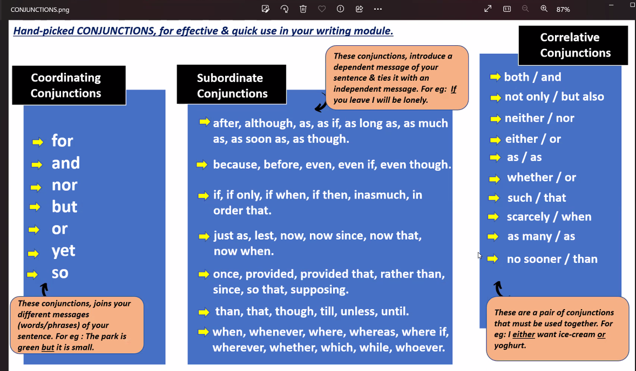
As though-not true/pretending
He is acting as though he is smart
Prepositions: It’s a word to clarifies the time and place

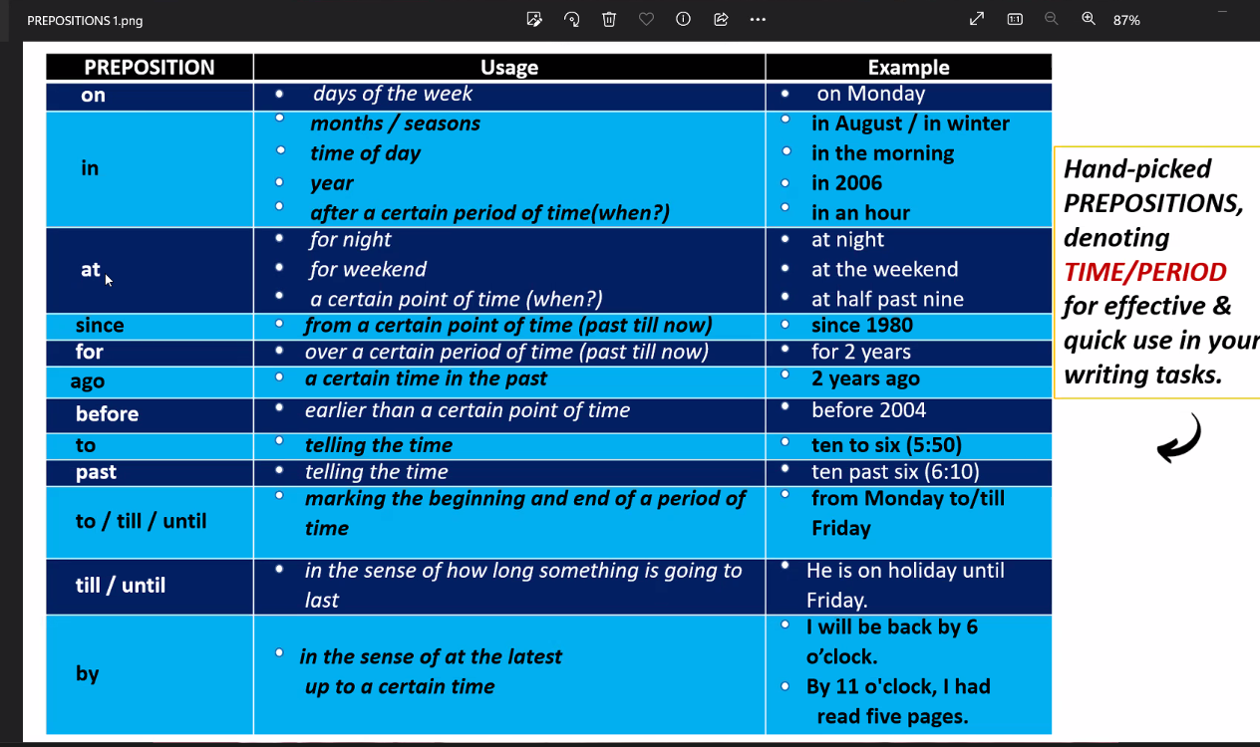

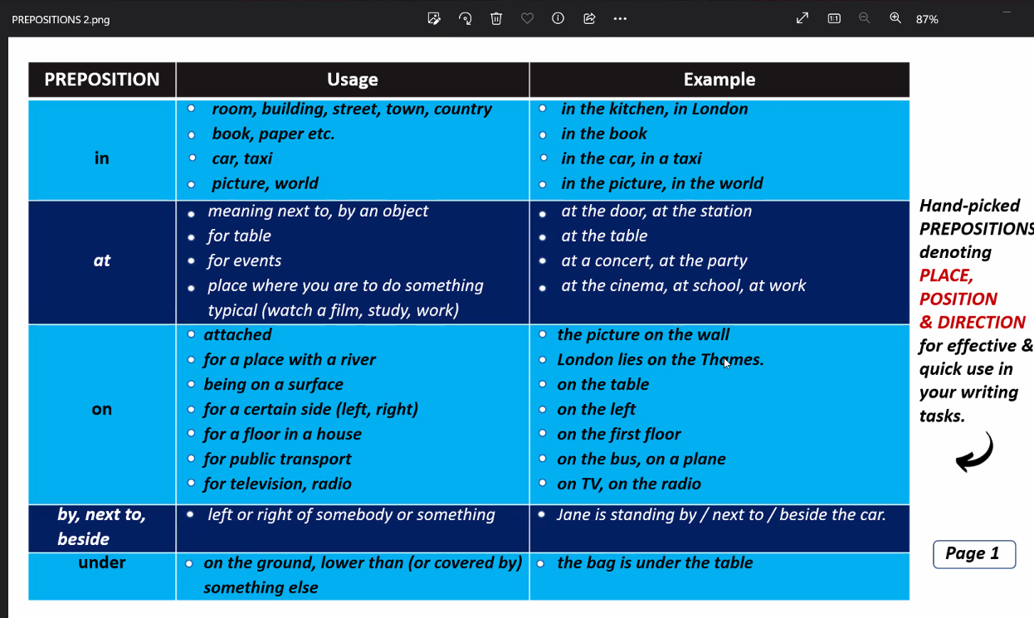

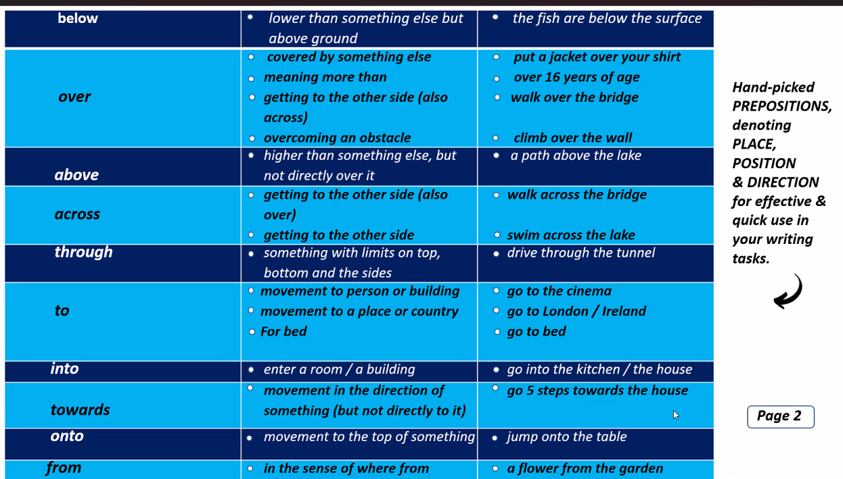
Hellen Muphy – book for grammarTO PROCURE A HARD COPY FROM AMAZON - LINK:
Essential English Grammar – By Helen Naylor & MurphySupplementary Exercises Indian edition
https://amzn.eu/d/759CxSi
amazon.in/dp/0521002680/ref=cm_sw_r_apa_i_BQXYB3M32TGMPAQVCSV9_0
3.Articles – A, An , The
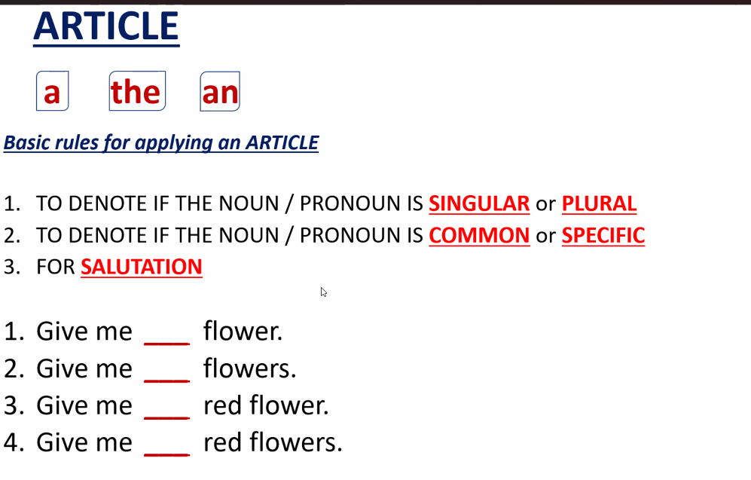
1.a 2.the 3.a/the 4. the
Singular/common- a
Specific/plural- the
4.Verbs
Eat ate will eat
Adverb – describes/defines verb
Adjective – defines name
Introduction
Body
Conclusion
Page 27 : Essays --- Identify crucs of the question
2. Children and behavior
Mother question/Conclusion: To what extent should children have to follow rules? -- some extent
5.pets and spending money
What are the advantages and disadvantages of having pets? Do people spend too much money on pets?
7.Stars and ordinary people’s salaries
What do you think about stars receiving very high salaries? Is it fair that people with jobs that directly help people are paid much less? Give reasons
13.Zoos and keeping animals
Conclusion-Discuss some of the arguments for and / or against keeping animals in zoos
Msg1-Zoos – where we find animals in a restricted place,
Msg2-sometimes seen as necessary - zoos are place where rare species of animals are found and are kept safe, for public exhibition of wild animals, it generates income for the govt and the employment, for the purpose of research and study of animal behavior, its an entertainment for the family and children, for breeding endangered species
Msg3-poor alternatives-they live under pathetic conditions, they loose their hunting skills and their natural behavior changes , From studies or reports its found that they are drugged for various purpose, they are tortured by humans, they are lonely depressed and they cannot migrate
Msg 4- natural environment - – weather, climate(for animals)
The most important natural env are weather climate rivers mountains lakes forests valleys
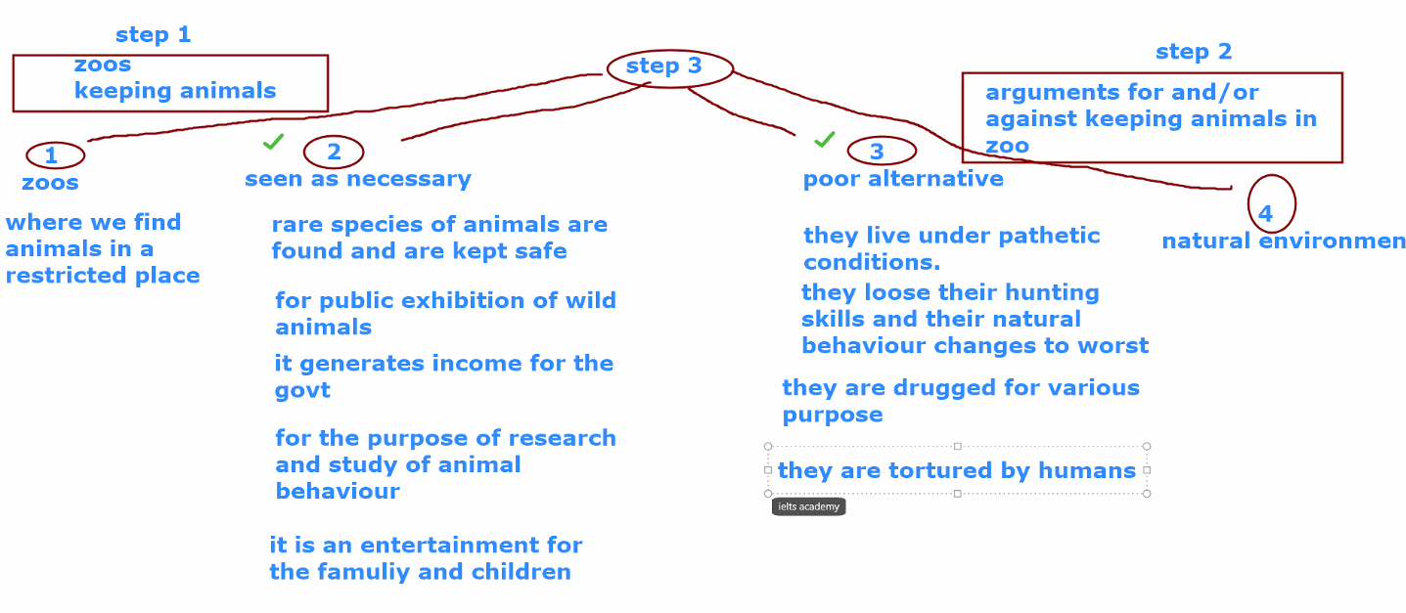
Choose imp ones first in 4 msgs - sometimes seen as necessary, poor alternatives
15. Tourism and disadvantages should not be overlooked -- disadvantages – cost of living, un-hygiene ,pollution, diseases, rental value gone up
Conclusion-Do you agree with the above statement? Give your opinion.
Msg1-Tourism – Countries such as Bali, Maldives, Sri Lanka
Msg2-Tourism is becoming increasingly important
Msg3-a source of revenue to
Msg4-many countries dependent on this
Msg5-its disadvantages
Msg6-should not be overlooked—shouldn’t be ignored
21.Men and Women parenting
Write an essay expressing your point of view. Give reasons for your answer
22.Mass media and influencing people’s ideas
1.Healthy person and do to stay healthy
11.Lives in danger and safety standards for building construction.
MAKING A DIAGRAM FOR THE BODY OF ESSAY WRITING
With 10-15 points Body can be written – 200 words
Intro,Conclusion- 70 words
Steps / Approaches / Methods – Task 2 Essay writing
Step 1 . Recognize the crucs of the questions.
Step 2. Identify what ielts wants me to write on the crucs subject.
Step 3 .Pull out the each and every input/message from the question.
Step 4. Firmly decide which inputs/messages have a huge scope for me to bring out my task achievement, comprehending and coherence.
Step 5.You must generate 10 points and above from above inputs
Step 6. Convert each point into simple sentences with basic conventions of grammar and lexical resource
Time management for essay writing
1.10 mins=making diagram
2.25 mins-writing essay
3.5 mins -for checking
Introductory phrase
Well it is a fact that…
Let us not forget that…
Undoubtedly, it is true that …
We shockingly understand that, …..
It is important to note that….
Nevertheless, …………
However,….
Besides,
Introductory phrases for writing introduction in essay writing
1.I shall now, share my views/ throw some light / give my opinion/ present my views/ present my arguments, as to ……….in the following paragraphs/essays.
Example:1. I shall now, share my views as to people do to stay healthy in your country in the following paragraphs.
6.Mother question -- How has it changed people’s lives? Have all the changes been positive?

Introductory part
- Undoubtedly, it is true that a healthy person is often described as someone who has a good di
Besides, gets lots of exercise and avoids stress.
Conclusion – is the answer for mother question
Introductory phrases for conclusion in essay writing
Based on all the above facts/taking the above facts into consideration/ in continuation to the above,
I wish to conclude that ……………
Ex 6:
13. Introduction:
Undoubtedly , Zoos are sometimes seen as necessary. However, poor alternatives to a natural environment. I shall now, present my opinions as to explain is it for or against keeping animals in zoos in the following paragraphs/essays.
Conclusion:
Based on all the above facts, I wish to conclude that animals can be kept in zoos only if it doesn’t harm animals or put them in trouble. I deny keeping them for entertaining humans but can be kept for research and understanding their behaviors . One more important reason for keeping animals in zoo is for captive breeding which improves count of endangered species and it wont get extinct for future generations.
Different tasks/formats of summarizing and reporting
1.Line graph/Bar graph/Pie chart
2.Flow process chart/Flow chart
3.Maps
4.Tables
Page 1 Writing Task 1:
Shows the results of survey of adult education
Shows reasons why adults decide to study
Shows how people think the costs of adult education should be shared
DO NOT IGNORE HEADINGS/SUB HEADINGS
Read and comprehend diagrams in following manner:
1.Study the data
2.Observe the movements of data
3.Watch out for the change sin the data
4.See if there are any striking differences

Step 1 : We have to club/connect data
Pag1.I shall now summarize the results of a survey of adult education …………in the following paragraphs.
Page 3 Writing Task 1: Bar graphs/Line graph/Pie chart
Mother question /msg:
1.money spent per week on fast foods
2.shows the trends in consumption of fast food

x-income group y-pence/currency per person per week
will interpret in food point of view
well we basically understadnd from above paragraph,all 3 groups spent on hamburgers but high income groups spent maximum for about 40 pence per week followed by average income groupps about 32% pence per week
we further understand from above para average income spent more on fish and chips compared to low and high income
low income groupps spent the least on pizza

line graph
we further found that consumption of fish and chips dripping trend. Started with 300gm and went down to 200 gm in 1980s and ended 220gm in 1990
Pizza was consumed comparatively less than hamburger and fish and chips in 1970 andnd increased till 280gms in 1990

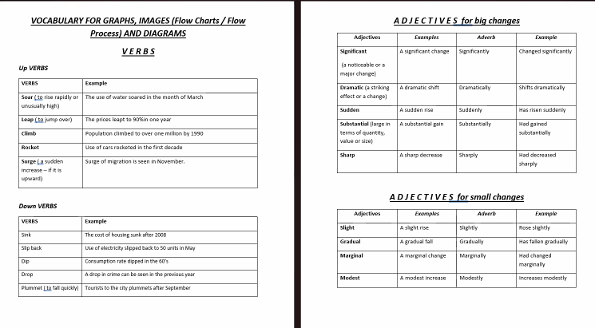
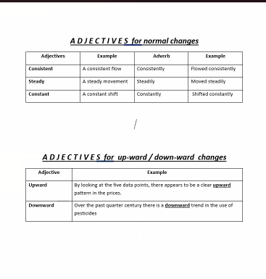
Writing Task 1: page 2 Flow chart
Msg1.Shows how the Australian Bureau of meterology
Msg2.collects min-min infor
Msg3.on weather
Msg4.to produce reliable forecasts
Step 1.Do not ignore heading/sub headings

First job is collection incoming information. Later, it is sent to analysing and forecasting. It is moved to preparing the broadcast. It is sent to broadcasting dept to broadcast to tv radio and recorded announcement.

We basically find that Australian Bureau of Meterology collects incoming information through satellite, radars and drifting buoy. Later, the collected information is sent to analysing and forecasting department which produces satellite photos from satellites, radar screens from radars and synoptic charts from drifting buoys after detailed analysis.
We further noticed that the detailed piece of news is now moved to department which prepares the broadcast.The gathered information is now sent to broadcasting department which broadcasts to Tv, radio and through recorded announcements.

Writing Task 1 Page 4: Map
Msg1.Chorleywood is a village near London
Msg2.Population has increased steadily since
We basically find from above map was developed between 1868-1883
We further surrounding choleywood railway station
Next part was developed be twe 1922 -1970.
Majpr part of the village was developed between 1970-1994 in the north eastern and south part. One part was developed at the intersection of main road and motorway.

Writing Task 1 : Page 5 Table
Horizontal heading- 1972 1974 1976 1978
Vertical heading : cosumer durable
Television and
Central heating and telephone
Central heating and telephone started ownership at 37 and 42 and ended at 64 and 77
Least owned was dish washer started at 1978 at 3 and ended to 5 at 1983
Video was not owned by Britain until 1983 and owned at 18 in 1983.

London has many attractions from Big Ben to Buckingham Palace. Would you surprise to hear that many tourists stop destination is a museum. The British museum contains thousands of important artefacts, objects of special historical interests including ancient Egyptian mummies, aesthetic serpent and Rosetta stone. Infact London has museum on every subject trains,fashion.Many museums are criticized for stealing ancient treasure during the imperial times, during the age of the British empire such as famous fanthomable marbles.
Another of London’s most visited museums features a grand entrance whole which for decades contain a lifecycle impressive life size model of a dinosaur. Dipip teri

Anthropoligist professor Adam Cooper has written a new book museum of other people which discusses the museum artifacts that were stolen and should be given back. Here he speaks

These are the two great ideologies of the imperialists ,the one is also said that it began from veryharm rough base where ancestors were together at one stage. Then they go through farming all those world getting smarter and smarter, their brains getting bigger and bigger and moving from primitive magic to sophisticated religion to local ppl to
Which is a myth we have our own culture
Ofcourse things didn’t get well for anyone ,the lands were stolen and opposing view argued that each culture is unique and should be valued and protected. The legacy of colonialism is now being publicly debated the question of stolen artifacts remain complex. Firstly, many of these treasure are 100 years old who should they be returned too and what’s more is the history behind this is complicated. In the case of Ben and Bronze for eg,the questions can be asked about the actions of local leader the European palace.
I want to see lot more temporary exhibitions, the type of exhibition I would be interested in is not about one part of tradition but the relation between different country traditions. These connections are sometimes violent,painful,difficult. The things are changing.
Diff cultures and how they are interconnected

GB-276|GMSA Search Navigator metric data ingest| Prod release completed , however business verification is in progress | Release 12.0
GB - 335| Future medical information requests - Ingest fields from Veeva | Analysis is completed, started working on the development| Release 13.0
GB-284|Ingest Axonify Discover data into datalake| SIT in progress |Release 12.0 | date of release TBD
GB-312|Create CMN view for Merck person data to update/revoke employee status
GB-299 | Restructure Archival folder in S3 [Non - Prod & Prod]
1)We keep jira ticket open until dev is completed, testing is completed.
2)when we r working on development, after succession of data load we can consider as completed but We need assistance from diff team from third party vendor for ex, file sharing sometimes then time schedule gets delayed. New columns to be added in existing columns , sometimes its not in source itself so generating file will get delayed. Since its dependent schedule also gets delayed
3)for revops..we have source and target ..when source is not completed then we cannot pull data into Our datalakes. Dev 1 is ready but higher one not ready. As per bi team dev is same for all evs.. we have to pull data from dev to dev1..we cannot proceed because their higher envs is not ready or deployed.
For this we can close ticket nd create new one – until dataload we can keep status as completed for development.
Data from 3rd vendor is not given then we can
These r the situation where cycle time affects
Solution: The user story need to be created. These r the changes that needs to be done
For dev,testing,sit,uat separate tickets need to be created
2 tickets for us…1 for third vendor to tack their activites
For every ticket we can create sub tickets
4)Taking time from our side like writing a python script takes time to build the code. When the complexity of the code is more, then cycle time extends
5)Sometimes we can ignore analysis part and user story can start from development phase

