|  |  |
| --- | --- |
| **MSP430 I/O** | **LaunchPad** |
| **MSP430 Laboratory** |

|  |  |
| --- | --- |
| **Goal** | Understand the operation of the MSP430 peripherals |
| **Resource** | MSP430G2553 Microcontroller |
| **Prerequisites** | MSP430 Base Course |
| **Theory** |  |
| **Equipment** | * MSP430G2-LaunchPad board * Code composer Studio cross development tools |
| **Duration** | ~6h |

# Introduction

The objective of this laboratory is to understand how to operate some of the programmable interfaces available on a microcontroller (specifically on the MSP430 family, part number G2553, available on the TI LaunchPad board).

This laboratory is divided into 3 sessions, and the final demonstration is to be able to convert an analog signal to a digital one using the Analog to Digital (A/D) converter available on the LaunchPad.

The microcontroller should output a Pulse Width Modulated (PWM) signal with a width that is proportional to the provided analog input. An oscilloscope and/or a logic analyzer will be used to display the PWM output as well as other useful signals.

**uC (MSP430)**

**ATD**

**uP**

**+**

**Program**

**PWM**

1. – General system block schematic, internal ADC

## Clock

## The clock subsystem is responsible for providing the clocks for the device. In the case of the MSP430G2553, it is referred to as the Basic Clock Module+ by the User guide and is shown in Figure 2 below.

It features three physical clock sources:

1. **LFXT1CLK**: a low or high frequency oscillator that requires an external clock or crystal (not present on the LaunchPad);
2. **DCOCLK**: an internal DCO (<https://en.wikipedia.org/wiki/Digitally_controlled_oscillator>); and
3. **VLOCLK**: an internal very low-power, low frequency oscillator with a non-programmable frequency of about 12 kHz.

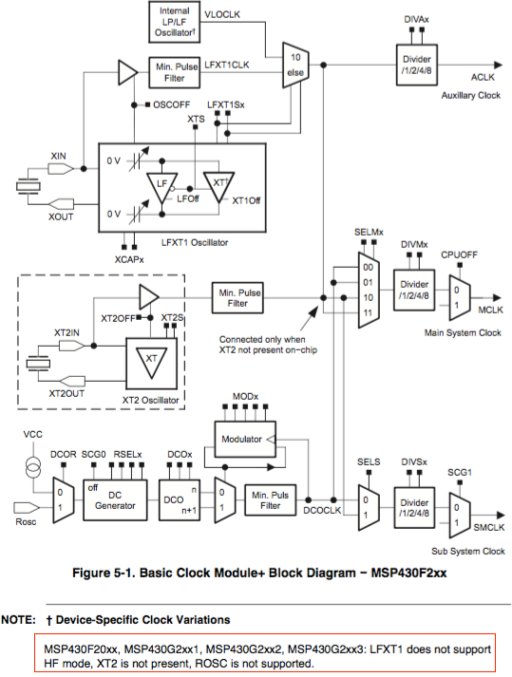

1. – Basic Clock Module+ Block Diagram

Each of these physical clock sources can be used as the source of three clock signals (Although, note that all binding are not possible according to the schematic!):

1. **MCLK**, stands for Main clock, the clock used by the CPU and the system;
2. **SMCLK**, stands for Sub-main clock; and
3. **ACLK** , stands for Auxiliary clock

Both the **SMCLK** and the **ACLK** can be selected to be used in certain subsystems, e.g a timer.

The clock selection logic is outlined in the schematic on the next page, and is detailed in the **MSP430G2553** User guide. Make sure you feel comfortable with the control registers of the clock subsystem, i.e. the **DCOCTL** and **BCSCTLx** registers.

## GPIO

The LaunchPad board has 2 I/O ports (**P1** and **P2**). Each of these I/O ports can be used as a standard GPIO port, or can be configured as functional ports for various peripherals.

Consider, as an example, **another** microcontroller (**MSP430F5437**) used in the WSN4U board from EPFL/LAP, which has 8 I/O ports (**P1** to **P8**).

|  |  |  |
| --- | --- | --- |
| Port | Primary Function | Peripheral Functions |
| Port 1 | I/O (P1.0 to P1.7) | Timer |
| Port 2 | I/O (P2.0 to P2.7) | Timer, A/D converter, DMA trigger |
| Port 3 | I/O (P3.0 to P3.7) | SPI, I2C, UART |
| Port 4 | I/O (P4.0 to P4.7) | Timer |
| Port 5 | I/O (P5.0 to P5.7) | SPI, I2C, A/C reference |
| Port 6 | I/O (P6.0 to P6.7) | A/D converter |
| Port 7 | I/O (P7.0 to P7.7) | Timer, A/D converter |
| Port 8 | I/O (P8.0 to P8.6) | Timer |

Figure 3 below illustrates how a typical I/O port is organized inside the microcontroller, along with the registers that need to be configured to obtain the intended operation for each pin:

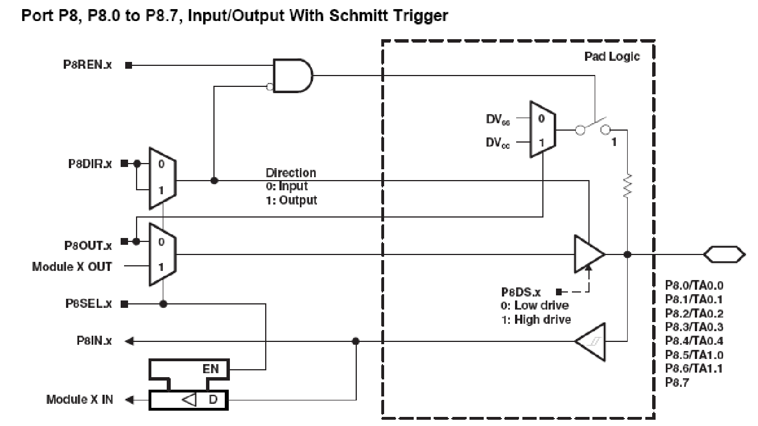

1. – Internal architecture of the Port 8

Depending on the I/O port, several registers should be configured in order to achieve the desired function. The table below summarizes the main registers and their configuration.

|  |  |  |  |
| --- | --- | --- | --- |
| Register | Description | Configuration | Comments |
| **PxDIR** | Direction Register – Input/Output | 0🡪 Input, 1 🡪 Output |  |
| **PxIN** | Read Value Register | 0🡪 Low, 1 🡪 High |  |
| **PxOUT** | Write Value Register | 0🡪 Low, 1 🡪 High |  |
| **PxSEL** | Function Selection Register | 0🡪 I/O, 1🡪 Peripheral |  |
| **PxREN** | Resistor Enable Register | 0🡪 Disabled, 1🡪 Enabled | If enabled, **PxOUT** select pull-up/down (0🡪 Pull-down, 1🡪 Pull-up) |
| **PxDS** | Output Drive Strength Register | 0🡪 Reduced, 1🡪 Full | Full drive can increase EMI |

*\* In the table above, (x) represents a specific register (for Port 1, P1)*

1. GPIO

* Using the LaunchPad board schematics and the TI MSP430 documentation, write a C program that generates a pulse width modulated (PWM) signal on one of board's available I/O ports.
* Test your solution with a logic analyzer or an oscilloscope.
* Test your solution by performing software measurements directly in your C code (try to count clock cycles used to generate the PWM signal to find out it's width).
* Compare the results you obtain through your software measurements with those you see on an oscilloscope/logic analyzer.

Required Documentation:

* [[](http://moodle.epfl.ch/mod/resource/view.php?id=867700)MSP430x2xx family full documentation, User's GuideFile](http://moodle.epfl.ch/mod/resource/view.php?id=867700) http://moodle.epfl.ch/pluginfile.php/1580215/mod_resource/content/1/Doc_composants/MSP430x2xx_slau144j.pdf

1. GPIO - Chenillard

* Write a program to generate a rotating strobe effect ("chenillard" effect) on the LaunchPad. This effect should be done by rotating a '1' on Port2, pins 0 to 5.

## Watchdog Timer

A watchdog timer is initialized during the power-up procedure. The watchdog timer will ***reset the CPU after ~32 ms unless it is serviced***. In order to service the watchdog timer, a specific access must be performed before a programmable expiration time.

***It is highly recommended to deactivate the watchdog timer for debugging purposes.***

The ***WDTCTL*** register is a "password-protected" register used to configure the watchdog timer. Any read/write operation to/from the ***WDTCTL*** register must be done using word instructions. Additionally, write accesses must include the the write password 0x5A (***WDTPW***) in the upper byte.

Check the MSP430 documentation for a description of the microcontroller's registers and each of their uses

**; Stop the watchdog timer**

WDTCTL = WDTPW + WDTHOLD;

Some other useful selections:

; Periodically clear an active watchdog and specify the delay for next period

WDTCTL = WDTPW + WDTIS2 + WDTIS1 + WDTCNTCL;

; Change watchdog timer interval

WDTCTL = WDTPW + WDTCNTCL + SSEL;

; Change WDT to interval timer mode, clock/8192 interval, clear counter

WDTCTL = WDTPW + WDTCNTCL + WDTTMSEL + WDTIS_8192;

## Timer

The **MSP430G2553** has two 16-bit timers (2 x TimerA with 3 CCR each):

* **TimerA0's** signals can be routed as follows:
  + **P1.0** (**TAClk**)
  + **P1.1** or **P1.5** (**TA0.0**)
  + **P1.2** or **P1.6** (**TA0.1**)
* **TimerA1**'s signals can be routed as follows:
  + **P2.0** or **P2.3** (**TA1.0**)
  + **P2.1** or **P2.2** (**TA1.1**)
  + **P2.4** or **P2.5** (**TA1.2**)

|  |  |  |  |  |
| --- | --- | --- | --- | --- |
| **P1** | **TimerA0** |  | **P2** | **TimerA1** |
| ***CCIxA*** | ***Input Capture*** |  | ***CCIxA*** | ***Input Capture*** |
| P1.0 | **TA0Clk** |  | P2.0 | **TA1.0** |
| P1.1 | **TA0.0** |  | P2.1 | **TA1.1** |
| P1.2 | **TA0.1** |  | P2.2 | **TA1.1** |
|  |  |  | P2.3 | **TA1.0** |
|  |  |  | P2.4 | **TA1.2** |
| P1.5 | **TA0.0** |  | P2.5 | **TA1.2** |
| P1.6 | **TA0.1** |  |  |  |
|  |  |  |  |  |

If Input Capture mode is used, the user should select the source of the input signal. Figure 5 shows that **TimerA** can be sourced from 2 sources (pins, i.e. **CCIxA** and **CCIxB**).

To use the Timer in output mode, the corresponding bit in the GPIO **PxSEL** register must be programmed for the specific peripheral mode wanted (and not in GPIO mode).

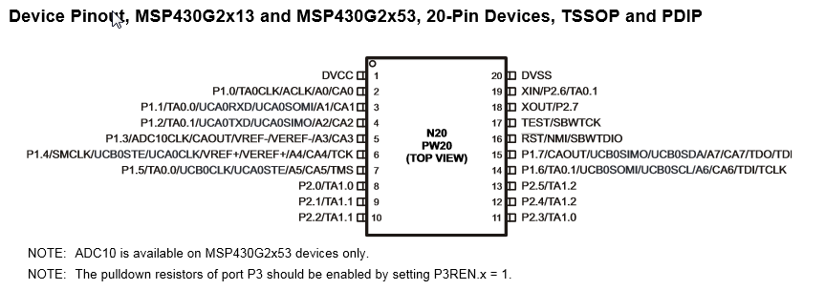

1. –Pinning og MSP430G2x53, 20 pins

### TimerA used as a counter

The main block of the Timer Module is a 16-bit free running counter that can be configured to count up or down (**TAxR**). The **TAxCCRy** register is used to compare a desired value with the free running counter (0xFFFF is the maximum upper value).

The **TAxCCRy** **CCIFG** flag is used to indicate when the counter has reached the desired value, and could generate an interruption if properly configured. Figure 5 below shows the general architecture of the TimerA unit:

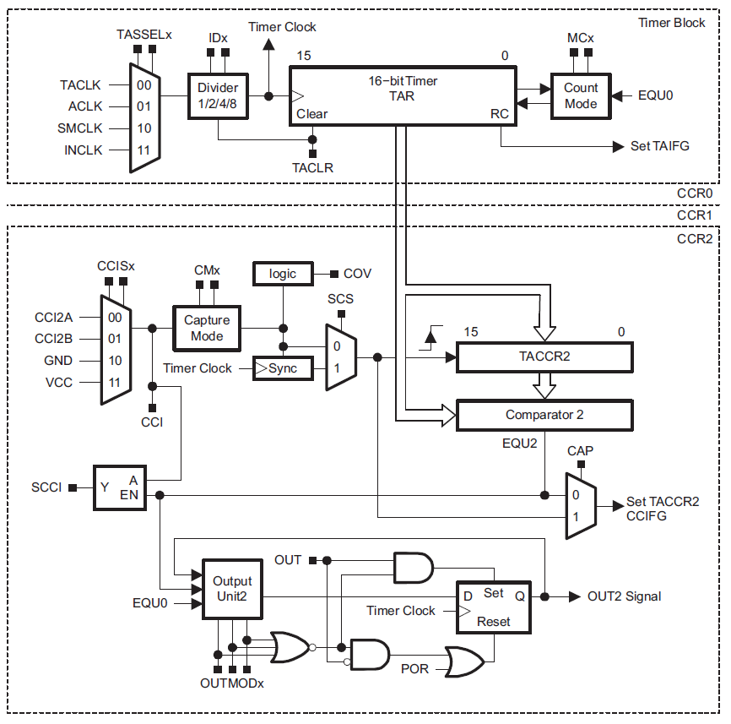

1. – TimerA block schematic (from TI)

You can easily program the timer with a delay by using the Compare function. The clock dividers can be used in order to achieve the desired counting range.

As an exercise, write a function that causes the microcontroller to wait for a certain delay in specified in *ms.*

1. TimerA0, delay

* Write a function that takes a delay [ms] as an input argument, and which causes the microcontroller to wait for the programmed time. You must use **TimerA0**’s **Compare** functionality. Don’t forget to correctly program the **TAxCCR** register and to actively poll the **CCIFG** flag!

### PWM generation

Use **TimerA0** to generate a periodic pulse through pulse width modulation (PWM mode).

Write a function that generates a pulse with a period of ~10 [ms]. The pulse’s duty cycle should be programmed as the function’s parameter. Study the different modes available on **TimerA** to generate the PWM pulse.

You can find a block diagram of **TimerA** in Figure 5 above.

1. PWM with TimerA

* Use **TimerA0** to generate a PWM pulse by configuring the CCR comparator to operate in the proper manner. The PWM pulse must have a period of ~10[ms]. Use an oscilloscope to view and validate the results.

## TimerA0 interrupt-generation

It is possible to use **TimerA0** in Output compare mode to generate a periodic interrupt. A vector table contains the address of every interrupt routine that needs to be called for a specific Interrupt Request.

As an example, we can study the vector table for the **MSP430F5437** microprocessor (not the one used in this laboratory!), which can be found in the header file for this specific microcontroller: **msp430f5437.h**.

We can see that the vector table starts at address ***0xFF80***, and each entry is 16 bits wide. The address for **TimerA0**’s interrupt routing is **0xFFEC** (entry 54 in decimal, so 0xFF80 + 2*54 = 0xFFEC)).

A specific compiler ***pragma*** is used by the compiler to specify the interrupt service routine and the corresponding vector address.

**#define** TIMER0_B0_VECTOR (60 * 1u) /* 0xFFF8 Timer0_B7 CC0 */

**#define** TIMER0_B1_VECTOR (59 * 1u) /* 0xFFF6 Timer0_B7 CC1-6, TB */

**#define** TIMER0_A0_VECTOR (54 * 1u) /* 0xFFEC Timer0_A5 CC0 */

**#define** TIMER0_A1_VECTOR (53 * 1u) /* 0xFFEA Timer0_A5 CC1-4, TA0 */

**#define** TIMER1_A0_VECTOR (49 * 1u) /* 0xFFE2 Timer1_A3 CC0 */

**#define** TIMER1_A1_VECTOR (48 * 1u) /* 0xFFE0 Timer1_A3 CC1-2, TA1 */

Below, you will find a code segment that specifies and interrupt routine in Code Composer 6:

**#pragma** vector=TIMER0_A1_VECTOR

__interrupt **void** TimerA0(**void**) // Interrupt routine for TAIFG

{

// something to do…

TA0CTL &= (~TAIFG); // Clear TAIFG flag in TA0CTL register

}

In order to enable global interrupts, the following instruction must be executed:

__bis_SR_register(GIE); // Enable global Interrupt

1. Interruption on TimerA0

* Use **TimerA0** to generate periodic interrupts every ~50ms. Toggle a GPIO pin on each interrupt. Use an oscilloscope to view and validate the results.

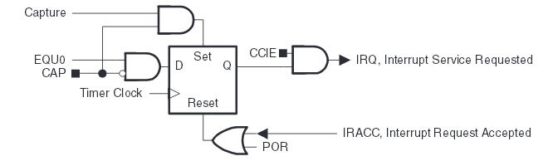

1. TimerA/B Interrupt Request/Ack block schematic TAxCCR0 / TBxCCR0 (from ti)

Timer interrupt vectors

|  |  |  |  |  |
| --- | --- | --- | --- | --- |
| **Timer** | **Source** | **Vector address = 0xFF80 + 2* Priority** | **Symbol Name  = Priority** | **Priority** |
| TB0 | TB0CCR0: CCIFG0 | 0xFFF8 | TIMER0_B0_VECTOR | 60 |
| TB0 | Highest active in ***TB0IV***: TB0CCR1: CCIFG1 TB0CCR2: CCIFG2 TB0CCR3: CCIFG3 TB0CCR4: CCIFG4 TB0CCR5: CCIFG5 TB0CCR6: CCIFG6 TB0CTL; TBIFG | 0xFFF6  One address for 7 sources | TIMER0_B1_VECTOR | 59 |
| TA0 | TA0CCR0: CCIFG0 | 0xFFEC | TIMER0_A0_VECTOR | 54 |
| TA0 | Highest active in ***TA0IV*** : TA0CCR1: CCIFG1 TA0CCR2: CCIFG2 TA0CCR3: CCIFG3 TA0CCR4: CCIFG4 TA0CTL : TAIFG | 0xFFEA  One address for 5 sources | TIMER0_A1_VECTOR | 53 |
| TA1 | TA1CCR0: CCIFG0 | 0xFFE2 | TIMER1_A0_VECTOR | 49 |
| TA1 | Highest active in ***TA1IV*** : TA1CCR1: CCIFG1 TA1CCR2: CCIFG2 TA1CTL : TAIFG | 0xFFE0  One address for 3 sources | TIMER1_A1_VECTOR | 48 |

### General Interruption architecture

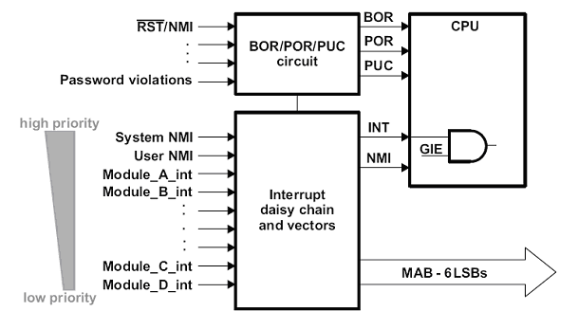

1. - General interruption architecture (from TI)

### General Interruption architecture

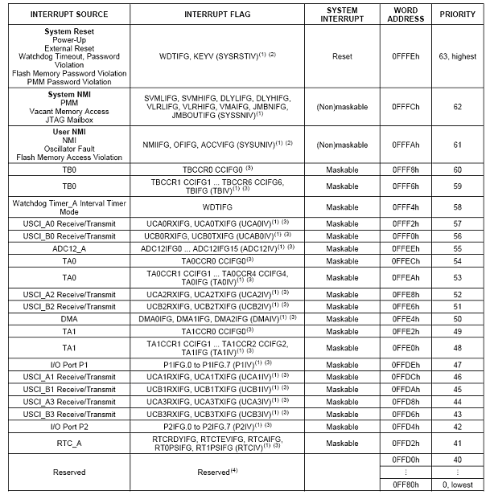

1. - General interrupt architecture (fromTI)

(1) Multiple source flags

(2) A reset is generated if the CPU tries to fetch instructions from within peripheral space or vacant memory space.

(Non)maskable: the individual interrupt-enable bit can disable an interrupt event, but the general-interrupt enable cannot disable it.

(3) Interrupt flags are located in the module.

(4) Reserved interrupt vectors at addresses are not used in this device and can be used for regular program code if necessary. To maintain compatibility with other devices, it is recommended to reserve these locations.

## ADC

The **MSP430G2553** supports 10-bit analog-to-digital conversion. The programmable module responsible for this is referred to as the **ADC10** peripheral. Its block diagram is depicted below.



It basically works as follows:

* Pins can be configured as analog inputs to the **ADC10**. Using the **P1SEL** register, as specified by the datasheet, one can map **P1.7**..**P1.0** to **A7**..**A0**, respectively.
* The inputs can be selected using the **INCHx** bits of the **ADC10CTL1** register (again, make sure to check the *ADC10 Registers* section of the user manual).
* At the rising edge of the **SHI** signal, a sampling stage will be initiated. Then, depending on how the **Sample Timer** is configured by the programmer (i.e. you), the **SAMPCON** signal is held high during a certain period (in function of the period of **SHI**). The **SAMPCON** signal determines how long the analog signal must be sampled.
* As soon as **SAMPCON** goes low, the conversion stage is initiated and will last 13 **ADC10CLK** cycles.
* Finally, the sampled value will be available in the **ADC10MEM** register.

Now it is your turn to have fun configuring all these registers, and don’t forget to read the documentation ;) !

1. ADC, Analog to Digital Converter

* Write a function that use the **ADC10** module to acquire an analog signal obtained from an external potentiometer. To plug in the potentiometer, refer to figure and the explanations provided in the next section.

### ADC to control PWM

The goal of this section is to use the sampled value obtained from the **ADC10** to control the duty cycle of your PWM. The A/D converter should be read every ~50ms. Use interrupts to meet this timing requirement.

The figure below shows an example configuration of the system for the 7th manipulation:

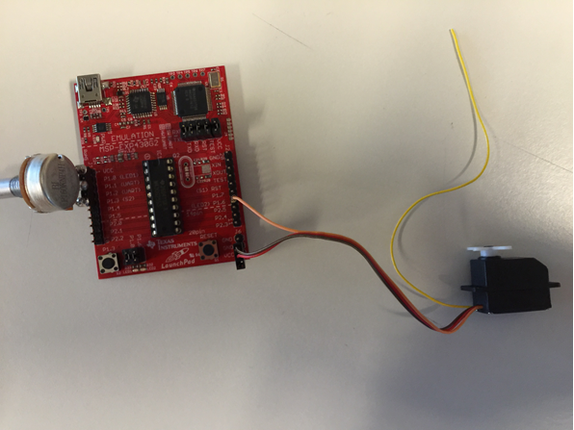

A potentiometer is plugged such that its VCC pin matches the one of the LaunchPad board, its output is tied to **P1.1** (which can be configured to be the analog input of the **ADC10**), and its ground is tied to **P1.3**. **P1.3** must therefore must be grounded by configuring this pin as GPIO in output mode, and programmed to a 0 level.

The servomotor is connected to the GND and VCC pins of the Launchpad at the bottom right of the board. The servomotor is controlled via PWM and expects to be configured as shown in the figure below.

**WARNING: THE BLACK WIRE OF THE SERVOMOTOR MUST BE CONNECTED TO GND AND THE RED ONE TO VCC! THE SERVOMOTOR CAN BE DAMAGED IF NOT PLUGGED IN CORRECTLY.**

The orange wire is the input of the servomotor and should be tied to a pin that outputs the PWM generated by your timer.

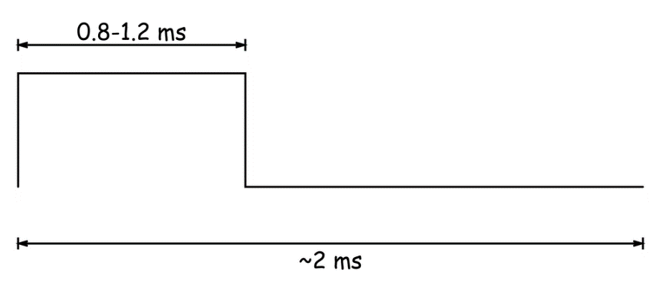

1. Timer, ADC, PWM, GPIO and interrupts

* Use a timer interrupt to periodically enable the ADC converter in **software** and to start a conversion of the potentiometer value.
* Use another interrupt from the (**ADC10** module this time) to catch the sampled value and use it to adjust the duty cycle of the pulses your pulse-width modulator generates.
* Make a demo to an assistant where you can visualize the result with an oscilloscope/logic analyzer and the servomotor.
* **Extra**: try to avoid the use of a **software** routine to enable the ADC conversion process, but instead connect the timer directly to the **ADC10** (find out where to perform the connection from the **ADC10** bloc diagram above).