**Plant Cultivation and Monitoring Solution using IOT and Machine Learning**

**Dissertation Project Proposal**

**Sahan Dinuka**

**CL/BSCSD/26/11**

**st20284589**

**Table of Contents**

**Background of the Study** 3

**Problem Statement** 4

**Solution** 5

**Research Question** 5

**Objectives** 6

**Feasibility** 7

**Significance of the study** 9

**Context diagram for the business** 10

**Project Description** 10

**Conceptual framework and Hypothesis** 13

**Hypothesis** 14

**System Process Workflow** 15

**Architecture** 17

**Resources required** 19

**Expected output and outcome of the system** 21

**Time Plan for Implementation** 23

**Limitations** 25

**References** 27

# **Background of the Study**

Technology is used various industries in nowadays. And this technology can be used for agriculture also. In recent years, the integration of Internet of Things (IoT) technology has offered unparalleled opportunities to enhance precision agriculture and improve plant cultivation techniques. (Lei Zhang, Dabipi, & Brown Jr., 2018)

The main purpose of this project is to get real-time data from IoT sensors and analyse data to provide information on decision-making in plant cultivation and management. By getting real-time environmental data, such as temperature, humidity, soil moisture, pH, nitrogen, phosphorus, and potassium this system aims to provide insights into optimal plant growth conditions and suitable plant species for specific geographical areas.

This project is hope to develop to make a system for modern farming. It uses IOT sensors and smart technology to help and make decision. These IOT sensors collect information like temperature, how much water the soil has, and how bright it is outside. With this info, we can figure out what plants will grow best in certain places.

The technology will use machine learning algorithms to analyse and evaluate the data before giving information to the users and control the IOT devices.

Machine learning is an evolving branch of computational algorithms that are designed to emulate human intelligence by learning from the surrounding environment. It is learned and make decisions by machines and learn from experiences like human does, machines can learn from data. It uses patterns in information to learn and make decisions. (Naqa & Murphy, 2015)

This project also uses machine learning algorithms to analyse and evaluate the data before giving information to the users and control the IOT devices. Users can use this system to predict things or make smart decisions based on what the data tells us. For prediction and decision-making, Random Forest Classifier (RFC) is used in the project.

Random Forest Classifier (RFC) is used to classify the e-health data with the help of optimal features. It is observed from the implementation results is that the maximum precision of the proposed technique is 94.2%. In order to verify the effectiveness of the proposed method, the different performance measures are analysed and compared with existing methods. (Lakshmanaprabu, et al., 2019)

The process of Random Forest Classifier (RFC) is, looking at lots of example data from the past, like how crops grew in different conditions. It learns from the data and creates a system that can decide which crops should be the best for similar conditions in the future.

It selects the best crop choice based on the environmental data.

In this project, I train the Random Forest Classifier (RFC) using historical data on environmental factors like temperature, humidity, and soil quality, along with the corresponding successful crops grown in those conditions.

After successfully training the model, it will use the knowledge to suggest the most suitable crops for new environmental conditions to make informed planting decisions.

With this new system, it’ll help farmers and researchers to give useful information to grow plants better. The goal is to make this project farming smarter and help everyone involved do a better job.

# **Problem Statement**

In farming, it's difficult to know exactly what plants need to grow well in different environments. We can't measure the soil, air, or sunlight that plants need in regular ways of farming.

So, my project is using special technology called IoT and smart computers to solve this problem. These IoT devices can gather data by connecting with different devices like sensors. It collects information about the weather, soil, and light in real time. And we can try to predict what's best for the plants using smart computer programs.

People have used similar smart programs before, but we want to try new ways that haven't been used much. We're going to see if these new methods, like random forest stuff and looking at different things that affect plants, can help predict what's best.

The goal is to make it easier for farmers to know what to do for their plants. By using new tech and smart programs, I hope to help farmers grow better crops by giving them good advice based on the latest data.

# **Solution**

To solve this problem, we can use smart gadgets and computer programs. We can gather data from IoT sensors like how sunny it is, how much water the soil has, and other plant-friendly details.

This smart system learns from this sensor data. This data will use the system to tell farmers the best plants to farm.

First, we have to set up the IoT sensors, in fields to gather important data. Then, we can use smart computer programs, like the random forest thing, to get an idea about the patterns from this data. These patterns will help us understand what's good for the plants.

The important part of this system is that once we learn these patterns, we can predict what might work best for the plants in different situations. In this way, farmers can get helpful advice based on this information.

By making this system we can make farming easier and better by using new technology and sharing smart advice based on real-time information. This could help farmers grow healthier crops and make farming more efficient.

# **Research Question**

These smart sensors and computer programs can help farmers to grow plants more effectively. By using these sensors, we can collect data like soil moisture and sunlight. Then, after the collected data is entered into a machine learning model can learn from this data to understand what's best for the plants.

The main goal is to see if this collected information can help predict the best plant to farm in different environments.

# **Objectives**

* Development of Predictive Models:
  + Implement machine learning models using IoT sensor data and machine learning algorithms to predict what is the best way to grow a plant.
  + Train the models with real-time environmental data collected by IoT sensors and send data to machine learning models to learn and identify patterns in plants.
* Comparison of Predictive Accuracy:
  + Check and compare the prediction accuracy of different machine learning algorithms for plant cultivation predictions.
  + Check the performance of various algorithms, such as random forest regression, logistic regression, etc.
* Analysis of Influential Factors:
  + Conduct an analysis to determine the most influential environmental factors affecting plant growth based on the machine learning models.
  + Identify key factors such as temperature, humidity, and soil moisture that significantly impact plant health.
* Provision of Actionable Insights:
  + Interpret and translate the findings into actionable insights for farmers and agricultural practitioners.
  + Provide practical advice and recommendations based on the analysis to aid in optimal plant care and cultivation strategies.
* Contribution to Knowledge Enhancement:
  + Contribute new insights and understanding to the field of plant cultivation and monitoring using IoT and machine learning.
  + Offer a comprehensive analysis of different machine learning techniques and their efficacy in predicting optimal plant growth conditions.
* Informing Future Research and Applications:
  + Discuss the implications of the research findings for future studies in agricultural practices and precision farming.
  + Explore potential applications of the research outcomes in improving plant cultivation strategies beyond the scope of this project.

By completing these objectives, this project aims to advance the understanding of utilizing IoT and machine learning in optimizing plant cultivation, offering actionable insights for farmers, and contributing to the domain of predictive modelling in agriculture.

# **Feasibility**

This project presents a feasible approach leveraging existing technology and methodologies in the domains of IoT and machine learning for enhancing plant cultivation practices. Several aspects contribute to the feasibility of implementing this solution:

* Technological Feasibility:
  + The availability and advancement of IoT sensor technology offer accessible means to collect real-time environmental data crucial for plant health assessment.
  + Established machine learning algorithms and frameworks provide a solid foundation for analysing complex data patterns derived from IoT sensors.
* Data Accessibility and Quality:
  + The accessibility of IoT sensor data from various sources ensures a continuous inflow of real-time environmental information critical for predictive analysis.
  + The quality and accuracy of collected data, subject to appropriate sensor calibration and validation, are vital for the reliability of machine learning predictions.
* Resource Utilization and Scalability:
  + The project utilizes existing resources like IoT sensors and standard machine learning libraries, minimizing additional infrastructure requirements.
  + The solution's scalability enables its application in diverse agricultural settings, catering to varying plant species and environmental conditions.
* Skill and Expertise:
  + Availability of skilled personnel with expertise in IoT sensor deployment, data processing, and machine learning model development contributes to the project's successful implementation.
  + Collaborations with agricultural experts and stakeholders ensure alignment with practical farming requirements.
* Cost and Time Considerations:
  + The project's cost-effectiveness stems from utilizing off-the-shelf IoT sensors and open-source machine learning frameworks, minimizing development expenses.
  + Timely implementation is feasible with a structured timeline for data collection, model training, and iterative refinement based on predictive analysis outcomes.

In consideration of these aspects, the project demonstrates practical feasibility in leveraging existing technology and expertise to develop a viable solution for optimizing plant cultivation and monitoring using IoT and machine learning methodologies.

And also, Feasibility analysis in the project involves evaluating various aspects to ensure its success:

* Commercial Feasibility

Assess the market demand for optimal plant prediction based on NPK, temperature, humidity, pH, and rainfall. Evaluate if there's a need for such a solution in the agricultural sector.

* Technical Feasibility

Ensure the availability and practicality of the technology required for data collection, machine learning modelling, and IoT sensor integration. Confirm that the necessary technical resources and skills are feasible for implementation.

* Financial Feasibility

Conduct a thorough financial analysis, considering the costs associated with data collection, model development, and IoT device implementation. Evaluate potential returns and assess if the project aligns with budget constraints.

* Economic Feasibility

Examine the broader economic impact of predicting optimal plants. Consider how the project contributes to agricultural efficiency, resource optimization, and overall economic sustainability.

* Institutional Feasibility

Evaluate support and acceptance from relevant agricultural institutions, farmers, and regulatory bodies. Ensure alignment with agricultural practices, regulations, and standards.

* Environmental Feasibility

Assess the environmental impact of the project. Consider sustainability, eco-friendly practices, and whether the implementation aligns with environmental regulations in agriculture.

# **Significance of the study**

This project is very important because it helps farmers to grow plants better way with new technology. By using smart gadgets and computer programs, we can try to get ideas about the best way to farm plants.

Also, farmers can get advice based on real-time information, like how much water the soil needs or how much sun the plants should get.

This scenario contributes to agriculture, technology, and predictive analytics in the following ways:

* Enhanced Farming Decisions:
  + Farmers and agricultural practitioners often face challenges in knowing exactly what their plants need. This project aims to change that by using smart gadgets and computer programs to give them better advice.
  + If successful, this study can help farmers make smarter decisions about plant care. They might get advice based on real-time information, such as when to water the plants or how much sunlight they need.
* Exciting Changes in Farming:
  + This study is exciting because it could make farming easier and help plants grow healthier. This could be really helpful for farmers and might change the way we take care of plants in the future.
  + If this technology works out, it could bring big improvements to farming and make life easier for farmers.
* Potential Impact Beyond:
  + The insights gained from this research might not only help farmers but could also lead to new ways of taking care of plants in other places and situations.
  + It's a small step that could make a big difference in farming practices and plant health in different areas.

# **Context diagram for the business**

A context diagram provides a high-level visual representation of the interactions between a system and its external entities.

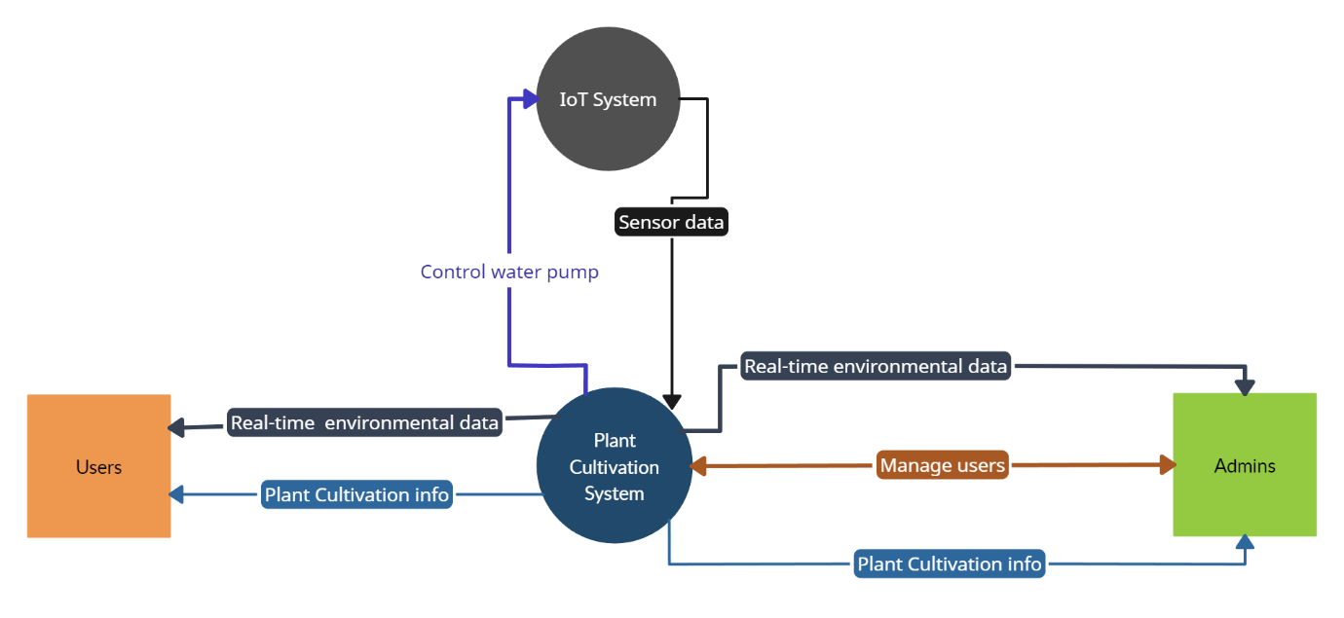

Figure 1: Context diagram for the business.

# **Project Description**

This project aims to help farmers grow plants better using modern technology. This project uses special gadgets called IoT sensors to get real-time environment information.

The project goal is to make a clever system that learns from this information. And also using smart computer programs to understand what's best for the plants. The idea is to give farmers smart advice based on what's happening right then and there in their fields. And also farmers can be able to get an idea about plant healthiness.

If this works, it will make farming easier for farmers. And they can know exactly what their plants need to grow better. This project could change how farmers take care of plants, making them more high-tech and smarter.

**Deliverables**

The Agriculture Monitoring and Prediction System project aims to generate significant deliverables that contribute to advancing farming practices and providing actionable insights for agricultural stakeholders. These deliverables encompass diverse outcomes and comprehensive analyses resulting from the extensive research and development conducted within the project.

* Predictive Models for Plant Cultivation
  + Trained machine learning models utilizing IoT sensor data to predict optimal plant growth conditions based on real-time environmental factors.
  + Detailed model configurations, parameters, and documentation for model replication and future enhancements.
* Model Performance Evaluation and Comparison
  + Comparative analysis of different machine learning models used in predicting plant growth patterns.
  + Presentation of performance metrics showcasing model accuracy, precision, and efficiency.
* Insights and Recommendations for Smart Plant Care
  + Interpretation of research findings highlighting critical factors influencing plant growth and health.
  + Actionable recommendations for farmers and agricultural practitioners to optimize plant care strategies based on real-time sensor data.
* Pre-processed Sensor Data and Documentation
  + Cleaned and pre-processed datasets containing real-time environmental data collected from IoT sensors.
  + Documented data preprocessing methodologies outlining steps, treatment of missing values, and outlier handling.
* Technical Documentation and Methodology
  + Detailed documentation outlining the project's methodology, including sensor data collection, preprocessing steps, model development, and evaluation procedures.
  + Description of the system's implementation process utilizing IoT sensor data for predictive analysis.
* Codebase and Collaborative Repository
  + Access to the project's codebase, encompassing scripts for data preprocessing, model training, and system implementation.
  + A collaborative platform (e.g., GitHub repository) ensuring version control and enabling collaboration among project contributors.

These deliverables encapsulate the tangible and intellectual outcomes of the Agriculture Monitoring and Prediction System project, offering valuable resources for farmers, researchers, and professionals keen on improving plant cultivation practices through technology-driven insights and predictive analytics.

# **Conceptual framework and Hypothesis**

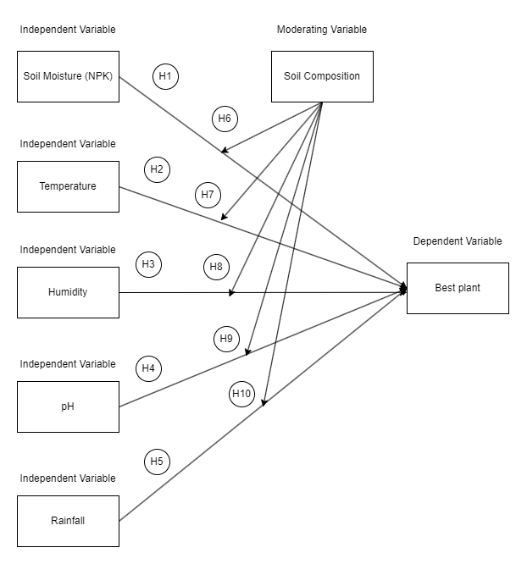

Figure 2: Conceptual framework and hypothesis

# **Hypothesis**

* Hypothesis 1: There is a significant relationship between NPK levels and the optimal plant growth across varying soil compositions.
* Hypothesis 2: Temperature variations significantly impact the choice of optimal plants to grow, moderated by soil composition.
* Hypothesis 3: Humidity levels play a crucial role in determining the ideal plant species for cultivation, considering different soil compositions.
* Hypothesis 4: pH levels significantly influence the selection of plants for optimal growth, contingent on soil composition.
* Hypothesis 5: Rainfall patterns have a significant effect on the choice of plants best suited for growth, moderated by soil composition.
* Hypothesis 6: There is an interaction effect between NPK levels and soil composition on determining the optimal plant species for cultivation.
* Hypothesis 7: Interaction between temperature and soil composition significantly influences the choice of plants suitable for growth.
* Hypothesis 8: Humidity levels interact with soil composition to impact the selection of optimal plants for cultivation.
* Hypothesis 9: pH levels interact with soil composition, affecting the choice of plants best suited for growth.
* Hypothesis 10: Rainfall patterns interact with soil composition to determine the ideal plant species for cultivation.

# **System Process Workflow**

The system processing workflow for the Plant Growth Prediction System involves a comprehensive set of procedures designed to handle data collection, preprocessing, model development, evaluation, and insights derivation. These sequential steps provide a structured framework for the project, facilitating the progression of tasks essential to predicting optimal plant growth based on various environmental factors.

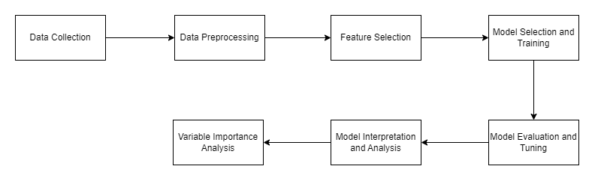

Figure 3: System processing workflow of the machine learning model

* Data Collection
  + Gather relevant datasets containing information about the plants, including growth attributes, environmental conditions, soil composition, and any other pertinent factors affecting plant growth.
* Data Preprocessing
  + Cleanse the data by handling missing values, outliers, and inconsistencies.
  + Normalize or scale numerical features and encode categorical variables if necessary.
  + Split the data into training, validation, and testing sets.
* Feature Selection
  + Perform feature selection to identify the most influential attributes impacting plant growth.
  + Engineer new features if needed based on domain knowledge or insights.
* Model Selection and Training
  + Choose appropriate machine learning algorithms suitable for the prediction task (e.g., Decision Trees, Random Forests, Gradient Boosting, Neural Networks).
  + Train the models using the pre-processed training dataset.
* Model Evaluation and Tuning
  + Evaluate model performance using suitable metrics (e.g., accuracy, precision, recall, F1-score, or specific domain-related metrics).
  + Perform hyperparameter tuning using techniques like grid search or random search to optimize model performance.
* Model Interpretation and Analysis
  + Interpret model predictions and analyse feature importance to understand which factors are most influential in determining plant growth.
* Variable Importance Analysis
  + Utilize the trained model to identify the importance of each independent variable.
  + Rank variables based on their contribution to predicting optimal plant.

# **Architecture**

Frontend user interface implemented using ReactJS. This interface presents real-time data to users, providing visualizations and insights derived from IoT sensor readings.

The backend, developed using Node.js, functions as the central processing unit, managing interactions between the frontend, IoT devices, and the machine learning module. It hosts APIs and routes to receive requests from the frontend, iot sensors, and ML backend.

Embedded within the system are IoT devices equipped with sensors for gathering environmental data like temperature, humidity, soil metrics, or any other relevant parameters. These devices continuously collect data and await requests from the backend for transmission.

The machine learning module, stationed within the backend environment, is responsible for processing the acquired sensor data. Upon receiving the data stream from the IoT devices, it engages in predictive analysis using pre-trained models or real-time model inference. This module predicts optimal plant choices based on the environmental metrics received.

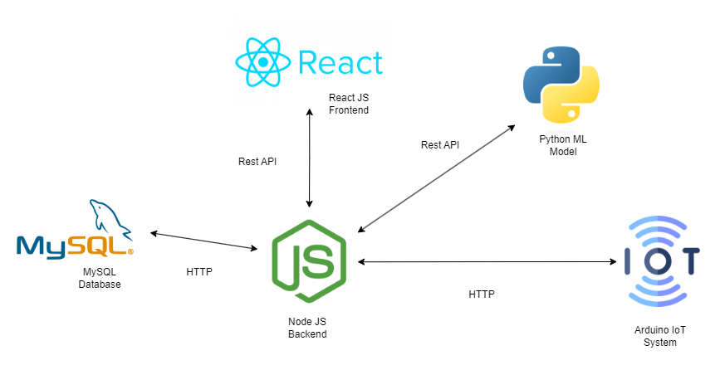

Figure 4: High level architecture

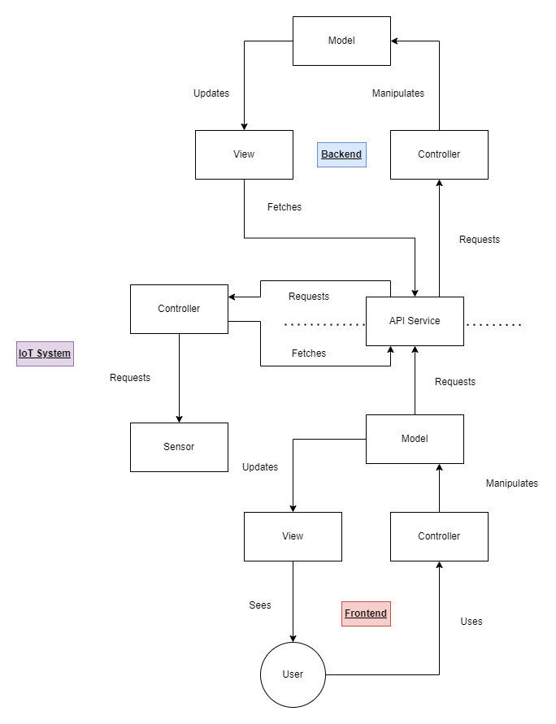

Figure 5: Architecture

# **Resources required**

* Hardware
  + **Computing Power**: A computer with ample processing capabilities to efficiently handle data preprocessing, model training, and analysis tasks.
  + **Arduino Board**: Utilize Arduino for interfacing with IoT sensors, collecting real-time data, and initiating data transfer to the backend.
* Software
  + **Python**: The primary programming language for data analysis, machine learning, and model development.
  + **Jupyter Notebook**: An interactive coding environment for experimenting, coding, and documenting processes.
  + **Data Collection Libraries**: Utilize libraries like pandas, numpy, and requests for efficient data collection, manipulation, and preprocessing.
  + **Machine Learning Libraries**: Leverage scikit-learn for implementing random forest regression and TensorFlow or Keras for LSTM model development.
  + **Data Visualization Libraries**: Utilize matplotlib and seaborn for creating insightful visualizations and plots.
* Data
  + **NPK, Temperature, Humidity, pH, Rainfall Data**: Access relevant data for independent variables crucial for predicting optimal plant growth conditions.
  + **Soil Composition Data**: Gather data on soil composition, which acts as a moderating variable in the prediction model.
* IoT Sensors
  + **Arduino-Compatible Sensors**: Deploy sensors to measure NPK levels, temperature, humidity, pH, and rainfall in real-time.
* Tools
  + **Code Version Control**: Employ tools like Git and platforms such as GitHub for version control and seamless collaboration.
  + **Integrated Development Environment (IDE)**: Use Jupyter Notebook, PyCharm, or Visual Studio Code for efficient coding and experimentation.
* Internet Access
  + **Reliable Internet Connectivity**: Ensure consistent internet access for retrieving data from sources, accessing research materials, and obtaining relevant resources.
* Data Storage
  + **Storage Space**: Allocate sufficient storage space for storing collected data, pre-processed data, and intermediate model files.
* Educational Resources
  + **Online Tutorials and Courses**: Utilize online tutorials, courses, and documentation to enhance understanding of machine learning concepts, time series analysis, and specific algorithms like random forest regression and LSTM.
* Collaboration and Communication Tools
  + **Communication Platforms**: email, messaging platforms, or project management tools to foster effective collaboration with team members and stakeholders.
* Publication and Reporting
  + **Document Creation Tools**: Utilize tools such as Microsoft Office Suite or Google Workspace for creating presentations, research reports, and project documentation.
* Special Considerations

**Cloud Computing Resources**: If deploying models in a production environment, consider cloud computing resources for hosting and serving predictive models.

# **Expected output and outcome of the system**

The Agriculture Plant Prediction Project is designed to produce tangible results and valuable insights to optimize plant cultivation decisions. The anticipated output and outcomes reflect the project's objectives and the benefits it aims to provide to stakeholders.

**Expected Output**

* Predictive Models: Developed machine learning models utilizing NPK levels, temperature, humidity, pH, and rainfall data to predict optimal plant choices for specific conditions.
* Model Performance Metrics: Quantitative metrics, including prediction accuracy scores and comparison measures, to evaluate the effectiveness of the predictive models.
* Comparative Analysis: A detailed analysis comparing the performance of the prediction models, offering insights into which model provides more accurate plant recommendations.
* Variable Importance Insights: Identification of critical independent variables influencing plant growth recommendations, highlighting factors crucial for decision-making.
* Temporal Trends Analysis: Insights into how the significance of independent variables evolves over different time periods, facilitating adaptation to changing environmental conditions.
* Interpretation of Results: Clear and interpretable insights and recommendations regarding factors influencing optimal plant choices based on the provided data.

**Outcome**

* Accurate Plant Recommendations: The project's developed models will contribute to accurate predictions of optimal plant choices, empowering farmers and cultivators to make informed decisions.
* In-Depth Understanding of Influencing Factors: Uncovering significant variables affecting plant growth, enhancing the understanding of environmental dynamics impacting cultivation.
* Comparison of Models: A comprehensive comparison between different prediction models, guiding the selection of the most effective approach for future cultivation decision-making.
* Temporal Analysis Knowledge: Insights into how independent variables' importance changes over time, enabling stakeholders to adapt cultivation strategies to evolving environmental conditions.
* Informed Decision-Making: Farmers and cultivators can leverage the insights to strategize and optimize resource allocation, minimizing risks associated with suboptimal plant choices.
* Educational Contribution: The project's research findings contribute to agricultural knowledge, providing insights into optimal plant cultivation methodologies for specific environmental conditions.
* Best Practices Dissemination: Sharing project code, documentation, and methodologies with the agricultural community promotes best practices in leveraging machine learning for cultivation decisions.
* Applicability to Other Fields: The project's methodology can serve as a template for predicting optimal choices in other agricultural domains, promoting sustainable and informed cultivation practices.

The expected output and outcome of the Agriculture Plant Prediction Project align with its overarching goals of enhancing cultivation decision-making, providing valuable insights, and contributing to advancements in agricultural practices.

# **Time Plan for Implementation**

The realization of the Agriculture Plant Prediction Project necessitates a strategic and organized approach, comprising a sequence of interlinked tasks. The following is a proposed time plan, delineating the crucial phases and their estimated durations to guide the project implementation process.

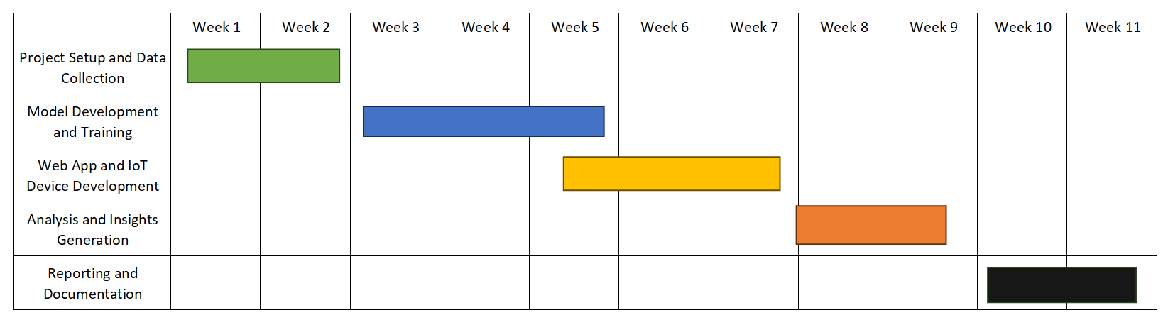

Figure 6: Gantt Chart

**Phase 1**: Project Setup and Data Collection

* Duration: 2 weeks

1. Week 1: Project Initiation
   1. Define project objectives, scope, and deliverables.
   2. Set up version control (Git) repository.
   3. Create project structure and directories.
2. Week 2: Data Collection and Preprocessing
   1. Gather datasets for NPK levels, temperature, humidity, pH, and rainfall.
   2. Preprocess data, handle missing values, outliers, and engineer features.

**Phase 2**: Model Development and Training

* Duration: 3 weeks

1. Week 3: Model Selection and Setup
   1. Choose machine learning models for plant prediction.
   2. Set up Python environment and required libraries.
2. Week 4: Model Development and Training
   1. Develop and train machine learning models using historical data.
   2. Experiment with different model architectures and parameters.
3. Week 5: Web App and IoT Device Development
   1. Develop the frontend web app using ReactJS.
   2. Implement the backend using NodeJS.
   3. Integrate IoT devices (Arduino) for real-time data collection.

**Phase 3**: Analysis and Insights Generation

* Duration: 2 weeks

1. Week 6: Variable Importance Analysis
   1. Determine the importance of NPK levels, temperature, humidity, pH, and rainfall in predicting optimal plant choices.
   2. Identify key factors influencing plant growth recommendations.
2. Week 7: Interpretation and Insights
   1. Interpret findings from analysis and model evaluations.
   2. Generate insights into optimal plant choices based on environmental data.

**Phase 4**: Reporting and Documentation

* Duration: 2 weeks

1. Week 8: Presentation and Research Report
   1. Create a presentation summarizing methodologies and results.
   2. Compile a detailed research report with analyses and insights.
2. Week 9: Documentation and Code Cleanup
   1. Document code, methodologies, and analyses.
   2. Clean up and organize the codebase for future reference.

Note: The above time plan is a rough estimate and can vary based on the complexity of the data, unforeseen challenges, and the pace of progress. Flexibility is essential to adjust the timeline as needed while maintaining the quality of the project.

By following this time plan, the Agriculture Plant Prediction Project can be executed efficiently, leading to the development of accurate predictive models and valuable insights into optimal plant choices based on environmental conditions.

# **Limitations**

While the Agriculture Plant Prediction Project aims to offer accurate predictive models and valuable insights into optimal plant choices, it is crucial to acknowledge certain limitations and potential challenges that may impact the project's outcomes:

* Data Quality and Availability
  + The accuracy of predictions heavily relies on the quality and completeness of NPK, temperature, humidity, pH, and rainfall data.
  + Limited availability of high-quality data for certain independent variables may affect the model's performance.
* Environmental Variability
  + Agricultural environments can be highly variable, leading to challenges in capturing all influencing factors accurately.
  + Sudden changes in local conditions, such as microclimates, could impact the model's ability to provide universally applicable recommendations.
* Model Sensitivity
  + Predictive models are sensitive to hyperparameters, model architectures, and training data.
  + Small changes in these parameters may result in variations in prediction results.
* Correlation Among Variables
  + Some independent variables may exhibit high correlation, potentially causing multicollinearity issues and affecting model accuracy.
* External Factors
  + Environmental conditions can be influenced by external factors like unexpected weather events, soil composition changes, or pest infestations.
  + The models may not fully account for or adapt to unforeseen external factors affecting plant growth.
* Limited Scope of Predictions
  + The project's predictions are limited to the variables included in the model, and certain nuanced factors influencing plant growth may not be captured.
* Data Lag
  + Real-time updates from IoT sensors may have a lag, impacting the timeliness of predictions.
* Future Environmental Dynamics
  + The project's findings may be valid for current environmental conditions, but future changes in climate or agricultural practices could impact the model's relevance over time.

Addressing these limitations transparently in the project's documentation is crucial to providing a comprehensive understanding of the Agriculture Plant Prediction Project's results and insights.

# **References**

Lakshmanaprabu, S., Shankar, K., Ilayaraja, M., Nasir, A. W., Vijayakumar, V., & Chilamkurti, N. (2019). *Random forest for big data classification in the internet of things using optimal features.*

<https://link.springer.com/article/10.1007/s13042-018-00916-z>

Lei Zhang, L., Dabipi, I., & Brown Jr., W. (2018). *Internet of Things Applications for Agriculture.*

<https://doi.org/10.1002/9781119456735.ch18>

Naqa, I. E., & Murphy, M. J. (2015). *What Is Machine Learning?*

<https://link.springer.com/book/10.1007/978-3-319-18305-3>

Thi Pham, H., Awange, J., Kuhn, M., Nguyen, B. V., & Bui, L. K. (n.d.). *Enhancing Crop Yield Prediction Utilizing Machine Learning on Satellite-Based Vegetation Health Indices.*

<https://www.mdpi.com/1424-8220/22/3/719>

Murlidharan, S., Shukla, V. K., & Chaubey, A. (n.d.). *Application of Machine Learning in Precision Agriculture using IoT.*

<https://ieeexplore.ieee.org/abstract/document/9445312/authors#authors>

Madushanki, A. R., Halgamuge, M. N., Wirasagoda, W. S., & Syed, A. (n.d.). *Adoption of the Internet of Things (IoT) in agriculture and smart farming towards urban greening.*

<https://researchoutput.csu.edu.au/en/publications/adoption-of-the-internet-of-things-iot-in-agriculture-and-smart-f>

Hannah, L., Roehrdanz, P. R., K. C., K. B., Fraser, E. D., Donatti, C. I., Saenz, L., & Hijmans, R. J. (n.d.). *The environmental consequences of climate-driven agricultural frontiers.*

<https://journals.plos.org/plosone/article?id=10.1371/journal.pone.0228305&utm_source=midlandtoday.ca&utm_campaign=midlandtoday.ca&utm_medium=referral>

Nayyar, A., & Puri , E. V. (n.d.). *Smart Farming: IoT Based Smart Sensors Agriculture Stick for Live.*

<https://www.researchgate.net/profile/Anand-Nayyar/publication/313804002_Smart_farming_IoT_based_smart_sensors_agriculture_stick_for_live_temperature_and_moisture_monitoring_using_Arduino_cloud_computing_solar_technology/links/59d9f67c0f7e9b12b36d66f8/Smart-farming-IoT-based-smart-sensors-agriculture-stick-for-live-temperature-and-moisture-monitoring-using-Arduino-cloud-computing-solar-technology.pdf>

Balducci, F., Impedovo, D., & Pirlo, G. (n.d.). *Machine Learning Applications on Agricultural Datasets for Smart Farm Enhancement.*

<https://www.mdpi.com/2075-1702/6/3/38>

Nayak, P., Kavitha, K., & Rao, C. M. (n.d.). *IoT-Enabled Agricultural System Applications, Challenges and Security Issues.*

<https://link.springer.com/chapter/10.1007/978-981-13-9177-4_7>