# Tenant Flow

## Insert/Delete/Update for tenant list

### Flow



### Reference

Website (erp_ui/erp_ui/dashboards/tenant/urls.py)

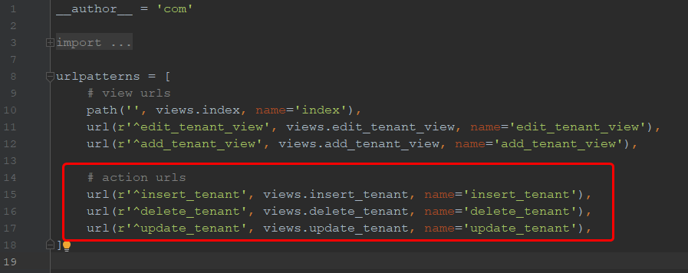

API server (erp_api/erp_api/basic/url.py)

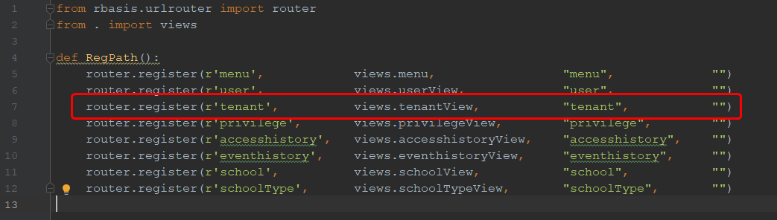

# School Flow

## Insert the school

### Flow



### Reference

**Ref-1** (erp_ui/erp_ui/dashboards/school/view.py)

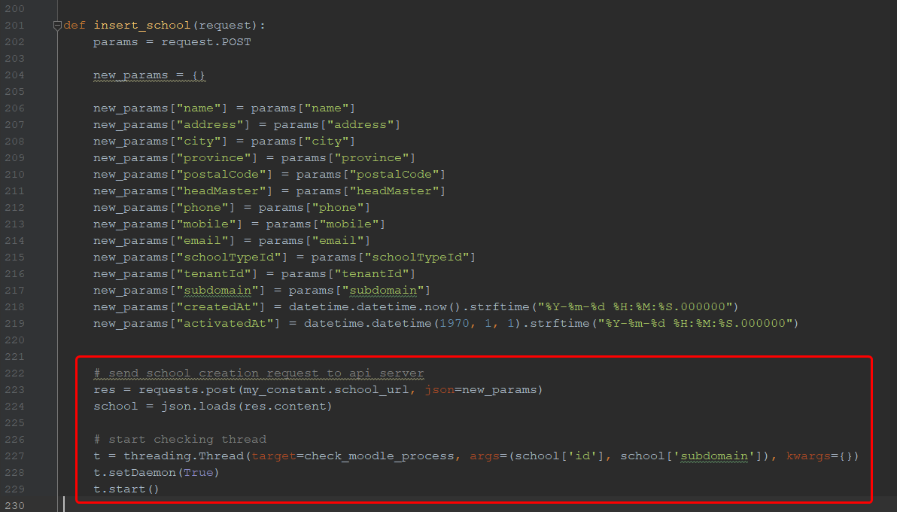

**Ref-2** (erp_api/erp_api/basic/views.py)

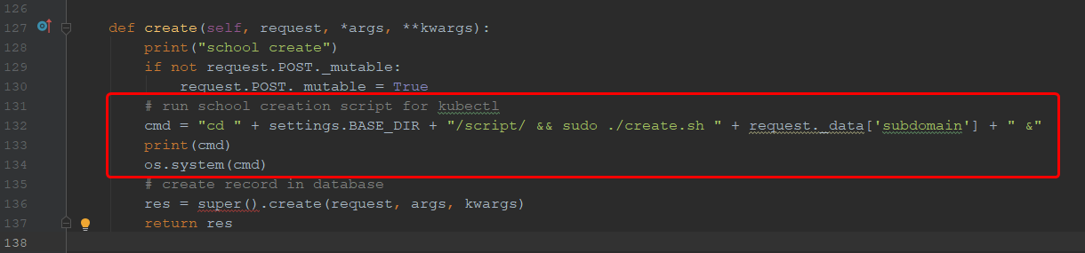

“erp_api/script/create.sh” will create all the related resources for a school by using kubectl

**Ref-3** (erp_api/erp_api/basic/views.py)

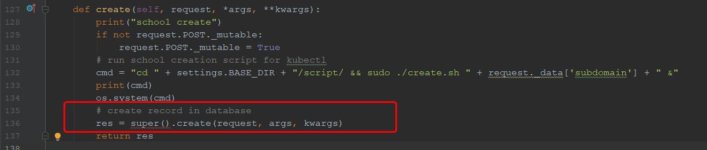

**Ref-4** (erp_ui/erp_ui/dashboards/school/views.py)

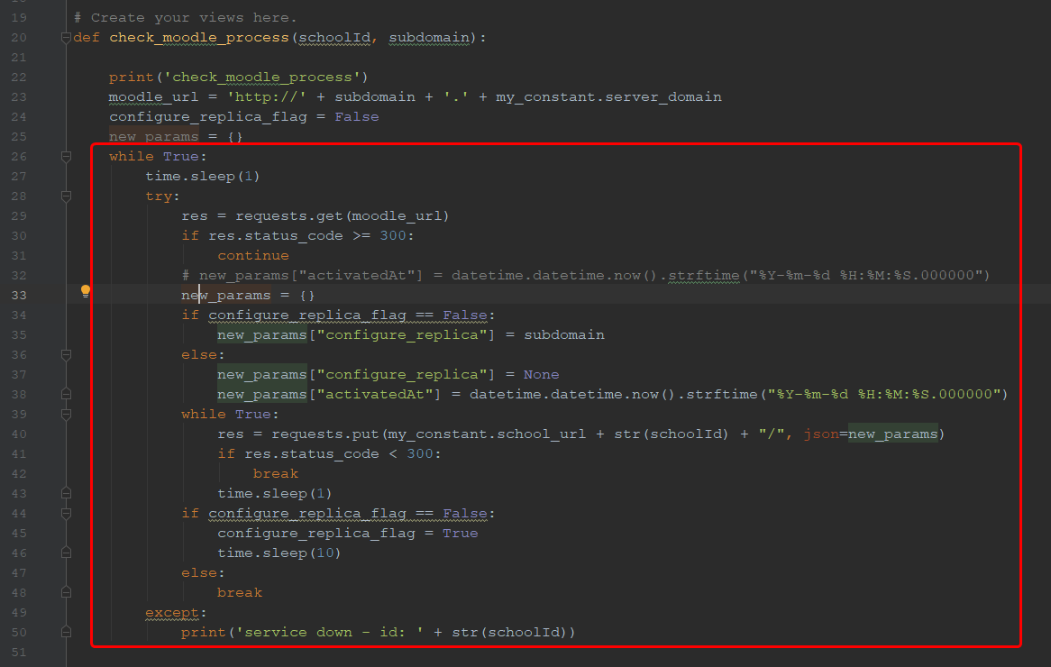

This while loop will wait until school activated.

It is checking school’s status by requesting to the url http://<school_domain>.deuspace.web.id.

**Ref-5** (erp_ui/erp_ui/dashboards/school/views.py)

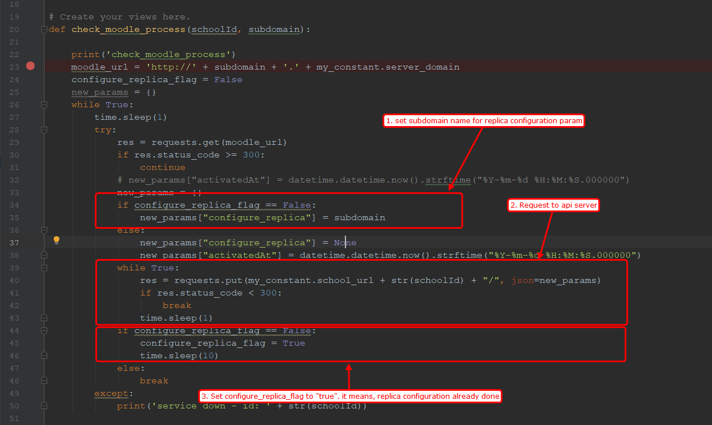

When the school activated, the checking process will request to api server to configure replica and then wait for the school activated again.

**Ref-6** (erp_api/erp_api/basic/views.py)

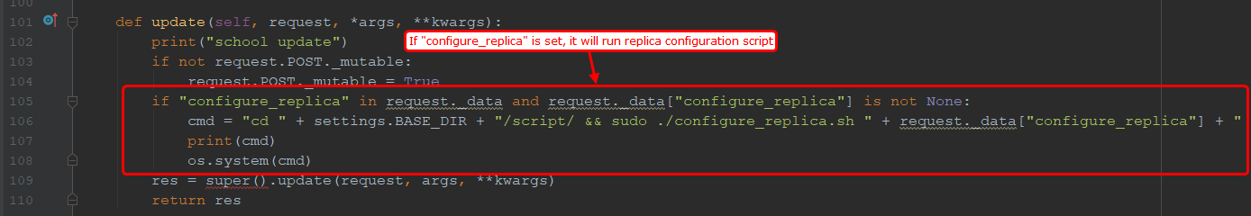

“erp_api/script/configure_replica.sh” will create all the related resources for hpa by using kubectl

**Ref-7** (erp_ui/erp_ui/dashboards/school/views.py)

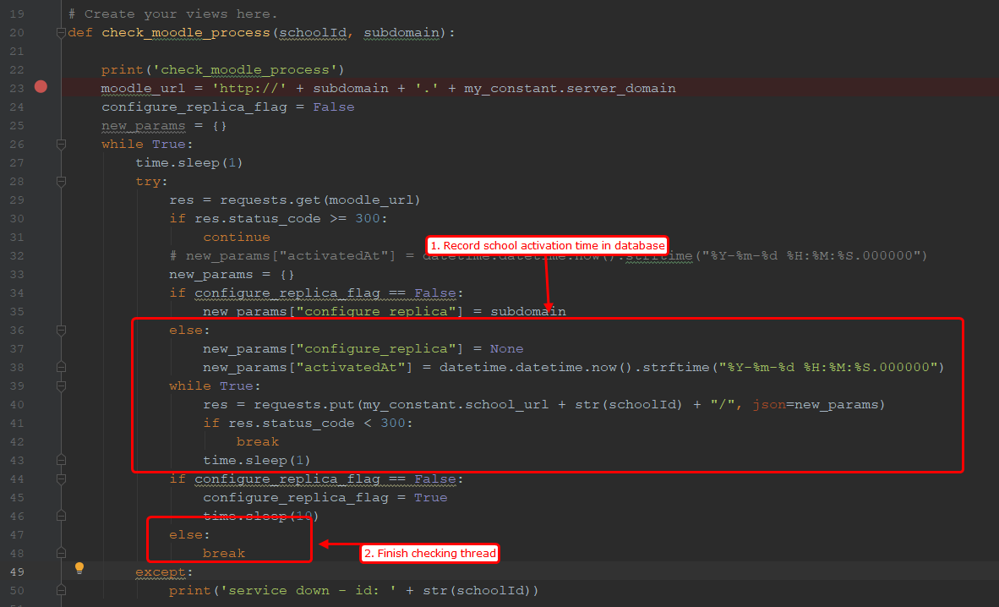

## Update school

The same with tenant.

## Delete School

### Flow



### Reference

**Ref-1** (erp_ui/erp_ui/dashboards/school/views.py)

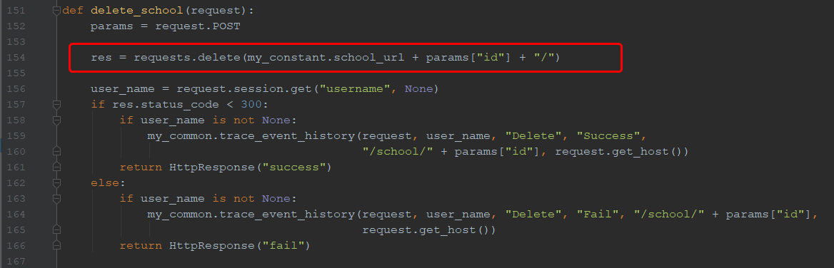

**Ref-2** (erp_api/erp_api/basic/views.py)

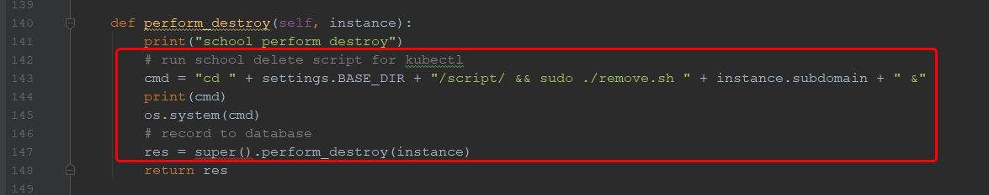

“erp_api/script/remove.sh” will delete all the related resources for a school by using kubectl

# Scripts

## create.sh

This script will create the school:

* Create namespace (yaml/01namespace.tmpl)
* Create maridadb pod (yaml/15stateful-mariadb.yaml)
  + Check local image repository and download image from dockerhub if there is no one in local repository.
  + Create pod instance from image
* Create service for mariadb (yaml/14service-mariadb.yaml)
* Create moodle pod (yaml/22deployment-moodle.yaml)
  + Check local image repository and download image from dockerhub if there is no one in local repository.
  + Create pod instance from image
* Create service for moodle (yaml/23service-moodle.yaml)
* Create ingress rule for subdomain routing (yaml/24ingress-moodle)

## configure_replica.sh

This script will configure replica for school:

* Recreate moodle pod with replica mode (yaml_spec/22deployment-moodle.yaml)
* Create hpa for moodle (yaml_spec/25hpa-moodle.yaml)

## remove.sh

It will remove all the resources created by create.sh and configure_replica.sh

# Native Kubernetes vs Google Kubernetes

We are using native kubernetes for our project and it has following advantage and disadvantage.

**Advantage:**

* We can easily migrate our project to any cloud service or private servers. GKE is providing their own command suite to manage kubernetes cluster and it is much similar to kubectl but there are some differences. So if we developed this project based on GKE, there should be some overhead when we migrate our project. For example, when we use GKE and we need to migrate our project to AWS cloud or local servers, we need to rewrite the related part to access kubectl.

**Disadvantage:**

* It took more time and labor for development, because we should define all the features like auto-scaling. (As you know, it is not providing node scaling for now.)